NAST

Nonadiabatic Statistical Theory

Version 2.0

User manual and installation guide

University of Nevada, Reno
New York University, New York

MIT License

Copyright (c) 2026 Sergey A. Varganov, Claudia E. Avalos

Permission is hereby granted, free of charge, to any person obtaining a copy of this software and associated documentation files (the "Software"), to deal in the Software without restriction, including without limitation the rights to use, copy, modify, merge, publish, distribute, sublicense, and/or sell copies of the Software, and to permit persons to whom the Software is furnished to do so, subject to the following conditions:

The above copyright notice and this permission notice shall be included in all copies or substantial portions of the Software.

THE SOFTWARE IS PROVIDED "AS IS", WITHOUT WARRANTY OF ANY KIND, EXPRESS OR IMPLIED, INCLUDING BUT NOT LIMITED TO THE WARRANTIES OF MERCHANTABILITY, FITNESS FOR A PARTICULAR PURPOSE AND NONINFRINGEMENT. IN NO EVENT SHALL THE AUTHORS OR COPYRIGHT HOLDERS BE LIABLE FOR ANY CLAIM, DAMAGES OR OTHER LIABILITY, WHETHER IN AN ACTION OF CONTRACT, TORT OR OTHERWISE, ARISING FROM, OUT OF OR IN CONNECTION WITH THE SOFTWARE OR THE USE OR OTHER DEALINGS IN THE SOFTWARE.

If you use the NAST package, please cite the following publications:

(1) Dergachev, I. D.; Dergachev, V. D.; Rooein, M.; Patel, Y. H.; Weiss, P. S.; Avalos, C. E.; Varganov, S. A. NAST 2.0: Magnetic Field Effects and Marcus-Levich-Jortner Theory for Complex Open-Shell Systems. ACS Omega 2026, 11, 59936–59945. https://doi.org/10.1021/acsomega.6c07270.
(2) Rooein, M.; Varganov, S. A. Predicting Kinetics of Spin-Dependent Reactions in an External Magnetic Field with Nonadiabatic Statistical Theory. J. Chem. Phys. 2024, 161, 164306. https://doi.org/10.1063/5.0232469.
(3) Dergachev, I. D.; Dergachev, V. D.; Rooein, M.; Mirzanejad, A.; Varganov, S. A. Predicting Kinetics and Dynamics of Spin-Dependent Processes. Acc. Chem. Res. 2023, 56, 856–866. https://doi.org/10.1021/acs.accounts.2c00843.
(4) Rooein, M.; Varganov, S. A. How to Calculate the Rate Constants for Nonradiative Transitions Between the M_{S} Components of Spin Multiplets? Mol. Phys. 2022, e2116364. https://doi.org/10.1080/00268976.2022.2116364.
(5) Dergachev, V. D.; Rooein, M.; Dergachev, I. D.; Lykhin, A. O.; Mauban, R. C.;
Varganov, S. A. NAST: Nonadiabatic Statistical Theory Package for Predicting Kinetics of Spin-Dependent Processes. Top. Curr. Chem. 2022, 380, 15. https://doi.org/10.1007/s41061-022-00366-w.
(6) Lykhin, A. O.; Varganov, S. A. Intersystem Crossing in Tunneling Regime: T₁ → S₀ Relaxation in Thiophosgene. Phys. Chem. Chem. Phys. 2020, 22 (10), 5500–5508. https://doi.org/10.1039/c9cp06956a.
(7) Lykhin, A. O.; Kaliakin, D. S.; DePolo, G. E.; Kuzubov, A. A.; Varganov, S. A. Nonadiabatic Transition State Theory: Application to Intersystem Crossings in the Active Sites of Metal-Sulfur Proteins. Int. J. Quantum Chem. 2016, 116 (10), 750–761. https://doi.org/10.1002/qua.25124.

Table of content

0. New Features in NAST 2.0 7
1. Installation guide 8
2. Nonadiabatic Statistical Theory 12
2.1. Introduction 12
2.2. Main equations 12
2.3. NAST input data and electronic structure calculations 23
References 24
3. Program structure 27
3.1. Input structure 27
3.2. Groups and keywords 27
3.2.1 &keys 28
3.2.2 &inputdata 29
3.2.3 &external 30
3.2.4 &probability 31
3.2.5 &reverse 31
3.2.6 &split 33
3.2.7 &polynomials 35
References 35
4. Navigation through output files 36
4.1. nast.out 36
4.2. energy_rates.out 36
4.3. energy_tst_rate.out (written if tst = .true. in &keys) 37
4.4. energy_probabilities.out 37
4.5. TST_energy_probabilities.out (written if tst_tunn = .true. in &keys) 37
4.6. Densities of states (written if printmore = .true. in &keys) 37
4.7. effective_number_of_states.out 37
4.8. effective_number_of_states_TST.out (written if tst = .true.) 37
4.9. adiabatic_energies.out (written if zn = .true.) 37
4.10. split_LZ_probabilities.out (written if sp = .true.) 37
4.11. split_WC_probabilities.out (written if sp = .true.) 38
4.12. split_LZ_energy_rate.out (written if sp = .true.) 38
4.13. split_WC_energy_rate.out (written if sp = .true.) 38
4.14. split_LZ_tempt_rate.out (written if sp = .true.) 38
4.15. split_WC_tempt_rate.out (written if sp = .true.) 38
4.16. Bz_LZ_probabilities.out (written if sp = .true.) 38
4.17. Bz_LZ_energy_rate.out (written if sp = .true. in &keys) 38
4.18. Bz_LZ_tempt_rate.out (written if sp = .true.) 38
5. Marcus-Levich-Jortner program 40
5.1. Introduction 40
5.2. Installation and running 41
5.3. Input structure, groups, and keywords 42
5.4. Navigation through output files 43
References 43
6. Examples 44
6.1 Example 1. TST case study: Isomerization of Propylene Oxide to Acetone and Propanal 44
6.2 Example 2. TST case study: Cis-trans isomerization in but-2-ene 47
6.3 Example 3. Dehydrogenation of the triplet methoxy cation, CH₃O⁺ 51
6.4 Example 4. Spin-forbidden izomerization of dichloro-1,3-bis(diphelylophosphino)propanenickel(II) 56
6.5. Example 5. T₁ → S₀ relaxation in thiophosgene in tunneling regime 62
6.6. Example 6. T₁ → S₀ relaxation in cyclopropene 65
6.7 Example 7. Ultrafast ISC in a metal-free diketone with MLJ program 69
References 71
7. Tools 73
7.1. Effective Hessian code 73
7.1.1. Introduction to Effective Hessian 73
7.1.2. Working equations 73
7.1.3. Installation 74
7.1.4. Running Effective Hessian (effhess.x) 75
7.1.5. Input structure 76
7.1.6. Input files 77
7.1.7. Navigation through output files 77
7.1.8. Example of running Effective Hessian for methoxy cation, CH₃O⁺ 78
7.2. Intrinsic reaction coordinate fitting (ircfit) 86
7.2.1. Introduction to ircfit 86
7.2.3. Installation 88
7.2.4. Running IRC fit (ircfit.x) 89
7.2.5. Input file syntax 89
7.2.6. Input files 89
7.2.7. Navigation through output files 90
7.2.8. Example 1. Calculating 1-D crossing potentials for T₁ → S₀ relaxation in cyclopropene 90
7.3. Vibrational tool (vib) 94
7.3.1. Introduction to vib 94
7.3.3. Installation 94
7.3.4. Running vib 95
7.3.5. Input file syntax 95
7.3.6. Navigation through output files 96
7.3.7. Example 1. Calculating Huang-Rhys factors for S₁ ⟶ T₃ relaxation in a 1,2-diketone 96
References 98
8. pyMECP program 100
8.1. Introduction 100
8.2. Installation 100
8.3. Workflow 100
References 102

0. New Features in NAST 2.0

- Magnetic field effects

The NAST package now allows to study the effect of an external magnetic field on probabilities and rate constants of spin-dependent reactions.

- Marcus-Levich-Jortner program

Fermi’s golden rule-like calculations are implemented in the form of the Marcus-Levich-Jortner theory (MLJ) for the cases where locating a minimum energy crossing point (MECP) geometry is challenging or a reaction is effectively barrierless. The MLJ program uses the input data provided by the new vib tool.

- vib tool

A new tool called vib is implemented to calculate the Huang-Rhys factors and vibrational reorganization energies for Fermi’s golden rule calculations. The vib tool is interfaced with the GAMESS US, Molpro, ORCA, and Q-Chem electronic structure software packages.

- Quantum tunneling corrections for TST

The Eckart’s and Wigner’s quantum tunneling correction coefficients can now be calculated to improve the semi-classical TST rate constants.

- Effective Hessian calculations with Q-Chem and ORCA

The effective Hessian tool is now extended to work with the outputs from the Q-Chem and ORCA electronic structure packages.

- Intrinsic reaction coordinate fitting with ORCA

The intrinsic reaction coordinate fitting tool is now extended to work with the outputs from the ORCA electronic structure package.

- Adjustable integration accuracy

The previous default and fixed step of one cm⁻¹ for numerical integration is now user-specified.

- pyMECP program

A new MECP search program written in Python and interfaced with the ORCA 6 electronic structure package.

1. Installation guide

- Quick start

The NAST package can be installed with the following Linux commands:

$ ./configure.py --lib_path=path_to_math_library
$ make
$ make clean
$ cd checkcomp
$ ./checknast

Here, path_to_math_library is the path to the preinstalled math library. The make command creates the executable nast.x. The checknast script tests the installation by running several examples of NAST calculations.

- Installation overview

The NAST package is distributed as a source code written in modern Fortran for Linux distributions.

- Prerequisites

The following prerequisites are strongly recommended:

- Fortran compiler. The NAST source code has been successfully compiled using GNU Fortran (GCC) 4.8.5, GNU Fortran (GCC) 8.2.0, GNU Fortran (GCC) 8.5.0, GNU Fortran (GCC) 9.3.0, GNU Fortran (GCC) 11.5.0, ifort (IFORT) 13.0.0, ifort (IFORT) 2023.1.0, and ifort (IFORT) 2023.2.1.

- Math library. NAST has been successfully tested with the Intel® Math Kernel Library (MKL) versions 2018.2.199 – 2018.4.274, 2019.0.177 – 2019.5.281, 2020.0.166, 2023.1.0, and 2023.2.1.

- Python interpreter, version 2.4 or greater (usually included in any modern Linux distribution).

- Configuration

NAST is configured using the Python script configure.py. The default configuration settings can be overwritten using the following flags:

--fc=. . . Fortran compiler
--fcflags=”. . .” List of compiler flags
--lib_path=. . . Path to math library
--libs=”. . .” Library files to be linked

A typical script execution will look like the following:

$ ./configure.py --fc=. . . --fcflags=”. . .” --lib_path=. . . --libs=”. . .”

The default values for --fc, --fcflags, --lib_path and --libs can be printed by executing ./configure.py --help. If multiple compilers are available, the full path should be provided (e.g. --fc=/path/to/bin/gfortran). Executing ./configure.py with all defaults is equivalent to

$ ./configure.py --fc=gfortran --fcflags=”-O0 -g -fcheck=bounds -fcheck=all -C” --lib_path=/usr/local/include/mkl/lib/intel64 --libs=”-lmkl_intel_lp64 -lmkl_sequential -lmkl_core -lpthread -lm -ldl”

- Configuration notes

- The default --fcflags are set for the GNU Fortran compiler gfortran. For the Intel Fortran compiler ifort, the user must set the corresponding Intel flags. If defaults are used, the best-case scenario is that these flags will be ignored with a warning (e.g. ifort: command line warning #10006: ignoring unknown option '-fcheck=bounds').

- The default for the MKL flag is lmkl_intel_lp64, even if gfortran is used as a compiler. Perhaps the proper combination would be gfortran and -lmkl_gf_lp64. However, in practice, both combinations produce the same result.

- Recommendations for the GNU and Intel compilers:

GNU Fortran: --fcflags=”-g -fcheck=bounds -fcheck=all -Wall”
Intel Fortran: --fcflags= “-g -ftz -auto”

- Compilation

The configure.py script creates Makefile. The Linux command make uses the configuration information stored in the Makefile to compile the NAST source files and create the executable nast.x.

$ make
$ make clean (optional – deletes temporary files)

- Compilation notes

- If necessary, Makefile can be edited manually.

- For the executable nast.x to run, the environmental variables PATH and LD_LIBRARY_PATH must contain path to the math library. For example, if bash shell is used, these variables can be set in .bash_profile as:

export PATH = $PATH:/…/compilers_and_libraries_20XX.X.XXX/linux/bin

export LD_LIBRARY_PATH = $LD_LIBRARY_PATH:/ …/linux/mkl/lib/intel64

- If multiple versions of MKL are installed, to avoid possible conflicts, the environmental variable LIB should be specified. For example, it can be set in .bash_profile as:

export LIB=/specific_version /linux/mkl/include/
specific_version/linux/mkl/bin/mklvars.sh intel64

- Testing

To test a new NAST build, several test examples are available in the /path/to/nast/checkcomp directory. Executing the checknast script will invoke a loop over the test examples.

$ ./checknast
Sun Mar 29 14:56:47 EDT 2026

An empty directory is being created for:

---- exam01_1 ----
---- exam01_2 ----
---- exam02_1 ----
---- exam02_2 ----
---- exam02_3 ----
---- exam03_1 ----
---- exam03_2 ----
---- exam04_1 ----
---- exam04_2 ----
---- exam04_3 ----
---- exam05 ----
---- exam06 ----
---- exam07 ----

Done creating directories. Running the tests now.

---- Testing exam01._1inp ----
…………………………………………… Passed

---- Testing exam01_2.inp ----
…………………………………………... Passed

and so on
Done with tests

All tests should terminate with Passed. Failed tests may indicate problems with the new NAST build.

For your convenience, you may want to assign an alias to the executable so you can access it from any directory. For example, modify your .bash_profile to include the path to the executable

alias nast = '/path/to/nast.x'

and then source .bash_profile. Now can run NAST calculations with

nast inputfile

2. Nonadiabatic Statistical Theory

2.1. Introduction

The nonadiabatic statistical theory (NAST) describes the kinetics of nonradiative transitions between electronic states with different spin multiplicities.¹⁻⁷ A central NAST approximation is that the interstate transitions effectively take place at the minimum energy crossing point (MECP) on the crossing seam of coupled potential energy surfaces (PESs) of two spin states.^{8,9} The main capabilities of NAST, implemented in this package, include calculations of microcanonical and canonical rate constants, as well as microcanonical and velocity-averaged transition probabilities. The NAST package has two modes of operation. First is the forward rate constant calculations. In this mode, a standard NAST run requires knowledge of molecular properties only at the reactant and the MECP. A more sophisticated optional run will require knowledge about points along the potentials, which represent the minimum energy paths that connect MECP with the reactant and product. Use of such potentials ensures higher accuracy of rate constant calculations. The second operation mode is the calculation of the forward and reverse rate constants in the same run. Such a calculation will require molecular properties at the reactant, MECP, and product geometries. Note that in this mode, the reactant and product are defined as minima of higher-energy and lower-energy states, respectively. Therefore, the forward transitions correspond to the relaxation process. Note that in this mode, the calculations employing explicit crossing potentials are currently available for forward transitions only.
In the limit of an adiabatic reaction proceeding on a single electronic state, NAST reduces to the traditional transition state theory (TST).⁵ The corresponding TST rate constants can be calculated using the NAST package.

2.2. Main equations

Microcanonical rate constant. The central quantity of NAST is the microcanonical rate constant of the transitions between two electronic states of different spin multiplicities:

$$k\left(E\right)= σ\frac{N_{X}\left(E\right)}{hρ_{R}\left(E\right)}, \left(2.1\right)$$

$$N_{X}\left(E\right)= \int_{0}^{E}{ρ_{X}}\left(E-ε_{⊥}\right)P\left(ε_{⊥}\right)dε_{⊥}, \left(2.2\right)$$

$$σ=\frac{σ_{R}}{σ_{X}}γ_{X}, \left(2.3\right)$$

where $N_{X}\left(E\right)$ is the effective number of states at the MECP, $ρ_{R}$ and $ρ_{X}$ are the densities of rovibrational states at reactant and MECP, respectively, and $h$ is Planck’s constant. The interstate transition probability $P\left(ε_{⊥}\right)$ is a function of the energy $ε_{⊥}$ partitioned in the reaction coordinate orthogonal to the crossing seam. The reaction path degeneracy $σ$ is defined in terms of the symmetry numbers of the reactant ($σ_{R})$ and MECP ($σ_{X}$), and the number of chiral MECP isomers ($γ_{X}$).¹⁰
The densities of vibrational and rotational states are obtained using the rigid rotor and harmonic oscillator approximations. To calculate vibrational density of states, the direct counting algorithm is used:¹¹

define E_{max} as the energy limit
do loop over all vibrational frequencies of reactant or MECP:
do j = 1 to number 3N-6 (3N-5 for linear molecule, or 3N-7 for MECP)
set counter k = 0
do while frequency(j)*k < E_{max}
k = k +1; e_bin = ceil (frequency(j)*k)
vib_density(e_bin) = vib_density(e_bin) + 1
end do
To account for ZPE:
vib_density(1) = vib_density(1) + 1
end do

To calculate rotational density of states, the classical asymmetric top model is used:

$$ρ_{rot}\left(E_{rot}\right)=\frac{4\sqrt{2E_{rot}}}{ℏ^{3}}\sqrt{I_{A}I_{B}I_{C}}, \left(2.4\right)$$

where $I_{A}$, $I_{B}$ and $I_{C}$ are the principal moments of inertia of a molecule. The rovibrational density of states are calculated as the convolution:

$$ρ\left(E\right)=\int_{0}^{E}{ρ_{νib}}\left(E-E_{rot}\right)ρ_{rot}\left(E_{rot}\right)dE_{rot}, \left(2.5\right)$$

where $ρ_{vib}$ and $ρ_{rot}$ are the vibrational and rotational densities of states defined above.

Microcanonical ISC probabilities. The transition probability used in equation 2.2 is central to calculating the rate constants. The Landau-Zener (LZ) and weak coupling (WC) transition probabilities⁵ are defined as:

$$P_{LZ}\left(ε_{⊥}\right)=p_{LZ}+\left(1-p_{LZ}\right)p_{LZ}=2p_{LZ}- {p_{LZ}}^{2}, \left(2.6\right)$$

$$p_{LZ}\left(ε_{⊥}\right)=1-exp\left(-\frac{2πH_{SO}^{2}}{ℏ\left|Δg\right|}\sqrt{\frac{μ_{⊥}}{2\left(ε_{⊥}-E_{X}\right)}}\right), \left(2.7\right)$$

$$P_{WC}\left(ε_{⊥}\right)=4π^{2}H_{SO}^{2}{\left(\frac{2μ_{⊥}}{ℏ^{2}\overline{g}\left|Δg\right|}\right)}^{\frac{2}{3}}{Ai}^{2}\left(-\left(ε_{⊥}-E_{X}\right){\left(\frac{2μ_{⊥}{\left|Δg\right|}^{2}}{ℏ^{2}{\overline{g}}^{4}}\right)}^{\frac{1}{3}}\right), \left(2.8\right)$$

where $p_{LZ}$ is the single-passage LZ probability, $H_{SO}$ is the spin-orbit coupling constant, $ℏ$ is reduced Planck’s constant. The norm of the gradient parallel to the reaction coordinate $\left|Δg\right|= \left|g_{1}-g_{2}\right|$ and the mean gradient $\overline{g}= {\left(\left|g_{1}\right|\left|g_{2}\right|\right)}^{\frac{1}{2}}$ are defined in terms of the gradients of two crossing PESs at MECP, $g_{1}$ and $g_{2}$. In equations 2.7 and 2.8, $μ_{⊥}$ is the reduced mass for the motion along the reaction coordinate, and $E_{X}$ is the MECP energy barrier with respect to the reactant minimum. In equation 2.8, $Ai$ is the Airy function. The WC formula accounts for quantum tunneling and for double passage through the crossing seam of two PESs. The double-passage form of the LZ probability is given by equation 2.6. Details on the derivation and applicability limits of the LZ and weak coupling formulas can be found elsewhere.¹²⁻¹⁷ Briefly, the LZ probability is defined only at the reaction energy $ε_{⊥}$ above MECP and therefore does not account for quantum tunneling through the MECP barrier. In addition, the LZ probability formula does not account for quantum interference between the primary and secondary passages at MECP.⁵ In contrast, these two quantum effects are included in the WC probability formula that has been extensively used.^{16,18,19} However, both the LZ and WC formulas are only valid within the limited region of the parameters $ε_{⊥}$, $μ_{⊥}$, $H_{SO}$ and the energy gradients.
To account for a zero-point energy (ZPE), the MECP energy can be redefined as $E_{X}{→E}_{X}+{ZPE}_{X}-{ZPE}_{R}$. The ${ZPE}_{R}$ and ${ZPE}_{X}$ are the zero-point energies at the reactant minimum and MECP, respectively, and for nonlinear molecules are:

$${ZPE}_{R}=\frac{1}{2}\sum_{i=1}^{3N-6}{ℏω_{i}^{R}}, \left(2.9\right)$$

$${ ZPE}_{X}=\frac{1}{2}\sum_{i=1}^{3N-7}{ℏω_{i}^{X}}, \left(2.10\right)$$

where $ω_{i}$ are the frequencies of the fundamental transitions. For non-linear molecules, i in equation 2.9 runs over $3N-6$ vibrational degrees of freedom (DOF), while only $3N-7$ transverse DOF contribute to the ZPE at the MECP. Note that the use of ${ZPE}_{X}$ at the classical turning point along the minimum energy path is equivalent to the zero-curvature tunneling approximation in TST, where the density of the rovibrational states is approximated by the density at TS and the effective TS barrier is reduced by the difference between ${ZPE}_{R}$ and ${ZPE}_{TS}$.

Zhu-Nakamura transition probabilities. A more sophisticated approach to predict transition probabilities was suggested by Zhu and Nakamura.^{5,6,20,21} In their approach, predicting the transition probability at each energy $ε_{⊥}$ requires knowledge of abscissa points along the reaction coordinate for each of two crossing potentials. Therefore, the use of the Zhu-Nakamura (ZN) transition probability requires two analytical crossing potentials. These potentials can be obtained in either spin-diabatic or spin-adiabatic representation. In addition, the ZN theory distinguishes two possible intersection types: a sloped intersection ($g_{1}∙g_{2}>0$) and a peaked intersection ($g_{1}∙g_{2}<0$).

Figure 2.1. Sloped (upper left) and peaked (lower right) intersections of potentials of two states along the one-dimensional reaction coordinate r. The E₁ and E₂ electronic states are shown in spin-diabatic (thin grey lines) and spin-adiabatic (red and green curves) representations.

Note: In the current implementation, the ZN transition probability can be calculated only for the sloped-type intersections in the spin-adiabatic representation. However, most of the electronic structure packages, which can be used to obtain the NAST input data, work in spin-diabatic representation. Therefore, spin-adiabatic implementation of ZN requires adiabatization of the crossing potentials, which is done by diagonalizing the following 2x2 matrix with the constant spin-orbit coupling calculated at the MECP:

$${\hat{H}}_{0}+ {\hat{H}}_{SOC}=\left(\begin{matrix}E_{1}\left(r\right) & H_{SOC} \\ H_{SOC} & E_{2}\left(r\right)\end{matrix}\right), \left(2.11\right)$$

where $E_{1}$ and $E_{2}$ are the spin-diabatic energies of two electronic states with arbitrary spin multiplicities, r is arc length along the minimum-energy path in mass-scaled coordinates²², and $H_{SO}$ is the spin-orbit coupling constant computed at the MECP.
The double passage ZN probability of transition $P_{ZN}$ at the reaction energy $ε_{⊥}$ is calculated as:

$$P_{ZN}\left(ε_{⊥}\right)=4p_{ZN}\left(1-p_{ZN}\right)\sin^{2}\left(ψ\right), \left(2.12 A\right)$$

$$p_{ZN}= p_{ZN}\left(a,b,d,σ,δ,ψ\right), \left(2.12 B\right)$$

$$a^{2}={\left(d^{2}-1\right)}^{\frac{1}{2}}\frac{ℏ^{2}}{μ{\left(t_{2}^{0}-t_{1}^{0}\right)}^{2}\left(E_{2}\left(r_{0}\right)-E_{1}\left(r_{0}\right)\right)}, \left(2.12 C\right)$$

$$b^{2}\left(ε_{⊥}\right)={\left(d^{2}-1\right)}^{\frac{1}{2}}\frac{ε_{⊥}-\frac{E_{2}\left(r_{0}\right)+E_{1}\left(r_{0}\right)}{2}}{\frac{E_{2}\left(r_{0}\right)-E_{1}\left(r_{0}\right)}{2}}, \left(2.12 D\right)$$

$$d^{2}=\frac{{(E}_{2}\left(t_{1}^{0}\right)-E_{1}(t_{1}^{0}))({(E}_{2}\left(t_{2}^{0}\right)-E_{1}(t_{2}^{0}))}{{\left(E_{2}\left(r_{0}\right)-E_{1}\left(r_{0}\right)\right)}^{2}}, \left(2.12 E\right)$$

$$σ ≈ δ ≈ Integral\left(r,r_{0},t_{1},t_{2}\right), \left(2.12 F\right)$$

$$ψ=f\left( σ, δ\right), \left(2.12 G\right)$$

where $p_{ZN}$ is the single passage probability and $ψ$ is the overall transition phase. $p_{ZN}$ is a function of parameters $a$, $b$, $d$, $σ$, $δ$ and $ψ$. All the parameters depend on the turning points $r_{0}$, $t_{1}^{0}$, $t_{2}^{0}$, $t_{1}$ and $t_{2}$ on the two spin-adiabatic potentials (Figure 2.2). The turning points $r_{0}$, $t_{1}^{0}$, $t_{2}^{0}$ are calculated at the MECP, whereas $t_{1}$ and $t_{2}$ are calculated at each value of the reaction energy $ε_{⊥}$ (Figure 2.2). More details on the ZN theory can be found in a recent paper.⁵

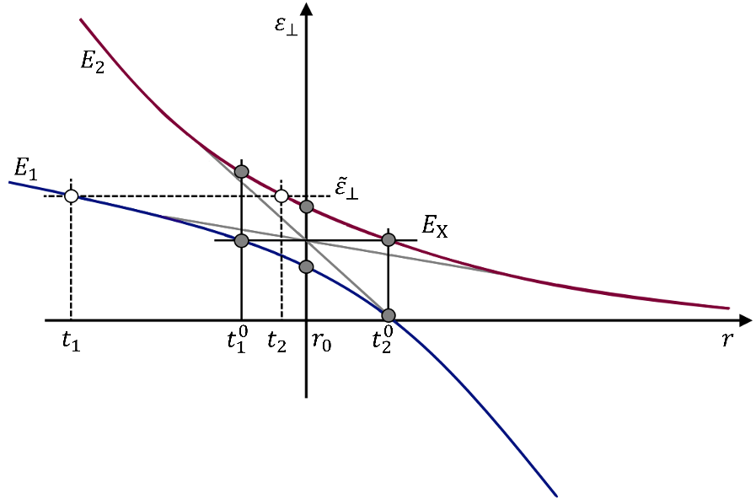
Figure 2.2. Sloped intersection of two spin-diabatic potentials (gray) with the spin-adiabatic potentials with the energies E₁ (blue) and E₂ (red). The classical turning points $r_{0}$, $t_{1}^{0}$, $t_{2}^{0}$, $t_{1}$ and $t_{2}$ are defined in the text.

Canonical rate constants and transition probabilities. A canonical (temperature-dependent) rate constant can be obtained by averaging the microcanonical rate constant defined in equation 2.1 over the Boltzmann distribution, leading to the following expression:

$$k\left(T\right)= \frac{σ}{hQ_{R}\left(T\right)}\int_{0}^{∞}{N_{X}\left(E\right)e^{-\frac{E}{k_{B}T}}dE}, \left(2.13\right)$$

$$Q_{R}\left(T\right)= \int_{0}^{∞}{ρ_{R}\left(E\right)e^{-\frac{E}{k_{B}T}} dE}, \left(2.14\right)$$

where $Q_{R}$ is the partition function of the reactant, T is the temperature, and $k_{B}$ is the Boltzmann constant.
Calculation of the canonical rate constants in the solution phase is invoked with the solution = .true. keyword in the input file. A solution-phase calculation assumes that no molecular rotation occurs and thus uses only the vibrational density of states in equations 2.1, 2.2, and 2.14.
NAST can also calculate the LZ and WC velocity-averaged transition probabilities obtained by averaging microcanonical probabilities over the Maxwell-Boltzmann (MB) and Kuki (K)²³ distributions of velocity $υ$:
$${〈p_{LZ}\left(T\right)〉}_{MB}=1- {\left(\frac{2}{πk_{B}T}\right)}^{\frac{1}{2}}\int_{0}^{∞}{\exp\left(-\frac{2πH_{SO}^{2}μ_{⊥}^{\frac{1}{2}}}{ℏ\left|Δg\right|υ}\right)\exp\left(-\frac{υ^{2}}{2k_{B}T}\right)dυ,} \left(2.15\right)$$

$${〈p_{LZ}\left(T\right)〉}_{K}=1- \frac{1}{k_{B}T}\int_{0}^{∞}{υ exp\left(-\frac{2πH_{SO}^{2}μ_{⊥}^{\frac{1}{2}}}{ℏ\left|Δg\right|υ}\right)\exp\left(-\frac{υ^{2}}{2k_{B}T}\right)dυ,} \left(2.16\right)$$

$${〈P_{WC}\left(T\right)〉}_{MB}= α{\left(\frac{2}{πk_{B}T}\right)}^{\frac{1}{2}}\int_{0}^{∞}{{Ai}^{2}\left(-\frac{1}{2}υ^{2}μ_{⊥}γ\right)}\exp\left(-\frac{υ^{2}}{2k_{B}T}\right)dυ, \left(2.17\right)$$

$${〈P_{WC}\left(T\right)〉}_{K}= \frac{α}{k_{B}T}\int_{0}^{∞}{{υ Ai}^{2}\left(-\frac{1}{2}υ^{2}μ_{⊥}γ\right)}\exp\left(-\frac{υ^{2}}{2k_{B}T}\right)dυ, \left(2.18\right)$$

$$a= 4π^{2}H_{SO}^{2}{\left(\frac{2μ_{⊥}}{ℏ^{2}\overline{g}\left|Δg\right|}\right)}^{\frac{2}{3}}, \left(2.19\right)$$

$$γ={\left(\frac{2μ_{⊥}{\left|Δg\right|}^{2}}{ℏ^{2}{\overline{g}}^{4}}\right)}^{\frac{1}{3}}. \left(2.20\right)$$

It is important to note that, in contrast to the microcanonical probabilities, these velocity-averaged WC probabilities do not account for quantum tunneling.

Rate constants and transition probabilities between individual $M_{S}$ components of spin states. A simple approach to model transitions between electronic states with different spin quantum numbers $S$ and $S^{'}$ is to calculate the effective probabilities and rates accounting for all $M_{S}$ components of these spin multiplets. In this approach, the effective SOC, also called the SOC constant, is obtained as the RMS of the couplings between the individual $M_{S}$ components:

$$H_{SO}={\left(\sum_{M_{s}=-S}^{S}{\sum_{M_{S}^{'}=-S^{'}}^{S^{'}}{{\left|〈S{,M}_{S}{\left|{\hat{H}}_{SO}\right|S}^{'}, M_{S^{'}}〉\right|}^{2}}}\right)}^{1/2}, \left(2.21\right)$$

where ${\hat{H}}_{SO}$ is the spin-orbit operator, for example, from the Breit-Pauli Hamiltonian.²⁴ This approach is easy to justify for the case of linear singlet-triplet crossing, where the energy gap between the two spin-adiabatic states at the MECP is equal to 2$H_{SO}$.² However, for the states with higher spin multiplicities, for example, a triplet-quintet crossing, there are multiple energy gaps between the adiabatic states. Therefore, employing a single effective SOC to calculate the transition probability and rate constant is not well-justified.
This issue can be resolved by calculating the rate constants and transition probabilities between individual $M_{S}$ components of the spin multiplets using the LZ formula (equations 2.6 and 2.7). As an example, for a singlet-triplet crossing, the non-zero spin-orbit coupling matrix elements are:

$$z=\left\langle 0,0 | {\hat{H}}_{SO} | 1,-1\right\rangle , ib=\left\langle 0,0 | {\hat{H}}_{SO} | 1,0\right\rangle , z^{*}=\left\langle 0,0 | {\hat{H}}_{SO} | 1,+1\right\rangle , \left(2.22\right)$$

where $z$ and $z^{*}$ are complex conjugates to each other, and $b$ is real. The single-passage LZ probabilities $p_{LZ}^{M_{S} , { M}_{S^{'}}}\left(ε_{⊥}\right)$ between the components $M_{S}$and${ M}_{S^{'}}$ of the spin states $S=0$ and $S^{'}$=1 read:

$$p_{LZ}^{0,-1}\left(ε_{⊥}\right)=p_{LZ}^{0,+1}\left(ε_{⊥}\right)=1-exp\left(-\frac{2πzz^{*}}{ℏ\left|Δg\right|}\sqrt{\frac{μ_{⊥}}{2\left(ε_{⊥}-E_{X}\right)}}\right), \left(2.23\right)$$

$$p_{LZ}^{0,0}\left(ε_{⊥}\right)=1-exp\left(-\frac{2πb^{2}}{ℏ\left|Δg\right|}\sqrt{\frac{μ_{⊥}}{2\left(ε_{⊥}-E_{X}\right)}}\right). \left(2.24\right)$$

The double-passage probabilities $P_{LZ}^{0,±1}$ and $P_{LZ}^{0,0}$are obtained from the single passage probabilities using equation 2.6 and employed to calculate the microcanonical rate constants between individual $M_{S}$ components:

$$k_{0,±1}\left(E\right)=\frac{σ }{h ρ_{R}\left(E\right)}\int_{0}^{E}{ ρ_{X}\left(E-ε_{⊥}\right)P_{LZ}^{0,±1}\left(ε_{⊥}\right)dε_{⊥}}, \left(2.25\right)$$

$$k_{0,0}\left(E\right)=\frac{σ }{h ρ_{R}\left(E\right)}\int_{0}^{E}{ ρ_{X}\left(E-ε_{⊥}\right)P_{LZ}^{0,0}\left(ε_{⊥}\right)dε_{⊥}}. \left(2.26\right)$$

The probabilities and rate constants between $M_{S}$ components are calculated for all pairs of coupled spin states with $\left|S - S^{'}\right|$ = 1. For more details on how to calculate the probabilities and rate constants between the individual $M_{S}$ components are provided in a recent work.⁴
Magnetic field effect on transition probabilities and rate constants. Currently, the magnetic field effect is implemented only for the singlet-triplet crossing. In an external magnetic field, the degeneracy of the $M_{S}$ components of spin multiplets are lifted, and the $M_{S}$ = 0 and $M_{S}$ = ±1 components of the triplet state can mix due to the off-diagonal terms in the Zeeman Hamiltonian:²

$$H_{0}+H_{z}=\begin{matrix} \\ \\ \begin{matrix}\left\langle \left.S\right|\right. \\ \\ \begin{matrix}\left\langle \left.T_{-1}\right|\right. \\ \\ \begin{matrix}\left\langle \left.T_{0}\right|\right. \\ \\ \left\langle \left.T_{+1}\right|\right.\end{matrix}\end{matrix}\end{matrix}\end{matrix}\begin{matrix}\begin{matrix}\left|\left.S\right\rangle \right. & \left|\left.T_{-1}\right\rangle \right. & \left|\left.T_{0}\right\rangle \right. & \left|\left.T_{+1}\right\rangle \right.\end{matrix} \\ \left(\begin{matrix}E_{S} & 0 & 0 & 0 \\ 0 & E_{T}-gμ_{B}B_{z} & \frac{gμ_{B}B_{+}}{\sqrt{2}} & 0 \\ 0 & \frac{gμ_{B}B_{-}}{\sqrt{2}} & E_{T} & \frac{gμ_{B}B_{+}}{\sqrt{2}} \\ 0 & 0 & \frac{gμ_{B}B_{-}}{\sqrt{2}} & E_{T}+gμ_{B}B_{z}\end{matrix}\right)\end{matrix}. \left(2.27\right)$$

The full spin-orbit-Zeeman Hamiltonian reads:

$$H_{0}+H_{SO}+H_{z}=\begin{matrix} \\ \\ \begin{matrix}\left\langle \left.S\right|\right. \\ \\ \begin{matrix}\left\langle \left.T_{-1}\right|\right. \\ \\ \begin{matrix}\left\langle \left.T_{0}\right|\right. \\ \\ \left\langle \left.T_{+1}\right|\right.\end{matrix}\end{matrix}\end{matrix}\end{matrix}\begin{matrix}\begin{matrix}\left|\left.S\right\rangle \right. & \left|\left.T_{-1}\right\rangle \right. & \left|\left.T_{0}\right\rangle \right. & \left|\left.T_{+1}\right\rangle \right.\end{matrix} \\ \left(\begin{matrix}E_{S} & z & ib & z^{*} \\ z^{*} & E_{T}-gμ_{B}B_{z} & \frac{gμ_{B}B_{+}}{\sqrt{2}} & 0 \\ -ib & \frac{gμ_{B}B_{-}}{\sqrt{2}} & E_{T} & \frac{gμ_{B}B_{+}}{\sqrt{2}} \\ z & 0 & \frac{gμ_{B}B_{-}}{\sqrt{2}} & E_{T}+gμ_{B}B_{z}\end{matrix}\right)\end{matrix}. \left(2.28\right)$$

In the current implementation, it is assumed that only the $B_{z}$ component of the magnetic field is non-zero. The magnetic field strength relative to the SOC strength can be defined through the dimensionless parameter m = $gµ_{B}B_{z}$/$H_{SO}$, where $g$ is the g-factor, $µ_{B}$ is the Bohr magneton, and $H_{SO}$ is the spin-orbit coupling constant from equation 2.21.² The values of m that distinguish between the weak, intermediate, and strong regimes are system-dependent and should be examined in each particular case. At this time, approaches I and III for a weak magnetic field and a strong field, respectively, are implemented. Approach II, which describes an intermediate-strength field, is not yet implemented.
In Approach I (weak field), the same LZ and WC probability defined by equations 2.6-2.8 are employed based on the assumption that the MECP energy is not affected by the external magnetic field. However, the SOC constant is replaced by half of the adiabatic energy gap defined as the difference between the minimum and maximum of two adiabats. In approach III (strong field), three distinct crossing regions are considered (Figure 2.3). Two crossing points have the energies of $gμ_{B}B_{z}$ below and above the middle crossing, the last has the same energy as the field-free MECP (equation 2.27). Thus, three distinguished probabilities of transition are calculated. Note that in approach III, the single-passage LZ probability is used.

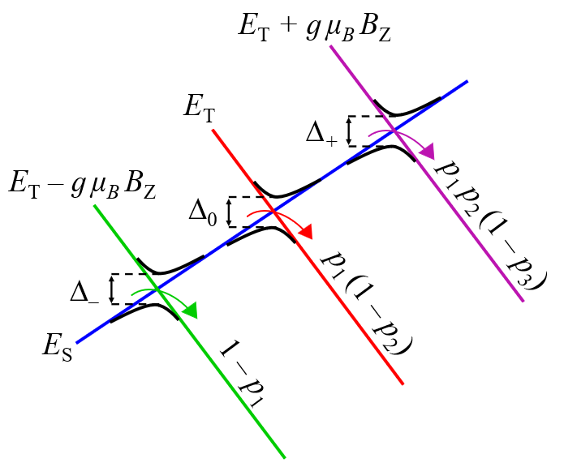
Figure 2.3. Three adiabatic energy gaps, ∆_{0,±} , between a singlet state and three components of a triplet state in a strong external magnetic field. Also shown are the single-passage Landau-Zener probabilities, p_{i}, of staying on the singlet state at each crossing.

As Figure 2.3 shows, in approach III, the transition probabilities are calculated from the single-passage LZ probabilities p_{i} of staying on the singlet state surface at each crossing:

$$p_{1}\left(ε_{⊥}\right)=exp\left(-\frac{π∆_{-}^{2}}{2ℏ\left|Δg\right|}\sqrt{\frac{μ_{⊥}}{2\left(ε_{⊥}-E_{X}-\frac{gμ_{B}B_{z}}{2}\right)}}\right), \left(2.29\right)$$

$$p_{2}\left(ε_{⊥}\right)=exp\left(-\frac{π∆_{0}^{2}}{2ℏ\left|Δg\right|}\sqrt{\frac{μ_{⊥}}{2\left(ε_{⊥}-E_{X}\right)}}\right), \left(2.30\right)$$

$$p_{3}\left(ε_{⊥}\right)=exp\left(-\frac{π∆_{+}^{2}}{2ℏ\left|Δg\right|}\sqrt{\frac{μ_{⊥}}{2\left(ε_{⊥}-E_{X}+\frac{gμ_{B}B_{z}}{2}\right)}}\right), \left(2.31\right)$$

where the halves of the adiabatic energy gaps ∆_{0,±} are used as coupling constants.

To obtain an adiabatic energy gap ∆ for the magnetic field calculations with either approaches I or III, a user can use the Wolfram Mathematica code provided in the supplementary materials for this paper.² Calculations with WC and ZN transition probabilities in a strong external magnetic field are not implemented. The rate constant calculations can only be performed for singlet-to-triplet transitions; the inverse triplet-to-singlet rate constants are not implemented.

Transition state theory rate constants. For adiabatic reactions, both microcanonical and canonical NAST rate constants can be reduced to the traditional TST rate constants by replacing the MECP with the transition state (TS) and the transition probability in equation 2.2 with the Heaviside step function.²⁵ The canonical TST rate constant $k\left(T\right)$, obtained by averaging the microcanonical constants over the Boltzmann distribution of the reactants' density of states, is equivalent to the traditional analytical TST formula:^{2,7}

$$k\left(T\right)=σ\frac{k_{B}T}{h}\frac{Q_{TS}}{Q_{R}}e^{-\frac{E_{TS}}{k_{B}T}}, \left(2.32\right)$$

where $Q_{TS}$ and $Q_{R}$ are the partition functions of the TS and reactant, respectively.

Tunneling corrections for TST. Tunneling corrections are used to correct a classical TST rate constant to account for the quantum tunneling effect at energies below the TS barrier. The Wigner and Eckart tunneling corrections are implemented.²⁶⁻²⁹ The Wigner correction is calculated in the form of a tunneling coefficient:

$$κ_{W}\left(T\right)=1+\frac{1}{24}{\left(\frac{h\left|ν^{‡}\right|}{k_{B}T}\right)}^{2}, \left(2.33\right)$$

where $ν^{‡}$ is the TS frequency. The rate constant is calculated as:

$$k_{W}\left(T\right)=k\left(T\right)∙κ_{W}\left(T\right). \left(2.34\right)$$

For a more sophisticated Eckart correction, a tunneling probability is obtained using the following equations:

$$P_{Eck}\left(E\right)=1-\frac{\cosh\left(2π\left(a-b\right)\right)+\cosh\left(2πd\right)}{\cosh\left(2π\left(a+b\right)\right)+\cosh\left(2πd\right)} \left(2.35\right)$$

$$a\left(E\right)=\frac{2\sqrt{E}}{h\left|ν^{‡}\right|\left(\frac{1}{\sqrt{{∆E}_{1}}}+\frac{1}{\sqrt{{∆E}_{2}}}\right)}, \left(2.36\right)$$

$$b\left(E\right)=\frac{2\sqrt{E-{∆E}_{1}+{∆E}_{2}}}{h\left|ν^{‡}\right|\left(\frac{1}{\sqrt{{∆E}_{1}}}+\frac{1}{\sqrt{{∆E}_{2}}}\right)}, \left(2.37\right)$$

$$d\left(E\right)=\frac{1}{2}\sqrt{\frac{16{∆E}_{1}{∆E}_{2}}{{\left(h\left|ν^{‡}\right|\right)}^{2}}-1}, \left(2.38\right)$$

where $E$, ${∆E}_{1}$, and ${∆E}_{2}$ are the internal energy, and the TS energy barriers in the forward and reverse directions, respectively. In this case, the microcanonical TST rate constant is calculated from the convolution of the density of states and the Eckart transition probability using equation 2.1. The canonical rate constant is obtained using equation 2.13.

2.3. NAST input data and electronic structure calculations

Note: input data should be given in units specified below. Conversion to atomic units will be done automatically by the program.

NAST input data:

- $v_{R}$ – vibrational frequencies of the reactant, (cm⁻¹)
- $I_{R}$ – principal moments of inertia of the reactant, (amu × bohr²)
- $v_{X}$ – vibrational frequencies of the MECP, (cm⁻¹)
- $I_{X}$ – principal moments of inertia of the MECP, (amu × bohr²)
- $μ_{⊥}$ – reduced mass (amu) along the vibrational mode associated with the reaction coordinate at the MECP or TS.
- $E_{X}$ – electronic energy of the MECP, (hartree)
- $E_{R}$ – electronic energy of the reactant, (hartree)
- $E_{P}$ – electronic energy of product, (hartree) (optional, used for calculating reverse rate constant)
- $\left|Δg\right|= \left|g_{1}-g_{2}\right|$ – norm of the gradient parallel to the reaction coordinate at the MECP, (hartree/bohr)
- $\overline{g}= {\left(\left|g_{1}\right|\left|g_{2}\right|\right)}^{\frac{1}{2}}$ – mean gradient (hartree/bohr)
- SOC – the spin-orbit coupling (SOC) constant (cm⁻¹).

Note: To obtain $v_{X}$, $I_{X}$, $μ_{⊥}$, $\left|Δg\right|$ and $\overline{g}$ the user must perform a vibrational analysis at MECP. Since MECP is a non-stationary point on a PES, the conventional vibrational analysis using a Hessian matrix of one of the electronic states will not work. The required effective Hessian (a Hessian matrix characterizing the crossing seam between two states) can be calculated using the effhess code described in Section 7. Tools.

TST input data:

The input for TS theory calculations reduces to:

- $v_{R}$ – vibrational frequencies of the reactant, (cm⁻¹)
- $I_{R}$ – principal moments of inertia of the reactant, (amu × bohr²)
- $v_{TS}$ – vibrational frequencies of the transition state, (cm⁻¹)
- $I_{TS}$ – principal moments of inertia of the transition state, (amu × bohr²)
- $E_{X}$ – electronic energy of the TS, (hartree)
- $E_{R}$ – electronic energy of the reactant, (hartree)
- $E_{P}$ – electronic energy of product, (hartree) (optional, used for calculating reverse rate constant)
- TST_freq – TST frequency, (cm⁻¹) (optional, used for calculating tunneling corrections)

To obtain the input data for the NAST rate calculations, the geometry optimization and hessian calculations have to be performed using one of the electronic structure programs, such as GAMESS³⁰, Molpro³¹, CFOUR³², Dalton³³, Q-Chem³⁴, ORCA^{35,36}, or others. At the MECP, two Hessian calculations (one for each state) are required to obtain state-specific Hessian matrices. These two Hessian matrices, together with state-specific gradients at the MECP, are used by effhess to generate and diagonalize the effective Hessian. The effhess can read the GAMESS, Molpro, Q-Chem, and ORCA output files.

References

(1) Dergachev, I. D.; Dergachev, V. D.; Rooein, M.; Patel, Y. H.; Weiss, P. S.; Avalos, C. E.; Varganov, S. A. NAST 2.0: Magnetic Field Effects and Marcus-Levich-Jortner Theory for Complex Open-Shell Systems. ACS Omega 2026, 11, 59936–59945. https://doi.org/10.1021/acsomega.6c07270.
(2) Rooein, M.; Varganov, S. A. Predicting Kinetics of Spin-Dependent Reactions in an External Manetic Field with Nonadiabatic Statistical Theory. J. Chem. Phys. 2024, 161, 164306. https://doi.org/10.1063/5.0232469.
(3) Dergachev, I. D.; Dergachev, V. D.; Rooein, M.; Mirzanejad, A.; Varganov, S. A. Predicting Kinetics and Dynamics of Spin-Dependent Processes. Acc. Chem. Res. 2023, 56, 856–866. https://doi.org/10.1021/acs.accounts.2c00843.
(4) Rooein, M.; Varganov, S. A. How to Calulate the Rate Constants for Nonradiative Transitions Between the M_{S} Components of Spin Multiplets? Mol. Phys. 2022, e2116364. https://doi.org/10.1080/00268976.2022.2116364.
(5) Dergachev, V. D.; Rooein, M.; Dergachev, I. D.; Lykhin, A. O.; Mauban, R. C.;
Varganov, S. A. NAST: Nonadiabatic Statistical Theory Package for Predicting Kinetics of Spin-Dependent Processes. Top. Curr. Chem. 2022, 380, 15. https://doi.org/10.1007/s41061-022-00366-w.
(6) Lykhin, A. O.; Varganov, S. A. Intersystem Crossing in Tunneling Regime: T₁ → S₀ Relaxation in Thiophosgene. Phys. Chem. Chem. Phys. 2020, 22 (10), 5500–5508. https://doi.org/10.1039/c9cp06956a.
(7) Lykhin, A. O.; Kaliakin, D. S.; DePolo, G. E.; Kuzubov, A. A.; Varganov, S. A. Nonadiabatic Transition State Theory: Application to Intersystem Crossings in the Active Sites of Metal-Sulfur Proteins. Int. J. Quantum Chem. 2016, 116 (10), 750–761. https://doi.org/10.1002/qua.25124.
(8) Bearpark, M. J.; Robb, M. A.; Bernhard Schlegel, H. A Direct Method for the Location of the Lowest Energy Point on a Potential Surface Crossing. Chem. Phys. Lett. 1994, 223 (3), 269–274. https://doi.org/10.1016/0009-2614(94)00433-1.
(9) Harvey, J. N.; Aschi, M.; Schwarz, H.; Koch, W. The Singlet and Triplet States of Phenyl Cation. A Hybrid Approach for Locating Minimum Energy Crossing Points between Non-Interacting Potential Energy Surfaces. Theor. Chem. Accounts Theory, Comput. Model. 1998, 99 (2), 95–99. https://doi.org/10.1007/s002140050309.
(10) Fernández-Ramos, A.; Ellingson, B. A.; Meana-Pañeda, R.; Marques, J. M. C.; Truhlar, D. G. Symmetry Numbers and Chemical Reaction Rates. Theor. Chem. Acc. 2007, 118 (4), 813–826. https://doi.org/10.1007/s00214-007-0328-0.
(11) Green, N. J. B. Unimolecular Kinetics Part 1. The Reaction Step; Elsevier, 2003.
(12) Landau, L. D. On the Theory of Energy Transfer I. Phys. Z. Sowjetunion 1932, 1, 88–95.
(13) Landau, L. D. On the Theory of Energy Transfer II. Phys. Z. Sowjetunion 1932, 2, 46–51.
(14) Zener, C. No Title. Proc. R. Soc. A Math. Phys. Eng. Sci. 1932, 137 (696–702).
(15) Stueckelberg, E. C. G. Theory of Inelastic Collisions between Atoms. Helv. Phys. Acta 1932, 5, 369–422.
(16) Nikitin, E. E. Nonadiabatic Transitions near the Turning Point in Atomic Collisions. Opt. Spectrosc. (USSR)(English Transl. 1961, 11, 246–248.
(17) Fedorov, D. A.; Lykhin, A. O.; Varganov, S. A. Predicting Intersystem Crossing Rates with AIMS-DFT Molecular Dynamics. J. Phys. Chem. A 2018, 122 (13), 3480–3488. https://doi.org/10.1021/acs.jpca.8b00883.
(18) Delos, J. B. On the Reactions of N 2 with 0. J. Chem. Phys. 1973, 59 (5), 2365–2369. https://doi.org/10.1063/1.1680345.
(19) Dashevskaya, E. I.; Nikitin, E. E. Uniform Airy Approximation for Nonadiabatic Transitions in a Curve-Crossing Weak-Coupling. Z. Phys. Chem. 2017, 232 (3), 311–323.
(20) Zhao, Y.; Mil’nikov, G.; Nakamura, H. Evaluation of Canonical and Microcanonical Nonadiabatic Reaction Rate Constants by Using the Zhu-Nakamura Formulas. J. Chem. Phys. 2004, 121 (18), 8854–8860. https://doi.org/10.1063/1.1801971.
(21) Nakamura, H. Nonadiabatic Transition: Concepts, Basic Theories and Applications. World Scientific, 2012.
(22) Melissas, V. S.; Truhlar, D. G.; Garrett, B. C. Optimized Calculations of Reaction Paths and Reaction-Path Functions for Chemical Reactions. J. Chem. Phys. 1992, 96 (8), 5758–5772. https://doi.org/10.1063/1.462674.
(23) Kuki, A. Adiabaticity Factor for Electron Transfer in the Multimode Case: An Energy Velocity Perspective. J. Phys. Chem. 1993, 97, 13107–13116. https://doi.org/10.1021/j100152a013.
(24) Fedorov, D. G.; Koseki, S.; Schmidt, M. W.; Gordon, M. S. Spin-Orbit Coupling in Molecules: Chemistry beyond the Adiabatic Approximation. Int. Rev. Phys. Chem. 2003, 22 (3), 551–592. https://doi.org/10.1080/0144235032000101743.
(25) Bracewell, R. N. The Fourier Transform and Its Applications, 3d ed.; McGraw-Hill, 2000.
(26) Wigner, E. On the Quantum Correction For Thermodynamic Equilibrium. Phys. Rev. 1932, 40, 749. https://doi.org/10.1103/PhysRev.40.749.
(27) Eckart, C. The Penetration of a Potential Barrier by Electrons. Phys. Rev. 1930, 35, 1303–1309. https://doi.org/10.1103/PhysRev.35.1303.
(28) Johnston, H. S.; Heicklen, J. Tunnelling corrections for unsymmetrical Eckart potential energy barriers. J. Phys. Chem. 1962, 66, 532–533. https://doi.org/10.1021/j100809a040.
(29) Brown, R. A Method of Calculating Tunneling Corrections For Eckart Potential Barriers. J. Res. Natl. Bur. Stand. 1981, 86, 357–359. https://doi.org/10.6028/jres.086.014.
(30) Barca, G. M. J.; Bertoni, C.; Carrington, L.; et al. Recent Developments in the General Atomic and Molecular Electronic Structure System. J. Chem. Phys. 2020, 152, 154102. https://doi.org/10.1063/5.0005188.
(31) Werner, H.-J.; Knowles, P. J.; Knizia, G.; Manby, F. R.; et al. The Molpro Quantum Chemistry Package. J. Chem. Phys. 2020, 152, 144107. https://doi.org/ 10.1063/5.0005081.
(32) Matthews, D. A.; Cheng, L.; Harding, M. E.; Lipparini, F.; Stopkowicz, S.; Jagau, T. C.; Szalay, P. G.; Gauss, J.; Stanton, J. F. Coupled-Cluster Techniques for Computational Chemistry: The CFOUR Program Package. J. Chem. Phys. 2020, 152 (21), 214108. https://doi.org/10.1063/5.0004837.
(33) Aidas, K.; Angeli, C.; Bak, K. L.; Bakken, V.; Bast, R.; Boman, L.; Christiansen, O.; Cimiraglia, R.; Coriani, S.; Dahle, P.; et al. The Dalton Quantum Chemistry Program System. Wiley Interdiscip. Rev. Comput. Mol. Sci. 2014, 4 (3), 269–284. https://doi.org/10.1002/wcms.1172.
(34) Epifanovsky, E.; Gilbert, A. T. B.; Feng, X.; et al. Software for the frontiers of quantum chemistry: An overview of developments in the Q-Chem 5 package. J. Chem. Phys. 2021, 155, 084801. https://doi.org/10.1063/5.0055522.
(35) Neese, F. Software update: The ORCA program system–Version 5.0. WIREs Comput. Mol. Sci. 2022, 12, e1606. https://doi.org/10.1002/wcms.1606.
(36) Neese, F. Software update: the ORCA program system, version 6.0. WIREs Comput. Mol. Sci. 2025, 15, e70019. https://doi.org/10.1002/wcms.70019.

3. Program structure

3.1. Input structure

Execution of NAST is controlled by the keywords and molecular data read from an input file. As an example, consider modeling the kinetics of the spin-forbidden dehydrogenation of the triplet methoxy cation:³⁷

&keys
printmore = .true. ! Print auxiliary data
&end

&inputdata
freX = 671, 1064, 1093, 1301, 1429, 2071, 2855, 2967 ! MECP vib. frequencies
freR = 848, 854, 1122, 1122, 1230, 1239, 2676, 2683, 2685 ! Reactant vib. frequencies
inertX = 12.085, 56.731, 57.962 ! MECP moments of inertia
inertR = 12.151, 59.527, 59.531 ! Reactant moments of inertia
enX = 0.022788 ! MECP electronic energy
enR = 0 ! Reactant energy
maxn = 20000 ! Energy integration limit
T1 = 290.0 ! Initial temperature
T2 = 300.0 ! Final temperature
&end

&probability
redmass = 1.318 ! Reduced mass at MECP
soc = 45.7 ! SOC at MECP
grad = 0.16575 ! Norm of parallel gradient
gradmean = 0.08190 ! Geometric mean
&end

The standard input file consists of three data groups: &keys, &inputdata, and &probability. The keywords of the &keys group specify the calculation type. For example, solution=.true. keyword would simulate reaction kinetics in the solution phase (default: .false.).

3.2. Groups and keywords

Given below is the full list of data groups and keywords used by NAST. Note: the order of the data groups in the input file matters. Groups should be given in the following order:

&keys
&inputdata
&external (if externR/
externX/externP=.t. in &keys)
&probability (if tst=.f. in &keys)
&reverse (if rev=.t. in &keys)
&split (if sp=.t. in &keys)
&polynomials (if zn=.t. in &keys)

3.2.1 &keys

zpe | Possible values are 0, 1, and 2. ZPE = 0 means no ZPE correction is applied. ZPE = 1 is a regular ZPE correction. ZPE = 2 accounts for turning points below ZPE. (default ZPE =1).
externR  externX  externP | If either one is .true., NAST reads the &external group to include external vibrational levels of reactant and/or MECP and/or product. Should be used when some vibrational modes of a molecule are not described by a harmonic oscillator model. An example is a double well vibrational mode of the lowest triplet state of a thiophosgene molecule (see Section 6.5). Default: .false.
zn | If .true., activates the Zhu-Nakamura probability calculation. This is currently implemented only for a sloped-type intersection and requires the explicit spin-diabatic potentials to be given in &polynomials group described below. One way to calculate these potentials is to use the provided ircfit code. (default: .false.)
rev | If .true., invokes additional calculation of reverse rate constant (see &reverse group). Note: The direction of the reaction path must be defined such that E(reactant) > E(product).
sp | Calculates the Landau-Zener transition probabilities between individual $M_{S}$ components of the spin multiplets, in contrast to the average (effective) transition probability (default .false.).
solution | Turns on calculations in the solution phase (default .false.). If .true., the rovibrational densities of states are replaced by vibrational densities of states (rotations are assumed to be frozen).
tst | When set .true., calculates rate constants for traditional TS theory: MECP is replaced with TS and the probability of transition with the Heaviside step function. The &probability group does not need to be provided.
printmore | Controls output flow. If printmore=.t., auxiliary data will be printed, including all densities of states.
TST_tunn | Turns on calculations of the Wigner and Eckart tunneling corrections (default .false.). Requires tst=.true. and rev=.t. The last is because the Eckart correction requires information about the product.

&end

3.2.2 &inputdata

symR  symX | Symmetry numbers of the reactant and MECP. Symmetry number equals the order of the symmetry group of the molecule. Used to calculate reaction path degeneracy as a multiplier of the rate constant (default 1).
chir | Number of chiral equivalents of the MECP (default 1).
freR  freX | Fundamental frequencies of reactant and MECP. Note 1: freX comes from the effective Hessian calculations. Note 2: If external vibrational modes are used (see &external below), fundamental frequencies of ‘incorrect’ vibrational modes of freR and/or freX should be removed.
inertR  inertX | (I_{xx}, I_{yy}, I_{zz}) rotational moments of inertia. Typically provided by an electronic structure code at the end of the reactant/product/MECP geometry optimization.
enX | Electronic energy of MECP barrier (hartree). If rev = .false. in &keys, the value of enX can be set relative to the reactant, which means enR = 0. If rev = .true., it is better to provide the absolute MECP energy obtained from the electronic structure calculation. Note: the ΔZPE correction to the MECP barrier is calculated and added automatically by the NAST package from vibrational frequencies provided in the input file.
enR | Energy of reactant (hartree). If enX is given relative to the reactant energy, enR should be set to zero. Alternatively, the absolute energy from the electronic structure calculation can be used. Note that enR should always be greater than enP (see Section 3.2.5 below), as a product is always assumed to be lower in energy than the reactant.
maxn | Energy integration limit in cm⁻¹. Should be set high enough to achieve convergence in canonical rate constants. Set maxn to at least 1.5 times the enX barrier.
T1, T2, Tstep | Temperature range (K), from T1 to T2 with step Tstep, for canonical rate constant calculations (default T1=290, T2=300, Tstep=1.
TST_freq | Transition state frequency (in cm⁻¹) required for the calculations of the Wigner and Eckart tunneling corrections.
Estep | Energy integration step (default 1 cm⁻¹). Reducing Estep below 0.5 cm⁻¹ can significantly increase the calculation time, especially for large molecules and/or high MECP or TST energy barriers. Calculations with the Zhu-Nakamura probability must use the default Estep of 1 cm⁻¹.

&end

3.2.3 &external

extR, extX, extP | Arrays of vibrational level energies (in cm⁻¹) for the reactant, MECP, and product, respectively.

&end

Note: Vibrational frequencies in the NAST input file are used to generate the vibrational energy levels according to the harmonic oscillator (HO) model. In turn, these energy levels are used to calculate densities of vibrational states. However, some molecules have vibrational modes that cannot be accurately described by the HO model (e.g., internal rotations of CH₃ groups and inversion modes in NH₃ and PH₃). If the energy levels of such modes are known from experiment or other computational studies, they can be provided using the following syntax:

&keys extern = .true. &end | Set extern = .true. to read external vibrational levels in the &external group
&external  extR = 0, 298, 303,..  &end | As an example, there is one external vibrational mode for the reactant described by a double-well potential, as in the case of thiophosgene.⁶ The energy levels of this vibrational mode are given in extR (cm⁻¹).

3.2.4 &probability

redmass | Reduced mass (amu) along the reaction coordinate
soc | SOC (cm⁻¹) at the MECP
grad | $\left|Δg\right|,$gradient parallel to the reaction coordinate (hartree/bohr)
gradmean | $\overline{g}$, gradient mean (hartree/bohr)

&end

Note: The &probability group contains the input data for calculating transition probabilities. The reduced mass and gradients are obtained from the effective Hessian calculation. For the TS rate calculations (TST = .true. in &keys), the probability is equal to the Heaviside step function and the &probability group is not needed.

3.2.5 &reverse

symP | symmetry number of product (default: 1).
freP, inertP, enP | same format as in &inputdata

&end

Note: By default, NAST calculates only forward rate constants. The forward direction is defined as the transition from the higher energy spin state (reactant, R) to the lower energy spin state (product, P). Such calculations require molecular properties only at the reactant minimum and MECP (or TS). In addition, NAST allows performing reverse rate calculations (rev=.true. in &keys). To invoke a reverse TST calculation, both rev and tst should be set .true. Therefore, rates in the forward and reverse directions can be calculated in a single run. The reverse rate constant calculations require the following modifications to the input file:
&keys ZPE = 1 printmore = .true rev = .true. &end

&inputdata
freX = 671, 1064, 1093, 1301, 1429, 2071, 2855, 2967
freR = 848, 854, 1122, 1122, 1230, 1239, 2676, 2683, 2685
inertX = 12.085, 56.731, 57.962
inertR = 12.151, 59.527, 59.531
enX = -114.45522
enR = -114.47801
maxn = 20000
T1 = 290.0
T2 = 300.0
&end

&probability
redmass = 1.3188 soc = 45.7
grad = 0.16575 gradmean = 0.08190
&end

&reverse
freP = 1020, 1112, 1246, 1377, 1477, 1663, 3066, 3207, 3566
inertP = 9.036 52.413, 61.449
enP = -114.62007
&end

If the quantum tunneling is neglected, it is possible to perform two independent calculations, one for the forward and one for the reverse rate constant. Such calculations should produce the same results as a single run with rev=.true. However, if tunneling contributions are included, the forward and reverse rate constants must be calculated in a single run with the reactant defined as the higher-energy state and the product as the lower-energy state. Such calculation of the forward and reverse rate constants in a single run eliminates the unphysical reverse tunneling (Figure 3.1).

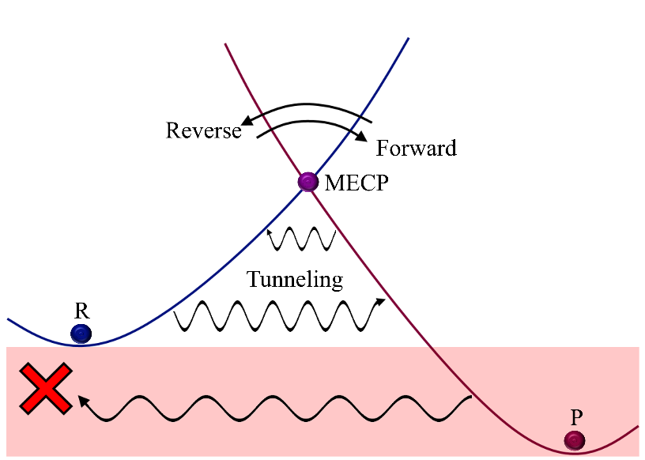
Figure 3.1. Transitions between two spin states. States are defined according to the $E_{X}> E_{R}> E_{P}$ energy order. The wiggly arrows indicate tunneling contribution in the forward and reverse directions. Arrows above MECP indicate the classical transition region. The unphysical tunneling region is in red.

Note: A calculation with rev = .true. may require a more careful choice of maxn energy integration limit in &inputdata. The maxn limit is always defined with respect to the reactant. For reverse rate calculation, maxn → maxn + ($E_{R}- E_{P}$). However, if the product minimum lies much lower in energy than the reactant minimum, a large maxn could be needed to achieve the rate constant convergence. It is recommended to do several runs increasing maxn to check convergence.

The &split group controls the calculation of the rate constants and transition probabilities between specific $M_{S}$ components of two spin states. This calculation type is invoked with sp = .true. in &keys.

3.2.6 &split

mults | Multiplicities of reactant and product, respectively. For example, for a singlet-triplet transition, mults = 1,3.
icp | Number of independent coupling parameters (icp) at the MECP. These are the SOC matrix elements. For example, for a singlet-triplet transition, icp = 2 (see Table 1).
socmat | Independent coupling parameters (cm⁻¹). These parameters are either complex (z) or purely imaginary (ib) numbers given in parentheses with the Re and Im parts separated by comma, such as (Re_part, Im_part). For example, for a singlet-triplet transition, socmat = (Re(z), Im(z)), (0, b).
The next three parameters are needed only if the rate constants are calculated in an external magnetic field. This is implemented for a singlet-triplet crossings only.
delta | An array of the two energy gaps between spin-adiabatic states in an external magnetic field. The first value ∆₀ is the energy gap between two adiabats with extrema at MECP. The second value corresponds to the two energy gaps ∆± between the adiabats with extrema shifted in the opposite directions from MECP. For each crossing, the SOC value is half of the corresponding energy gaps.
Bz | Magnetic field strength in Tesla.
g | Isotropic molecular g-factor (g_{iso}).

&end

Table 3.1. Independent coupling parameters (icp) for interstate transitions between states of different spin multiplicities.
Types of transition | Multiplicity of reactant, product | Number of independent coupling parameters (icp) | SOC matrix elements
Singlet-Triplet | 1,3 | 2 | $$z, ib$$
Doublet-Quartet | 2,4 | 3 | $$z_{1}, ib, z_{2}$$
Triplet-Quintet | 3,5 | 5 | $$z_{1}, ib_{1}, z_{2},z_{3}, ib_{2}$$
Quartet-Sextet | 4,6 | 6 | $$z_{1}, ib_{1}, z_{2},z_{3}, ib_{2},z_{4}$$

3.2.7 &polynomials

hs4-hs0 | Polynomial coefficients for the potential of reactant, R: R → MECP → P, E_{R} > E_{P}, where E is an energy at equilibrium geometry. The hs4 coefficient corresponds to the leading order: f(r) = hs4*r⁴ + hs3*r³ + …, where r is the reaction coordinate
ls4-ls0 | Coefficients for product potential
limitL, limitR | The left and right limits along r. limitR must be greater than limitL. limitL should be chosen at the reactant minimum (minimum of R in R → MECP → P). The choice of limitR depends on the intersection type. For the sloped intersection, limitR should be chosen so that the energy of reactant potential at this point is well above MECP to ensure convergence: E(limitR) = f_{hs}(limitR) >> E_{MECP}, where f_{hs} is the polynomial describing the reactant potential. Note: Detailed explanation of how to obtain the crossing potentials using the ircfit tool is given in Section 7.2.

&end

Note: The &polynomials group contains the coefficients of polynomials used to fit the crossing spin-diabatic potentials. These coefficients are required for the rate constant calculations with the Zhu-Nakamura transition probability. The highest polynomial order supported by NAST is four, i.e., a quartic polynomial. All five coefficients must be given in the input file, even if some are zero.

References

(6) Lykhin, A. O.; Varganov, S. A. Intersystem Crossing in Tunneling Regime: T1 → S0 Relaxation in Thiophosgene. Phys. Chem. Chem. Phys. 2020, 22 (10), 5500–5508. https://doi.org/10.1039/c9cp06956a.
(37) Harvey, J. N.; Aschi, M. Spin-Forbidden Dehydrogenation of Methoxy Cation: A Statistical View. Phys. Chem. Chem. Phys. 1999, 1 (24), 5555–5563. https://doi.org/10.1039/a907723e.

4. Navigation through output files

4.1. nast.out

The main output file generated by NAST is nast.out. This file contains the canonical rate constants and velocity-averaged transition probabilities. Below is an example of nast.out from the calculation of the T₁ → S₀ intersystem crossing rates in thiophosgene.

------------------------------------------------
NAST control parameters and related data

zpe = 2 sp = F zn = T solution = F
tst = F TST_tunn = F printmore = T rev = F
externR = T externX = F externP = F
------------------------------------------------
zpe = 2: ZPE correction scheme II (accounts for turning points below ZPE).
Electronic barrier from reactant to MECP is 3185 cm-1
ZPE of reactants = 0.00 cm-1
ZPE of MECP = 0.00 cm-1
ZPE-corrected MECP energy bin = 3186 cm-1

Canonical rate constant, k(T)

T (K) | Landau-Zener | Weak Coupling | Zhu-Nakamura
296.0 | 0.00E+00 | 1.44E+08 | 7.10E+05
297.0 | 0.00E+00 | 1.44E+08 | 7.14E+05

Landau-Zener and Weak Coupling double passage velocity-averaged
probabilities of transition, p(T)
Calculated using Maxwell-Boltzmann (MB) and Kuki (K) distributions

T (K) | Landau-Zener MB | Landau-Zener K | Weak Coupling MB | WC K
296.0 | 0.6823 | 0.4628 | 0.0142 | 0.0001
297.0 | 0.6819 | 0.4623 | 0.0142 | 0.0001

4.2. energy_rates.out

This file contains the microcanonical rate constants calculated using the LZ, WC, and ZN (optional) probabilities.

4.3. energy_tst_rate.out (written if tst = .true. in &keys)

This file contains microcanonical TST rate constants.

4.4. energy_probabilities.out

This file contains the microcanonical transition probabilities calculated using the LZ, WC and ZN (optional) equations.

4.5. TST_energy_probabilities.out (written if tst_tunn = .true. in &keys)

This file contains microcanonical transition probabilities calculated using the Eckart tunneling correction.

4.6. Densities of states (written if printmore = .true. in &keys)

There is a group of output files containing the rotational, vibrational and rovibrational densities of states at reactant (dos_reactant.out), MECP (dos_mecp.out), transition state TS (dos_ts.out) if tst=.true., and dos_product.out if rev=.true. In addition, the densities of turning points, calculated using the molecular properties at MECP, are stored in dos_tp.out.

4.7. effective_number_of_states.out

This file contains the effective number of states calculated using the LZ and WC probabilities.

4.8. effective_number_of_states_TST.out (written if tst = .true.)

This file contains the effective number of states for TST.

4.9. adiabatic_energies.out (written if zn = .true.)

This file contains energies of the two adiabatic potentials used to calculate the Zhu-Nakamura probabilities and rate constants.

4.10. split_LZ_probabilities.out (written if sp = .true.)

This file contains the microcanonical probabilities of transitions between the $M_{S}$ components of two spin states using the LZ probability.

4.11. split_WC_probabilities.out (written if sp = .true.)

This file contains microcanonical probabilities of transitions between the $M_{S}$ components of two spin states calculated with the WC formula.

4.12. split_LZ_energy_rate.out (written if sp = .true.)

This file contains the microcanonical rate constants of transitions between the $M_{S}$ components of two spin states calculated using the LZ formula.

4.13. split_WC_energy_rate.out (written if sp = .true.)

This file contains microcanonical rate constants of transitions between the $M_{S}$ components of two spin states calculated using the WC transition probability.

4.14. split_LZ_tempt_rate.out (written if sp = .true.)

This file contains canonical rate constants of transitions between the $M_{S}$ components of two spin states calculated using the LZ transition probability.

4.15. split_WC_tempt_rate.out (written if sp = .true.)

This file contains canonical rate constants of transitions between the $M_{S}$ components of two spin states calculated using the WC transition probability.

4.16. Bz_LZ_probabilities.out (written if sp = .true.)

This file contains microcanonical probabilities of transitions between the $M_{S}$ components of two spin states in a strong magnetic field (approach III) calculated using the single-passage LZ equation.

4.17. Bz_LZ_energy_rate.out (written if sp = .true. in &keys)

This file contains microcanonical rate constants of transitions between the $M_{S}$ components of two spin states in a strong magnetic field (approach III) calculated using the single-passage LZ equation.

4.18. Bz_LZ_tempt_rate.out (written if sp = .true.)

This file contains canonical rate constants of transitions between the $M_{S}$ components of two spin states in a strong magnetic field (approach III) calculated using the single-passage LZ equation.

5. Marcus-Levich-Jortner program

5.1. Introduction

The Marcus-Levich-Jortner (MLJ) code is a stand-alone program distributed with the NAST package. It is based on the Fermi Golden Rule (FGR) rate expressions and is useful if the MECP cannot be located. The MLJ theory has been successfully applied to a wide range of electronic relaxation processes.^{38–41} The FGR transition rate between two weakly coupled electronic states is calculated as:^{42–46}

$$k^{FGR}=\frac{2π}{ℏ}{\left|\left\langle Ψ_{f} | \hat{V} | Ψ_{i}\right\rangle \right|}^{2}δ\left(E_{f}-E_{i}\right), \left(5.1\right)$$

where $Ψ_{i}$ and $Ψ_{f}$ are the total wavefunctions of the initial and final states, respectively, $\hat{V}$ is the operator that couples two states, and $δ\left(E_{f}-E_{i}\right)$ is the delta function that ensures energy conservation. The total wavefunction $\left|\left.Ψ\right\rangle \right.$ is the product of the electronic wavefunction $\left|\left.φ\right\rangle \right.$ and the nuclear wavefunction $\left|\left.χ\right\rangle \right.$. The nuclear wavefunction is approximated as the product of 1D harmonic oscillator potentials, each with m quanta of energy. Assuming that the coupling acts only on the electronic wavefunction (Franck-Condon approximation), the FGR rate constant transforms as:

$$k^{FGR}=\frac{2π}{ℏ}{\left|V_{el}\right|}^{2}\sum_{n}{\sum_{m}{p_{im}{\left|\left\langle χ_{f,n} | χ_{i,m}\right\rangle \right|}^{2}δ\left(E_{fn}-E_{im}\right)=\frac{2π}{ℏ}{\left|V_{el}\right|}^{2}FCWD}}, (5.2)$$

where $V_{el}$ is the electronic coupling evaluated at the equilibrium geometry, and the product of Franck-Condon factors $\left\langle χ_{fn} | χ_{im}\right\rangle$ and $δ$ function gives the Franck-Condon weighted density of states (FCWD). In Eq. 5.2, $p_{im}$ is the Boltzmann distribution of the vibrational population for the initial electronic state i:

$$p_{im}=\frac{\exp\left(-βE_{im}\right)}{\sum_{m}{\exp\left(-βE_{im}\right)}}, (5.3)$$

where $β=\frac{1}{k_{B}T}$.
Finally, separating vibrational modes k (harmonic oscillators) into classical (${ℏω_{k}≪k}_{B}T$) and quantum (${ℏω_{k}≫k}_{B}T$), FCWD can be transformed to produce the MLJ rate constant expression:

$$k^{MLJ}=\frac{2π}{ℏ}{\left|V_{el}\right|}^{2}\frac{1}{\sqrt{4πλ_{c}k_{B}T}}\sum_{n}{\frac{e^{{-S}_{eff}}S_{eff}^{n}}{n!} ∙\exp\left[-\frac{{\left(ΔE+λ_{c}+nℏω_{eff}\right)}^{2}}{4πλ_{c}k_{B}T}\right]. (5.4)}$$

Equation 5.4 assumes there is only one effective high-frequency quantum mode with frequency$ω_{eff}$ and occupation number $n$. The Huang-Rhys factor, $S_{eff}$, approximates the effect of multiple vibrational modes, $λ_{c}$ is the classical reorganization energy, and $ΔE$ is the energy gap between the two electronic states. $ω_{eff}$ and $S_{eff}$ are calculated as:
$$S_{eff}=\sum_{k}{S_{k}}, (5.5)$$

$$ω_{eff}=\frac{\sum_{k}{S_{k}ℏω_{k}}}{S_{eff}}. (5.6)$$

The Huang-Rhys factors and reorganization energies can be calculated using the vib tool as described in Section 7.3 Vibrational tool (vib). Note that Equation 5.4 is most accurate for the exergonic process with $ΔE=E\left(P\right)-E\left(R\right)<0$ defined as forward. NAST calculates the rate constant for the reverse endergonic process from the detailed balance equation
$k_{rev}=k_{fwd}e^{∆E/k_{B}T}$.⁴⁷

5.2. Installation and running

The parent directory for the MLJ program is named “MLJ” and is located in the parent directory of the NAST package “nast”. The installation and running of the MLJ program are identical to those described for the NAST main code. The compilation of the source code has been tested with

- GNU Fortran (GCC) 8.2.0 compiler
- GNU Fortran (GCC) 8.5.0 compiler
- GNU Fortran (GCC) 9.3.0 compiler
- GNU Fortran (GCC) 11.5.0 compiler
- ifort (IFORT) 13.0.0 20120731 compiler
- ifort (IFORT) 2023.1.0 compiler
- ifort (IFORT) 2023.2.1 compiler
- Intel® MKL 2018.2.199 – 2018.4.274
- Intel® MKL 2019.0.117 – 2019.5.281
- Intel® MKL 2020.0.166 Initial Release
- Intel® MKL 2023.1.0
- Intel® MKL 2023.2.1

For more details, see Section 1. Installation Guide.

5.3. Input structure, groups, and keywords

The input file structure for the MLJ program is very similar to one used by NAST and has only one data group called “&inputdata”. Given below is the full list of keywords used by MLJ.

&inputdata

symR | The symmetry number of the reactant, which is equal to the order of the molecular symmetry group. Used to calculate reaction path degeneracy as a multiplier of the rate constant (default 1).
freR | Fundamental frequencies of reactant (cm⁻¹).
enR  enP | Energies of reactant and product (hartree). If enP is set relative to the reactant, enR should be equal to zero.
V | Electronic coupling (cm⁻¹).
S | Huang-Rhys factors (dimensionless). Calculated with the vib tool.
lambda_vib | Vibrational reorganization energies (hartree). Calculated with the vib tool.
lambda_ext | External (solvent) reorganization energy (hartree). Provided by the user. Classical reorganization energy $λ_{c}$ in equation 5.4 shown above is the sum of “lambda_vib” and “lambda_ext”.
n_vib | Vibrational quantum number $n$ in Eq. 5.4 (default 10).
trsh | A threshold that separates the low-frequency vibrational modes (classical, $ℏω < trsh∙k_{B}T$) from high-frequency modes (quantum, $ℏω> trsh∙k_{B}T$). The default value of 4.80 corresponds to $ω$ of 1000 cm⁻¹ at 300 K.
T1, T2, Tstep | Temperature range (K), from T1 to T2 with step Tstep, for canonical rate constant calculations (default T1=290, T2=300, Tstep=1.

&end

5.4. Navigation through output files

The output file MLJ.out is very similar to the NAST output file nast.out and contains temperature-dependent MLJ rate constants in s⁻¹. In addition to MLJ.out, there is the vib.out file that contains the effective frequency, Huang-Rhys factor, reorganization energy, and quantum number at a given temperature.

References

(38) Cho, E.; Coropceanu, V.; Brédas, J.-L. Organic Neutral Radical Emitters: Impact of
Chemical Substitution and Electronic-State Hybridization on the Luminescence Properties. J. Am. Chem. Soc. 2020, 142, 17782–17786. https://doi.org/10.1021/jacs.0c08997.
(39) Gorgon, S.; Lv, K.; Grüne, J.; et al. Reversible Spin-Optical Interface in Luminescent Organic Radicals. Nature 2023, 620, 538–544. https://doi.org/10.1038/s41586-023-06222-1.
(40) Lv, L.; Zhang, Y.; Ning, Z. Deciphering the Doublet Luminescence Mechanism in Neutral Organic Radicals: Spin-Exchange Coupling, Reversed-Quartet Mechanism, Excited-State Dynamics. RSC Adv. 2024, 14, 23987–23999. https://doi.org/10.1039/D4RA03566F.
(41) Kandrashkin, Y. E.; van der Est, A. Spin Polarization Generated by Reversible Doublet-Quartet Transitions in Photoexcited Chromophore-Radical Conjugates.
J. Chem. Phys. 2025, 162, 074109. https://doi.org/10.1063/5.0250081.
(42) Englman, R.; Jortner, J. The Energy Gap Law for Radiationless Transitions in Large Molecules. Mol. Phys. 1970, 18, 145–164.
https://doi.org/10.1080/00268977000100171.
(43) Ulstrup, J.; Jortner, J. The Effect of Intramolecular Quantum Modes on Free Energy Relationships for Electron Transfer Reactions. J. Chem. Phys. 1975, 63, 4358–4368. https://doi.org/10.1063/1.431152.
(44) Jortner, R. Temperature Dependent Activation Energy for Electron Transfer Between Biological Molecules. J. Chem. Phys. 1976, 64, 4860–4867. https://doi.org/10.1063/1.432142.
(45) Penfold, J. T.; Gindensperger, E.; Daniel, C.; Marian, C. M. Spin-Vibronic Mechanism for Intersystem Crossing. Chem. Rev. 2018, 118, 6975−7025. https://doi.org/10.1021/acs.chemrev.7b00617.
(46) Marian, C. M. Understanding and Controlling Intersystem Crossing in Molecules. Annu. Rev. Phys. Chem. 2021, 72, 617–640.
https://doi.org/10.1146/annurev-physchem-061020-053433.
(47) Boyd, R. K. Detailed Balance in Chemical Kinetics as a Consequence of Microscopic Reversibility. J. Chem. Phys. 1974, 60, 1214–1222.
https://doi.org/10.1063/1.1681185.

6. Examples

We start with examples of classical TST reaction rate calculations as a limiting case of NAST. The TST examples we discuss in Sections 6.1 and 6.2 below. The NAST examples are covered in Sections 6.3 – 6.6. Example 6.4 contains the NAST rate constant calculations in an external magnetic field. Examples 6.5 and 6.6 include the NAST calculations with the ZN transition probabilities. The MLJ program example is given in Section 6.7.

6.1 Example 1. TST case study: Isomerization of Propylene Oxide to Acetone and Propanal

This example demonstrates how the NAST package can be used to calculate the reaction rates for single-state adiabatic reactions using the traditional TST. We consider the isomerization of propylene oxide to acetone and propanal, following the original theoretical work of Dubnikova and Lifshitz⁴⁸. For each isomerization reaction, four canonical TST rate constants were compared: i) predicted by the NAST package, ii) calculated analytically using equation 2.27, iii) calculated analytically using equation 6.1 below⁴⁸ and iv) experimental.⁴⁹ The TS rate constant can be calculated as:

$$k\left(T\right)= σ\frac{k_{B}T}{h}e^{-\frac{∆S^{\#}}{R}}e^{-\frac{∆H^{\#}}{RT}}, \left(6.1\right)$$

where $R$ is the universal gas constant; $∆S^{\#}$and $∆H^{\#}$ are the entropy and enthalpy of activation, respectively. Because for a unimolecular reaction, $∆H^{\#}= E_{TS}+ ∆ZPE$, the activation enthalpy is equal to the ZPE-corrected electronic barrier between the transition state and the reactant. The input data for NAST were obtained using the B3LYP geometry optimization and Hessian calculations in GAMESS, and the single-point CCSD(T) energy calculations in Molpro. The cc-pVDZ basis set was used in all calculations. The partition functions $Q_{TS}$ and $Q_{R}$ used in equation 2.32 were taken as calculated by GAMESS. In equation 6.1, the original data from Table 1 of Dubnikova and Lifshitz was used.⁴⁸ The energy profiles for two isomerization reactions are shown in Figure 6.1.

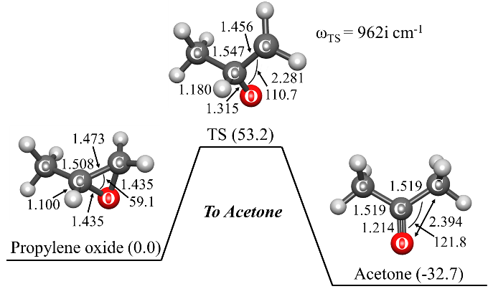 | 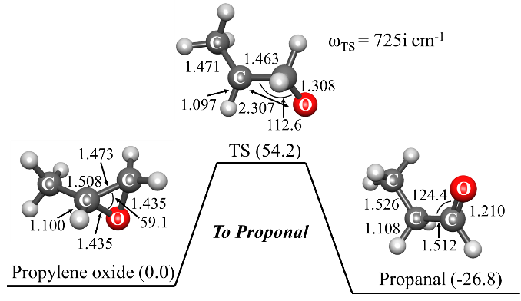
Figure 6.1. Energies and structural parameters for the isomerization reactions of propylene oxide to acetone (left) and propanal (right). The relative CCSD(T) energies (kcal.mol⁻¹) in parenthesis are corrected with the ${ΔZPE=ZPE}_{X}-{ZPE}_{R}$ calculated with B3LYP. Bond lengths and angles are given in Å and degrees, respectively.

The NAST input file and the main parts of the output file are shown below.

Input file

&keys zpe = 1 tst = .true. &end ! Traditional TST calculation set true.

&inputdata
freX = 263, 294, 374, 580, 729, 871, 886, 958, 999, 1081, 1118, 1241, 1283, 1357, 1434, 1452, 1471, 2296, 3026, 3092, 3118, ,3142, 3238
freR = 240, 370, 416, 773, 848, 903, 974, 102, 1117, 1136, 1153, 1173, 1277, 1381, 1423, 1451, 1471, 1515, 3025, 3059, 3076, 3098, 3117, 3153
inertX = 170.850, 217.264, 351.144 ! Moments of inertia for TS/MECP
inertR = 100.305, 272.514, 305.514 ! Moments of inertia for reactant
enX = 0.09129754 ! Electronic energy of TS in hartree. Program will add ∆ZPE
enR = 0.0 ! Energy of reactant in hartree
maxn = 30000 ! Maximum energy bin: integration limit in cm-1
T1 = 1000 ! Initial temperature in K for canonical rate calculation
&end

Main parts of the output file

*********************************************************
~~~~~~~ NAST: Nonadiabatic Statistical Theory ~~~~~~~
~~~~~ v. 2.0 ~~~~~
*********************************************************
---------------------------------------------
NAST control parameters and related data

zpe = 1 sp = F zn = F solution = F
tst = T TST_tunn = F printmore = F rev = F
externR = F externX = F externP = F
---------------------------------------------
zpe = 1: ZPE correction scheme I (eliminates turning points below ZPE).
Electronic barrier from reactant to MECP is 20037 cm-1
ZPE of reactants = 18586 cm-1
ZPE of MECP = 17149 cm-1
ZPE-corrected MECP energy bin = 18602 cm-1

---------------------------------------------------------
Start NAST calculation
---------------------------------------------------------

1. Calculating densities of states

......vibrational.
.......rotational.
........rovibrational.

Calculating microcanonical TST rate constant.
................................... Done.

(The forward rate constant k(E) is multiplied by reaction path degeneracy equal to 1 )

Canonical rate constant, k(T)

T(K) TST rate constant

1000.0 6.78E+01

Total CPU time = 10.35
NAST terminated now.

Comparison of results with original work and canonical TST rate constant. Table 6.1 shows the calculated and experimental rate constants for the isomerization of propylene oxide to acetone and propanal. The factor-of-two difference between the acetone rate constants calculated with two analytical expressions can be explained by a 1.0 kcal.mol⁻¹ discrepancy in the TS barrier (using the same barrier height of 53.2 kcal.mol⁻¹ in both analytical expressions reduces this difference to 18%). Similar differences in the reaction rates calculated with different methods are observed for the isomerization to propanal. All calculated rate constants are in reasonable agreement with the experimental values for both isomerization reactions.

Table 6.1. Canonical TST rate constants for isomerization of propylene oxide to acetone and propanal at T=1000 K.
Product | Source | E_{TS}, kcal.mol⁻¹ | k₁₀₀₀, s⁻¹
Acetone | NAST  Analytical, equation 6.1ª  Analytical, equation 2.32  Experiment^{b} | 53.2  54.2  53.2  - | 67.8  50.2  101.0  30.0
Propanal | NAST  Analytical, equation 6.1ª  Analytical, equation 2.32  Experiment^{b} | 54.2  54.4  54.2  - | 43.0  69.6  88.6  90.0
ª Ref. 48.
^{b} Experimental values are estimated from the log(k) vs. T plots in Ref. 49.

Analysis of convergence and execution time. Here we bring an example of convergence in rate constant calculations and CPU time vs. the maxn integration limit (Figure 6.2). The calculations were run on a single core of an Intel(R) Xeon(R) CPU E5630 @ 2.53GHz.

Figure 6.2. Convergence in rate constant calculations vs. maxn integration limit in isomerization of propylene oxide to acetone and to propanal. The transition state (TS) energy for isomerization to acetone and propanal are 18602 cm⁻¹ and 18969 cm⁻¹, respectively.

For acetone, the ZPE-included electronic TS barrier is 18602 cm⁻¹ with respect to reactant as calculated at the CCSD(T)/cc-pVDZ level of theory. Therefore, the rate constant converges to the limiting value around maxn=26000 cm⁻¹. The calculation time approximately follows linear growth. The same trend in convergence and CPU time growth is found for isomerization to propanal.

6.2 Example 2. TST case study: Cis-trans isomerization in but-2-ene

In this example, we compare the canonical rate constants of adiabatic TST reaction of cis-to-trans and trans-to-cis isomerization in but-2-ene calculated with the NAST and MESMER packages.⁵⁰ The NAST input data were taken from the MESMER input file (cis_to_trans_But-2-ene.xml). In the MESMER input file, the relative energies of reactant, TS and product are corrected to ZPE, while in the NAST input file, electronic energies are provided, and the ZPE correction is calculated and added automatically if requested. Thus, in the NAST input file we subtracted the ZPE correction added by MESMER to get electronic barriers. Given below are the input and output files for cis-to-trans isomerization. The groups and keywords to activate the calculation of the Eckart tunneling correction are given in bold.

Input file

$keys zpe = 1 printmore = .true. tst =.true. tst_tunn = .true. rev = .true. &end

&inputdata
TST_freq=550
freX=131, 131, 304, 304, 304, 1000, 1000, 1000, 1000, 1000, 1000, 1000, 1340, 1340, 1340, 1452, 1452, 1452, 1452, 1452, 1672, 2976, 2976, 2976, 2976, 2976, 2976, 2976, 2976
inertX=109.86829, 396.10409, 396.10409
freR=258, 290, 290, 396, 575, 673, 873, 950, 970, 1009, 1037, 1050, 1134, 1261, 1380, 1387, 1408, 1464, 1464, 1464, 1464, 1670, 2878, 2935, 2950, 2988, 2988, 2988, 3036, 3050
inertR=109.86829, 354.16366, 442.70456
enX = 0.102777
enR = 0.0
maxn=23000
T1=100
Tstep=100
T2=2000
&end

&reverse
freP=210, 210, 240, 290, 501, 750, 866, 964, 973, 1030, 1039, 1065, 1146, 1302, 1309, 1380, 1385, 1449, 1449, 1457, 1457, 1680, 2930, 2950, 29 50, 2950, 2950, 2954, 3011, 3050
inertP=51.45966, 485.54674, 514.59657
enP = -0.00072d0
&end

Main parts of the output file

*********************************************************
~~~~~~~ NAST: Nonadiabatic Statistical Theory ~~~~~~~
~~~~~ v. 2.0 ~~~~~
*********************************************************
---------------------------------------------
NAST control parameters and related data

zpe = 1 sp = F zn = F solution = F
tst = T TST_tunn = T printmore = F rev = F(T)
externR = F externX = F externP = F
---------------------------------------------
zpe = 1: ZPE correction scheme I (eliminates turning points below ZPE).
Electronic barrier from reactant to MECP = 22556 cm-1
ZPE of reactants = 23140 cm-1
ZPE of MECP = 22467 cm-1
ZPE-corrected MECP energy bin = 21884 cm-1
ZPE of product = 22948 cm-1
Gap between reactant and product = 349 cm-1
ZPE-corrected reverse MECP energy bin = 22234 cm-1
---------------------------------------------------------
Start NAST calculation
---------------------------------------------------------

1. Calculating densities of states

......vibrational.
.......rotational.
........rovibrational.

Calculating microcanonical TST rate constant.
................................... Done.

(The forward rate constant k(E) is multiplied by reaction path degeneracy equal to 1 )

Canonical TST rate constant, k(T)

T(K) k, s-1 k_Wigner, s-1 k_Eckart, s-1

100.0 5.02E-125 1.81E-124 9.16E-121
200.0 2.95E-56 4.87E-56 6.45E-56
500.0 3.45E-15 3.81E-15 4.22E-15
600.0 1.04E-10 1.12E-10 1.25E-10
…
1800.0 2.47E+04 2.49E+04 2.79E+04
1900.0 5.54E+04 5.58E+04 6.25E+04
2000.0 1.14E+05 1.14E+05 1.28E+05

Calculating product densities of states
.........vibrational.
...........product rotational.
.............product rovibrational.

Calculating microcanonical TST reverse rate constant.

Calculating reverse rate constant.

The reverse rate constant k(E) is multiplied by reaction path degeneracy equals to 1
................................... Done.

(The reverse TST rate constant k(E) is multiplied by reaction path degeneracy equal to 1 ).

Canonical TST reverse rate constant, k(T)

T(K) k, s-1 k_Wigner, s-1 k_Eckart, s-1

100.0 3.46E-127 1.25E-126 7.35E-122
200.0 1.90E-57 3.14E-57 1.95E-56
500.0 5.76E-16 6.36E-16 2.25E-15
600.0 1.89E-11 2.03E-10 7.48E-11
…
1800.0 5.74E+03 5.79E+03 2.72E+04
1900.0 1.29E+04 1.30E+04 6.18E+04
2000.0 2.67E+04 2.69E+04 1.28E+05

Total CPU time = 6.66 (16.20)
NAST terminated now.
Comparison of the NAST rate constants with those of MESMER are given in Table 6.2 in the temperature range from 100 to 2000 K. In NAST, the maxn=40000 cm⁻¹ to ensure convergence of canonical rate constants. In MESMER, the temperature of the He gas bath was set to 2500 K.

Table 6.2. Canonical rate constants for cis-trans and trans-cis isomerization in but-2-ene. Relative difference between the NAST and MESMER values is defined as
(k_{NAST}-k_{MESMER})/k_{MESMER}.

T, K | k(cis-trans), s⁻¹ |  |  | k(trans-cis), s⁻¹
T, K | NAST | MESMER | Relative difference | NAST | MESMER | Relative difference
100 | 5.02×10⁻¹²⁵ | 8.68×10⁻¹²⁵ | -0.42 | 3.47×10⁻¹²⁷ | 6.53×10⁻¹²⁷ | -0.47
200 | 3.04×10⁻⁵⁶ | 4.68×10⁻⁵⁶ | -0.35 | 2.25×10⁻⁵⁷ | 3.14×10⁻⁵⁷ | -0.28
300 | 2.89×10⁻³³ | 5.44×10⁻³³ | -0.47 | 4.82×10⁻³⁴ | 7.07×10⁻³⁴ | -0.32
400 | 9.32×10⁻²² | 2.07×10⁻²¹ | -0.55 | 2.38×10⁻²² | 3.66×10⁻²² | -0.35
500 | 7.72×10⁻¹⁵ | 1.92×10⁻¹⁴ | -0.60 | 2.58×10⁻¹⁵ | 4.05×10⁻¹⁵ | -0.36
600 | 3.24×10⁻¹⁰ | 8.61×10⁻¹⁰ | -0.62 | 1.30×10⁻¹⁰ | 2.04×10⁻¹⁰ | -0.36
700 | 6.64×10⁻⁰⁷ | 1.83×10⁻⁰⁶ | -0.64 | 3.03×10⁻⁰⁷ | 4.70×10⁻⁰⁷ | -0.36
800 | 2.05×10⁻⁰⁴ | 5.78×10⁻⁰⁴ | -0.65 | 1.04×10⁻⁰⁴ | 1.57×10⁻⁰⁴ | -0.34
900 | 1.80×10⁻⁰² | 5.09×10⁻⁰² | -0.65 | 9.82×10⁻⁰³ | 1.45×10⁻⁰² | -0.32
1000 | 6.50×10⁻¹ | 1.83 | -0.64 | 3.78×10⁻¹ | 5.39×10⁻¹ | -0.30
1100 | 1.23×10¹ | 3.40×10¹ | -0.64 | 7.57 | 1.03×10¹ | -0.27
1200 | 1.45×10² | 3.81×10² | -0.62 | 9.26×10¹ | 1.18×10² | -0.22
1300 | 1.17×10³ | 2.84×10³ | -0.59 | 7.76×10² | 8.99×10² | -0.14
1400 | 7.04×10³ | 1.51×10⁴ | -0.53 | 4.82×10³ | 4.85×10³ | -0.01
1500 | 3.35×10⁴ | 6.03×10⁴ | -0.44 | 2.36×10⁴ | 1.97×10⁴ | 0.20
1600 | 1.32×10⁵ | 1.90×10⁵ | -0.31 | 9.52×10⁴ | 6.27×10⁴ | 0.52
1700 | 4.44×10⁵ | 4.88×10⁵ | -0.09 | 3.27×10⁵ | 1.63×10⁵ | 1.01
1800 | 1.31×10⁶ | 1.06×10⁶ | 0.24 | 9.81×10⁵ | 3.56×10⁵ | 1.76
1900 | 3.45×10⁶ | 1.99×10⁶ | 0.73 | 2.63×10⁶ | 6.75×10⁵ | 2.90
2000 | 8.28×10⁶ | 3.32×10⁶ | 1.49 | 6.41×10⁶ | 1.14×+10⁶ | 4.65

There is a good agreement between calculated canonical rate constants in NAST and MESMER at all temperatures. We recommend that a user set the maxn value to be at least 1.5 times larger than the energy gap between the reactant and transition state to ensure convergence of canonical rate constants. In Table 6.3 we compare the canonical TST rate constants calculated with the Eckart correction from NAST and MESEMER. Here, maxn is set to 45000 cm⁻¹ to ensure convergence of the reverse rate constant. The transition frequency of 550 cm⁻¹ was used in both NAST and MESMER.

Table 6.3. Canonical rate constants calculated with the Eckart tunneling correction for cis-trans and trans-cis isomerization in but-2-ene. The relative difference between the NAST and MESMER values is defined as (k_{NAST}-k_{MESMER})/k_{MESMER}.

T, K | k(cis-trans), s⁻¹ |  |  | k(trans-cis), s⁻¹
T, K | NAST | MESMER | Relative difference | NAST | MESMER | Relative difference
100 | 9.16×10⁻¹²¹ | 4.35×10⁻¹¹⁷ | -1.00 | 7.35×10⁻¹²² | 3.27×10⁻¹¹⁹ | -1.00
200 | 6.54×10⁻⁵⁶ | 1.00×10⁻⁵⁵ | -0.35 | 1.95×10⁻⁵⁶ | 6.71×10⁻⁵⁷ | 1.91
300 | 3.95×10⁻³³ | 7.40×10⁻³³ | -0.47 | 1.40×10⁻³³ | 9.61×10⁻³⁴ | 0.46
400 | 1.11×10⁻²¹ | 2.45×10⁻²¹ | -0.55 | 4.39×10⁻²² | 4.33×10⁻²² | 0.01
500 | 8.62×10⁻¹⁵ | 2.13×10⁻¹⁴ | -0.60 | 3.80×10⁻¹⁵ | 4.50×10⁻¹⁵ | -0.16
600 | 3.50×10⁻¹⁰ | 9.27×10⁻¹⁰ | -0.62 | 1.69×10⁻¹⁰ | 2.20×10⁻¹⁰ | -0.23
700 | 7.02×10⁻⁰⁷ | 1.93×10⁻⁰⁶ | -0.64 | 3.67×10⁻⁰⁷ | 4.97×10⁻⁰⁷ | -0.26
800 | 2.14×10⁻⁰⁴ | 6.02×10⁻⁰⁴ | -0.64 | 1.20×10⁻⁰⁴ | 1.64×10⁻⁰⁴ | -0.27
900 | 1.86×10⁻⁰² | 5.26×10⁻⁰² | -0.65 | 1.10×10⁻⁰² | 1.50×10⁻⁰² | -0.27
1000 | 6.68×10⁻⁰¹ | 1.88 | -0.64 | 4.13×10⁻⁰¹ | 5.54×10⁻⁰¹ | -0.25
1100 | 1.26×10¹ | 3.48×10¹ | -0.64 | 8.14 | 1.06×10¹ | -0.23
1200 | 1.48×10² | 3.89×10² | -0.62 | 9.84×10¹ | 1.21×10² | -0.18
1300 | 1.19×10³ | 2.89×10³ | -0.59 | 8.16×10² | 9.14×10² | -0.11
1400 | 7.14×10³ | 1.53×10⁴ | -0.53 | 5.04×10³ | 4.93×10³ | 0.02
1500 | 3.40×10⁴ | 6.12×10⁴ | -0.44 | 2.45×10⁴ | 2.00×10⁴ | 0.23
1600 | 1.33×10⁵ | 1.92×10⁵ | -0.31 | 9.84×10⁴ | 6.35×10⁴ | 0.55
1700 | 4.48×10⁵ | 4.94×10⁵ | -0.09 | 3.36×10⁵ | 1.65×10⁵ | 1.04
1800 | 1.32×10⁶ | 1.07×10⁶ | 0.23 | 1.01×10⁶ | 3.60×10⁵ | 1.80
1900 | 3.48×10⁶ | 2.01×10⁶ | 0.73 | 2.70×10⁶ | 6.83×10⁵ | 2.95
2000 | 8.35×10⁶ | 3.35×10⁶ | 1.49 | 6.55×10⁶ | 1.15×10⁶ | 4.70

Comparison of Table 6.2 and Table 6.3 shows that the magnitude of the Eckart correction decreases with temperature and approaches unity. Table 6.3 also shows a close agreement between the NAST and MESMER rate constants calculated with the Eckart tunneling correction. The largest differences are observed for both cis-trans and trans-cis reactions at 100 K. These differences arise from different accuracy in evaluating the Eckart tunneling probability at low energies (equation 2.35).

6.3 Example 3. Dehydrogenation of the triplet methoxy cation, CH₃O⁺

The spin-forbidden dehydrogenation of the triplet methoxy cation was studied by Harvey and Aschi.³⁷ The dehydrogenation reaction mechanism is shown below in Figure 6.4 and in Figure 2 of the original paper:

Figure 6.4. Reaction channels of the spin-forbidden dehydrogenation of triplet CH₃O⁺.

The dehydrogenation can proceed through two reaction channels, either through states crossing at direct MECP 1 located on the left from the ³CH₃O⁺ reactant minimum, or through indirect MECP 2. In this test example, we consider only interstate transitions at MECP 2. The NAST input data were obtained at the CCSD(T)/cc-pVTZ level of theory. The electronic MECP barrier was found to be 15.0 kcal mol⁻¹. Our SA-MCQDPT2 calculated SOC value of 64 cm⁻¹ is different from the 45.7 cm⁻¹ value of Harvey and Aschi, where the latter was obtained with a FOCI wavefunction and one-electron SOC operator. In this example, Harvey and Aschi’s SOC value is used for clearer comparison. The rest of the parameters are taken from our calculations. Given below are the corresponding NAST input and output files. These are followed by microcanonical rate constants calculated using the LZ and WC transition probability formulas plotted in Figure 6.5. We also illustrate the effect of the adjustable integration step Estep=0.5, and the results for the smaller step are shown in bold in the output file.

Input file

$keys zpe = 1 printmore = .true. &end

&inputdata
Estep = 0.5
freX = 671, 1064, 1093, 1301, 1429, 2071, 2855, 2967
inertX = 12.085, 56.731, 57.962
freR = 848, 854, 1122, 1122, 1230, 1239, 2676, 2683, 2685
inertR = 12.151, 59.527, 59.531
enX = 0.022788
enR = 0.0
maxn=20000
T1=290.0
T2=300.0
&end

&probability
redmass = 1.3188
soc = 45.7
grad = 0.16576
gradmean = 0.08190
&end

Main parts of the output file

*********************************************************
~~~~~~~ NAST: Nonadiabatic Statistical Theory ~~~~~~~
~~~~~ v. 2.0 ~~~~~
*********************************************************
---------------------------------------------
NAST control parameters and related data

zpe = 1 sp = F zn = F solution = F
tst = T TST_tunn = F printmore = F rev = F
externR = F externX = F externP = F
---------------------------------------------
zpe = 1: ZPE correction scheme I (eliminates turning points below ZPE).
Electronic barrier from reactant to MECP is 5001 cm-1
ZPE of reactants = 7229 cm-1
ZPE of MECP = 6725 cm-1
ZPE-corrected MECP energy bin = 4499 cm-1

---------------------------------------------------------
Start NAST calculation
---------------------------------------------------------

1. Calculating densities of states

......vibrational.
.......rotational.
........rovibrational.

2. Calculating microcanonical probabilities

LZ formula is valid at energies much greater than 6031 cm-1.

........Landau-Zener

Warning! Rate calculations using transition probabilities that account
for quantum tunneling should be run with caution.
Make sure that in a reaction studied, reactant lies higher in energy than product.
Otherwise, there will be a region of unphysical tunneling, which should be excluded.
If this is the case, run a reverse (rev = .true.) calculation. This will allow NAST to prevent
unphysical tunneling. Details on reverse rate calculations can be found in the NAST package manual.

..........Weak Coupling

3. Calculating microcanonical NAST rate constant
(The forward rate constant k(E) is multiplied by reaction path degeneracy equal to 1 ).

Canonical rate constant, k(T)

T(K) Landau-Zener Weak Coupling
296.0 1.14E+01 1.15E+01 5.25E+06 5.24E+06
297.0 1.23E+01 1.24E+01 5.28E+06 5.27E+06
298.0 1.32E+01 1.33E+01 5.31E+06 5.30E+06

Total CPU time = 10.11 (30.32)
NAST terminated now.

As can be seen in nast.out, reducing the Estep from 1.0 cm⁻¹ to 0.5 cm⁻¹ changes rate constants by less than 1%. Therefore, the default integration step of 1.0 cm⁻¹ is sufficiently small.

Figure 6.5. Microcanonical rate constants of the spin-forbidden dehydrogenation of CH₃O⁺, calculated using the LZ (blue) and WC (green) probabilities with the default Estep=1.0 cm⁻¹.

As can be seen in Figure 6.5, at low energies, there are cusps in the NAST predicted rate constants, which are due to the low density of rovibrational states. At higher energies, more rovibrational states are accessible and therefore, the rovibrational density of states becomes a smooth function of energy. This is illustrated in Figure 6.6, showing the ratio of rovibrational densities of states at MECP and reactant, $\frac{ρ_{X}\left(E\right)}{ρ_{R}\left(E\right)}$:

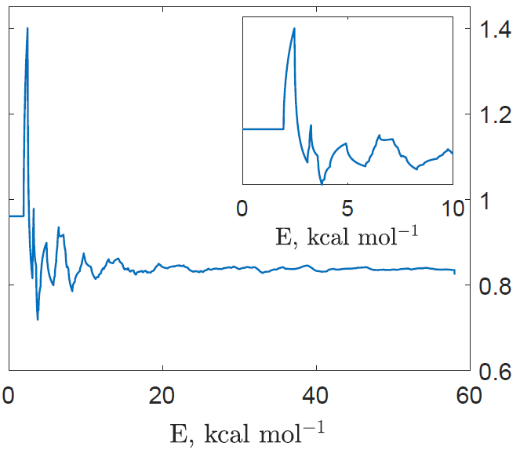

Figure 6.6. Ratio of densities of rovibrational states at MECP and reactant as a function of the internal energy $E$, kcal mol⁻¹.

The cusps at the energies of 2.4, 3.2, and 4.8 kcal mol⁻¹ are due to only a small number of low-frequency vibrational levels of the reactant being populated. Specifically, the first cusp at 2.4 kcal mol⁻¹ corresponds to two vibrational modes, 848 cm⁻¹ (2.42 kcal mol⁻¹) and 854 cm⁻¹ (2.44 kcal mol⁻¹). The next cusp at 3.2 kcal mol⁻¹ corresponds to the doubly degenerate mode, 1122 cm⁻¹ (3.21 kcal mol⁻¹). Finally, the cusp at 4.8 kcal mol⁻¹ comes from the first overtones of the 848 cm⁻¹ and 854 cm⁻¹ modes: 848 cm⁻¹ × 2 = 1696 cm⁻¹ (4.85 kcal mol⁻¹) and 854 cm⁻¹ × 2 = 1708 cm⁻¹ (4.88 kcal mol⁻¹).
The large difference between the low-energy values of rate constants predicted by NAST and Harvey & Aschi is likely due to different ways of calculating rovibrational densities of states. In NAST, we use the direct counting algorithm to calculate vibrational densities of states, and the classical asymmetric top model for obtaining the rotational densities of states. While rovibrational densities of states are calculated as a convolution of the first two. In contrast, Harvey & Aschi use analytical expressions for the rovibrational partition function, $Q=Q_{rot}Q_{vib}$ and obtain the density of the rovibrational states via the inverse Laplace transform:⁵¹

$$ρ\left(E\right)=\frac{1}{2πi}\int_{c-i∞}^{c+i∞}{Q\left(β\right)e^{βE}dβ}, \left(6.2\right)$$

where $β=\frac{1}{k_{B}T}$. One way to evaluate the inverse Laplace integral is by using the steepest descent method.⁵² It is important to notice that the rovibrational density of states $ρ\left(E\right)$ in equation 6.2 is a smooth function of $E$, whereas the real density of states, due to discrete vibrational levels, is not.

6.4 Example 4. Spin-forbidden izomerization of dichloro-1,3-bis(diphelylophosphino)propanenickel(II)

This is an example of the forward and reverse rate constants calculation in a single NAST run. In addition, it demonstrates how the rate constants between individual $M_{S}$ components of two spin states are calculated. The interconversion between the singlet (planar) and triplet (tetrahedral) isomers of Ni(dpp)Cl₂ complex (dpp – 1,3-bis(diphenylphosphino)propane) has been studied in acetonitrile.⁵³ To reduce the computational cost, the phenyl groups were replaced by methyl groups (Figure 6.7). The optimized geometries and Hessians for singlet, triplet, and the MECP structures were obtained with the M11-L density functional, the PCM (acetonitrile) implicit solvation model, and the def2-TZVP basis set, as implemented in GAMESS US.³⁰ The SOC value of 135 cm⁻¹ was calculated with the multiconfigurational quasi-degenerate perturbation theory (MCQDPT2) using the CASSCF(2e, 4o) wavefunction averaged over the lowest-energy singlet and triplet electronic states and the same basis set. The forward S₁ → T₀ rate constant calculated using the WC transition probability at 296 K (4.96 ×10⁶ s⁻¹ ) agrees with the experimental value of 4.5 × 10⁵ s⁻¹. However, the reverse
T₀ → S₁ rate constant predicted to be 3.50 ×10² s⁻¹ is significantly smaller than the experimental value of 6.0 × 10⁵ s⁻¹, which could indicate that the barrier for the reverse reaction is overestimated due to the low level of electronic structure calculations and the reduced model size.

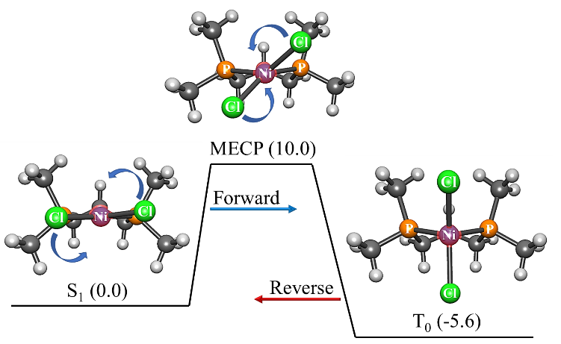

Figure 6.7. Reaction path of singlet-triplet isomerization of the Ni(dpp)Cl₂ model from square-planar to tetragonal geometry. The angles between the Cl-Ni-Cl and P-Ni-P planes are 6°, 42° and 90° for the singlet, MECP, and triplet geometries, respectively. The benzene rings of Ni(dpp)Cl₂ are replaced with the methyl groups.

Input file

$keys zpe = 1 printmore = .true. rev = .true. solution = .true. sp = .true. &end

&inputdata
freX=44, 64, 90, 94, 120, 130, 146, 155, 168, 184, 192, 197, 201, 206, 219, 226, 233, 253, 262, 270, 319, 325, 352, 371, 453, 638, 680, 720, 743, 751, 762, 768, 793, 813, 826, 842, 865, 902, 911, 944, 953, 954, 1003, 1080, 1116, 1178, 1257, 1285, 1289, 1292, 1303, 1305, 1329, 1378, 1387, 1391, 1395, 1398, 1402, 1404, 1409, 1412, 1421, 1424, 1454, 2983, 2986, 2989, 2990, 2996, 2999, 3000, 3059, 3063, 3066, 3117, 3123, 3127, 3128, 3130, 3142, 3143, 3151
inertX=3509.61929 3642.53089 5640.84788
freR=40 91, 106, 123, 152, 160, 172, 179, 193, 206, 207, 213, 215, 224, 225, 239, 241, 269, 280, 308, 325, 335, 345, 408, 420, 467, 659, 684, 733, 738, 760, 769, 774, 817, 840, 846, 861, 877, 911, 924, 948, 952, 963, 1010, 1088, 1116, 1179, 1263, 1289, 1293, 1294, 1306, 1315, 1328, 1377, 1392, 1394, 1403, 1405, 1407, 1409, 1411, 1421, 1425, 1430, 1458, 2984, 2991, 2992, 2998, 3000, 3001, 3005, 3060, 3070, 3071, 3125, 3126, 3127, 3131, 3148, 3150, 3163, 3164
inertR=3203.70539, 3475.30910, 5655.32379
enX = -3389.355567
enR = -3389.371528
maxn=10000
T1 = 290.0
T2 = 300.0
&end

&probability
redmass=5.05674
soc=135.0
grad=0.046067
gradmean=0.022625
&end

&reverse
freP=32, 47, 57, 72, 80, 82, 126, 140, 156, 169, 173, 179, 186, 203, 205, 215, 221, 228, 245, 252, 279, 314, 315, 359, 363, 444, 647, 677, 733, 742, 745, 766, 771, 806, 819, 828, 842, 864, 905, 907, 941, 951, 956, 1007, 1083, 1123, 1194, 1261, 1289, 1295, 1299, 1304, 1317, 1333, 1368, 1386, 1393, 1394, 1397, 1400, 1404, 1408, 1412, 1415, 1419, 1450, 2980, 2982, 2987, 2993, 2995, 2996, 2997, 3056, 3059, 3063, 3121, 3123, 3122, 3124, 3131, 3133, 3136, 3137
inertP=3614.38309, 4076.66807, 4552.08660
enP = -3389.377261
&end

&split
mults = 1,3
icp = 2
socmat = (-68.98,-63.83),(0,21.32)
&end

Main parts of the output file

*********************************************************
~~~~~~~ NAST: Nonadiabatic Statistical Theory ~~~~~~~
~~~~~ v. 2.0 ~~~~~
*********************************************************
---------------------------------------------
NAST control parameters and related data

zpe = 1 sp = F zn = F solution = T
tst = F TST_tunn = F printmore = T rev = T
externR = F externX = F externP = F
---------------------------------------------

zpe = 1: ZPE correction scheme I (eliminates turning points below ZPE).
Electronic barrier from reactant to MECP is 3505 cm-1
ZPE of reactants = 52954 cm-1
ZPE of MECP = 52319 cm-1
ZPE-corrected MECP energy bin = 2871 cm-1
ZPE of product is 52260 cm-1.
Gap between reactant and product is 1951 cm-1.

---------------------------------------------------------
Start NAST calculation
---------------------------------------------------------

1. Calculating densities of states

......vibrational.
.......rotational.
........rovibrational.

2. Calculating microcanonical probabilities

LZ formula is valid at energies much greater than 3285 cm-1.

........Landau-Zener

Warning! Rate calculations using transition probabilities that account
for quantum tunneling should be run with caution.
Make sure that in a reaction studied, reactant lies higher in energy than product.
Otherwise, there will be a region of unphysical tunneling, which should be excluded.
If this is the case, run a reverse (rev = .true.) calculation. This will allow NAST to prevent
unphysical tunneling. Details on reverse rate calculations can be found in the NAST package manual.

..........Weak Coupling

3. Calculating microcanonical NAST rate constant
(The forward rate constant k(E) is multiplied by reaction path degeneracy equal to 1 ).

Canonical rate constant, k(T)

T(K) Landau-Zener Weak Coupling
296.0 1.76E+06 4.96E+06
297.0 1.85E+06 5.17E+06

Landau-Zener (LZ) and Weak Coupling (WC) double passage velocity-averaged
probabilities of transition, p(T)
Calculated using Maxwell-Boltzmann (MB) and Kuki (K)
energy distributions

T(K) LZ MB LZ K WC MB WC K

296.0 0.5230 0.3033 0.0137 0.0001
297.0 0.5226 0.3029 0.0137 0.0001

Calculating product densities of states.

.........vibrational.
...........product rotational.
.............product rovibrational.

Reverse LZ probability is valid at energies much greater than 5236 cm-1.
..........Weak Coupling for reverse rate constant.

Calculating reverse rate constant.

The reverse rate constant k(E) is multiplied by reaction path degeneracy equals to 1

Canonical reverse rate constant, k(T)

T(K) Landau-Zener Weak Coupling

296.0 8.76E+01 3.50E+02
297.0 9.50E+01 3.76E+02

Total CPU time = 4.40
NAST terminated now.

Calculations of the transition probabilities and rate constants between individual $M_{S}$ components of the singlet and triplet states were carried out using the spin-orbit matrix elements (z = -69.0 – 63.8i cm⁻¹ and b = 21.3 cm⁻¹), obtained from the MCQDPT2 calculation. The${ M}_{S}$-specific rate constants $k_{M_{S} , { M}_{S^{'}}}$ for the transitions between the ${ M}_{S}=0$ component of the singlet state and three${ M}_{S^{'}}=±1$and ${ M}_{S^{'}}=0$ components of the triplet state were calculated using the LZ transition probability. These rate constants are stored in the “split_LZ_energy_rate.out” file (see Section 4. Navigation through output files) and are plotted in Figure 6.8. The stronger couplings between the${ M}_{S}=0$ component of the singlet state and the ${ M}_{S^{'}}=±1$ components of the triplet result in the faster population transfer, as evident from the $k_{0,±1}$ rate constant being larger than $k_{0,0}$.

Figure 6.8. The microcanonical rate constants $k_{0,0}$ and $k_{0,+1}=k_{0,-1}$ for transitions between the $M_{S}$ components of the singlet and triplet states calculated using the LZ probabilities.

We also used the S₁ → T₀ spin-forbidden isomerization reaction in Ni(dpp)Cl₂ to illustrate calculations of the rate constants with an applied magnetic field.² In the case of the weak magnetic field regime (approach I), the structure of the NAST input file is the same as the one shown above. The only modification is the new SOC value obtained as described in Chapter 2 of this Manual and in the corresponding paper.² Note that, because for a weak field (approach I) only the magnitude of SOC changes, the WC formula is still applicable. In the case of the strong magnetic field regime (approach III), the following keywords were added to the NAST input file (note that sp must be kept true in &keys):

&keys sp = .true &end

&split
mults = 1,3
icp = 2
socmat = (-68.98,-63.83),(0,21.32)
delta = 186.4,40.5
Bz = 432
g = 2.00231930436256
&end

Here, delta is the array of the energy gaps for three distinct crossing regions (Figure 2.3) in the strong magnetic field in cm⁻¹, B_{Z} is the magnetic field strength in Tesla, and the isotropic g-factor is set to the free electron g-factor in this example. Note that in the case of a strong field (approach III), the main output files are Bz_LZ_energy_rate.out and Bz_LZ_tempt_rate.out, which contain the microcanonical and canonical single-passage LZ rate constants, respectively. Three canonical rate constants for transitions at three crossing regions (equations 2.29 – 2.31) at different temperatures are given in Table 6.4 below.

Table 6.4. Canonical rate constants for the S₁ → T₀ isomerization of Ni(dpp)Cl₂ in a strong magnetic field.
T, K | k₁, s⁻¹ | k₂, s⁻¹ | k₃, s⁻¹
290 | 4.72×10⁴ | 8.36×10² | 1.54×10⁴
295 | 6.29×10⁴ | 1.13×10³ | 2.09×10⁴
300 | 8.30×10⁴ | 1.52×10³ | 2.81×10⁴

As can be seen from Table 6.4, k₂ is smaller than k₁ and k₃ at any temperature. This is explained by the smaller SOC value of delta(2)/2 for the second crossing than of delta(1)/2 for the first and third crossings. If user wishes to compare the rate constants calculated with the zero or a weak magnetic field to the constant calculated with the strong magnetic field, then those must be calculated using the single-passage Landau-Zener probability formula. To do so, a user will need to make a simple change in the NAST prob.f90 file before compilation in order to change the default double-passage Landau-Zener formula to the single-passage form (Figure 6.9).

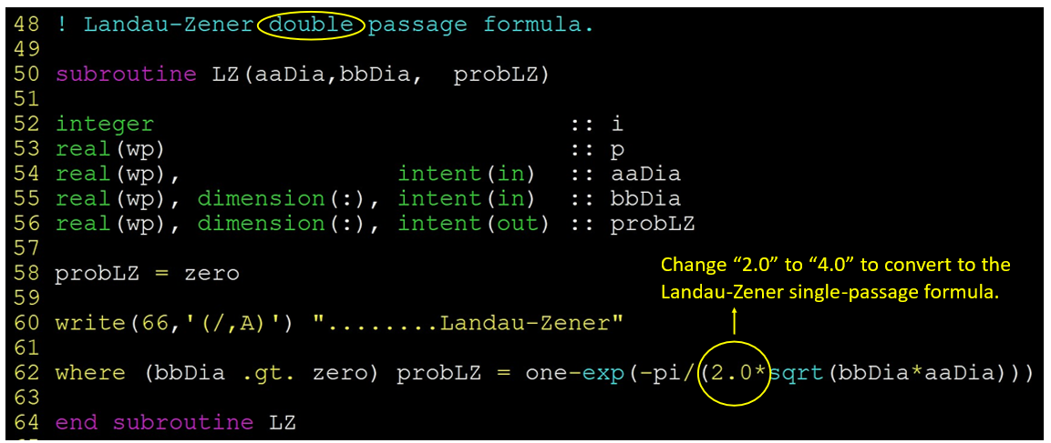
Figure 6.9. Changing the double-passage Landau-Zener probability to the single-passage probability in prob.f90.

Then, the magnetic field effect (MFE) on the reaction rate constant can be calculated as:¹

$$MFE=\frac{k_{m≠0}-k_{m=0}}{k_{m=0}}x100\%, \left(6.1\right)$$

where $k_{m≠0}$ and $k_{m=0}$ are the rate constants calculated with and without an applied external magnetic field, respectively. For the Ni(dpp)Cl₂ complex, the MFE of 9% was observed going from the 0 to 50 Tesla field (using approach I).²

6.5. Example 5. T₁ → S₀ relaxation in thiophosgene in tunneling regime

In this example, we test the rate constant calculation using the Zhu-Nakamura transition probability formulas on the T₁ → S₀ relaxation in thiophosgene (Figure 6.10). Fujiwara et al. measured lifetimes of the lowest vibrational states of the T₁ state for the CSCl₂ molecule using the optical-optical double resonance technique.^{54,55} Energies of these vibrational states are all under the transition barrier. Therefore, the T₁ → S₀ relaxation observed in the experiment is proceeding exclusively in the quantum tunneling regime. Experimental rate constants of transitions from these vibrational states of T₁, obtained as the inverse of the corresponding lifetimes, turned out to be in disagreement by around three orders of magnitude with estimates in multiple theoretical investigations.^{56,57} We used NAST to calculate tunneling rates of the T₁ → S₀ relaxation in thiophosgene using the WC and ZN transition probabilities.⁶
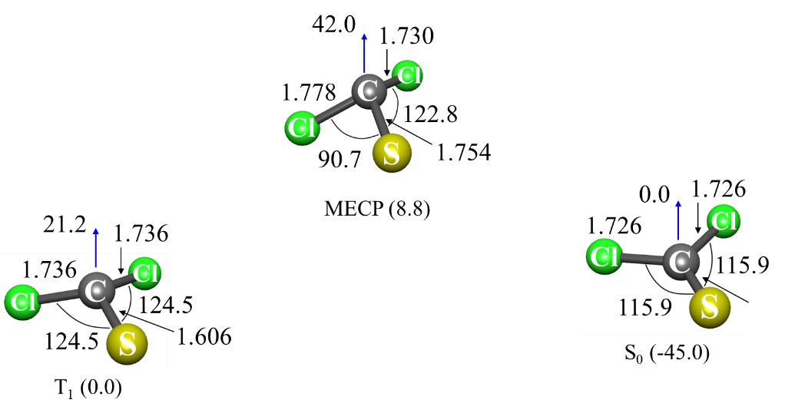
Figure 6.10. CASPT2/def2-TZVP optimized geometries for T₁, S₀ and MECP in thiophosgene. Blue arrows indicate the angle (degree) between the Cl-S-Cl plane and C atom.

Input file

&keys zn =.true. zpe = 2 printmore = .true. externR = .true. &end

&inputdata
chir = 2
freX = 244, 311, 490, 795, 919
freR = 174, 247, 489, 848, 926
inertX = 488.923, 569.396, 1048.550
inertR = 506.042, 555.108, 1052.703
enX = -1355.021
enR = -1355.036
maxn = 1000 ! All calculations are in tunneling regime.
&end

&external
extR = 1, 298, 303, 563, 601, 795, 915 ! Double well levels.
&end

&probability
redmass = 14.6302
soc = 189
grad = 0.085073
gradmean = 0.077815
&end

&polynomials
hs4 = 0.025062
hs3 = -0.025452
hs2 = 0.0283647
hs1 = -0.001514
hs0 = 0.000016
ls4 = -4.847727
ls3 = 14.218237
ls2 = -15.528009
ls1 = 7.61989931
ls0 = -1.43837683
limitL = 0
limitR = 0.9
upper = .true.
&end

Main parts of the output file

*********************************************************
~~~~~~~ NAST: Nonadiabatic Statistical Theory ~~~~~~~
~~~~~ v. 2.0 ~~~~~
*********************************************************
---------------------------------------------
NAST control parameters and related data

zpe = 2 sp = F zn = F solution = F
tst = F TST_tunn = F printmore = T rev = F
externR = T externX = F externP = F
---------------------------------------------

zpe = 2: ZPE correction scheme II (accounts for turning points below ZPE).
Electronic barrier from reactant to MECP is 3185 cm-1
ZPE of reactants = 0.00 cm-1
ZPE of MECP = 0.00 cm-1
ZPE-corrected MECP energy bin = 3186 cm-1
---------------------------------------------------------
Start NAST calculation
---------------------------------------------------------

1. Calculating densities of states

......vibrational.
.......rotational.
........rovibrational.

2. Calculating microcanonical probabilities

........Landau-Zener

Warning! Rate calculations using transition probabilities that account
for quantum tunneling should be run with caution.
Make sure that in a reaction studied, reactant lies higher in energy than product.
Otherwise, there will be a region of unphysical tunneling, which should be excluded.
If this is the case, run a reverse (rev = .true.) calculation. This will allow NAST to prevent
unphysical tunneling. Details on reverse rate calculations can be found in the NAST package manual.

..........Weak Coupling
...........Zhu-Nakamura

Sloped intersection of PESs
Origin is High-Spin state at limitL
Origin is at 0.00 bohr

3. Calculating microcanonical NAST rate constant
(The forward rate constant k(E) is multiplied by reaction path degeneracy equal to 2 ).

Canonical rate constant, k(T).

T(K) Landau-Zener Weak Coupling Zhu Nakamura

296.0 0.00E+00 1.44E+08 7.10E+05
297.0 0.00E+00 1.44E+08 7.14E+05

Landau-Zener (LZ) and Weak Coupling (WC) double passage velocity-averaged
probabilities of transition, p(T)
Calculated using Maxwell-Boltzmann (MB) and Kuki (K)
energy distributions

T(K) LZ MB LZ K WC MB WC K

296.0 0.6823 0.4628 0.0142 0.0001
297.0 0.6819 0.4623 0.0142 0.0001

Total CPU time = 6.01
NAST terminated now.

In this example, we compare microcanonical calculated and experimental rate constants (Table 6.5).

Table 6.5. Microcanonical rate constants for T₁ → S₀ relaxation from the lowest vibrational levels of T₁.
Vibrational mode, cm⁻¹ | k_{WC}, s⁻¹ | k_{ZN}, s⁻¹ | Experiment⁵⁴, s⁻¹
0 | 7.87×10⁵ | 6.07×10¹ | 4.40×10⁷
247 | 1.47×10⁸ | 6.89×10⁴ | 5.90×10⁷
494 | 2.97×10⁸ | 5.40×10⁵ | 8.00×10⁷

We see that the rate constants calculated using the WC transition probability are in reasonable agreement with experimental values. However, such an agreement must be accidental, since the WC formula, derived from the assumption of the linear crossing potentials in the vicinity of the intersection of two states, underestimates the contribution of quantum tunneling. In contrast, the ZN approach more accurately accounts for tunneling by allowing an arbitrary shape of the crossing potentials.⁶ Thus, the discrepancy between WC and ZN results is the largest at small energies, where the barrier width is maximum. The two to three orders of magnitude discrepancy between experimental results and ZN-predicted rate constants reflects the complexity of the T₁ → S₀ relaxation in thiophosgene and indicates the importance of multidimensional tunneling.⁶

6.6. Example 6. T₁ → S₀ relaxation in cyclopropene

This example demonstrates the calculation of the rate constant using the ZN transition probability. Here we consider the T₁ → S₀ relaxation in cyclopropane (Figure 6.11). This example was inspired by the work of Miller and Klippenstein, who published a detailed kinetics study of different reactions of C₃H₄, including those proceeding on multiple PESs with different spin multiplicities.⁵⁸ The equilibrium geometries and Hessians of S₀, T₁ and the MECP were obtained at the B3LYP/cc-pVTZ level of theory. The SOC=4.0 cm⁻¹ was calculated with the MCQDPT2 method based on the CASSCF(2,2) wave function averaged over the S₀ and T₁ states, using the same basis set. All calculations were performed in GAMESS.

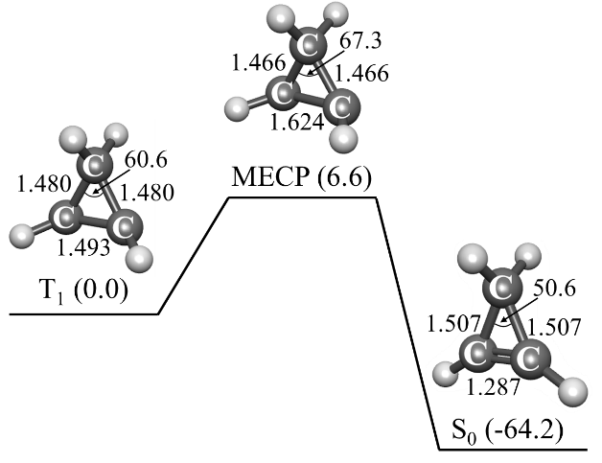
Figure 6.11. The T₁ → S₀ relaxation pathway in cyclopropene. The relative energies of the T₁ minimum, the S₀ minimum, and MECP are in kcal mol⁻¹. The bond lengths and angles calculated at the B3LYP/cc-pVTZ level of theory are in Å and degrees.

To perform the rate calculations with the ZN transition probability, the T₁ → MECP → S₀ reaction pathway was fitted with the ircifit tool using the geometries and energies generated by two IRC calculations starting from MECP and following to the T₁ and S₀ minima. The MECP → T₁ pathway was fitted with the quartic polynomial, while MECP → S₀ is linear between the T₁ minimum and MECP (Figure 6.12). The NAST input and output files are given below.

Figure 6.12. The fitted T₁ → MECP → S₀ reaction pathway. The circles mark the energies of the IRC geometries projected on the reaction coordinate r. Green area shows an increase in the tunneling barrier width compared to the linear model (dashed black line). The coefficients of the fitting polynomials (f(x) = 0.092 x⁴ – 0.121 x³ + 0.093 x² – 0.004 x – 1.86 × 10⁻⁶ and g(x) = 0.127 x – 0.048) are included in the NAST input file.

Input file

$keys zpe = 1 printmore = .true. zn = .true. &end

&inputdata
freX = 399, 622, 797, 860, 947, 1002, 1132, 1182, 1290, 1344, 2868, 3096, 3110, 3117
inertX = 70.65814, 82.17973, 131.86505
freR=468, 715, 746, 865, 923, 935, 1031, 1070, 1098, 1259, 1399, 3000, 3087, 3140, 3156
inertR = 72.16025, 75.97359, 129.26232
enX=0.010435
enR=0
maxn=17000
T1=900
Tstep=100
T2=1000
&end

&probability
redmass=2.59106
soc=4
grad=0.144858
gradmean=0.123021
&end

&polynomials
hs4 = 0.09147
hs3 = -0.1207
hs2 = 0.09307
hs1 = -0.004072
hs0 = -0.000001816
ls4 = 0.00000
ls3 = 0.00000
ls2 = 0.00000
ls1 = 0.12690
ls0 = -0.0488
limitL = 0.0
limitR = 1.10
&end

Main parts of the output file

*********************************************************
~~~~~~~ NAST: Nonadiabatic Statistical Theory ~~~~~~~
~~~~~ v. 2.0 ~~~~~
*********************************************************
---------------------------------------------
NAST control parameters and related data

zpe = 1 sp = F zn = T solution = F
tst = F TST_tunn = F printmore = T rev = F
externR = F externX = F externP = F
---------------------------------------------

zpe = 1: ZPE correction scheme I (eliminates turning points below ZPE).
Electronic barrier from reactant to MECP is 2290 cm-1
ZPE of reactants = 11444 cm-1
ZPE of MECP = 10881 cm-1
ZPE-corrected MECP energy bin = 1728 cm-1
---------------------------------------------------------
Start NAST calculation
---------------------------------------------------------

1. Calculating densities of states

......vibrational.
.......rotational.
........rovibrational.

2. Calculating microcanonical probabilities

LZ formula is valid at energies much greater than 4031 cm-1.

........Landau-Zener

Warning! Rate calculations using transition probabilities that account
for quantum tunneling should be run with caution.
Make sure that in a reaction studied, reactant lies higher in energy than product.
Otherwise, there will be a region of unphysical tunneling, which should be excluded.
If this is the case, run a reverse (rev = .true.) calculation. This will allow NAST to prevent
unphysical tunneling. Details on reverse rate calculations can be found in the NAST package manual.

..........Weak Coupling
...........Zhu-Nakamura

Sloped intersection of PESs
Origin is High-Spin state at limitL
Origin is at 0.00 bohr

3. Calculating microcanonical NAST rate constant
(The forward rate constant k(E) is multiplied by reaction path degeneracy equal to 1 ).

Canonical rate constant, k(T).

T(K) Landau-Zener Weak Coupling Zhu Nakamura

900.0 5.57E+07 1.05E+08 2.09E+07
1000.0 7.72E+07 1.24E+08 3.07E+07

Landau-Zener (LZ) and Weak Coupling (WC) double passage velocity-averaged
probabilities of transition, p(T)
Calculated using Maxwell-Boltzmann (MB) and Kuki (K)
energy distributions

T(K) LZ MB LZ K WC MB WC K

900.0 0.0002 0.0000 0.0000 0.0000
1000.0 0.0002 0.0000 0.0000 0.0000

Total CPU time = 106.05
NAST terminated now.

The NAST calculated rate constants (Table 6.6) show that the use of the WC transition probability formula overestimates the rate constant when compared to the LZ and ZN probabilities. This is due to the overestimated contribution to rate constants from quantum tunneling in the WC linear-crossing model. As predicted by more sophisticated ZN theory, the real barrier width is significantly larger due to the nonlinear form of the T₁ state potential (green area in Figure 6.12). As a result, the reaction rate constant predicted using the ZN formulas is an order of magnitude smaller than the WC rate constant. The good agreement between the LZ and ZN rate constants can be explained by the large barrier width, which practically eliminates the tunneling contribution to the reaction rate.

Table 6.6. Canonical rate constants (s⁻¹) for the T₁ → S₀ relaxation of cyclopropene at T = 900 – 1000 K.
Temperature | Landau-Zener | Weak Coupling | Zhu-Nakamura
900 | 5.57×10⁷ | 1.05×10⁸ | 2.09×10⁷
1000 | 7.72×10⁷ | 1.24×10⁸ | 3.07×10⁷

Table 6.7 demonstrates good agreement between the canonical T₁ → S₀ relaxation rate constants calculated in the NAST and MESMER 6.0 packages using the LZ transition probabilities.

Table 6.7. The T₁ → S₀ relaxation rate constant (s⁻¹) for different temperatures. The relative difference between the NAST and MESMER values is defined as (k_{NAST}-k_{MESMER})/k_{MESMER}.
T, K | MESMER | NAST | Relative difference
100 | 2.37×10⁻¹⁶ | 1.52×10⁻¹⁶ | -0.36
200 | 7.88×10⁻⁴ | 6.71×10⁻⁴ | -0.15
300 | 1.29×10¹ | 1.19×10¹ | -0.08
400 | 1.68×10³ | 1.62×10³ | -0.03
500 | 3.09×10⁴ | 3.16×10⁴ | 0.02
600 | 2.13×10⁵ | 2.33×10⁵ | 0.09
700 | 8.43×10⁵ | 9.81×10⁵ | 0.16
800 | 2.35×10⁶ | 2.91×10⁶ | 0.24
900 | 5.18×10⁶ | 6.81×10⁶ | 0.32
1000 | 9.71×10⁶ | 1.35×10⁷ | 0.39
1100 | 1.62×10⁷ | 2.36×10⁷ | 0.46
1200 | 2.47×10⁷ | 3.75×10⁷ | 0.52
1300 | 3.52×10⁷ | 5.55×10⁷ | 0.58
1400 | 4.76×10⁷ | 7.74×10⁷ | 0.63
1500 | 6.17×10⁷ | 1.03×10⁸ | 0.67
1600 | 7.73×10⁷ | 1.31×10⁸ | 0.69
1700 | 9.42×10⁷ | 1.63×10⁸ | 0.73
1800 | 1.12×10⁸ | 1.96×10⁸ | 0.75
1900 | 1.31×10⁸ | 2.31×10⁸ | 0.77
2000 | 1.50×10⁸ | 2.67×10⁸ | 0.78

6.7 Example 7. Ultrafast ISC in a metal-free diketone with MLJ program

This example is based on a combined spectroscopic and theoretical study of room-temperature phosphorescence in a series of metal-free 1,2-diketones.⁵⁹ We use an example of the ultrafast S₁ → T₃ photoinduced ISC in 1,2-bis[3-bromothiophen-2-yl]ethane-1,2-dione in cyclohexane to illustrate the calculation of the Marcus-Levich-Jortner (MLJ) rate constant (Figure 6.13).
Geometries and Hessians of S₁ and T₃ states were calculated with TD-DFT using the B3LYP-D3/6-311G(d) level of theory, as implemented in ORCA 6.0.1.³⁶ Spin-orbit coupling constant between S₁ and T₃ states was calculated at the CAM-B3LYP-D3/6-311G(d) level of theory. All calculations were performed under the Tamm-Dancoff approximation to reduce computational cost.

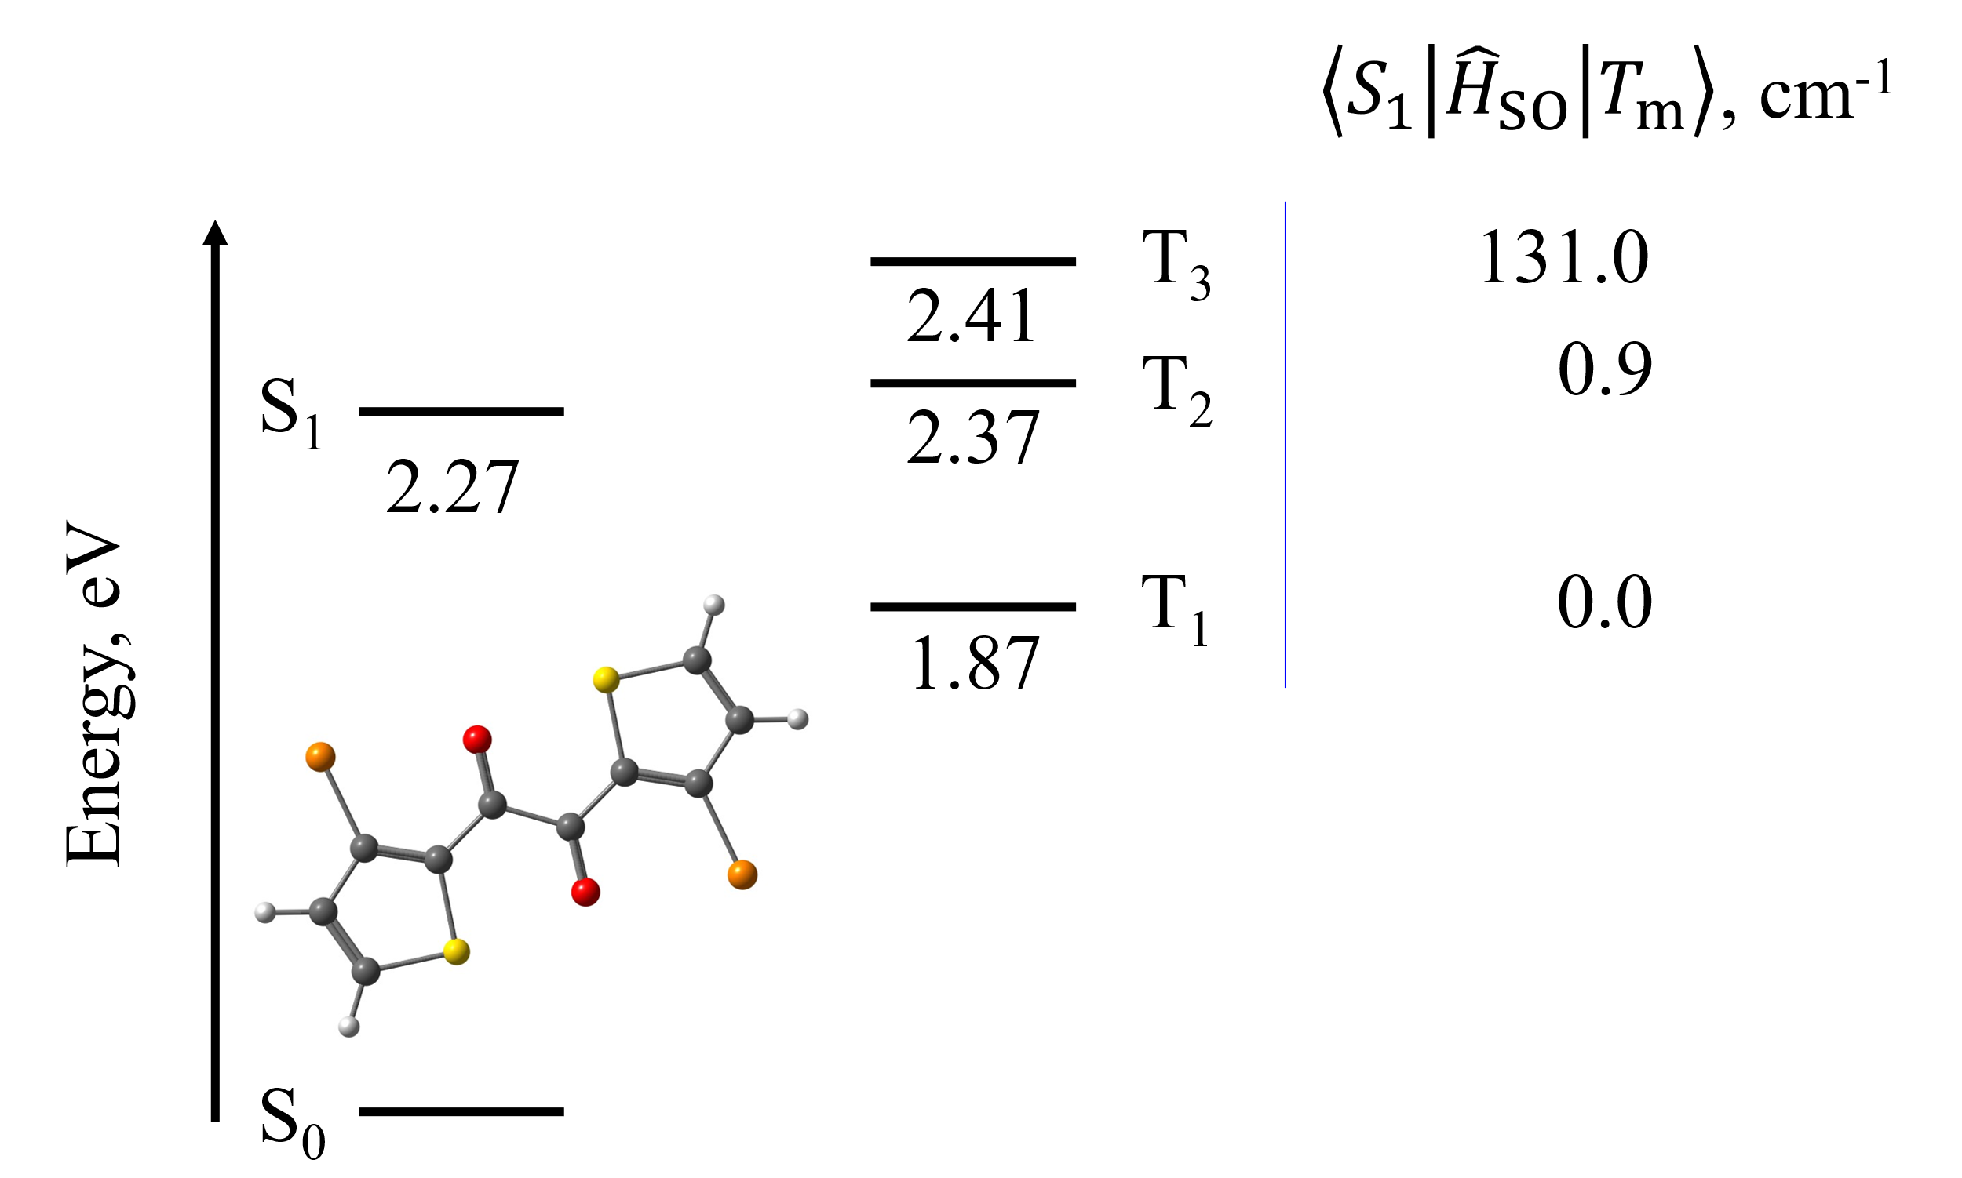
Figure 6.13. Relative energies of the excited singlet and triplet states at the optimized S₁ geometry with respect to the energy of the ground S₀ state. Inset: S₁ optimized geometry of 1,2-bis[3-bromothiophen-2-yl]ethane-1,2-dione with C atoms in dark grey, O atoms in red, Br atoms in orange, S atoms in yellow, and H atoms in light grey.

As Figure 6.13 shows, the energy of the S₁ state is close to the energy of the T₃ state at the S₁ relaxed geometry, and the two states are strongly coupled with the SOC constant of 131 cm⁻¹. Optimizing the molecular geometry of the T₃ state yields ΔE = E(T₃) – E(S₁) of –0.14 eV. The MLJ-predicted rate constant of 5.4.10¹² s⁻¹ at 300 K is in good agreement with the lifetime constant of < 10 ps estimated from the femtosecond transient absorption spectroscopy.⁵⁹ The input and output files are given below.

Input file

&inputdata
enR = -6477.99109422d0
enP = -6477.99612690d0
V = 131
freR = 21.2 39.7 58.2 …
S = 1.655E-03 4.847E-04 5.367E-01 …
lambda_vib = 1.600E-07 8.758E-08 1.423E-04 …
lambda_ext = 0.0d0
n_vib = -1
T1 = 250
Tstep = 10
T2 = 300
trsh = 4.796
&end

Main part of the output file

**********************************************
~~~ MLJ: Marcus-Levich-Jortner theory ~~~
~~~~~ v. 1.0 ~~~~~
**********************************************

---------------------------------------------------------
Start MLJ calculation
---------------------------------------------------------

Calculating Marcus-Levich-Jortner rate constant

Canonical rate constant k(T), s-1.

T(K) Marcus-Levich-Jortner

250.0 5.38E+12
260.0 5.28E+12
270.0 5.26E+12
280.0 5.17E+12
290.0 5.08E+12
300.0 5.41E+12

Total CPU time = 0.00
MLJ terminated now.

References

(6) Lykhin, A. O.; Varganov, S. A. Intersystem Crossing in Tunneling Regime: T₁ → S₀ Relaxation in Thiophosgene. Phys. Chem. Chem. Phys. 2020, 22 (10), 5500–5508. https://doi.org/10.1039/c9cp06956a.
(30) Schmidt, M. W.; Baldridge, K. K.; Boatz, J. A.; Elbert, S. T.; Gordon, M. S.; Jensen, J. H.; Koseki, S.; Matsunaga, N.; Nguyen, K. A.; Su, S.; et al. General Atomic and Molecular Electronic Structure System. J. Comput. Chem. 1993, 14 (11), 1347–1363. https://doi.org/10.1002/jcc.540141112.
(35) Neese, F. Software update: The ORCA program system–Version 5.0. WIREs Comput. Mol. Sci. 2022, 12, e1606. https://doi.org/10.1002/wcms.1606.
(36) Neese, F. Software update: the ORCA program system, version 6.0. WIREs Comput. Mol. Sci. 2025, 15, e70019. https://doi.org/10.1002/wcms.70019.
(37) Harvey, J. N.; Aschi, M. Spin-Forbidden Dehydrogenation of Methoxy Cation: A Statistical View. Phys. Chem. Chem. Phys. 1999, 1 (24), 5555–5563. https://doi.org/10.1039/a907723e.
(48) Dubnikova, F.; Lifshitz, A. Isomerization of Propylene Oxide. Quantum Chemical Calculations and Kinetic Modeling. J. Phys. Chem. A 2000, 104 (19), 4489–4496. https://doi.org/10.1021/jp9944885t.
(49) Lifshitz, A.; Tamburu, C. Isomerization and Decomposition of Propylene Oxide. Studies with a Single-Pulse Shock Tube. J. Phys. Chem. 1994, 98, 1161–1170. https://doi.org/10.1021/j100055a020.
(50) Glowacki, D. R.; Liang, C. H.; Morley, C.; Pilling, M. J.; Robertson, S. H. MESMER: An Open-Source Master Equation Solver for Multi-Energy Well Reactions. J. Phys. Chem. A 2012, 116 (38), 9545–9560. https://doi.org/10.1021/jp3051033.
(51) Baer, T.; Hase, W. L. Unimolecular Reaction Dynamics; 1996. https://doi.org/10.1093/oso/9780195074949.001.0001.
(52) Hoare, M. R.; Ruijgrok, T. H. W. Inversion of the Partition Function: The First-Order Steepest-Descent Method. J. Chem. Phys. 1970, 52 (1), 113–120. https://doi.org/10.1063/1.1672655.
(53) McGarvey, J.; Wilson, J. Photochemical Pertrurbation and Chemical Relaxation of the Planar - Tetrahedral Equilibrium in a Di(Tertiary Poshpine) Complex of Nickel(II). J. Am. Chem. Soc. 1975, 2531–2532. https://doi.org/10.1021/ja00842a034.
(54) Fujiwara, T.; Moule, D. C.; Lim, E. C. Optical-Optical Double Resonance Probe of the Dark State of Thiophosgene in Supersonic Free Jet. Chem. Phys. Lett. 2004, 389 (1–3), 165–170. https://doi.org/10.1016/j.cplett.2004.03.093.
(55) Fujiwara, T.; Lim, E. C. Temporal Characteristics of the S1 and T1 Thiophosgene Cl2 CS in the Gas Phase: Comparison of the T1 Decay with Theoretical Predictions. J. Chem. Phys. 2008, 129 (4), 1–5. https://doi.org/10.1063/1.2963037.
(56) Moule, D. C.; Burling, I. R.; Liu, H.; Lim, E. C. The Cavity Ringdown Spectrum of the Visible Electronic System of Thiophosgene: An Estimation of the Lifetime of the T1(ã 3A2) Triplet State. J. Chem. Phys. 1999, 111 (11), 5027–5037. https://doi.org/10.1063/1.479760.
(57) Rashev, S.; Moule, D. C.; Djambova, S. T. On the T₁ → S₀ Intersystem Crossing Rate Constant in Thiophosgene. Chem. Phys. Lett. 2007, 441 (1–3), 43–47. https://doi.org/10.1016/j.cplett.2007.04.093.
(58) Miller, J. A.; Klippenstein, S. J. From the Multiple-Well Master Equation to Phenomenological Rate Coefficients: Reactions on a C3H4 Potential Energy Surface. J. Phys. Chem. A 2003, 107 (12), 2680–2692. https://doi.org/10.1063/5.0046438.
(59) Tani, Y.; Miyata, K.; Ou, E.; Oshima, Y.; Komura, M.; Terasaki, M.; Kimura, S.; Ehara, T.; Kubo, K.; Onda, K.; Ogawa, T. Fast, efficient, narrowband room-temperature phosphorescence from metal-free 1,2-diketones: rational design and the mechanism. Chem. Sci. 2024, 15, 10784–10793. https://doi.org/10.1039/D4SC02841D.

7. Tools

7.1. Effective Hessian code

The Effective Hessian code is a part of the NAST package.

7.1.1. Introduction to Effective Hessian

The rate constant calculations require the knowledge of the rovibrational states at critical points of a reaction. The vibrational states at MECP are described by an effective Hessian matrix defined on the seam of two crossing electronic spin states. As the electronic structure packages usually do not support effective Hessian calculation, the effhess tool was designed.
The effhess program requires the gradients and Hessian matrices of two spin states at MECP. Currently, the program supports reading input data from the GAMESS³⁰, Molpro³¹, Q-Chem³⁴, and ORCA^{35,36} electronic structure programs. The effhess program generates an output file containing the vibrational frequencies ($v_{X}$) and principal moments of inertia ($I_{X}$) at MECP, as well as the reduced mass $μ_{⊥}$ along the reaction coordinate (RC) degree of freedom, the norm of the gradient parallel to the reaction coordinate $\left|Δg\right|$, and the mean gradient $\overline{g}= {\left(\left|g_{1}\right|\left|g_{2}\right|\right)}^{\frac{1}{2}}$.

7.1.2. Working equations

To perform vibrational analysis at MECP, one needs to build the effective Hessian matrix:

$$H_{eff}=\frac{\left|g_{1}\right|H_{2} ± \left|g_{2}\right|H_{1}}{\left|g_{1}\right|±\left|g_{2}\right|}, \left(7.1\right)$$

where $g_{i}$ and $H_{i}$ are the state-specific gradients and Hessian matrices obtained from electronic structure calculations. We perform a projection of the mass-weighted effective Hessian (MWEH) to remove seven zero frequencies associated with the translational, rotational, and RC degrees of freedom:

$$H_{proj}=\left(I-P\right)H_{eff}^{mw}\left(I-P\right), \left(7.2\right)$$

where $I$, $H_{eff}^{mw}$ and $P= P_{tr}+P_{rot}+P_{rc}$ are the identity, MWEH, and projection matrices, correspondingly. To avoid linear dependence between the projected eigenvectors, we separately project the MWEH onto $P_{rc}$ to define the reaction coordinate eigenvector and calculate reduced mass along RC:

$$H_{proj}^{RC}=P_{rc}H_{eff}^{mw}P_{rc}. \left(7.3\right)$$

The $H_{proj}^{RC}$ matrix is then diagonalized to obtain the RC eigenvector $k^{mw}$ with the only non-zero eigenvalue. The eigenvector $k^{mw}$ is then transformed back to the Cartesian space by dividing every element of the vector by the square root of the mass of the corresponding atom. The transformed eigenvector is denoted as $k^{Cart}$. The reduced mass is then calculated as the inverse of the scalar product of the vector with itself:

$$μ_{⊥}= \frac{1}{{(k^{Cart})}^{T}k^{Cart}}. \left(7.4\right)$$

The effhess program allows the user to visualize the nuclear motion along RC at the MECP and visualize displacements along imaginary normal modes, if any are found upon diagonalization of the effective Hessian. To visualize nuclear motion, we generate Cartesian displacements from the MECP geometry along the selected degree of freedom (RC or imaginary frequency mode) using the corresponding eigenvector $Q$. In the case of RC, we diagonalize $H_{proj}^{RC}$ to get a vector $k$. In the case of imaginary frequencies, we use eigenvectors $Q$ of $H_{proj}$ that correspond to imaginary frequency modes. The general formula for generating displacements is:

$$x=x_{0}+DQ, \left(7.5\right)$$

where $x_{0}$ describes the MECP nuclear geometry, $D$ is the scaled displacement, $Q$ is the selected normal mode, and $x$ is the vector of the atomic Cartesian coordinates along $Q$.

7.1.3. Installation

The installation process of effhess is identical to the one described for the NAST main code in 1. Installation Guide. The compilation of the source code has been tested for

- GNU Fortran (GCC) 8.2.0 compiler
- GNU Fortran (GCC) 8.5.0 compiler
- GNU Fortran (GCC) 9.3.0 compiler
- GNU Fortran (GCC) 11.5.0 compiler
- ifort (IFORT) 13.0.0 20120731 compiler
- ifort (IFORT) 2023.1.0 compiler
- ifort (IFORT) 2023.2.1 compiler
- Intel® MKL 2018.2.199 – 2018.4.274
- Intel® MKL 2019.0.117 – 2019.5.281
- Intel® MKL 2020.0.166 Initial Release
- Intel® MKL 2023.1.0
- Intel® MKL 2023.2.1

Note: Issues have been found when using Intel® MKL 2019.3.199 or later with the GNU Fortran compiler. The test examples produce artificial imaginary frequencies when diagonalizing the effective Hessian. At this point, we recommend using either the ifort compiler with one of the libraries listed above or the GNU compiler with the MKL version no higher than 2019.2.187.

7.1.4. Running Effective Hessian (effhess.x)

To run the effhess.x executable, you need the math library to be run-time accessible: modify your PATH and LD_LIBRARY_PATH environmental variables to include

export PATH = $PATH:/…/compilers_and_libraries_20XX.X.XXX/linux/bin

export LD_LIBRARY_PATH = $LD_LIBRARY_PATH: /…/intel/…/linux/mkl/lib/intel64

You may want to give an alias to the effhess.x executable, so it can be run in any directory. For example, add the following line to your .bash_profile:

alias effhess = '/path/to/effhess.x'

and then source .bash_profile. Now you can invoke a calculation with

effhess inputfile.

7.1.5. Input structure

Here, we consider a general R → MECP → P spin-forbidden reaction. The reactant is chosen as the minimum on the excited state surface, so that the R → MECP→ P reaction is a relaxation reaction. The effhess input file looks as follows:

&programs
GAMESS = .true.
or
Molpro = .true.
or
QChem = .true.
or
ORCA = .true.
&end

&games_input_files
low_spin_dat = ‘hess_S.dat’
high_spin_dat = ‘hess_T.dat’
input_geometry = ‘hess_S.inp’
&end

or

&molpro_input_files
low_spin_grad = 'grad_S.out'
high_spin_grad = grad_T.out'
low_spin_hess = 'hess_S.out'
high_spin_hess = 'hess_T.out'
&end

or

&qchem_input_files
geometry_in = ‘grad_S.in'
low_spin_grad_fchk = 'grad_S.fchk'
high_spin_grad_fchk = 'grad_T.fchk'
low_spin_hess_fchk = 'hess_S.fchk'
high_spin_hess_fchk = 'hess_T.fchk'
&end

or

&orca_input_files
low_spin_grad_orca = 'grad_S.out'
high_spin_grad_orca = ‘grad_T.out'
low_spin_hess_orca = ‘hess_S.hess'
high_spin_hess_orca = ‘hess_T.hess'
&end

7.1.6. Input files

The keywords available in &programs are GAMESS, Molpro, QChem, and ORCA. The corresponding input files containing state-specific gradients and Hessians, as well as the Cartesian coordinates for the MECP optimized geometry, are specified in the &gamess_input_files, &molpro_input_files, &qchem_input_files, or &orca_input_files group. Note that each electronic structure program has its own way of printing the output data; thus, the number of input files for the effhess program differs.
For GAMESS, low_spin_dat and high_spin_dat are the two .dat files, one for each spin state, containing the corresponding state-specific gradients and Hessians. The input_geometry is one of the GAMESS .inp files containing the MECP geometry.
For Molpro, gradients and Hessians are stored in separate .out files. The MECP geometry is read from one of the gradient output files. Thus, four files must be specified in the effhess input file: low_spin_grad, high_spin_grad, low_spin_hess, and high_spin_hess.
For Q-Chem, gradients and Hessians are also stored in separate .fchk files. The geometry is read from the Q-Chem .in input file. There are thus five files to be specified in the effhess input file: geometry_in, low_spin_grad_fchk, high_spin_grad_fchk, low_spin_hess_fchk, and high_spin_hess_fchk.
Finally, there are four output files from ORCA for the effhess input file: low_spin_grad_orca, high_spin_grad_orca, low_spin_hess_orca, and high_spin_hess_orca.

7.1.7. Navigation through output files

There are three main and one optional output file generated by the effhess code. They contain molecular properties at MECP for the NAST input. The effhess code generates the template of the NAST input file. The only required parameter not included in the template is the SOC constant, which is usually obtained in a separate electronic structure calculation.

.out | The .out file is the main output file of the effective Hessian code. It contains results of the MECP vibrational analysis, including the intersection type (peaked or sloped), geometric mean of two gradients ($\overline{g}$, hartree/bohr), norm of the gradient parallel to the reaction coordinate ($\left|Δg\right|$, hartree/bohr), the reduced mass $μ_{⊥}$ (amu), vibrational frequencies (cm⁻¹), ZPE (kcal/mol), and the principal moments of inertia $I_{X}$ (amu*bohr²). The results are also written into the NAST input template .nast (see below).
.imag | There is always a chance that the vibrational analysis at the MECP geometry will show one or multiple imaginary frequency modes. This means that the MECP re-optimization is needed. The .imag file offers aid in this respect. Note: The file will be generated only if there are imaginary frequencies found. Let’s say there are two imaginary frequency modes. Then, for each of them, a list of Cartesian coordinates will be generated by sampling displacements along the corresponding normal mode. The default is to generate twenty displacements. Therefore, for two imaginary modes, there will be a total of forty Cartesian geometries that correspond to displacements along the modes. User is free to choose any of those geometries as a starting guess for the MECP re-optimization, which hopefully will converge to the molecular geometry without imaginary frequencies in the effective Hessian.
.rc | Similar to the .imag file, the .rc file contains the Cartesian geometries generated along the reaction coordinate. These geometries can be used to visualize the molecular motion along the reaction coordinate.
.nast | Template of the NAST input file containing the MECP data.

The structure of the effhess output files is the same for the GAMESS, Molpro, Q-Chem, and ORCA inputs. An example of running effhess with the GAMESS and Molpro inputs are given below. Test examples for all four electronic structure programs are provided as part of the NAST package.

7.1.8. Example of running Effective Hessian for methoxy cation, CH₃O⁺

Here we construct an effective Hessian for the spin-forbidden dehydrogenation of methoxy cation, ³CH₃O⁺ (see section 6.1. Example 1). The input to the effective Hessian code contains the state-specific gradients and Hessian matrices at the MECP geometry, as well as the atomic coordinates of the MECP geometry. Let us run two effective Hessian calculations using the input data from two different electronic structure methods and compare the results. For this example, we choose B3LYP in GAMESS and CCSD(T) in Molpro, with cc-pVTZ basis set. We first run the electronic structure calculations to locate the minimum of reactants and the MECP structure, then use the corresponding data as input for two independent effective Hessian runs and finally compare the results. The structure of this example looks as follows:

1. Effective Hessian from GAMESS B3LYP gradients and state-specific Hessians;
2. Effective Hessian from Molpro CCSD(T) gradients and state-specific Hessians;
3. The comparison of results;
4. .nast and .rc output: NAST input template and visualization of the reaction coordinate.

1. Effective Hessian from GAMESS B3LYP gradients and state-specific Hessians.

Let us create an input file, meth_cation_eff_hess_GAMESS.com, where we specify the GAMESS .dat and .inp files to be read by effhess. The MECP search was performed as implemented in GAMESS. Given an alias - alias effhess = '/path/to/effhess.x' – has been added to the .bash_profile, the calculation is executed with:

effhess meth_cation_eff_hess_GAMESS.com

meth_cation_eff_hess_GAMESS.com:

&programs
GAMESS = .true.
&end

&games_input_files
low_spin_dat = 'meth_cation_mecp_geometry_s.dat'
high_spin_dat = 'meth_cation_mecp_geometry_t.dat'
input_geometry = 'meth_cation_mecp_geometry_s.inp'
&end

meth_cation_eff_hess_GAMESS.out (some headers skipped):

***********************************************************
~~~~~ Effective Hessian: part of the NAST package ~~~~~
~~~~~ v. 2.0 ~~~~~
***********************************************************

Opening the methoxy_cation_eff_hess.inp input file

Effective Hessian data

Gradmean = 8.190326591E-02
Norm of parallel gradient = 1.657563917E-01
Norm of low-spin gradient = 7.020334815E-02
Norm of high-spin gradient = 9.555306327E-02
Lambda = 0.423533E+00
Gradients dot product = -6.708141697E-03 indicates peaked intersection

Principal moments of inertia (amu*bohr**2)

12.084982390 56.731153496 57.962092062

Frequency (cm-1) Reduced mass (amu)
0.00 3.6577635
0.00 1.4484445
0.00 1.7494525
0.00 2.4888227
0.00 3.8202261
0.00 1.8795309
0.00 6.3846805
670.56 1.0652821
1063.90 1.2606661
1093.35 1.1924504
1301.17 2.0051169
1429.34 1.6200189
2071.39 1.0750162
2855.30 1.0358111
2966.86 1.1137742

Reduced mass along the reaction coordinate (amu): 1.3188641
zpe in kcal mol-1: 19.23042629
Total CPU time = 0.050

2. Effective Hessian from Molpro CCSD(T) gradients and state-specific hessians.

An input file, meth_cation_eff_hess_Molpro.com, contains names of the Molpro output files, .out. Below are contents of the meth_cation_eff_hess_Molpro.com and meth_cation_eff_hess_Molpro.out files:

meth_cation_eff_hess_Molpro.com:

&programs
Molpro = .true.
&end

&molpro_input_files
low_spin_grad = ‘low_grad_mecp_geometry.out'
high_spin_grad = ‘high_grad_mecp_geometry.out'
low_spin_hess = ‘low_hess_mecp_geometry.out'
high_spin_hess = ‘high_hess_mecp_geometry.out'
&end

meth_cation_eff_hess_Molpro.out (some headers skipped):

****************************************************************
~~~~~~~ Effective Hessian: part of the NAST package ~~~~~~~
~~~~~ v. 2.0 ~~~~~
****************************************************************

Opening the methoxy_cation_eff_hess.inp input file

Effective Hessian data

Gradmean = 7.785103926E-02
Norm of parallel gradient = 1.564105184E-01
Norm of low-spin gradient = 7.076154507E-02
Norm of high-spin gradient = 8.565081936E-02
Lambda = 0.452403E+00
Gradients dot product = -6.060495575E-03 indicates peaked intersection

Principal moments of inertia (amu*bohr**2)

12.110459569 57.572646482 58.796000070

Frequency (cm-1) Reduced mass (amu)
0.00 2.0622685
0.00 1.7794739
0.00 2.1473270
0.00 3.4686578
0.00 4.3118504
0.00 3.3434755
0.00 1.8844205
672.20 1.0803063
1068.04 1.2365189
1080.22 1.1981384
1284.86 2.4840173
1423.35 1.3717062
2125.98 1.0628045
2913.69 1.0358137
3033.15 1.1133256

Reduced mass along the reaction coordinate (amu): 1.3535208
zpe in kcal mol-1: 19.44427734
Total CPU time = 0.013

3. The comparison of results

In Table 7.1 below, we compare the NAST input data obtained from the above effective Hessian runs. For each input data, we calculate the absolute relative difference: $∆\left[X\right]=\frac{\left|X_{GAMESS,DFT}-X_{Molpro, CCSD\left(T\right)}\right|}{\left|X_{Molpro, CCSD\left(T\right)}\right|}$. For example, $∆\left[\left|Δg\right|\right]=\frac{\left|{\left|Δg\right|}_{GAMESS, DFT}- {\left|Δg\right|}_{Molpro,CCSD\left(T\right)}\right|}{\left|{\left|Δg\right|}_{Molpro, CCSD\left(T\right)}\right|}$ or $∆\left[μ_{⊥}\right]=\frac{\left|{μ_{⊥}}_{GAMESS, DFT}- {μ_{⊥}}_{Molpro,CCSD\left(T\right)}\right|}{\left|{μ_{⊥}}_{Molpro,CCSD\left(T\right)}\right|}$ or $∆\left[I_{X}\right]=\frac{\left|{I_{X}}_{GAMESS, DFT}- {I_{X}}_{Molpro,CCSD\left(T\right)}\right|}{\left|{I_{X}}_{Molpro,CCSD\left(T\right)}\right|}$, where $∆\left[I_{X}\right]$ is an average among xx-, yy-, and zz–principal components of the moments of inertia tensor.

Table 7.1. Comparison of the effective Hessian part of the NAST input data obtained from GAMESS and Molpro electronic structure programs.
$$∆\left[\overline{g}\right]$$ | $$∆\left[\left|Δg\right|\right]$$ | $$∆\left[g_{1}∙g_{2}\right]$$ | $$∆\left[μ_{⊥}\right]$$ | $$∆\left[I_{X}\right]$$
0.052 | 0.059 | 0.107 | 0.025 | 0.010
${\left\{∆\left[ν_{X,i}\right]\right\}}_{i=1}^{8}$,
where $i$ runs through all vibrational modes at the MECP (3N-7)
N = 5 for CH₃O⁺

0.002, 0.004, 0.012, 0.012, 0.004, 0.026, 0.020, 0.022

There are several sources of discrepancy between the data from the two runs. One of them comes from the slightly different MECP structures predicted by two levels of theory. In Figure 7.1, we show structural parameters of B3LYP/cc-pVTZ and CCSD(T)/cc-pVTZ CH₃O⁺ MECPs. We notice that the most prominent changes are in parameters related to the reaction coordinate and that involve the upper hydrogen shown in Figure 7.1: C-H bond length 1.242 vs. 1.224 $Å$, H-C-O angle $∠$77.2 ° vs. $∠$80.3 ° and C-O bond length 1.283 vs. 1.295 $Å$. Due to differences in geometry, we would expect slight variations in geometry-dependent properties such as frequencies and principal moments of inertia.

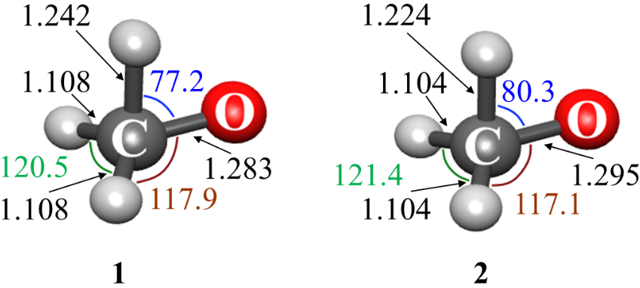
Figure 7.1. B3LYP/cc-pVTZ (1) and CCSD(T)/cc-pVTZ (2) CH₃O⁺ MECP structures.

However, as seen from Table 7.1, the largest absolute relative differences are those for the gradient data: $g_{1}∙g_{2}$, $\overline{g}$ and $\left|Δg\right|$. The reason for that is a different number of figures in the printed gradients. GAMESS prints the gradient components in Fortran scientific notation format with eleven significant figures. For example:

$GRAD
E= -114.6214870595 GMAX= 0.0413225 GRMS= 0.0181264
CARBON 6. 2.2253110167E-02 -4.1322469734E-02 -3.9992020539E-03
HYDROGEN 1. 1.0174276459E-02 4.2805715286E-03 2.5607227680E-02
…
$END
Therefore, the number of significant figures is fixed. On the other hand, Molpro prints the same data in Fortran F format for a string of ten-digit floating-point numbers:

Atom dE/dx dE/dy dE/dz
1 -0.029434150 0.053529845 0.003913258
2 -0.009795518 -0.008059090 -0.029300563
…
5 0.029711615 -0.028674867 0.026025381

We see that in the case of Molpro, different components of a gradient have different numbers of significant figures. Therefore, the GAMESS and Molpro gradients have different accuracy. Therefore, there are two sources of discrepancy in these two effective Hessian runs: different levels of theory and different accuracy of gradients. To eliminate the second source and directly compare results from two levels of theory, we reduce the accuracy of the GAMESS gradients to the same number of significant digits by using the Molpro gradient format. Re-running the effective Hessian calculation, we find the changes in the eighth significant digit. Therefore, all the differences in Table 7.1 come solely from the differences in the two electronic structure methods.
To get the final confirmation, let us run two NAST calculations with the same reactant data, the same MECP barrier, but different MECP properties ($\overline{g}$, $\left|Δg\right|$, $μ_{⊥}$, $I_{X}$ and $ν_{X}$ ) obtained from the Molpro and GAMESS effective Hessian runs, keeping the same number of significant digits in the GAMESS and MOLPRO gradients. Below, we compare ZPE-corrected MECP barriers and microcanonical and canonical rate constants at selected energies and temperatures:

GAMESS: ZPE-corrected MECP = 4751 cm⁻¹ (13.6 kcal mol⁻¹)
Molpro: ZPE-corrected MECP = 4826 cm⁻¹ (13.8 kcal mol⁻¹)

GAMESS: k_{WC}(E=1 cm⁻¹): 7.50E+03 k_{WC}(E=6000 cm⁻¹): 4.20E+09
Molpro: k_{WC}(E=1 cm⁻¹): 1.73E+04 k_{WC}(E=6000 cm⁻¹): 4.53E+09

GAMESS: k_{WC}(T=297 K): 2.97E+06 k_{WC}(T=298 K): 2.99E+06
Molpro: k_{WC}(E=297 K): 6.25E+06 k_{WC}(T=298 K): 6.28E+06

We see that the effect on the final rate constants is small, as expected, because we describe the same MECP with small structural differences coming from two different electronic structure methods.

4. NAST input template and visualization of reaction coordinate (.nast and .rc output files).

If finished successfully, the code generates the NAST input template .nast file that contains the MECP part of the input data. For the above example of the methoxy cation, the .nast file looks the following:

methoxy_cation_eff_hess.nast:

! This is an NAST template input file automatically generated
! by the Effective Hessian code. The file contains the MECP part
! of NAST input. Check NAST manual to finish the input file.

&keys zpe=1 &end

&inputdata
freR =
freX = 671 1064 1093 1301 1429 2071 2855 2967
inertX= 12.08498 56.73115 57.96209
inertR =
enX = enR =
redmass = 1.3188641 soc =
grad = 0.165756392 gradmean = 0.081903266
maxn = 10000
&end

The .rc file contains the Cartesian coordinates for the molecular geometries along reaction coordinate:

methoxy_cation_eff_hess.rc:

Geometry # 0
CARBON 6.0 -1.928645748 -0.006530451 -2.277655863
HYDROGEN 1.0 -1.164444021 -0.823984548 -1.702797871
HYDROGEN 1.0 -1.217219172 1.018216165 -2.125297851
HYDROGEN 1.0 -2.773842684 0.104946208 -1.354278063
OXYGEN 8.0 -2.547205994 0.021671629 -3.493235621
…
Geometry # 4
CARBON 6.0 -1.955420467 0.043203831 -2.272821423
HYDROGEN 1.0 -1.310216188 -0.885344623 -2.069726700
HYDROGEN 1.0 -1.177421821 0.924375917 -2.136209287
HYDROGEN 1.0 -2.721637543 0.018347865 -1.371313405
OXYGEN 8.0 -2.523730585 -0.000405434 -3.471981846
…
Geometry # 7
CARBON 6.0 -1.975501506 0.080504542 -2.269195592
HYDROGEN 1.0 -1.419545312 -0.931364679 -2.344923321
HYDROGEN 1.0 -1.147573808 0.853995731 -2.144392863
HYDROGEN 1.0 -2.682483687 -0.046600893 -1.384089912
OXYGEN 8.0 -2.506124029 -0.016963232 -3.456041515
…
One can inspect these geometries using one of molecular visualization packages.

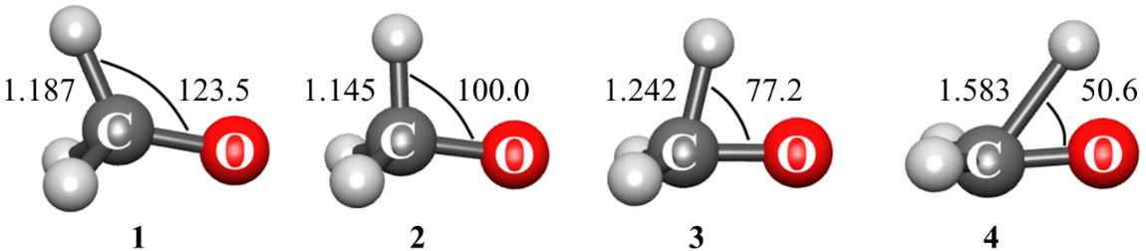

Figure 7.2. CH₃O⁺ structures (1 → 4) generated by displacements along the reaction coordinate normal mode at MECP and visualized by MacMolPlt.

If upon diagonalization of the effective Hessian, one or more imaginary normal modes are found, the molecular geometries generated by displacing atoms along these modes will be written in the .imag file. These geometries can be used to restart the MECP search.

7.2. Intrinsic reaction coordinate fitting (ircfit)

The tool ircfit is part of the NAST package.

7.2.1. Introduction to ircfit

The central NAST quantity is the probability of transition between states with different spin multiplicities. The two-state models, used to derive probability expressions, adopt a picture of two 1-D crossing electronic potentials. The Landau-Zener (LZ) and weak coupling (WC) theories assume a constant slope of the potentials in the crossing region, i.e., linear crossing. This assumption allows one to derive simple analytical expressions for transition probabilities, such as the LZ and WC formulas (see Section 2.2). The transition probability expressions derived from the models that use more realistic non-linear potentials can improve accuracy. For instance, the Zhu-Nakamura (ZN) transition probability formulas come from one of such models. Rate constant calculations that employ the ZN formulas require explicit crossing potentials. The ircfit code helps to generate such potentials from results of electronic structure calculations.

7.2.2. Methodology

The main idea behind the intrinsic reaction coordinate (IRC) fit is to build one-dimensional electronic potentials for different spin multiplicities that 1) connect key stationary points of the reaction, namely the reactant, the MECP and the product, and 2) can be described with an analytical continuous function, i.e., by a polynomial, to provide access to any arbitrary point on the potential. To build the crossing potentials, the ircfit tool does the following:
- Read the IRC data from the outputs of the GAMESS or ORCA electronic structure programs. The user must perform two IRC calculations to obtain the molecular geometries at the points between the reactant and the MECP, and between the MECP and the product. As input, IRC fit requires two .log files from GAMESS or two .out files from ORCA. The IRC points are a collection of ${\left\{Q_{i},E_{i}\right\}}_{i=1}^{n+m}$, where $Q_{i}$ and $E_{i}$ are molecular structure and energy at the IRC point i; $Q_{1}$ and $E_{1}$ are the MECP geometry and energy; and $n$ and $m$ are the total numbers of IRC points for the reactant and the product, respectively. In general, $n$ and $m$ are different. The ircfit tool works independently with each of the .log or .out files.
- Project the ${\left\{Q\right\}}^{reac}$ and ${\left\{Q\right\}}^{prod}$ nuclear geometries onto a chosen one-dimensional reaction coordinate $r$. Note that the ${\left\{Q\right\}}^{reac}$ and ${\left\{Q\right\}}^{prod}$ geometries are found by following different minimum energy paths, and therefore correspond to different multi-dimensional curvilinear coordinates, they must be projected onto a single reaction coordinate to generate the crossing potentials.
We choose the minimum of reactants as the origin of the x-axis, that represent single reaction coordinate $r$. Therefore, there is a single reference point for both sets of $Q$. Then, we convert a set of $Q$ into r according to the arc length formula:

$$r_{j}= {\left(\sum_{i=1}^{3N}{{\left(dQ_{j,i}\right)}^{2}}\right)}^{\frac{1}{2}}, j=\overline{1,n+m} \left(7.6\right)$$

where $dQ_{j,p}$ is the difference between the Cartesian coordinates of the reference point and point j, where j runs over all IRC points. The reference point will therefore be set to zero, the origin of the x-axis.
3) Fits the ${\left\{r_{i},E_{i}\right\}}_{X→R}$ and ${\left\{r_{i},E_{i}\right\}}_{x→P}$ data points to analytical continuous functions to obtain two one-dimensional crossing potentials, where x is the one-dimensional reaction coordinate.
Note 1: We now choose the reference point for energy as the energy of the minimum of reactants. In the MECP → reactant IRC path, this will be the energy of the last point (first IRC point is MECP): $E_{n}$. Now, the energies of all the points are referenced to $E_{n}$.
Note 2: For the MECP → product IRC path, we retain only points with energies > 0; i.e., only product IRC points that lie at or above the reactant minimum. Therefore, all IRC points for the product below the reactant minimum are excluded.
The ircfit tool works with polynomials up to the fourth order. The choice of polynomial order is based on the numbers $n$ and $m$, where $m$ pertains only to the IRC points for a product above the minimum of reactants. If $n=2$, so only two IRC points from MECP to the minimum of reactant or product are provided, then the IRC path is fitted by a line, if $n=3$ – by a parabola, if $n=4$ – by a cubic polynomial, if $n≥5$ – by a quartic polynomial. Illustrative examples of polynomial fitting are shown in Figure 7.3.

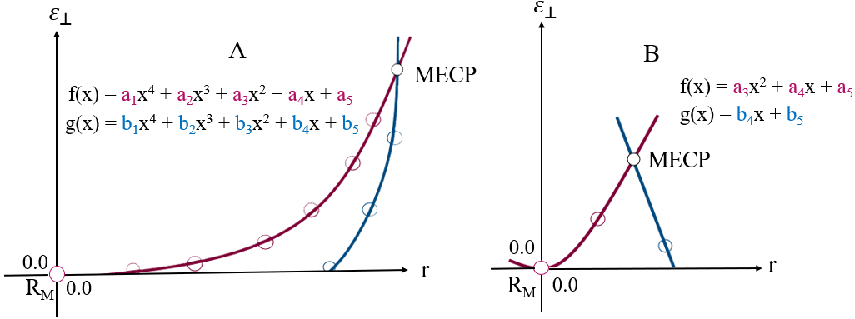
Figure 7.3. Examples of the fitted IRC paths along 1-D reaction coordinate r. R_{M} is the reactant minimum, $ε_{⊥}$ is the energy perpendicular to the crossing seam. A) Sloped-type intersection; reactant and product points are fitted to a quartic polynomial. B) Peaked-type intersection; reactant and product points are fitted to a parabola and a line, respectively.

The polynomial coefficients are found by solving the following system of linear equations:

$$f\left(c,r\right)=\left\{\begin{aligned}c_{1}r^{4}+c_{2}r^{3}+c_{3}r^{2}+c_{4}r+c_{5} or \\ c_{2}r^{3}+c_{3}r^{2}+c_{4}r+c_{5} or \\ c_{3}r^{2}+c_{4}r+c_{5} or \\ c_{4}r+c_{5}\end{aligned}, \left(7.7\right)\right.$$

$$F= \sum_{i=1}^{k}{{\left(E_{i}-f\left(c,r_{i}\right)\right)}^{2}}→\min\left(c\right), \left(7.8\right)$$

$$\frac{∂F}{∂c}=0,$$

where $k$ is either $n$ or $m$, and $F$ is the non-linear least squares function.

7.2.3. Installation

The installation process is identical to the one described for the NAST main code. The compilation of the source code has been tested with

- GNU Fortran (GCC) 8.2.0 compiler
- GNU Fortran (GCC) 8.5.0 compiler
- GNU Fortran (GCC) 9.3.0 compiler
- GNU Fortran (GCC) 11.5.0 compiler
- ifort (IFORT) 13.0.0 20120731 compiler
- ifort (IFORT) 2023.1.0 compiler
- ifort (IFORT) 2023.2.1 compiler
- Intel® MKL 2018.2.199 – 2018.4.274
- Intel® MKL 2019.0.117 – 2019.5.281
- Intel® MKL 2020.0.166 Initial Release
- Intel® MKL 2023.1.0
- Intel® MKL 2023.2.1

For more details, see Section 1. Installation Guide.

7.2.4. Running IRC fit (ircfit.x)

To run the irc.x executable, the math library must be run-time accessible. The PATH and LD_LIBRARY_PATH environmental variables should include

export PATH = $PATH:/…/compilers_and_libraries_20XX.X.XXX/linux/bin

export LD_LIBRARY_PATH = $LD_LIBRARY_PATH: /…/intel/…/linux/mkl/lib/intel64

For convenience, you might want to give an alias to the executable to access it across all directories. For example, modify your .bash_profile to include the path to the executable

alias irc = '/path/to/irc.x'

and then source .bash_profile. Now ircfit can be invoked with irc inputfile.

7.2.5. Input file syntax

Here, we consider a general R → MECP → P spin-forbidden reaction. The reactant is chosen as the minimum on the excited state surface, so that the R → MECP→ P reaction is a relaxation reaction. The ircfit input file looks as follows:

&programs
GAMESS = .true.
or
ORCA = .true.
&end

&games_input_files
g_irc_output_reac = ‘mecp_irc_reactant.log’
g_irc_output_prod = ‘mecp_irc_product.log’
&end
or
&orca_input_files
g_irc_output_reac_orca = ‘mecp_irc_reactant.xyz’
g_irc_output_prod_orca = ‘mecp_irc_product.xyz’
&end

7.2.6. Input files

The keywords available in &programs are “GAMESS” and “ORCA”. The corresponding input files containing Cartesian coordinates and energies along the IRC path are specified in the &gamess_input_files or &orca_input_files group.
For GAMESS, g_irc_output_reac and g_irc_output_prod are the two .log files, one for each spin, containing the IRC geometries and energies to be extracted by ircfit. For ORCA, Cartesian coordinates and energies are stored in .xyz files generated by the IRC job.

7.2.7. Navigation through output files

There are two output files generated by the ircfit code.

.out | The .out file is the main output file of the ircfit code. It contains the fitted polynomial coefficients and the raw and fitted IRC points for comparison. The polynomial coefficients are used in the NAST input in the &polynomials group if ZN calculation is requested. In addition, coefficients are written separately to the .nast file, which can be used as a template for the NAST input file.
.nast | The NAST template input file that contains the polynomial coefficients.

The structure of the ircfit output files is the same for the GAMESS and ORCA inputs. An example of running ircfit with GAMESS is given below. Test examples for both GAMESS and ORCA are also provided in the NAST package.

7.2.8. Example 1. Calculating 1-D crossing potentials for T₁ → S₀ relaxation in cyclopropene

In this example, we use our ircfit code to calculate coefficients of polynomials that approximate the 1-D crossing potentials of T₁ and S₀ states in cyclopropene (6.6. Example 6. T₁ → S₀ relaxation in cyclopropene). These coefficients are then used in the &polynomials group to model spin-diabatic potentials. The calculations were run as:

[user@fe folder] ls

cyclopropene.inp irc_s.log irc_t.log

[user@fe folder] irc cyclopropene.inp

[user@fe folder] ls

cyclopropene.inp cyclopropene.out cyclopropene.nast irc_s.log irc_t.log

The contents of .inp, and parts of .out and .nast files are shown below.

Input file
&programs
GAMESS = .true.
&end

&games_input_files
g_irc_output_reac = 'irc_t.log'
g_irc_output_prod = 'irc_s.log'
&end

Output file
*********************************************************************
~~~ Intrinsic Reaction Coordinate fit: part of the NAST package ~~~
~~~~~ v. 2.0 ~~~~~
*********************************************************************

Opening the cyclopropene.inp input file

MECP-reactant minimum energy path has been fit to a quartic polynomial:

f(x) = a1*x^4 + a2*x^3 + a3*x^2 + a4*x + a5, where

a1 = 0.09146 a2 = -0.12069 a3 = 0.09307 a4 = -0.00407 a5 = -0.00000

The polynomial has been fit in the range of [0.000,0.467] bohr.

MECP-product minimum energy path has been fit to a line:

g(x) = b1*x + b2, where

b1 = 0.12693 b2 = -0.04880

The polynomial has been fit in the range of [0.409,0.467] bohr.

MECP-reactant irc points, energies and energies fit from f(x)

n x, Bohr E, a.u. E_fit, a.u.

1 0.46674 0.01044 0.01044
2 0.40844 0.00818 0.00818
3 0.35027 0.00619 0.00618
…
10 0.00000 0.00000 -0.00000

MECP-product irc points, energies and energies fit from g(x)

n x, Bohr E, a.u. E_fit, a.u.

1 0.46674 0.01044 0.01044
2 0.40924 0.00314 0.00314

Total CPU time = 0.178

nast output file
*********************************************************************
~~~ Intrinsic Reaction Coordinate fit: part of the NAST package ~~~
~~~~~ v. 2.0 ~~~~~
*********************************************************************

========================================================

NAST &polynomial input group for Zhu-Nakamura

========================================================

&polynomials
hs4 = 0.0914638
hs3 = -0.1206945
hs2 = 0.0930742
hs1 = -0.0040723
hs0 = -0.0000018
ls4 = 0.0000000
ls3 = 0.0000000
ls2 = 0.0000000
ls1 = 0.1269290
ls0 = -0.0487998
limitL = 0.00
limitR = 0.93
&end

==================

limitL & limitR

==================

limitR must be greater than limitL. limitL should be chosen at the reactant minimum. Therefore, limitL is effectively zero: limitL = 0.0.

The choice of limitR depends on the intersection type.

For the sloped intersection, limitR should be chosen so that E1 = f(limitR) is well above MECP to ensure convergence. For that, our default choice is limitR = 2.0 * x_M, where x_M is the coordinate of MECP.

In this example, x_M was 0.47, E1(x_M) = 0.0104435 a.u. ( 2292.08 cm-1 ).
Then, suggested limitR = 0.93, E1(limitR) = 0.0485754 a.u. ( 10661.07 cm-1 ).

Figure 7.4 shows the crossing potentials built using the polynomial coefficients calculated with the ircfit code.

Figure 7.4. The fitted T₁ → MECP → S₀ reaction pathway. The circles mark the energies of the IRC geometries projected on the reaction coordinate r. The green area shows an increase in the tunneling barrier width compared to the linear model (dashed black line). The coefficients of the fitting polynomials (f(x) = 0.092 x⁴ – 0.121 x³ + 0.093 x² – 0.004 x – 1.86 × 10⁻⁶ and g(x) = 0.127 x – 0.048) are included in the NAST input file.

The &polynomials group from the .nast file can be readily used as part of the input file for the NAST calculation. The parameters limitL and limitR set the left and right limits on the 1-D reaction coordinate. Effectively, they set the limits on the coordinate space where the potentials are scanned at each specific energy to calculate the ZN transition probability.

7.3. Vibrational tool (vib)

The vib source code is available as part of the NAST package.

7.3.1. Introduction to vib

The vib tool computes Huang-Rhys factors ($S$) and vibrational reorganization energies ($λ$) for the MLJ input file to calculate Marcus-Levich-Jortner rate constants. Under the assumption of a displaced harmonic oscillator model, $S_{k}$ and $λ_{k}$ are calculated for every vibrational mode k as:^{42,43}

$$S_{k}=\frac{1}{2}\frac{ω_{k}}{ℏ}{\left(∆Q_{k}\right)}^{2}, (7.9)$$

$$λ_{k}=\frac{1}{2}ω_{k}^{2}{\left(∆Q_{k}\right)}^{2}, (7.10)$$

where $ℏ$ is the reduced Planck’s constant, $ω_{k}$ is the vibrational frequency of the normal mode $k$, and $∆Q_{k}$ is the difference between the reactant and product geometries along this mode. Thus, to calculate the arrays of $S_{k}$ and $λ_{k}$, vib requires the optimized geometries of the reactant and product states and the vibrational Hessian matrix for one of the states.

7.3.3. Installation

The installation of the vib tool is identical to the one described for the NAST main code. The compilation of the source code has been tested with

- GNU Fortran (GCC) 8.2.0 compiler
- GNU Fortran (GCC) 8.5.0 compiler
- GNU Fortran (GCC) 9.3.0 compiler
- GNU Fortran (GCC) 11.5.0 compiler
- ifort (IFORT) 13.0.0 20120731 compiler
- ifort (IFORT) 2023.1.0 compiler
- ifort (IFORT) 2023.2.1 compiler
- Intel® MKL 2018.2.199 – 2018.4.274
- Intel® MKL 2019.0.117 – 2019.5.281
- Intel® MKL 2020.0.166 Initial Release
- Intel® MKL 2023.1.0
- Intel® MKL 2023.2.1

For more details, look at 1. Installation Guide.

7.3.4. Running vib

To run the vib.x executable, you need the math library to be run-time accessible: modify the PATH and LD_LIBRARY_PATH environmental variables to include

export PATH = $PATH:/…/compilers_and_libraries_20XX.X.XXX/linux/bin

export LD_LIBRARY_PATH = $LD_LIBRARY_PATH: /…/intel/…/linux/mkl/lib/intel64

For convenience, you might want to give an alias to the executable to access it across all directories. For example, modify your .bash_profile to include the path to executable

alias irc = '/path/to/vib.x'

and then source .bash_profile. Now invoke calculations with vib inputfile.

7.3.5. Input file syntax

The vib input file contains three groups. The first group, called &programs, specifies from which program the hessian file is read (GAMESS, Molpro, ORCA, or Q-Chem). The second group, which is either &gamess_input_file, &molpro_input_file, &qchem_input_file, or &orca_input_file, specifies the name of the Hessian file. The last group, called &geometries, specifies the names of the files that contain the XYZ geometries of the initial (reactant) and final (product) molecular structures.

&programs
ORCA = .true.
GAMESS = .false.
Molpro = .false.
QChem = .false.
&end

&orca_input_file
hess_orca = 'orca_hess.hess'
&end

&geometries
initial_geometry = ‘initial_geom.xyz’
final_geometry = ‘final_geom.xyz’
&end

The initial_geometry file has the following format:

N_of_atoms
Atom1 Charge1 X1 Y1 Z1
Atom1 Charge1 X1 Y1 Z1
…
AtomN ChargeN XN YN ZN

The final_geometry file has the following format:

Atom1 X1 Y1 Z1
Atom1 X1 Y1 Z1
…
AtomN XN YN ZN

7.3.6. Navigation through output files

There are two main and one optional output file generated by the vib tool.

.out | The .out file is the main output file of the vib tool. It contains the vibrational frequencies, Huang-Rhys factors, and reorganization energies.
.fgr | The FGR template input file that contains vibrational frequencies, Huang-Rhys factors and reorganization energies.
.imag | This file is similar to the .imag file in the effhess tool.

7.3.7. Example 1. Calculating Huang-Rhys factors for S₁ ⟶ T₃ relaxation in a 1,2-diketone

In this example, we use the vib tool to calculate the Huang-Rhys factors and reorganization energies for calculating the Marcus-Levich-Jortner rate constants for the S₁ ⟶ T₃ transition in 1,2-bis[3-bromothiophen-2-yl]ethane-1,2-dione (1,2-diketone) with the MLJ program (see Section 6.7). The Huang-Rhys factors calculated using the vib code are shown in Figure 7.5. The vib calculation was run as:

[user@hpc folder] ls

diketone.com diketone_S1.hess diketone_S1.xyz diketone_T3.xyz

[user@hpc folder] vib diketone.com

[user@hpc folder] ls

diketone.com diketone.out diketone.fgr diketone_S1.hess diketone_S1.xyz diketone_T3.xyz

The .inp file and parts of .out and .fgr files are shown below.

Input file
&programs
ORCA = .true.
&end

&orca_input_file
hess_orca = 'diketone_S1.hess'
&end

&geometries
initial_geometry = 'diketone_S1.xyz'
final_geometry = 'diketone_T3.xyz'
&end

Output file
*************************************************************
~~~~~~~~~~~~ Vib: part of the NAST package ~~~~~~~~~~~~
~~~~~ v. 1.0 ~~~~~
*************************************************************
..... Opening the exam01.com input file

...... Performing vib calculations

....... Vib data calculated

Vibrational mode Frequency, cm-1 Huang-Rhys factor Reorganization energy, a.u.

1 0.00
2 0.00
3 0.00
4 0.00
5 0.00
6 0.00
7 21.22 1.655E-03 1.600E-07
8 39.66 4.847E-04 8.758E-08
9 58.18 5.367E-01 1.423E-04

.fgr output file
&inputdata
enR =
enP =
V =
freR = 21.2 39.7 58.2 70 …
S = 1.655E-03 4.847E-04 5.367E-01 2.377E-03 …
lambda_vib = 1.600E-07 8.758E-08 1.423E-04 7.646E-07 …
lambda_ext =
n_vib = -1
T1 =
Tstep =
T2 =
trsh = 4.796
&end

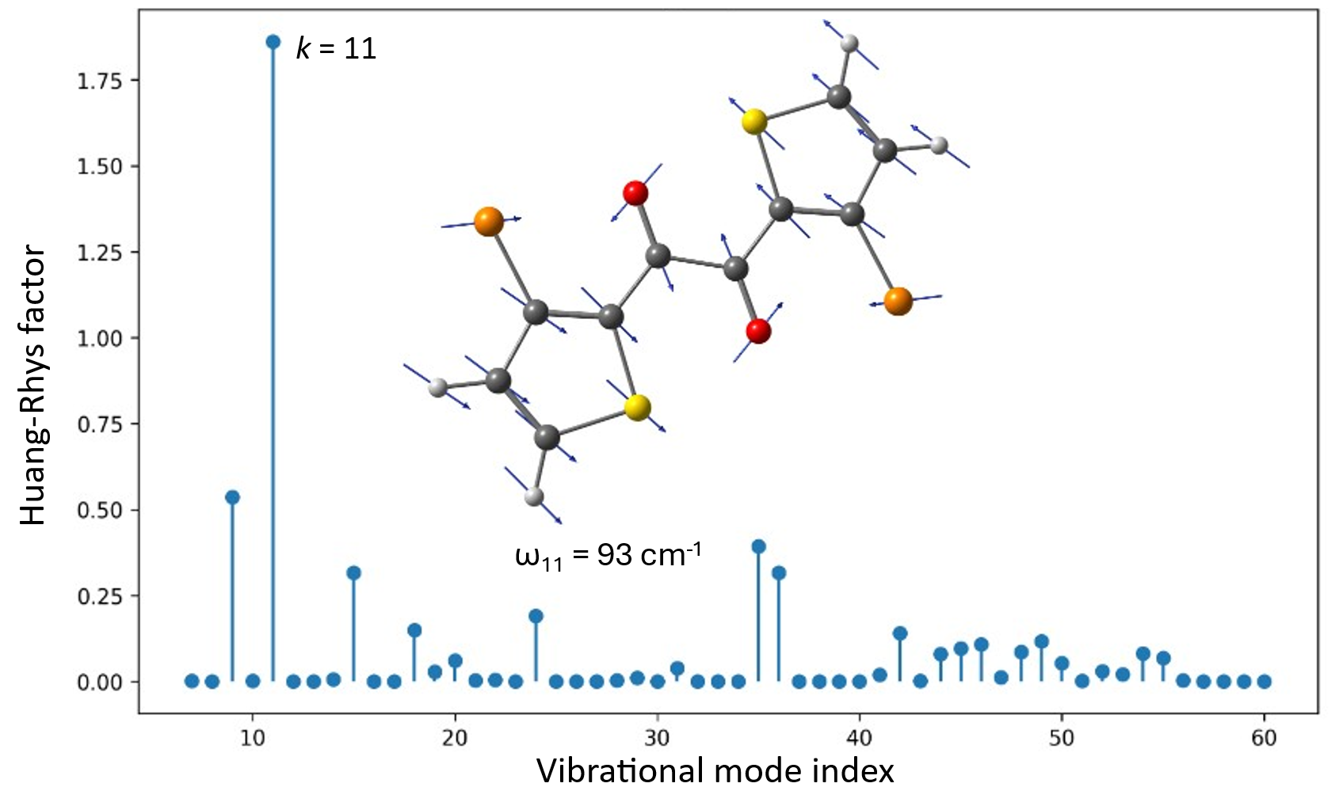
Figure 7.5. Huang-Rhys factors for the relaxed geometries of the S₁ and T₃ states in the 1,2-diketone molecule (C - grey, O - red, Br - orange, S - yellow, and H - light grey). The largest Huang-Rhys factor is predicted for the vibrational mode Q₁₁. Blue arrows show atomic displacements along this vibrational mode.

References

(30) Barca, G. M. J.; Bertoni, C.; Carrington, L.; et al. Recent Developments in the General Atomic and Molecular Electronic Structure System. J. Chem. Phys. 2020, 152, 154102. https://doi.org/10.1063/5.0005188.
(31) Werner, H.-J.; Knowles, P. J.; Knizia, G.; Manby, F. R.; et al. The Molpro Quantum Chemistry Package. J. Chem. Phys. 2020, 152, 144107. https://doi.org/ 10.1063/5.0005081.
(34) Epifanovsky, E.; Gilbert, A. T. B.; Feng, X.; et al. Software for the frontiers of quantum chemistry: An overview of developments in the Q-Chem 5 package. J. Chem. Phys. 2021, 155, 084801. https://doi.org/10.1063/5.0055522.
(35) Neese, F. Software update: The ORCA program system–Version 5.0. WIREs Comput. Mol. Sci. 2022, 12, e1606. https://doi.org/10.1002/wcms.1606.
(36) Neese, F. Software update: the ORCA program system, version 6.0. WIREs Comput. Mol. Sci. 2025, 15, e70019. https://doi.org/10.1002/wcms.70019.
(42) Englman, R.; Jortner, J. The Energy Gap Law for Radiationless Transitions in Large Molecules. Mol. Phys. 1970, 18, 145–164. https://doi.org/10.1080/00268977000100171.
(43) Ulstrup, J.; Jortner, J. The Effect of Intramolecular Quantum Modes on Free Energy Relationships for Electron Transfer Reactions. J. Chem. Phys. 1975, 63, 4358–4368. https://doi.org/10.1063/1.431152.

8. pyMECP program

8.1. Introduction

The pyMECP program is a Python MECP search script working with ORCA electronic structure program (tested with ORCA 6.1).³⁶ The MECP search method is inspired by work of Harvey et al⁶⁰ and is based on the Broyden–Fletcher–Goldfarb–Shanno (BFGS) optimization.^{61–64} The script allows the MECP geometry optimization with electronic structure methods for which the MECP search is not implemented. In principle, the MECP geometry can be located with any electronic structure method, provided that the energy gradient can be calculated using the ORCA engrad keyword.

8.2. Installation

No installation is required for the pyMECP program. The only prerequisite is a Python interpreter, usually included in any modern Linux distribution. We have tested pyMECP with Python versions 3.8 and later.

8.3. Workflow

Below are the steps to prepare the files and run pyMECP.
1. In master_script.py, change NATOM to the number of atoms in your molecule and MAX_STEPS to the maximum number of optimization steps. If you seek the MECP between excited states with TD-DFT, it is worth remembering that the target states can change their energy orders in the spin manifolds during the optimization. For example, the S₂ state at the starting geometry can become the S₁ state at a certain optimization step. So, it is wise to set the total number of optimization steps to a small value, revise the last *.out files for the two states, adjust the ORCA input to the correct states if needed, and then proceed.
2. Remove old Job* files, outfile, ReportFile, and ProgFile if there are any from a previous run.
3. Paste the starting geometry (XYZ coordinates) of your molecule in geom.
4. Set “Number of Atoms” and “Geometry” (XYZ coordinates) in first_progfile.
5. Copy first_progfile to ProgFile.
6. Prepare the first input files:
a. Edit Input_Header_A for the first state and Input_Header_B for the second state at MECP. For example, if you aim to perform the MECP search with DFT, the difference will be in the spin multiplicity and in the names of the starting *.gbw files (optional).
b. Paste the XYZ coordinates of your molecule in geom.
c. Run ./Make_First_Inputs. It will create two input files Job0_A.inp and Job0_B.inp for the first MECP run. It is recommended to run the first two jobs manually to get starting orbitals (*.gbw files) and to estimate the total run times. The latter can be used to set the sleep time in sub_script.py – the time after which the script will examine the *.out files to extract the data for the next step. If sleep is less than the job time, the script will terminate. It is also recommended to include some “queue” time in sleep if you submit the jobs with a job scheduler like SLURM. If you don’t want to run the first two jobs in advance without the script, delete the “moread” keyword and the “%moinp” group in Job0_A.inp and Job0_B.inp ORCA input files.
7. Run the script with “nohup python master_script.py >& 'outfile' &” from a login (head) node or send it to a compute node with a scheduler like SLURM. A SLURM submission file may look like this:

#!/bin/bash
#SBATCH --job-name=mecp
#SBATCH --nodes=1
#SBATCH --tasks-per-node=1
#SBATCH --mem=10GB
#SBATCH --time=12:00:00

function copy_files_back()
{
if [[ "$(pwd)" != "${SLURM_TMPDIR}" ]]; then return; fi
rm -rf *.tmp* *tmp ompi*
/bin/rsync -zavr * --exclude ${SLURM_TMPDIR}/* ${work_dir}/.
}

trap copy_files_back SIGKILL EXIT

module load anaconda3/2025.06

python master_script.py >& 'outfile' 2>&1

Note that the SLURM script above submits the MECP search job on a compute node. The actual MECP search is initialized by master_script.py. The ORCA jobs are then submitted by the sub_script.py, called by master_script.py. Before running your first MECP search job, please check the submit_job function in sub_script.py to adjust the ORCA submission process to your HPC cluster.
You can track the progress of the MECP optimization by checking the outfile and ReportFile files. While the program is running, the JobX_A.* and JobX_B.* files will be created at each optimization step, where X ranges from 0 to the total number of requested optimization steps, unless the optimization converges sooner. If the MECP was not located in X optimization steps, you can simply resubmit the search from the last geometry, copying the last JobX_A.inp and JobX_B.inp files to Job0_A.inp and Job0_B.inp, respectively. You will also need to remove the old ProgFile, update geom and first_progfile, and copy first_progfile to the new ProgFile.
Although the pyMECP program was developed to enable MECP searches using methods that currently lack intrinsic ORCA MECP optimization, we tested the program by performing the DFT MECP optimization and comparing the results with an analogous optimization performed with ORCA 6.1.0 (Figure 8.1). As an example, we used a Fe(II)-porphyrin model and searched for the MECP between the lowest triplet and quintet states, ³A_{2g} and ⁵A_{1g}.⁶⁵⁻⁶⁷ The MECP geometry was optimized using the B3LYP functional and def2-SVP basis set. The convergence criteria in ORCA and the pyMECP program were the same. Despite some differences in performance between the two search algorithms, both runs converged to the same geometry (RMSD = 0.0003 Å) and energy (|ΔE| = 0.06 kcal/mol).

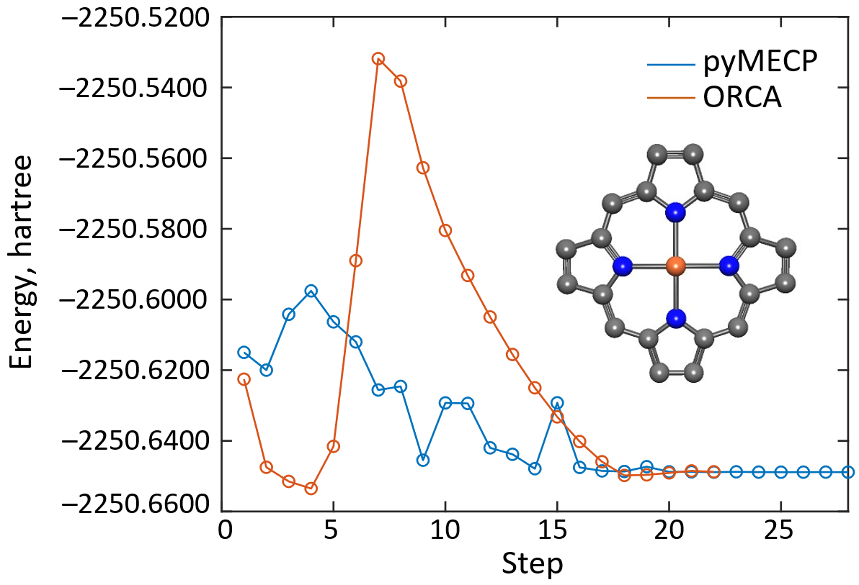
Figure 8.1. MECP optimization with pyMECP and ORCA. The inset shows the optimized ³A_{2g}/⁵A_{1g} MECP geometry of Fe(II)-porphyrin at the B3LYP/def-SVP level of theory. Fe - dark orange, N - blue, C - grey. H atoms are omitted for clarity.

References

(36) Neese, F. Software update: the ORCA program system, version 6.0. WIREs Comput. Mol. Sci. 2025, 15, e70019. https://doi.org/10.1002/wcms.70019.
(60) Harvey, J. N.; Aschi, M.; Schwartz, H.; Koch, W. The Singlet and Triplet States of Phenyl Cation. A Hybrid Approach for Locating Minimum Energy Crossing Points Between Non-Interacting Potential Energy Surfaces. Theor. Chem. Acc. 1998, 99, 95–99. https://doi.org/10.1080/00268977000100171.
(61) Broyden, C. G. The Convergence of a Class of Double-Rank Minimization Algorithms 1. General Considerations. J. Inst. Math. Appl. 1970, 6, 76–90. https://doi.org/10.1093/imamat/6.1.76.
(62) Fletcher, R. A New Approach to Variable Metric Algorithms. Comp. J. 1970, 13, 317–322. https://doi.org/10.1093/comjnl/13.3.317.
(63) Goldfarb, D. F. A Family of Variable-Metric Methods Derived by Variational Means. Math. Comp. 1970, 24, 23–26.
(64) Shanno, D. Conditioning of Quasi-Newton Methods for Function Minimization. Math. Comp. 1970, 24, 647–656.
(65) Choe, Y-K.; Nakajima, T.; Hirao, K. Theoretical Study of the Electronic Ground State of Iron(II) Porphine. II. J. Chem. Phys. 1999, 111, 3837–3845. https://doi.org/10.1063/1.479687.
(66) Antalík, A.; Nachtigallová, D.; Lo, R.; Matoušek, M.; Lang, J.; Legeza, Ö.; Pittner, J.; Hobza, P.; Veis, L. Ground State of the Fe(II)-Porphyrin Model System Corresponds to Quintet: a DFT and DMRG-Based Tailored CC Study. Phys. Chem. Chem. Phys. 2020, 22, 17033−17037. https://doi.org/10.1039/D0CP03086D.
(67) Pierloot, K.; Phung, Q. M.; Domingo, A. Spin State Energetics in First-Row Transition Metal Complexes: Contribution of (3s3p) Correlation and Its Description by Second-Order Perturbation Theory. J. Chem. Theory Comput. 2017, 13, 537–553. https://doi.org/10.1021/acs.jctc.6b01005.

