**Application running instruction**

1. Import project as maven project into work space.
2. Run Assignment.java file as a java application

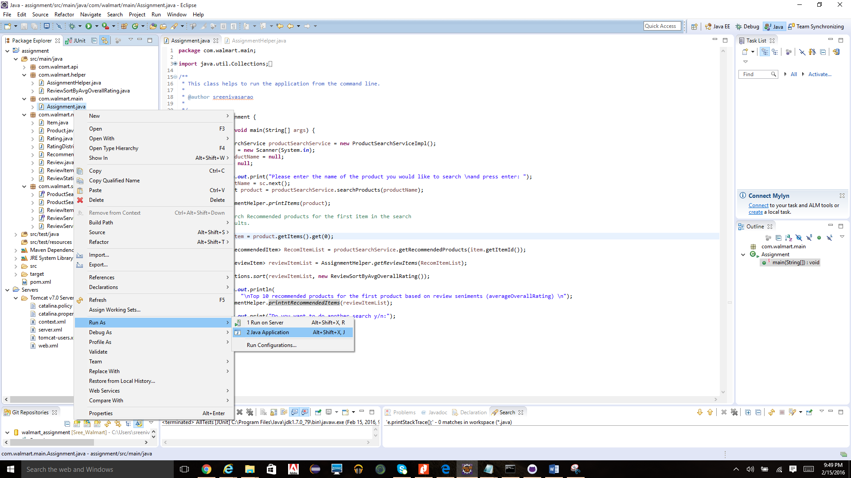

1. In console enter the product name you want search and press enter.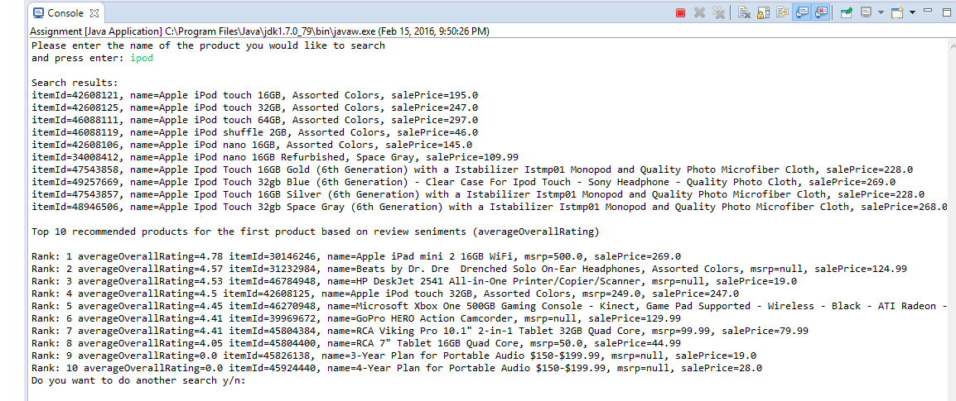
2. If you want to run the application again type y and press enter else type n and press enter to close.