1. **Creating the Non-Relational Database in DynamoDB**

1. **Setting up the non-relational database for use in python using boto3**

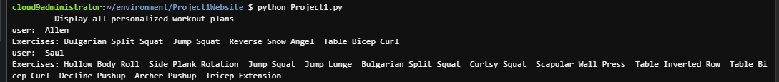

1. **C.R.U.D for the Non-relational Database (using the row with the user being “Gonzalo” for demonstrating C.R.U.D)**

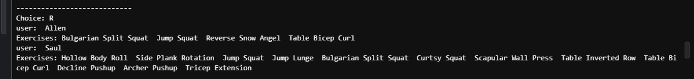

1. **Creating the RDS Instance**

1. **Setting up the instance and the relational database in cloud9**

1. **Performing Queries on the relational databases**

Since it’s difficult to come up with bodyweight exercises with zero gym equipment that work the Pull muscles (Biceps, Lats, and Upper Back), let’s have a look at all the exercises in the Exercises table under the category ‘Pull’ to get an idea of what kind of exercises are listed.

*There is a total of 7 exercises that work the Pull muscles, not bad considering all of these exercises require no gym equipment and can be done at home.*

Although we obtained 7 exercises that work the Pull muscles, there are also Hybrid exercises (exercises that work a variety of muscles, such as ones with the lower body and upper body simultaneously). There may be a possibility that there are Hybrid exercises that target the Pull muscles to some extent.

*There are 9 hybrid exercises that work the Pull muscles to a certain extent, not bad at all!*

However, we shouldn’t get excited just yet. Unfortunately, not all hybrid exercises are accessible though when looking carefully. Some hybrid exercises shown here require gym equipment, such as kettlebells and dumbbells. In order to get hybrid exercises that are the most ideal for home workouts without any kind of gym equipment, we need to look at those in the Exercises table. Therefore, let’s determine all the hybrid exercises from the Exercises table that work the Pull muscles to a certain extent.

T*here are a total of 3 hybrid exercises that work the Pull muscles to a certain extent. Combine it with exercises individually targeting the Pull muscles, there are 10 exercises to choose from all 30 in the Exercises table. Not bad at all! Although these exercises may not be the most ideal compared to those that can be done at the gym, it nevertheless goes to show that there are no excuses for not exercising. Regardless of one’s circumstances, they can still find a way to be fitter and healthier.*

Besides lack of equipment, time can also be an issue. With 30 exercises to choose from, how would you know which ones to prioritize? Since hybrid exercises work various muscles groups at once, they may potentially be helpful in adding to a workout plan for a person who doesn’t have much time to exercise. As a good starting point, it may be helpful to answer what hybrid exercises from the Exercises table work all the major muscle groups: Push (chest, shoulders, triceps), Pull (upper back, lats, biceps), Legs (hips, thighs, calves), Core (abs, obliques, lower back).

*We have 8 Hybrid exercises in total from the Exercises table. Let’s individually check all of them to see which of these has all four attributes: Push, Pull, Legs, and Core*

First, let’s check to see if the exercise Scorpion Squat Burpee has all four attributes.

*The Scorpion Squat Burpee only has 3 attributes. Though it is definitely an exercise that gives a lot of bang for your buck, the one with all four attributes may still be better to prioritize as it gives even better bang for your buck in terms of exercise efficiency.*

Let’s check to see if the exercise Crab Crawl Toe Touch has all four attributes

*This exercise also has 3 attributes. Let’s keep going*

*This exercise also has 3 attributes. Let’s keep going*

*This exercise also has 3 attributes. Let’s keep going*

*This exercise has 2 attributes. Let’s keep going*

*This exercise also has 2 attributes. Let’s keep going*

*This exercise has 3 attributes. Let’s keep going*

*Finally, the exercise Half Burpee has all four attributes. This exercise would probably be a great one to prioritize for someone who is short on time when it comes to exercising, yet wants an effective workout.*

1. **Using an Image from an S3 Bucket**

*The Project1.HTML file uses the image muscle-anatomy.jpg, which is stored inside an S3 bucket, as shown below.*

1. **Creating a Web Application Using Flask**

First, I created the home page. The code pertaining to the home page as well as the home page itself is portrayed below.





Next, I created a page where the user can choose which muscle group they want to choose exercises from.

*This is the HTML code for the Project1.html file, that is being received and saved by the methods GET and POST*

Then, I created a page that displays all the exercises associated with the muscle group the user has chosen from the page above.

*The Project1connect file is what allows the relational databases from the RDS instance created earlier to be connected through Flask*

*Below is the actual code for writing an SQL query to the webpage itself*

From there, the next webpage allows the user to add two exercises based on the ones they’ve seen from the previous webpage.

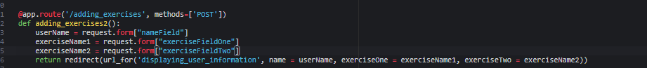

*Below is the Project1_1.html file whose data is retrieved and saved by the above lines of code for the functions adding_exercises1() and adding_exercises2()*

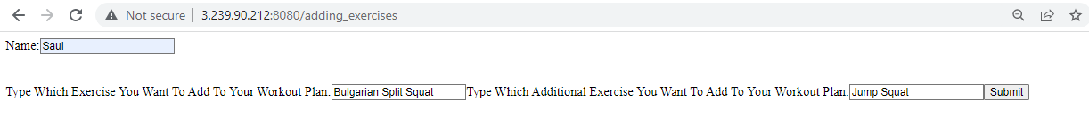

The last webpage displays the specific user information and stores it in the non-relational database created earlier through DynamoDB (stores the name of the user and exercise(s) they’ve chosen)

Let’s verify that the user’s information (Saul in this case) was actually added to the non-relational database (refer to the Project1DynamoDB.py file)

*Indeed the user’s information was added successfully*

