**Mongo DB Queries**

1. **Count of job postings by job industry.**

db.job_postings.aggregate([

{ $unwind: "$industry_ids" },

{ $group: { _id: "$industry_ids", count: { $sum: 1 } } }

])

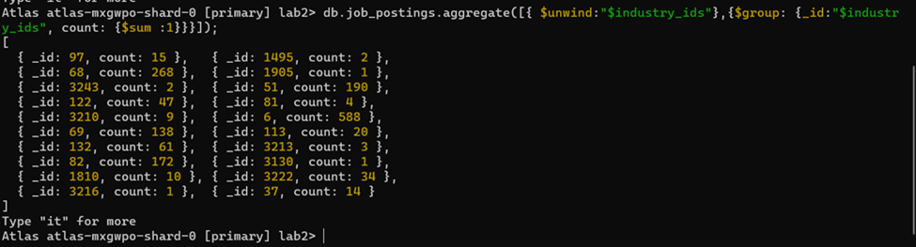

1. **Job postings with a salary range**

db.job_postings.find(

{"salary_details.min_salary" {$gte:30000},

"salary_details.max_salary":{$lte:100000}},

{job_id:1,"salary_details.min_salary":1,

"salary_details.max_salary":1}

);

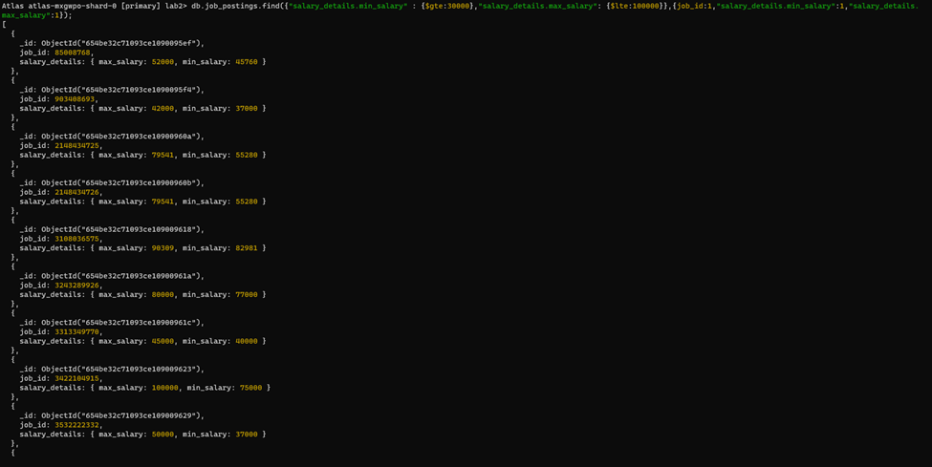

1. **Query to find all the posting having ‘senior’ position job_postings with details of job location and salary.**

db.job_postings.find(

{ title: /senior/i },

{ _id: 0, job_id: 1, location: 1, title: 1, salary_details: 1 }

)

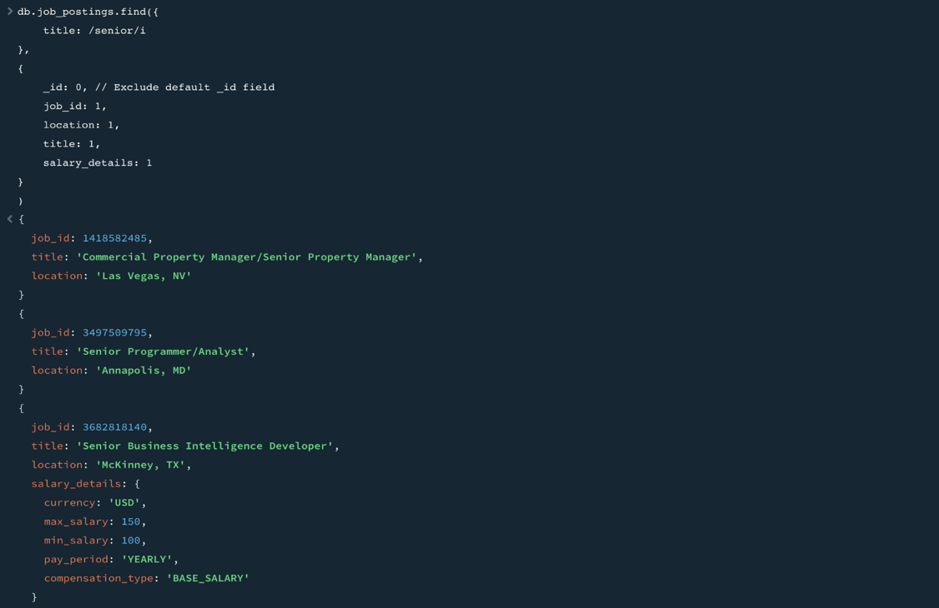

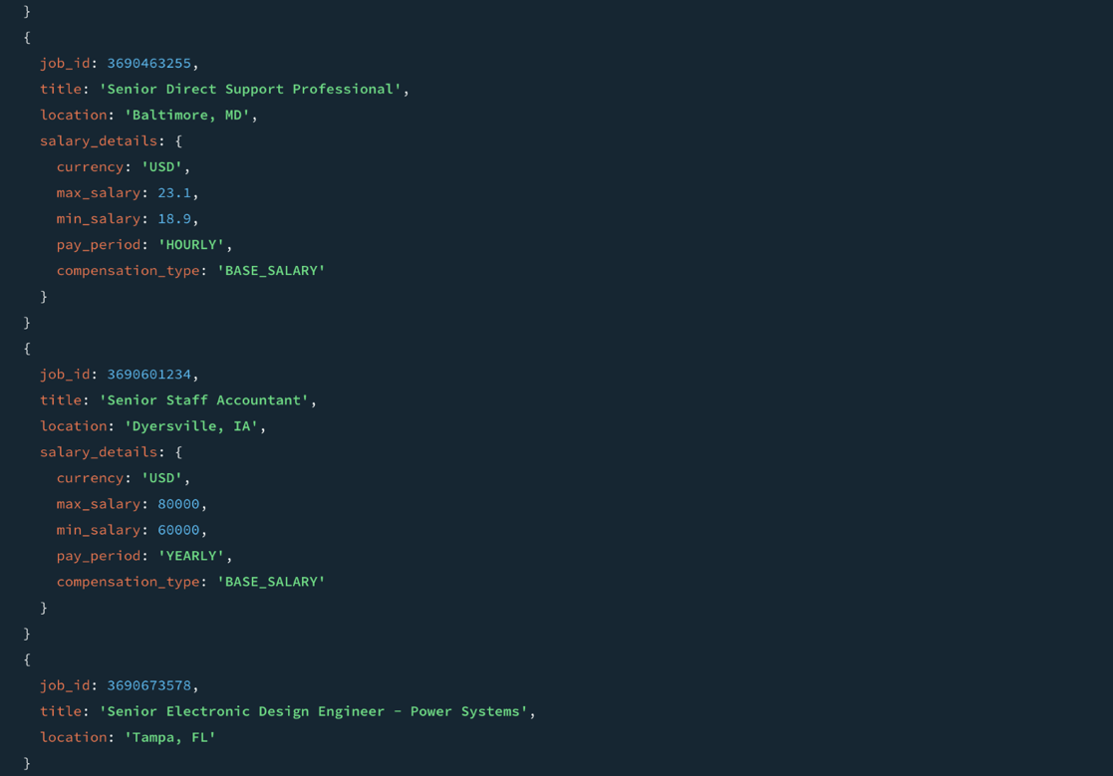





1. **Top 3 job_postings with highest number of views.**

db.job_postings.aggregate([

{ $sort: { views: -1 } },

{ $limit: 3 },

{

$project: {

job_id: 1,

title: 1,

views: 1,

work_type: 1,

location: 1,

expiry: 1,

application_type: 1,

job_posting_url: 1,

_id: 0

}

}

])

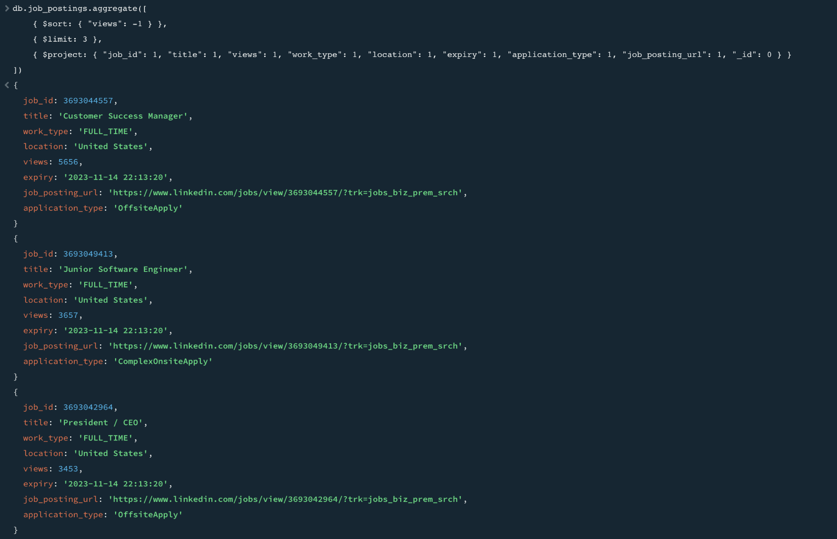

1. **Locations with the Highest Number of Remote Work Opportunities**

db.job_postings.aggregate([

{ $match: { remote_allowed: 1 } },

{ $group: { _id: "$location", totalRemoteJobs: { $sum: 1 } } },

{ $sort: { totalRemoteJobs: -1 } },

{ $limit: 5 },

{ $project: { _id: 0, location: "$_id", totalRemoteJobs: 1 } }

])

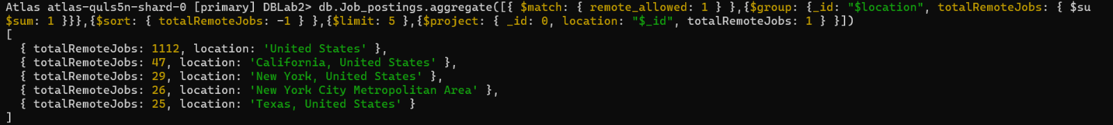

1. **Top 5 Locations with the Sponsored Job Postings**

db.job_postings.aggregate([

{ $match: { sponsored: 1 } },

{ $group: { _id: "$location", total_sponsored_jobs: { $sum: 1 } } },

{ $sort: { total_sponsored_jobs: -1 } },

{ $limit: 5 },

{ $project: { _id: 0, location: "$_id", total_sponsored_jobs: 1 } }

])

1. **Company with highest employee count where specialities is “analytics”.**

db.companies.aggregate([

{ $match: { specialities: "analytics" } },

{ $sort: { employee_counts: -1 } },

{ $limit: 1 },

{

$project: {

_id: 0,

company_name: "$name",

company_size: "$company_size",

employeeCount: "$employee_counts"

}

}

])

1. **Find top 10 company industries having highest job postings.**

db.getCollection("job_postings").aggregate([

{

$lookup: {

from: "companies",

localField: "company_id",

foreignField: "company_id",

as: "CompanyDetails"

}

},

{ $unwind: { path: "$CompanyDetails" } },

{ $unwind: { path: "$CompanyDetails.industries" } },

{ $group: { _id: "$CompanyDetails.industries", countInd: { $sum: 1 } } },

{ $sort: { countInd: -1 } },

{ $limit: 10 }

])

1. **Finding the top 3 companies possessing maximum employee_counts.**

db.companies.aggregate([

{ $unwind: "$employee_counts" },

{ $sort: { "employee_counts.employee_count": -1 } },

{

$group: {

_id: "$name",

maxEmployeeCount: { $max: "$employee_counts.employee_count" }

}

},

{ $sort: { maxEmployeeCount: -1 } },

{ $limit: 3 },

{ $project: { _id: 0, name: "$_id", maxEmployeeCount: 1 } }

])



1. **Finding the top 20 specialities and sorted based on the maximum count of specialities.**

db.companies.aggregate([

{ $unwind: "$specialities" },

{ $group: { _id: "$specialities", count: { $sum: 1 } } },

{ $sort: { count: -1 } },

{ $limit: 20 }

])

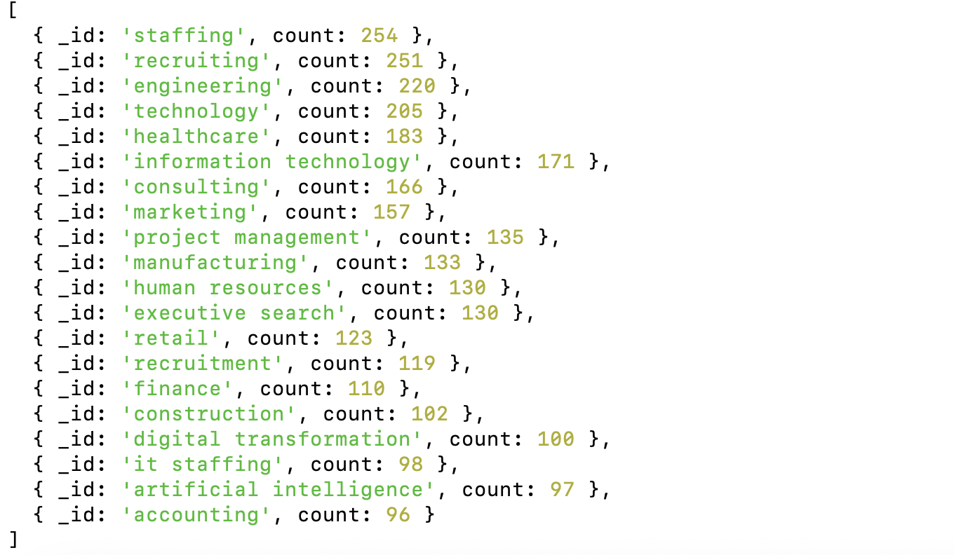

1. **Finding the companies that are offering FULL_TIME positions as remote opportunities along with the company_name, title.**

db.job_postings.aggregate([

{ $match:

{ "work_type": "FULL_TIME",

"remote_allowed": 1 },

{ $lookup:

{ from: "companies",

localField: "company_id",

foreignField: "company_id", as: "company"} },

{ $unwind: "$company" },

{ $project:

{_id: 0,

title: 1,

work_type: 1,

remote_allowed: 1,

company_name: "$company.name" } }

]);

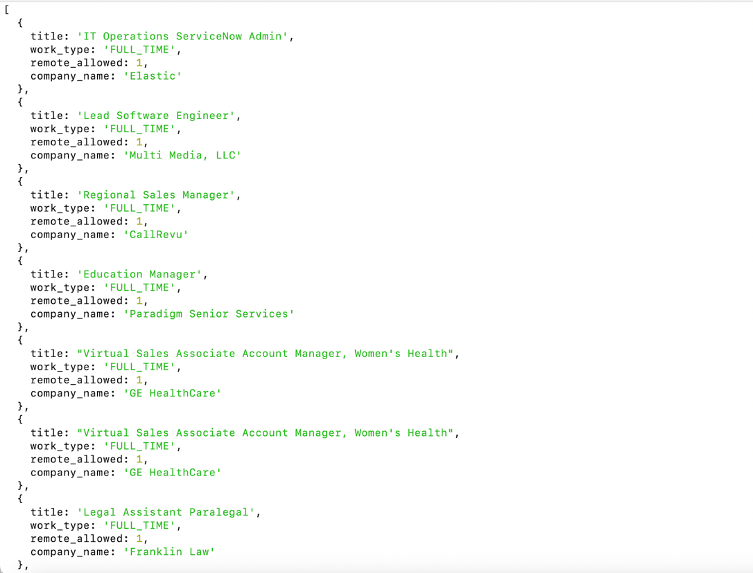

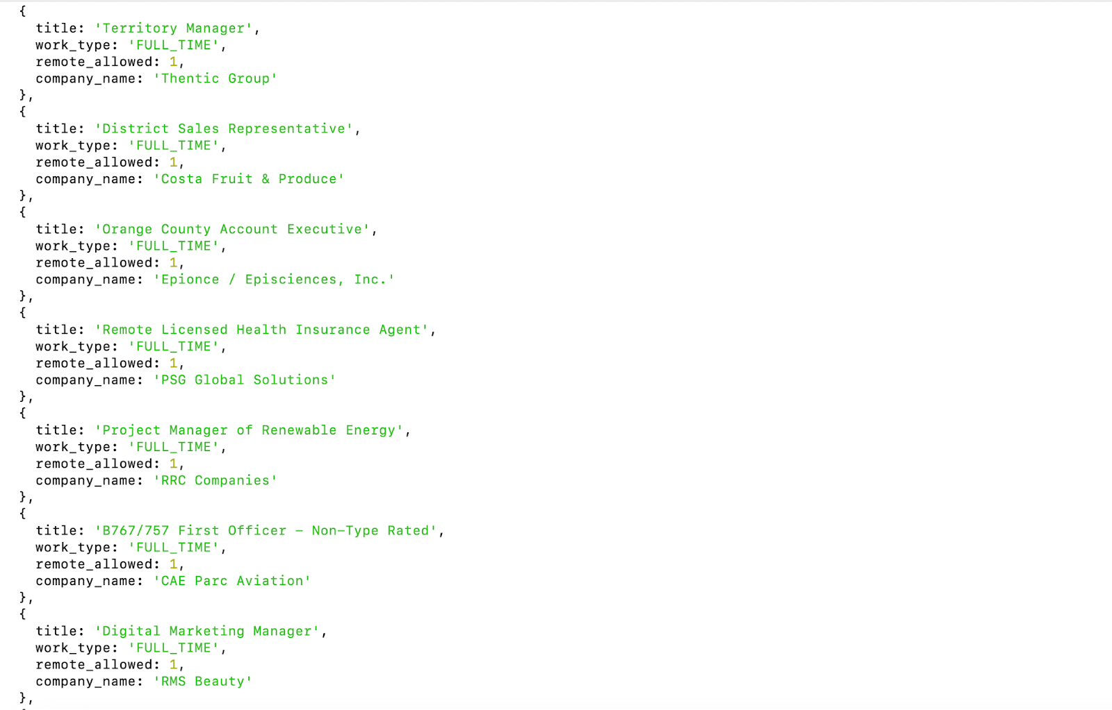



**12**. **Count of companies for the respective specialties: internet of things, cloud, iot, ai, network.**

db.companies.aggregate([

{ $match: { specialities: "internet of things" } },

{ $group: { _id: null, count: { $sum: 1 } } }

]);

db.companies.aggregate([

{ $match: { specialities: "cloud" } },

{ $group: { _id: null, count: { $sum: 1 } } }

]);

db.companies.aggregate([

{ $match: { specialities: "iot" } },

{ $group: { _id: null, count: { $sum: 1 } } }

]);

db.companies.aggregate([

{ $match: { specialities: "ai" } },

{ $group: { _id: null, count: { $sum: 1 } } }

]);

db.companies.aggregate([

{ $match: { specialities: "network" } },

{ $group: { _id: null, count: { $sum: 1 } } }

]);

