**Aiswarya’s Queries**

1. Checking the field names in companies column/field names

Atlas atlas-x3w03j-shard-0 [primary] linkedinlab2> Object.keys(db.companies.findOne())

[

'_id',

'company_id',

'name',

'description',

'company_size',

'url',

'address_details',

'industries',

'employee_counts'

]

**Explanation:**

Displaying the field names present in companies collection.

1. Checking the field names in job_postings column/field names

Atlas atlas-x3w03j-shard-0 [primary] linkedinlab2> Object.keys(db.job_postings.findOne())

[

'_id', 'job_id',

'company_id', 'title',

'description', 'work_type',

'location', 'remote_allowed',

'sponsored', 'formatted_work_type',

'views', 'original_listed_time',

'listed_time', 'expiry',

'job_posting_url', 'application_type',

'industry_ids', 'skills',

'benefits'

]

Atlas atlas-x3w03j-shard-0 [primary] linkedinlab2>

**Explanation:**

Displaying the field names present in the job_postings collection.

1. Checking the maximum employee_counts amongst all other companies.

Atlas atlas-x3w03j-shard-0 [primary] linkedinlab2> db.companies.aggregate([

... {

... $unwind: "$employee_counts"

... },

... {

... $sort: {

... "employee_counts.employee_count": -1

... }

... },

... {

... $limit: 1

... }

... ]);

**Explanation:**

Displaying the complete document information of the companies collection who has the maximum employee_count. Here the company ‘Amazon’ has the maximum employee_count: 829111.

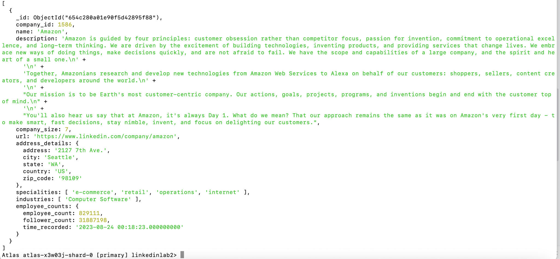

1. Finding the top 3 companies possessing maximum employee_counts.

Atlas atlas-x3w03j-shard-0 [primary] linkedinlab2> db.companies.aggregate([

... {

... $unwind: "$employee_counts"

... },

... {

... $sort: {

... "employee_counts.employee_count": -1

... }

... },

... {

... $group: {

... _id: "$name",

... maxEmployeeCount: { $max: "$employee_counts.employee_count" }

... }

... },

... {

... $sort: {

... maxEmployeeCount: -1

... }

... },

... {

... $limit: 3

... },

... {

... $project: {

... _id: 0,

... name: "$_id",

... maxEmployeeCount: 1

... }

... }

... ]);

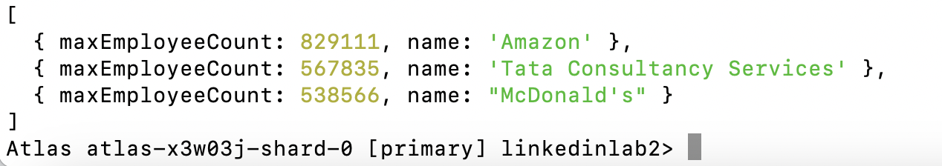

**Explanation:**

Displaying the company name and the employee_count of the top 3 companies having the maximum employee_count.

1. Finding the speciality having the maximum count.

Atlas atlas-x3w03j-shard-0 [primary] linkedinlab2> db.companies.aggregate([

... {

... $unwind: "$specialities"

... },

... {

... $group: {

... _id: "$specialities",

... count: { $sum: 1 }

... }

... },

... {

... $sort: {

... count: -1

... }

... },

... {

... $limit: 1

... }

... ]);

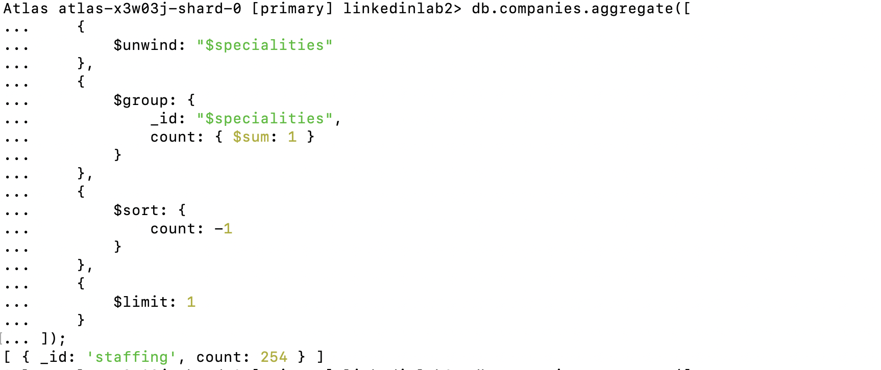

**Explanation:**

Displaying the speciality which is repeated the maximum. Here staffing speciality with a count of 254 is displayed.

1. Finding the top 20 specialities and sorted based on the maximum count of specialities.

Atlas atlas-x3w03j-shard-0 [primary] linkedinlab2> db.companies.aggregate([

... {

... $unwind: "$specialities"

... },

... {

... $group: {

... _id: "$specialities",

... count: { $sum: 1 }

... }

... },

... {

... $sort: {

... count: -1

... }

... },

... {

... $limit: 20

... }

... ]);

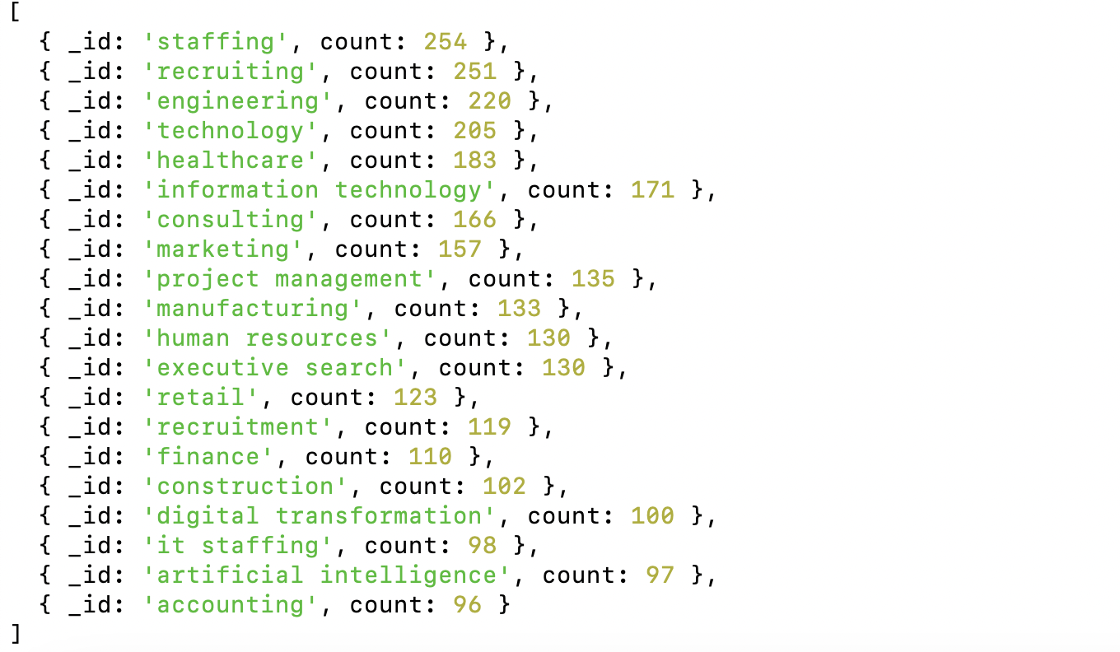

**Explanation:**

Displaying the top 20 specialities which have maximum count sorted based on the maximum value count.

1. Finding the companies that are offering FULL_TIME positions as remote opportunities along with the company_name, title.

Atlas atlas-x3w03j-shard-0 [primary] linkedinlab2> c

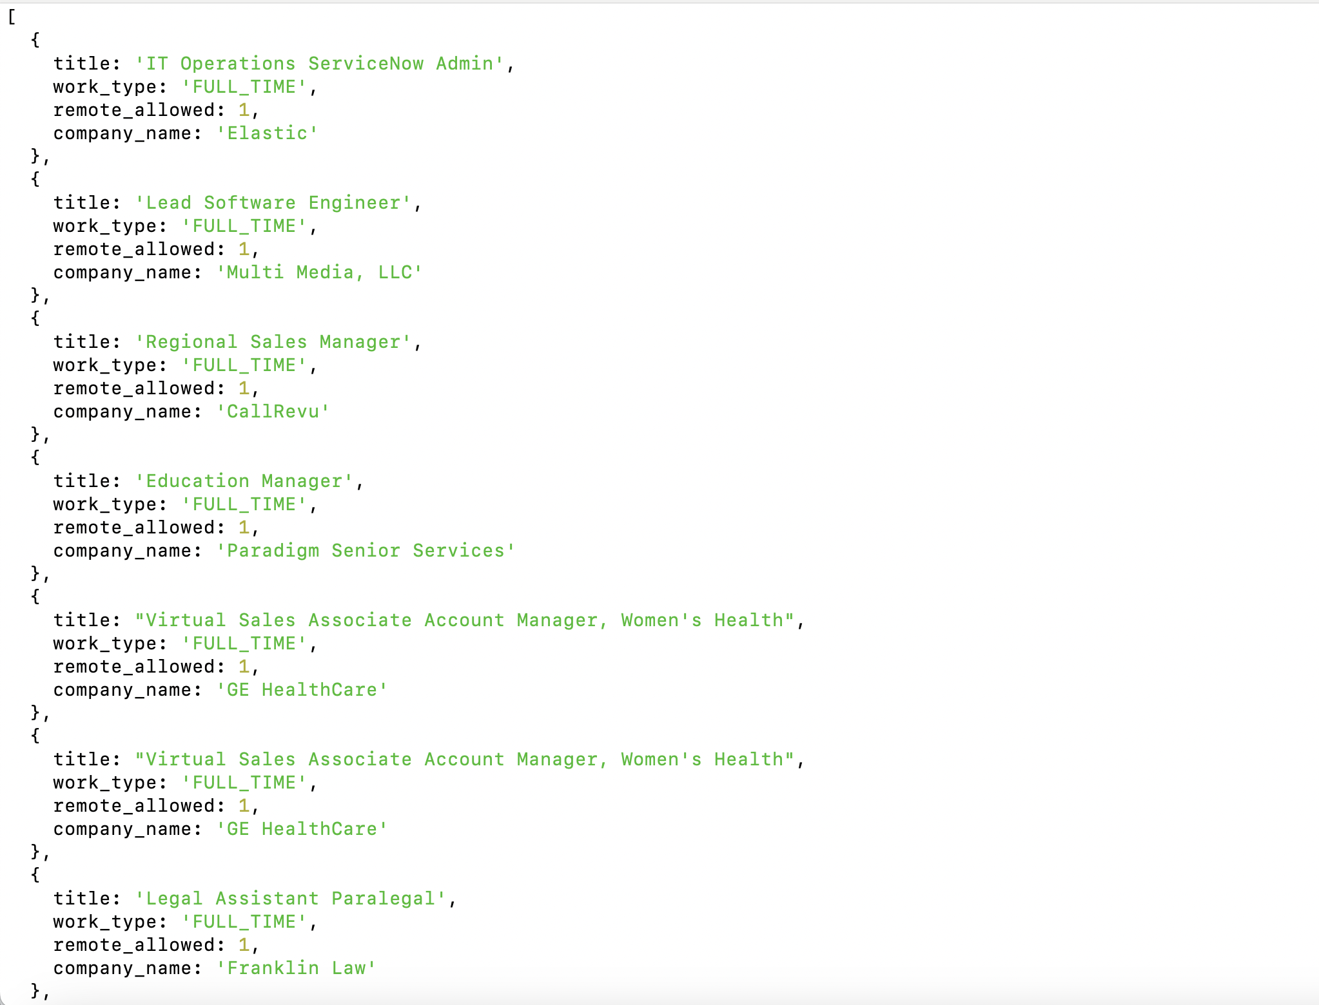

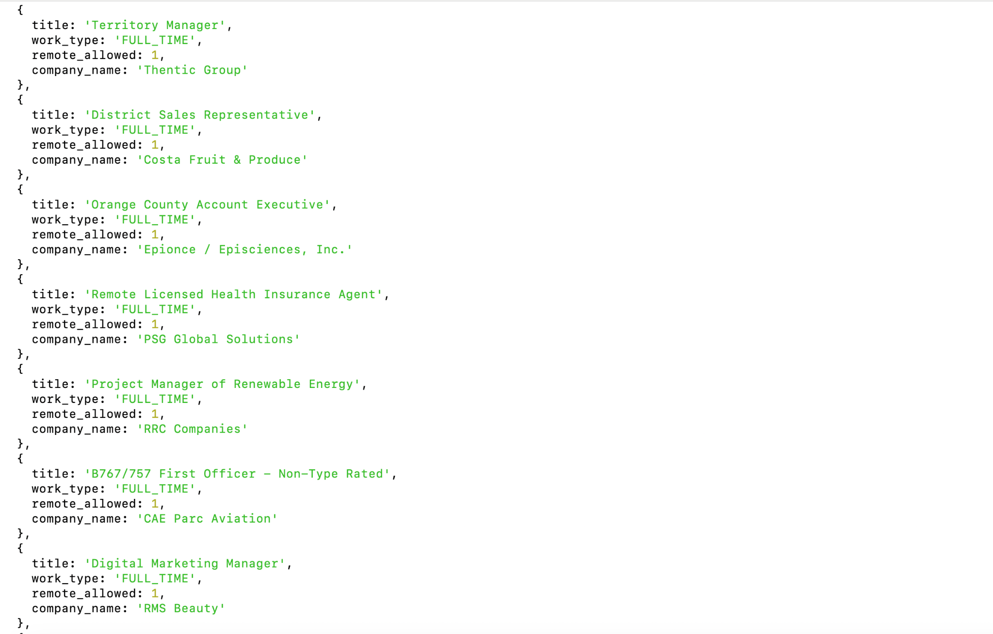

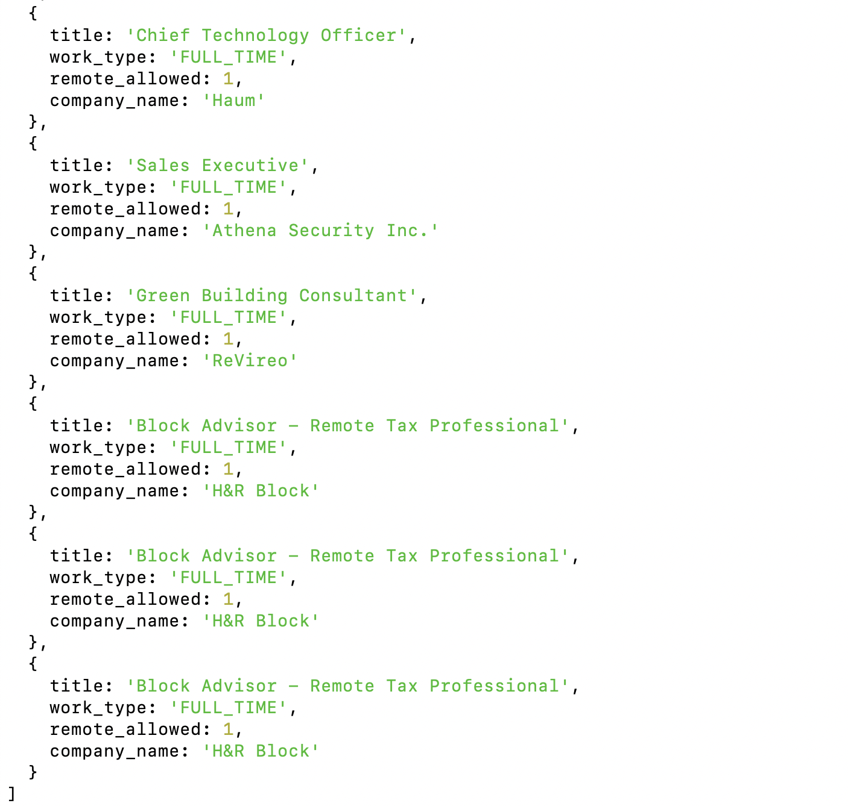

**Explanation:**

Displaying the company name along with the job posting title , work type as FULL_TIME and having remote opportunities by joining 2 collections.

1. Finding the total number of documents which has the combination of FULL_TIME as work type and remote positions allowed.

Atlas atlas-x3w03j-shard-0 [primary] linkedinlab2> db.job_postings.count({

... "work_type": "FULL_TIME",

... "remote_allowed": 1

... });

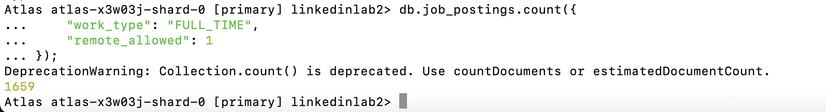

**Explanation:**

Displaying the count of the documents that are offering both FULL_TIME worktype and remote opportunities.