1. Query to find all the ‘senior’ job_postings with details of job location and salary.

db.job_postings.find({  
 title: /senior/i  
},  
{  
 _id: 0, // Exclude default _id field  
 job_id: 1,  
 location: 1,  
 title: 1,  
 salary_details: 1  
}  
)

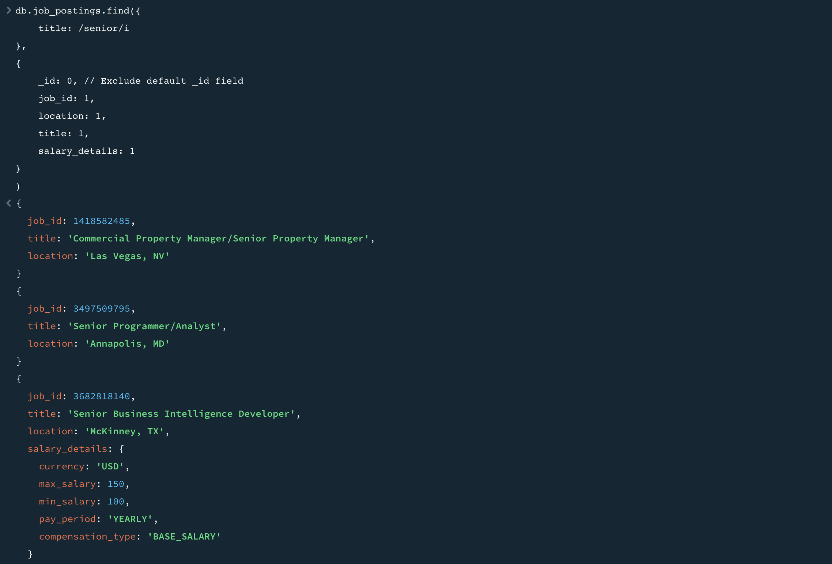

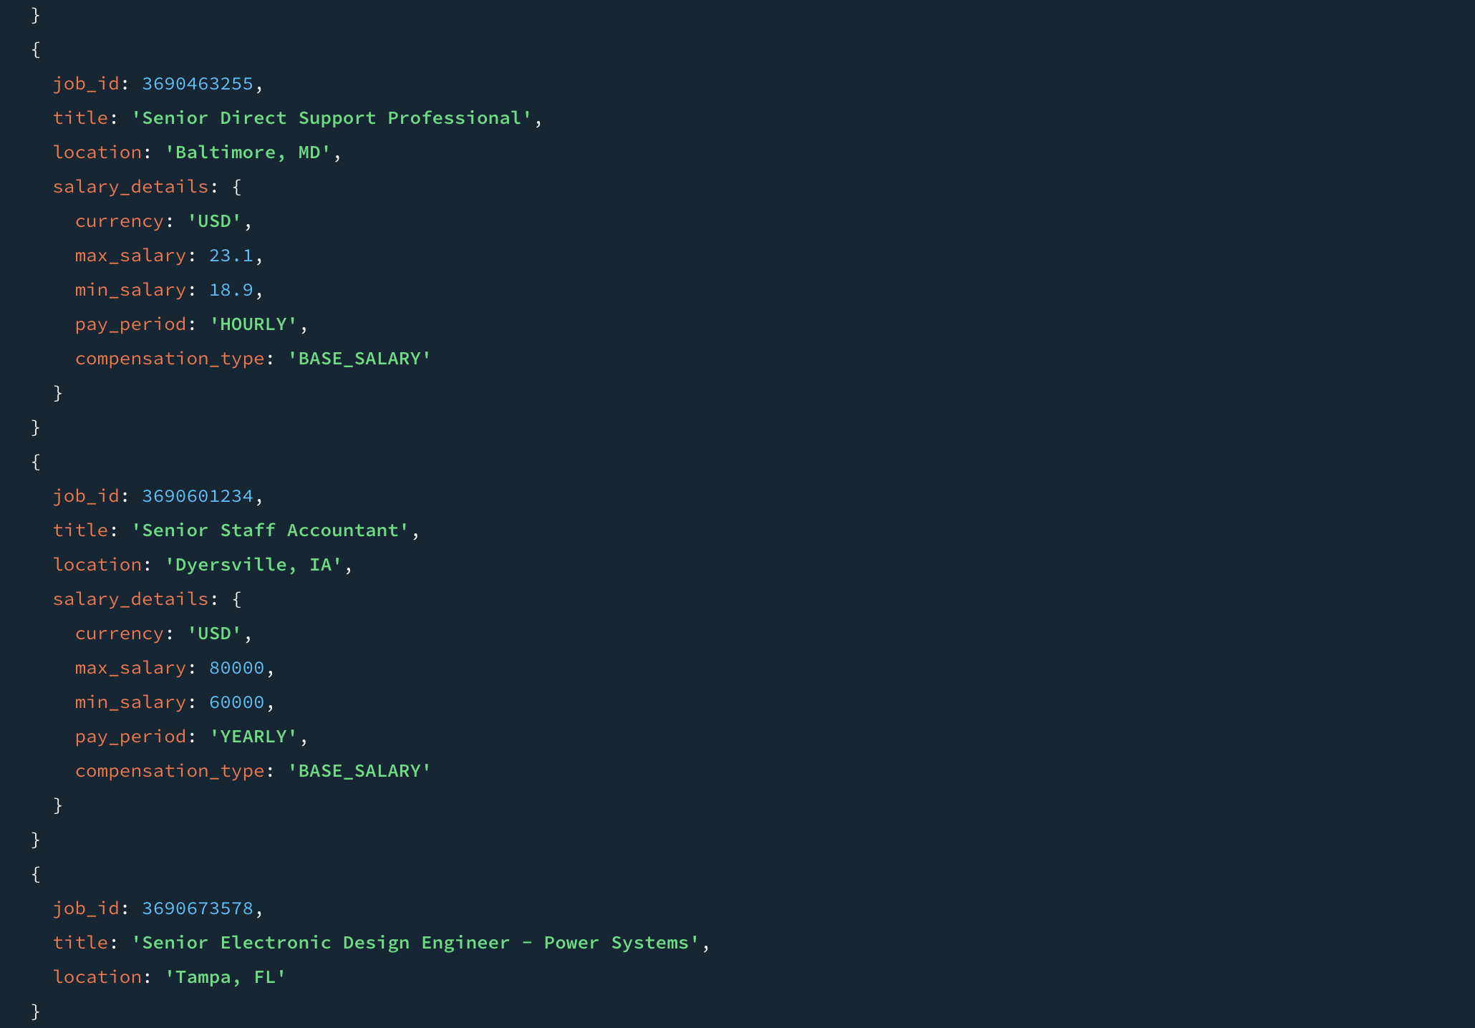

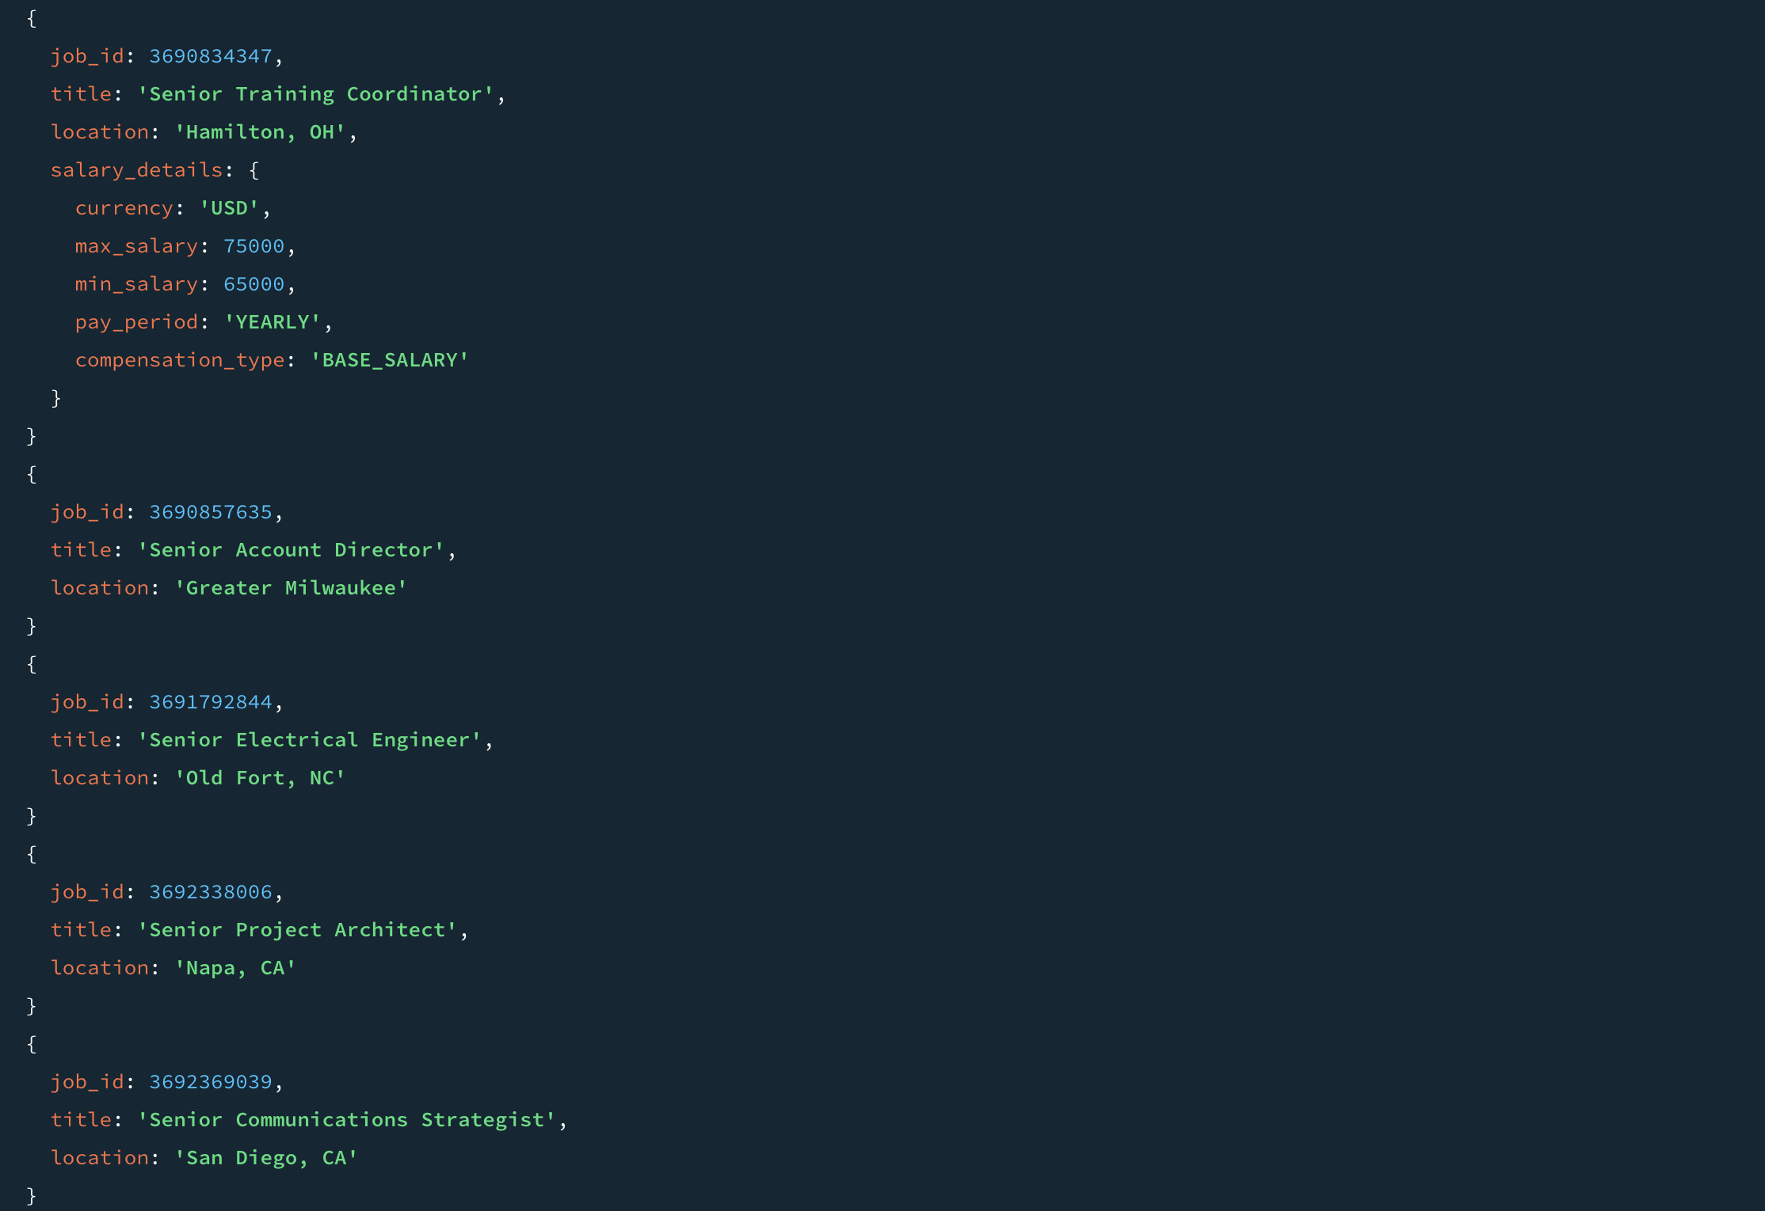



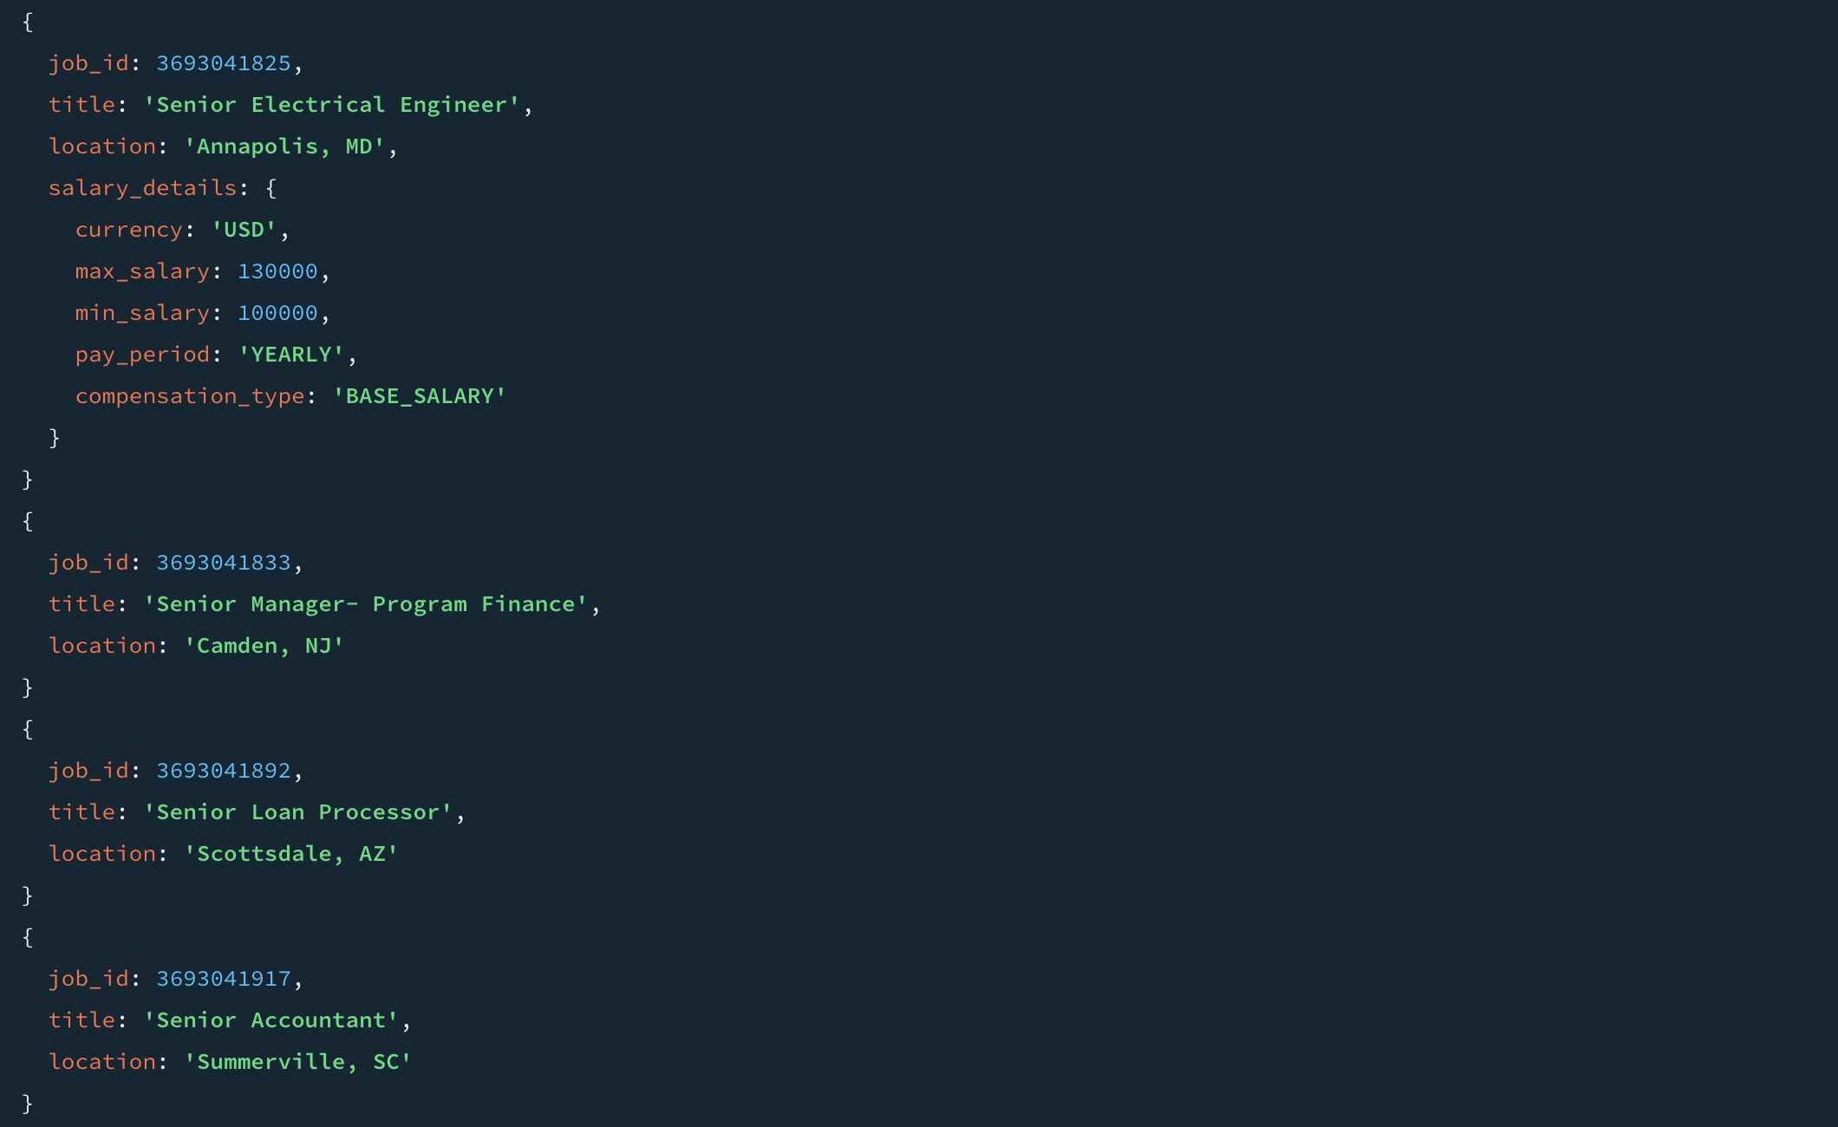



1. Top 3 job_postings with highest number of views.

db.job_postings.aggregate([  
 { $sort: { "views": -1 } },  
 { $limit: 3 },  
 { $project: { "job_id": 1, "title": 1, "views": 1, "work_type": 1, "location": 1, "expiry": 1, "application_type": 1, "job_posting_url": 1, "_id": 0 } }  
])

