**1.** **Locations with the Highest Number of Remote Work Opportunities**

db.Job_postings.aggregate([{ $match: { remote_allowed: 1 } },{$group: {_id: "$location", totalRemoteJobs: { $sum: 1 }}},{$sort: { totalRemoteJobs: -1 } },{$limit: 5 },{$project: { _id: 0, location: "$_id", totalRemoteJobs: 1 } }])

Output screenshot is given below-

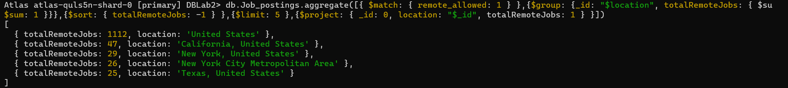

**2. Top 5 Job Titles with highest average salary.**

db.Job_postings.aggregate([{$group: {_id: "$title",jobIds: { $push: "$job_id" },averageSalary: { $avg: { $avg: ["$salary_details.min_salary", "$salary_details.max_salary"] } },totalPostings: { $sum: 1 }}},{ $sort: { averageSalary: -1 } }, { $limit: 5 },{ $project: { _id: 0, jobTitle: "$_id", jobIds: 1, averageSalary: 1}}])

**3.** **Top 5 Locations with the Sponsored Job Postings-**

db.Job_postings.aggregate([{ $match: { sponsored: 1 } },{$group: {_id: "$location", total_sponsored_jobs: { $sum: 1 }}},{$sort: { total_sponsored_jobs: -1 } },{$limit: 5 }, {$project: { _id: 0, location: "$_id", total_sponsored_jobs: 1 } }])

**4**. **Job posting with maximum no. of views and total number of applications**.

db.Job_postings.aggregate([{$group: {_id: "$job_id",title: { $first: "$title" },total_views: { $max: "$views" },

total_applications: { $sum: "$applies" }}},{ $sort: { total_views: -1 } },{ $limit: 5 }])

**5.Company with highest employee count where specialities is “analytics”**

db.Companies.aggregate([{$match: { "specialities": "analytics" } },{$sort: { "employee_counts": -1 }},{

$limit: 1},{$project: {_id: 0,company_name: "$name",company_size: "$company_size",employeeCount: "$employee_counts"}}])

