1. Top 3 job_postings with highest number of views.

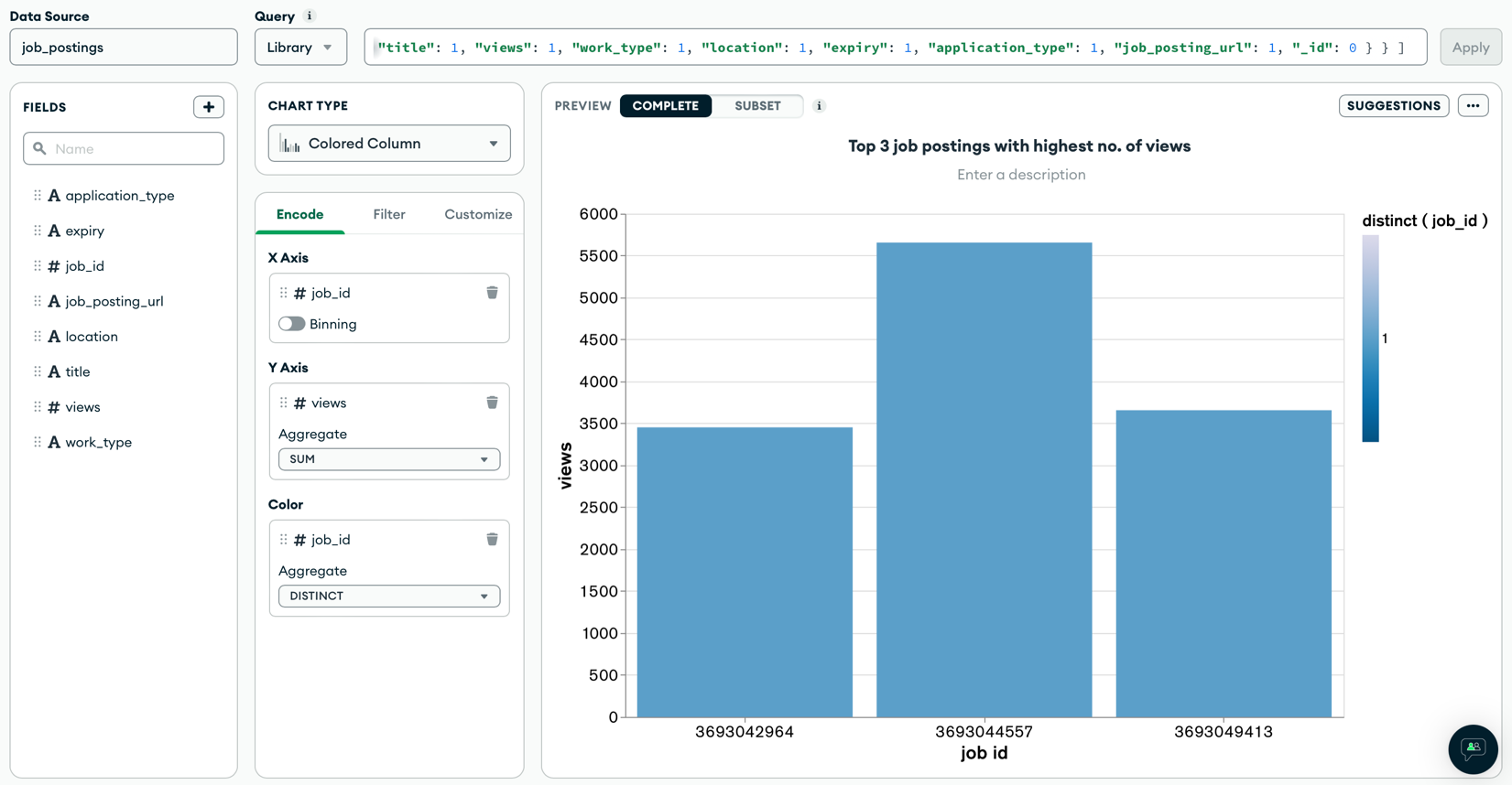

1. Distribution of work type in top 200 job postings with highest no. of views.

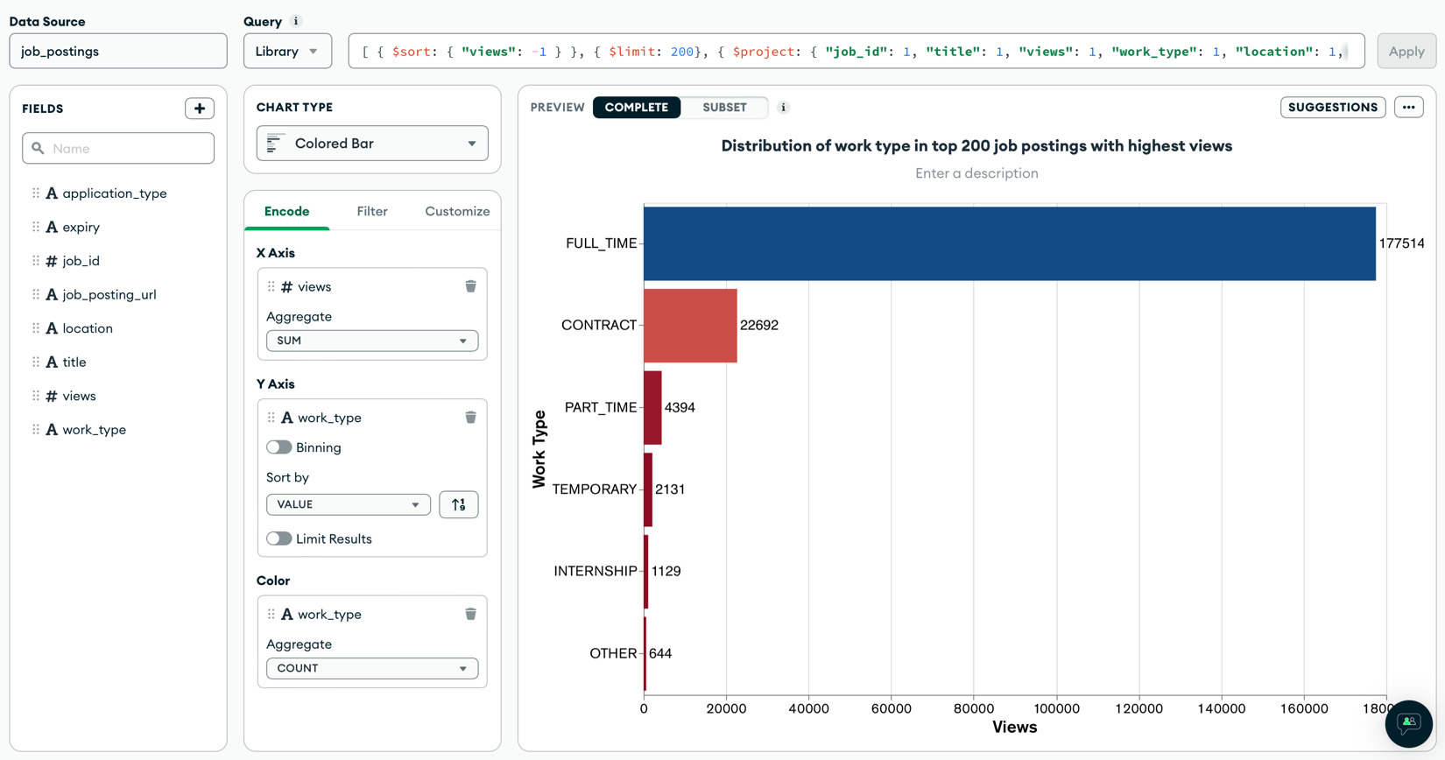

1. In demand skills for senior positions.

