* Introduction

Advanced communications can dramatically change how information is provided and consumed, business is transacted and essential services are undertaken. They enhance wireless technologies giving higher speeds, better connectivity, and more pervasive access to communications systems. The insatiable societal demand for an intelligent, automated, and ubiquitous digital world accompanying decreased cost of extracting, processing, storing, and transmitting data has enabled extensive interconnectedness of devices. It is predicted that by 2022, 29 billion devices will be connected globally and 500 million of these will be through 5G wireless networks which is the next wave of fast mobile broadband networks. The AJ Paulraj Steering Committee on 5G predicted the economic impact of 5G to be over $1 trillion by 2035. Global telecom industry body GSMA expects India to have 920 million unique mobile subscribers by 2025 that include 88 million 5G connections. The transition to 6G with a speed of 1 Tbps over 5G’s 1 Gbps compared to 20-100 Mbps of 4G will be swift. High-speed wireless communications accompanied by security and reliability are critical to India’s economic and overall competitiveness. Such advanced communication technologies include- Satellite Communication, Navigation systems, Quantum, and Molecular Communication

.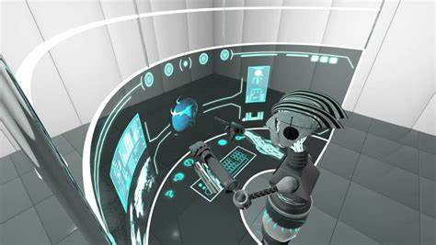

* Connecting remote communities using advance communication

One the most effective way to revive and sustain remote communities is to help them to gain access to the global information network. Since the early community telecentres were set up, such as the multi-purpose community telecentre  in Timbuktu, Mali in 1997, many different stakeholders have got involved in a variety of pilot projects and initiatives around the world. By connecting to the digital world abroad, as well as closer to home, communities can seek economic prosperity, social stability and the personal and professional development of its members. ICTs, in conjunction with wider measures, can bring the digital age to isolated and marginalized communities and help ensure their integration into wider society at the local, national and international levels.



Success Strategy: The challenges faced by rural communities in Latin America include the lack of communication infrastructure and limited finances available to provide this infrastructure. With these as setbacks, there are little or no communication technologies to link the inhabitants to the city The project brings Wi-Fi connectivity to these seemly unreachable areas in an inexpensive manner, thereby connecting remote areas to the internet. The project is unique because of its use of Wi-Fi technology. It connects rural communities across Latin America and the Caribbean to the internet using a single antenna. The project has successfully been rolled out in the mountainous regions of the Amazon rainforest, Ecuador, Panama, Peru El Salvador Mexico and Argentina.

The Latin America School of Network Foundation in collaboration with the Institute for Connectivity in the Americas has launched a portal called WiLAC designed to support wireless connectivity implementation..

Partners: International Development and Research Center (IDRC), Institute for Connectivity in the Americas (ICA)

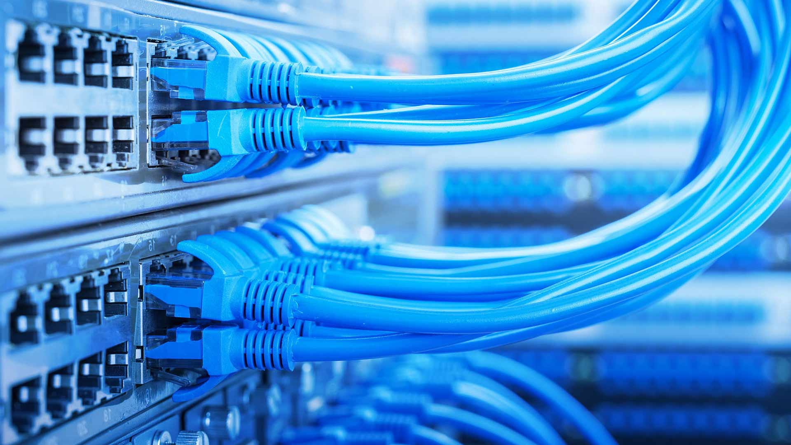

A project organized by American Assistance for Cambodia and Japan Relief for Cambodia consists of a motorcycle with a rear-mounted box that is equipped to send e-mail messages to schools. An antenna on the top of the box, and a Wi-Fi wireless communication system inside, enable e-mails to be relayed to schools in 13 remote Cambodian villages via satellite dishes. These villages have no water, electricity or phones and are far from health centres, but they now have e-mail. The schools are equipped with solar panels to run a computer for six hours, with an e-mail link via a motorcycle delivery system.

Every morning, five Honda motorcycles leave the hub in the provincial capitol of Banlung, where a satellite dish, donated by Shin Satellite, links the provincial hospital and a special skills school to the internet for telemedicine and computer training. The bike drivers begin the day by collecting e-mails from the hub's dish, which takes just a few seconds.

Then, as they pass each school and one health centre, they transmit the messages. At the end of the day they return to the hub to transmit all the collected e-mail to the internet for any point on the globe.

Each school also has a computer and e-mail-trained young teacher graduated from the Future Light Orphanage in Phnom Penh, including four women, who are the village computer teacher and e-mail postmaster. The children in the village are being trained to take over this function in a couple of years.

This program opens the village up to receiving and sending messages to the whole world and also doing internet searches for information.

**Thank you...**