Sonali Vassantcumar

Superstore sales and profitability report (2014-2017)

**Total Sales (in millions)**

**£2,297,200.8**

**Total Profit (in millions)**

**£286,397.02**

**Most sold product**

**TEC -MA 10002412**

**Cisco TelePresence System EX90 Videoconferencing Unit**

**General Trend**

The general trend for the sales between 2014-2017 at the Superstore shows that the highest number of sales were in the year 2014 in the month of March. Thereafter, the highest number of sales have been in the months of July, August, and November for 2014. In 2015, the highest number of sales have been in September and November. The figures for 2016 display that sales have been more consistently higher this year from February to May, and then there is a dip before the second highest sale in October 2016 after March 2014. March 2017 also had a high volume of sales and thereafter October and November 2017.

Recommendation:

* Seeing as the highest volume of sales have been in the month of March previously, it is recommended that the Superstore look at offering more discounts and seasonal promotions in this month as it may contribute towards more sales.

**Profit vs Shipping**

The chart for the shipping modes show that the highest amount of profit has been achieved with standard class shipping across all categories. First and second-class shipping have not had a significant impact on the volume of sales and same day delivery has achieved little profit in comparison with standard class.

Recommendation:

* It is recommended that the Superstore initiate promotions or deals that offer free standard shipping. The cost of shipping can be counteracted if customers have a backet of items with a minimum total. This can in turn result in higher profit for the business.

**Optimal Discount**

The line graph shows that the optimal sales have occurred with either no discount applied or 0.2 (20%). The rest of the discount amounts have not resulted in a significant increase of sales which suggests that those amounts do not have as much correlation with sales.

Recommendation:

* It is recommended that the Superstore continue offering discounts of 20% or 40% which have had an impact on the number of sales previously. It is also recommended that the Superstore consider not having any discounts at times as the data shows that there have been significant sales when there have been no discount amounts applied.
* Having no discount has demonstrated that sales are still gained, and customers may be willing to pay the full price for products.
* The Superstore may also offer free shipping with standard shipping and give the impression that the products price is lower if shipping is free which can enhance sales.

**Segments Distribution**

The pie chart shows that the largest number of segments that buy the Superstores products are consumers, which are at 52%, followed by corporate and home office buyers.

Recommendation:

* It is recommended that the Superstore start offering more discounts targeted to the home office and corporate sector. This may potentially raise sales and offer incentive to these sectors to make purchases.
* The Superstore should also continue offering discounts to the consumer segment to keep this population as their highest purchasing sector.

**Sum of Discount by Segment**

The bar chart displays the sum of discounts per segment. It highlights that the consumer sector has the highest number of purchases with discounts whilst the home office has the least. This trend displayed by the bar chart matches the trend displayed by the sales and segment distribution.

Recommendation:

* The data reinforces the statement that the Superstore should consider offering more discounts in the home office and corporate sector to attract more buyers.
* The Superstore should also consider introducing new products which may be more useful for corporate and home office clients.
* The Superstore should continue offering discounts to the consumer segment and may also introduce a loyalty program to maintain the clients.

**Sales per Sub-Category**

The bar chart shows that phones and chairs have had the highest number of sales, whilst the lowest number of sales have been with labels and fasteners. Other strong selling products include storage, tables, binders, and machines.

Recommendation:

* It is recommended that the Superstore continue selling phones and chairs and look at expanding their product line for these subcategories. They may also consider increasing the prices of these products to increase their profits by monitoring the sales with price increases. As demonstrated with the optimal discount chart, consumers are willing to make purchases of products without discounts or at 20% which can be applied to the phone prices if they are increased.

**Sales per Category**

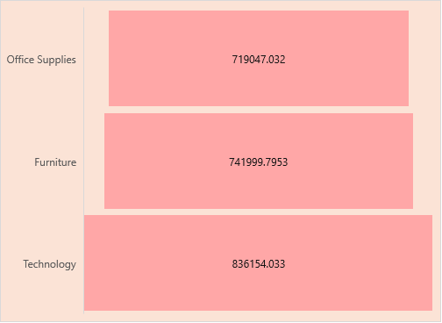

The chart above shows that the technology category has had the highest sales from 2014-2017. Furniture and Office Supplies have had slightly less compared to Technology.

Recommendation:

* It is recommended that the company consider increasing products to the technology category to increase the sales further.

**Sum of Profit per Category**

* Increase price of tables as they are sold frequently and have a high number of sales, but they are still not providing profit for the company
* Similar to tables, bookcases price should be increased as it is giving negative profits, but they have a good number of sales -+ both don’t have as many returns compared to some other products so increasing price may not have an impact on returns or sales
* Can possibly omit the sale of fasteners as they have little sales and don’t provide much profit for the company – also 19 were returned so maybe not a good product – can look at bringing other products to office supplies

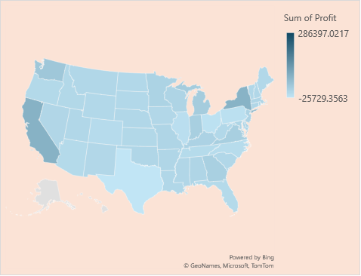**Sum of Profit per State**

The map highlights the states and their profits. It shows that the highest profits were in California, New York, and Washington.

Recommendation:

* It is recommended that the company consider increasing their marketing in these highlighted states with more profit and allocate more resources and budget to the high performing states. They should target their products to consumers in this area more by offering discounts.
* The Superstore may also conduct questionnaires to find out why some areas have lower profits, and they can have targeted campaigns in the lower performing states to improve performance.

**Count of Returns per Sub-Category**

The data shows that binders and paper have had the highest number of returns.

Recommendation:

* The Superstore should consider getting rid of binders and paper in their product line as they have had the most returns.
* They can also consider replacing these products with other products based on feedback from consumers.
* The company can ask consumers to fill forms explaining why they are returning the products to decrease the number of returns.

**Count of Returned per State**

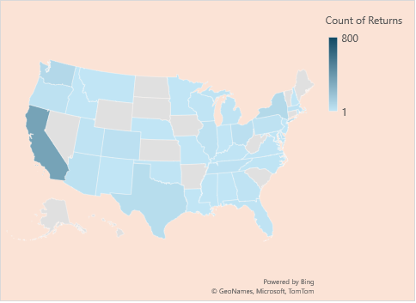

The map chart shows that the highest number of returns have been in California, Texas, Washington and New York.

Recommendation:

* The company can conduct consumer feedback to find out why consumers are returning products in California.
* The company should ensure that the quality assurance of products is conducted properly in the states with high returns to ensure the products do not have potential issues.
* The Superstore can offer loyalty programs in consumers and more discounts in the states with high returns to encourage future purchases and reduce the loss of profit from returns.

**Final Dashboard**