

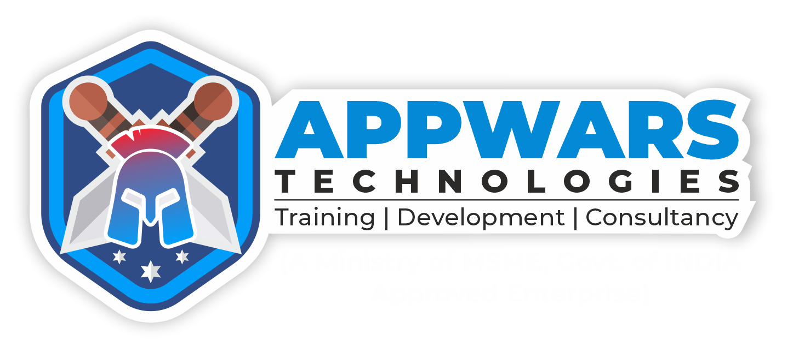

**ATPL/CA/**  **DATE:**

**Appwars Technologies Campus Ambassador Program Application Form**

Thank you for your interest in becoming a Campus Ambassador for Appwars Technologies! Our Campus Ambassador Program is designed to give college students an opportunity to gain real-world experience while promoting our brand on their campus.

Please fill out the following information to apply for the program:

**Personal Information:**

•Full Name:   
•Email Address:   
•Phone Number:   
•College/University Name:   
•Current Year of Study:   
•Major/Field of Study:

**Social Media and Online Presence:**

•LinkedIn Profile URL:   
 •Instagram Profile URL:   
 •Twitter Handle:   
 •Facebook Profile URL:   
 •Personal Website/Blog:   
 •  
**References: Please provide the names and contact information of two references who can speak to your character and work ethic.**

**APPWARS TECHNOLOGIES PRIVATE LIMITED**

B-3, First Floor, Sector-2, Near Sector 15 Metro Station, Noida Pin-201301 Uttar Pradesh www.appwarstechnologies.com | info@appwarstechnologies.com   
Contact: 0120-491-7040 | +91-9911169001





**Terms and Conditions:**   
 •By submitting this form, you agree to promote Appwars Technologies in a positive and professional manner on your campus and online.

•You understand that failure to fulfill the requirements of the program may result in termination as a Campus Ambassador.

•You grant Appwars Technologies permission to use your name and image in promotional materials related to the Campus Ambassador Program.

**Signature: By signing below, you acknowledge that you have read and agree to the terms and conditions of the Campus Ambassador Program.**

(Signature)

**Benefits of Being a Campus Ambassador:**   
•Gain real-world experience in marketing and promotion   
•Receive training and guidance from Appwars Technologies professionals •Build your resume and portfolio with valuable experience   
•Earn incentives and rewards based on your performance   
•Connect with other Campus Ambassadors and industry professionals •Opportunity for career advancement within the company

Thank you for your interest in our Campus Ambassador Program.

**APPWARS TECHNOLOGIES PRIVATE LIMITED**

B-3, First Floor, Sector-2, Near Sector 15 Metro Station, Noida Pin-201301 Uttar Pradesh www.appwarstechnologies.com | info@appwarstechnologies.com   
Contact: 0120-491-7040 | +91-9911169001