# 02. Escape the Maze

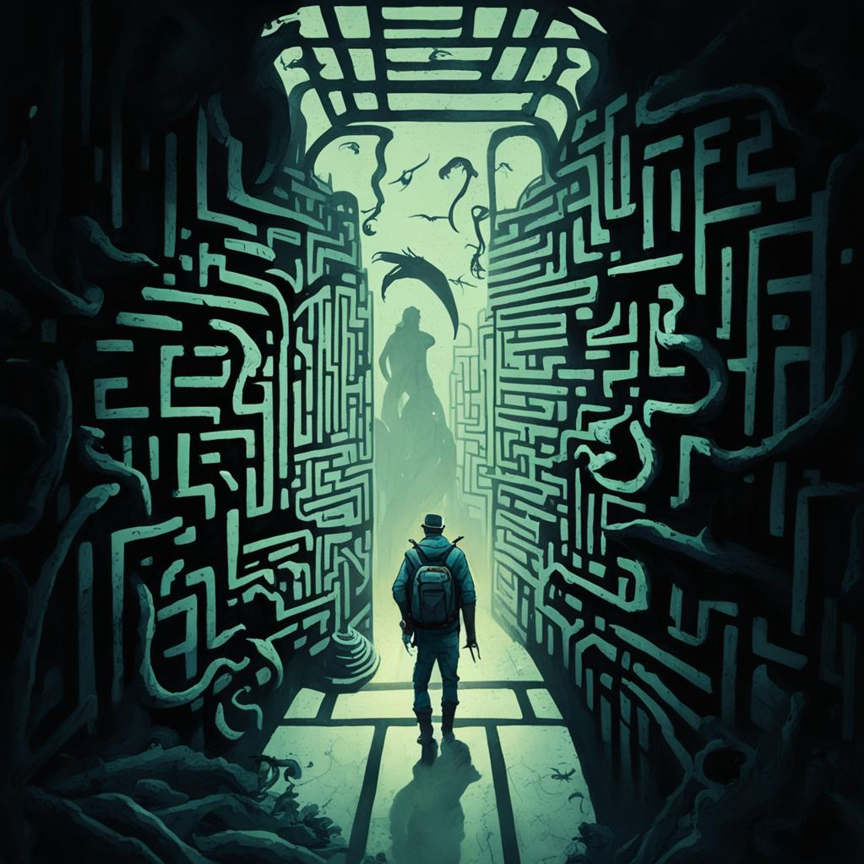

*Embark on an epic adventure as a brave traveller lost in a dangerous maze! Your mission is to navigate through the maze's intricate corridors, avoiding traps and monsters while seeking the path to freedom. Will you find your way out or succumb to the dangers lurking within? Good luck on your journey!*

You are a brave traveler that got lost in a maze and you need to find your way out. The maze is represented by a matrix - **field**. **Each cell** in the field represents a **part of the maze**, and it **can contain one of the following elements**:

* '**P**' - Represents the **starting position** of the traveller.
* '**X**' - Represents the location of the **exit** that leads outside of the maze.
* '**M**' - Represents a **monster** which wants to harm the traveller.
* '**H**' - Represents a **health potion** which will **restore the health** of the traveller.
* '**-**' – Represents the maze's corridors, which the **traveller can walk through**.

Initially, you will be given **N** – an **integer,** indicating the **size of a square matrix.** The traveller starts with **100** **units** of health.

The traveller must carefully navigate through the maze, following the commands that will be received on each of the following lines- **"up", "down", "right",** and **"left"**, moving **one position towards the direction given**. If the command leads the traveller **outside the bounds of the field, skip the command and proceed with the next one.**

However, in the maze, encountering a **cell marked with 'M'** signifies the presence of a monster. When the traveller encounters a monster, he takes substantial damage, his **health is reduced by 40 units**. It's important to note that the **monster disappears from the maze only if the traveller survives the encounter**. In the case where the **traveller's health drops to 0 or below** due to the encounter with a monster, the traveller is considered defeated, **health is set to zero** and the **maze traversal concludes**. If the **traveller survives**, the **monster disappears** from the maze, and its position is **marked with '-'**. This indicates that the monster has been successfully dealt with and is no longer a threat in the subsequent maze traversal.

In addition, within the maze, encountering a **cell marked with 'H'** signifies the presence of a health potion. When the traveller encounters a health potion, he moves in that direction and experiences a **boost in his health by 15 units**. It's crucial to note that the traveller's health **may happen to exceed the maximum limit of 100 units during the adventure**. If the traveller's **health surpasses 100 units** due to the health potion, it is **adjusted to the maximum limit of 100 units**. This ensures that the traveller's health does not exceed the predefined maximum value. The position is **marked with '-'.**

Once the traveller successfully reaches a position **marked as 'X'**, he finally **reaches the exit and escapes the maze**. **The adventure is over.**

Remember, the traveller must follow the commands, he will **always either reach the exit or die in the maze**.

In the end, **print the final state of the matrix** (maze area) with **the traveller in his ending position.** **Each row is on a new line**.

## Input

* **On the first line,** you will get **N - the size of the matrix (square).**
* On the next **N** lines, you will receive strings, representing each **row** of the matrix.
* On each of the following lines, you will receive the possible directions for the traveller to move - **"up", "down", "right",** and **"left"**.

## Output

* **On the first line:**
  + If the traveller has less than or equal to 0 health:

**"Player is dead. Maze over!"**

* + If the traveller survived with more than 0 health and managed to escape the maze:

**"Player escaped the maze. Danger passed!"**

* On the second line, print the **final value of the traveller's health** following the format:

**"Player's health: {health value} units"**

* On the next lines, print the **final state of the matrix** with **the traveller in its ending position**. **Each row - on a new line**.

## Constraints

* The commands are guaranteed to lead him **either to escape out of the maze** or to **die by monsters**, ensuring that the **commands are sufficient in all cases**.
* Some commands may lead our hero **outside of the boundaries of the matrix**. Do not allow that.
* The size of the matrix will always be a valid positive integer in the range [4,10].
* The **last known position** of the traveller should **always be marked with 'P' in the final state of the matrix**.

## Examples

|  |  |  |
| --- | --- | --- |
| **Input** | **Output** | **Comments** |
| 5  -----  -PM--  -M---  ---H-  -X---  down  right  down  down  left | Player escaped the maze. Danger passed!  Player's health: 60 units  -----  --M--  -----  ---H-  -P--- | The player starts from the position **[1,1].** The direction is **down**, towards the **monster**. The player's **health** becomes **60 units**, the monster **position is marked with '-'.** Next direction is **right**, the **position is empty**(corridor) so we continue to the next command. **Down** – empty position, **down** – empty position. **Last direction is left**. The player reaches the **'X' mark** and manages to escape the maze. |
| 8  --H-----  ---P---X  --------  --M--M--  --H--M--  H-----M-  --------  ------H-  down  right  right  down  down  right  down  left  up  up | Player is dead. Maze over!  Player's health: 0 units  --H-----  -------X  --------  --M-----  --H-----  H-----P-  --------  ------H- |  |
| 4  ----  P-H-  ----  X---  right  right  right  right  down  down  down  left  left  left | Player escaped the maze. Danger passed!  Player's health: 100 units  ----  ----  ----  P--- |  |