# 4 april

## What did we do?

* We have decided to no longer use the code that localizes the droplet in a complex image (LocateDroplet), as this requires a lot of effort to do properly and, as the set-up remains the same among different experiments, manual cropping is more effective and more precise.
* We wrote a function (FindDropletEdges) that finds the edges of a cropped droplet. This is important to scale the droplet to a width of 2 and translate the vertex of the droplet to (0,0). This function relies on screening the droplet image space in segments and then selecting the segments that contain the outermost points of the droplet, thus finding the edges.
* The function that simulates a droplet for a Bond number (MakeDroplet) is now resized as to correspond with the resizing of the droplet points. This is required for proper fitting.
* We wrote a fitter (YLFitter) that fits a set of experimental points to the Young-Laplace equation for a range (Bmin to Bmax with steps of a certain accuracy) of Bond numbers. This fitting is done by minimalizing the least distances of the experimental points to the Y-L equation simulation. The error is normalized for the number of experimental points to allow for comparison amongst different droplets.
* Iterative fitting was added to the main code, as to allow zooming on the region of best Bond numbers a few times to find a more accurate result for the Bond number.
* We added minor other improvements to and fixed minor mistakes in the code.

## What are we going to do?

* Improve the FindDropletEdges function to make it more precise. It appears as if the edges are really fitted on the outskirts of the data points, instead of in the middle. This might give a bias in fitting.
* Calculate the droplet volume (V) from the Y-L equation, calculate surface tension and Worthington number from the obtained Bond number and radius.
* Make a list of suitable liquids that we want to test our set-up with.

## Other ideas

* Flow behaviour and elasticity
* Arduino/RaPI system
* Measure surface tension of gelatin droplet while solidifying and try to relate surface tension to temperature
* Find the effect of a surfactant on surface tension of an oscillating droplet

## 5 april

What did we do

* We made movies of the dispensing of multiple solvents (water, ethylene glycol and ethanol). The movies were analysed with the software. From the obtained data we could conclude that, as suggested by Berry et al., the surface tension approaches the values reported in literature when Wo (Vdrop/Vmax) approaches 1 (see Figure 4).
* We had difficulties measuring the surface tension of ethanol (especially as function of time), as ethanol had a strong tendency to stick to the needle and form a droplet around the needle, instead of hanging from the needle (see Figure 5).

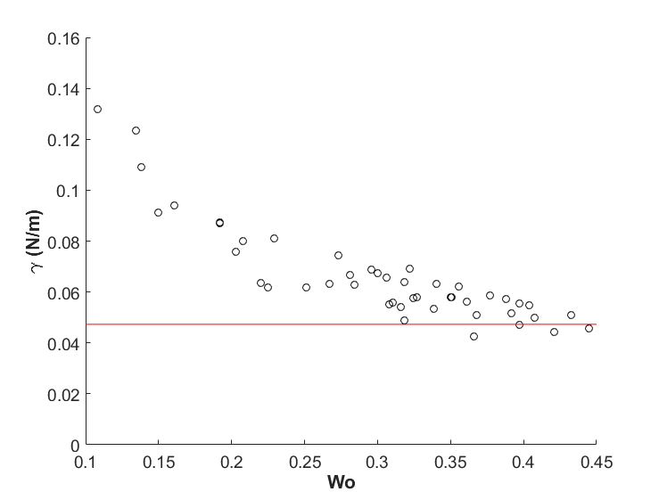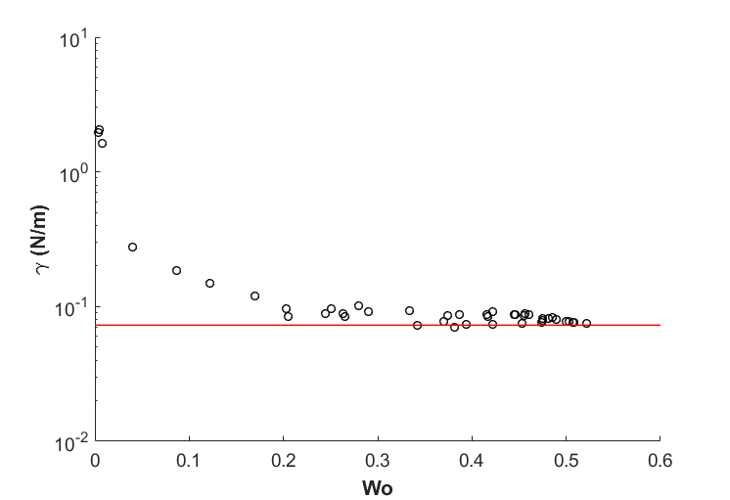

Figure 4 Surface tension plotted as function of the Worthington number (Vdrop/Vmax) for an ethylene glycol droplet (a) and a water droplet (b). The reported literature surface tensions are indicated by the red line.

**A**

**B**

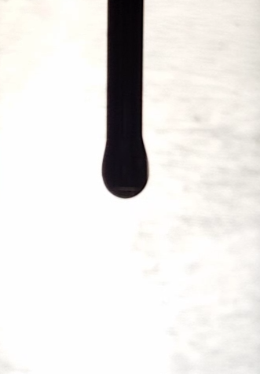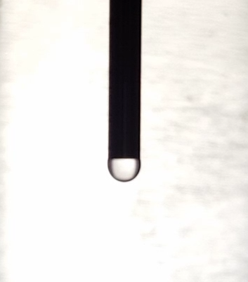

Figure 5 Droplet of ethanol during the dispension. A) Small droplet hanging from the needle. B) Bigger droplet, adhered to the needle (needle indicated with red lines).

What are we going to do

* + Measure droplet containing pectin and lysozyme at different lysozyme concentrations to find optimal lag time for change in surface tension
  + Make droplet video of diethylene glycol and propylene carbonate
  + Measure surface tension using a wilhelmy plate
  + Find correct parameters by making droplet videos with higher resolution and use less slices in the fitting process
  + Flow behaviour and elasticity
  + Arduino/RaPI system
  + Measure surface tension of gelatin droplet while solidifying and try to relate surface tension to temperature
  + Find the effect of a surfactant on surface tension of an oscillating droplet
  + Use magnetic nanoparticles and a magnet to alter surface tension

### 20180406

What did we do

* The surface tension of water, ethylene glycol and ethanol was determined using the Wilhelmy plate method.
* A short protocol for the Wilhelmy plate method:
  1. Clean all glassware and rinse it with the solvent to be used.
  2. Measure the width of the plate and straighten the Wilhelmy plate.
  3. Rinse the Wilhelmy plate with ultra-pure water. After rinsing, dry and clean the plate by heating it, untill it is red-hot, with a butane-torch (only use torches that produce a blue flame, as other torches will leave carbon contamination on the plate).
  4. Hang the plate underneath the balance using tweezers (to avoid contamination), make sure the plate does not swing and tare the balance.
  5. Put the beaker on the platform under the plate and move the platform so the plate just touches the liquid.
  6. Wet the complete plate by slightly lifting the beaker with liquid.
  7. Wait untill the wait is stable.
  8. Calculate the surface tension by γ = 9.81 * M/2L, with γ the surface tension in mN/m, M the mass in g, and L the width in M.
  9. Repeat step 3 to 9 for the duplo/triplo measurement.