
The IoT & Device Management Company
Friendly AI AEP Tool

System Specification v2.2
Complete Merged Architecture with Embedded Diagrams

Version 2.2 | April 2026 | Confidential

Table of Contents

1. Executive summary
This document is the complete, merged System Specification for the Friendly AI AEP Tool — an Agentic AI-powered IoT Application Enablement Platform. It supersedes both the original System Specification v2.0 and the Spec Addendum v2.1, incorporating all six resolved design decisions inline throughout every section.
The AEP Tool is a proprietary, commercially licensed SaaS/PaaS product that enables Friendly Technologies customers to create, deploy, and maintain production-grade IoT applications through conversational AI and a visual low-code builder, tightly integrated with the Friendly One-IoT DM Platform.
Target Revenue Opportunity: $130–150M by Year 5 based on AEP licensing, metering, and generated application runtime fees.

1.1 Product identity
Attribute | Value
Product Name | Friendly AI AEP Tool
Category | Agentic AI IoT Application Enablement Platform
Licensing | SaaS/PaaS add-on to Friendly One-IoT DM
LLM (Phase 1) | Claude Opus 4.6 (all agents) via LLMProvider abstraction
LLM (Future) | Ollama (Enterprise), OpenAI, Gemini via pluggable adapter
Backend | Node.js 20 LTS / TypeScript strict / Fastify 4.x
Frontend | Angular 17+ / Material 3 / Signals
Analytics | Grafana OSS 10+ with Friendly navy/orange theme
Data Tier | PostgreSQL 15 + InfluxDB v2 (or TimescaleDB)
Deployment | Docker Compose (SaaS + Dedicated) / Kubernetes / Helm
APIs Integrated | 3 Friendly APIs: Northbound REST, Events/Webhook REST, QoE/Monitoring REST
Auth Methods | UID/PW Basic Auth, API Key, JWT, future OAuth2
Deployment Modes | Multi-tenant SaaS (Friendly-hosted) + Dedicated single-tenant
Pricing Tiers | Starter $499/mo | Professional $2,499/mo | Enterprise $7,999/mo
Monorepo | Nx workspace (35 modules)
CI/CD | GitHub Actions
Repository | github.com/friendly-technologies/friendly-ai-aep-tool

1.2 Key differentiators
- Deep integration to three Friendly One-IoT DM APIs via Swagger/OpenAPI
- IoT-specific domain intelligence: device management, telemetry, OTA, alarms, fleet health, geofencing
- Angular-first output with real, customer-ownable source code and fresh Friendly-branded design
- Grafana-first analytics with custom navy/orange Friendly theme
- Friendly-exclusive runtime/license lock: generated apps only operate against licensed Friendly DM environments
- Built-in metering and billing with third-party IoT data ingestion support
- Docker-first portability with dual SaaS/dedicated deployment
- Multi-agent agentic UX — all 11 agents on Claude Opus 4.6 with Ollama option for Enterprise
- Disconnected operation support with tier-dependent grace periods

2. Competitive platform analysis
Consolidated recommendation matrix extracting the strongest patterns from Base44, Replit, and Appsmith, adapted for Friendly’s IoT use case.
Capability | Source | Adaptation for Friendly
Prompt-to-app generation UX | Base44 | Replace generic data model with IoT domain + three Friendly APIs
Template marketplace | Base44 | IoT-specific templates (fleet ops, metering, OTA, etc.)
Planning conversation mode | Base44 | IoT domain agent with three-API awareness
Agent task decomposition | Replit | Multi-agent (11 agents, all Opus 4.6) with supervisor routing
Workspace layout | Replit | Add Grafana panels, deployment mode selector, connectivity status
Live preview with hot-reload | Replit | Docker sandbox with mock/live/disconnected-sim modes
One-click publish workflow | Replit | Docker Compose/Helm + license inject + dual SaaS/dedicated target
Page/Widget/Binding schema | Appsmith | Schema drives real Angular codegen, not metadata runtime
Git-backed version control | Appsmith | Push to customer’s own GitHub/GitLab/Bitbucket
Self-hosting deployment | Appsmith | Docker Compose + Helm + air-gapped license for Enterprise
IoT widget library | Friendly (unique) | Fresh designs inspired by Admin Portal + Support Portal
Grafana provisioning-as-code | Friendly (unique) | Dashboard JSON + datasource YAML + custom Friendly theme
Multi-agent IoT architecture | Friendly (unique) | 11 agents on Opus 4.6 with LLMProvider abstraction
License/runtime commercial lock | Friendly (unique) | Rust sidecar + Friendly-exclusive DM enforcement
Metering/billing engine | Friendly (unique) | Usage capture including third-party IoT data ingestion

3. System architecture overview
The platform comprises 35 modules across 10 architectural layers within an Nx monorepo.
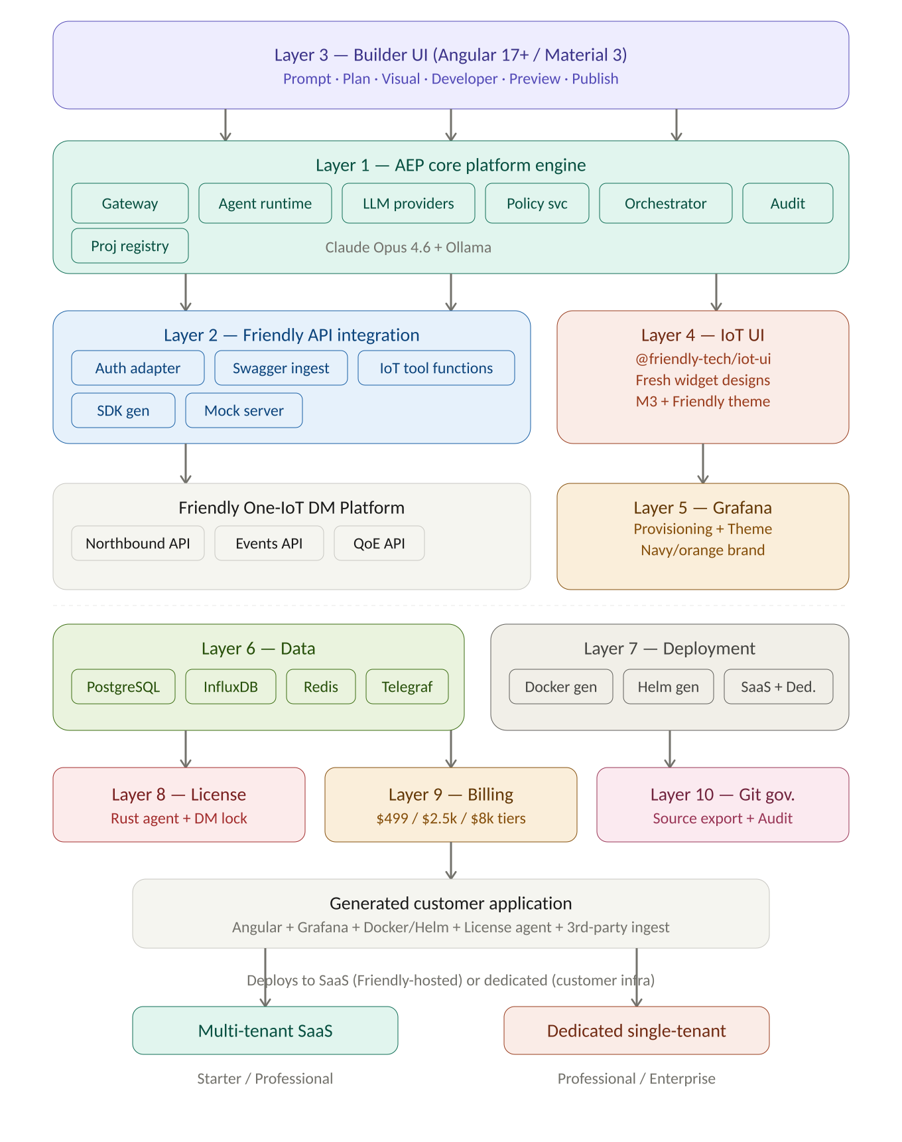
Figure 1 — 10-layer system architecture (v2.2) with three APIs, LLM abstraction, and dual deployment

3.1 Architecture layer summary
Layer | Name | Key Technologies
1 | AEP Core Platform Engine | Fastify, LangGraph, llm-providers (Opus 4.6 + Ollama), Redis
2 | Friendly API Integration (3 APIs) | auth-adapter (Basic/JWT/APIKey/OAuth2), openapi-generator-cli
3 | Agentic Builder | Angular 17+, Material 3, Monaco, Docker preview (3 modes)
4 | IoT UI Components | @friendly-tech/iot-ui (fresh designs), Signals, Storybook
5 | Grafana Composition | Grafana OSS 10+, Friendly theme (navy/orange), provisioning-as-code
6 | Data Architecture | PostgreSQL 15 + Prisma, InfluxDB v2, Redis 7, Telegraf (3rd-party ingest)
7 | Deployment Engine | Docker Compose (SaaS+Dedicated), Helm (Enterprise), GitHub Actions
8 | License & Protection | Rust binary (tier grace periods), iot-api-proxy (Friendly-exclusive DM lock)
9 | Billing Engine | Redis Streams, rating engine ($499/$2.5k/$8k tiers), Stripe/SAP, 3rd-party metering
10 | Git Governance | isomorphic-git, GitHub/GitLab/Bitbucket, customer source ownership

3.2 Monorepo structure
friendly-ai-aep-tool/
├─ apps/aep-builder/ # Angular 17+ builder UI
├─ apps/aep-api-gateway/ # Fastify gateway
├─ apps/aep-preview-host/ # Preview container manager
├─ libs/core/agent-runtime/ # LangGraph multi-agent
├─ libs/core/llm-providers/ # LLM abstraction (NEW)
├─ libs/core/builder-orchestrator/
├─ libs/core/project-registry/ # + tenant LLM config
├─ libs/core/policy-service/ # tier enforcement
├─ libs/core/license-service/ # Rust FFI
├─ libs/core/billing-service/ # + 3rd-party metering
├─ libs/core/audit-service/
├─ libs/iot/swagger-ingestion/ # 3 API specs
├─ libs/iot/auth-adapter/ # 3-API auth (NEW)
├─ libs/iot/sdk-generator/ # 3 service classes
├─ libs/iot/iot-tool-functions/ # 3-API tools
├─ libs/iot/mock-api-server/ # simulates all 3 APIs
├─ libs/builder/{page-composer,widget-registry,codegen,
│ preview-runtime,publish-service,git-service,
│ environment-service,template-marketplace}
├─ libs/ui/iot-ui/ # @friendly-tech/iot-ui
├─ libs/grafana/{provisioning,dashboard-templates,theme}
├─ libs/data/{prisma-schema,influx-schemas,telegraf-ingest-config}
├─ libs/deploy/{docker-generator,helm-generator}
├─ tools/{license-agent,iot-api-proxy}
├─ docs/ docker/ .github/
└─ nx.json tsconfig.base.json package.json

4. Multi-agent architecture
All agents run Claude Opus 4.6 in Phase 1, configured through the llm-providers abstraction which allows per-agent model overrides and future provider swapping including Ollama for Enterprise customers.
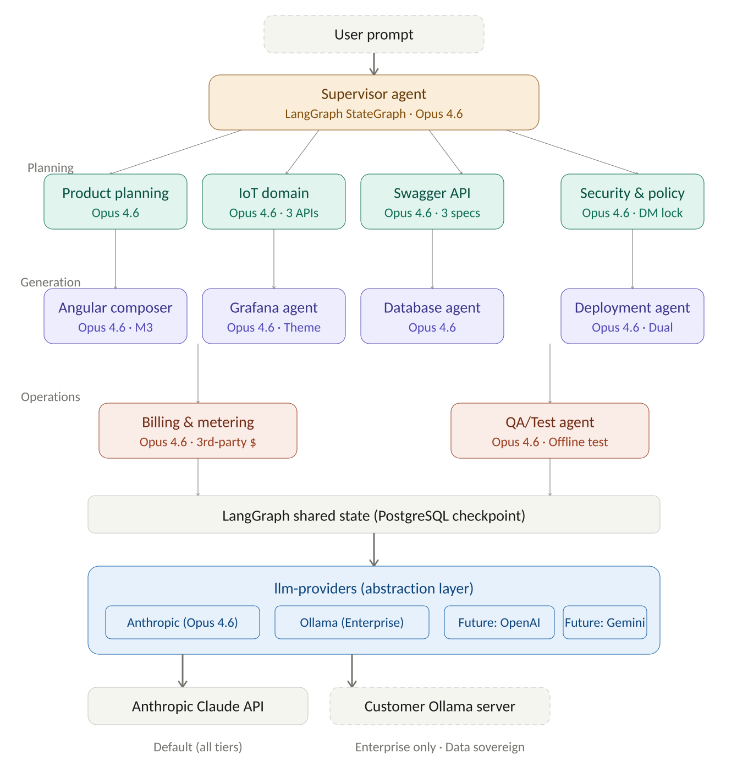
Figure 2 — Multi-agent orchestration with Claude Opus 4.6 and LLM provider abstraction

4.1 Agent model assignments
Agent | LLM (Phase 1) | Tools | Future Candidates
Supervisor | Claude Opus 4.6 | All agent dispatch tools | Opus (default), Ollama
Product Planning | Claude Opus 4.6 | project-registry, templates | Opus, Ollama Llama 3.1
IoT Domain | Claude Opus 4.6 | iot-tool-functions (3 APIs) | Opus, Ollama Mistral
Swagger API | Claude Opus 4.6 | swagger-ingestion, sdk-gen | Haiku 4.5 (cost opt), Ollama
Angular UI Composer | Claude Opus 4.6 | codegen, widget-registry | Opus (quality-critical)
Grafana Dashboard | Claude Opus 4.6 | grafana-provisioning, influx | Sonnet 4.6, Ollama
Database | Claude Opus 4.6 | prisma-schema, influx-schemas | Haiku 4.5, Ollama
Deployment | Claude Opus 4.6 | docker-gen, helm-gen | Sonnet 4.6, Ollama
Billing & Metering | Claude Opus 4.6 | billing-service | Haiku 4.5
Security & Policy | Claude Opus 4.6 | policy-svc, license-svc | Opus (security-critical)
QA/Test | Claude Opus 4.6 | preview-runtime, test-runner | Sonnet 4.6, Ollama

4.2 LLM provider abstraction
interface LLMProvider {
id: string; // 'anthropic' | 'ollama' | 'openai' | 'google'
chat(msgs, tools): AsyncIterable<Chunk>;
embed?(text): Promise<number[]>;
}

// Per-agent config, overridable per-tenant via project-registry
const AGENT_LLM_MAP: Record<AgentRole, LLMConfig> = {
supervisor: { provider:'anthropic', model:'claude-opus-4-6' },
// Enterprise tenant override example:
// supervisor: { provider:'ollama', model:'llama3.1:70b', baseUrl:'http://...' }
};
- Anthropic adapter: @anthropic-ai/sdk with streaming + tool-calling
- Ollama adapter: OpenAI-compatible HTTP endpoint with tool-calling translation
- Fallback chain: configurable per-agent (e.g., Ollama → Claude on failure)
- Token usage: tracked per provider per agent for billing (Claude metered at cost; Ollama at $0 but tracked)

5. Friendly One-IoT DM API integration
The platform integrates with three separate Friendly RESTful APIs, each with its own authentication mechanism, unified through the auth-adapter module.
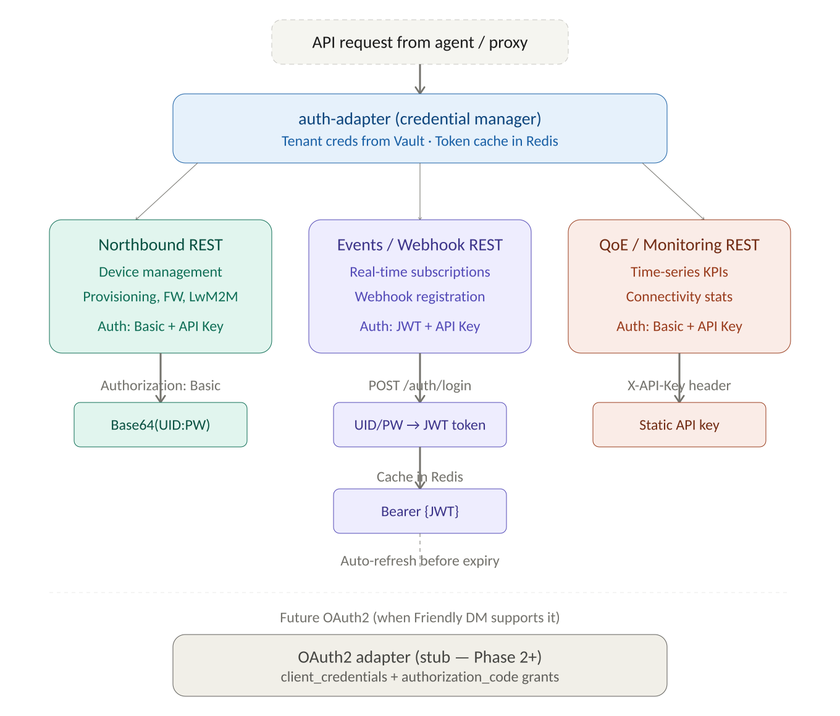
Figure 3 — Three-API authentication flow via auth-adapter

5.1 Three Friendly APIs
API | Purpose | Auth Methods | Documentation
Northbound REST | Device mgmt, provisioning, FW, LwM2M, bulk ops | UID/PW Basic Auth + API Key | FT-IoT Northbound REST API specs.pdf
Events/Webhook REST | Real-time event subscriptions, webhook push | JWT (from UID/PW exchange) + API Key | FT-IoT Register for Event REST API specs.pdf
QoE/Monitoring REST | Time-series monitoring, KPIs, connectivity stats | UID/PW Basic Auth + API Key | FT-IoT QoE REST API guide.pdf

5.2 IoT tool functions (all 3 APIs)
Function | Source API | Description
getDeviceList(tenantId, filters) | Northbound | Paginated device list
getDeviceDetails(deviceId) | Northbound | Full device record + data model
triggerOTAUpdate(deviceId, fwVer) | Northbound | Firmware update campaign
executeLwM2MCommand(deviceId, path, payload) | Northbound | Execute LwM2M operation
readLwM2MResource(deviceId, path) | Northbound | Read LwM2M resource value
writeLwM2MResource(deviceId, path, value) | Northbound | Write LwM2M resource
registerWebhook(eventType, callbackUrl) | Events | Subscribe to device events
getEventSubscriptions(tenantId) | Events | List active subscriptions
unregisterWebhook(subscriptionId) | Events | Remove subscription
getDeviceTelemetry(deviceId, metric, range) | QoE | Time-series monitoring data
getFleetTelemetry(filters, metric, range) | QoE | Aggregated fleet data
getKPIMetrics(tenantId, kpiType, period) | QoE | Performance KPIs
getConnectivityStats(deviceId, period) | QoE | Connection quality data

6. Builder experience
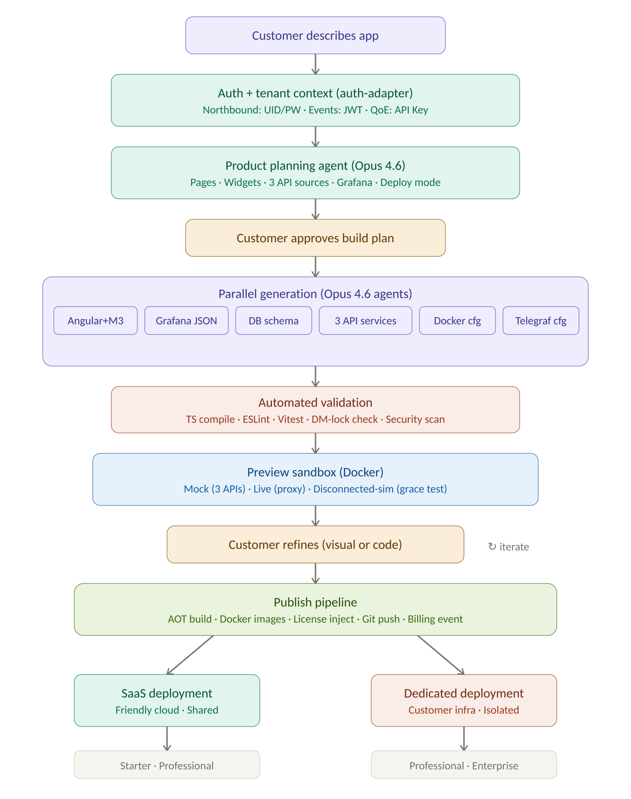
Figure 4 — Prompt-to-deploy pipeline with three-API auth and dual deployment

6.1 Workspace layout
Panel | Position | Content
Agent Chat | Left (300px, collapsible) | Conversational AI, task list, suggested actions
Canvas / Editor | Centre (fluid) | Visual canvas | Monaco editor | Live preview (tabbed)
Properties | Right (320px, collapsible) | Widget props, data bindings (3 API sources), theme
Status Bar | Bottom (200px, collapsible) | Build logs, tests, preview status, connectivity indicator

6.2 Builder modes
Mode | System Behaviour
Prompt | Product Planning Agent captures requirements via all 3 APIs
Plan | Orchestrator decomposes into ordered build tasks
Visual | Drag-and-drop page composition with fresh Friendly-branded widgets
Developer | Monaco editor with IntelliSense for 3 SDK service classes
Preview | Docker sandbox: Mock (3 APIs) | Live (proxy) | Disconnected-sim
Publish | Build pipeline → SaaS deployment or Dedicated deployment package

6.3 UI design system
Fresh component designs from scratch, inspired by Friendly Admin Portal (data-dense tables, sidebar nav, form panels) and Support Portal (tabbed device detail, status badges, quick-action panels). Angular Material 3 with Friendly custom theme tokens.
- Navy (#12174C) as primary navigation and header colour
- Orange (#FF5900) as accent for CTAs, alerts, and interactive highlights
- Dark mode: navy as dark surface, white text, orange accents
- Responsive breakpoints: desktop (1440px+), tablet (768–1439px), mobile (<768px)
- ft-device-table: sortable columns, status badges, bulk select (Admin Portal pattern)
- ft-device-card: tabbed detail — Status/Config/Firmware/History (Support Portal pattern)
- ft-gauge: circular SVG, navy arc, orange indicator (fresh design)
- ft-device-map: Leaflet with navy/orange markers, cluster groups (fresh design)
- Grafana theme: navy panel headers, orange primary series, Calibri font, navy dark mode

7. Deployment model
Both multi-tenant SaaS and dedicated single-tenant deployment supported from Phase 1.
Aspect | Multi-Tenant SaaS | Dedicated Single-Tenant
Hosting | Friendly-managed cloud (AWS/Azure) | Customer infra or Friendly-managed dedicated
Isolation | Logical (row-level security, namespace) | Physical (separate DB, separate containers)
Data Residency | Friendly-selected region | Customer-selected region / on-premises
LLM Provider | Claude only (Friendly-hosted) | Claude + Ollama (customer-hosted)
Update Cycle | Continuous deployment by Friendly | Customer-controlled schedule
Pricing | Lower per-seat/device | Higher base, lower marginal at scale
Target Tier | Starter, Professional | Professional, Enterprise

7.1 Generated application stack
Service | Image | Purpose
frontend | nginx:alpine + Angular | Serves generated SPA
grafana | grafana-oss:10.x + Friendly theme | Analytics dashboards
influxdb | influxdb:2.7 | Time-series (Friendly + external buckets)
postgres | postgres:15-alpine | Relational data
telegraf | telegraf:1.29 | Ingestion bridge (Friendly MQTT + 3rd-party sources)
iot-api-proxy | Node.js Fastify | Friendly-exclusive DM proxy + license check
license-agent | Rust binary (signed) | Runtime license validation sidecar
redis | redis:7-alpine | Cache + pub/sub + disconnected queue
nginx-proxy | nginx:alpine | Reverse proxy / TLS termination

8. Commercial tiers and pricing
Market-benchmarked pricing based on IoT AEP platform norms (ThingsBoard, Losant, Kaa, Particle). Friendly to adapt based on competitive positioning.
Dimension | Starter $499/mo | Professional $2,499/mo | Enterprise $7,999/mo
Included Devices | 1,000 | 25,000 | 100,000+
AI Generation Sessions | 50/month | 500/month | Unlimited
Generated Applications | 3 | 10 | Unlimited
Active Users/Seats | 5 | 25 | Unlimited
API Calls | 100k/month | 2M/month | 20M/month
Time-Series Ingestion | 1GB/month | 25GB/month | 500GB/month
Grafana Dashboards | 3 | Unlimited | Unlimited + custom plugins
Deployment Output | Docker Compose | Docker Compose + Git | Docker + Helm + Git + K8s
Deployment Mode | SaaS only | SaaS or dedicated | SaaS or dedicated
LLM Provider | Claude (Friendly-hosted) | Claude (Friendly-hosted) | Claude + Ollama
Disconnected Mode | Not supported | 24h grace period | 7-day grace + air-gap
3rd-Party Ingestion | Not included | Metered ($0.01/1k msgs) | Metered ($0.005/1k msgs)
Support | Community + docs | Business hours email | 24/7 + dedicated engineer

8.1 License key format
FTECH-AEP-{TIER}-{DEPLOY_MODE}-{TENANT_HASH}-{EXPIRY_EPOCH}-{FEATURE_FLAGS}-{HMAC}
- TIER: STR/PRO/ENT
- DEPLOY_MODE: S (SaaS) or D (Dedicated)
- FEATURE_FLAGS: encoded bitfield (Helm, Git, Ollama, air-gap, 3rd-party ingest, custom widgets)
- HMAC: HMAC-SHA256 with Friendly private key

9. Disconnected operation and data policy

9.1 Offline behaviour
- License agent grace: Starter (none), Professional (24h), Enterprise (7d + air-gap offline license file)
- Redis cache: 4h rolling cache of recent device data for dashboard rendering during disconnection
- Command queue: device commands queued in Redis, flushed on reconnection
- Telegraf buffer: 1GB disk buffer for telemetry during InfluxDB/API connectivity loss
- UI indicator: connectivity status banner (Connected / Degraded / Offline) in Angular nav bar

9.2 Friendly-exclusive DM integration
- iot-api-proxy maintains domain whitelist of verified Friendly One-IoT DM endpoints
- Requests to non-Friendly API endpoints blocked with 403
- Competitor DM platforms explicitly blocked: AVSystem, Cumulocity, Axiros, Incognito
- Generated SDK only imports @friendly-tech/dm-sdk; no generic HTTP escape hatch
- License agent verifies DM endpoint URL matches licensed Friendly instance

9.3 Third-party IoT data ingestion
While DM integration is Friendly-exclusive, the platform supports ingesting IoT data from third-party sources for analytics and dashboards:
- Telegraf inputs: MQTT, HTTP listener, Kafka consumer, syslog, SNMP
- External data routed to InfluxDB buckets tagged source=external
- Separately metered in billing engine under ‘Third-Party Data Ingestion’ dimension
- Grafana dashboards visualise Friendly DM data and third-party data side-by-side
Dimension | Professional | Enterprise
Third-party MQTT messages | $0.01/1000 msgs | $0.005/1000 msgs
Third-party HTTP ingestion | $0.02/1000 requests | $0.01/1000 requests
External data storage | $0.10/GB/month | $0.05/GB/month

10. Security, policy, and data privacy

10.1 Authentication and authorisation
- Three-method auth via auth-adapter: Basic Auth (Northbound/QoE), JWT exchange (Events), API Key (all), future OAuth2
- Role-based access: Admin, Developer, Viewer per project
- Tenant isolation: row-level security in PostgreSQL; dedicated mode uses physical isolation

10.2 Infrastructure security
- mTLS between internal services
- Secret management via HashiCorp Vault (credential encryption for three API credential sets)
- Container image scanning (Trivy) + dependency scanning (Snyk) in CI/CD
- Image signing with cosign/Sigstore

10.3 Application security
- OWASP Top 10 protections in builder UI and generated apps
- CSP headers, Fastify JSON schema validation on all endpoints
- No eval(), no dynamic require(), no unproxied external fetch in generated code
- Friendly-exclusive DM enforcement: codegen validation blocks competitor API references

10.4 GDPR / Privacy
- Tenant data isolation at every layer; dedicated mode keeps all data on customer infrastructure
- Data residency: customer chooses region (SaaS) or controls entirely (dedicated)
- Right to deletion: customer can purge all project data and generated assets

11. Implementation phases

11.1 Phase 1 — Foundation (Weeks 1–12)
Goal: Nx monorepo, core infra, working prompt-to-preview pipeline with three-API awareness and Claude Opus 4.6.
Deliverable | Layer | Key Detail
Nx monorepo scaffold | All | 35-module workspace, tsconfig, CI
aep-api-gateway | 1 | Fastify + auth-adapter (3 methods)
llm-providers | 1 | Anthropic adapter (Opus 4.6) + Ollama stub
auth-adapter | 2 | Basic Auth + API Key + JWT for 3 APIs
swagger-ingestion (3 specs) | 2 | Ingest Northbound + Events + QoE specs
sdk-generator (3 services) | 2 | NorthboundService, EventsService, QoEService
5 core IoT tool functions | 2 | getDeviceList, getDetails, getTelemetry, registerWebhook, getKPIs
Plan-mode agent | 1 | Supervisor + Planning + IoT Domain (Opus 4.6)
Angular builder shell | 3 | Four-panel layout, Friendly M3 theme, dark mode
Preview runtime MVP | 3 | Docker sandbox with mock (3 APIs) mode
Docker stack generator | 7 | docker-compose.yml (SaaS + dedicated stubs)
License service MVP | 8 | Key format with deploy mode, basic validation
PostgreSQL + Prisma schema | 6 | Core tables incl. 3-API creds, deployment mode

11.2 Phase 2 — Core Builder (Weeks 13–26)
Goal: Visual page builder, Angular codegen, Grafana provisioning, first publish pipeline.
Deliverable | Layer | Key Detail
Visual page builder | 3 | Drag-and-drop with fresh Friendly widget designs
10 core widgets | 4 | ft-device-table, ft-gauge, ft-metric-card, ft-sparkline, ft-device-map, ft-alert-feed, ft-fleet-health, ft-ota-status, ft-command-button, ft-kpi-strip
Angular code generator | 3 | 8-stage pipeline incl. 3 SDK services and Friendly M3 theme
Grafana provisioning + theme | 5 | Dashboard JSON + navy/orange Friendly theme
3 starter templates | 4 | Fleet Operations, Utility Metering, OTA Campaign
Git integration | 10 | Push to customer GitHub/GitLab/Bitbucket
Publish pipeline v1 | 3/7 | Build, Docker Compose (SaaS + dedicated), license inject
Billing event capture | 9 | Redis Streams for API calls, generation sessions, 3rd-party ingest
InfluxDB + Telegraf | 6 | Buckets setup + 3rd-party ingestion config
Disconnected-sim preview mode | 3 | Periodic connectivity drops testing grace periods

11.3 Phase 3 — Commercial Launch (Weeks 27–40)
Deliverable | Layer | Key Detail
Full 11-agent orchestration | 1 | All agents operational on Opus 4.6
Ollama integration | 1 | llm-providers Ollama adapter for Enterprise
Environment promotion | 3 | Dev → Staging → Production with approvals
Helm/Kubernetes output | 7 | Enterprise tier Helm charts
Full billing/rating/invoicing | 9 | $499/$2.5k/$8k tiers, Stripe, 3rd-party metering
Collaboration and approvals | 10 | Multi-user access, publish approval workflow
Security hardening | 10 | mTLS, Vault, scanning, signing, DM-lock enforcement
Automated test suite | 3 | Vitest + Playwright for generated apps
Docusaurus docs | All | Admin, Builder, Developer, API Reference guides

11.4 Phase 4 — Ecosystem (Weeks 41–52+)
- Custom Widget SDK: customers build and register own Angular widgets
- Partner/reseller: white-label branding, sub-tenant management
- Template Marketplace expansion: community-contributed templates
- Advanced AI: anomaly detection, predictive maintenance (leveraging Ollama local models)
- Mobile-optimised runtime: responsive layouts, PWA support
- Multi-LLM cost optimisation: selective routing of low-complexity tasks to Haiku/Ollama

12. Architecture decision records

ADR-001: LangGraph over custom orchestration
Decision: Use LangGraph (TypeScript) for multi-agent orchestration.
Rationale: StateGraph with checkpointing, conditional edges, native tool-calling. Saves 3–4 months vs custom framework.

ADR-002: Angular codegen over metadata runtime
Decision: Generate real Angular source that customers own and maintain.
Rationale: Customer code ownership is key differentiator. No vendor lock-in on generated IP.

ADR-003: InfluxDB v2 over TimescaleDB
Decision: Default InfluxDB v2; TimescaleDB documented as alternative.
Rationale: Native Grafana datasource, Flux queries, Telegraf ecosystem for IoT ingestion.

ADR-004: Rust for license service binary
Decision: Compiled Rust binary for license-agent sidecar.
Rationale: Tamper-resistant, memory-safe, small footprint, napi-rs FFI to Node.js.

ADR-005: Nx over Turborepo
Decision: Nx with Angular plugin for monorepo.
Rationale: First-class Angular support, computation caching, affected-based CI.

ADR-006: Claude Opus 4.6 with LLMProvider abstraction
Decision: All agents use Claude Opus 4.6 in Phase 1. LLMProvider interface from Day 1 with Ollama adapter for Enterprise.
Rationale: Opus 4.6 is the most capable model for complex codegen and planning. Abstraction costs ~2 days and avoids hard-coding. Ollama essential for data sovereignty.

ADR-007: Three-API unified auth-adapter
Decision: Single auth-adapter module handles credential lifecycle for all three Friendly APIs.
Rationale: Unified credential management, Redis token cache, auto-refresh. Avoids scattered auth logic across modules. OAuth2 stub ready for future DM upgrade.

ADR-008: Dual deployment mode from Phase 1
Decision: Support both multi-tenant SaaS and dedicated single-tenant from initial architecture.
Rationale: Telco and utility customers require data sovereignty (dedicated). SaaS lowers barrier for SME customers. License key encodes deployment mode for enforcement.

13. Testing strategy
Level | Framework | Scope | Trigger
Unit | Vitest | Functions, services, agents, codegen transforms | Every PR
Integration | Supertest | API contracts, DB ops, 3-API tool calls | PR merge to develop
E2E (Platform) | Playwright | Builder UI: prompt → plan → build → preview → publish | Nightly + RC
E2E (Generated) | Playwright | Generated app navigation, data loading, Grafana embed | Every publish
Contract | Pact | Friendly 3-API contract vs Swagger specs | Weekly
Security | Trivy + Snyk | Container vulns, npm audit, SAST | Every PR + nightly
Performance | k6 | Gateway throughput, codegen latency, preview startup | Weekly + release
License | Rust tests | Key validation, grace period, tamper detection, DM-lock | License-service changes
LLM Integration | Custom | Ollama adapter, fallback chains, token metering | Nightly

14. Risk register
Risk | Impact | Likelihood | Mitigation
LLM output quality variance | High | Medium | Structured prompts, output validation, human review, fallback templates
Angular codegen unbuildable output | High | Medium | Strict TS compilation check, automated fix-up agent
License enforcement bypass | Critical | Low | Rust binary integrity, API proxy enforcement, periodic audit
Three-API spec changes break SDK | Medium | High | Versioned SDK, backwards-compatible proxy layer, contract tests
Preview environment exhaustion | Medium | Medium | Session timeouts, resource limits, queue-based provisioning
Multi-agent hallucination | High | Medium | Supervisor validation, structured tools, human approval gates
Tenant data leakage | Critical | Low | Row-level security, pen testing, dedicated mode for sensitive customers
Ollama model quality gap | Medium | Medium | Fallback to Claude on failure, quality benchmarks before enabling
Phase 1 timeline overrun | High | High | Strict MVP scope, defer visual builder to Phase 2

15. Assumptions (all resolved)
# | Question | Resolution
1 | LLM providers for MVP? | Claude Opus 4.6 only, with LLMProvider abstraction for Ollama/future providers
2 | Friendly DM API auth mechanism? | Three APIs: UID/PW + API Key + JWT. Future OAuth2 hooks via auth-adapter stub.
3 | SaaS or dedicated deployment? | Both. Dual-mode architecture with license key encoding deployment mode.
4 | Target tier pricing? | $499 / $2,499 / $7,999 monthly (market-benchmarked). Annual discounts 15–20%.
5 | Offline/disconnected support? | Yes with tier-dependent grace periods. Friendly DM exclusive. 3rd-party ingestion metered.
6 | Existing design system? | None. Fresh designs from scratch, inspired by Admin Portal + Support Portal.

This merged specification is the single authoritative architecture document for the Friendly AI AEP Tool. All design decisions are final and integrated. Use alongside the Module Reference v2.2 for the complete development blueprint.
— End of System Specification v2.2 —

