**Multifitting**

**v.1.10.2**

**User’s manual**

**v.1.2**

Mikhail Svechnikov

[svechnikovmv@gmail.com](mailto:svechnikovmv@gmail.com)

February 21, 2020

Contents

**Introduction** 2

**Installation and run** 3

**Windows** 3

**Linux** 3

**Quick start guide** 3

**Setting the structure** 4

**Reflectivity curve calculation** 7

**Work with structure table** 11

**Inverse problem** 12

**Additional experimental curves** 24

**Setting aperiodic structure** 28

**Save and load** 32

**Detailed description** 32

**Version history** 33

**References** 33

**Introduction**

This manual is intended for current and future users of Multifitting and is written by its author. It will talk about the purpose of the program, how to start using it, as well as comprehensive information about the available functionality and user interface. This document will be updated along with the program update (and even more often) to always reflect the current state of affairs. The program interface is in English only, and this manual is in two languages: Russian and English. Since English is not my native language, there will be many grammatical, stylistic and other linguistic mistakes in this version. However, in the Russian version they will also present. So if you see an error – write me an email to [svechnikovmv@gmail.com](mailto:svechnikovmv@gmail.com).

What is this program intended for? The main task is the numerical simulation of the reflection and transmission of radiation by a multilayer structure. By-turn this is required for the diagnostics of structures, the evaluation of the performance of reflective coatings and freestanding absorption filters, as well as for the development of coatings with specified optical properties. The radiation here is primarily understood as a plane monochromatic wave, which is continuously incident on the sample. The wavelength basically can be arbitrary, but the optical constants database is more appropriate for the range from extreme ultraviolet to hard X-rays. At wavelengths scale it is 0.01–100 nm; in energy scale it is 0.01–100 keV. The planar multilayer structure may contain the ambient, the substrate, individual layers, periodic stacks of arbitrary nesting with the number of layers in the period ≥2, aperiodic stacks. Each layer is characterized by a material, density, thickness and interface at the upper boundary. The material can be given by name (usually a chemical formula) if there are corresponding optical constants in the database, or composed of individual chemical elements with arbitrary stoichiometric ratios. Multifitting can use the IMD optical constants database. Interlayer interfaces are characterized by the root-mean-square width σ and profile type. Multifitting also allows you to take into account a number of instrument functionы that distort the observed value, such as finite angular and energy resolution, polarization, scattered background, “trace effect” in grazing angles depending on the sample and probe beam sizes and others. Multifitting calculates the one-dimensional dependences of optical functions on the angle or wavelength.

Similar programs for the numerical simulation of the optical properties of layered structures are created regularly, both free and commercial. Examples of free programs: IMD (<http://www.rxollc.com/idl/>,[1]), GenX (<http://genx.sourceforge.net>,[2]), REFLEX (<http://reflex.irdl.fr/Reflex/reflex.html>,[3]), BornAgain (<https://www.bornagainproject.org>,[4]). Among these tools, BornAgain has the most extensive functionality, but perhaps the most famous and most widely used for developing and diagnosing X-ray optical coatings and free-standing structures is IMD. For more than 20 years, it has in fact become a standard instrument in X-ray optics. I took its interface and functionality as a standard and adapted it for a number of tasks.

Multifitting has the interface specifically designed to quickly change the parameters of the structure and instantly display the results. This is important in the case of reflectometric diagnostics of samples, when the structure model is not exactly known, and it is required to manually consider and try many options. With frequent solving of such problems, the issues of interface ergonomics come to the fore (after required functionality, of course), therefore Multifitting is recommended to anyone who is involved in X-ray diagnostics of thin films, and especially to those who do it regularly.

Basic information about Multifitting is published in the Journal of Applied Crystallography [5]. When publishing your results obtained using Multifitting, please refer to this paper.

**Installation and run**

Multifitting is available for Widows (starting with Windows 7) and Linux. You can download it from the web page of the Laboratory of X-ray Optics of the Institute of Physics of Microstructures of the Russian Academy of Sciences. Page in Russian: <http://xray-optics.ru/products/software-multifitting/> and in English: <http://xray-optics.org/products/software-multifitting/>. The program is free for all users.

## **Windows**

The installation as such is not required, just download the archive, unpack it and run the executable file. Depending on the bit depth of the operating system, run the file from the appropriate folder: “Multifitting_v.X.Y.Z/windows_x64/Multifitting.exe” or “Multifitting_v.X.Y.Z/windows_x86/Multifitting.exe”, where “X.Y.Z” – version number. If you run Multifitting from the command line, then in case of an error and the emergency shutdown of the program, you can read the error code in order to report it later.

If when you run the program you get the following message:

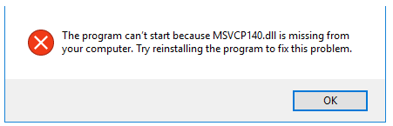

this means the absence of “standard” system libraries in the system. You can fix this by downloading the installation package “Microsoft Visual C++ 2015 Redistributable” (<https://www.microsoft.com/en-us/download/details.aspx?id=53840>) and installing it according to the bit depth of your operating system.

## **Linux**

The redistributable archive contains all the necessary libraries and an executable file. The executable file is “Multifitting_v.X.Y.Z/linux_x64/Multifitting”.

**Quick start guide**

A good way to get acquainted with the program and evaluate its capabilities is to start working with it right away. Here you can find step-by-step instruction on creating a model structure in Multifitting, basics of working with it, loading of external experimental data and solving the inverse problem — finding the structure parameters along the reflection curve.

## **Setting the structure**

Run the program.

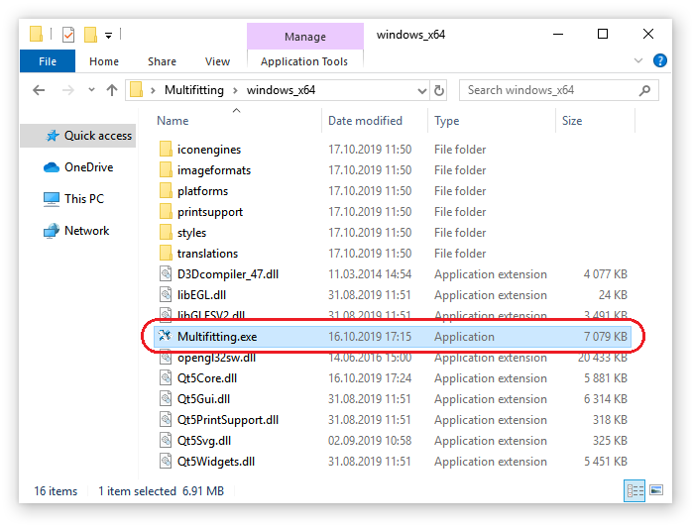

The main Multifitting window and the terminal window are opened. The terminal is used by the program to display text information during the work. The main window allows you to set a layered structure and gives access to all other tools. The interface of the main window is well known to users of IMD – it is almost completely reproduced here.

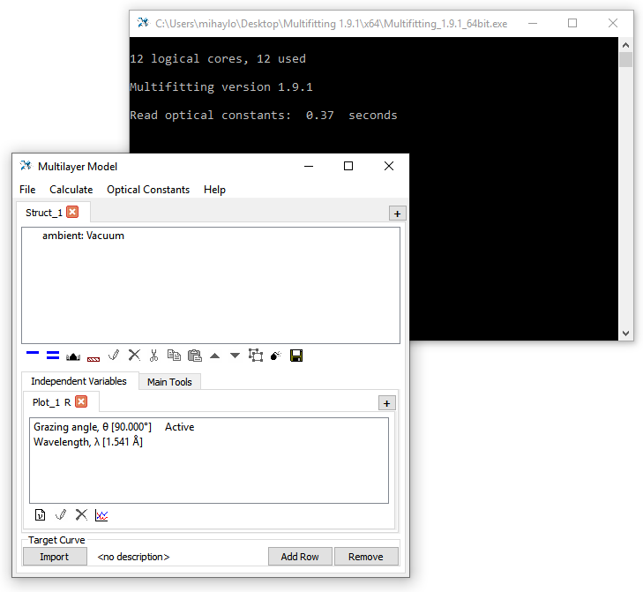

Menu

Structure

Toolbar

Parameters

for curve calculation

Measured and target curves

Create a periodic Mo/Be stack on the Si substrate. To do this, on the toolbar you need to click the “Add Substrate”  button, then “Add Multilayer” .

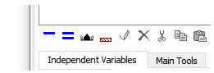

When you click “Add Multilayer” , a window will appear in which you can enter the number of layers in the unit cell of the periodic stack (≥2). Leave the number “2” and press Enter.

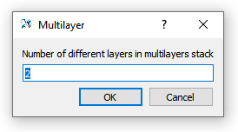

Now the structure looks like this:

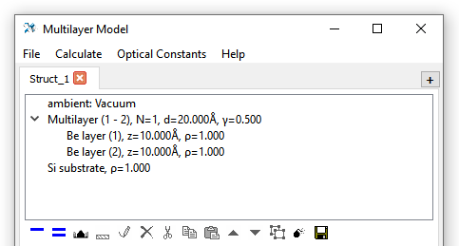

The structure is presented in the form of a tree-like list with basic information about each element. By default, the stack contains one period with the specified number (in our case 2) of the identical layers. Layers also have material, density, thickness and default interface. Default values can be changed in the configuration file. You can change the current parameters of a structure element by double-clicking on an element or selecting an element and clicking the icon “Edit” .

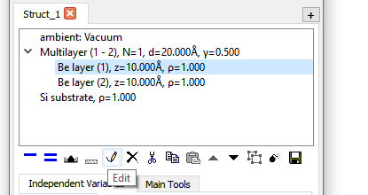

The opened window allows you to set various parameters of the layer. Let's set the following: first layer: material – Be, thickness 35 Å, Roughness/Diffuseness 5 Å. The second layer: material – Mo, thickness 25 Å, Roughness/Diffuseness 5 Å.

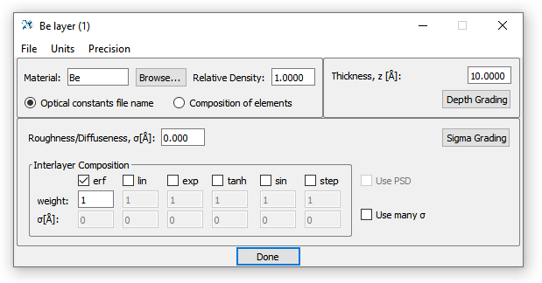

The properties of the substrate can be edited in the same way. Leave the Si as a material, and set the Roughness/Diffuseness to 3 Å. Again, the stack parameters window opens in the same way. Set the number of periods as 110. The period value and the thickness ratio γ (the ratio of the thickness of the first (top) layer to the period in two-component stack) have already been calculated in accordance with the specified layer thicknesses.

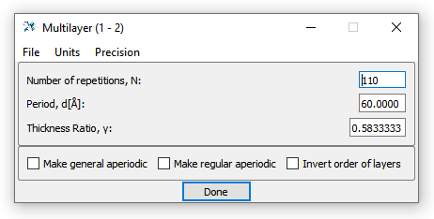

That’s all, the structure of periodic Mo/Be mirror is set!

## **Reflectivity curve calculation**

Now we calculate the reflection curve from this mirror. To do this, you need to specify which functions to calculate (reflection/transmission/absorption), set the properties of the probe beam, the type and range of the argument values. All this can be done in the “Independent Variables” tab. To specify the calculated value, click on the icon . In the window that opens, make sure that the “Reflectance” function is enabled (it is enabled by default).

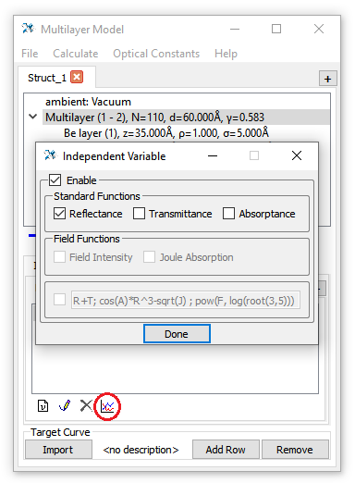

Now we can set the “scan” parameters. In the “Plot_1 R” tab (“Plot_1” is the automatically generated name for this curve; “R” means Reflectance) there are two lines: “Grazing angle” and “Wavelength”. This means that scanning can be carried out by the slip angle of the probe beam or by wavelength. Status “Active” across “Grazing angle” means that the angle scan will be calculated. However, in square brackets there is only one angle value – 90°. Open the editing window “Grazing angle” and set 2000 points in the grid. It will automatically be possible to set a range of angles. Along with this, you can adjust the angular resolution, the size of the beam and the sample.

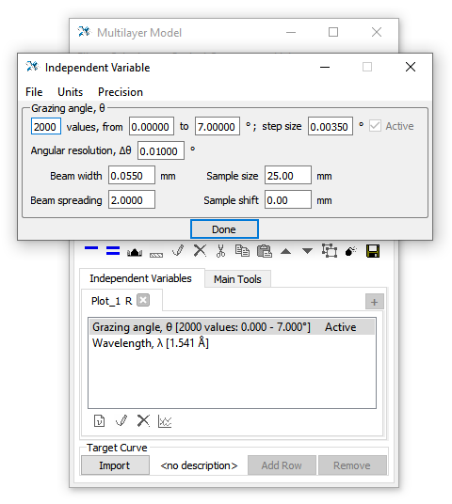

Remain the default value for the wavelength. Since the wavelength is fixed, it is not necessary to set the grid of its values. Now the parameters of the calculation of the reflection curve are set and you can proceed to the calculation.

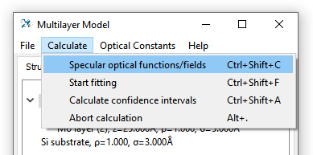

To calculate the reflection, you can open the “Calculate” menu and select the corresponding item. But it is much more practical to use the corresponding keyboard shortcuts, so press Ctrl+Shift+C. The curve is calculated! Where can you see it? In a special window. To open it, go to the “Main Tools” tab next to “Independent Variables” and click the “Graphs” button.

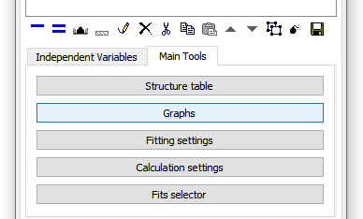

A window with a plot will open. This window can be kept open and the plot will also be updated when the structure is changed and recalculated. Graphs can be presented on a linear and logarithmic scale; the default scale is linear. Using the mouse wheel, you can zoom in or out, separately on each axis. To return to the original zoom at which the entire curve is visible, simultaneously press the scale switch again. This works when the “Rescale” option is on, and also when the option is on, the zoom returns to the original one with each recalculation of the structure. When the option is disabled, the zoom doesn’t change automatically on recalculation and remains custom. The title of each plot indicates the name of the tab in “Independent Variables” and the main parameters of the scan.

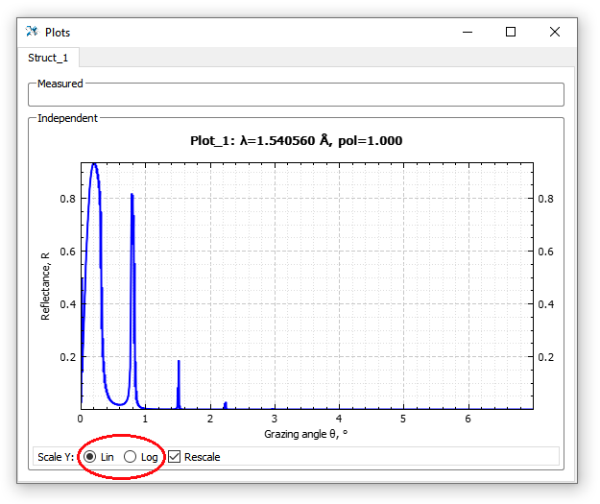

The window is horizontally divided into two sections: “Measured” and “Independent”. The “Measured” section lists the loaded experimental curves and calculated curves on the same grid. In the “Independent” section, only calculated curves on a given grid are presented. There is an invisible separator between the sections; by moving it, you can reduce or completely hide the unnecessary section.

## **Work with structure table**

You can change the structure parameters by clicking on individual elements, and set the desired values in the opened window. But it is inconvenient and inefficient if you need to repeat the procedure at least several times. A more correct way is to use a table in which all numerical parameters describing the structure are presented. You can open it with the “Structure Table” button in the “Main Tools” tab:

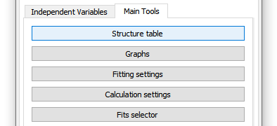

The table contains many fields, so it occupies a considerable area on the screen. The upper part contains a color legend for the parameters and options, allowing more convenient changing the of the parameters values.

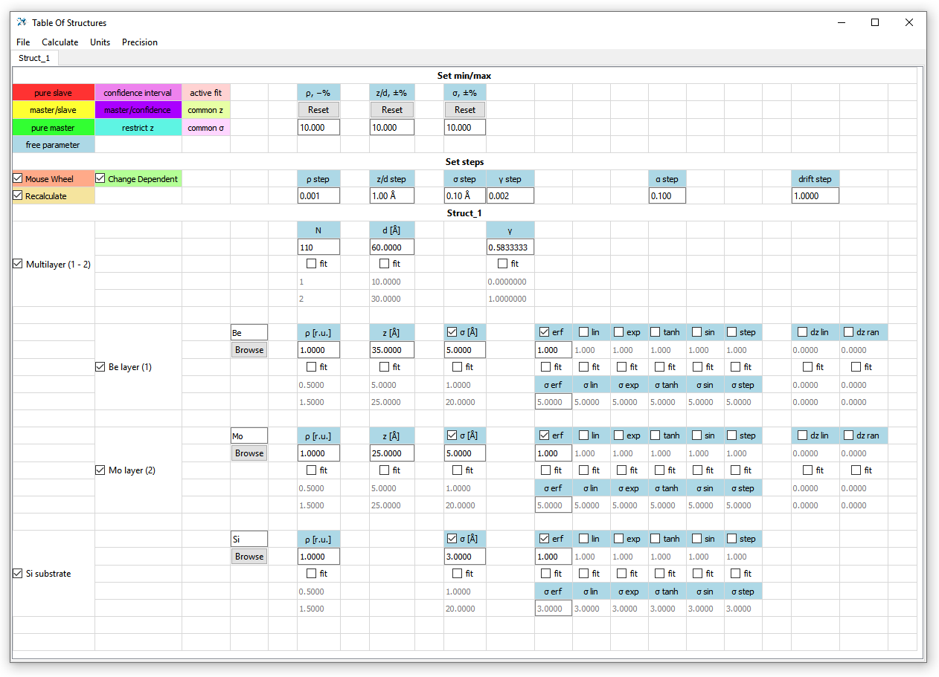

The “Recalculate”  modifier is turned on by default, which means that every time any parameter is changed, the curves are automatically recalculated. This can be easily seen if the graphs window is open and in front of your eyes. You can change values either by typing or by scrolling through the values using the mouse wheel or the Up and Down arrow keys. The parameter change step is set in the “Set steps” section.

## **Inverse problem**

Now we will try to solve the inverse problem: find the structure parameters from the experimentally obtained reflection curve from the Mo / Be mirror. The curve file is called “Sample D364 Mo_Be angular 0.154nm.txt”, it is distributed with the program. To load it into Multifitting and compare the model structure, click on the “Import” button at the bottom of the main window. The “<no description>” label means that no curve is currently loaded.

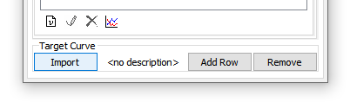

The window that opens serves to import data and specify the parameters at which it was measured, such as the optical function, argument, units of measurement, normalization, polarization, background, parameters of the instrumental function. To load the data, just drag the text file into this window (drag-and-drop). The alternative is to select a file by clicking the “Browse” button or enter the path to the file and click “Read Data”. Also “Read Data” allows you to reload data when an already loaded text file is modified.

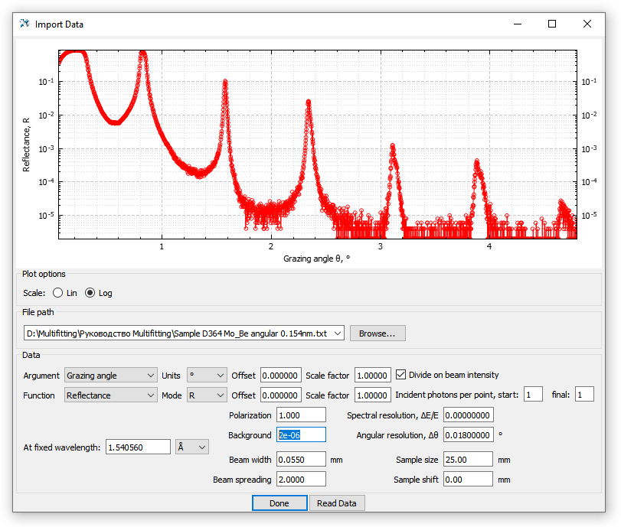

Here we set the value of “Background” to 2×10-6, this will not affect the calculations, but will allow us to limit the range of scales from below. In fact, this is the addition of a constant to the reflection coefficient only to display the calculated curve. The values of the remaining parameters can be left by default. Close the window. Now a brief information about the loaded curve is displayed in the main window in the “Target Curve” area

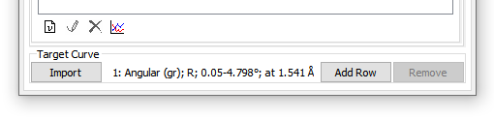

If you now reopen the graph window, then the loaded curve will appear in the “Measured” section. Pressing Ctrl+Shift+C will also display the calculated curve superimposed on the experimental one.

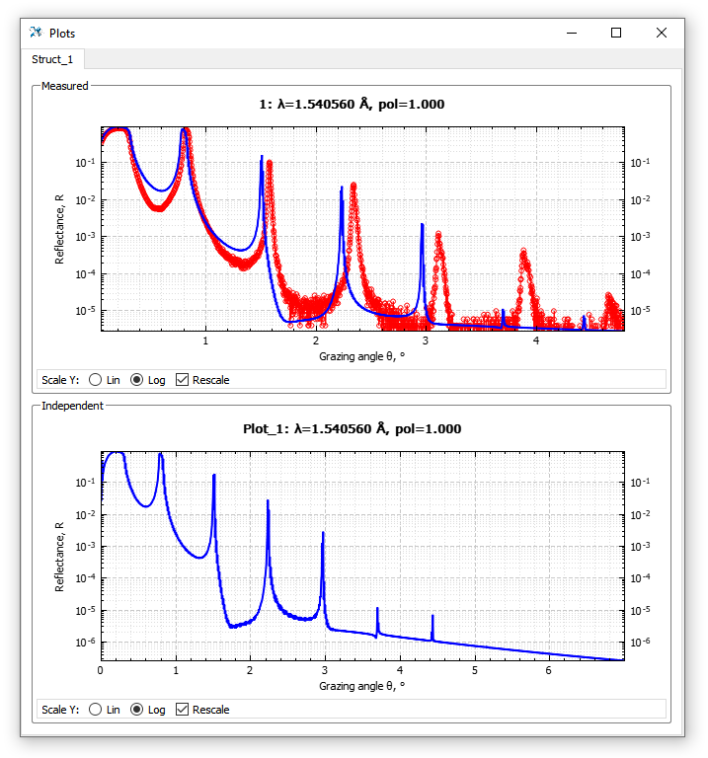

The curve in the “Independent” section will not disappear anywhere. If it is not needed, then its calculation can be turned off so that the calculation goes faster. This can be done in the “Calculation Settings” window in the “Main Tools” tab.

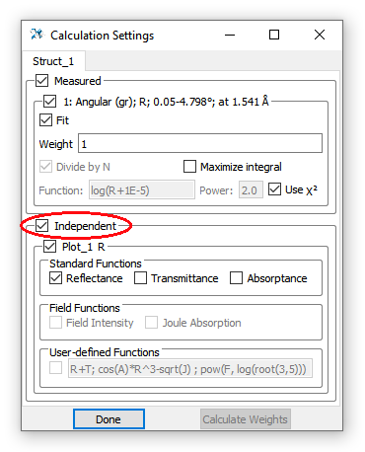

From here you can control all the curves calculated by the “experimental” and “independent” grids. Disable the “Independent” checkbox and hide the corresponding section in the graphs window. Then we work only with an experimentally defined grid and compare two curves – model and measured.

Now, having an open table and graphs before your eyes, you can begin the selection of model parameters. The goal is to find such physically reasonable values ​​for which the reflection curves will be as similar as possible. You can start the selection by manually changing in the table (scrolling with a suitable step) period values, thickness ratio γ (or layer thicknesses separately) and σ values. But you can see that even with a good visual coincidence of the position and (to a lesser extent) the height of the peaks, we get a difference in the shape and width of the peaks. The picture below is an example of such a “coincidence” obtained in the manner described.

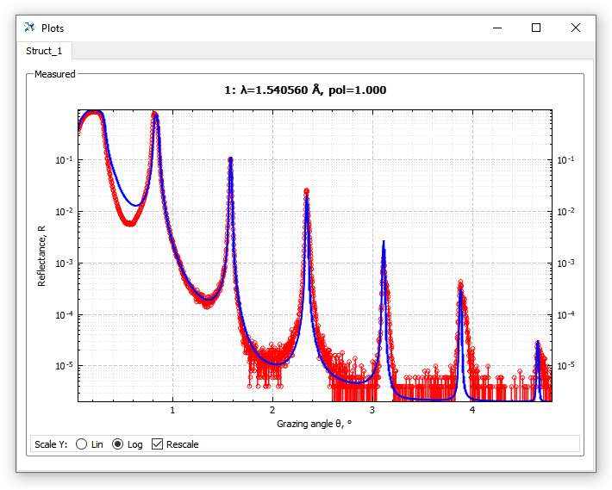

The parameters of the model structure presented on the graph are as follows:

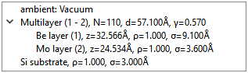

What mismatch between the curves we see? The first is the difference in the region between the critical angle and the first Bragg peak. Here, the simplicity of our model has an effect: the reflection in this area of ​​angles is largely determined by the surface layer of the structure, which is oxidized in air and covered with an adhesive layer of water, hydrocarbons, etc. In the first place, the reflection curve at a wavelength of 0.154 nm is influenced by the thickness of the surface layer. To take into account these effects, at least in the first approximation, the first period of the stack should be replaced with a couple of independent layers, and a BeO layer should be added over the Be layer. To do this, *close the structural table*, select the uppermost structure element with the mouse (this is the ambient) and click the “Add Layer”  icon three times on the toolbar (to add three layers). Layers are always added below the selected element, but above the substrate. You can change the position of an existing selected layer using the “Move up”  and “Move down”  buttons on the toolbar. When the table is open, the toolbar is inactive! This is done to synchronize the structure in the main window and in the table. Therefore, if you cannot add a layer, check if the table window is closed.

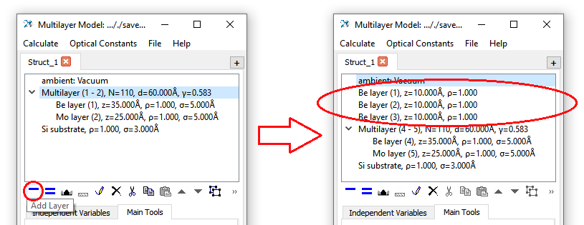

Layer materials should be Mo, Be and BeO, respectively. The thickness of Mo should be set the same as in the stack, and the thickness of Be - less, because part of the beryllium is in the oxide. For example, it is easy to calculate that the oxide thickness is related to the beryllium thickness prior to oxidation as follows: the oxidation of the beryllium layer with thickness *x* produces BeO oxide with a thickness of 1.7*x*.

Bragg peaks are also different. The first peak is shifted by the angle, and the model 4,5,6 peaks are much narrower than the measured ones. Resonances are determined by the periodic part of the structure and therefore they should be adequately described by the presented model. What we did not take into account? That the real structure is not perfectly periodic. In the process of deposition, the pressure of the gases changes, the target erodes, and the growth rate of the films also changes. The easiest to detect is the effect of monotonous increase or decrease in the thickness of the period throughout the depth of the structure. The magnitude of this effect depends on the magnitude of the drift, the number of periods, and the order number of the Bragg peak. Multifitting allows to set such deviations from strict periodicity, so we add them to the stack. To do this, in the structural table turn on the “dz lin” parameter for both Mo and Be layers. This parameter indicates the magnitude of the linear change in the layer thickness with the growth of the period number by one, as a percentage of the nominal layer thickness, from the surface of the sample into depth. This drift can be both positive and negative, i.e. layers can become thicker deep into the stack or thinner. In our case, it follows from the shape of the experimental peaks that the layers on the substrate are thinner than on the surface.

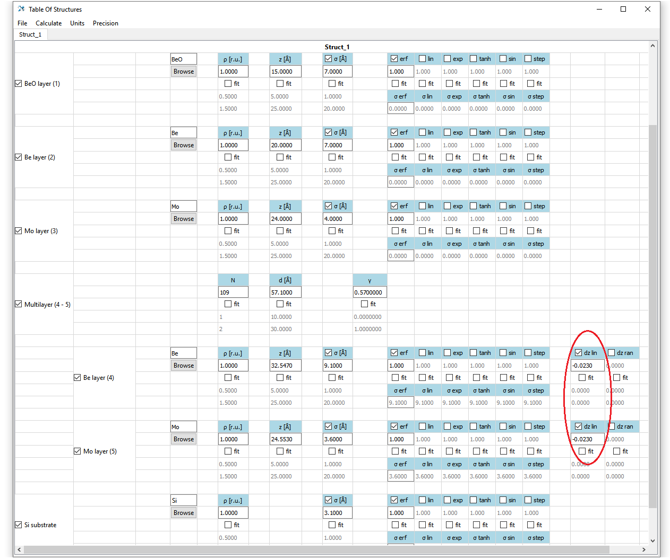

Another factor that influences peak heights and their proportion is the interface type between the layers. By default, the laterally averaged dielectric constant profile is described by the error function *erf* (see the checkmarks in the table in each of the layers), but in reality the shape may differ. You can change the profile view, including other functions (*erf, lin, exp, tanh, sin, step*). The details of the appearance and effects of these functions are described in the following section of the manual. Now it is proposed to simply use them, and, by changing the weights, to observe the effect on the reflection curve. The weight of each function is given under its name. Only the ratios of these values ​​between different functions matter; absolute value is not important. If the weight is zero, then this is equivalent to disabling this profile function.

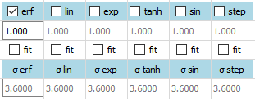

So, now the model structure has become much more complex and multivariate. You can still change the parameters manually and look at the result in real time (and it is always useful to do this at any stage of the reflectometric reconstruction), but the chances of finding the desired parameter region are very small. At this stage, an automated fit becomes necessary. Before proceeding to the automatic fit, you should pay attention to one thing. Although the optimally chosen function of the residual somewhat “aligns” the contribution of the portions of the curves with significantly different reflectance values, but very conditionally. The inequality of different parts of the reflection curve leads to the fact that the algorithm often tries to reduce the discrepancy primarily due to the field of total external reflection (angles 0–0.3 °), often to the detriment of important features of the reflection curve (such as high-order Bragg peaks). To avoid such a conflict, you should take care in advance that in total external reflection area, where the curve depends more on the measurement geometry than on the characteristics of the structure itself, does not have large mismatches. To do this, specify the sample size, the width and shape of the probe beam, the displacement of the sample relative to the center of the beam. An example is shown in the picture below. To find suitable values, you need to keep an open window with graphs and when changing the geometric parameters, recalculate the curve. So that the scale of the curves does not change every time to the original one, you need to turn off the “Rescale” option in the graph window.

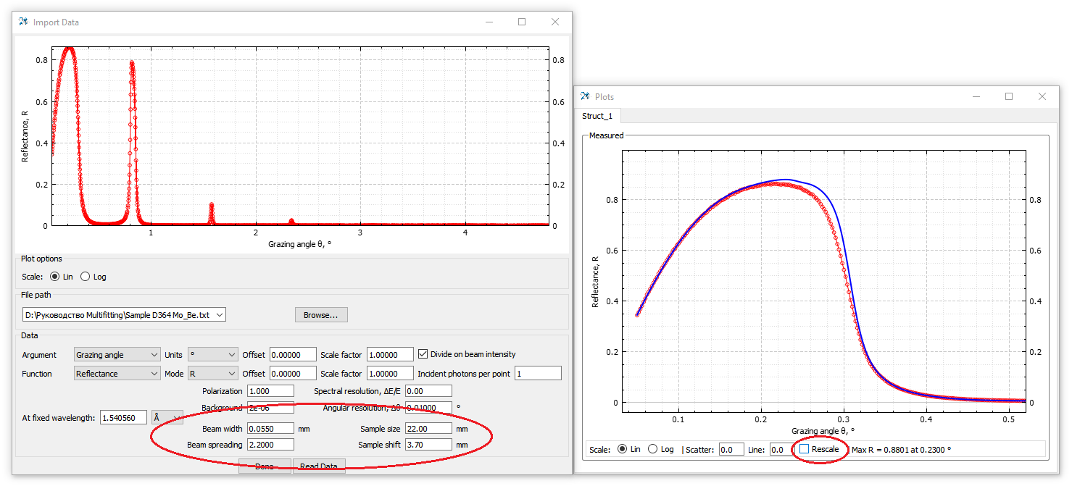

Now prepare the structure for the fitting. First of all, for this you will need to mark in the table the parameters that will be adjusted. For these parameters, you need to enable the “fit”  option and set the lower and upper limits of the search range.

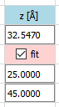

fitting on/off

min

max

current value

Now the table with all the marked fitting parameters and initial values looks like this:

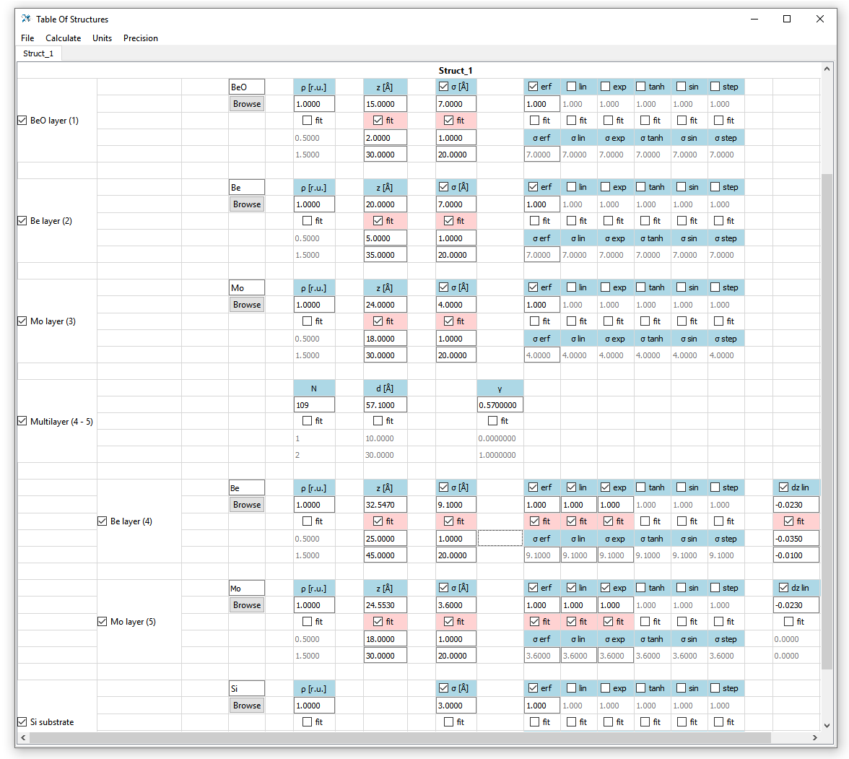

The next step is to enable a fit for this experimental curve and set the residual function. This can be done in the “Calculation Settings” window.

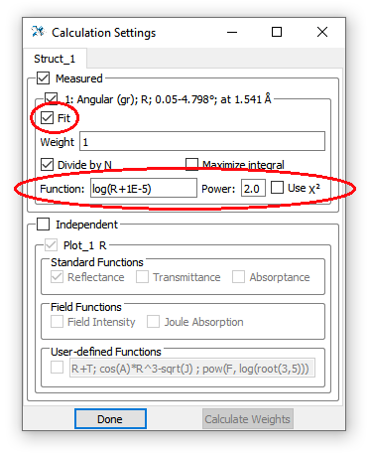

The "Fit" checkbox is checked by default, and the function of the residual can be either chi-square or an arbitrary function (the valid syntax for writing expressions is described in the next chapter). In this case, it is enough to switch to the logarithmic function, turning off “Use χ2” checkbox, and leave the values as is. The algorithm for minimizing the functional of the residual is selected in the special window “Fitting Settings”. The window can be opened from the main window, the “Main Tools” tab.

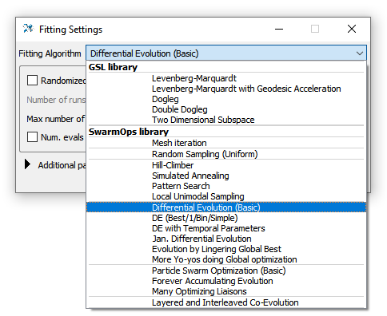

The list contains several algorithms. In the first group there are gradient algorithms “related” to the classical Levenberg-Marquardt algorithm. They perform a “local” search, effectively converging to the nearest minimum of the residual in the parametric space. The second group is global search algorithms: uniform grid search, random search, and genetic (evolutionary) algorithms. The main tool for a task with a large number of parameters is genetic algorithms, therefore we select “Differential Evolution (Basic)”. The other parameters are left by default.

Preparation is over. Now you need to start the fitting by pressing Ctrl+Shift+F or by choosing “Start fitting” in the “Calculate” menu of the main window:

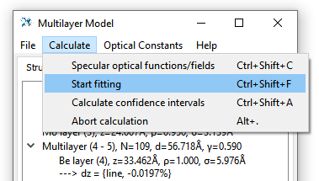

The calculation process displayed in the terminal will proceed. The “iteration” number, the current values of the variable parameters (without decoding) and the current values of the residual are displayed there.

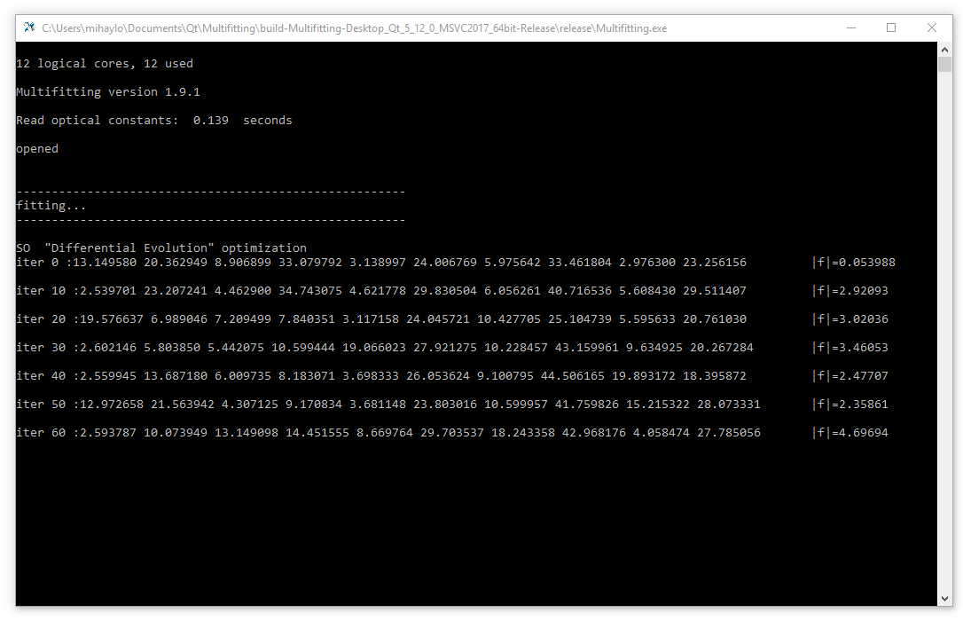

At the end, a comparison of the initial and final residuals will be output to the terminal. The user will be prompted to accept the result or return to the start values. When you click “Yes”, the structure in the table and graphs will be updated.

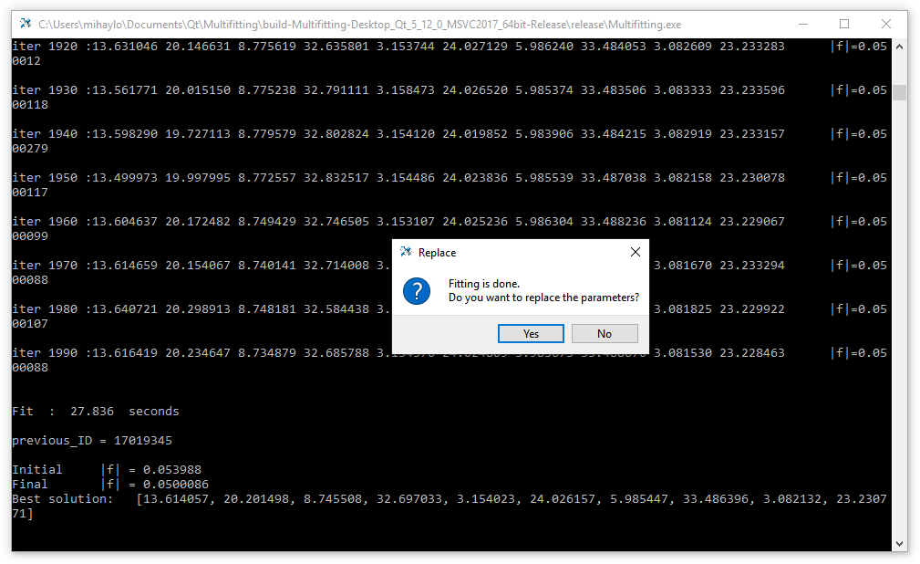

It is not always necessary to adjust all the parameters simultaneously, because if the parametric space is too large, it is more difficult to identify the desired parameter region and the algorithm will converge worse. Therefore, it is necessary to “uncheck” and “check” parameter groups in successive fittings, combining an automatic fitting with manual parameter changes, residual correction, etc. With one run, you can get an acceptable curve fit only for very simple structures with a minimum of parameters. In the general case, fitting is an iterative process and requires manual intervention. As a result of this combined search, you can get about the following picture:

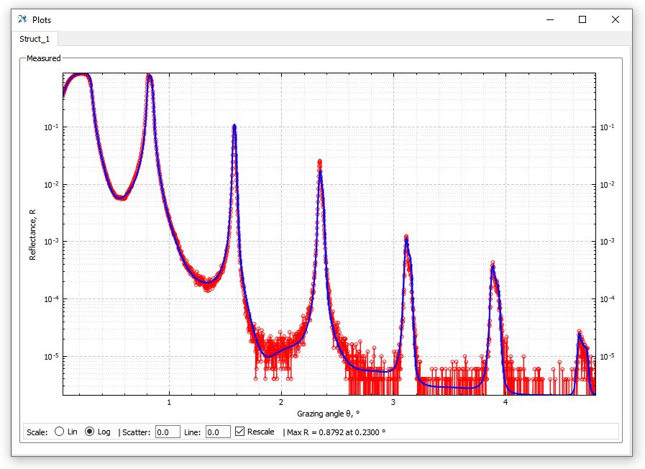

The found structure corresponding to the picture above has the following parameters:

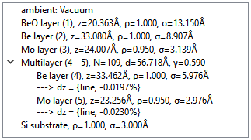

The main question: does the coincidence of the reflection curves mean the truth of the parameters found? No, it does not, but it is a weighty argument for operating with the values found in further work. Assessing the reliability of certain data requires some experience with such “reconstruction” work; it is also highly desirable to involve the results of additional sample studies.

## **Additional experimental curves**

First of all, reflectometry curves of the same sample, made with other measurement parameters, can be considered as such additional studies. For example, for the Mo/Be mirror under consideration, this is a spectral reflection curve obtained at an angle close to the normal. Let’s add this curve to Multifitting. To do this, click on the “Add Row” button at the bottom of the main Multifitting window on the existing experimental curve. Another line will appear in which you can load the experimental curve in the same way as it was done the first time.

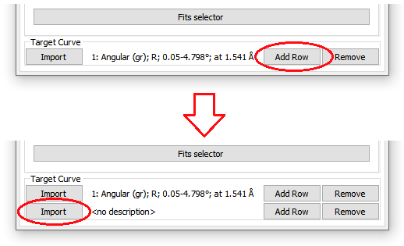

After clicking on the “Import” button, the corresponding window opens, in which you should “drag” the file with the second curve, “Sample D364 Mo_Be spectral 88deg.txt”, which is also attached to the program.

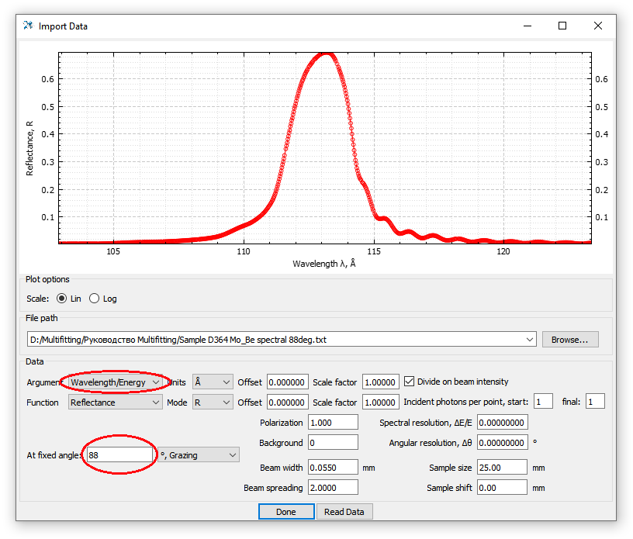

Compared with the default parameters, you should change the argument type to “Wavelength/Energy”, make sure that the units of the argument are “Å”, since the wavelengths are given in angstroms in this file, set the grazing angle to 88°. Now you can close the import window and open the “Plots” window to see two curves at the same time.

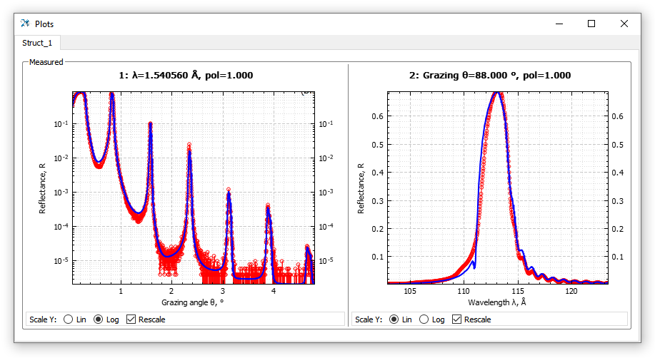

Now, with each change in the parameters, the differences between the experimental and model data in two types of measurements are visible. In the “Calculation Settings” window, options for both curves are now available. You can fit two curves at the same time if both have “Fit” checkboxes turned on; the total residual is the sum of the residuals of each curve with the corresponding weight, which can also be set in the “Weight” field.

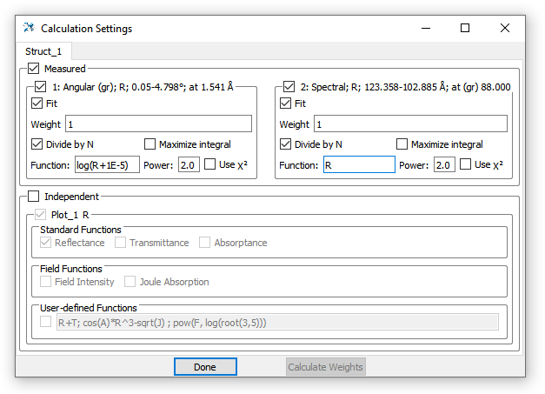

If you want to consider only one curve, then the other can be temporarily disabled by unchecking  or . For a disabled curve, no calculation will be made and no graph will be displayed.

## **Setting aperiodic structure**

Now we will demonstrate the work with aperiodic structure. Obviously, any layered structure can be created by adding separate independent layers, however, the definition of such a structure and work with it are extremely labor intensive. Therefore, to set aperiodic and work with it, Multifitting has special features. Let’s make the Mo/Be mirror aperiodic. To do this, open the “Multilayer (4 - 5), N = 109, d = 56.718Å, γ = 0.590” item in the main window by double-clicking or clicking the “Edit” icon . In the window that opens, check the “Make regular aperiodic” box and confirm the change.

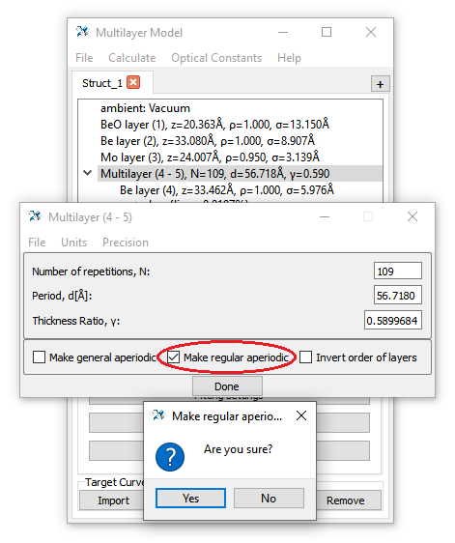

The type of structure will change, along with this the information displayed about the layers will change.

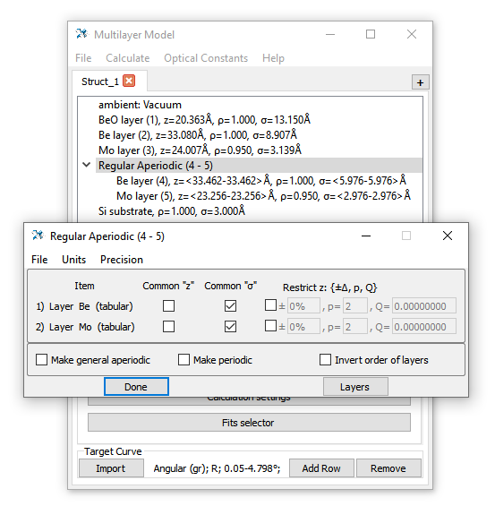

“Regular aperiodic” is a structure with an integer number of unit cells; the corresponding layers from different cells can differ only in thickness and interface width. The material and density of the layers are the same throughout the depth of the structure. Therefore, the range of thicknesses and roughness is shown in the main window. In the “Regular aperiodic” window that opens, the item “Common σ” means that the interfaces are the same in depth of the structure. Accordingly, if all the checkboxes “Common z” and “Common σ” are checked, then this will be a periodic structure. Close the window, open the structural table.

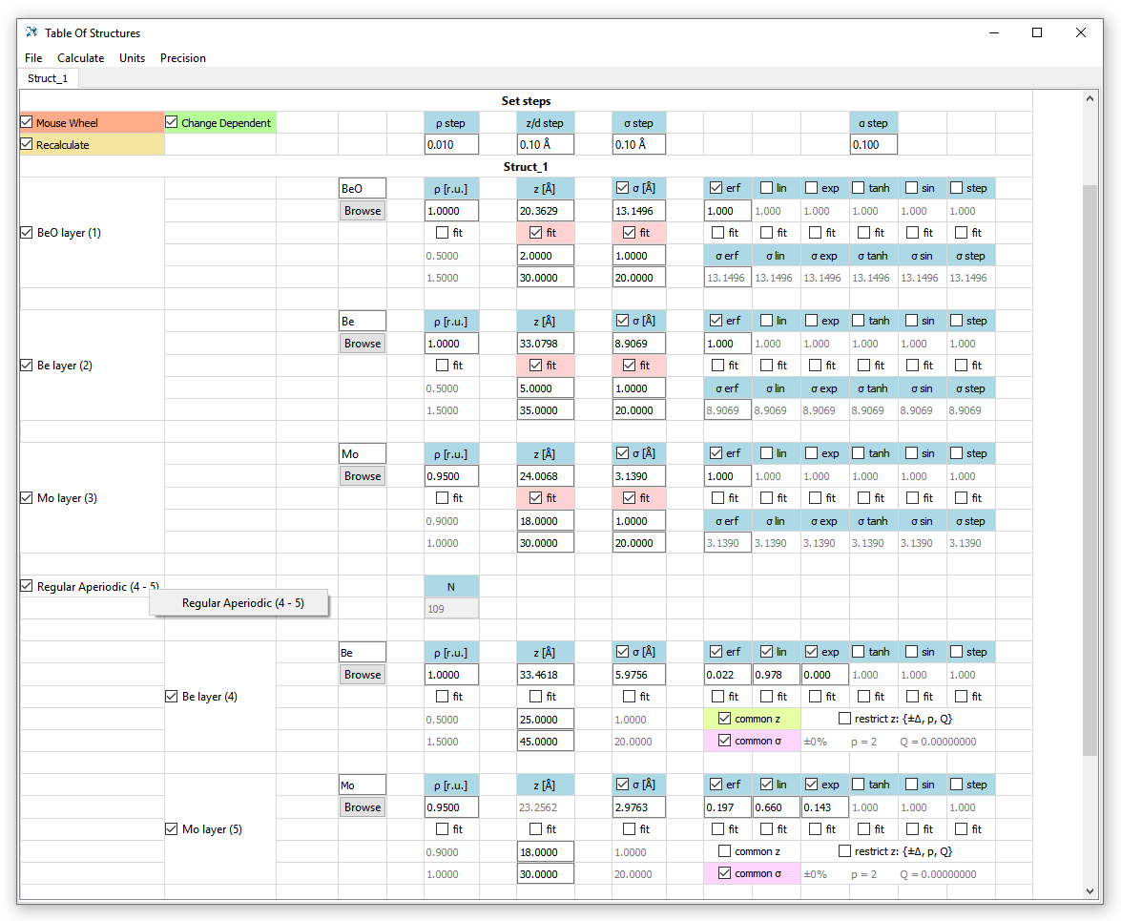

Some of the options have changed in comparison with the periodic structure. Now for aperiodic layers it is possible to impose and dispose of the condition of uniform thickness and interfaces. To set individual thicknesses (and interfaces) of layers, you need to open a special auxiliary table. Right-click to open the context menu on the name of the structure element “Regular Aperiodic (4 - 5)”  and click on the menu item. In the opened table all layers of aperiodic structure are shown. Color legend denotes the presence of links between the respective layers. If there is a link, then when the thickness/interface of one layer changes, the values ​​of all other layers change automatically. Layer thicknesses can be individually marked as variable. Interfaces can vary (with automatic fitting) only altogether, regardless of the links.

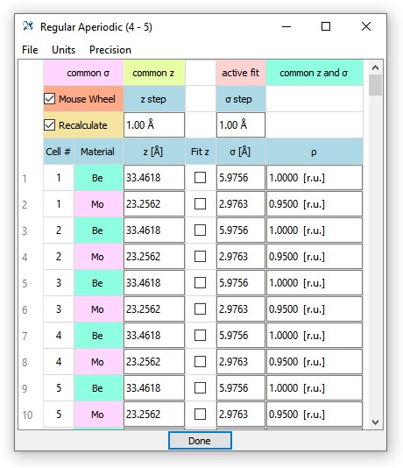

The parameters of the aperiodic structure layers can be set manually or loaded from a text file. The file needs to be dragged (drag-and-drop) to the “Regular Aperiodic” table. The format of the file with parameters is completely analogous to that in IMD, the number of layers in the file must correspond to the one specified in the structure parameters:

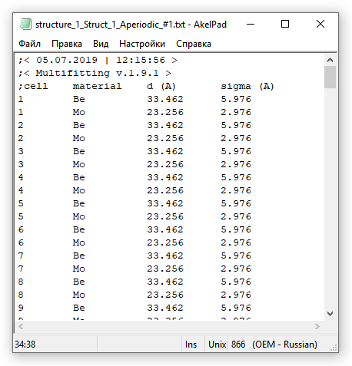

When importing, you need to specify which columns are present in the data file and which length units are used:

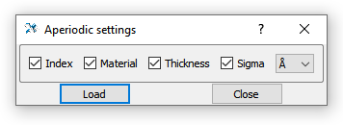

## **Save and load**

Multifitting saves the data in binary format, the files have the extension “.fit”. You can save the structure by selecting the item in the “File” menu or by pressing the corresponding key combination. “Save” saves to the *last opened file*. If there was no previous file (i.e. the structure was created “from scratch”), the file “save_v.X.Y.Z.fit” will be created in the folder with the executable file (X.Y.Z is the version number of the Multifitting). “Open last”, as the name suggests, opens the last file that was being worked on. If this is not the case, the file “save_v.X.Y.Z.fit” will be opened. If it also does not exist, it will be reported.

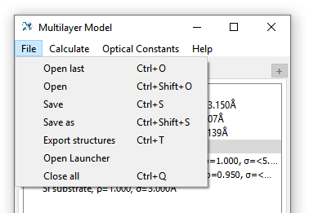

You can also open a file simply by drag-and-drop it onto the main Multifitting window.

This chapter allows you to start using Multifitting and gives an idea of the nature of working with it during the reflectometric reconstruction of multilayer nanofilms. Not all features of the program are reflected here, but the basic cycle from setting some initial model to getting a result is presented here.

If you have problems with this miniature guide or any transitions are too complicated and not obvious – report it and the instruction will be updated. The most detailed description of all aspects of Multifitting is presented in the next chapter.

**Detailed description**

< in progress >

**Version history**

* Multifitting v.1.9.2 – release (*06.07.2019*).
* Multifitting v.1.10.0 (*19.10.2019*):
  + Various bugs fixed.
  + The graphical interface now supports scaling from the operating system.
  + Updated angular and spectral resolution. Now the resolution values ​​that were set in versions ≤1.9.2 should be multiplied by 2. Now the thin line is blurred into a wide one with FWHM ≈ the given resolution.
  + Angular and spectral resolution each act on both types of curves: spectral and angular (according to a simplified scheme).
  + The initial and final intensities of the probe beam with linear interpolation between them are specified.
  + Warning when overwriting files from previous versions.
  + Additional options are available for graphs: header with measurement parameters, logarithmic scale for the X axis.
  + Information can be shown/hidden in the Settings window of the context menu of the “Plots” window.
  + Instant recalculation when switching on/off structural items in the table if the "Recalculate" modifier is enabled.
  + The plots in the “Plots/Measured” window are assigned serial numbers that allow you to correlate the curve with the loaded data.
  + Added the ability to maximize the integral under the reflection curve with the source function.
  + Added settings for fitting algorithms.
  + Decimal separators in data files - dots and commas.
  + Files added to the database of optical constants: Cr_delmotte.nk, Pt_soufli.nk, Be_svechnikov.nk
* Multifitting v.1.10.2 (*21.02.2020*):
  + Various bugs have been fixed, including a fitting bug for a scaled experimental curve.
  + Files Sc_larruquert.nk, ScSi.nk, Sc5Si3.nk and Sc3Si5.nk were added to the database of optical constants, the range of MoSi2.nk was extended, the range of Sc.nk was extended
  + Subrange of experimental data can be set for fitting.
  + The ability to duplicate structure tabs has been added
  + Visualization of structure profile has been added
  + The ability to calculate the permittivity profile with its slicing division into thin sublayers has been added.
  + The ability to export an already loaded experimental curve back to a text file has been added.
  + The ability to fit a scaling intensity factor for experimental curves has been added.
  + It is possible to eliminate the moiré distortions of the calculated curve arising when the period of oscillations of reflection from thick structures is almost a multiple of the step of the experimental curve.
  + An automatic calculation of the spectral width of the reflection peak when calculating the corresponding curve has been added.

**References**

1. D. Windt, "IMD—Software for modeling the optical properties of multilayer films," Comput. Phys. **12**(4), 360 (1998).

2. M. Björck and G. Andersson, "GenX : an extensible X-ray reflectivity refinement program utilizing differential evolution," J. Appl. Crystallogr. **40**(6), 1174–1178 (2007).

3. G. Vignaud and A. Gibaud, "REFLEX : a program for the analysis of specular X-ray and neutron reflectivity data," J. Appl. Crystallogr. **52**(1), 201–213 (2019).

4. C. Durniak, M. Ganeva, G. Pospelov, W. Van Herck, J. Wuttke, and D. Yurov, "BornAgain — Software for simulating and fitting X-ray and neutron small-angle scattering at grazing incidence," http://www.bornagainproject.org (n.d.).

5. M. Svechnikov, "Multifitting : software for the reflectometric reconstruction of multilayer nanofilms," J. Appl. Crystallogr. **53**(1), 244–252 (2020).