run

cmd

diskmgmt.msc

select c drive -> right click shrink volume

Ubuntu requires atleast 25GB we we allocate 30GB

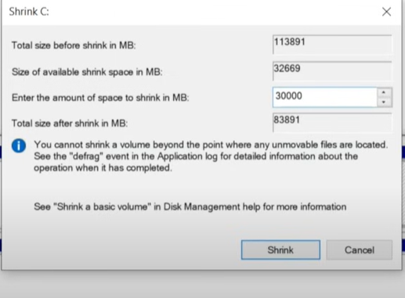

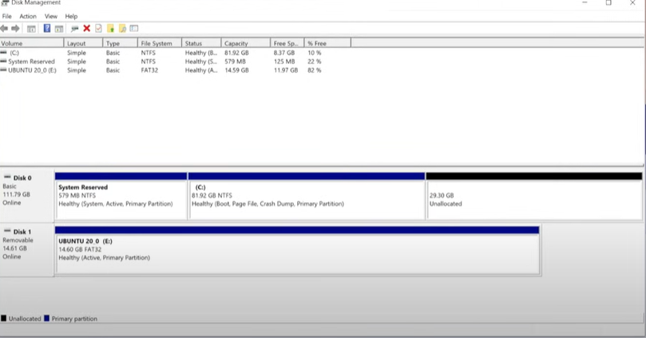

Installing unbunt

Restart computer

While rebbotig laptop press F10

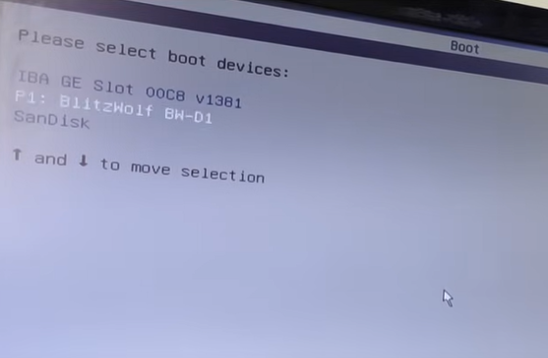

Click on install

Choose English

Keyboard layout English US

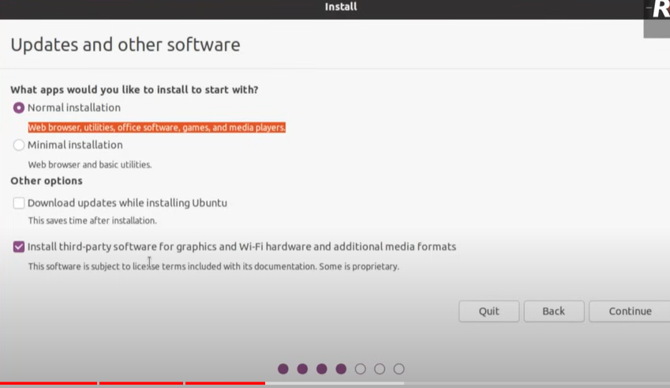

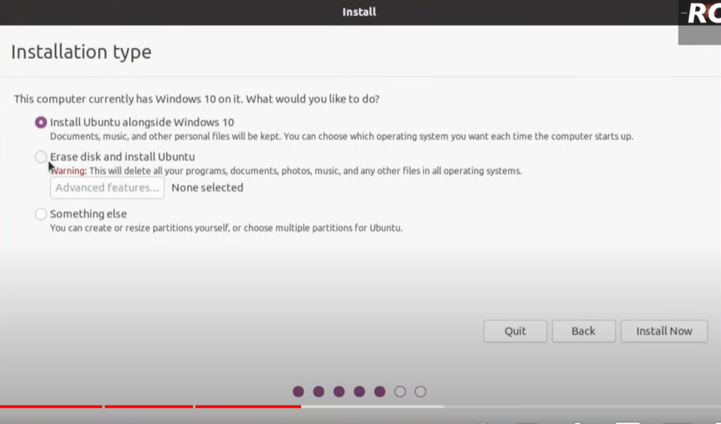

For now we are selection something else click on continoue

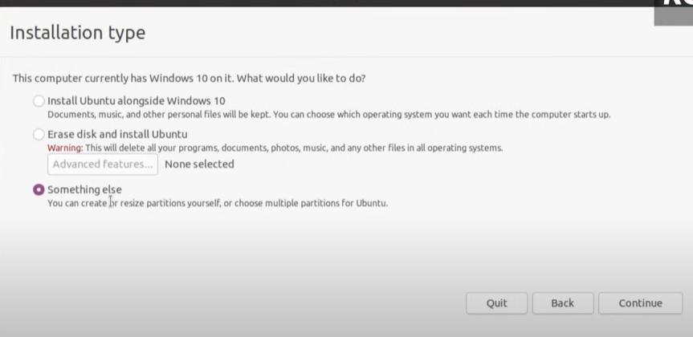

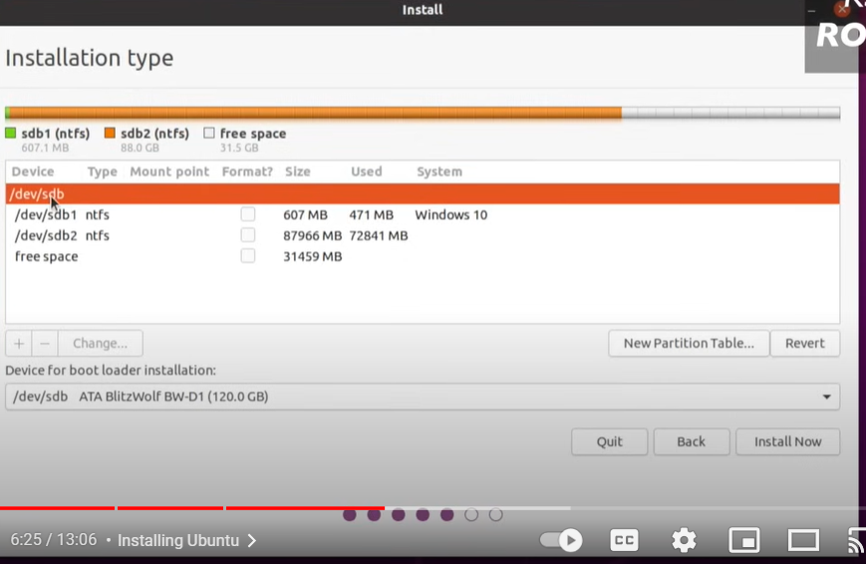

Click on free space

Click on + button

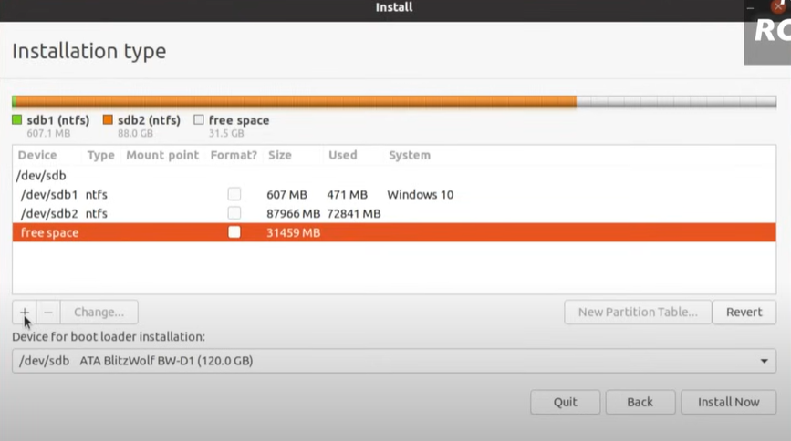

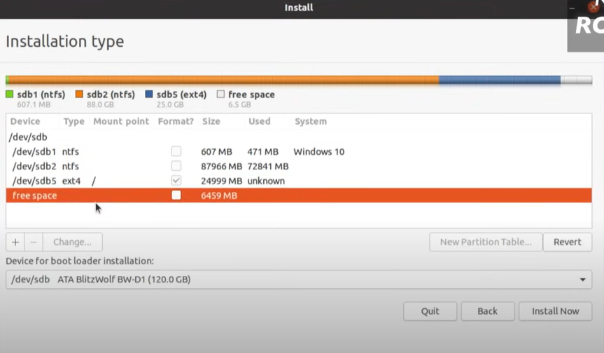

Again click on frees space and + button

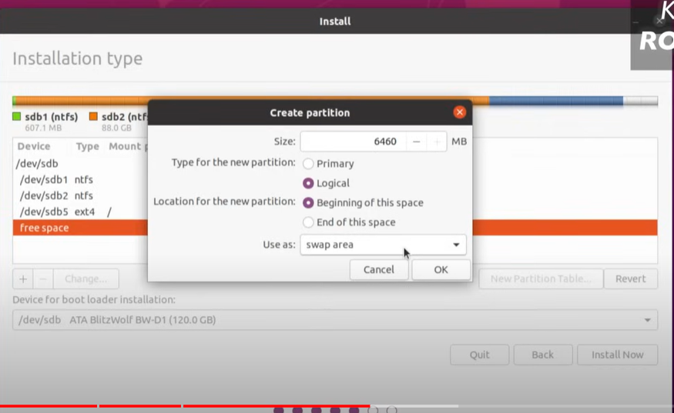

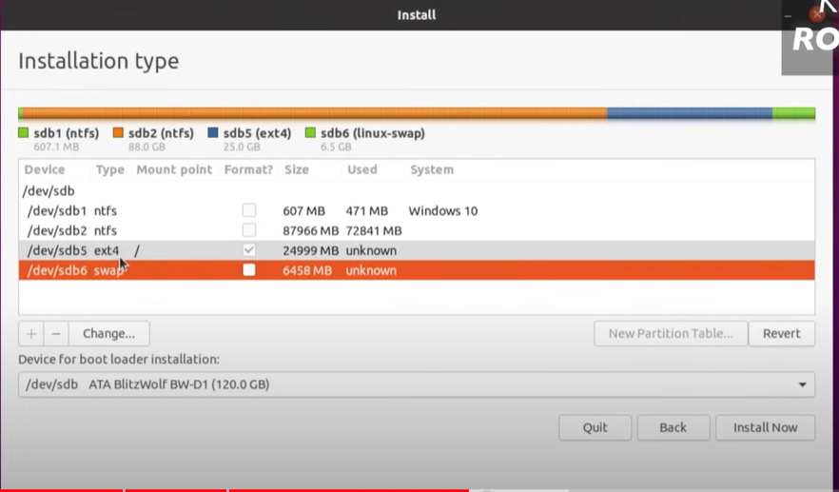

To create a swap memory space

Device boot loader is important do it carefully

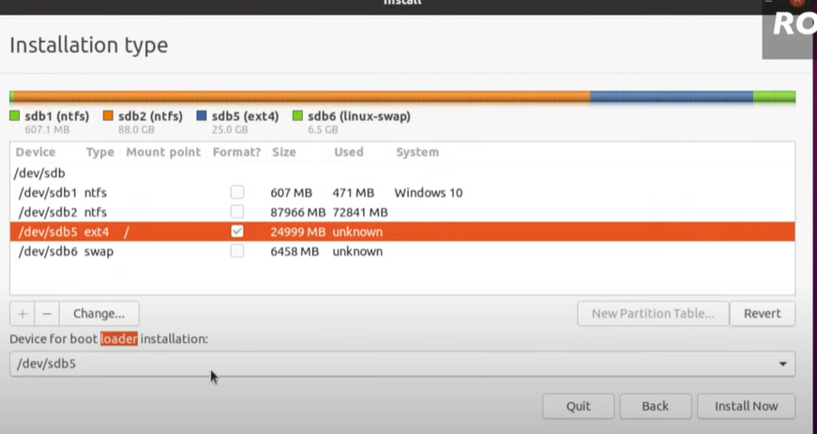

Click on install option

Click on continue

Select time zone

Kolakta india

Provide user name and password

Restart computer by remove the pendrive

We will login to windows

Now we need to configure dual boot

Install Easy BCD software