**Display Connector**

1. Operation for Shroff office RW 2

2. Sample Json 2

a. Display Template for Shroff office 3

b. Display template for gate octopus 6

## Operation for Shroff office RW

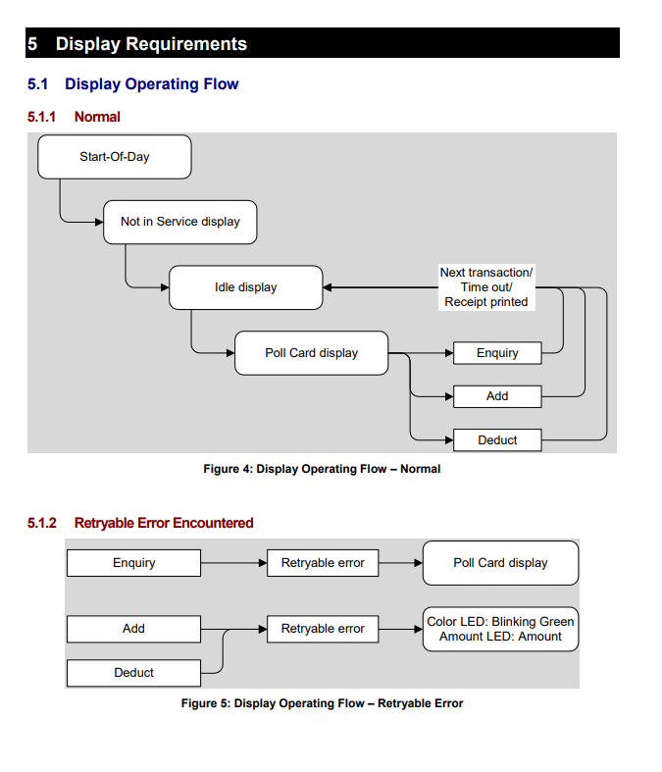

## Sample Json

Connection Id : entrance ID

{

"templateId":0,

"templateName":"Welcome Screen",

"messageEN":"welcome to use",

"messageCN":"welcome to use",

"entranceId":"c61fd54c-5b8f-405b-9777-a56d073a5cf6",

"entranceName":"Entry-Test",

"entryTime":"2021-06-11 08:04:25",

"exitTime":"2021-06-11 10:04:25",

"estTime":60,

"parkingTime":90,

"error":0,

"octopusData":[

{

"OctopusType":0,

"RemainValue":382.6,

"ProcessAmount":100,

"AutoPayValue":250

}

]

}

### Display Template for Shroff office

Request SignalR: /workstation-display-hub

|  |  |  |  |  |  |
| --- | --- | --- | --- | --- | --- |
| **Template Number** | **Template Name** | **Category** | **Display Example** | **Chinse** | **Json Fields** |
| 1 | Idle, Not in service, Card Type=1 when enquiry |  |  |  |  |
| 2 | Enquiry | Poll |  |  |  |
| 3 | EnquiryResult | Poll |  | 餘額 | Remain Value: octopusData.RemainValue |
| 4 | AddValue | Add Value |  | 請拍卡  金額 | Amount: octopusData.ProcessAmount |
| 5 | AddValueSuccess | Add Value |  | 交易摘要  增值金額  餘額 | Add Value Amount:  octopusData.ProcessAmount  Remaining Value: octopusData.RemainValue |
| 6 | DeductValue | Deduct Value |  | 請拍卡  金額 | Amount:  octopusData.ProcessAmount |
| 7 | DeductValueSuccess | Deduct Value |  | 交易摘要  交易金額  餘額 | Transation Amount: octopusData.ProcessAmount  Remain Value:  octopusData.RemainValue |
| 8 | DeductValueSuccessWithAutopay | Deduct Value |  | 交易摘要  自動增值  交易金額  餘額 | Auto Reload Amount: octopusData.AutoPayValue  Transaction Amount: octopusData.ProcessAmount  Remain Value:  octopusData.RemainValue |
| 9 | DeductValueSuccessNetgativeValue | Deduct Value |  | 交易摘要  交易金額  餘額  請增值 | messageEN  messageCN  Transaction Amount:  octopusData.ProcessAmount  Remaining Value:  octopusData.RemainValue |
| 10 | DeductValueFailInsufficient | Deduct Value | Error code:100048 |  | messageEN  messageCN  Remaining Value:  octopusData.RemainValue |
| 11 | DeductValueFailInvalidCard | Poll/Add Value/Deduct value | Error code:100019 |  | messageEN  messageCN |
| 12 | Retry | Poll/Add Value/Deduct value |  |  | messageEN  messageCN |
| 13 | Error | Poll/Add Value/Deduct value |  |  | messageEN  messageCN |

### Display template for gate octopus

Request SignalR: /gate-monitor-hub

|  |  |  |
| --- | --- | --- |
| Template Number | Template Name | Screen |
| 1 | Ready |  |
| 2 | TapCard |  |
| 3 | Entry |  |
| 3 | Entry  [octopusData.cardType]=1 |  |
| 4 | Exit |  |
| 4 | Exit  [octopusData.cardType]=1 |  |
| 5 | CallSuport | Turn outer boarder to Red when [error] equals 1. |