This plugin works together with the address field and can display the address directly on a map, all you need is:

* Google Maps Embedded API Key
* One Address field on the Form
* Use the "Formatted Adress" Variable to send the address.
* You can add your own placeholder text.

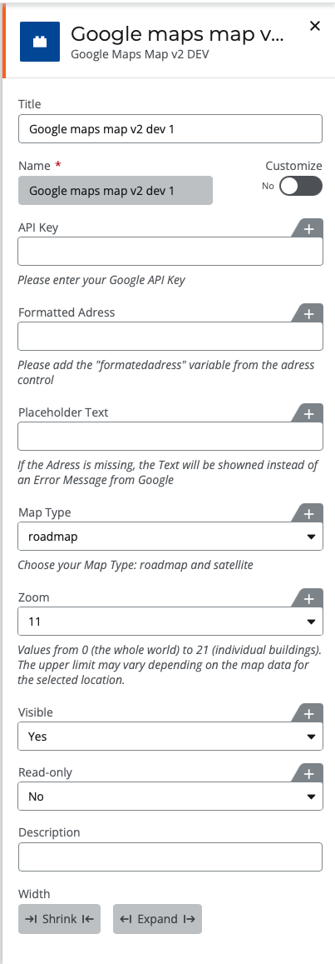

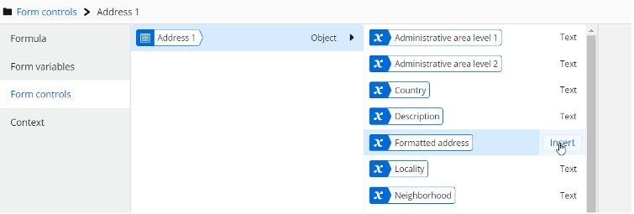

### Using this Plugin

To evaluate and try this plugin you will need two items, the source URL to the plugin:

https://plugins.ntxgallery.com/assets/Plu.....

And the element name:

googlemap-maps

Both of these need to be filled in when adding the plugin.