Seed surface sterilization for *Artemisia tridentata* ssp. *tridentata*

Prepared by: Peggy Martinez

Adapted from: Dr. Marcelo Serpe

Date of last revision: 4/16/19

The purpose of this protocol is to surface sterilize seeds, thereby reducing chance of contamination when starting plants in culture. Surface sterilization needs to occur in a laminar flow hood. Before beginning, have ~500 mL of DI water, 200mL beaker and 50 mL beaker autoclaved. Seeds must be placed in culture immediately after sterilization.

**Equipment:** **Reagents:**

1 L flask or beaker (for autoclaved DI water) 0.1% Triton X-100 (CAS 9005-64-5)

200 mL beaker (autoclaved) 10% Bleach solution

50 mL beaker (autoclaved) 70% Ethanol (spray bottle)

Dissecting scope 95% Ethanol (falcon tube or coplin jar)

Glass petri dish

160 µm cheese cloth

Cut falcon tube with lid hollowed out (see attached picture)

Long, thin forceps

Support stand

Clamp (attaches to support stand)

Timer (phone will do)

Laminar Flow Hood

**Step 1 (count seeds) ~1 hr:**

* Pour small amount of seeds into plastic weigh boat or glass dish.
* Using dissecting scope and forceps, count and place seeds into another glass dish.

**NOTE:** For *Artemisia tridentata* ssp. *tridentata* there is ~50% germination rate of seeds.

**Step 2 (wash seeds) ~1.5 hrs:**

* Place 160µm cheese cloth into lid of falcon tube (see attached picture)
* Place seeds into falcon tube, onto cheese cloth.
* Secure falcon tube to support stand using a clamp and place under running DI water.
* Make sure water is running over cheese cloth, “washing” the seeds.

**NOTE:** Washing seeds for 3 hrs has been done in the past, 1.5 hrs seems to be sufficient.

**Step 3 (while seeds are washing):**

* If using a bead sterilizer, turn on (takes about 45 min to warm up)
* Take doors off Laminar Flow hood, turn on lights, fan, and power outlet

**Step 4 (Aseptic techniques for laminar flow hood):**

* Bring all items that need to be placed into the hood near the hood.
* Spray 70% ethanol all over the inside of the hood, wipe down.
  + Wipe all flasks and beakers that go into the hood with 70% ethanol.
  + Spray gloved hands with ethanol.
* Place forceps in falcon tube containing 95% ethanol and let sit for a minute.
* Wipe bottom and sides of 200mL beaker with 70% ethanol, bring into hood and add ~100 mL bleach/TritonX solution.
* Bring in washed seeds (keep in falcon tube)
* Place forceps in bead sterilizer for ~30 seconds, dip again in 90% ethanol tube to cool.
* Spray gloved hands with 70% ethanol.

**Step 5 (surface sterilize seeds) 10 min:**

* Keeping seeds in the falcon tube, place entire device into 200 mL beaker with bleach/TritonX solution.
  + You can leave the forceps in the falcon tube to weigh down the device.
  + Set timer for 10 minutes.
  + Stir once in a while.

**Step 6 (rinse seeds) ~20 min:**

* Place falcon tube with seeds into 50 mL beaker, pour enough autoclaved water over seeds to thoroughly cover seeds. Rinse for 5 minutes. Remove falcon tube (using forceps) and pour off rinse water into 200 mL beaker.
  + Repeat this step until seeds have been rinsed 4 times for 5 minutes each.
* Seeds are now ready to be placed in culture

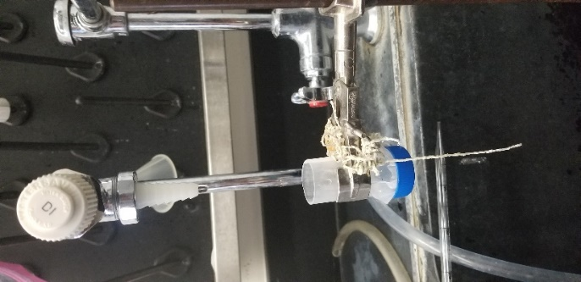

Figure 1: Rinsing seeds in falcon tube.

