

**Name: -** S.Venkat.

**Registration No: -** 1183610.

**Section: -** K18PA.

**Roll No: -** 42.

**Course Code: -** CSE316.

**Course Instructor: -** Suruchi Talwani.

**Academic Task No: -** 12.

**Academic Task Title: -** LRTF (Longest Remaining Time First)

**GitHub Link: -** <https://github.com/svenkat143?tab=repositories>

**Emai ID: -** [svenkat.kgp@gmail.com](mailto:svenkat.kgp@gmail.com)

**Date of submission: -** 19-04-2020.

**Declaration:**

I declare that this Assignment is my individual work. I have not copied it from any other student‟s work or from any other source except where due acknowledgement is made explicitly in the text, nor has any part been written for me by any other person.

**Student’s Signature: S.Venkat.**

**Learning Outcomes:**

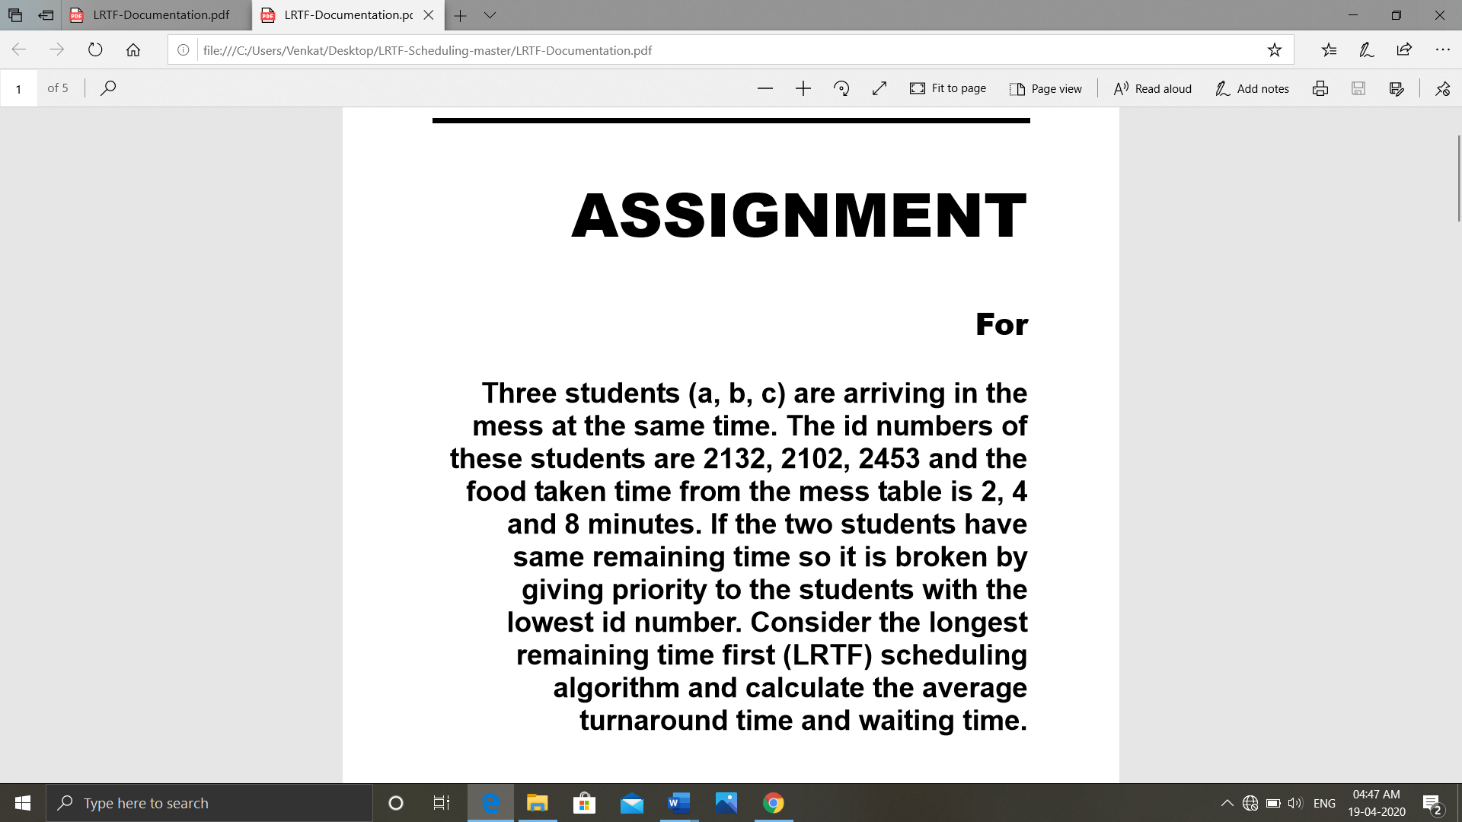

**Contents: -**

|  |  |  |
| --- | --- | --- |
| ***S.NO.*** | ***Topic.*** | ***Page no.*** |
| **1.** | **Introduction.** |  |
| **1.1** | **Overall explanation of the question: -** |  |
| **1.1** | **Purpose.** |  |
| **1.2** | **Minimum Requirements and Suggestions for Learning .** |  |
| **2.** | **Full description.** |  |
| **2.1** | **Conditions of Use.** |  |
|  | **Algorithm.** |  |
| **3.** | **CPU Configuration | Longest Remaing Time (LRTF) algorithm.** |  |
| **3.1** | **Applied Algorithms.** |  |
| **3.2** | **Procedure.** |  |
| **3.3** | **Gantt Chart.** |  |
|  |  |  |
| **4.** | **Method.** |  |
| **4.1** | **Common Usernames.** |  |
| **3.2** | **Methods used.** |  |
| **5.** | **SnapShots of LRTF Working.** |  |
|  |  |  |
|  | **Revisions on GitHub.** |  |
|  |  |  |

**1.Introduction.**

**1.1 Overall explanation of the question: -**

In the above question it has been mentioned that 3 students with names a, b, c are daily appearing into their hostel mess all at the similar timings. The details of id card Nos of all the 3 students are given as 2132, 2102, 2453 and the time taken out for the food to reach from the mess table to the student is 2, 4 and 8 minutes. According to the question it is given that 2 students among the 3 have the similar Remaining Time(RT) hence such case is cracked down by initialising specific priority to each of the students based on their lowest id nos. It is also said that the question should be solved out with the help of the longest remaining time first (LRTF) scheduling algorithm and finally the average Turn Around Time(TAT) and Waiting Time(WT) should be calculated out.

**1.2 Purpose**

This text document describes the Presentation and Specification of the LRTF (longest remaining start time) CPU Scheduling algorithm and calculate out the average turnaround time and the average waiting time.

In-order to explain the complete concept of LRTF (Longest Remaining Time First) We took an issue like,

If these two students have the same remaining time when they both are compared with each other then the condition is completely violated by giving the priority to the students with a lower ID number.

**1.3 Minimum Requirements, Study Suggestions and The basics to solve the given problem are: -**

* DESCENT LAPTOP OR PC
* The Assignment project provided is completely developed in Dev C++ IDE using the C language.
* Largest Remaining Time First(LRTF) method is used to complete the project.

**2. Overview.**

**2.1 Testcases that are to be achieved out in the code: -**

* The user should be able to provide input (sitting on the computer).
* The data entered by the user should be calculated out using the Largest Remaining Time First(LRTF) method algorithm.
* The board should always be printed out all the time which shows out all the no of students along with their IDs are to be displayed.
* The user should be able to get the Average Turn Around Time(TAT) and the Average Waiting Time(WT).

**2.2 Algorithm: -**

* Step-1: Create a complete process framework which contains out all the necessary required fields such as Arrival Time(AT), Burst Time(BT), Completion Time(CT), Turn Around Time(TAT), Waiting Time(WT).
* Step-2: Sort the data by their Arival Time(AT).
* Step-3: Find the process with the Greatest Burst Time and use each unit during the time of its execution. Now Increase the total time by 1 and reduce the Burst Time for that process by 1.
* Step-4: If any process is left at 0 Burst Time(BT), then update the Completion Time(CT) of that entire process and the CT will become the Total Time of the process at that time
* Step-5: After calculating the Completion Time(CT) for each procedure of the process, find the Turn Around Time(TAT) and Waiting Time(WT).

**3. CPU Configuration | Longest Remaining Time (LRTF) algorithm**.

**3.1 (Algorithms Used):**

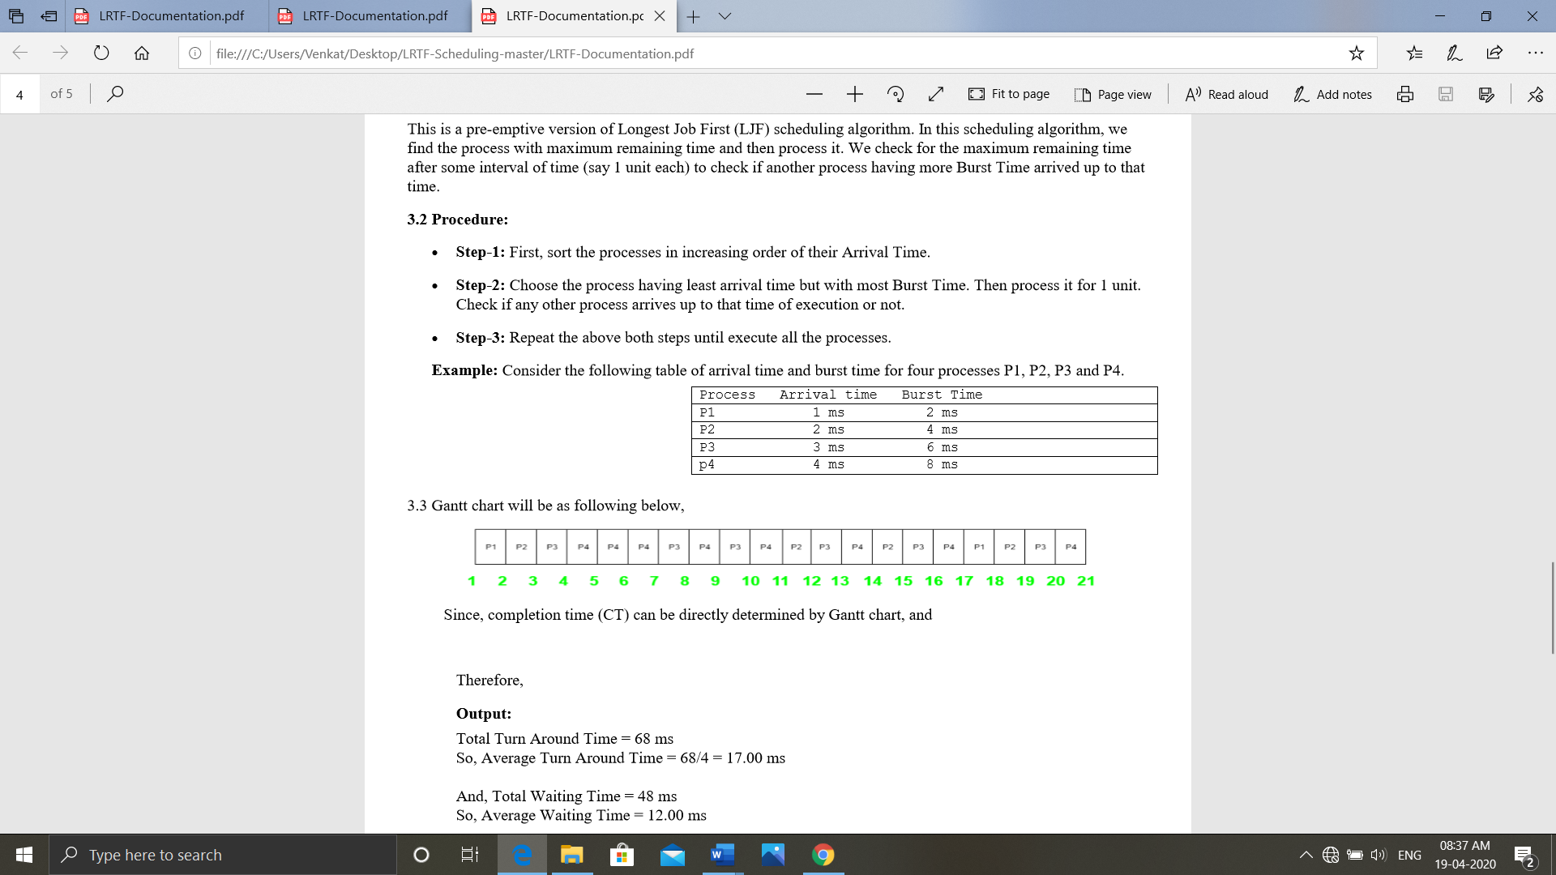



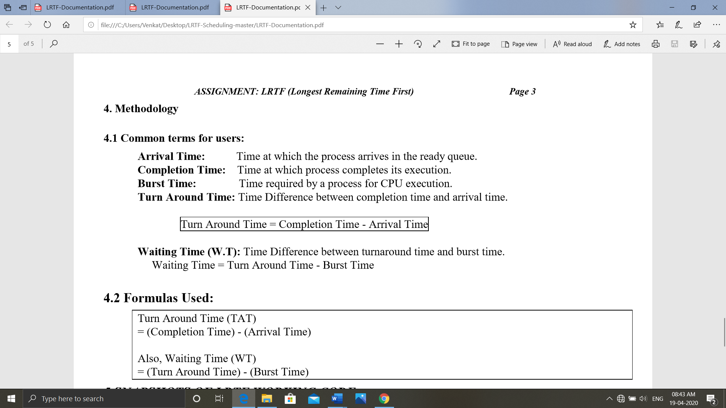

**5. Code For the Given Example: -**

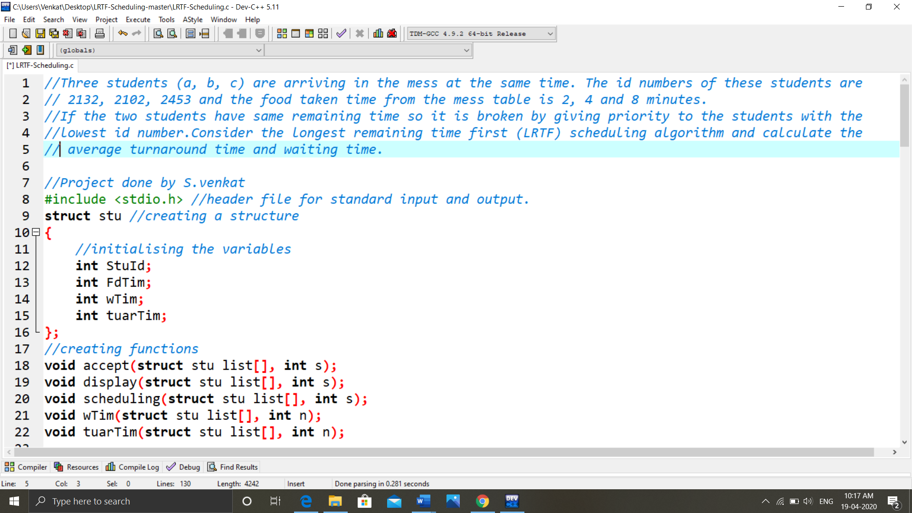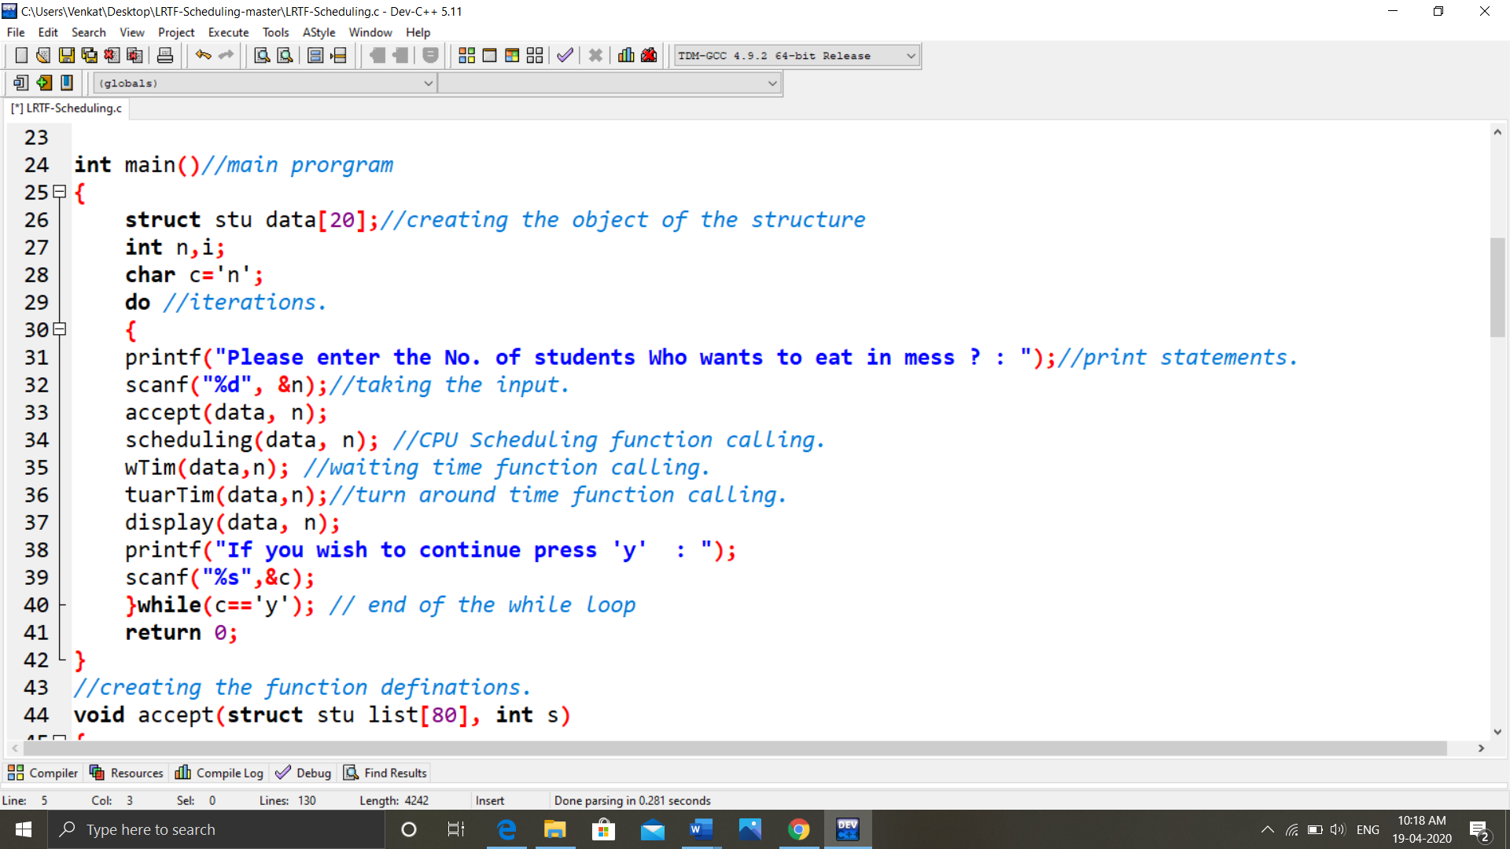

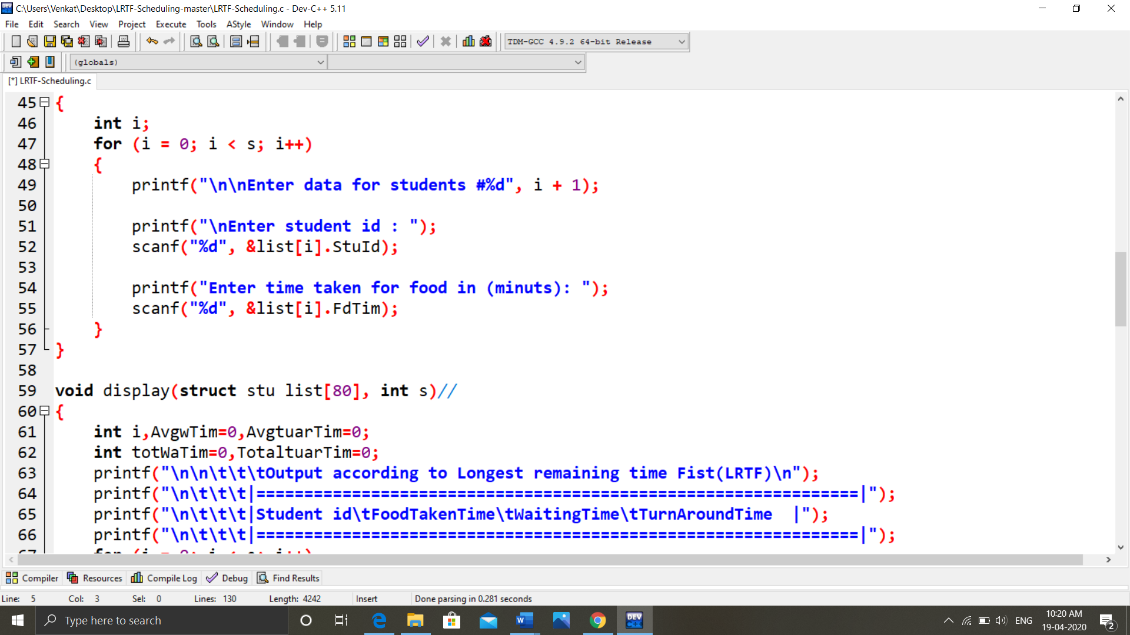

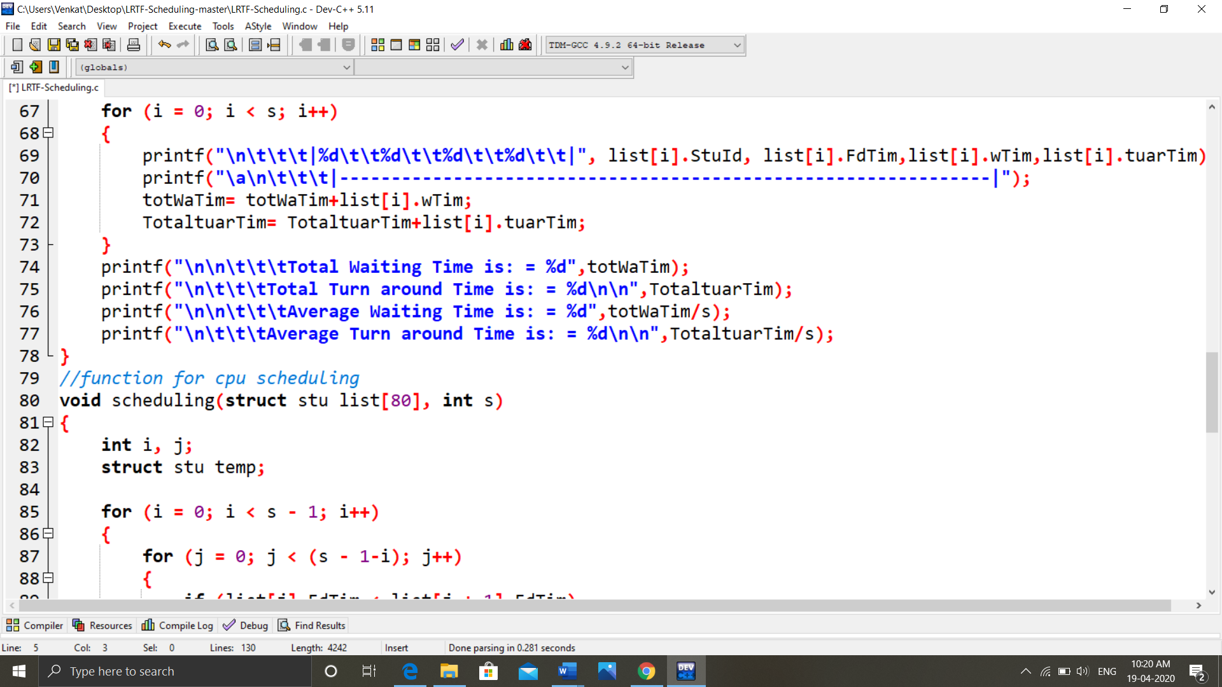

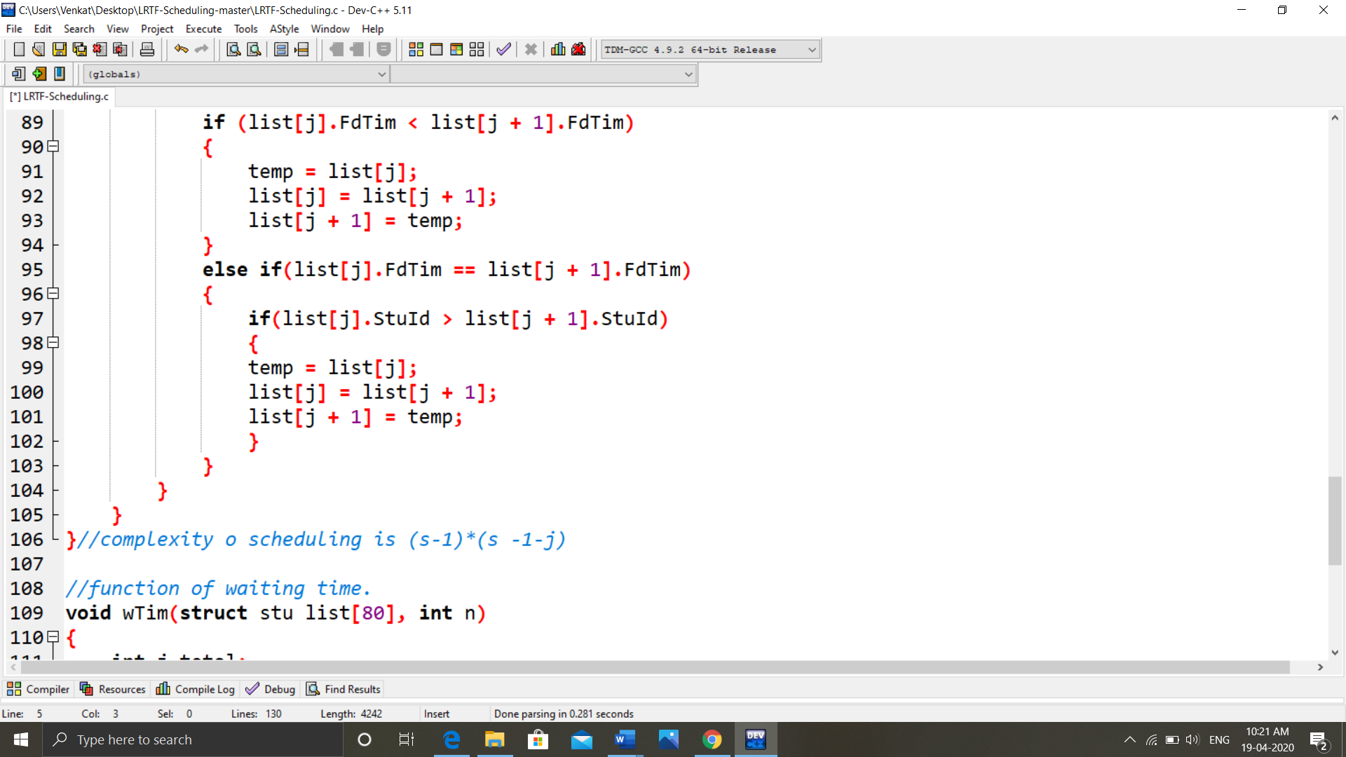

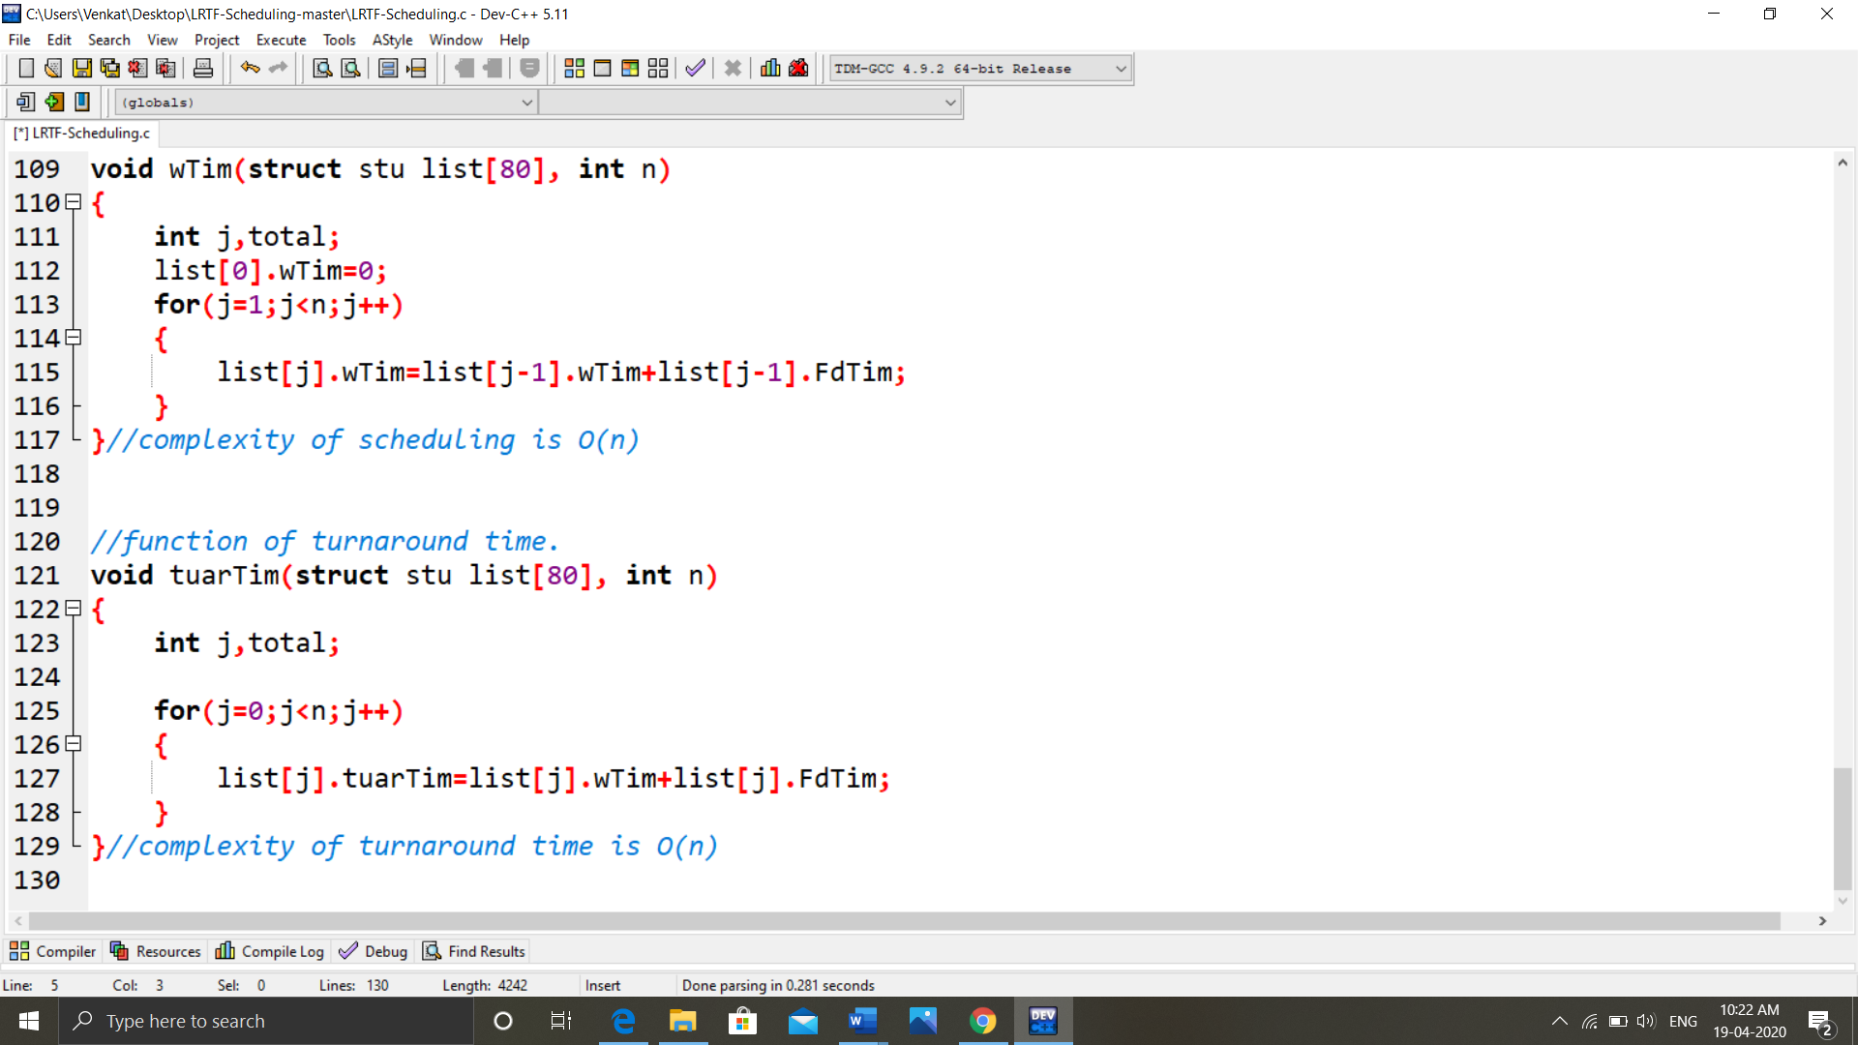

**ScreenShort of the Output of the following code:-**

