SQL db tables
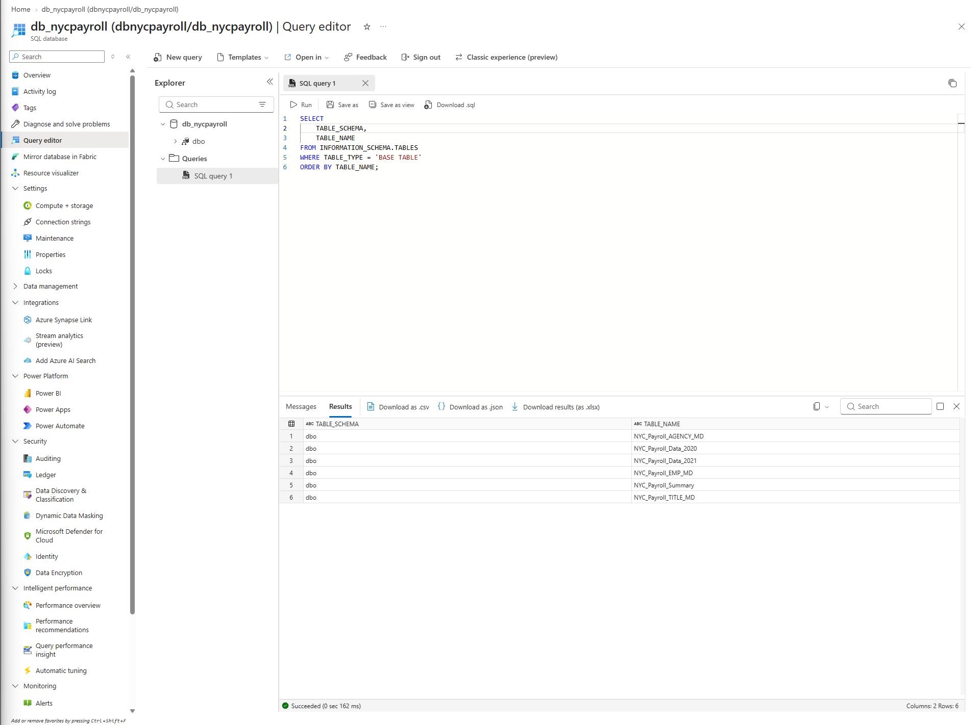

Azure Synapse
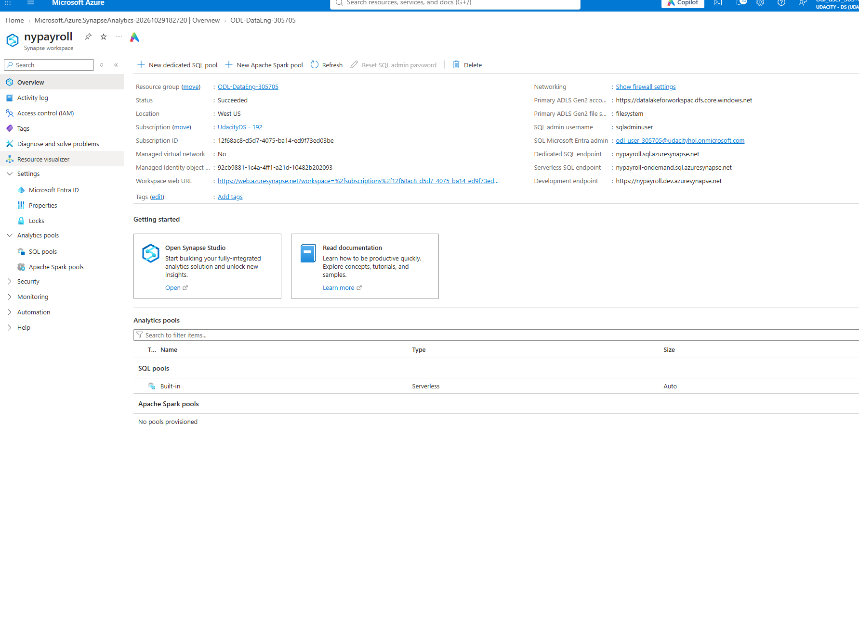
External table created in Synapse
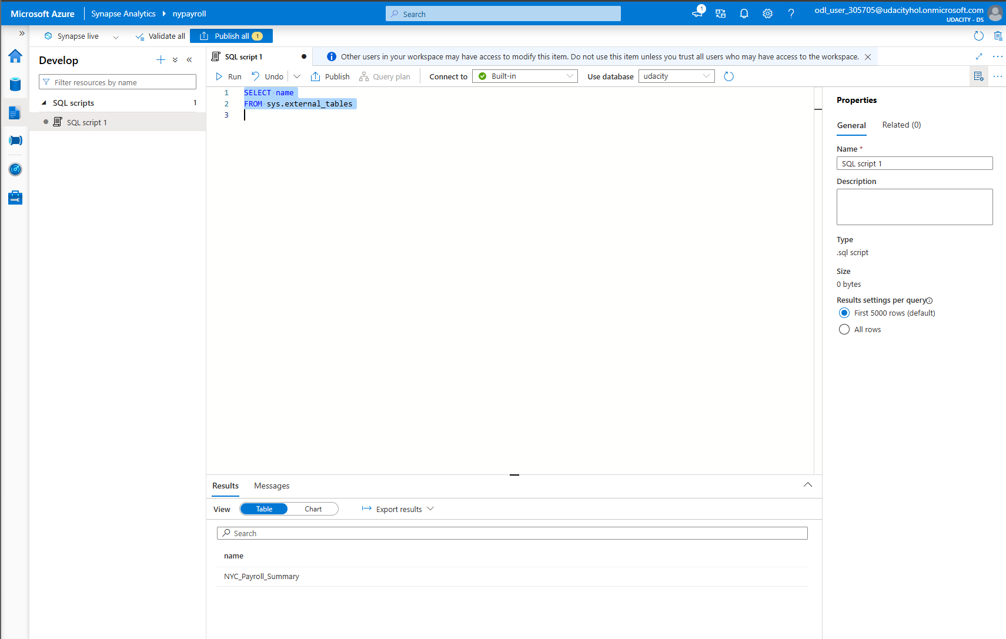
Test connections from datafactor for linked service.
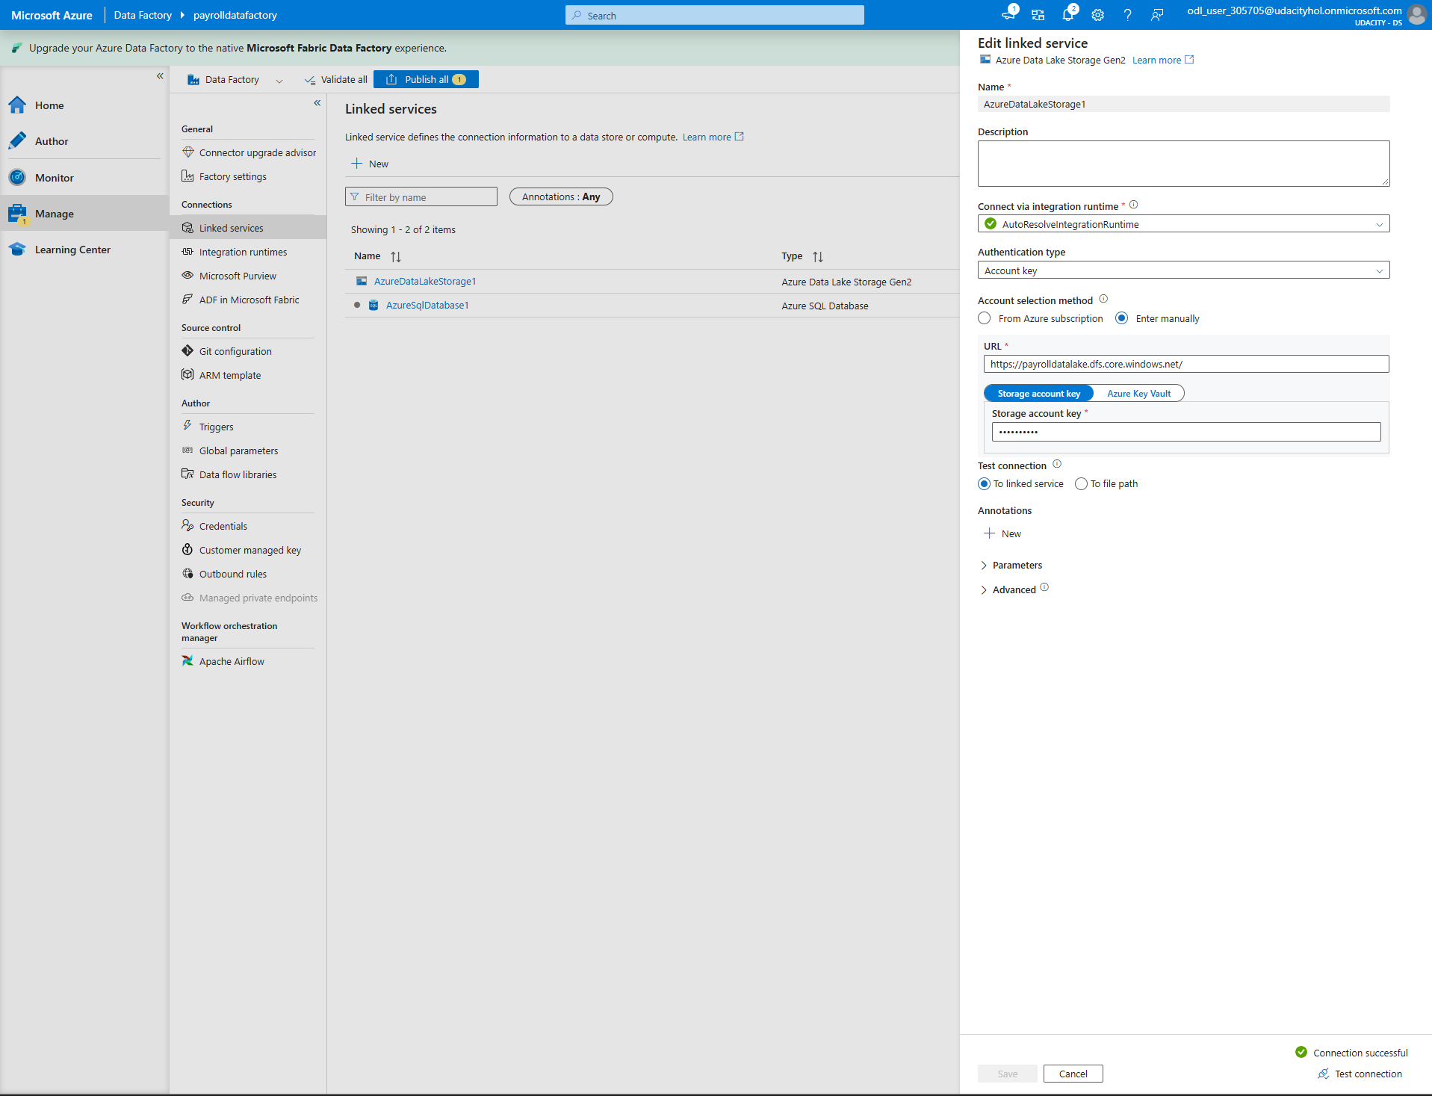

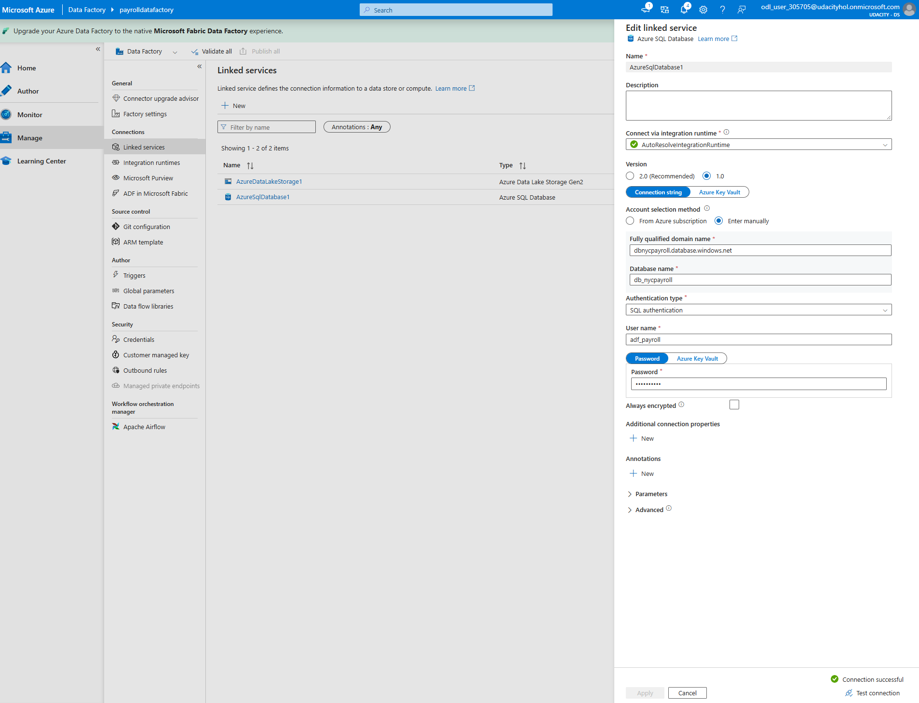

Created datasets for files in dta lake gen2
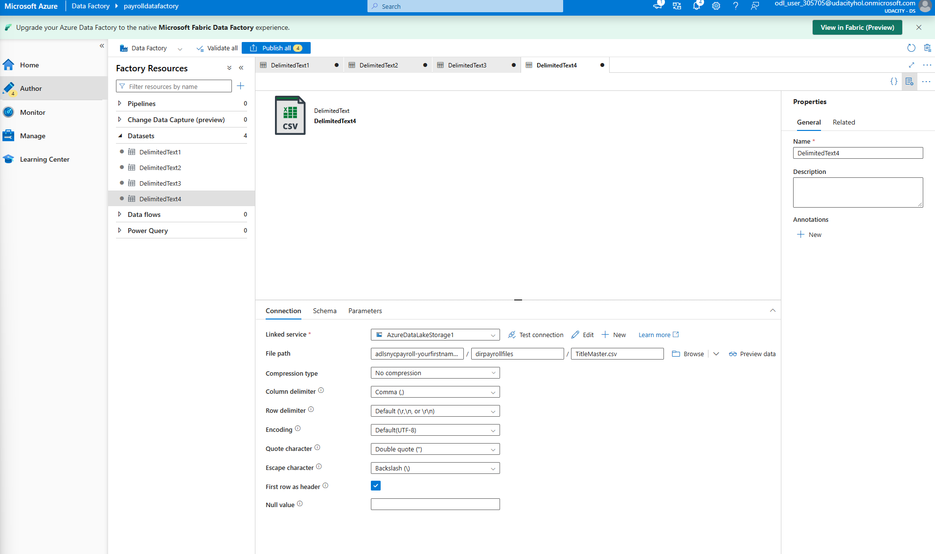
3. Create the dataset for all the data tables in SQL DB
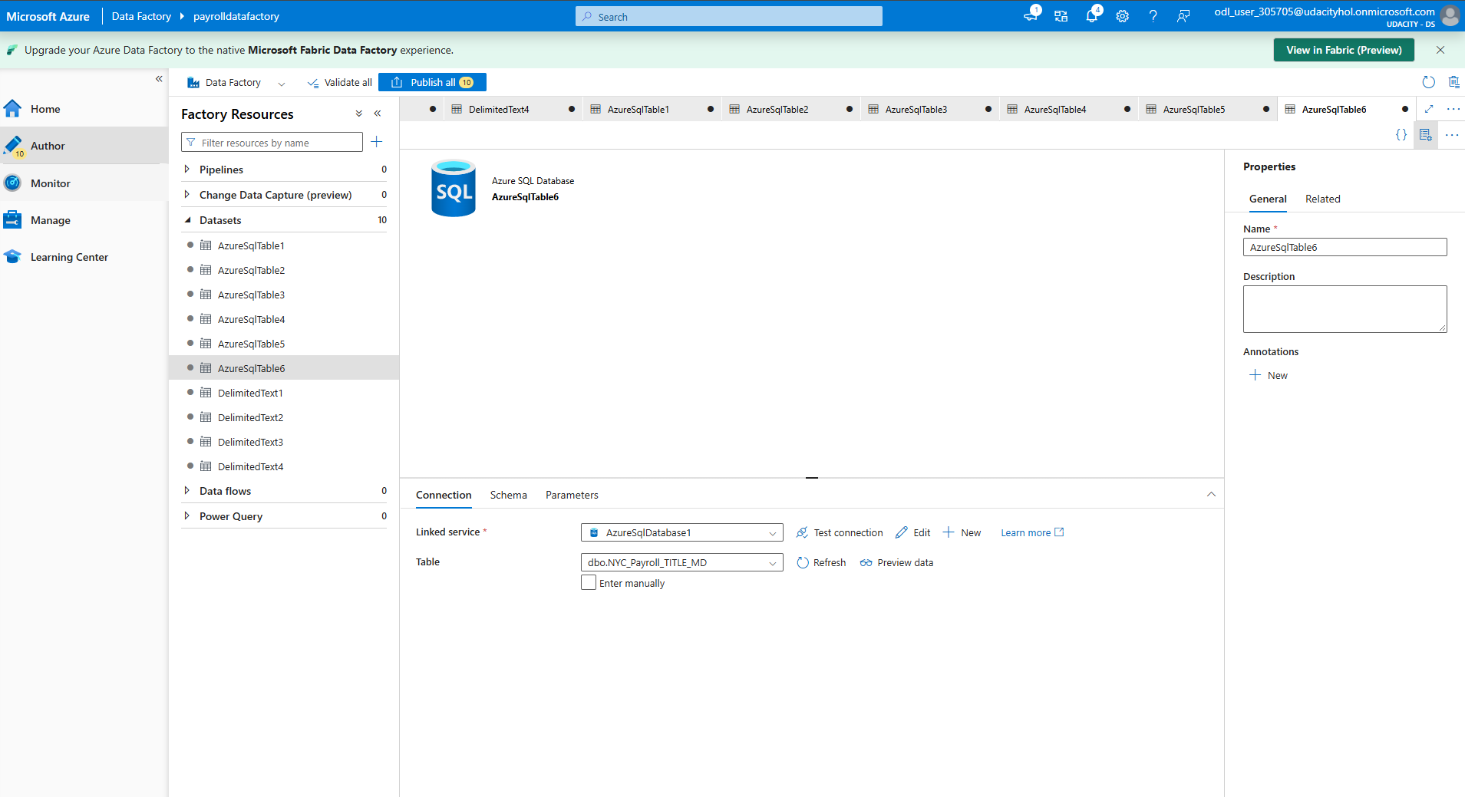

4. Create the datasets for destination (target) table in Synapse Analytics

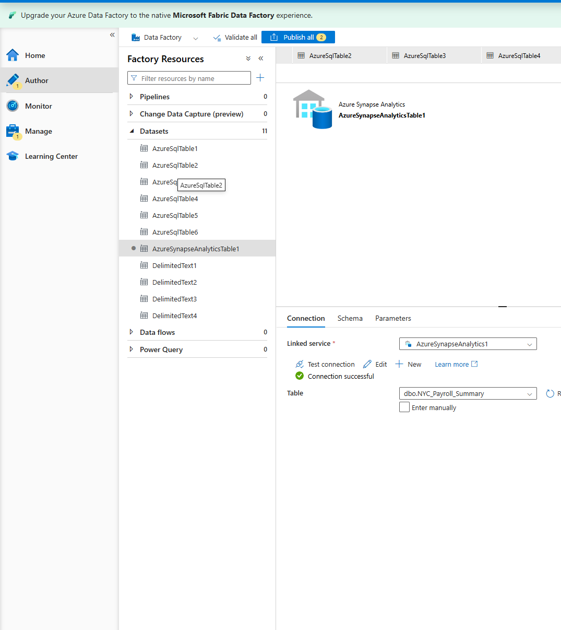

screenshots of dataflows in Data Factory
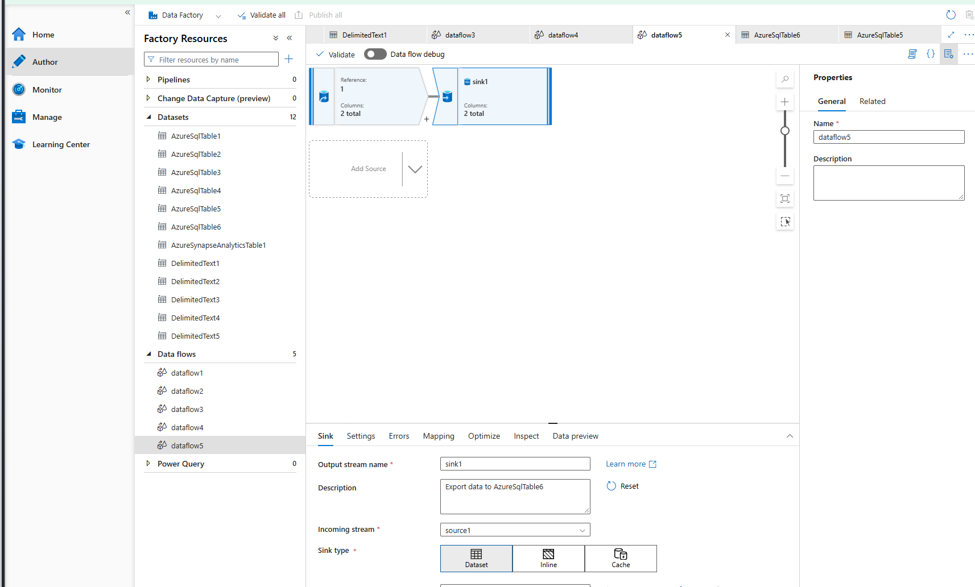
screenshot of aggregate dataflow in Data Factory
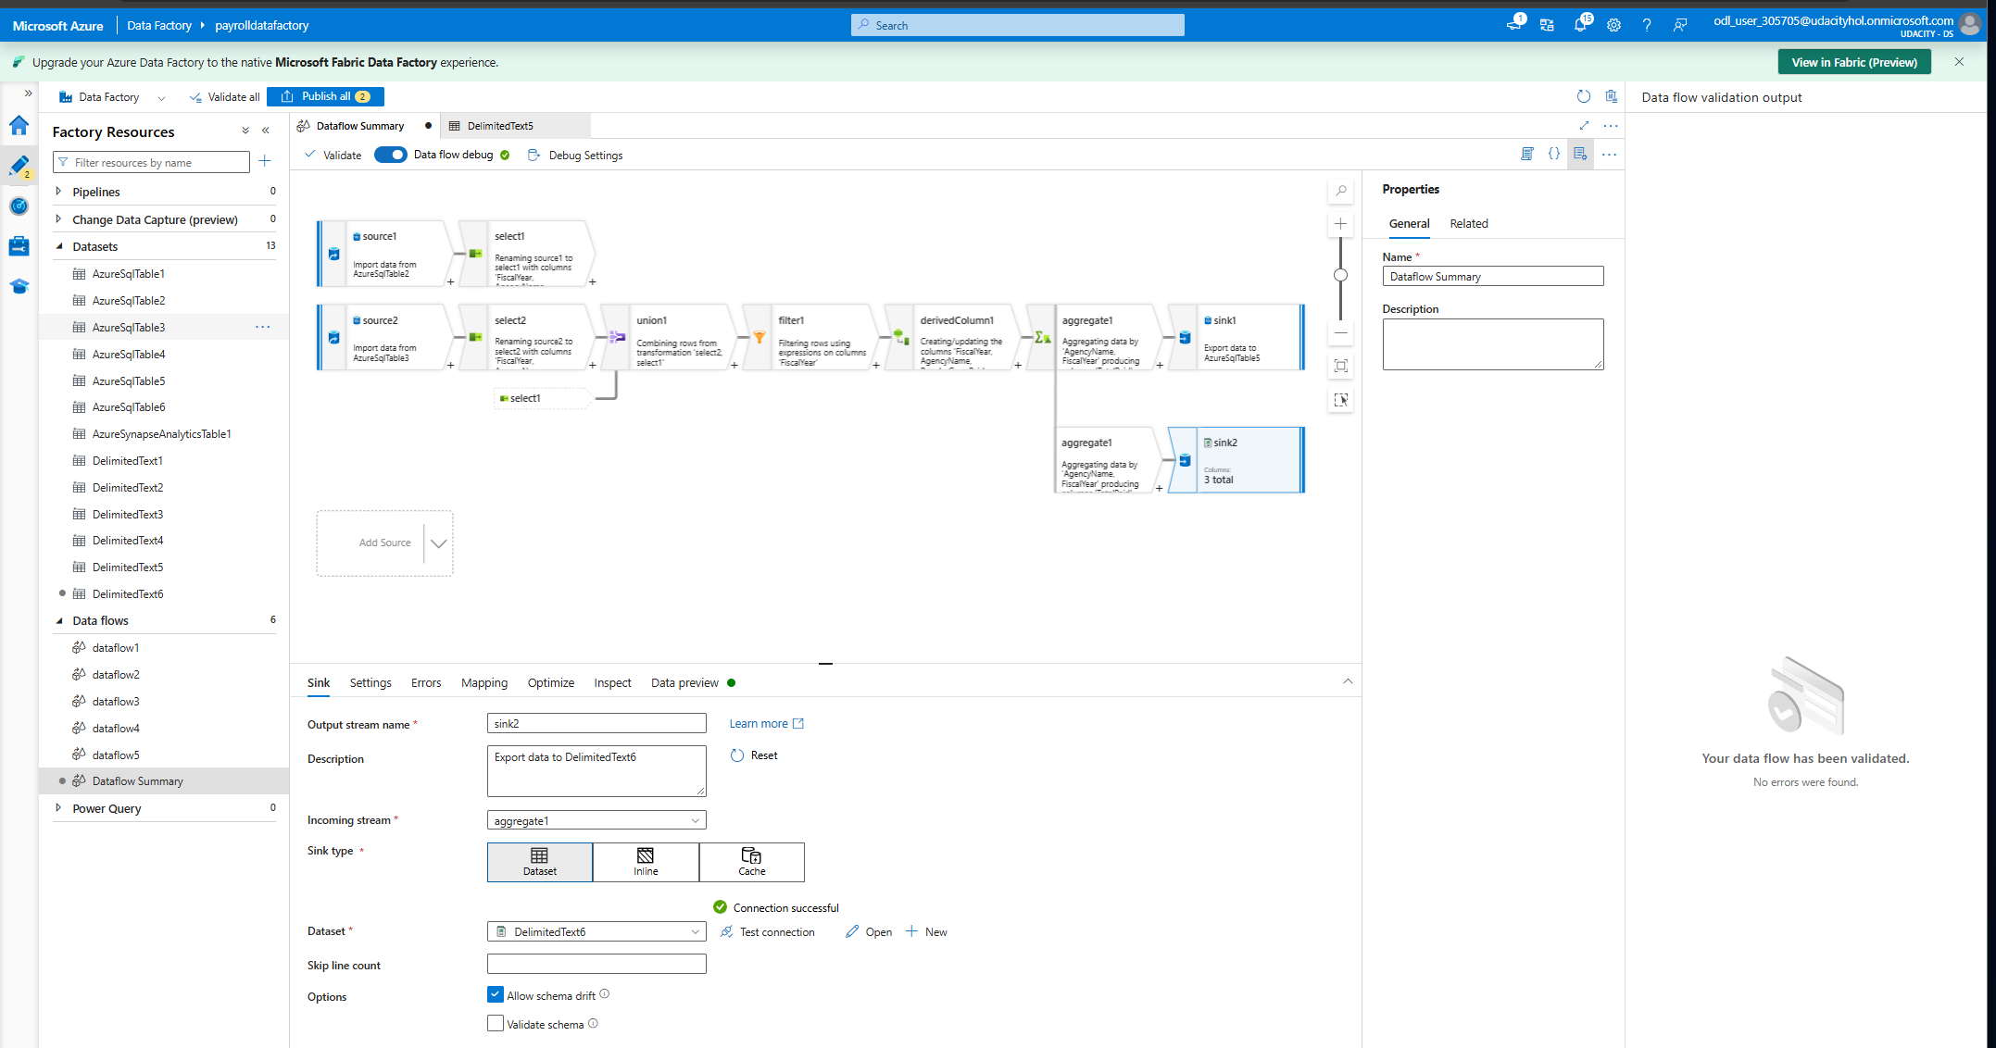

screenshot of pipeline resource from Datafactory 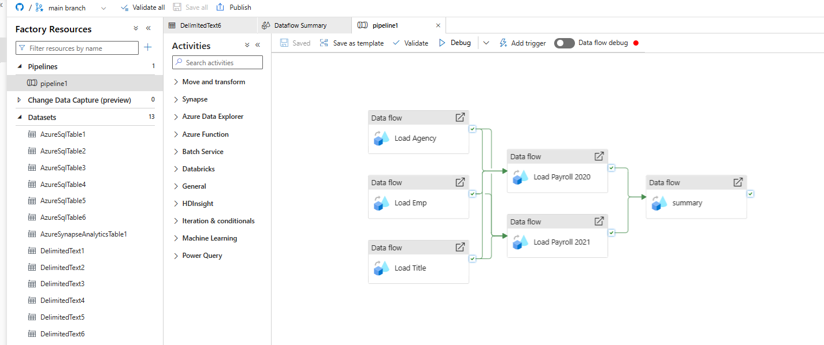
screenshot of successful pipeline run (as the last run got stopped at the last stage, re-ran it again.)
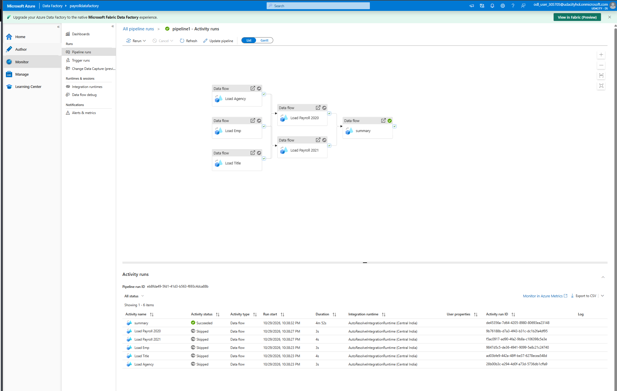

screenshot of query from SQL DB summary table
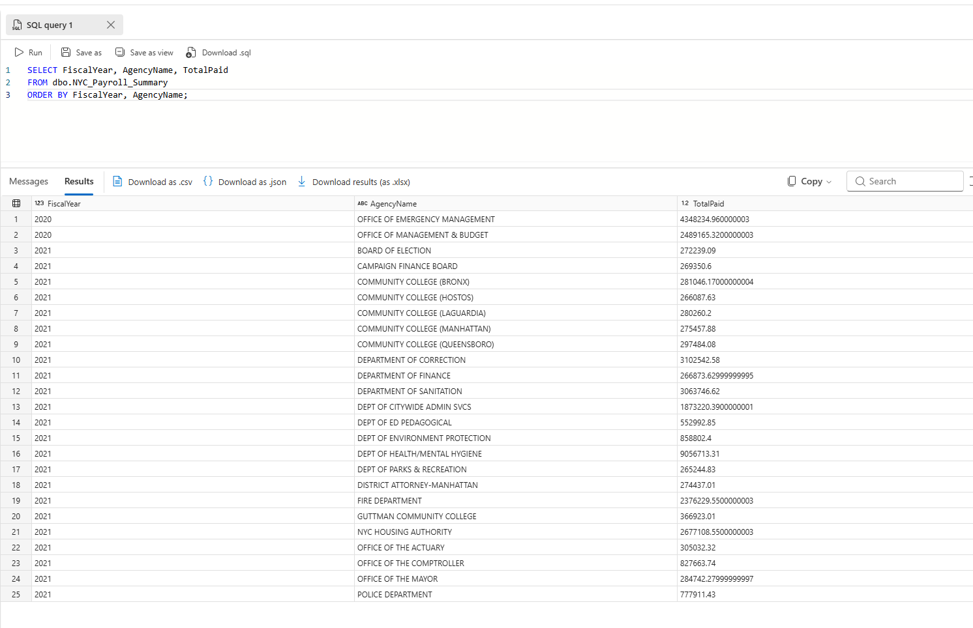
screenshot of dirstaging directory listing in Datalake that shows files saved after pipeline runs
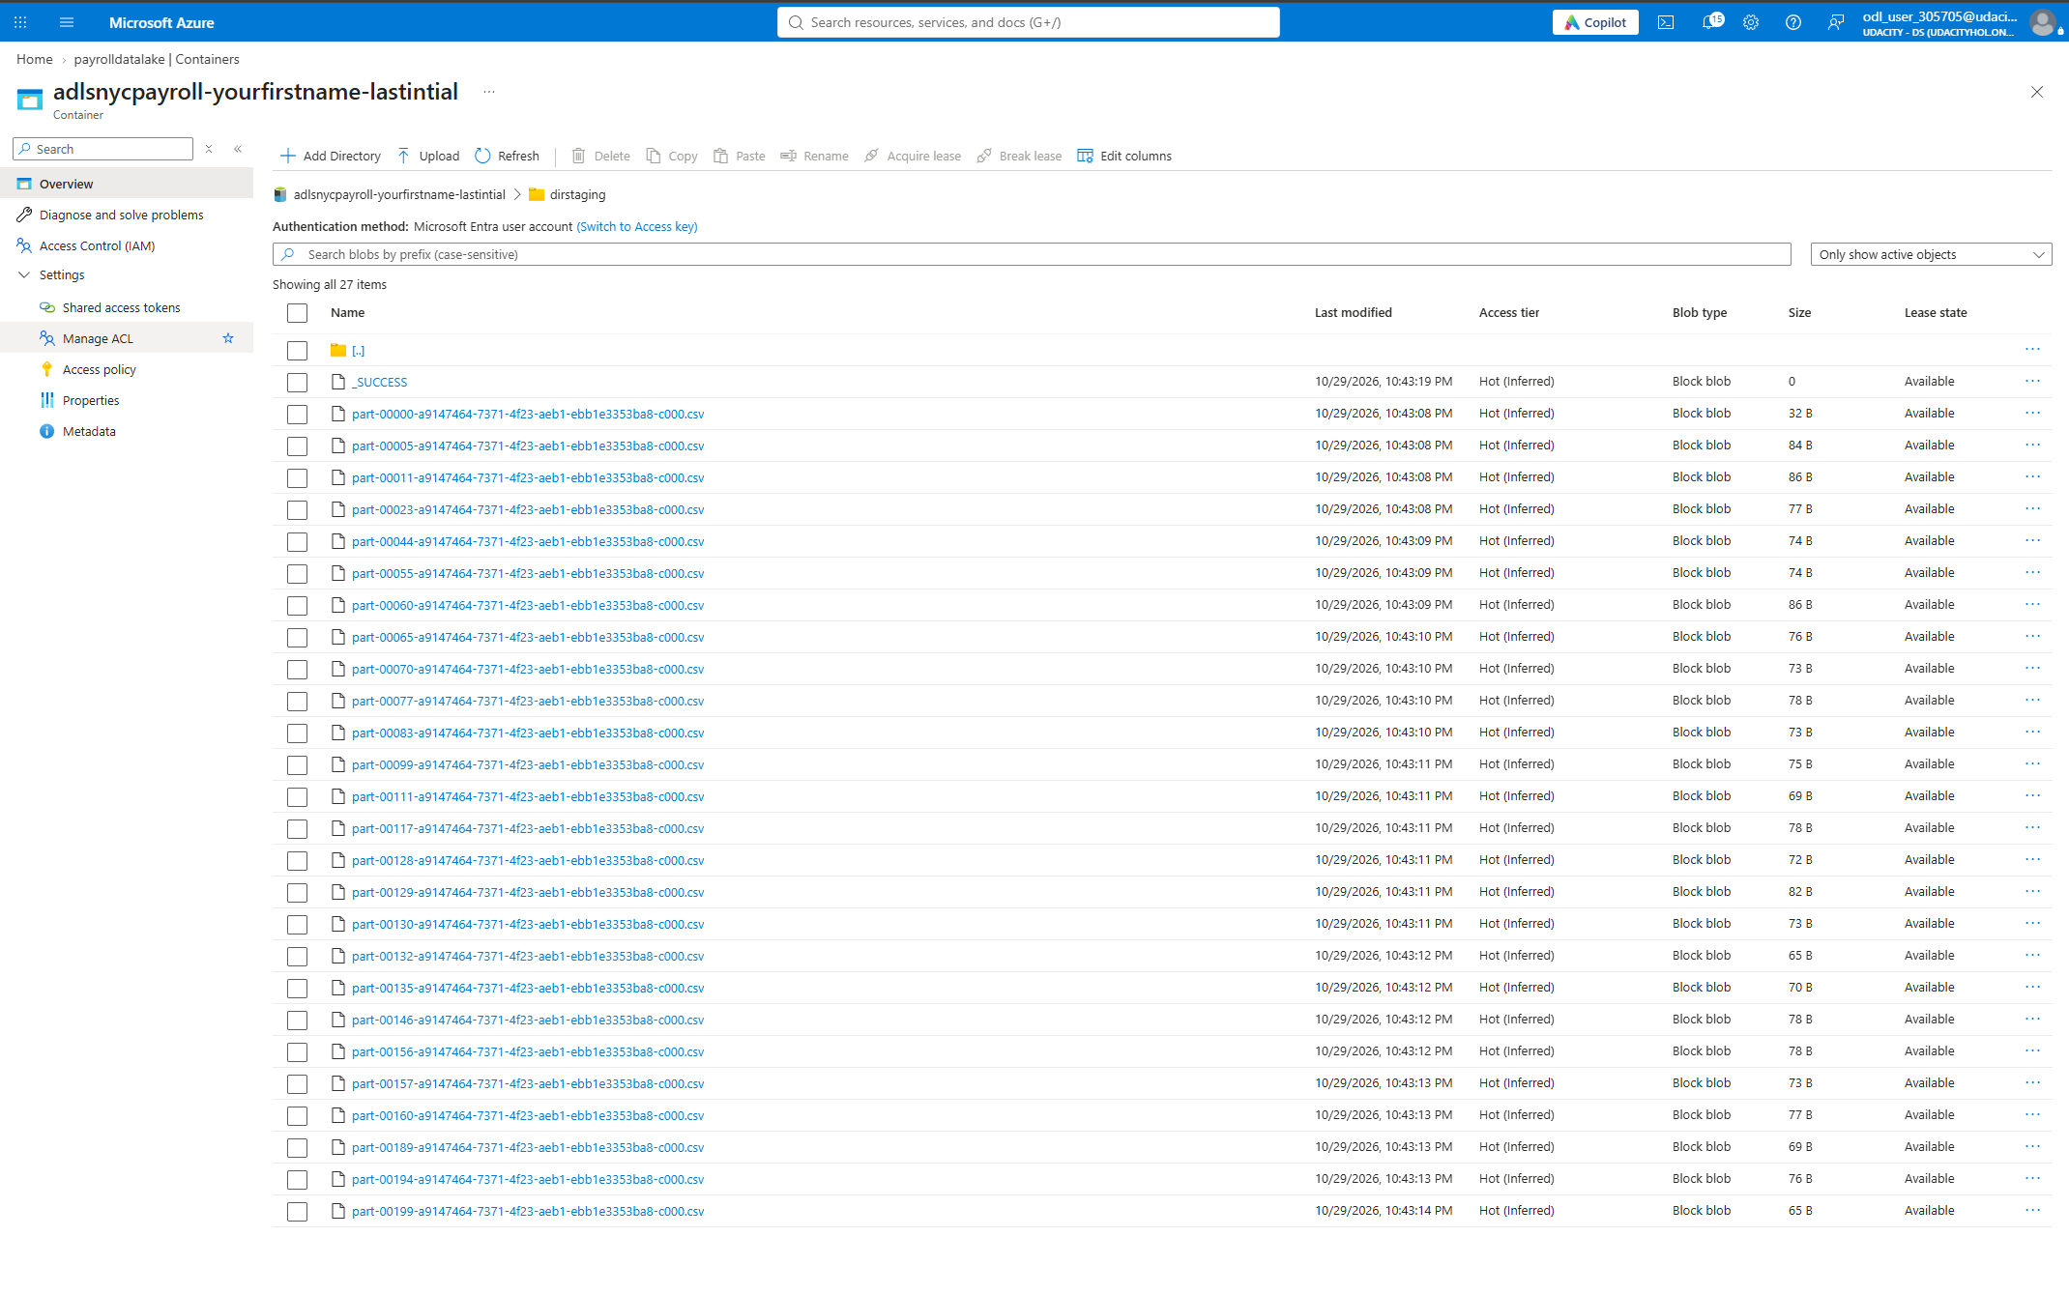
screenshot of query from Synapse summary external table
