Diagnostic Rev. 586220 Harness - User Port Rev. 3
Module Description

Introduction
The User Port module is the central part of the Diagnostic Rev. 586220 harness. It provides the required feedback connections for testing the C64’s CIA U2, which is connected to the user port. It also holds the analog switches, which are required to test the Control Ports and the feedback connections for testing the cassette port.
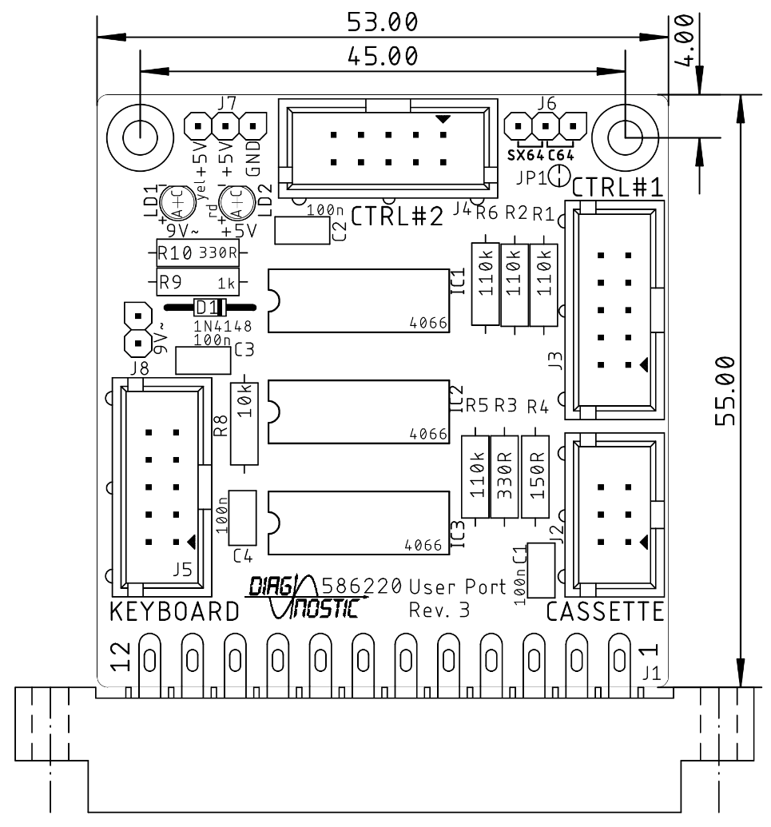
Figure 1: User Port PCB Rev. 3
The MOTOR output signal of the cassette port has approximately a 6V level. To use it as a control signal for operating logic devices, a voltage divider consisting out of a 150Ω resistor and a 330Ω resistor is required, which has a ratio of about 0.7.
This way, the MOTOR signal is fed back to the WRITE pin and is also used for switching the analog switches between the joystick signals of both control ports.
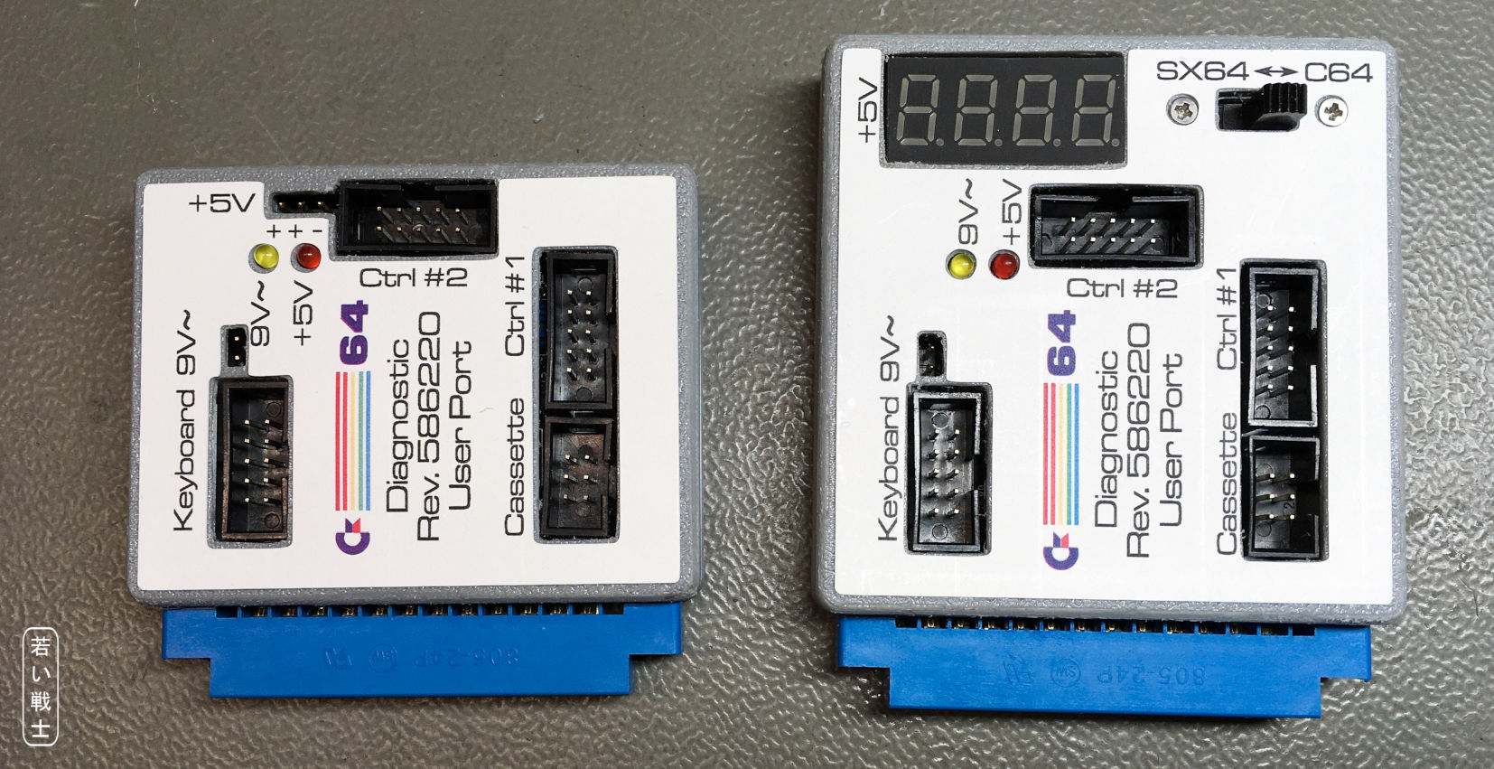
Figure 2: User Port Dongle Rev. 3, without and with a panel voltmeter
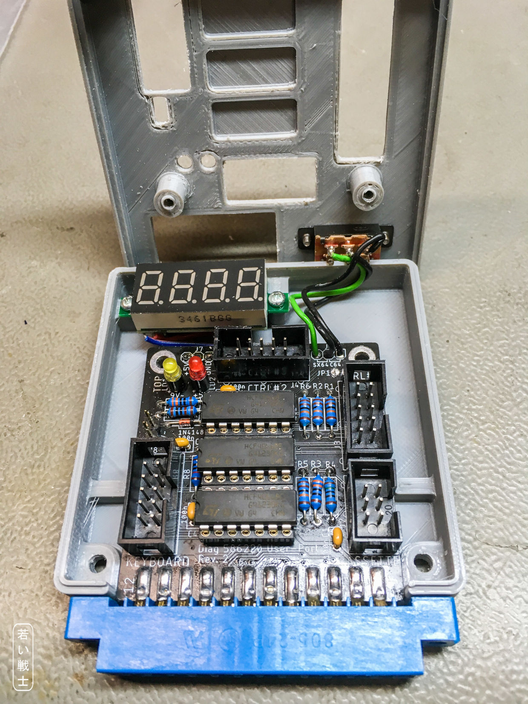
Figure 3: Installation of the panel voltmeter and the switch for SX/64 and C64 mode.
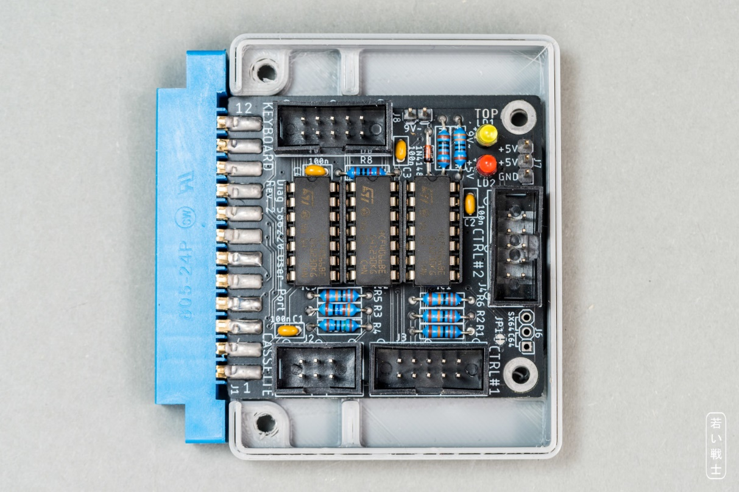
Figure 4: Installation without the panel voltmeter, but the pin headers for voltage measurement.

Rev. 1
New on Rev. 1 are the analog switches for the keyboard feedbacks. This feature requires a ribbon cable to the keyboard PCB (Rev. 1). It does not connect to the Keyboard PCB Rev. 0.
The reason for this modification:
The feedbacks on keyboard dongle are identical to the feedback provided by the analog switches for the control port feedback. Since the feedbacks on the keyboard dongle are permanent, the analog switches are not effective and the control ports are not fully tested. This can lead to a false “OK”.
The new version can open the keyboard feedbacks with additional analog switches, so it is not required to remove the keyboard dongle for proper testing anymore.

The SX-64 test feature (Rev. 2 and later)
The SX-64 does not provide a cassette port. Since the control port (and keyboard) feedbacks are switched by the cassette port MOTOR signal, J6 provides a manual switching option. It can either be jumpered or a toggle switch can be connected. Connecting J6 pin 1 and pin 2 configures the regular C64 setup (the feedbacks are controlled by MOTOR), connecting pin 3 and pin 2 configured the control port feedbacks being switched on permanently for the SX-64 option. For switching between options, the cut pad JP1 has to be opened.
By default, the C64 only mode is selected, which meansJP1 is closed. Do not connect a switch to J6 without opening JP1.
The keyboard testing of the SX-64 requires the C128 keyboard PCB and a DB female-female gender changer. For complete SX-64 testing, the diagnostic software has to be run in C64 mode (control port feedbacks off, keyboard feedbacks on) at least one pass and then in SX-64 mode (control port feedbacks on, keyboard feedbacks off).

Rev. 3: Voltage indicators and voltmeter
The purpose of the voltmeter is measuring the +5VDC inside the C64, which does make sense. A too low voltage here might indicate a bad power switch or a bad/oxidized power jack.
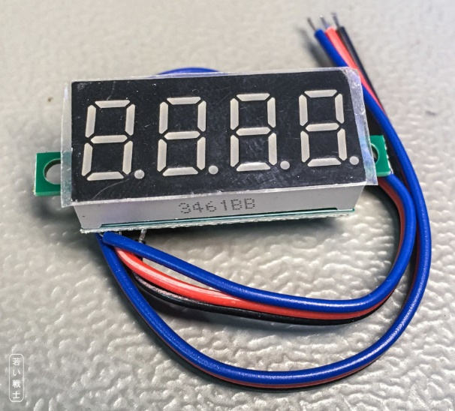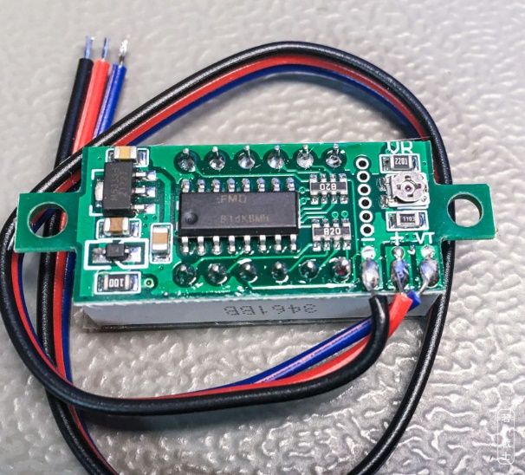
Figure 5: Front and back of the 0.36" 4-digit voltmeter
Previously, three-digit and four-digit models have been tested. The three-digit models are not suitable, since they showed an error of almost 100mV. The four-digit models can be adjusted on a little potentiometer. Adjustment is required and should be performed before the assembled PCB is installed in the case.
The adjustment is best performed by measuring the voltage between the GND pin and one of the +5V pins of J7, then adjusting the reading of the voltmeter at the potentiometer on the back side. This potentiometer is shown in Figure 5: Front and back of the 0.36" 4-digit voltmeter.
Note: The panel voltmeters, that I have bought for this project were sufficiently accurate, but I would not grant for all 4 digit “precision panel meters, so the recommended configuration is to install a pin header and perform the measurement with a multimeter.

Pinouts

User Port
J1- Edge Connector (2x12, 3.96mm pitch)
Pin | Signal | Pin | Signal
1 | GND | A | GND
2 | +5V | B | /FLAG2
3 | /RESET | C | PB0
4 | CNT1 | D | PB1
5 | SP1 | E | PB2
6 | CNT2 | F | PB3
7 | SP2 | H | PB4
8 | /PC2 | J | PB5
9 | ATN | K | PB6
10 | 9VAC(1) | L | PB7
11 | 9VAC(2) | M | PA2
12 | GND | N | GND

Cassette Port
J2 – 2x3 pin header for a ribbon cable connected to the cassette port PCB (project number 114).
Pin | Signal | Pin | Signal
1 | GND | 2 | n.c.
3 | MOTOR | 4 | READ
5 | WRITE | 6 | SENSE

Control Port #1
J3 – 2x5 pin header for a ribbon cable which connects via a D-SUB 9 (female) to the control port.
Pin | D-SUB | Signal | Pin | D-SUB | Signal
1 | 1 | JOYA0 (up) | 2 | 6 | FIREA
3 | 2 | JOYA1 (down) | 4 | 7 | +5VCTR1
5 | 3 | JOYA2 (left) | 6 | 8 | n.c. (GND)
7 | 4 | JOYA3 (right) | 8 | 9 | POTXA
9 | 5 | POTYA | 10 | - | n.c.

Control Port #2
J4 – 2x5 pin header for a ribbon cable which connects via a D-SUB 9 (female) to the control port.
Pin | D-SUB | Signal | Pin | D-SUB | Signal
1 | 1 | JOYB0 (up) | 2 | 6 | FIREB
3 | 2 | JOYB1 (down) | 4 | 7 | +5VCTR2
5 | 3 | JOYB2 (left) | 6 | 8 | n.c. (GND)
7 | 4 | JOYB3 (right) | 8 | 9 | POTXB
9 | 5 | POTYB | 10 | - | n.c.

Keyboard
J5 – 2x5 pin header for a ribbon cable which connects to the keyboard PCB.
Pin | Signal | Pin | Signal
1 | Keyboard PB0 | 2 | Keyboard PA0
3 | Keyboard PB4 | 4 | Keyboard PA4
5 | Keyboard PB3 | 6 | Keyboard PA3
7 | Keyboard PB2 | 8 | Keyboard PA2
9 | Keyboard PB1 | 10 | Keyboard PA1

SX-64 Option
J6 – 1x3 pin header (pitch 2.54mm)
Pin | Signal
1 | WRITE
2 | WRITE*
3 | +5V

To use J 6 for switching between SX-64 and C64, cut open JP1. This is the cut pad right beside J6.
Connection pin 1-2 selects the C64 option, connecting pin 2-3 selects the SX-64 option, which switches on the control port feedbacks.

Panelmeter Connector
J7 – 1x3 pin header, 2.54mm pitch
Pin | Signal | Voltmeter
1 | GND | -
2 | +5V | +
3 | +5V | VT

9VAC Connector
J8 - 1x2 pin header, 2.54mm pitch
Pin | Signal
1 | 9VAC1
2 | 9VAC2

Interconnects

User Port
Pin | Signal |  | Signal | Pin
4 | CNT1 | ↔ | CNT2 | 6
5 | SP1 | ↔ | SP2 | 7
8 | /PC2 | ↔ | /FLAG2 | B
9 | ATN | ↔ | PA2 | M
C | PB0 | ↔ | PB4 | H
D | PB1 | ↔ | PB5 | J
E | PB2 | ↔ | PB6 | K
F | PB3 | ↔ | PB7 | L

Cassette Port
Pin | Signal |  | Signal | Pin
1 | GND |  | n/c | 2
3 | MOTOR | Volt.div. | WRITE | 5
4 | READ | ↔ | SENSE | 6

Control Ports
Signal |  | Signal
FIREA | switched by MOTOR | FIREB
JOYA0 | switched by MOTOR | JOYB0
JOYA1 | switched by MOTOR | JOYB1
JOYA2 | switched by MOTOR | JOYB2
JOYA3 | switched by MOTOR | JOYB3
POTXA | via 110kΩ (R1) | +5V (CTR 1)
POTYA | via 110kΩ (R2) | +5V (CTR 1)
POTXB | via 110kΩ (R5) | +5V (CTR 2)
POTYB | via 110kΩ (R6) | +5V (CTR 2)

The digital signals of the control ports are connected by an analog switch. A HIGH level of the MOTOR signal will switch on.
The POT (paddle) signals are tested with a fix resistor of 110k, that is connected to the +5V provided by the respective control port.

Cables

User Port/Cassette Port Cable
One cable as shown in Doc.-No. 113-3-01-01 is required. It connects to J2. This cable needs to be longer for C128

User Port/Control Cables
Two cables as shown in Doc.-Nr. 113-3-02-01 are required. They connect to J3 and J4.

User Port/Keyboard PCB Cable
One cable as shown in Doc.-No. 113-3-04-01 is required. It connects to J5 and the keyboard PCB (C64 or C128). For the C128 this cable has to be longer.

The IEC-Dongle
The IEC-Dongle is not attached to the PCB, it is an extra built.
6p. DIN plug, connect according to Doc.-No. 113-3-03-01
Pin | Signal |  | Signal | Pin
1 | SRQ | ↔ | DATA | 5
3 | ATN | ↔ | CLK | 4

Block diagram of the Diagnostic Harness Rev. 3

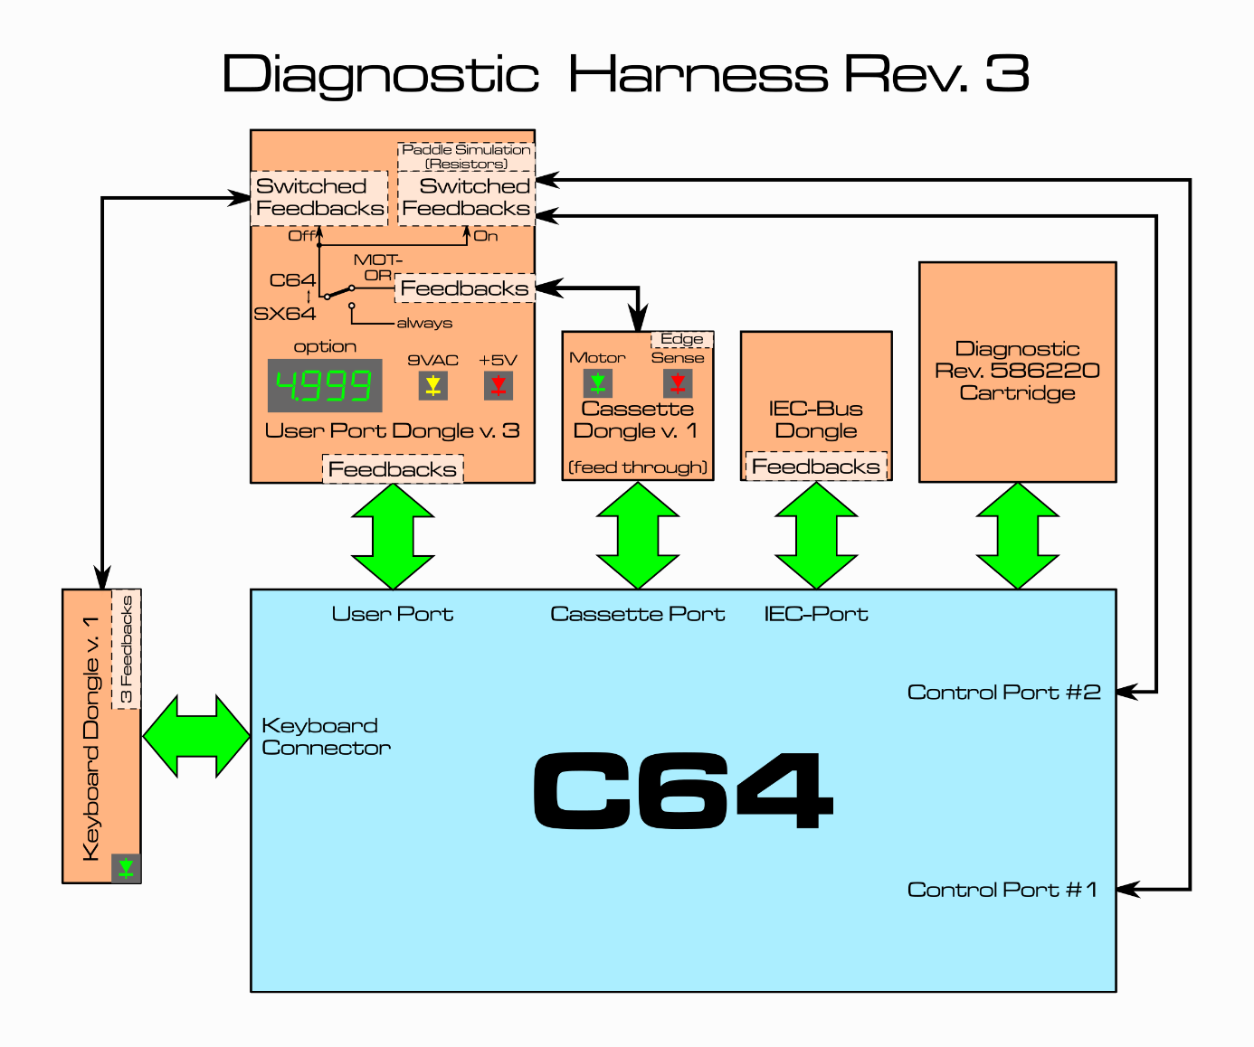Connecting the Voltmeter
The Voltmeter has three connections:
+ = positive supply voltage. It is connected to J7, Pin 2 (+5V)
- = negative supply voltage. It is connected to J7, Pin 1 (GND)
VT = measured voltage. It is connected to J7, Pin 3 (+5V)
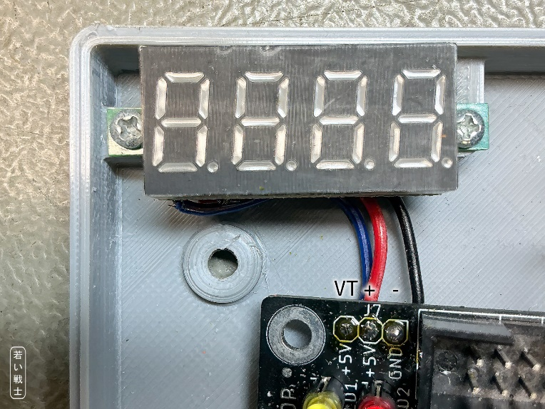
Figure 6: Connection of the panel voltmeter

Revision History

BOM v0.1 → v0.2
- Pos. 6: value 120k →110k
- Pos. 8: value 320R →316R

Rev. 0 → Rev. 1
- This is a PCB revision
- Analog switches added (IC3)
- Pin header added (J5)
- New Ribbon Cable
- 3D printed case (Rev. 1) is required

Rev. 1 → Rev. 2
- This is a PCB revision
- Pin header J6 and cup pad JP1 added
- It can either be installed in the Rev. 1 3D printed case, if no switch option SX64 is desired or in the User Port Case SX-64, which provides mounting holes for a toggle switch (19mm hole distance, standard switch).

Rev. 2 → Rev. 3
- LEDs added for presence indication of +5V and 9VAC
- Connector for panel meter
- Connector for 9VAC
- New 3D printed cases.

