How To: 9U stabilizer (v.0)
Like 9U space bars, a 9U stabilizer cannot be purchased off the shelf. The only situation in which you need a 9U stabilizer is when using the original 9U space bar from a classic C64. A Blingboard64 or C64 Ultimate space bar is also 9U long, but uses a 7U stabilizer.
A 9U stabilizer can be made from a stabilizer of any length by replacing its stabilizer wire with a homemade wire of the appropriate length.

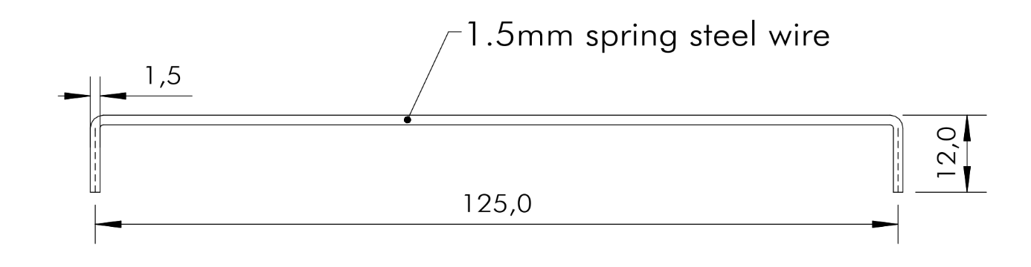
Figure 1: Dimensions of the 9U stabilizer wire
The material is 1.5 mm spring steel wire. This is often sold as a 5-meter spool, but a shorter, straight piece is easier to handle, as it does not need to be straightened first.
The required wire length is 147.5 mm. However, it is recommended to cut a slightly longer piece and trim and file the ends to the correct length after bending.
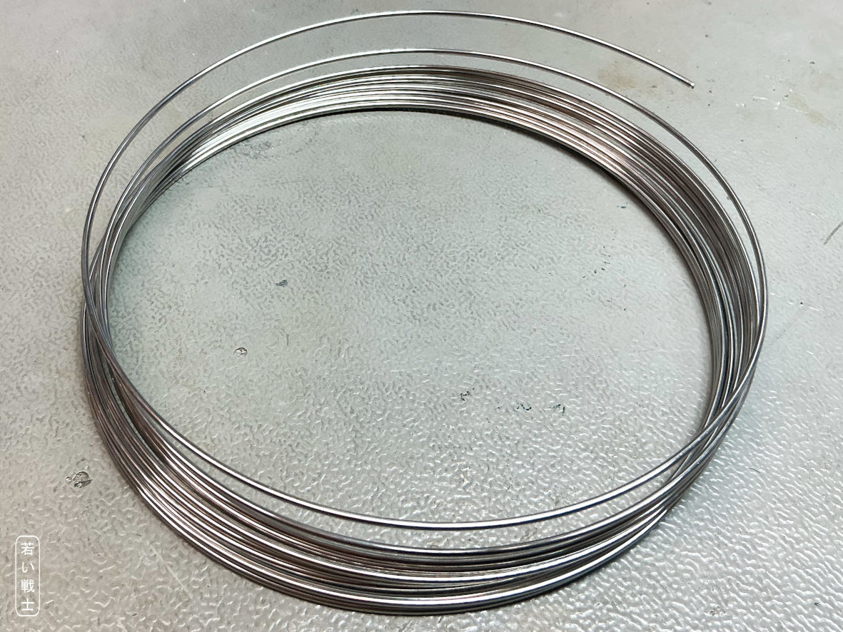
Figure 2: 1.5mm spring steel spool
The wire can be straightened using a wire straightener, which is an investment of €40 or more.
I was advised to unwind wire from the spool, then hold one end in a vise and pull the wire with combination pliers until it is straight. This, of course, requires a longer piece of wire, as the end will be worn out during this process.
The wire straightener I bought (Figure 3) gets the wire reasonably straight, but not perfectly straight. To achieve a perfectly straight wire, it can be rolled between two flat, hard surfaces as a final step. I tried it without this last step, and it worked fine.
The wire straightener consists of four steel rollers on one side and three on the other, all mounted on ball bearings. The distance between the rollers can be adjusted with a screw.
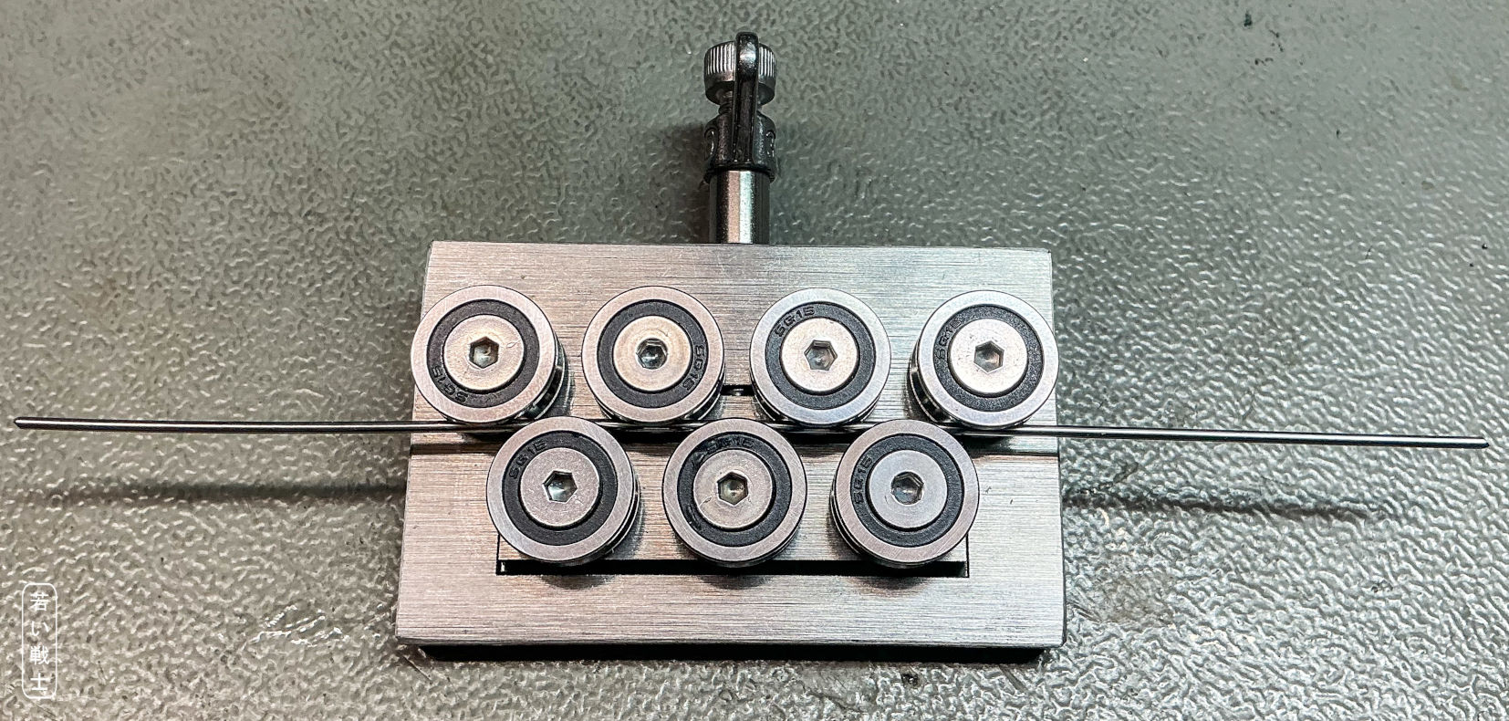
Figure 3: Wire straightener
The basic strategy for producing a straight wire is to cut a piece about 40–50 cm long from the spool.
Start with a relatively large distance between the rollers, which will leave the wire slightly curved. Push and pull the wire through the straightener several times. Then reduce the distance between the rollers and repeat the process. Reduce the distance again and continue in this way, gradually straightening the wire more and more.
If the wire becomes slightly overbent in the opposite direction, turn it 180°, increase the roller distance very slightly, and see what happens. “Pretty straight” is good enough.
The length of the stabilizer wire does not need to be highly accurate, neither does the angle. I estimate the tolerance to be ±0.7mm, that the stabilizers can accept, which I have used. The first 90° bend is not problematic at all. Just get the 12mm end a bit longer than that, it will later be trimmed and filed. For bending the wire, combination pliers and a hard surface are ok, a wire bender might be slightly better.
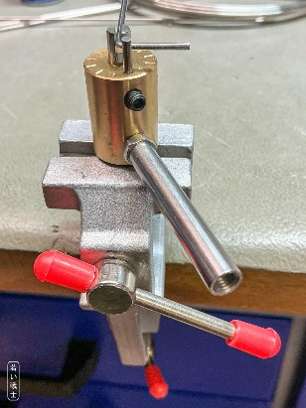
Figure 4: Not the greatest wire bender
I have bought a pretty crappy wire bender (Figure 4). The vise is actually the bad part of it. In case you always wanted to have a wire bender, make sure that a 1.5mm wire will fit in its slot.
Keep in mind, that the inner radius of the bend is not zero. I have managed about 1mm bending radius.
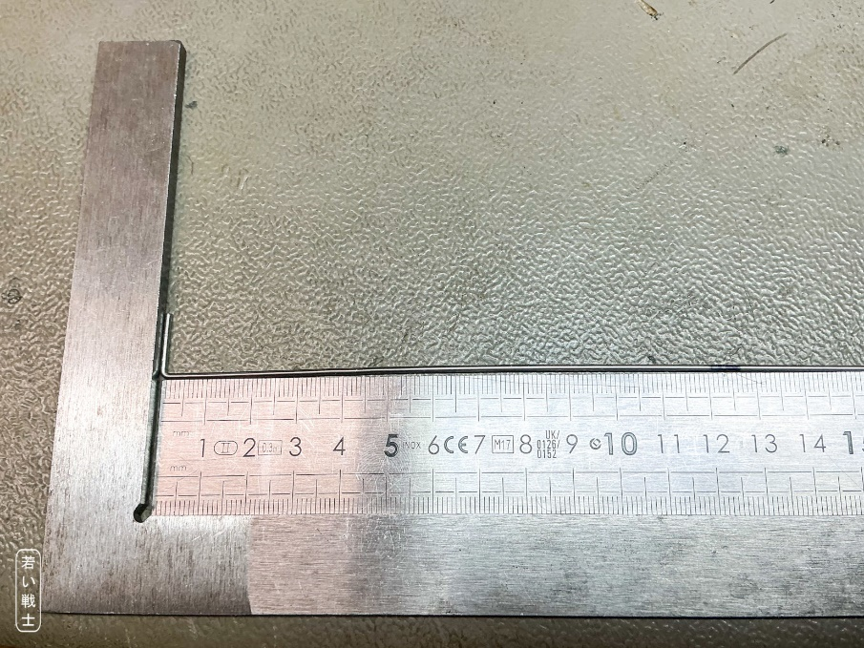
Figure 5: Marking the desired length after the first bend
For simplicity, I have measured the distance of the 2nd bend. It was a rough estimation, that marking 125mm from the outer surface of the first bend would be a good position. I first painted the wire a bit with a sharpie and marked the position with the scriber (Figure 5).
When bending the wire, it was important to have the first and the 2nd bend aligned (estimated), so the stabilizer wire is not twisted.
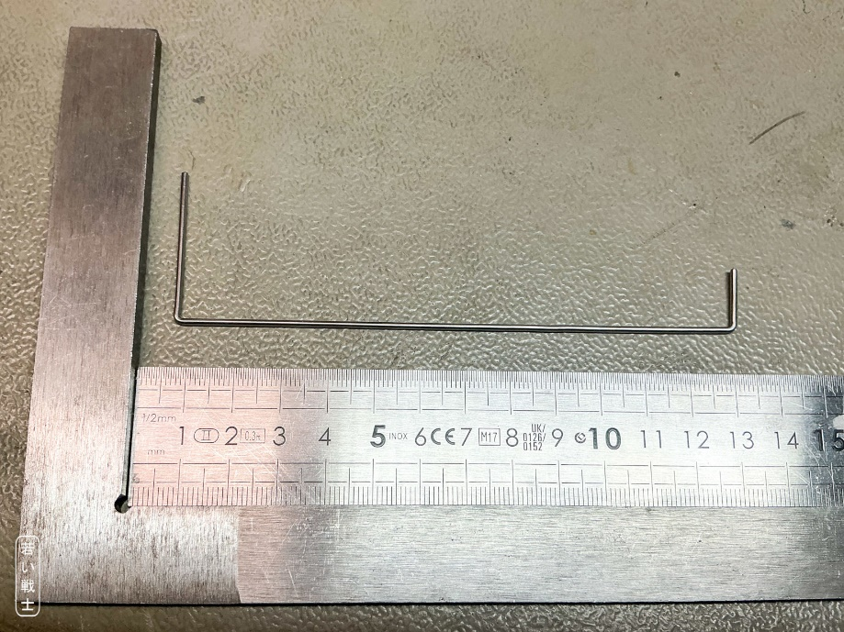
Figure 6: 2nd bend
The bent wire should lay flat on the work bench, the angle should be about 90°. To make it fit, you can manually twist and bend the wire a bit.
The bent parts of the wire should then be trimmed and filed to length. It should be 12mm or a bit less (Figure 1). If that it too long, the wire will not move freely, which is required.
Keep in mind, that testing the stabilizer wire before the switches are soldered in makes things a lot easier.
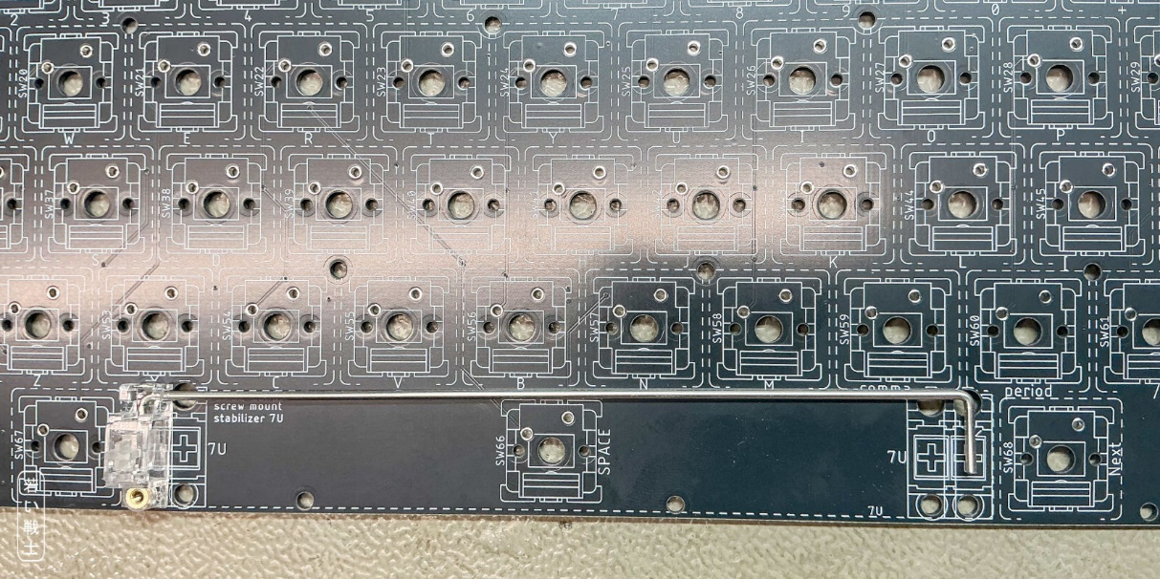
Figure 7: Checking the length of the stabilizer wire
Insert the wire into one of the stabilizers (the body with the little moving plastic part) and mount it on the PCB. The 2nd bend should be positioned on the center line of the 2nd stabilizer (Figure 7). If that is the case, the 2nd stabilizer can be mounted.
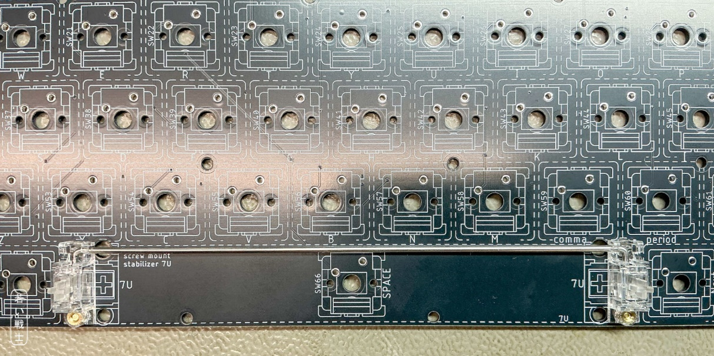
Figure 8: Space bar stabilizer completely mounted
The moving parts should move freely up and down. If you lift one side, the other should also lift in the same manner. When dropping it, the other side should drop, too. It should not get caught. The spring of the space bar switch needs to be able to fully push the space bar up.
I have made three stabilizer wires yet and screwed up one. So, it is a good thing to have enough wire for two or three attempts.
The perfect wire would have the outer dimension of 0.75mm + 125mm +0.75mm = 126.5mm. The screwed-up wire was only 125mm in total – 1.5mm too short. It could still be installed, but the stabilizer didn’t move freely anymore.

