Cable Making Rev. 0.0

The Ribbon Cable
There is one ribbon cable: the keyboard cable connecting the keyboard to the C64 keyboard connector PCB (see drawing no. 233-3-01-0*, file /Cables/pdf/KB-Cab.pdf).
The cable uses a 2×10-way IDC receptacle on one end and a MicroMatch (IDC) connector on the other. The only tool required is a small vice.
Insert the cut ribbon cable into the connector, making sure that the red wire (wire no. 1) is aligned with pin 1, which is marked by a triangle/arrow on the connector. Then compress the connector in the vice.
Note that the 2×10-way connector has a strain relief. This causes the connector to be rotated by 180° when the strain relief is installed.
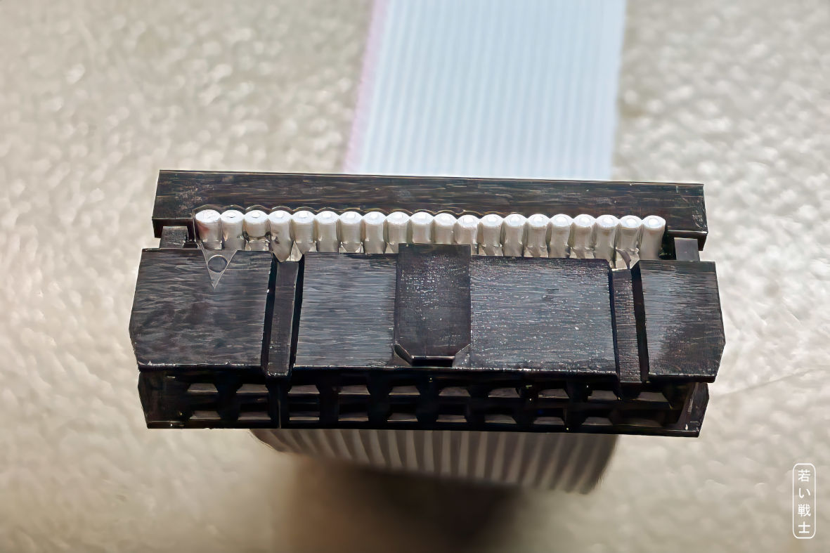
Figure 1: IDC receptacle - ribbon cable aligned
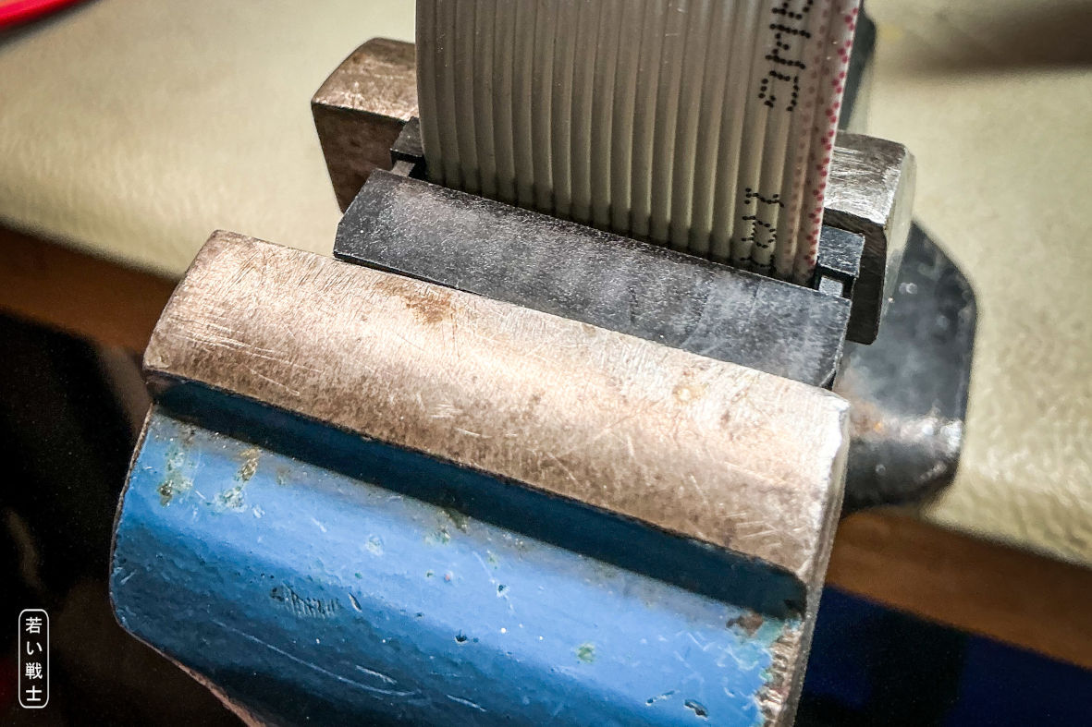
Figure 2: IDC receptacle in the vice, before compressing
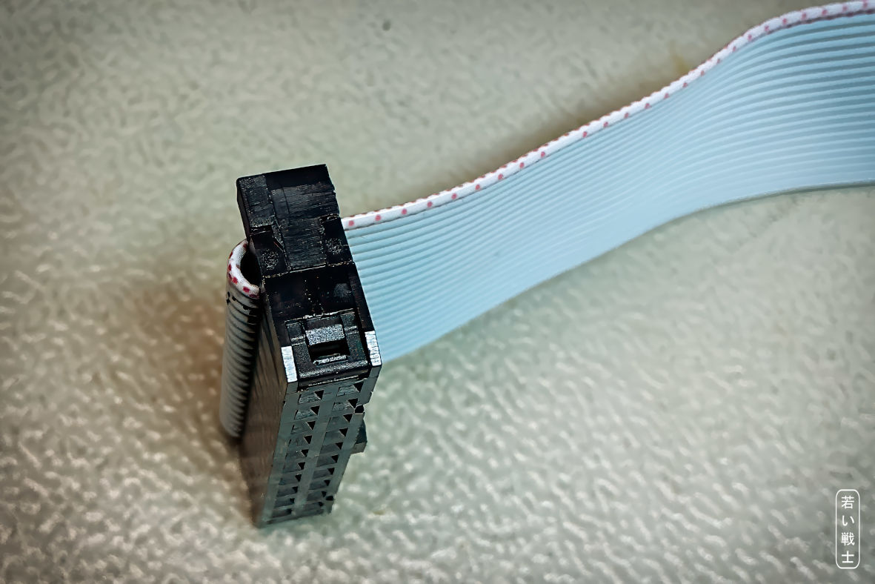
Figure 3: IDC receptacle - strain relief installed
The MicroMatch connector has a nipple that marks pin 1. There is no strain relief for this connector.
When compressing the connector with a vice, take care not to break off the pin-1 marking nipple.
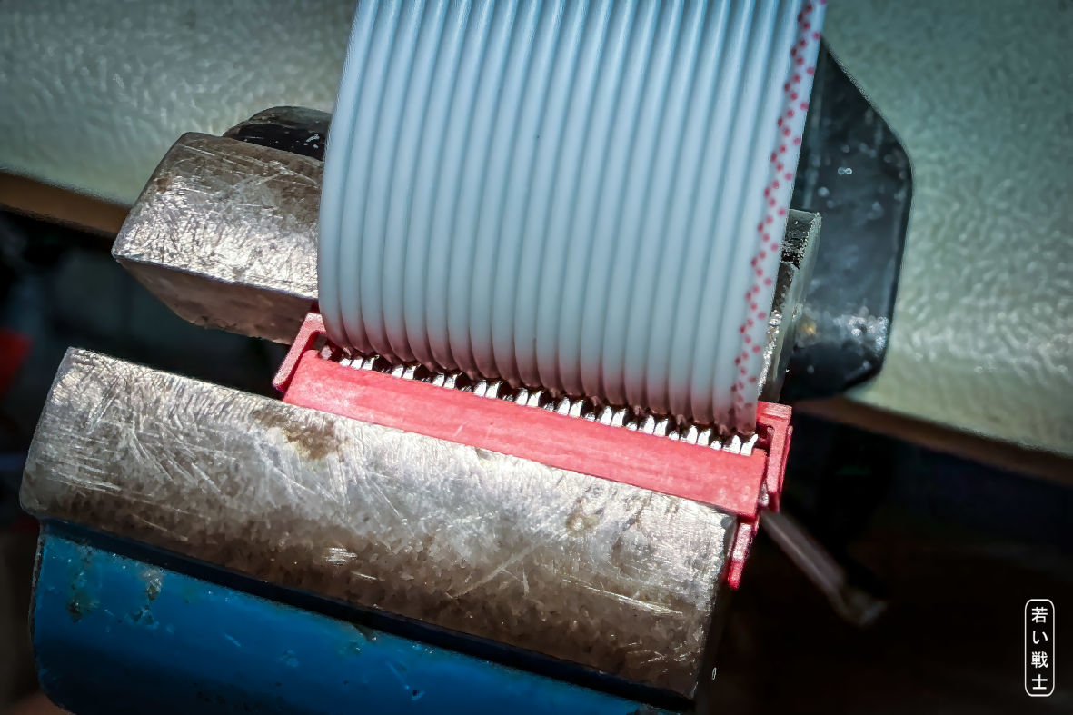
Figure 4: MicroMatch connector in vice with adjusted ribbon cable (
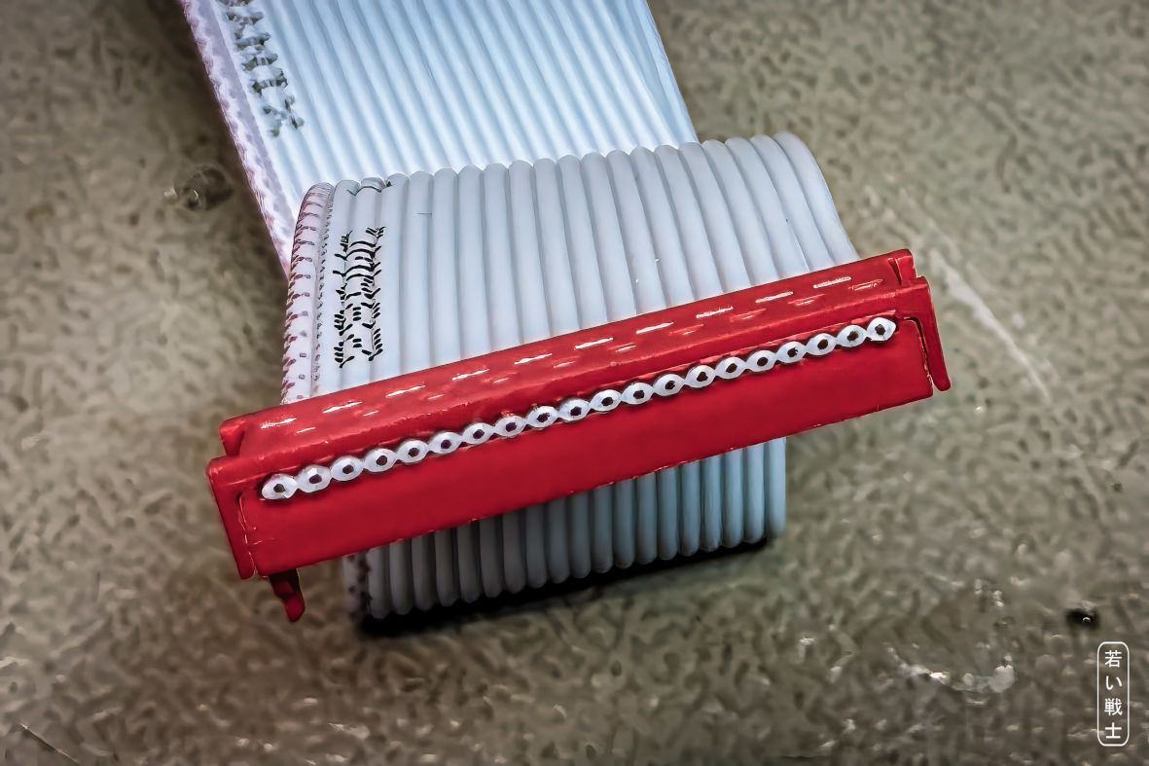
Figure 5: MicroMatch connector properly installed

The Dupont Cable(s)
The cables are designed to work with ready-made Dupont cables, which are readily available. These are ribbon cables with pre-crimped single-pin female Dupont connectors.
You will need 40 cm cables.
The simplest solution is to tear off the required number of individual wires from the ribbon cable and use them as they are.
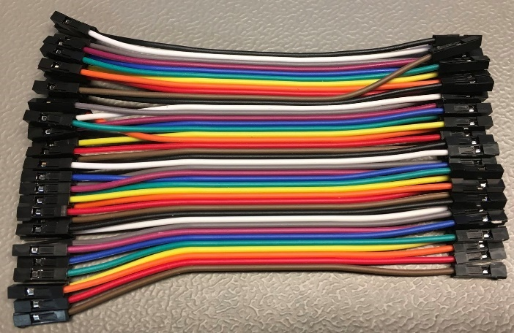
Figure 6: Ready-made Dupont cable (the length in the picture is short for photographic purposes)
A better solution is to use additional Dupont crimp housings. Remove the individual single-pin housings from the pre-crimped wires and replace them with 5-pin and 3-pin housings as required.
This method does not require a crimping tool, since the wires are already crimped. It also has the advantage of keeping the wires grouped correctly, making it much less likely that the pins will be mixed up.
The required Dupont housings are commonly available in assortment boxes.
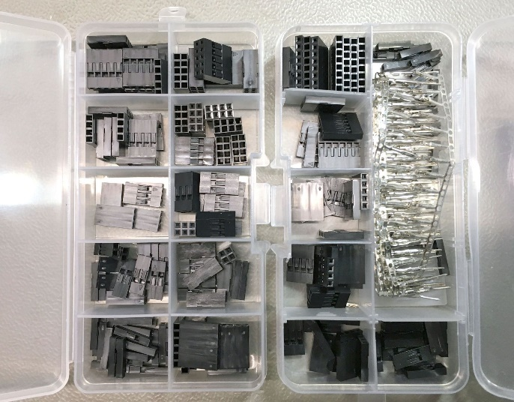
Figure 7: Dupont connector assortment box
For cables made to exactly the required length, you can use a crimp tool and crimp the terminals yourself.
The main problem with crimping Dupont terminals is that many tools are marketed as “Dupont” crimp tools but are not actually suitable for these terminals. The tool must form the insulation crimp correctly so that the finished terminal fits properly into the crimp housing.
The only crimp tool for Dupont terminals that I have used successfully is the IWISS SN-025.

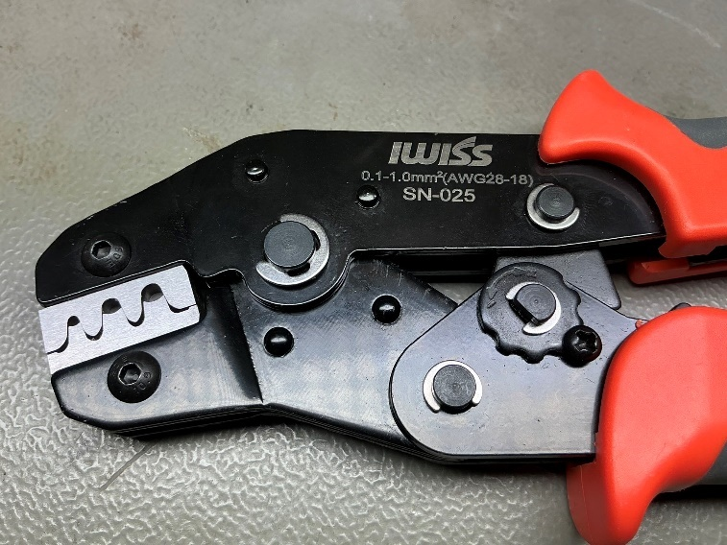
Figure 8: IWISS SN-025 crimp tool
The choice is yours.
In my opinion, buying a crimp tool solely for this project does not make much sense if it is going to end up as unused drawer clutter. However, if you intend to make your own crimped cables for other projects as well, I can recommend this tool.
Dupont assortment boxes are the simplest way to obtain all the crimp housings you need, typically including 3-way, 5-way, and optionally 4-way housings.
There are two Dupont based cables:
- Kernal Switcher Cable: /Cables/pdf/KSw_Cab.pdf
- Ultimate Button Cable: /Cables/pdf/Ulti_Cab.pdf
You only require one of them, depending on the application of the keyboard.

Revision History

Rev. 0.0
- Initial Release

