How to: Keycaps
Table Of Contents
1. Introduction 2
2. Blank Keycaps 2
3. Keyboard Layouts 3
4. Laser Engraving 5
5. Filled Laser Engraving 8
6. UV-Decals 9
6.1. General Information about UV-decals 9
6.2. Wear testing 10
6.3. Manual Alignment 11
6.4. The Process of applying UV Decals 12
6.4.1. Required Tools 12
6.4.2. Cleaning the Blank Keycap 12
6.4.3. Step One: Cutting Out the Decal 13
6.4.4. Step Two: Positioning the Decal 13
6.4.5. Step Three: Attaching the UV Decal 13
6.4.6. Step Three: Peeling Off the Top Foil 14
7. UV Printing 15
8. Dye Sublimation 16
9. Comparison of Methods 17
10. Other Ways 18
10.1. Buying Keycaps 18
10.2. Using Original Keycaps 18

Introduction
For every retro-computer mechanical keyboard project, keycaps have been a significant challenge. There are, however, several methods for making decent-looking keycaps. Making keycaps is also the subject of many YouTube videos. I have tried some of these methods with varying degrees of success.
Before making any C64 keycaps, there was a major task to complete: creating the legends with Inkscape. Inkscape is free and open-source vector graphics software, which I use for almost every project to create case labels, logos and block diagrams.
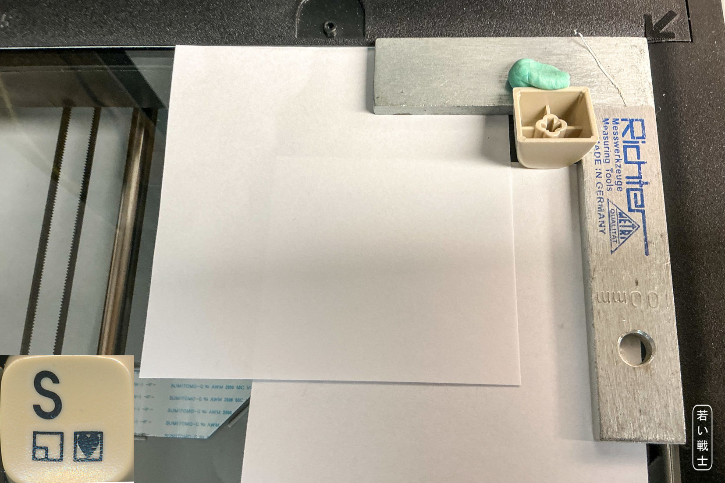
Figure 1: Scanning a single keycap
The legend drawings are based on scans of the top of every individual keycap of a C64C keyboard. These keycaps have top-printed legends only. A great help was discovering that the font used for the letters is ITC Avangarde Gothic LT Medium, which is also freely available on GitHub. To use the *.svg (Inkscape) files provided in this repository, you need to install this font first. It needs to be installed for all users so that it is available to Inkscape.
The Inkscape keycap legends are exported as pixel-based *.png images at a resolution of 600 dpi. These are the files I used for laser-engraving several sets of keycaps.
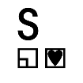
Of course, you can also use C64 Ultimate or original C64 keycaps with this C64 keyboard project.

Blank Keycaps
The basis for all DIY keycaps is blank keycaps, which are available from various sources. I have only tried purchasing them from AliExpress, so all of my market research is based on this source.
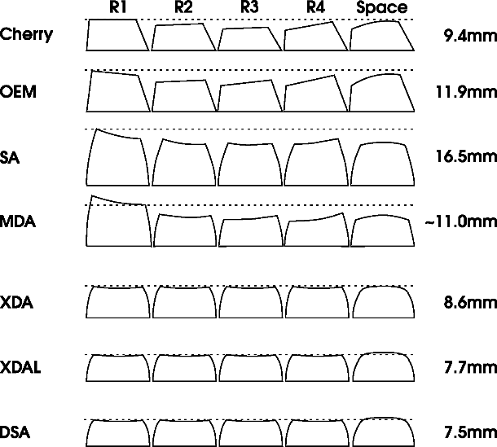
Figure 2: Some keycap profiles
Several keycap profiles are available (Figure 2). The problem is that we do not just need 1U keycaps, but also 1.5U keycaps for SHIFT, CONTROL, RESTORE and the function keys, a 2U keycap for RETURN, and a 7U space bar—all in the same profile. So far, I have only found a complete set of the required sizes in the DSA profile.
Obviously, some keycap profiles have a different shape for each row. The original C64 keyboard has ten different keycap types: four different 1U keycaps, four different 1.5U keycaps, one 2U keycap, and the space bar.
Most keycaps are made of PBT (polybutylene terephthalate), a type of plastic that feels very nice to the touch and is also suitable for dye-sublimation printing (temperature!), unlike ABS.

Keyboard Layouts
In addition to the standard keyboard layout, there are Danish, Swedish, and Spanish keyboard layouts, with language-specific keycaps. Of course, these also require a different Kernal ROM. In the 20th century, the language specific keycaps were modified with stickers - that is what I was told, and it is also what I have seen.
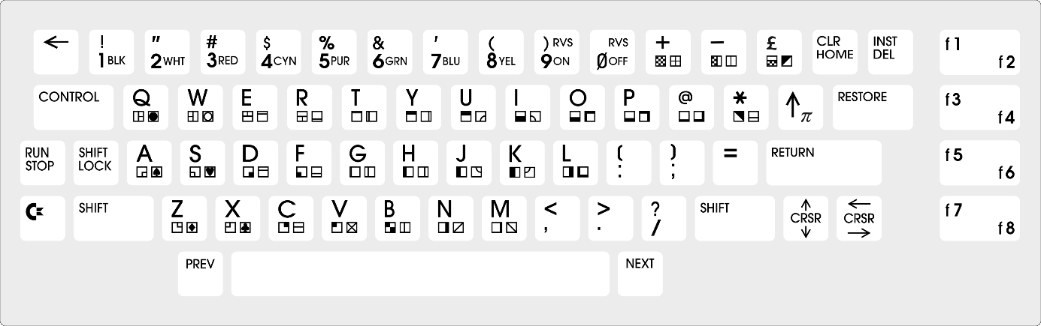
Figure 3: Standard/US keyboard layout
Apart from these, I have heard of a Turkish keyboard layout, but I do not have enough information about it. I have also heard of a German keyboard layout for the SX-64, but I have no further information about that, either.
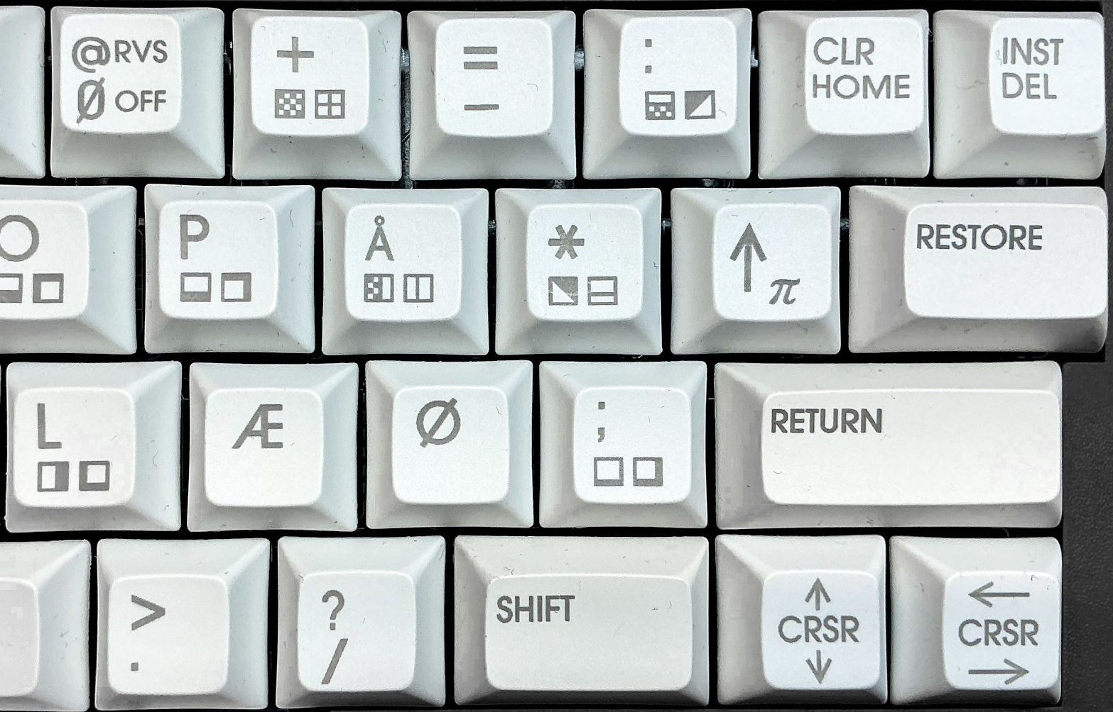
Figure 4: Danish-specific keycaps on the right-hand side of the keyboard
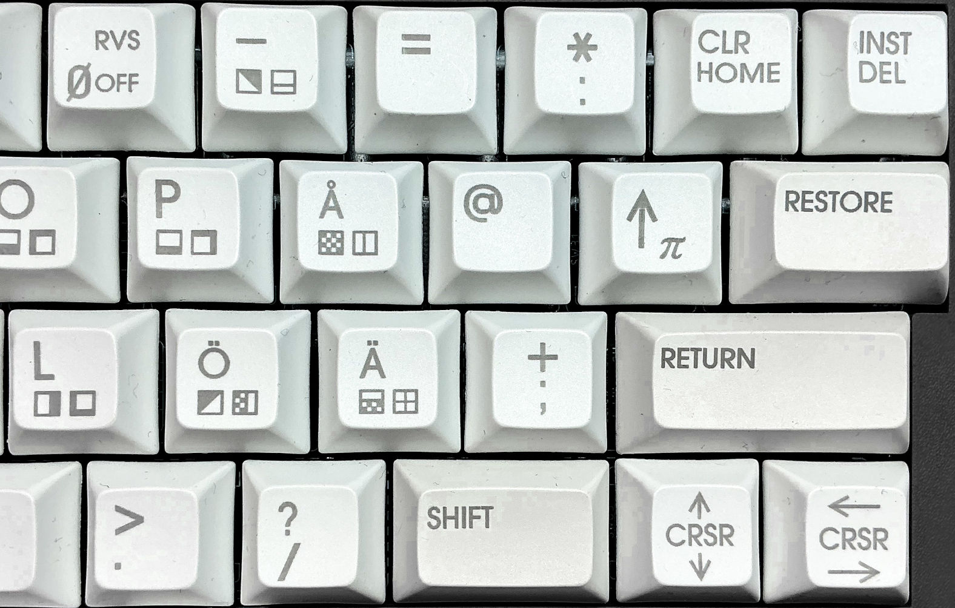
Figure 5: Swedish- (and Finnish-)specific keycaps on the right-hand side of the keyboard
The Danish and Swedish keyboard layouts require seven specific keycaps each (non of them works for both languages), while Spanish only requires three specific keycaps.
None of the keyboard layouts (even the US-/standard layout) is fully meeting the nowadays used ANSI layouts – sure, there are just more keys today. The Danish Å, Æ, Ø and the Swedish Å, Ö and Ä are in the same position relative to the other letters like on modern keyboards, while the Spanish- specific characters/letters are just moved to three specific keys.
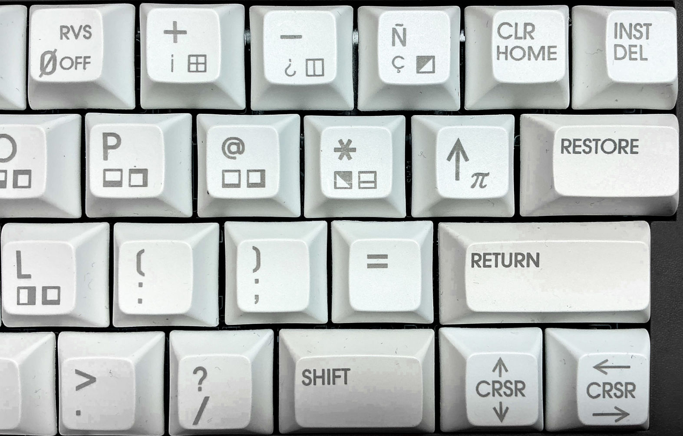
Figure 6: Right-hand side of the Spanish keyboard with the language-specific keycaps

Laser Engraving
Purchasing a fiber laser just to make a single set of keycaps is not very economical. The LaserPecker LP3 cost €1,260 in February 2025.
It is important to use a laser that is suitable for engraving plastic keycaps. This requires a 1064 nm infrared laser. The blue laser, that works for cutting and engraving wood will not produce any good results with plastic/PBT keycaps.
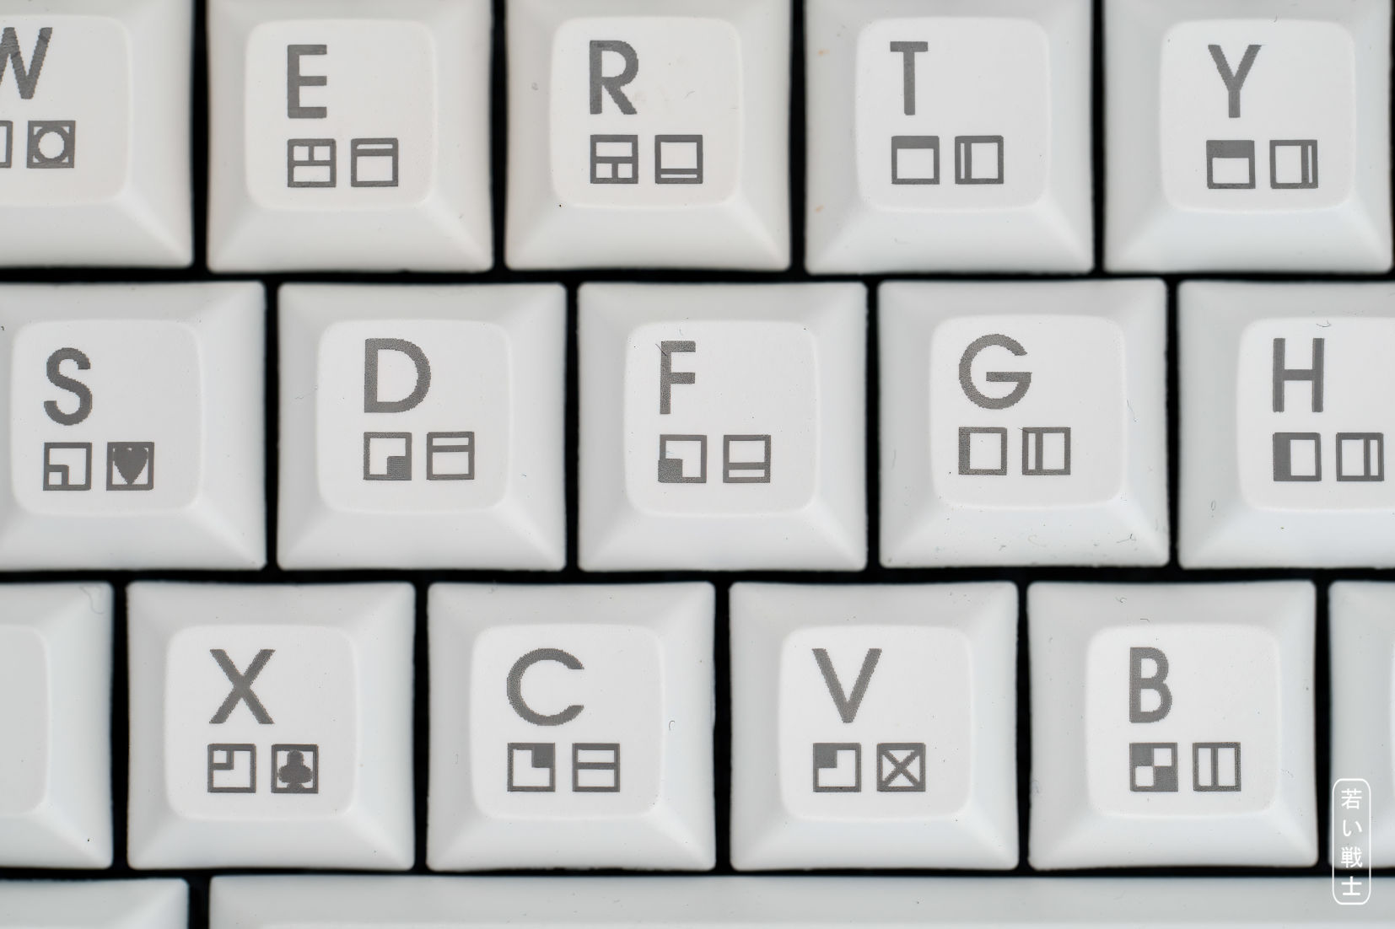
Figure 7: Keycaps made with a fiber laser (LaserPecker LP3)
Actually, the term “laser engraving” is somewhat misleading. The keycaps are not really engraved; they are laser marked, which means that the surface of the keycaps is locally charred by the laser. The result is a dark grey marking rather than a completely black one, but it still looks good (see Figure 7).
This process works best on white keycaps. Lighter colors also work for laser marking, it is required to optimize the parameters for laser marking for each color individually, since different colors react differently to the laser. Darker colors require significantly less energy.
For black/dark plastic, micro-foaming can be used to create a light-colored laser marking. The laser locally heats the material, causing microscopic bubbles to form below the surface and producing a contrasting light-grey-brownish mark.
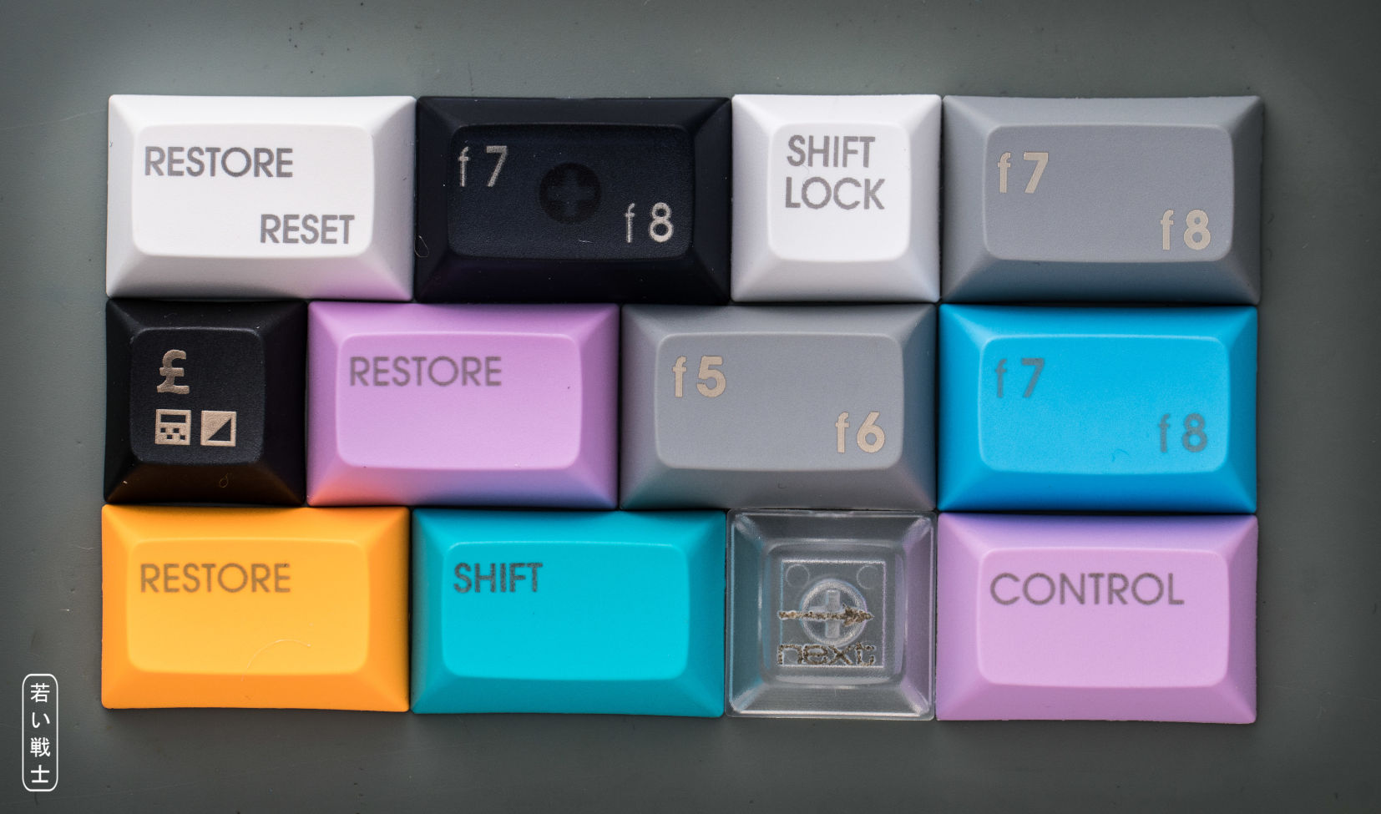
Figure 8: Colored keycaps experiments
It is not possible to laser-mark transparent or clear keycaps, as shown in Figure 4. The micro-foaming on the black and grey keycaps has a slight brownish tint. It was also possible to micro-foam the translucent black keycaps (f7/f8, top row, second from the left), but the result did not look good.
Here are some LP3 parameters, that I have used for laser marking the particular colored PBT keycaps.
Color | Resolution | Power | Depth | Passes
White | 4k | 40% | 1% | 4
Grey | 4k | 70% | 3% | 4
Orange | 4k | 30% | 1% | 4
Black | 4k | 20% | 1% | 4
Translucent black | 4k | 32% | 1% | 6
Light blue | 4k | 30% | 1% | 4
Light violet | 4k | 35% | 1% | 4

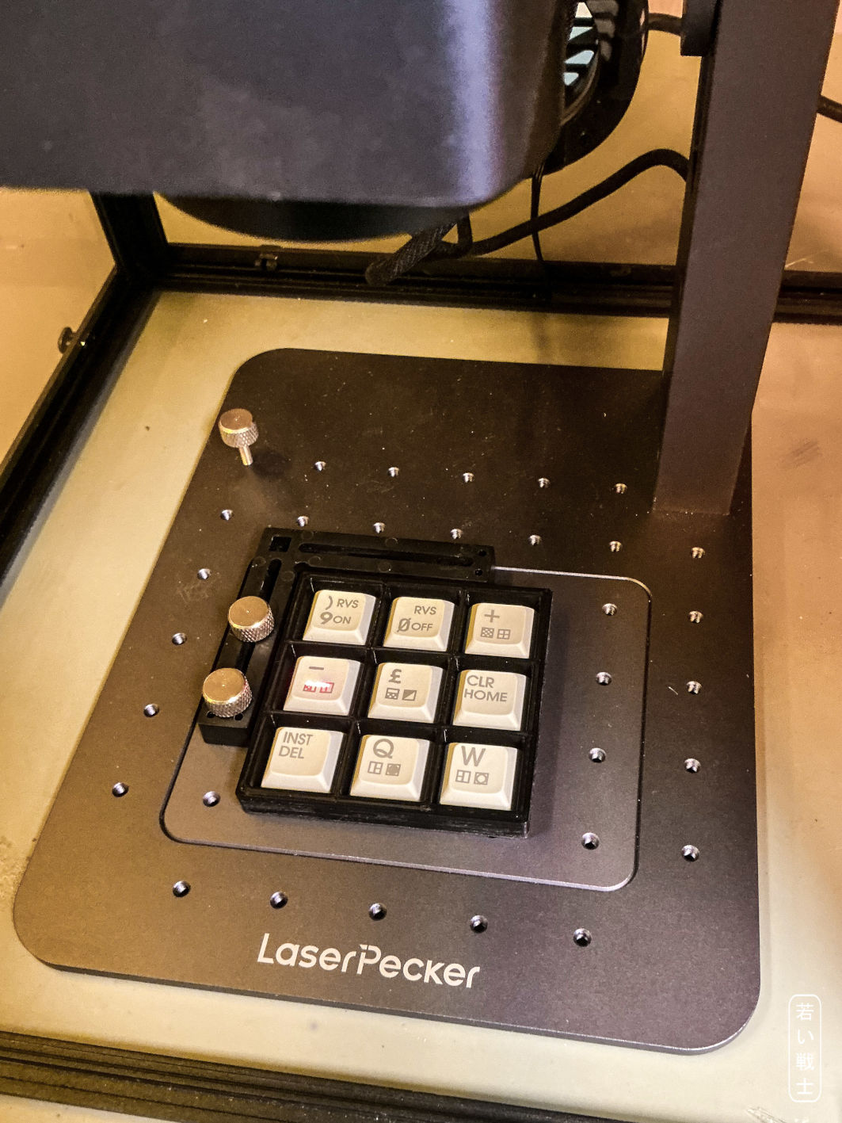
Figure 9: Laser marking nine keycaps simultaneously in a tray
I made the first keycap set one keycap at a time. Since positioning the keycap is the most time-consuming part of setting up the marking process, a complete set of 67 keycaps took about three hours.
To speed up the process, I made two keycap trays: one that holds nine 1U keycaps and another that holds four 1.5U keycaps (Figure 6). This significantly reduces the setup time, although it also increases the risk of ruining several keycaps at once—which happened to me once.
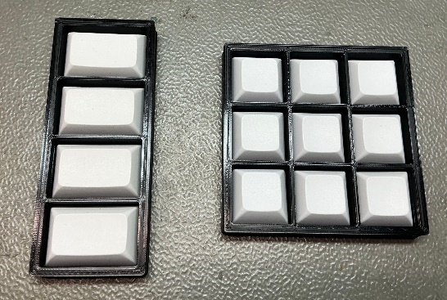
Figure 10: both keycap trays loaded with blank keycaps
Find the 3D print files in the \Keycaps\print_trays_3D\ directory.
I have tried different things to dye the laser marking (graphite, crayon, dye sublimation ink), none of that came any close to an acceptable result.

Filled Laser Engraving
The Legends can be laser engraved about 0.2mm deep onto the keycap and later filled with model paint. I have used Revell matt white for this purpose. johnsander from forum64.de suggested to apply a thick layer over the engraved parts, let it dry for a week and polish the excess away with an abrasive polishing wheel for rotary tools.
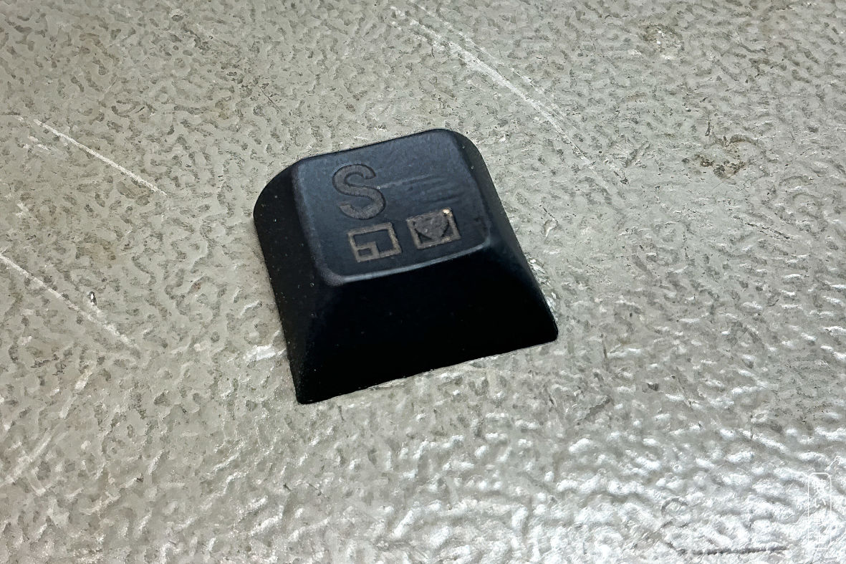
Figure 11: Engraved black keycap
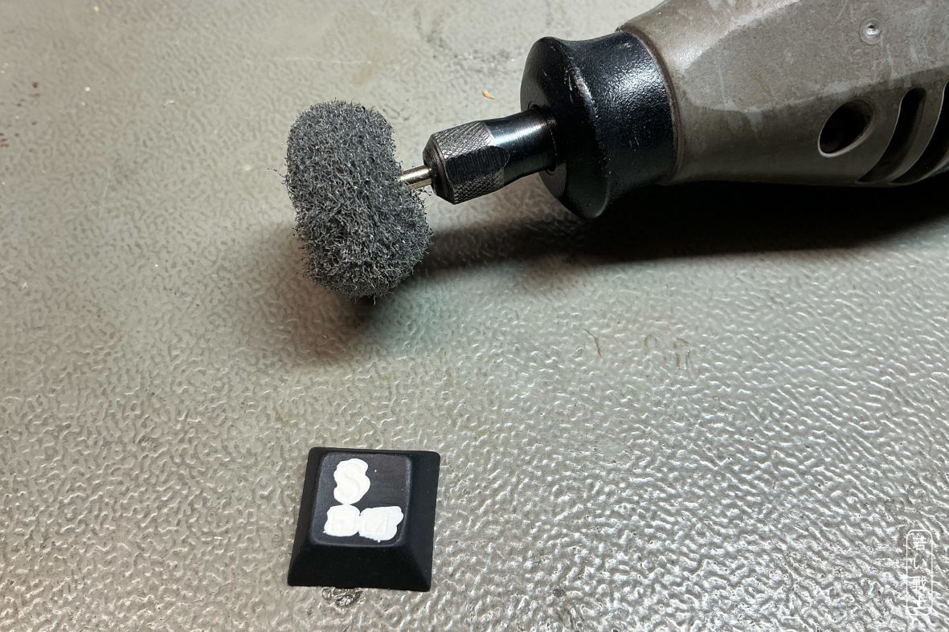
Figure 12: Keycap filled with white plastic paint and rotary tool
The white filling looked a bit dirty after polishing and the black surface of the keycap was not perfect, either, so I wiped it with a nano-sponge (my favorite is Ma Ant MY-065 because of the size and density) and isopropanol. The result looks impressive, almost like a double shot keycap. It is quite a bit of work to produce such a keycap. The advantage of this method is, that white on dark is possible. Most likely a coating is required to protect the white legends from getting dirty.
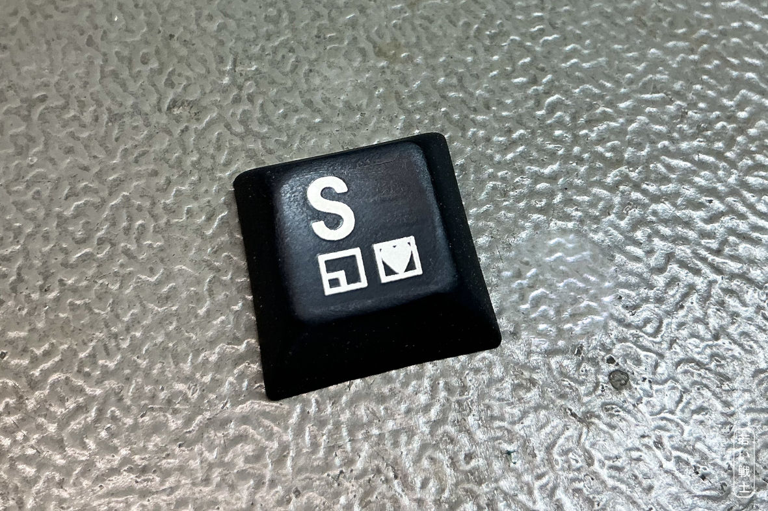
Figure 13: polished keycap

UV-Decals

General Information about UV-decals
During the documentation phase of the C64 keyboard project, I had a conversation with the BadgeMan, who provides really great labels and badges for retro-computer restorations and projects. He suggested making UV decals, which he then created from the files in this project's repository.
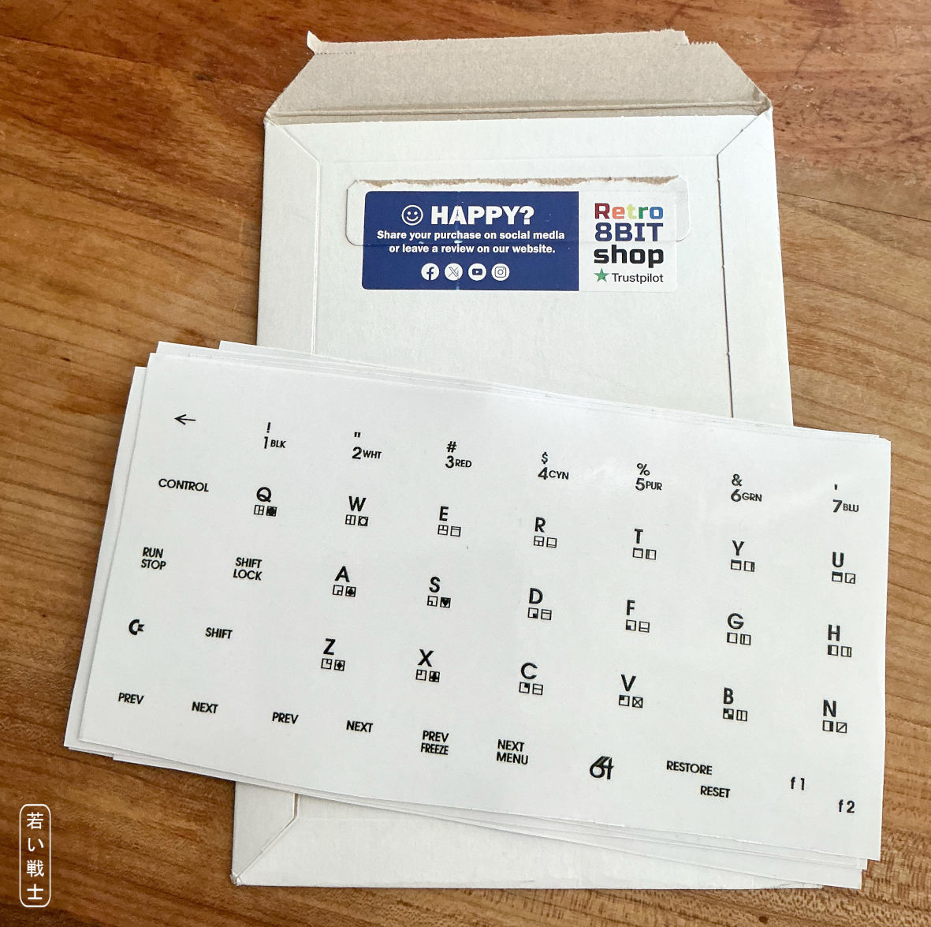
Figure 14: UV decal sheets from BadgeMan
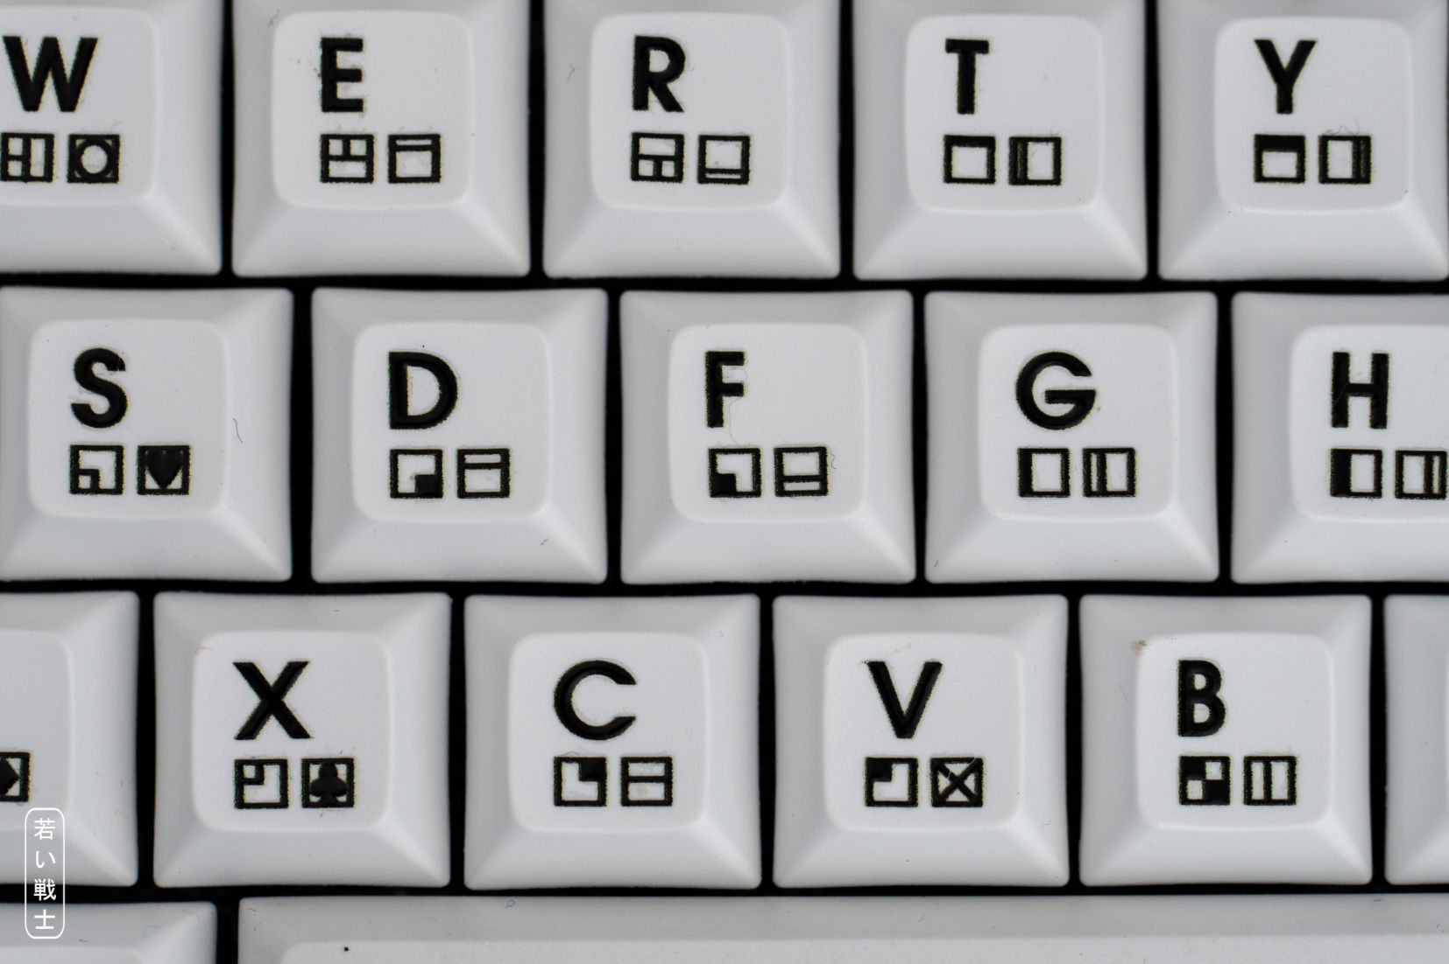
Figure 15: Keycaps with black UV-decals
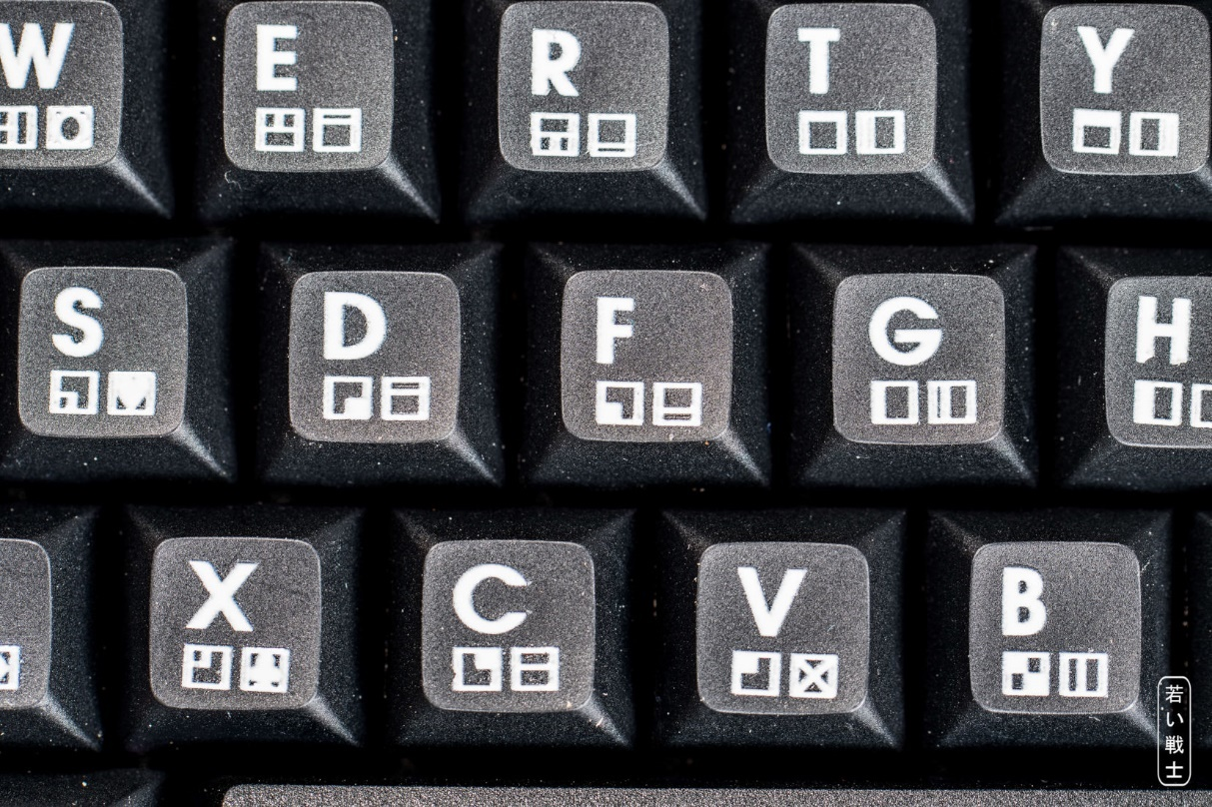
Figure 16: Keycaps with white UV-decals

Wear testing
The biggest concern with using UV decals (or any other type of decal) on keycaps was their durability. After applying UV decals to a set of keycaps, I therefore tested a RESTORE key that I had deliberately made for destructive testing.
I attached it to a VICE USB keyboard (as a function key), wrote a short BASIC program to count key presses, and then pressed the key 10,000 times, deliberately applying more friction than would be expected during normal use.
After the counter reached 10,000, I took some pictures of the keycap under a microscope.
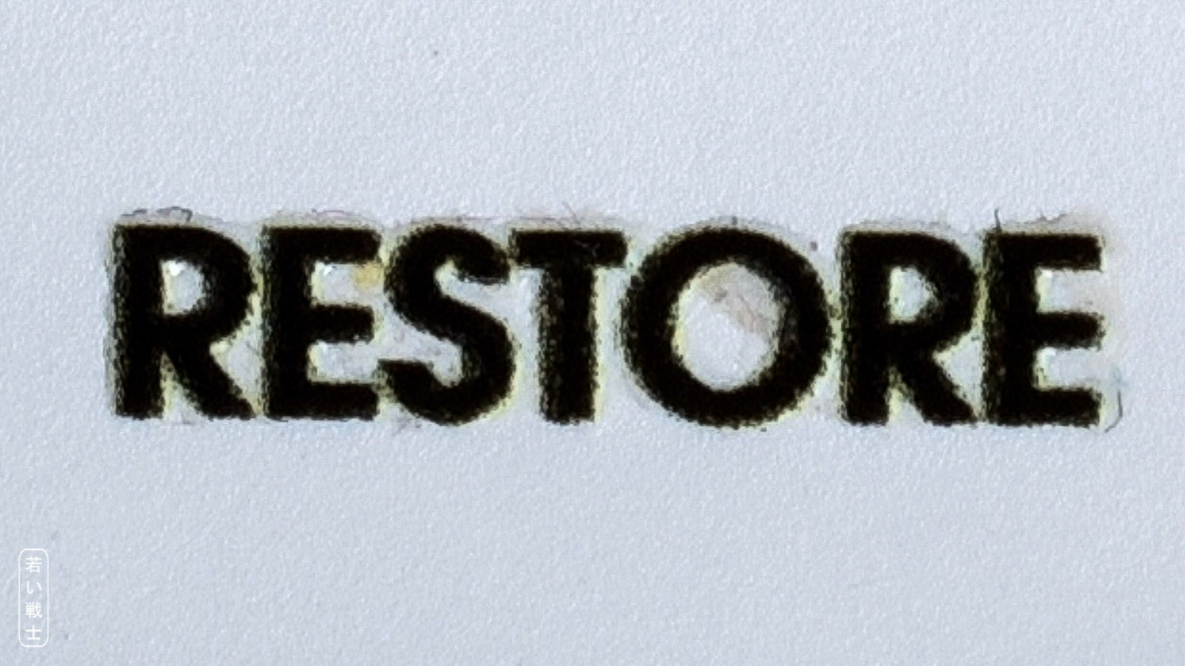
Figure 17: RESTORE UV-decal after 10,000 key presses (microscope image)
The result of the test was that I could not see any significant difference before and after the test. I therefore do not think that excessive wear of the UV decals is a concern.

Manual Alignment
A further concern was that manually aligning and positioning the UV decals might be difficult, time-consuming, or result in an inconsistent appearance.
Mr. BadgeMan told me that I just had to trust my “carpenter’s eye.” I didn’t even know I had such a thing, but I trusted it, and in my opinion, it worked out pretty well. Maybe there is a Dunning–Kruger effect for carpenter’s eyes, though.
Applying the UV decals is certainly not something you want to do before breakfast, but it didn’t take much longer than an hour and a half to finish the entire set.
What was sometimes difficult and annoying was that, in a few cases, parts of the decals did not stay on the keycap when I peeled off the protective foil. The left PETSCII icon on the C key in was one such case. Carefully reapplying the decal and applying some mild, but not excessive, pressure with a rubber eraser helped in by far the majority of cases, making the damage virtually invisible.
Mr. BadgeMan told me that I just had to trust my “carpenter’s eye.” I didn’t even know I had such a thing, but I trusted it, and in my opinion, it worked out pretty well. Maybe there is a Dunning–Kruger effect for carpenter’s eyes, though.
Applying the UV decals is certainly not something you want to do before breakfast, but it didn’t take much longer than an hour and a half to finish the entire set.
What was sometimes difficult and annoying was that, in a few cases, parts of the decals did not stay on the keycap when I peeled off the protective foil. The left PETSCII icon on the C key in Figure 9 was one such case. Carefully reapplying the decal and applying some mild, but not excessive, pressure with a rubber eraser helped in the vast majority of cases, making the damage virtually invisible.

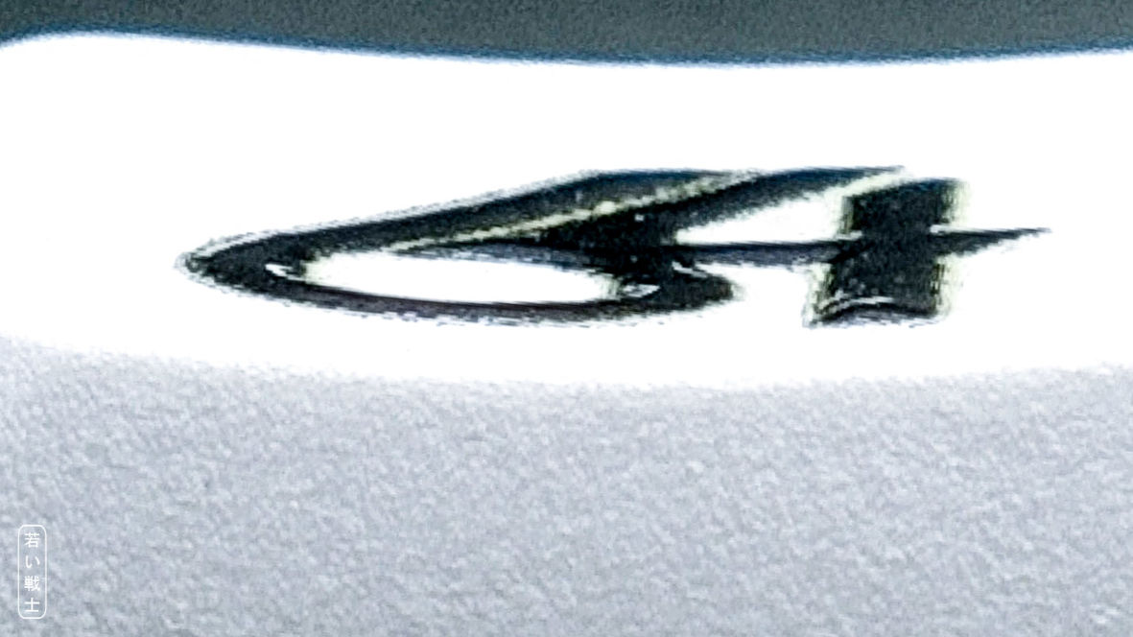
Figure 18: perspective view on a UV decal

The Process of applying UV Decals

Required Tools
There are actually no fancy tools required for applying UV decals. I only use an X-Acto knife (scalpel) and a pair of scissors. A rubber eraser is helpful for pressing the UV decal onto the keycap.
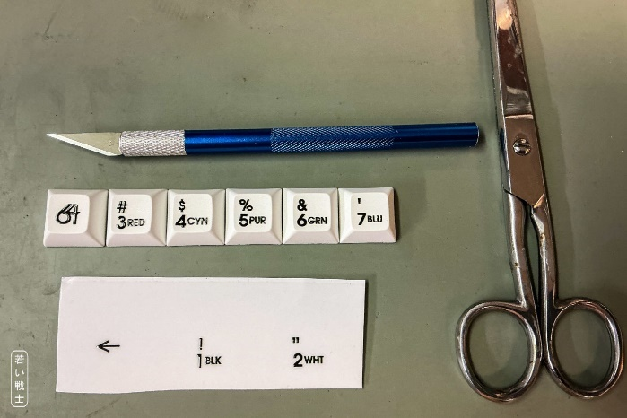
Figure 19: The required tools

Cleaning the Blank Keycap
A good practice is to rub the keycap with isopropanol and a clean, lint-free cloth. I recently came across “Cleanroom Wipers” from the MECHANIC brand on AliExpress, which I really like. I usually use them for cleaning up flux residues (also with the help of isopropanol), and they do an excellent job. They are anti-static, BTW.
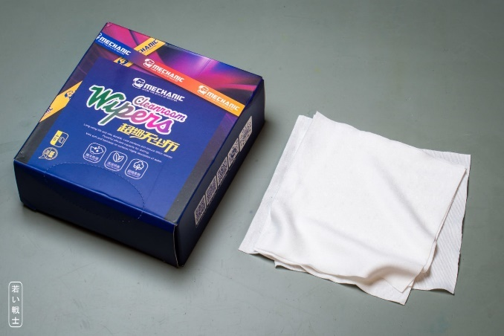
Figure 20: Cleanroom whipes

Step One: Cutting Out the Decal
The UV decals are intentionally printed with slightly more space between them. It is important to cut them out generously enough to leave sufficient space to hold them. This is essential for positioning the decal above the keycap before applying it.
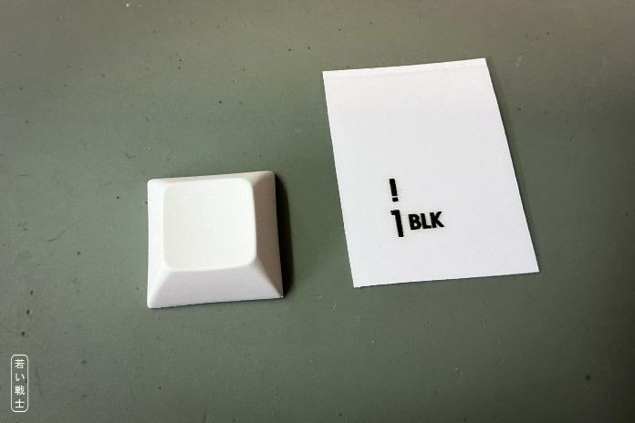
Figure 21: cutting out the decal

Step Two: Positioning the Decal
After peeling off the protective paper, it is easiest to hold and position the decal with the X-Acto knife. I usually hold the opposite corner with my fingers, because a slight tension helps to maneuver the decal above the keycap.
Some decals are positioned off-center, so it is a good idea to keep a picture of the keyboard layout at hand (Figure 3). Eyeballing the correct position of the decals works remarkably well. Most keycap legends are centered, and the PETSCII symbols on many keycaps provide a good reference point. The horizontal positioning should not be completely off, but most key rows are not vertically aligned anyway, so there is definitely some tolerance. The function keys are actually not difficult either—or perhaps you simply have some practice by the time you get there.
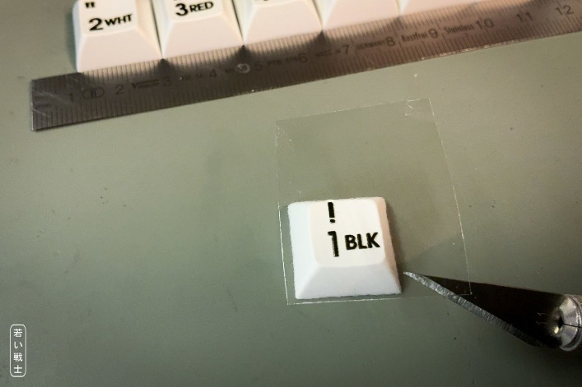
Figure 22: Positioning the decal

Step Three: Attaching the UV Decal
After sticking the decal onto the keycap, I briefly press it onto the keycap with a rubber eraser. Not for very long, and definitely not very hard—just using the weight of my hand. We don't want to deform or break it.
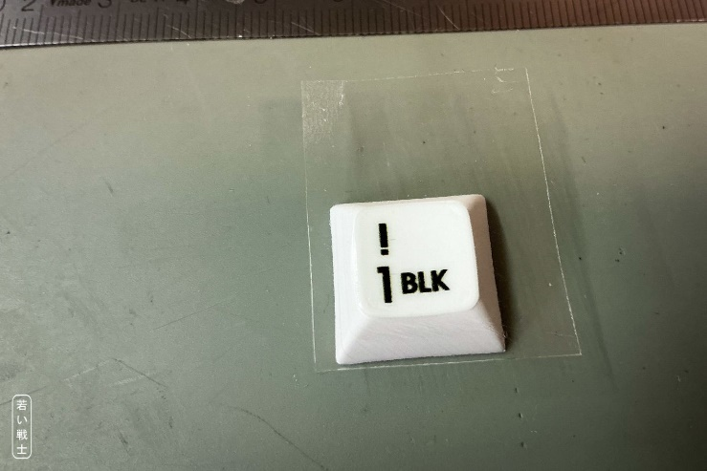
Figure 23: Sticking the UV decal to the keycap

Step Three: Peeling Off the Top Foil
Peeling off the foil is a crucial task. You need to carefully watch the keycap legend to prevent breaking it or to lose parts of it (like the dot of the ”!”). If something breaks, not everything is lost. Just lower the foil partially back on the keycap, press it slightly to the keycap and maybe retry peeling form an different direction. This sound more dramatic than it actually is. I only had problems with a handful of keycaps and I could fix all of them except the said dot from the ”!”.
Peeling off the foil is a crucial step. You need to carefully watch the keycap legend to prevent it from breaking or losing parts of it (like the dot of the “!”). If something breaks, not everything is lost. Just lower the foil partially back onto the keycap, press it lightly onto the keycap, and maybe try peeling it off again from a different direction. This sounds more dramatic than it actually is. I only had problems with a handful of keycaps, and I was able to fix all of them except for the aforementioned dot of the “!”.
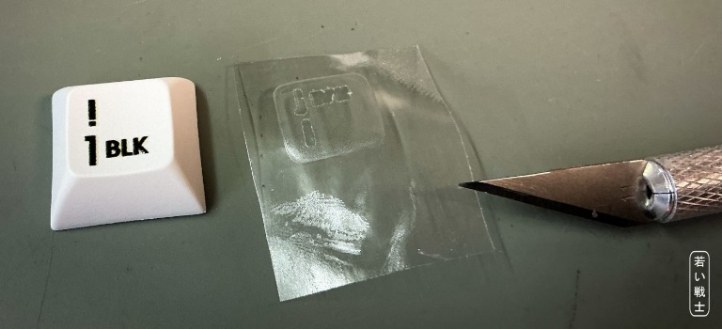
Figure 24: Peeling off the foil

UV Printing
UV printing is the method that requires the highest initial investment. UV ink is expensive and has a limited shelf life: it expires after about a year, or after only three months once opened (Mimaki). UV printers start at around €2,500 and can cost considerably more. There have also been a couple of crowdfunding campaigns recently (as of late 2026).
UV printing cannot really be recommended for producing just one or a few keyboards at home. There are UV printing services available, though. Since I do not do UV printing myself, I cannot provide any further insight into this method.
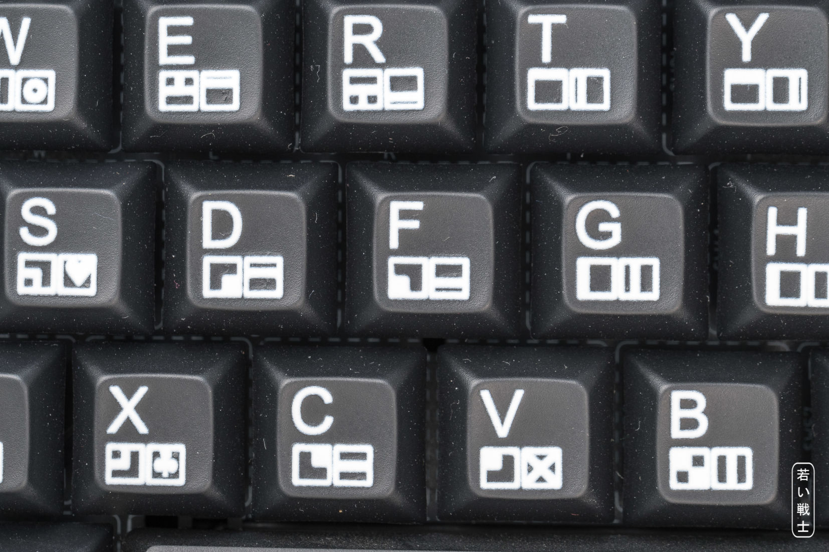
Figure 25: UV print (white on black keycaps) (by AKCZ/norths.de)
As with UV decals, it is possible to have white legends on black (or other dark) keycaps. The result may look slightly unsharp, although it is somewhat better than with white UV decals. When printing light colors onto dark objects, a white ink layer is typically used underneath the colors to provide a sufficiently bright and opaque base. The additional print layer can result in slightly less sharp edges, which may be noticeable with small keycap legends.
There is a single printing tray that can hold all keycaps (except the space bar, which does not require a print). This tray is meant for UV printing. The size is 191.3mm x 162.2mm x 7.9mm. The print file (vector graphics) is \Keycaps\Inkscape\DSA_keycaps_in_single_tray.svg. Find the 3D print files in the \Keycaps\print_trays_3D directory.
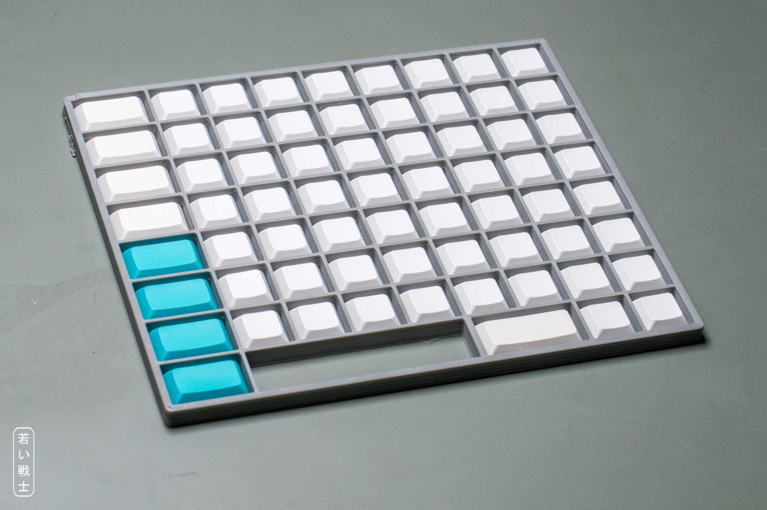
Figure 26: Tray for UV printing, which holds all keycaps
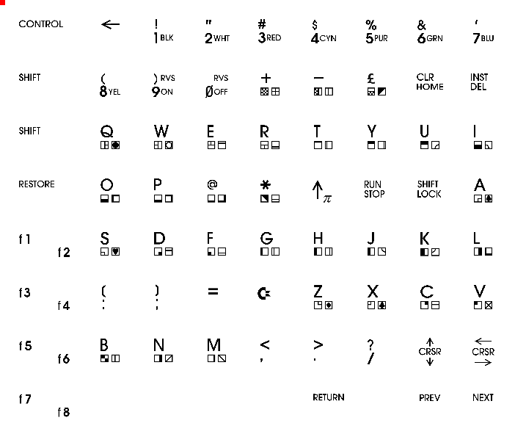
Figure 27: vector graphic file suitable for the above tray

Dye Sublimation
Dye sublimation is quite a popular method for adding legends to keycaps. The legends are printed in mirror image onto special paper using a dye-sublimation inkjet printer and dye-sublimation ink. Colored prints are also possible, but only on white keycaps.
The paper with the printed legend is cut out and placed on the keycap with the ink side facing down. The paper is secured with heat-resistant Kapton tape. Heat (about 210 °C) and manual pressure are then applied, with the pressure ensuring that the paper is held closely against the keycap surface. The dye sublimates and penetrates the keycap plastic. The keycap material should be PBT rather than ABS, as PBT can withstand the temperatures required for the process.

Comparison of Methods
This table shows the same keycaps produced with the different methods.
Laser Marking | 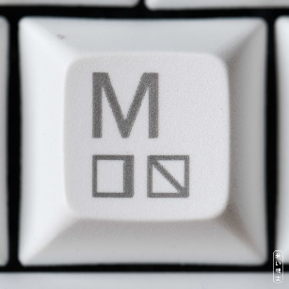 | 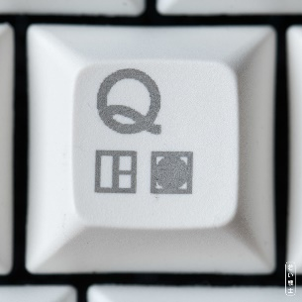 | 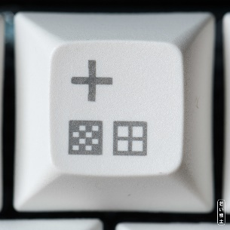 | 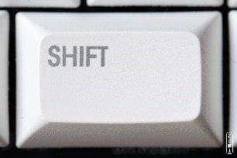
UV decals (black) | 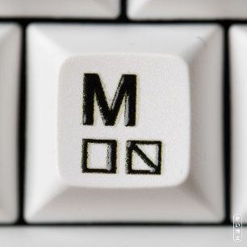 | 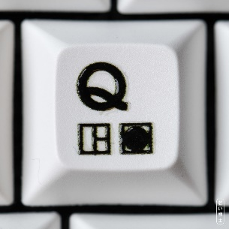 | 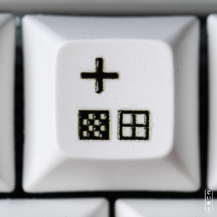 | 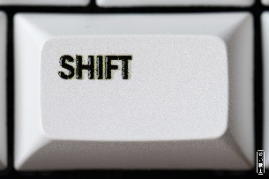
UV decals (white) | 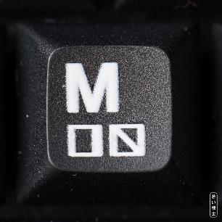 | 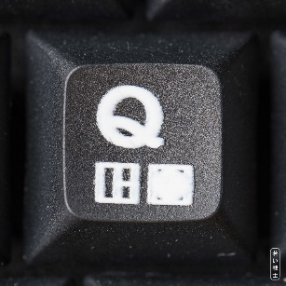 | 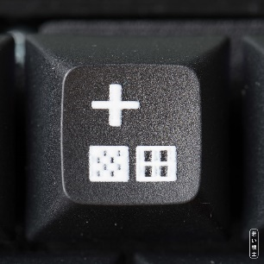 | 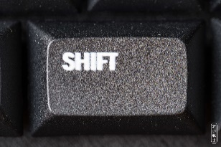
UV print (white) | 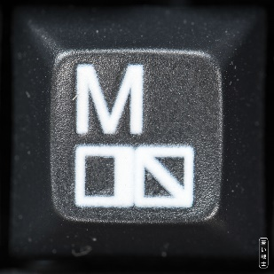 | 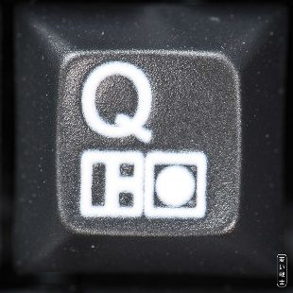 | 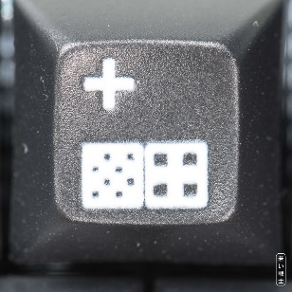 | 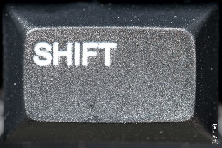

Note: The photos were taken on different days, so the camera and lighting setup was not always the same. This results in slightly different sizes and appearances.
The white UV print was made using a different keycap print file. The PETSCII characters are slightly larger, and the letters use a different font (see the “Q”).
Find the original images (not scaled down) in the \Keycaps\pictures\ folder.

 | Laser  Marking | UV  Decals | UV  Printing | Dye  Sublimation
Costs for printing service | ? |  |  | ?
Investment for own tools | 1600€ | >5000€ | >2500€ | 500€/30€
Costs per print (set)
Work | 1h | 1h | ?
Print sharpness (black on white)
Print contrast (black on white)
Prints white on black
Print sharpness (white on black) |  |  |  | d.n.a.
Print contrast (white on black) | Brownish tone |  |  | d.n.a.

Other Ways

Buying Keycaps
The C64 Ultimate/Blingboard64 keycaps will fit this keyboard project. They are the best possible reproduction of the original keycaps and can be purchased from https://www.cbmstuff.com/. There are “original” and “Blingboard64” keycaps. The latter are the proper choice. They fit the switches in the SWxxA position (modern) and require a 7U stabilizer for the spacebar.
The only disadvantage is that the “PREV” and “NEXT” key cannot be populated, which means, that quite a bit of functionality (Kernal switching, scrolling through the LED strip illumination modes) cannot be used.

Using Original Keycaps
Using original keycaps is also an option. Since the switch connector of the keycaps does not fit on the MX compatible switches, there is are adapters required for the keycaps. These are the same like for the MechBoard64. They can be purchased from https://www.retrofuzion.com/ (MechBoard 64 Injection Molded Keycap Adapters). If you chose this way, please make sure, that are not sold out.
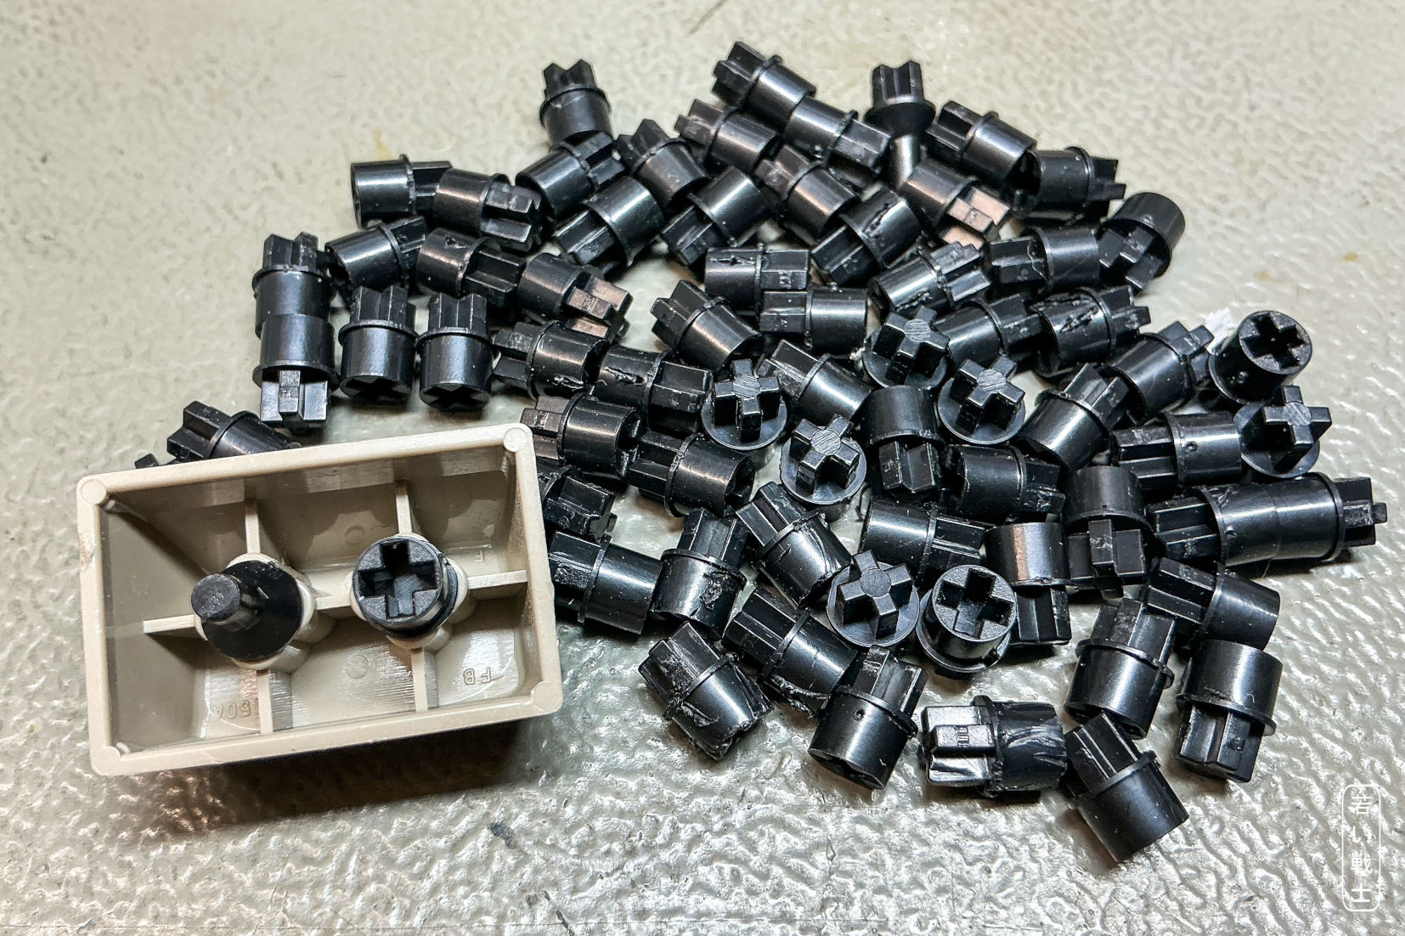
Figure 28: 1.5U keycap with keycap adapters (retroFuzion)
The disadvantage is again the 9U spacebar is occupying the space for the “PREV” and “NEXT” key, which offer the Kernal switching and LED strip functionality. Also, the adapters add some height to the keycaps (1.9mm).

