C64 Keyboard Software
Module Description v0.00
Table of Contents
1. Introduction 2
2. Functions 2
2.1. C64 (Matrix) keyboard 2
2.2. Ultimate (Matrix) keyboard 3
2.3. VICE USB-Keyboard 4
2.4. BMC64 USB-Keyboard 5
3. Installing and preparing the Arduino IDE 6
3.1. Download and Installation 6
3.2. Library Manager 6
4. Configuring the Software 7
4.1. Preprocessor macros 7
4.2. OLED display 8
4.3. Playing the “Are you keeping up with the Commodore” jingle 9
4.4. USB Keyboard 9
4.5. Ultimate 64 mode 10
4.6. WS2812B RGB LED Strip 10
4.7. Kernal Names 11
4.8. Boot Logo 11
5. Programming The Software 11
6. Revision History 14
6.1. Rev. 0.00 14

Introduction
The C64 Keyboard functions as a normal/standard matrix keyboard if no micro controller (Pro Micro) is installed. However, if you want to use “smart” functions, like
- RESET/EXROM RESET
- Kernal Switching
- RGB LED illumination (WS2812B strip)
- USB Keyboard (for VICE or BMC64)
some software needs to be installed on the Pro Micro. This can be done using the free Arduino IDE, a suitable USB-C or micro-USB cable, and a PC.
The software can be configured to suit your particular use case simply by uncommenting the appropriate preprocessor macros. This does not require a PhD in computer science and will be described later in this document.

Functions

C64 (Matrix) keyboard
This requires the Kernal switcher cable to be connected to a Kernal EPROM adapter (long board or short board), plus /RESET and /EXROM.
Key | Duration | Function
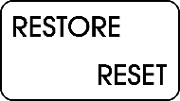 | < 0.3 secs | Normal RESTORE
 | ≥ 0.3 secs | “RESTORE Fix”: 5 pulses (of 30 msecs each) are issued on the RESTORE signal of the keyboard.
 | ≥ 3 secs | A “normal” RESET is issued. SHIFT LOCK is turned off.
 | ≥ 5 secs | An EXROM RESET is issued. This bypasses some CBM80 copy protections. SHIFT LOCK is turned off.
 |  | Cycle through RGB LED modes (downwards)
 |  | Cycle through RGB LED modes (upwards)
 +  |  | Cycle through Kernals (downwards), RESET the C64
 +  |  | Cycle through Kernals (upwards), RESET the C64

The requirement to press PREV/NEXT and RESTORE simultaneously prevents accidentally switching Kernals, since doing so resets the C64 and causes any running program to be lost.

Ultimate (Matrix) keyboard
This requires the Ultimate Buttons cable to be connected to the Buttons pin header on the Ultimate Elite II board. On earlier models, the button pin header is not implemented.
Key | Duration | Function
 | < 0.3 secs | RESTORE key
 | ≥ 0.3 secs | RESTORE key
 | ≥ 3 secs | The RESET button on the buttons pin header is simulated.  SHIFT LOCK is turned off.
 | ≥ 5 secs | SHIFT LOCK is turned off.
 |  | Cycle through RGB LED modes (downwards)
 |  | Cycle through RGB LED modes (upwards)
 +  |  | The FREEZE button on the buttons pin header is simulated.*
 +  |  | The MENU button on the buttons pin header is simulated.
* The FREEZE button only has an effect when a freeze cartridge is present.

VICE USB Keyboard
The USB keyboard in VICE mode uses a positional keyboard layout in either English, German, or Swedish. The keyboard is scanned 125 times per second (every 8 ms).
Key | Duration | Function
 | < 0.3 secs | RESTORE key sent.
 | ≥ 0.3 secs | RESTORE key sent twice.
 | ≥ 3 secs | A soft RESET (ALT+F9) is sent. SHIFT LOCK is turned off.
 | ≥ 5 secs | A hard RESET (ALT+F12) is sent. SHIFT LOCK is turned off.
 |  | Cycle through RGB LED modes (downwards)
 |  | Cycle through RGB LED modes (upwards)
 +  |  | <ALT>+<8> is sent (attach disk image)
 +  |  | <ALT>+<C> is sent (attach cartridge image)

BMC64 USB Keyboard
The USB keyboard in VICE mode is a positional English keyboard. The keyboard is scanned 125 times per second (every 8 ms).
Key | Duration | Function
 | < 3 secs | RESTORE key sent
 | ≥ 3 secs | + f1 is sent. SHIFT LOCK is turned off. *
 | ≥ 5 secs | + f3 is sent. SHIFT LOCK is turned off. *
 |  | Cycle through RGB LED modes (downwards)
 |  | Cycle through RGB LED modes (upwards)
 +  |  | + f5 is sent.*
 +  |  | + f7 is sent.*

* These functions require configuration in the BMC64 menu, which can be accessed by pressing RESTORE. The relevant submenu is:
Keyboard → Mapping → Positional
My Configuration:
Key | Configured Actions
+ f1 | Soft reset
+ f3 | Hard reset
+ f5 | Tape OSD
+ f7 | Menu
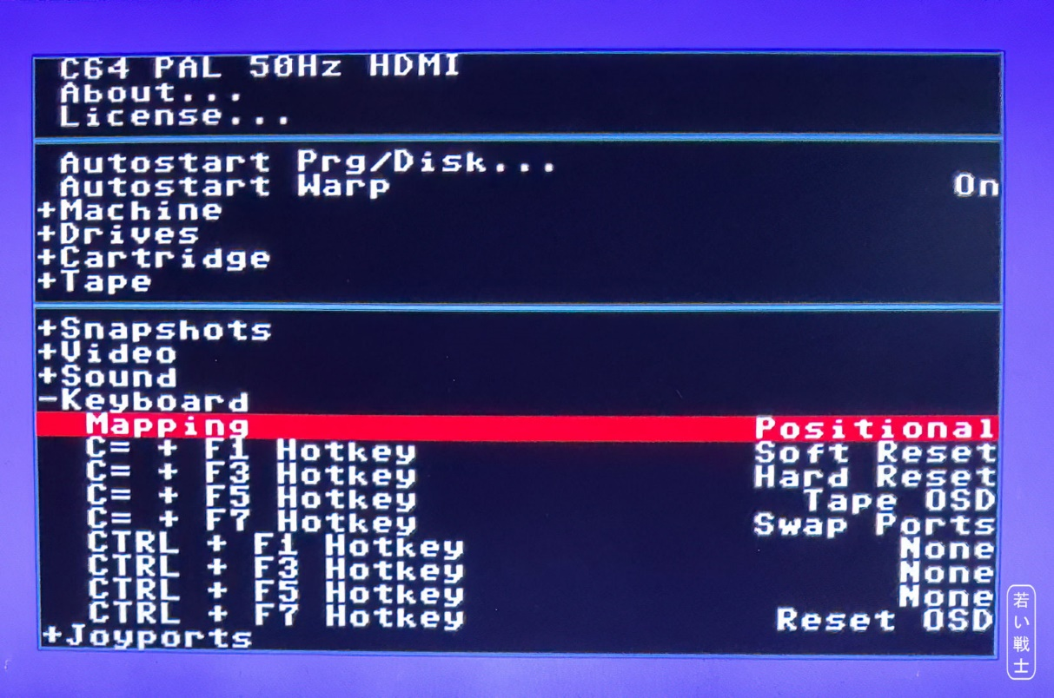
Figure 1: Configuration of BMC64 in the menu

Installing and preparing the Arduino IDE

Download and Installation
The Arduino IDE is required for programming the Pro Micro module. In addition, several libraries need to be installed using the IDE's Library Manager.
The Arduino IDE can be downloaded from arduino.cc. Select the version for your computer's operating system (Windows, Linux, or macOS) and follow the installation instructions.

Library Manager
Next, open the Library Manager in the Arduino IDE.
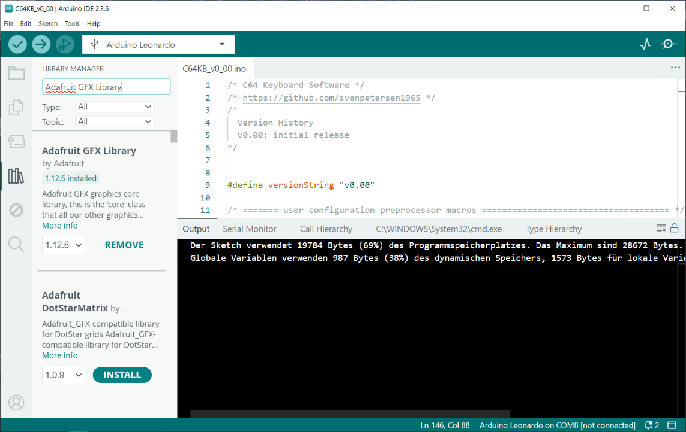
Figure 2: Library Manager (Arduino IDE 2.3.6)
The Library Manager can be found in the left-hand sidebar. It is represented by the “books” icon, as shown in Figure 2.
You need to install the following libraries:
Library | Source | Version used
Adafruit GFX Library | https://github.com/adafruit/Adafruit-GFX-Library | 1.12.6
Adafruit SSD1306 | https://github.com/adafruit/Adafruit_SSD1306 | 2.5.17
Adafruit SH110X | https://github.com/adafruit/Adafruit_SH110X | 2.1.15
PCF8575 | https://github.com/RobTillaart/PCF8575 | 0.3.0
HID-Project | https://github.com/NicoHood/HID | 2.8.4
Adafruit_NeoPixel | https://github.com/adafruit/Adafruit_NeoPixel | 1.15.5

The table above lists the required libraries, their Internet sources (which you probably will not need), and the library versions used for this project.
In most cases, using a newer version should not cause any problems. However, there may be cases where a newer version is incompatible with the project. If this happens, please install the specific library version used for this project.

Configuring the Software

Preprocessor macros
The C64 keyboard “C64KB_v?_??.ino” source code can be configured to suit your needs using preprocessor macros. These macros are evaluated during compilation and determine how the software is compiled.
Most of these macros are either defined or undefined. This allows options to be switched on or off simply by uncommenting or commenting out the corresponding line.
Comments are text annotations that are not compiled. A single-line comment starts with //. Preprocessor macros themselves are defined using a #define statement.
Note: Comments can also be enclosed between /* and */. However, this is less convenient when working with preprocessor macros.
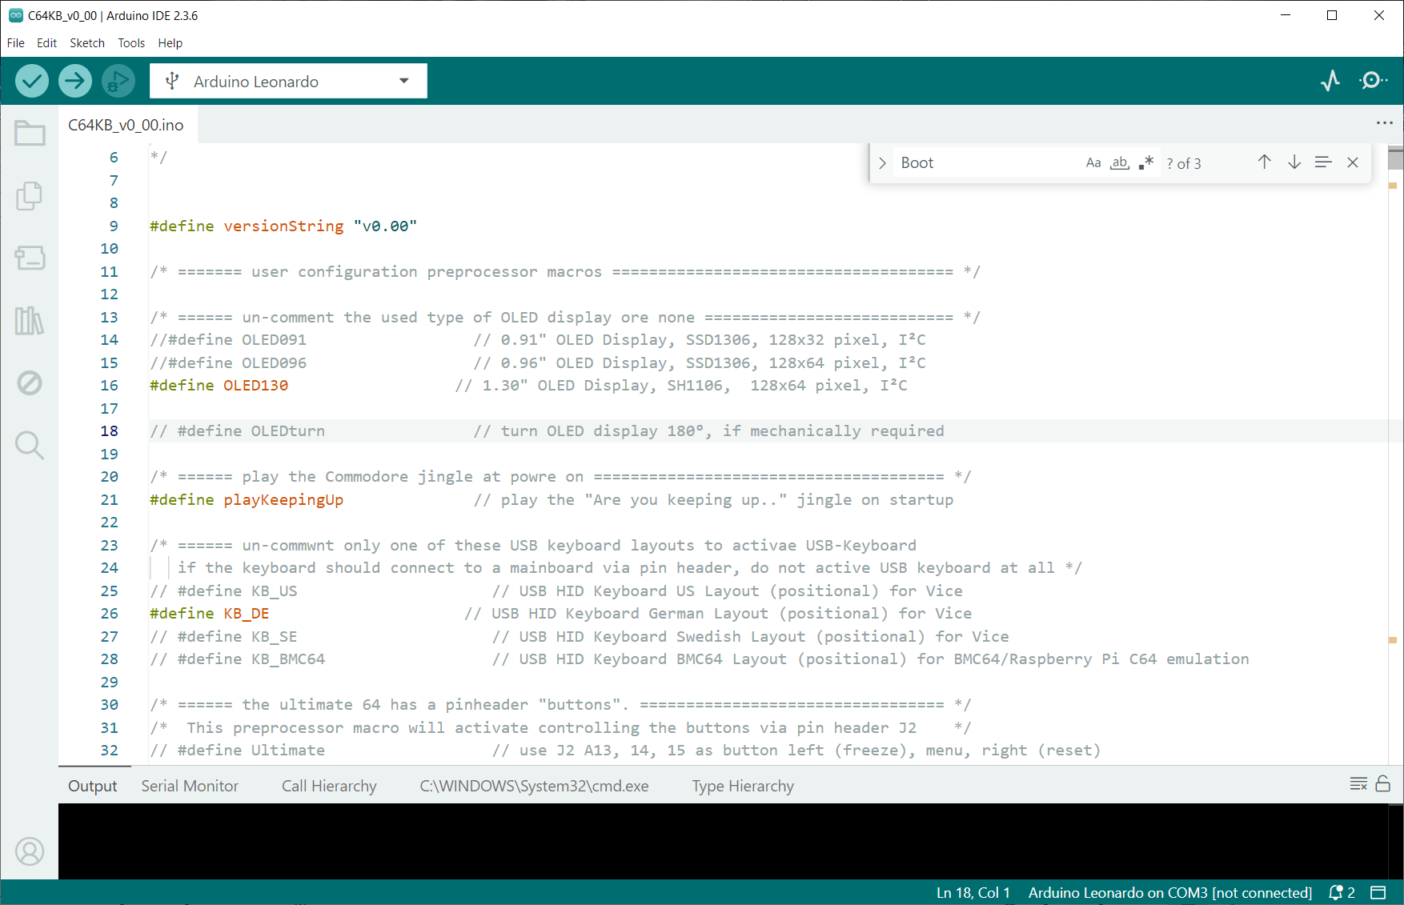
Figure 3: Some preprocessor macros (Arduino IDE)
In Figure 3 the preprocessor macros OLED130, playKeepingUp and KB_DE are enabled, while all other macros are disabled (i.e., commented out).
In the Arduino IDE editor, comments are displayed in grey, while active preprocessor macros are shown in color. The meaning of these macros is explained later in this document.

OLED display
The software supports three types of OLED displays.:
Preprocessor Macro | OLED Type
OLED091 | 0.91" OLED Display, SSD1306 controller, 128x32 pixel, I²C
OLED096 | 0.96" OLED Display, SSD1306 controller, 128x64 pixel, I²C
OLED130 | 1.30" OLED Display, SH1106 controller, 128x64 pixel, I²C

These OLED displays are widely available on eBay, Amazon, AliExpress, and other online retailers.
.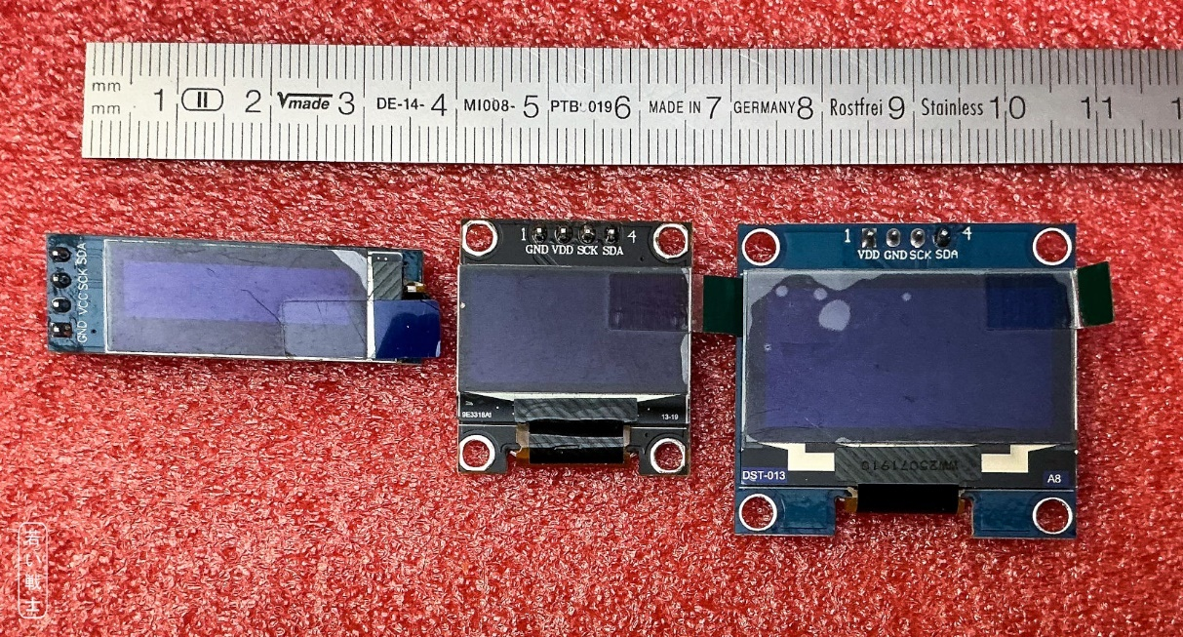
Figure 4: 0.91", 0.96" and 1.3" OLED Displays (l.t.r.)
If the display needs to be rotated 180° for a better installation, enable the OLEDturn preprocessor macro.
Only one display should be enabled at a time. If no display is connected, do not enable any of the display options.
Note:
- Enabling = uncommenting the macro definition by removing //.
- Disabling = commenting out the macro definition by adding // at the beginning of the line.

Playing the “Are you keeping up with the Commodore” jingle
Yes, I admit, it is a bit nerdy. I did it because I like to play…
The keyboard can play the jingle from the 1983 advertisement. Not in its full length, though—just a few seconds.
This feature can be activated by uncommenting the playKeepingUp. preprocessor macro definition. If it is not enabled, the keyboard starts up with just a beep.

USB Keyboard
There are four different types of positional USB keyboards: three for the VICE emulator and one for BMC64. To use these keyboards, VICE or BMC64 must be configured accordingly.
Preprocessor Macro | Keyboard Layout
KB_US | VICE, positional US Layout
KB_DE | VICE, positional German Layout
KB_SE | VICE, positional Swedish Layout
KB_BMC64 | BMC64, positional US Layout
The software does not support symbolic keyboard layouts (yet).
Only activate one or none of these layouts. If you want to connect the keyboard to a C64 or an Ultimate 64 via the pin header, do not enable any USB keyboard layout, as the keyboard scanning will interfere with the computer's keyboard scanning.
The Ultimate 64 and C64 Ultimate use a symbolic keyboard layout and are therefore not supported. The TheC64 Mini also uses a symbolic keyboard layout and is not supported. I was unable to determine which keyboard modes are required by the TheC64 Mini.
The USB keyboard requires the GPIO/PCF8575 module to scan the keyboard matrix.
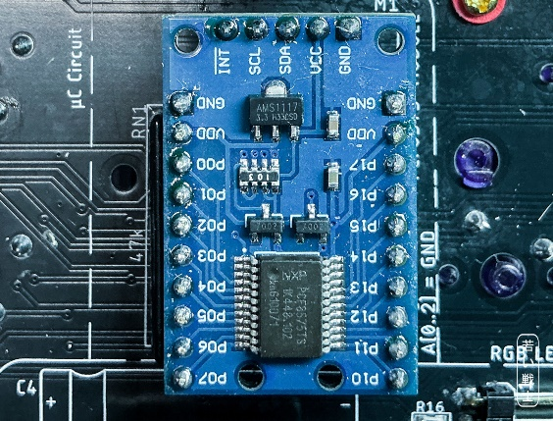
Figure 5: PCF8575 module M1

Ultimate 64 mode
In this mode, the keyboard is connected to the Ultimate 64 Elite II or C64 Ultimate mainboard via the 20-way ribbon cable/pin header. In addition, a cable must be connected between J2 and the “Buttons” pin header on the mainboard. In Ultimate mode, these buttons are emulated.
To enable this software option, uncomment the Ultimate preprocessor macro definition.
If you want to use the Kernal Switch functions with a regular C64 mainboard, disable this option.

WS2812B RGB LED Strip
The RGB LED strip can be enabled by uncommenting the RGB preprocessor macro definition. This requires several additional parameters, which are also defined as preprocessor macros:
- numRGB: The number of LEDs on your strip.
- effectLen: The length of the effect. It should be ≥ numRGB and can be a multiple of numRGB.
- RGBbright: The brightness of the LED effect.
- RGBspeed: The speed of the fade effect.
If numRGB is smaller than the actual number of LEDs, not all LEDs will be used. If it is larger, the additional value only wastes memory.
The brightness (and, in some cases, the hue) of the individual LEDs is derived from a sine wave function. Its wavelength is determined by effectLen. This value can—and should—be longer than the total number of LEDs (numRGB), resulting in a smoother and more subtle lighting effect.
RGBbright determines the brightness of the lighting effect—the amplitude of the sine wave described above. The maximum value is 255, while 0 turns the LEDs off. RGB LEDs can be very bright, potentially becoming distracting or even uncomfortable. Reflections from the LEDs on the monitor can also reduce the enjoyment of using the system. Therefore, the brightness should be selected carefully. I also recommend avoiding positioning the LEDs so that they point directly toward the monitor or the user's face.
RGBspeed determines the speed of the lighting effect. 0 is the fastest setting and the recommended value.

Kernal Names
The OLED display shows the Kernal name when the C64 Keyboard is used as a Kernal switcher. There are eight Kernals, or seven when using a short-board Kernal adapter. The default names are “Kernal #1” through “Kernal #8”. These names can be customized to match the Kernals programmed onto the Kernal EPROM. The names should not exceed 9 characters in length.
The names are defined using the preprocessor macros KrnName1 through KrnName8.

Boot Logo
There are two logos that can be shown on the OLED display during startup: the C64 logo and the VIC-20 logo, since the keyboard also works with the VIC-20.

Figure 6: 64 vs. VIC-20 logo
The Logo64 preprocessor macro displays the C64 logo, while Logo20 displays the VIC-20 logo. If neither preprocessor macro is defined, only the software version string (versionString) is displayed.

Programming The Software
The software is programmed using the Arduino IDE. All you need is a suitable USB cable: either a micro-USB or USB-C cable, depending on the model of your Pro Micro.
If you have a micro-USB model, please be careful while the cable is connected. The micro-USB connector is mounted directly on the PCB and can break off easily. USB-C Pro Micro boards are considerably more robust and are therefore the recommended model.
Connect the Pro Micro to your computer. It can either be connected to the C64 Keyboard or directly to the USB cable.
First, make sure that you select the correct board type in the Tools → Board → Arduino AVR Boards menu, as shown in Figure 7.
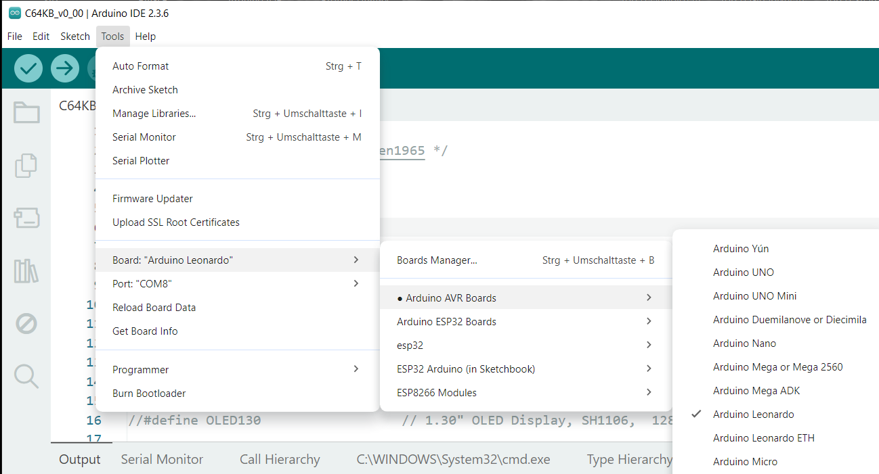
Figure 7: Selecting Arduino Leonardo
Now, select the appropriate COM port from the Tools → Port menu.
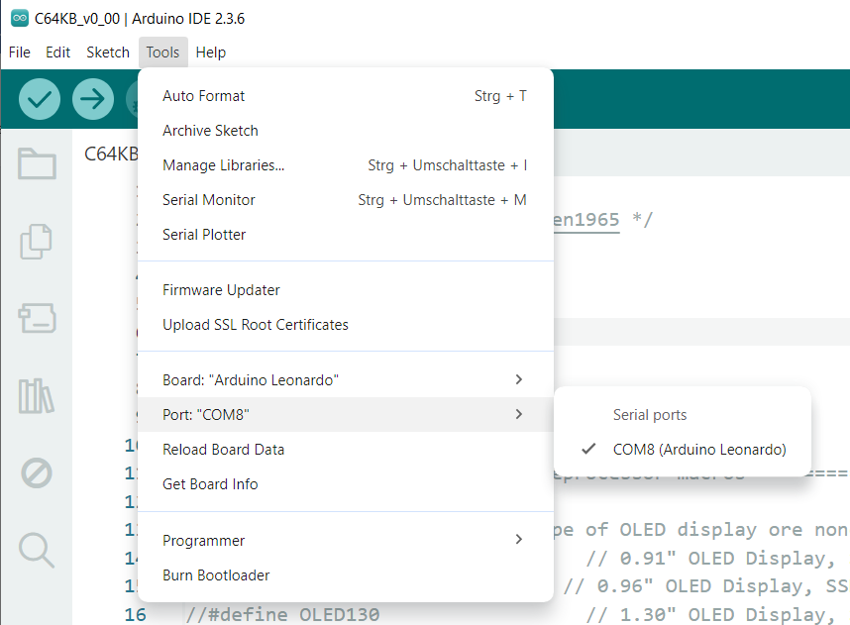
Figure 8: Selecting the port.
In my case, it is COM8. The port number depends on how the Pro Micro is registered on your computer, so it will be different for each system.
If you cannot find the Arduino Leonardo port, check the Device Manager in Windows:
Windows → Device Manager → Ports (COM & LPT)
The connected Pro Micro should appear there as Arduino Leonardo.
There are three buttons in the teal toolbar at the top of the Arduino IDE: Verify (), Upload () and Debug ().
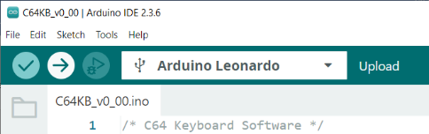
Figure 9: Verify, Upload and Debug buttons
The Verify button compiles the sketch (the term used by Arduino for source code). The Upload button also compiles the sketch, then connects to the Pro Micro and uploads the compiled program.
The result of compiling the source code (C64KB_v0_00.ino, where v0_00 indicates the version and may change) is displayed in the Output window at the bottom of the Arduino IDE. The output should show how much of the Pro Micro's flash memory and RAM is being used, without any error messages.
At some point during the upload process, the Arduino IDE will wait for the Upload Port. This should not take very long. The avrdude software will then write the program to the Pro Micro's flash memory. It produces red-colored output in the same window.
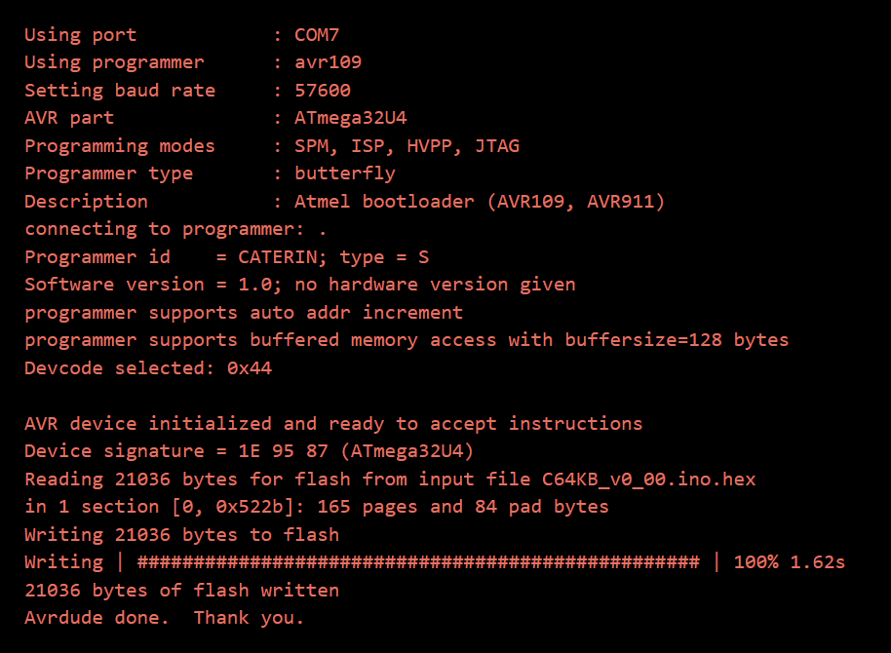
Figure 10: avrdude
It is important that the Writing | ##################### | progress indicator reaches 100%. This confirms that the Pro Micro has been programmed successfully.
In some cases, the Arduino IDE may fail to connect to the Pro Micro and remain at “Waiting for upload port…” for an extended period. I have read that this can be caused by incorrectly configured USB flags.
This problem can be resolved by resetting the Pro Micro after “Waiting for upload port…” has been displayed twice. To do this, briefly short the adjacent RST and GND pins on the Pro Micro using a jumper (Figure 11) or a reset button (Figure 12).
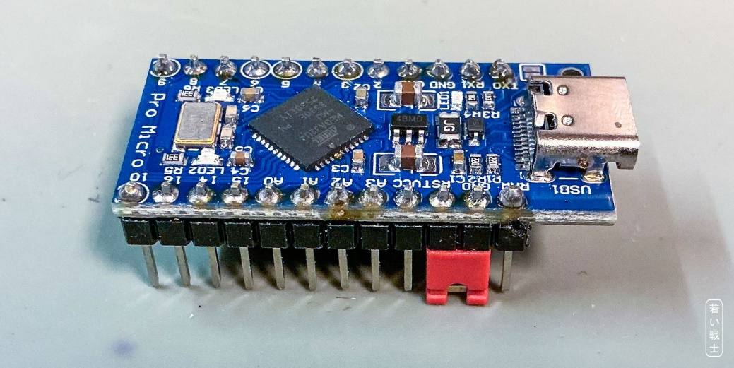
Figure 11: Pro Micro with a Reset jumper
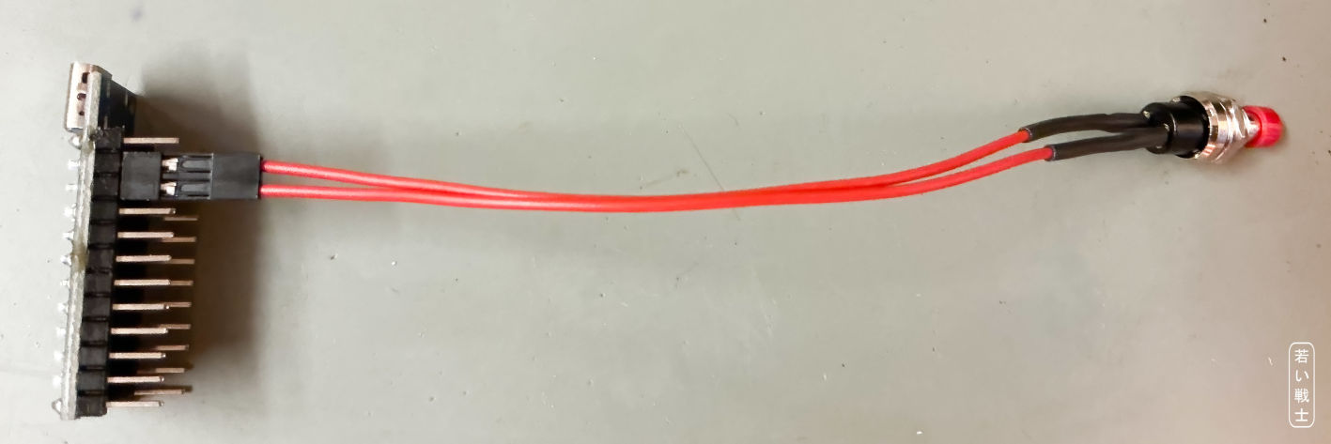
Figure 12: Pro Micro with a Reset button
In most cases, resetting the Pro Micro once was sufficient. In some cases, however, it was necessary to press the reset button twice. The same procedure can be performed using a jumper, or by briefly shorting the RST and GND pins with another suitable tool, such as tweezers or a Dupont wire.

Revision History

Rev. 0.00
- Initial Release

