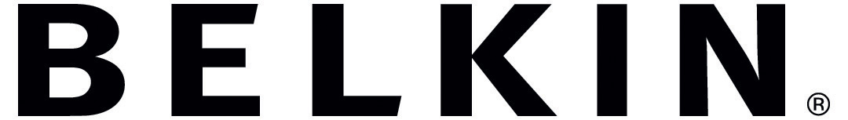

Jarden Slow Cooker
Device Variables

This document contains information of a confidential and/or proprietary nature. Neither this document nor any of the information contained herein may be reproduced, used or disclosed to or for the benefit of any other person or entity without the express written consent of Belkin International Inc.

Overview

The firmware and hardware interface between the Jarden Slow Cooker and the Belkin WeMo Smart Module is specified in generic terms by the WeMo Smart Module Firmware and Hardware Specifications document. This document provides details specific to the Jarden Slow Cooker product. This document assumes the reader has an understanding of the WeMo Appliance Software Protocol (WASP) detailed in the WeMo Smart Module Firmware and Hardware Specifications.

WASP Command Support

The following table lists commands that must be supported by the Slow Cooker.

Command | Support
CMD_NOP | Mandatory
CMD_GET_VALUE | Mandatory
CMD_GET_VALUE_CHUNK | Not required
CMD_GET_VALUES | Mandatory
CMD_SET_VALUE | Mandatory
CMD_SET_VALUE_CHUNK | Not required
CMD_SET_VALUES | Not required
CMD_SET_LED | Mandatory
CMD_GET_BUTTONS | Mandatory
CMD_GET_PRESSES | Mandatory
CMD_GET_SELFTEST_STATUS | Recommended
CMD_GET_VARIABLE_ATTRIBUTES | Mandatory
CMD_GET_ENUM_ATTRIBUTES | Mandatory

Standard Variables

The following table lists values for standard variables that must be supported by the Slow Cooker.

 | Variable ID | Value | Notes
Device ID | 0x01 | tbd | To be assigned by Belkin
Device Firmware Version | 0x02 | tbd | Format and value as Jarden's discretion
Device Description | 0x03 | tbd | Format and value as Jarden's discretion
Supported WASP version | 0x06 | "1.02" | Or later

Device variables

All device functions are controlled and monitored by variables that are defined by the device. The Slow Cooker defines one device variable namely Mode. The WeMo Smart Module reads the definitions of this device variable at startup via the CMD_GET_VARIABLE_ATTRIBUTES and CMD_GET_ENUM_ATTRIBUTES commands.

Mode

The Mode device variable is used to control and monitor the Slow Cooker’s cooking mode. The WeMo Smart Module sets this variable to control the mode. The WeMo Smart Module reads this variable to track the current mode. The mode changes as a result of local user changes or remote user changes via the WeMo mobile device application.

Field | Value
Variable ID | 0x80
Variable Type | 0x01 | Mode Enumeration
Usage | 0x04 | Controlled Value
Poll rate | 0x0ffff | Value only changes by user intervention
Min Value | 0x00
Max Value | 0x03
Name | "Mode"

Enumeration  value | Description
0x00 | "Off"
0x01 | "Keep Warm"
0x02 | "Low"
0x03 | "High"

Device Buttons

The Slow Cooker does not report the change of any buttons to the WeMo Smart Module.

The Slow Cooker must define a user procedure to perform a factory reset. The Slow Cooker requests the factory reset by returning the Factory Reset (0x70) pseudo key in response to the CMD_GET_BUTTONS and CMD_GET_PRESSES commands.

Device LEDs

The Slow Cooker must provide a Green/Amber WeMo status LED. The status LED will be connected to the WeMo Smart Module directly.

