# Project: Snake

## Introduction

Our goal is to create a classic working snake application for the IOS platform. To be enjoyable for public use and create a sense of nostalgia. We have one goal in mind and that is to make the snake finish eating the entire screen!

## Project goal

We aim to have a functional mobile IOS application. That will deliver a user friendly, simple design and good experience while using the app. As application programmers we will use this project to develop as future programmers and learn with new experiences while working on this project.

## In detail

The challenges we will be facing in creating our application, “Snake Classic”, some will be unknown and other more familiar. The first approach was our brainstorming of how we are going to take this project into a successful course and we came up with a solution.

Since we are all fresh on this new IOS concept we put our head together and let ideas pop and it yielded results. In short we are going to have to focus on these three parts: The main interface, which will include the mainframe, with start button and showing the control keys[1]. After which will load the game and bring you into the game which will show the game board and high score as well as current score in the session. At the end of the game, when a player lose we want to show that the game is over and give the option to start anew while it update the high score or quit. Difficulties with our task is how we should implement it (logical part) but we are confident it should pose no problem in this project.

The game itself is going to be typical part of classic “Snake”[2] and have snake represented by pixel blocks that go frame by frame on the screen. The player have the option to eat “apples” to grow and become longer as well as the player get points by doing so. If the player loses and the game is over you will be redirected to the game over screen[3]. There the player will see how well he/she performed and given the option to view the high score list[4] or play again.

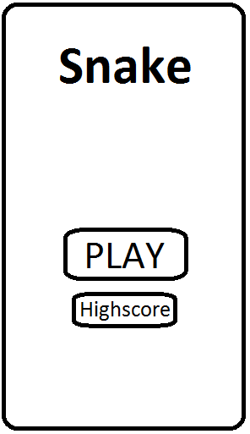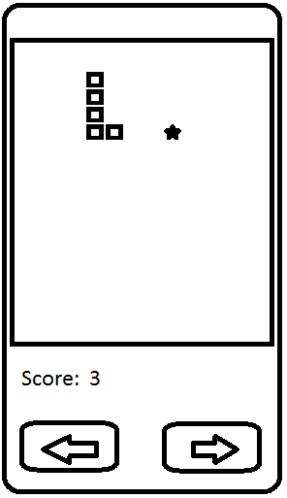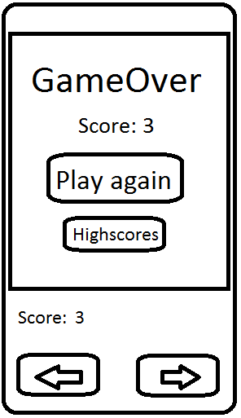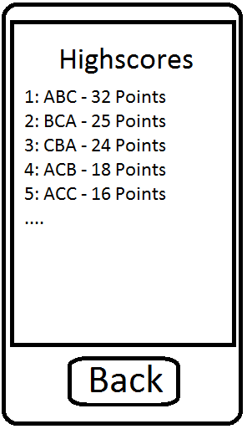

Figure . Main menu.

Figure . Gaming interface.

Figure . Game over screen.

Figure . Highscores.

1. See figure 1.
2. See figure 2.
3. See figure 3.
4. See figure 4.