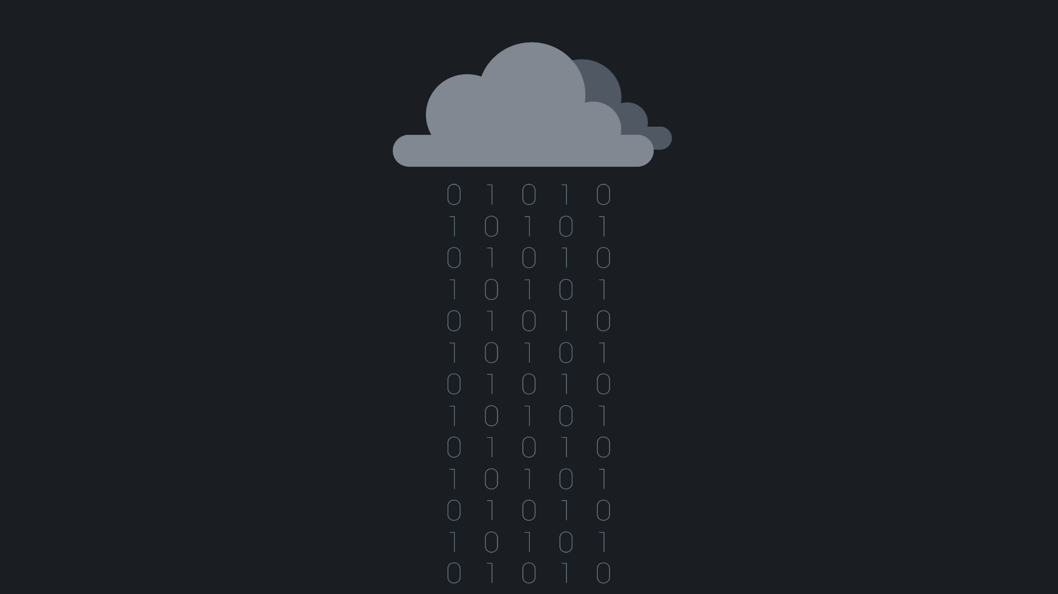

Cloud-Native Data Analytics for VDP

Process and Display IOT-Traffic-Data severless and in real time.   
Save up on maintenance costs and minimize overscaling.

Christian Studer ([studech3@students.zhaw.ch](mailto:studech3@students.zhaw.ch))

Sven Erbach ([erbacsve@students.zhaw.ch](mailto:erbacsve@students.zhaw.ch))

Volkan Caglayan ([caglavol@students.zhaw.ch](mailto:caglavol@students.zhaw.ch))

Container as a Service

Containerize your application using Docker. Containers require less system resources than traditional or hardware virtual machine environments because they don't include operating system images.

Use the newest Cloud Computing Services

Take advantage of the newest Cloud Computing Service Functionalities by deploying the service to the Google Cloud via Google Cloud Run.





Why serverless?

A company that gets backend services from a serverless vendor is **charged based on their computation** and do not have to reserve and pay for a fixed amount of bandwidth or number of servers, as the service is **auto-scaling.**

What is serverless computing?

Serverless computing is a method of providing backend services on an as-used basis. A serverless provider allows users to write and deploy code without the hassle of worrying about the underlying infrastructure.

See our solution

Visit our github repository to see how we created a cloud-native application to gain further insights into the VDP data.

<https://github.com/sverbach/P09_VDP_Analytics_Service_Mirror>