## Narratives and the perfect in East Caucasian

Samira Verhees [jh.verhees@gmail.com](mailto:jh.verhees@gmail.com)

Linguistic Convergence Laboratory at NRU HSE, Moscow

**Annotation**

Perfect forms of the verb can obtain an indirect evidential meaning, indicating that the speaker did not witness the event(s) they are talking about. This meaning arises as a conversational implicature which may subsequently be conventionalized and grammaticalized. In East Caucasian languages, perfects with evidential meanings are well-represented (though not absolute). The main problem I try to tackle in my Phd research, is to what extent this meaning is grammaticalized in different East Caucasian languages. This raises the question of how we can systematically compare the evidential usage (or lack thereof) across languages. In this talk I will argue for the usage of perfects in spontaneous narratives as a stable feature that can be quantified and compared across languages, and which, alongside other information, can give an indication of the grammatical status of evidentiality within the verbal paradigm of a given language. I will present some results from a pilot study, and explain the set-up of my dataset, which allows for more and less superficial analyses of the verbal forms employed in narratives.

### 1 Introduction

Areal distribution in EC

#### 1.1 The perfect and its meanings

Polysemy - two types of meanings: aspecto-temporal and conversational implicatures

Some meanings from the family of implicatures partially overlap with evidentiality.

**Elicitation** Elicitation of meanings from the family of implicatures is problematic first of all because adapting a certain evidential or epistemic perspective for a sentence requires some concentration and imagination on the side of the speaker; the target must be clear, while the researcher can not be too literal in their request. There is a fairly large chance the speaker will default to a neutral past tense because of some error on the side of the researcher. In addition, speakers who are fulfilling an elicitation task are sensitive to external stimuli which are hard to control, especially since we do not work in a controlled environment in Daghestan. Something or someone may distract them during the task, etc. Fluctuation in concentration can trigger them to change their mind on which forms to use during the task. Speakers are also prone to fabricate explanations for using a certain form when actually they are not sure, which is a potential cherry-picking hazard for the researcher, who tends to believe the speaker that gives the more plausible explanation. In general, elicitation prompts a certain degree of cherry-picking of consultants, because certain speakers are easier to work with and more inclined to do what we want them to do.

(Speakers of the Zilo dialect of Andi consistently used the perfect to narrate unwitnessed events, and the aorist for witnessed events. When asked afterwards what the difference would be if one would be substituted for the other, they suggested, among other things, an opposition between singular and plural, or between present tense (aorist) and past tense (perfect), neither of which is really consistent with how the forms are actually used. One speaker suggested that the difference is between whether the event was witnessed or not, in reaction to which another speaker chuckled that they were just making up nonsense.)

Due to all of these factors, the results from elicitation tasks are of varying reliability and difficult to compare systematically.

#### 1.2 Narrative use as a stable feature

Episodic vs. narrative use

Acquisition

### 2 Annotated texts

#### 2.1 Set-up of the data set and language sample

pnarr <- read_tsv("pnarr.csv")  
  
print(pnarr[1,])

# A tibble: 1 x 18  
 sentence `lexical verb` trans gloss form comment p text part   
 <dbl> <chr> <chr> <chr> <chr> <chr> <chr> <chr> <chr>  
1 1.00 идти <NA> 1=V.PF-E… aori… <NA> not P Текст… <NA>   
# ... with 9 more variables: theme <chr>, perspective <chr>,  
# speaker <chr>, language <chr>, dialect <chr>, affiliation <chr>,  
# source <chr>, page <int>, note <chr>

The aim of the dataset is to allow for different levels of analysis ranging from extremely superficial to more detailed. In the first place, I intend to bluntly measure the percentage of perfects among the finite forms appearing in texts with different evidential perspectives (personally witnessed vs. not witnessed by the speakers). The choice is between **P** (perfect) or **not P**. A second step is to look at the content of **not P**, followed by possible explanations for the usage of certain forms (e.g. present tense within the narrative is embedded in a quote). Other factors which can be taken into account at a later stage include the number of different forms used in a particular narrative, and the meaning of the verbs.

**Zero hypothesis:** Speakers do not prefer to use perfects when they narrate events they did not witness personally. -> alternative: Narratives about events not witnessed by the speaker contain significantly more verbs inflected for perfect.

NB. The column “comment” contains some relevant remarks about a certain form, for example, whether the sentence is introductory or a quote, or a morphological present tense form is translated as past (or vice versa). It does have quite a lot of information, however. Perhaps it would be more convenient to split this column into several columns indicating more frequently occurring and important contextual information.

**Language sample** The languages taken into account so far are: Bagvalal (Andic) and Tsakhur (Lezgic). Bagvalal is known to feature an evidential perfect (REF) and Tsakhur has a special set of forms originating from the perfect, which express something akin to evidentiality (REF).

#### 2.2 Results

Full sample

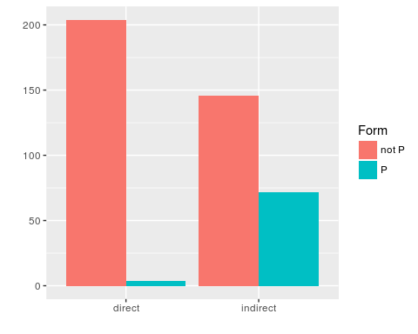

Figure 1. Number of perfects by perspective.

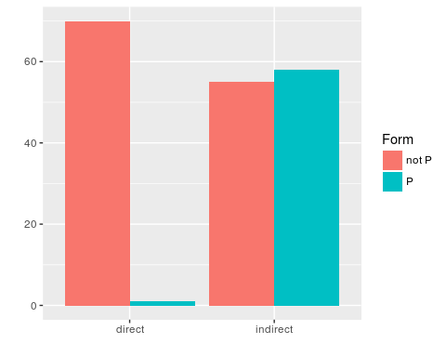

Figure 2. Perfects in Bagvalal narratives

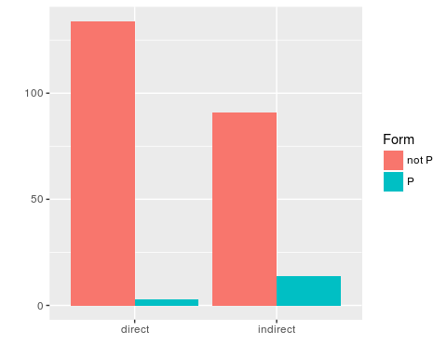 Random 100 sample

### 3 Future data collection

### 4 Discussion

### Bibliography