Language vitality and attitudes in Botlikh (Dagestan)

Samira Verhees

Version 2022-07-05

## Introduction

Botlikh ([botl1242](https://glottolog.org/resource/languoid/id/botl1242)) is an unwritten language of Dagestan. It belongs to the Andic branch of the East Caucasian family. In the last version of UNESCO’s Atlas of the World’s Languages in Danger (REF), the language was evaluated as **definitely endangered**,[1] i.e. it is no longer passed on to children. Similarly, the Endangered Languages Project ascribes Botlikh the status **threatened** (REF), meaning that children generally do not speak the language, and that the number of speakers is decreasing.

My personal observations during visits to Botlikh in 2017–2021 contradict this view. In my experience, a fair number of children still speak Botlikh, both to older relatives and to their peers. In order to get a clearer picture of the language’s dynamics and the speech community’s atittude towards it, I decided to conduct a survey among speakers of Botlikh. In this report I discuss the results of that survey. Section 1 first introduces some relevant sociolinguistic context about the language. Section 2 describes the methodology I used to conduct the survey, followed by a discussion of the answers divided into thematic blocks. These thematic blocks correspond to sections of the survey. In Section 3 I summarize my findings. You can find the original survey and a table with the respondents’ answers here.

## Background

Botlikh is mainly spoken in three villages in the Botlikh district of the Dagestan Republic: Botlikh (12,159), Miarso (1714) and Ashino (79) (REF TO AZAEV).[2] A fourth village Ankho had a population of 35 according to the latest census, but is currently uninhabited.

Botlikh on the map

Botlikhs and their language have no official status in Dagestan or the Russian Federation. Most Botlikhs are at least trilingual. In addition to Botlikh, they speak Russian (the language of administration and education) and Avar. Avar is a major literary language of Dagestan. Historically, it was an important L2 for speakers of Andic and Tsezic languages, as well as for speakers of Archi and Mehweb Dargwa. They used it to communicate with their numerous Avar neighbors and as a means of interethnic communication with other people who spoke Avar as L2.

Each village has a distinct dialect, but they are fully mutually intelligible. In the words of one of my consultants (f, 197? from Ashino): “In Botlikh people shorten their words more than in Miarso, and in Ashino they shorten their words even more than in Botlikh.” (REF) describes some of the main differences between Botlikh and Miarso. In (REF) I describe some differences in the agreement system specifically.

Ashino originated as a hamlet of Botlikh, and its dialect is quite similar to that of Botlikh. According to (REF), Miarso also originated as a hamlet of Botlikh, though this likely occurred much earlier.

Botlikh’s closest relative within the Andic branch is Godoberi, a small language spoken in two neighboring villages (Godoberi and Zibirkhali). The languages are similar enough to be mutually intelligible, though this does seem to require some exposure. (REF) reports that the languages are mutually intelligible among older generations due to more intensive contact, whereas younger generations have trouble understanding the other language. Gudava (1959: 3) considered Botlikh and Godoberi to form a single dialect continuum, where the idiom of Miarso occupies an intermediate position (REF). Lexicostatistical data show that Miarso is indeed slightly closer to Godoberi than Botlikh is.

#### Table 1. ASJP distance for Botlikh, Miarso, Godoberi (98 lexemes)

|  | Botlikh | Miarso | Godoberi |
| --- | --- | --- | --- |
| Botlikh | 0 | 0.17 | 0.34 |
| Miarso | 0.17 | 0 | 0.3 |
| Godoberi | 0.34 | 0.3 | 0 |

Table 1 shows the ASJP distance between the idioms based on a sample of 98 lexemes from the Swadesh list. The ASJP project (REF) works with a core list of 40 stable concepts, but not all of them were represented in the data I used. I used data from the DagSwadesh project, kindly provided to me by Konstantin Filatov. The pairwise distance was computed with the help of an [app](https://alkaitagi.github.io/language-ldn/) developed by Muhammad Magomedov.

Table 2 shows the ASJP distance for the sample of 34 concepts. The distances are lower overall, but the relative differences between the idioms are stable.

#### Table 2. ASJP distance for Botlikh, Miarso, Godoberi (34 lexemes)

|  | Botlikh | Miarso | Godoberi |
| --- | --- | --- | --- |
| Botlikh | 0 | 0.11 | 0.27 |
| Miarso | 0.11 | 0 | 0.24 |
| Godoberi | 0.27 | 0.24 | 0 |

If we assume that Godoberi and Botlikh once split off from a single ancestor (according to Koryakov (2006: 21) this happened over 1500 years ago), and Miarso split off from Botlikh some time after, intuitively Miarso should be more distant from Godoberi. Field data on multilingualism and contact patterns (REF??) suggest that the similarity between Miarso and Godoberi could be contact-induced.

## Survey

### Metadata

The first block of the survey was aimed at collecting some metadata on who filled out the survey. The fact that the survey was distributed through an Instagram account about the Botlikh language makes the sample inherently biased towards people who are more interested and invested in the preservation of the language. The sample also shows a strong bias towards female respondents: 10/13 respondents were female. This was also the case in earlier surveys. The majority of the active subscribers to the botlikh_rasha Instagram account are female. Figure 1 below shows the representation of age groups. Respondents were asked to select an age group as they are represented on the graph (rather than fill out their exact age).

#### Fig 1. Age groups of respondents (Question 2)

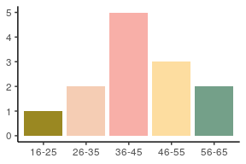

The majority of respondents were born in Botlikh and currently live there. There was an instruction to specify in which part of the village the respondent lived, but most did not provide this information. One respondent was born in Ashino. A fair number of respondents were city dwellers. Among them residents of Dagestanian cities like Kizlyar, Khasavyurt, Makhachkala, as well as two residents of Moscow.

#### Fig 2. Place of birth and place of residence (Questions 3–4)

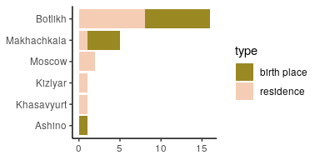

Respondents were asked about their nationality in several different formulations. First, they were simply asked what their nationality was. Within the Russian Federation this is typically interpreted as one’s ethnic identity. Next, they were asked how they would respond to this question in different environments: in Botlikh, in Makhachkala, in Moscow, and abroad. The questions were posed as open questions to get the most natural answer possible. The answers were then recoded for unification purposes. For example, different respondents could give the same answer in different languages (e.g. Russian or Botlikh).

#### Fig 4. Self-reported ethnicity of Botlikhs in different contexts (Questions 5–9)

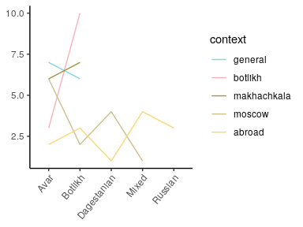

The graph shows that most of the respondents by default identify as Avar (general). A smaller number chose Botlikh in this context. When asked in Botlikh, 10/13 answered that they were Botlikhs. In Makhachkala (the capital of Dagestan), they majority identifies as Botlikh, with a smaller number identifying as Avar. One person answered “Avar from Botlikh” (coded as Avar). In Moscow the number of people identifying as Botlikh drops, and Avar becomes more prominent. Four people identify as “Dagestanian”, an identity not mentioned before. One respondent presented themselves as “Avar from Dagestan, born in Botlikh district” (coded as Mixed). Mixed identities were more common for abroad. This includes: “Dagestanian, Russian”, “Avar from Dagestan”, “Avar from Dagestan, Russia”, “Avar from Botlikh”. Three respondents identified as Russian in this context, using the word *rossijanin* (lit. ‘citizen of Russia’), rather than the adjective *russkij*, which refers to Russians as an ethnic group. Two people identified as Avar, three as Botlikh.

These answers show that the ethnic or national identity of Botlikhs is layered. Which layer they use to present themselves depends on the context. They anticipate on what they think will be familiar to the person who asks the question. For example, Russians may not be aware of the ethnic diversity of Dagestan, hence several respondents would identify themselves as Dagestanian in Moscow.

To conclude this section of questions, I asked what the respondent’s native language was called in their native language, to which everyone responded “Botlikh” (in Botlikh). The reason for asking this question in this way, was because I did not exclude the possibility that among the respondents were long-time residents of Botlikh who learned the language as an L2, people from Miarso who might answer differently than people from Botlikh, and finally Botlikhs who might consider Avar to be their native language.

### Ethnic identity, language and dialects

In the previous section I asked respondents about their ethnic identity and their native language. In this section I posed the same questions from a non-personal perspective. Question 7, illustrated in Figure 5, provided three possible ways to finish the sentence “Botlikhs are…”.

#### Fig 5. Ethnic affiliation of Botlikhs (Question 7)

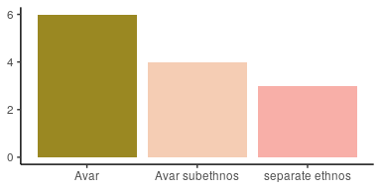

The concept of **subethnos** was introduced by Russian anthropologist Yulian Bromley in the 1980s, and it is still widely used in discussions of people and languages of the former Soviet Union (REF). It refers to a group of people within an ethnic group that inhabit a compact territory and have specific characteristics which set them apart from the rest of the group. In Bromley’s view subethnic groups emerge when the larger ethnic group is not fully consolidated, or when the subethnic group is separated from the larger group, for example due to migrations.

Botlikhs are not a subethnic group of Avars by any definition. They constitute a distinct group historically, culturally, and linguistically.

Despite its factual incorrectness, I included this term as an option in the question because it is still widely used in Dagestan, and because it represents a specific way of viewing Botlikhs within the ethno-political context, namely as belonging to the larger group of Avars while also having distinct traits.

Regardless of their ethnic identification, 100% of the respondents indicated Botlikh as the native language of Botlikhs (Question 8). This contradicts the framing of Avar as “native language” in the school system.

Questions 9–11 were aimed at the status and affiliation of each idiom. Respondents were asked to select whether a given idiom was an independent language or a dialect. In case they selected the latter, they could optionally specify to which language they thought this dialect pertained.

Botlikh was considered an independent language by 12/13 respondents (Question 9). One person indicated that it was a dialect, but did not specify of which language. Miarso was considered an independent language by 2 respondents. The remaining 11 considered it a dialect, and the majority of them indicated that it was a dialect of Botlikh, specifically. Unfortunately, there were no respondents from Miarso. It would have been interesting to see whether they are more inclined to view their idiom as distinct from Botlikh.

Ashino was universally considered a dialect, 11 out of 13 specified that it was a dialect of Botlikh.

For the sake of comparison, it might have been informative to include a similar question about a closely related and partially mutually intelligible language like Godoberi.

### Language use in the family

### Language use in other contexts

### Attitude statements

Section 5 of the survey consisted of 12 statements which speakers were asked to rate on a scale of 1–5, where 1 means “completely disagree” and 5 means “completely agree”.

#### “It is important to be able to speak your own language.” (Question 25)

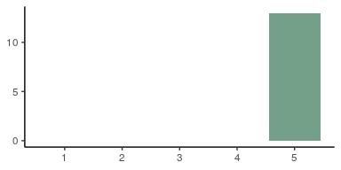

#### “The Botlikh language will not feed you.” (Question 26)

This question was meant to convey the idea that knowledge of a minority language does not have any economic benefits.[3^](Thanks%20to%20Muhammad%20Magomedov%20for%20advising%20me%20on%20how%20to%20formulate%20this%20statement.) Judging from the results, some speakers do agree with this idea.

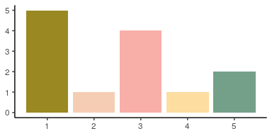

#### “Knowing the language of your ancestors is a must.” (Question 27)



#### “Knowledge of the Botlikh language hinders to learn Russian well.” (Question 28)

A common motivation to shift to a socioeconomically dominant language in a household, is that proper knowledge of such a language is highly valued, and knowledge of a native language would somehow impede its acquisition.

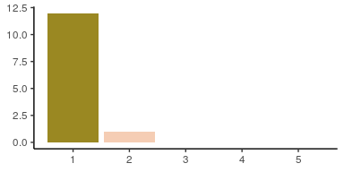

#### “If the Botlikh language were to disappear, that would be bad.” (Question 29)

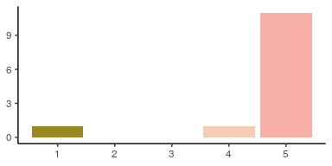

#### “Children should know Avar.” (Question 30)

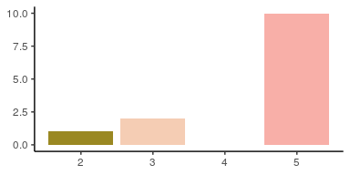

#### “Children should know Botlikh.” (Question 31)

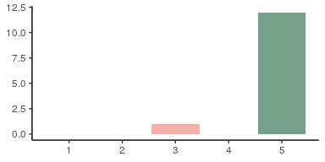

#### “Children should know Russian.” (Question 32)



#### “Children should know Arabic.” (Question 33)

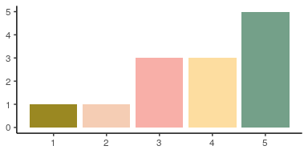

#### “Children should know English.” (Question 34)

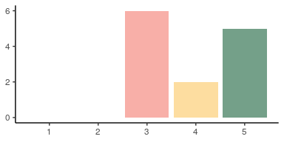

### Preservation efforts

### Bonus questions

## Conclusion and discussion

Village-based group identity, cf. native terms consisting of the name of the village and a genitive suffix.

## Appendix

some cyrillics: какая-то кириллица

some IPA symbols: ƛˁʷɨ

1. This version of the Atlas is now archived. A new version is forthcoming.
2. Population figures from the 2010 census of the Russian Federation (REF).