Running head: IRTm

Fitting Explanatory Item Response Theory Models:

a Matlab IRTm Toolbox

Johan Braeken*
Francis Tuerlinckx

Research group Quantitative Psychology and Individual Differences
K.U. Leuven
Belgium

The authors wish to thank Tom Wilderjans for his helpful comments on a first draft of the paper. Preparation of this manuscript was supported in part by the Fund for Scientific Research Flanders (F.W.O.) Grant no. G.0148.04 and by the K.U. Leuven Research Council Grant no. GOA/2005/04.

Abstract
Item response theory models are the central tools in modern measurement and advanced psychometrics. We offer a MATLAB IRT modeling (IRTm) toolbox that is freely available, and can fit a large variety of IRT models, with inclusion of the very recent copula IRT models to handle local item dependencies. A design-matrix approach is followed, giving the end-user control and flexibility in building a model that goes beyond standard models like the Rasch or 2PL model. This might even make the tool suitable to be used in a measurement course to acquire more insight in, and demystify the build up of, common (and less common) IRT models in practice.

Fitting Explanatory Item Response Theory Models:
a Matlab IRTm Toolbox
Item response theory (IRT) models are the central tools in modern measurement and advanced psychometrics. They differ from classical test theory in the sense that IRT posits a mathematical model to explain the pattern of observed item responses on a test (see e.g., Lord & Novick, 1968). The key idea is that tests are designed to measure an unobservable variable of interest, a latent trait. Hence, multiple measurements have to be made of the same person to be able to get a reliable estimate of a person’s latent proficiency. IRT assumes that both persons as well as test items have a position on this same underlying dimension the test is measuring. In relating both persons and items to this underlying dimension or latent trait, restrictions are imposed on the probability model for the observed item responses. This is a constructive theory-driven scientific strategy, as you can revise the test to fit the model restrictions (like for instance is done in strict Rasch measurement) or alternatively you can adapt your theory and the model to better fit the features of the data.
We will present an IRT modeling (IRTm) toolbox for MATLAB that is freely available, and can fit a large variety of IRT models, with inclusion of the very recent copula IRT models to handle local item dependencies (Braeken, Tuerlinckx, & De Boeck, 2007). MATLAB is a general-purpose, matrix programming language with a large user base in research and business. To our knowledge no other IRT specific toolboxes are available, and as such this IRT toolbox may be useful to some of these users. A design-matrix approach is followed, giving the end-user control and flexibility in building a model that goes beyond standard models like the Rasch or 2PL model. The capability of fitting these more advanced IRT models might be the biggest trump card of the IRTm toolbox.
In what follows some practical information is given about the IRTm toolbox for MATLAB and its general use will be laid out. In the next sections some didactical examples are used to build up from a basic Rasch model to a more general copula IRT model. These examples, including experimental design, cross-validation, latent regression, differential item functioning, hidden person groups, local item dependency, and data simulation, will be used to demonstrate some of the most interesting modeling possibilities in practice and will be accompanied by explicit key references that can redirect the reader when they are interested in more technical background and extensive discussion of the topic at hand. For ease of recognition, all MATLAB expressions, variables and functions will be typeset in an italic font of the courier family. Note that an appendix is also included with some more statistical details about the general copula IRT model that the toolbox is able to fit. A short discussion section points out possible extensions, further optimization possibilities, and the main objective underlying the build up of the current toolbox.

IRTm toolbox
Requirements: The IRTm toolbox requires that you have MATLAB 7.2 (Version R2006a) or a more recent version installed (7.6, Version 2008a is preferable), and the Optimization toolbox also needs to be installed. The IRTm toolbox was developed and tested on Windows and Linux platforms.
Installation: The IRTm toolbox for MATLAB can be freely downloaded via http://ppw.kuleuven.be/okp/software/IRTm . Upon filling out a form, you will be emailed a link to where a ZIP archive is available. Unpackage the file to the folder in which you want to install the toolbox and then execute the included installer, IRTmInstall, from the MATLAB command window. The installer will guide you from there. Note that during installation, you will be asked to accept a license agreement prior to completion of the installation. When the installation is finished, you can test the toolbox by running through some example case studies of which the code is provided in the m-file IRTmCase (also accessible through the MATLAB demo feature). This demo actually contains the code from the examples in the sections below. Since IRTm is constantly under development, its most recent version, bug reports, and fixes can be found at the web site above.
License agreement: Please note that, although IRTm and its source code may be freely downloaded, it is not permitted to redistribute the code or derived code without the authors’ consent. Cooperation from third parties in further developing the IRTm toolbox is welcomed, but in order to maintain transparency regarding exactly which methods an end user has implemented, we want the distribution of this toolbox to remain centralized. This will also allow us to keep an eye on the quality and correctness of the toolbox at all times and to have a bit of an overview of the user base which will allow better support and communication. We would appreciate acknowledgement if you would use the IRTm toolbox in your own work and papers. Note, however, that as usual, no warranty whatsoever is given for the results and outcomes obtained by means of the application of any function in this toolbox.

General Use
The general use of the toolbox involves three main actions: (1) One needs to specify the data and algorithm to be used [SETTINGS], (2) and then build up the IRT model [MODEL], (3) to be able to continue with the model fitting, such that one can acquire the necessary output and evaluate the model results [OUTPUT]. These three main actions correspond to defining two structures SETTINGS and MODEL in MATLAB, and feeding these to the main function IRTm to get the resulting OUTPUT.
We will start with a concrete and simple example in which we guide the reader through the different steps, and then go on and explore more of the functionalities of the IRTm toolbox in subsequent sections and examples. The code used in these examples can also be retrieved in the m-file IRTmCase.m, which allows you to access the code by opening it in the editor and easily go through the examples running the commands in this file from the MATLAB command line. The full model functionality of the toolbox is laid out in a separate slightly technical appendix at the end of the manuscript. Readers who prefer a top-down approach and are more familiar with IRT models might be more inclined to start with the contents of this appendix and then return to the practical examples in the current section.
Data requirements and preprocessing: A preliminary step to the procedure is making sure that your data is in the right format. The data to be analyzed with the IRTm toolbox is expected to be complete-case (no missing data), numeric and of a rectangular format, persons (rows) – by – repeated measurements (columns). Item responses are expected to be binary (0 and 1) coded. Additional information on the persons can be given under the form of continuous or categorical variables. The latter need to be recoded into dummy variables (it is considered to be continuous otherwise).

Example 1: A simple Rasch model
In this first example we will analyze the dataset ‘example_rasch.txt’ (included in the IRTm toolbox) following the Rasch model (Rasch, 1960), a well-known standard model of item response theory. The data consist of a variable with an unique number to identify the person (first column) and binary responses on 6 test items (columns 2 to 7) for all 500 persons. Note that there is no additional information present and that the data is already in the required format so no preprocessing is needed.
Data and algorithm setup [SETTINGS]: Our first action is to define the structure SETTINGS which contains fields with setup information on the data as well as specifications for the optimization algorithm to be used (see Table 1). A default SETTINGS structure can be acquired by the function call
SETTINGS = IRTmSet()
after which you can fill in and adapt the necessary fields yourself. Specifying the dataset to be used can be done by the statement SETTINGS.input = 'example_rasch.txt' , after which you only need to indicate the columns that correspond to the items in the dataset SETTINGS.I = [2 3 4 5 6 7] , and the delimiter that separates these columns SETTINGS.delim=' ' (here a space, which is also the default). If your current MATLAB working directory is not the directory in which you installed the IRTm toolbox, you will be required to give up an absolute, instead of relative, address to locate the data file ( SETTINGS.input = 'c:\\IRTmInstallDirectory\\example_rasch.txt' ). Note that you can use regular MATLAB tricks to define the items field. For instance, we could also have simply stated SETTINGS.I=[2:7] to indicate the item sequence. Also note that the defaults settings for the estimation algorithm will suffice for our example so no need to worry about that yet.
Model building [MODEL]: In a Rasch model the characteristic function of 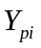, the binary item response of person p (p = 1, 2, …, P) on item i (i = 1, 2, …, I) is defined as
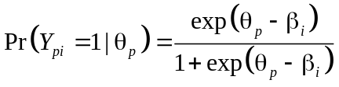,
with 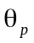a model parameter representing the proficiency of person p, and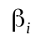 indicating the difficulty of item i. Thus, the probability of answering correctly is an S-shaped (logistic) function of the positions, of both the item and the person, on the latent trait the test is measuring. Note that the value of 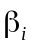, the difficulty of an item, corresponds exactly to the location on the latent trait where a person would have a chance of a half to answer the item correctly (i.e., the point of inflection of the characteristic curve).
The joint probability of the item responses on the full test (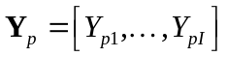) for a person p is then
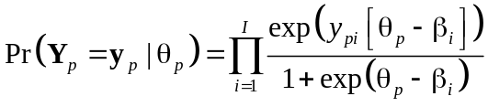.
Notice that in this model a person’s item responses are assumed to be independent given his/her proficiency on the latent trait. This assumption is commonly referred to as conditional independence or local stochastic independence, and implies that the latent trait accounts for all the dependency between a person’s responses on the test. Thus, the latent proficiency explains why there are differences between persons in performance and why the item responses of a given person interrelate.
The IRTm toolbox follows a marginal maximum likelihood approach to model estimation (see Appendix for technical details and references), and hence it is assumed that these latent proficiencies follow a distribution in the population (see e.g., Rijmen, Tuerlinckx, De Boeck, & Kuppens, 2003). Here we will assume 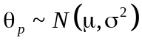, a normal distribution with mean set at zero (a convention to fix the scale of the model) and variance 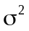. The larger the estimated value of this variance, the larger the individual differences between persons on the latent trait targeted by the test are assessed to be.
Given the model specifications above, a default Rasch model can be build with the function call
MODEL = IRTmModel(6,'Rasch');
where the first argument of the function takes the number of items in the test, the second argument defines the type of model structure you request.
Fitting the model and acquiring results [OUTPUT]: To fit this Rasch model on our dataset we feed the two structures SETTINGS and MODEL to the main function of the IRTm toolbox by means of the call
OUTPUT = IRTm(SETTINGS,MODEL);
The model likelihood 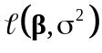 that is optimized contains the fixed parameter vector , gathering the 6 item difficulties , and the fixed parameter , whereas the random parameters will be integrated out and estimated by means of empirical Bayes methodology (see Appendix for technical details). The results of the procedure are gathered into the structure OUTPUT . It contains compressed data information stored in a format using only the unique response patterns and their frequency of occurrence, an index to keep track of which person has which response pattern, information on the algorithmic optimization outcome and model estimates (for a description of the fields of this structure, see Table 2).
The information and results inside this structure can easily be accessed. Model convergence can for instance be checked by looking at OUTPUT.optim, a zero indicating non-convergence (and some related fields as OUTPUT.message and OUTPUT.HEScheck). The compilation of some summary tables has also been preprogrammed, but customized displays of OUTPUT features are easily implemented either within the MATLAB environment or your favorite word processing software. A table with the different unique response patterns, item sum score, frequency of occurrence, predicted frequency, and corresponding latent trait estimates can be requested by the call
IRTmSummary(OUTPUT,'pred');
A basic table of the fixed model parameters, with their estimates, standard errors and a p-value from the corresponding Wald test (indicating whether the parameter deviates significantly from zero or not), can be displayed by means of the call
IRTmSummary(OUTPUT,'param',MODEL);
Note that not providing the third argument MODEL in the function call will leave out the parameter labels in the table. A third table, with most common goodness-of-fit measures can be displayed by
IRTmSummary(OUTPUT,'gof');
Comparison with commercial software: To have an idea of the performance of our toolbox, results were compared to two gold standards, being the commercial software packages SAS (Sas Institute inc., 1999) and MPLUS (Muthén & Muthén, 1998). The simple Rasch model was fitted on this dataset under similar conditions in each of the packages, and the results are shown in Table 3.
Parameter estimates for both the fixed parameters, being the vector of difficulty parameters and the variance of the latent trait, as well as the empirical Bayes estimates for the latent trait are comparable across programs. Note however, that SAS appears to follow a slightly different and more time-intensive way to estimate the latent trait, and that for more complicated models MPLUS follows a factor analytical reformulation of common IRT models. We did not find an option to access the standard errors for the latent trait estimates in MPLUS, and the time spent on the algorithm was not given accurately enough as it was displayed to be zero seconds. To represent this in the table, we used ‘(na)’, short for not available.
Post-processing of model results: The fact that the toolbox is integrated in the MATLAB environment allows convenient and easy post-processing of the model output. We will illustrate this with some examples.
The command theta = OUTPUT.ebe(OUTPUT.Index) gives each person its corresponding empirical Bayes estimate of the latent trait following his/her recorded response pattern and stores it in the variable theta. To plot a histogram of the resulting latent trait estimates the following command is used: hist(theta) . These figures can then be further adapted, annotated and exported by means of the graphic functions and editor included in MATLAB. To get an impression of the precision of measurement over the latent trait scale we can use the following commands:
thetaSE = OUTPUT.ebeSE(OUTPUT.Index);
[s order]=sort(theta);
plot(theta(order),thetaSE(order));
This will result in a plot of the ordered estimated latent trait values on the X-axis and their corresponding standard error on the Y-axis. The test is most precise for areas on the latent trait dimension where standard errors are the smallest. This concludes our first very basic example.

Model building by means of Design Matrices
As for now, we only made use of a default standard Rasch model, however the IRTm toolbox supports non-standard models as well and this by means of design matrices (see e.g., De Boeck & Wilson, 2004). The purpose of the design matrices is to allow very general models as well as models that further constrain parameter sets. This will provide additional flexibility in modeling and allows researchers to build models that go beyond standard IRT models as the Rasch or 2PL model for instance. First the main idea is illustrated by putting the previously introduced Rasch model within the proposed framework of design matrices. Then in a second part, it is shown how this framework for instance can be used to fix the latent distribution to be a standard normal, to take into account an experimental design on the item responses, and to crossvalidate a model.
General idea: Each parameter vector in the likelihood, like for instance the latent trait variance and the item difficulties in the Rasch model, will have a model specification part summarized in a corresponding MATLAB substructure (see Appendix and Table 4) consisting of fields that allow you to control and construct the design in detail. The following fields are included: a general design matrix .D, giving the exact parameterization of the model, a restriction matrix .R, indicating which of the model parameters are to be freely estimated or fixed at a given value, and an offset matrix .O , containing values that need to be added to the model parameter. The latter is a real valued matrix, whereas the two others are of the logical class. To compile the actual model the following expression is used:
.
To make it more clear how this combination of matrices allows you to specify the model parameterization, we will examine the structures relating to the previously introduced Rasch model.
Illustration: If we take a closer look at MODEL.TS, the substructure for the variance parameter of the latent trait distribution, we can see the following: the design MODEL.TS.D=logical(1) indicates that there is a variance for the latent trait distribution in our model that is parameterized by one parameter, the restriction MODEL.TS.R=logical(1) indicates that this parameter is to be freely estimated, and MODEL.TS.O=0 indicates that the offset of this parameter is 0. Thus, we have
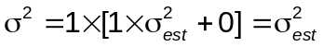,
resulting in one free model parameter 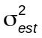 defining the variance of the latent trait 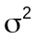 in our Rasch model.
The Rasch model also requires an unique difficulty parameter for each item. This is also reflected in the design for this parameter set given in MODEL.B :
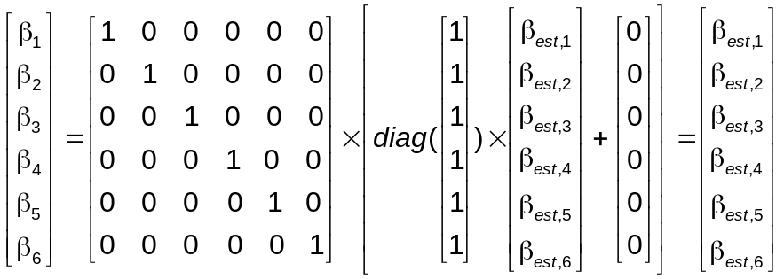.
The main design MODEL.B.D takes the form of a logical matrix, number of items I by number of item parameters K for that vector, with a one indicating that the parameter k needs to be included for item i. Restrictions on the parameters are imposed by a logical vector MODEL.B.R , that contains the diagonal elements of a matrix, and indicate which of the parameters are free (one) and which are fixed (zero). The offset MODEL.B.O is a vector with K rows, consisting of values that need to be added to the model parameters (here the offsets are all set to 0). This results in each of the item difficulties 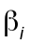 in the Rasch model being parameterized by an unique difficulty parameter 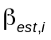.
Fixing a parameter at a given value: Consider that we want to restrict this model by requiring that the latent trait follows a standard normal distribution. This can be done by setting the restriction MODEL.TS.R=logical(0) , which indicates that the variance of our latent trait is a fixed parameter now, and setting the offset of this parameter at 1 by MODEL.TS.O=1 . Compiling all this together results in
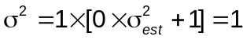.
Thus, this constrains the variance of the latent distribution to be equal to one.
We can fit this alternative model and store the results in a second set of outcome structures:
OUTPUT(2) = IRTm(SETTINGS,MODEL);
Comparing the two alternative models can be done by looking at the goodness-of-fit criteria,
IRTmSummary(OUTPUT,'gof');
Note, that OUTPUT now consists of two structures OUTPUT(1) and OUTPUT(2) . Given that the two models are nested with a difference of one free parameter, we can also opt for a likelihood ratio test with one degree of freedom:
1-chi2cdf(2*(OUTPUT(2).LL-OUTPUT(1).LL),1)
Both the likelihood ratio test and the information criteria reject the more restrictive standard normal model in favor of our original Rasch model.
Experimental design: Consider that you are given information that the six items are in fact realizations from an experiment in which the accuracy of hitting a target is measured in three conditions, and each person has to run through 2 trials of these conditions. In the first condition (item 1 and 4), there is loud noise added to the environment, in the second condition (item 2 and 5) the light in the room switches off and on, in the third condition (item 3 and 6) both disturbing effects have been added. Hence for each person 6 recordings (item responses) are made whether he/she missed the target or not. This experimental design can be reflected in the model design of the difficulty parameters using a Linear Logistic Test Model formulation (Fisher, 1973):
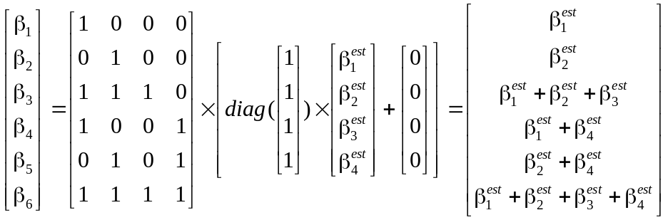.
The first parameter 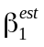 is the item difficulty due to the loud noise, 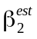 is the difficulty corresponding to the light flashes, 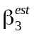 is the added difficulty when these effects are jointly present, and 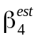 is the training effect of having a rerun in trial 2. So in fact the difficulty of the individual items is decomposed into common difficulties due to the experimental design, leading to a more parsimonious, but also more restrictive model.
The following commands setup and fit this model on our example data
MODEL.TS.R=logical(1);
MODEL.TS.O=0;
MODEL.B.D=logical([1 0 0 0;0 1 0 0;1 1 1 0;
1 0 0 1;0 1 0 1;1 1 1 1]);
MODEL.B.R=true(4,1);
MODEL.B.O=zeros(4,1);
OUTPUT(2)=IRTm(SETTINGS,MODEL);
To interpret the model estimates we request the table with parameter estimates by a call to IRTmSummary(OUTPUT(2),'param',MODEL) . Note that again the parameters are given in order of appearance in the likelihood, meaning that for instance the second parameter corresponds to the second column in the design MODEL.B.D of the item difficulties. At first glance all effects seem to be significant, which should be good news to our experimenter. The effect of is 0.801 on the latent trait scale, which means that there is a negative training effect, the difficulty of a condition increases on the second trial compared to the first. An effect size measure interpretation is that the odds of being accurate at a rerun are twice (i.e., exp(0.801) = 2.228) as low compared to the first trial (perhaps, the individuals get tired or less concentrated). If you compare this model to the original less restrictive Rasch model, you would again conclude that the statistical criteria would prefer the Rasch model. However, it is fairly obvious that interests and research questions of the experimenter are better answered by our latter LTTM model alternative.
Crossvalidation: Another advantage of this design matrices approach is the possibility to perform crossvalidation of your model (see e.g., Browne, 2000). To give a rough example, consider our simple example dataset, and randomly divide the sample of 500 persons in two. The first half will be used to estimate the model, the second half will be used to crossvalidate the estimated model.
The command [ignore randomorder] = sort(rand(500,1)) results in a random shuffle of the numbers 1 to 500 stored in the variable randomorder . By adapting the SETTINGS structure, we can select the set of persons that are to be included in the analysis, by assigning a vector of row numbers, here the first 250 numbers in the randomorder variable, to SETTINGS.Sel=[randomorder(1:250)] . A standard 2PL model is requested for the example dataset by means of MODEL = IRTmModel(6, '2PL') , leading to a likelihood 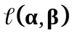with two parameter sets, item discrimination and difficulty parameters. Note that for identification reasons, the distribution of the latent trait is set to be a standard normal. The model is fitted by means of OUTPUT =IRTm(SETTINGS,MODEL) . The set of estimated parameters reports first the set of 6 item discrimination parameters followed by the set of item difficulty parameters. For instance, in our random sample the item parameters of the third item were 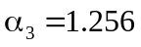 and 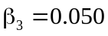.
We can crossvalidate this estimated model on the last 250 persons in the randomorder variable that were previously not used in the analysis. To do this we first need to select again the appropriate rows in the dataset, restrict all the previously free parameters to be fixed, filling in the estimated parameters of the previous model in the corresponding offset fields, and of course fit this new model.
SETTINGS.Sel=[randomorder(251:500)];
MODEL.A.R=logical(zeros(6,1));
MODEL.A.O=OUTPUT.param(1:6);
MODEL.B.R=logical(zeros(6,1));
MODEL.B.O=OUTPUT.param(7:12);
OUTPUT(2)=IRTm(SETTINGS,MODEL);
You can then calculate self-defined crossvalidation indexes within the MATLAB environment. For instance, a simple index can be the ratio of the crossvalidated model log likelihood and the estimated model log likelihood
CVI = OUTPUT(2).LL/OUTPUT(1).LL

Accounting for covariate information and person groups
Example 2: An international study on geometry
Consider a mathematics test, included in the IRTm toolbox as MATLAB dataset ‘covtest.mat’, that is designed for an international study on geometric knowledge and that consists out of 10 items (columns 1 to 10), each representing a problem case that needs to be solved correctly. As researcher you are interested in individual differences, but there is some background information about the 1000 pupils participating in the study, being whether they live in country E or in country F (column 11, value 1 indicating that the pupil belongs to country F, and 0 referring to country E) and a general mathematics end score (column 12) on a scale of 0 up to 100 from their last year in primary school.
We will show how this potentially interesting information can be taken into account in your IRT model for the test, including concerns about differential item functioning (DIF) and hidden person groups.
Overall person covariate effects: In our first example we assumed that the latent trait followed a normal distribution in the population with a given mean and variance. It is not unreasonable to think that pupils with a higher score on mathematics in primary school will on average also have a higher geometric knowledge, i.e., the latent trait the test is measuring. This reasoning can be reflected in our model formulation as 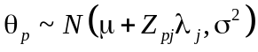, where 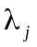 is a person covariate parameter indicating this expected increase in geometry knowledge depending on a person’s p mathematics score in primary school 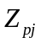, and is the mean parameter (set by convention at zero to fix the scale of the model) and is the variance. Equivalently, this can be seen as the decomposition of the geometric knowledge in a fixed part 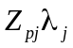 due to the mathematics score and a random residual part 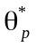, which leads to the following item characteristic function
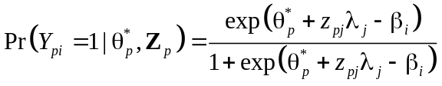,
with 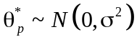.
This type of model is often referred to as a Latent Regression Model (see Andersen & Madsen, 1977) and can be regarded as the person-side analogue of the LLTM with its item decomposition in the previous experimental design example (see e.g., De Boeck & Wilson, 2004).
The new model part has a corresponding set of model design matrices that are situated in the MODEL.LM substructure. The same principles as in the previous section apply here as well. The size of the main design matrix is J covariates by K parameters. We will use the Rasch form of the Latent Regression Rasch model as a starting point in our example.
Reading in the data and setting up the algorithm can be done by first requesting and adapting the standard DATA structure by
SETTINGS = IRTmSet();
load('covtest.mat')
dataset(:,12)=dataset(:,12)-mean(dataset(:,12));
SETTINGS.input=dataset;
SETTINGS.I=[1:10];
SETTINGS.J=[11:12];
For ease of interpretation, we did recode the continuous end score variable by centering around the average mathematics score in the sample.
We can request the default MODEL structure for a latent regression model by MODEL = IRTmModel(10,'Rasch',2) , in which the third argument indicates the number of person covariates, and then continue with fitting the model. However, our second covariate, the end score, is continuous and more or less out of the range of the other variables as well as the latent trait, and this might lead to estimation issues (technically due to the global step size used in the optimization algorithms). There are two options to solve this when it occurs.
One is manually setting the initial parameter estimates for the covariate parameters to appropriate values, instead of choosing for the default random start, by filling in the initial value field of the relevant model substructure. For instance set MODEL.LM.I=[0.5;-0.5] and try fitting the model again (this can take some time!)
OUTPUT=IRTm(SETTINGS,MODEL);
The second option is more efficient and merely requires you to rescale the covariate to a more reasonable range compared to the other variables and parameters. We will set the end score on a scale from -0.5 to 0.5 by dividing it by 100.
dataset(:,12)=dataset(:,12)./100;
SETTINGS.input=dataset;
MODEL.LM.I=[];
OUTPUT(2)=IRTm(SETTINGS,MODEL);
If you would compare the model fitting in time (cfr., [OUTPUT.time] ) , you will notice that this second method is a lot faster. The model likelihood and estimates however, do not change, only the scale of the covariate parameter is different, i.e., instead of 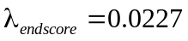, it will be 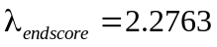 (see e.g., [OUTPUT.param] ), because the value of the parameter corresponds to the increase in geometric knowledge per unit of the covariate . The country effect 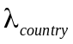 has a similar interpretation; the pupils in country F have on average 2.5 points more on the geometric knowledge scale , compared to the reference group, being the pupils in country E. The item difficulty parameters have to be interpreted acknowledging the known covariates, and as such they represent the difficulty of an item for a pupil with an average mathematics score.
Differential item functioning: In practice, these country effects are a sensitive issue and a topic of much discussion. Perhaps pupils of same ability, but from a different country, do not have an equally fair chance of answering on a particular item due to some contextual or culture-specific information in the given item. This type of phenomenon is commonly referred to as DIF, because the item ‘works’ in a different way depending on the group it is presented to. DIF has an important application area in the development of culture-fair tests and can also be investigated within IRT models (Holland & Wainer, 1993).
A way of doing this is to sequentially check whether an item functions differently by adding an item-covariate interaction parameter 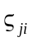 to the latent regression model, leading to the following item characteristic curve for the item under investigation
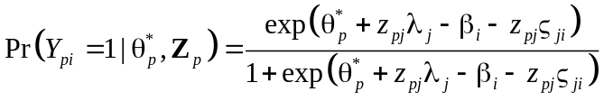,
while the other items retain their original formulation. The new interaction parameter represents the added difficulty for an item i given a person with a value 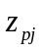 on person covariate j and given proficiency 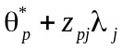.
The introduction of this new model parameter in the likelihood again coincides with a new set of model matrices that pop up in the substructure MODEL.BD . The model structure of the item-covariate interaction parameters has one added field .P , a row vector of length J, that indicates how many columns in the main design matrix MODEL.BD.D relate to which covariate (order corresponding to the order in SETTINGS.J). An example may clarify what is meant by this.
Given 10 items and two covariates, in theory a maximum of (10+10) = 20 item-covariate interaction parameters 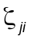 exist. However, most of the times a more parsimonious parameterization is more appropriate or necessary due to identification issues. Consider, that we want to investigate potential DIF on item 7 for the country effect, and on item 5 and 6 for the mathematics end score effect. Furthermore, assume that there are reasons to believe that this DIF would be the same for item 5 and 6. This can be reflected in the model design as follows. For each covariate we have a model for the interaction parameter, for instance 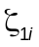
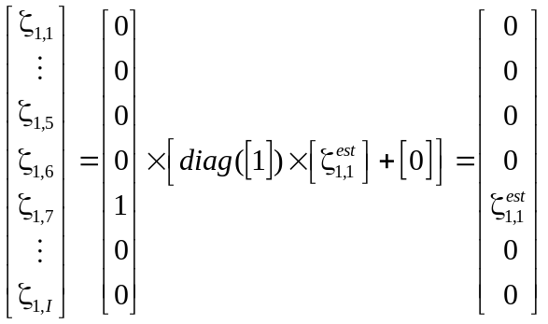,
and for 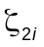
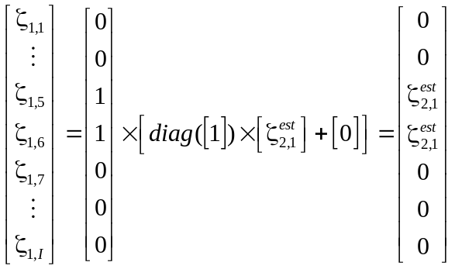.
These are consequently put next together within the MODEL.BD substructures, such that
MODEL.BD.P=[1;1];
MODEL.BD.D=logical([[zeros(6,1);1;zeros(3,1)]
[zeros(4,1);ones(2,1);zeros(4,1)]]);
MODEL.BD.R=logical(ones(2,1));
MODEL.BD.O=zeros(2,1);
OUTPUT(3)=IRTm(SETTINGS,MODEL);
IRTmSummary(OUTPUT(3),'param',MODEL)
The estimated parameters are again stored following their order in the likelihood which is 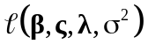, hence parameters 11 and 12 are the DIF parameters (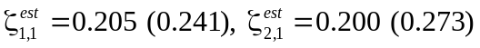 ). Looking at the p-values of the Wald tests for these item covariate interaction parameters it appears that there is no DIF for each set of item-covariate combination we investigated so far. Note that there is less information available to estimate these interaction parameters, than there is information present in the data to estimate the other model parameters. Hence, a Wald test can not entirely be trusted, and it would be more appropriate to use for instance a likelihood ratio test and sequentially check each item-covariate combination separately by comparing a full model with the item-covariate interaction and a reduced model without that interaction (For more on DIF, see Holland & Wainer, 1993).
Hidden groups and finite mixtures: Consider a situation in which the country information is not present in the data, yet might still have a significant impact. We can create a similar, but artificial situation by removing the country variable from the dataset. A possible way to retrieve this hidden grouping on country, is to make use of a finite mixture formulation of the latent trait.
Instead of assuming that your latent trait is normally distributed with a given mean and variance, you assume that the latent trait is actually a combination of two component distributions
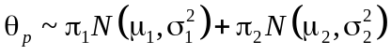,
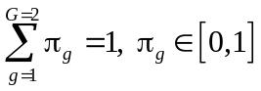
in which the component weights 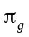 necessarily sum to one and are each restricted to the interval [0,1].
This type of finite mixture formulation (McLachlan & Peel, 2000) has two advantages. First, from a substantive point of view it implies that you consider having a hidden grouping on the persons in your data which might be reflected in the posterior allocation of persons among the components of the mixture and in the average latent trait values for these hidden groups. Second, from a technical point of view, this also allows you to not be restricted to a simple normal distribution for the latent trait, and consider non-normal distributions instead, because these mixtures can for instance give rise to skewed or multimodal distributions.
To test this out, store the country covariate in the variable Z for future reference, Z = dataset(:,11) , and then delete it from the data dataset(:,11)=[] . We first fit a latent regression Rasch model on the ‘new’ data (with only one covariate left, the mathematics end score) to have a model to compare the more advanced finite mixture alternative to.
SETTINGS.input=dataset;
SETTINGS.J=[11];
MODEL=IRTmModel(10,'Rasch',1);
OUTPUT=IRTm(SETTINGS,MODEL);
Fitting the finite mixture formulation of this model, involves setting the correct algorithm, SETTINGS.alg=1 , which is a generalized expectation maximization algorithm instead of the default Quasi-Newton implementation for the non-mixture models. For this illustration, we also limit the number of iterations to 50 and make the stopping criterion less strict to avoid having to wait too long. We put on the display option to be able to monitor the progress.
SETTINGS.alg=1;
SETTINGS.iter=50;
SETTINGS.crit=0.01;
SETTINGS.display='on';
The latent trait part of the model has to be adapted as well to reflect the mixture distribution. We specify the model substructure for the means of the mixture distribution, MODEL.TM , and fix the mean of the first component to zero, hereby functioning as reference and setting the scale.
MODEL.TM.D=logical(eye(2));
MODEL.TM.R=logical([0;1]);
MODEL.TM.O=zeros(2,1);
For identification reasons the variances of the components have to be restricted to be the same and remain fixed at 1.
MODEL.TS.D=logical(ones(2,1));
MODEL.TS.R=logical([0]);
MODEL.TS.O=1;
Next the component weights design structure is specified, with one weight for each component.
MODEL.TW.D=logical(eye(2));
MODEL.TW.R=logical(ones(2,1));
MODEL.TW.O=zeros(2,1);
Note that the combination of restrictions on the component weights are arranged internally in the algorithm and as such the restriction matrix MODEL.TW.R can be kept free as shown above.
Having completed all necessary steps, the mixture model fitting can be started.
OUTPUT(2)=IRTm(SETTINGS,MODEL);
Because we specified the SETTINGS.display to be on, the algorithm will display a set of numbers at each iteration. These are respectively, the iteration number, the maximum absolute difference between parameter values of consecutive iterations, the difference in log likelihood between consecutive iterations, the value of the objective function in the maximization step, and the log likelihood at the given iteration. Note that the algorithm stops when the given maximum number of iterations is exceeded or when both the maximum absolute difference between parameter values and the difference in log likelihood between consecutive iterations, are below the stopping criterion defined in SETTINGS.crit .
Compare the fit of both models and acquire the latent group division based upon the maximum posterior component probabilities:
[OUTPUT.LL;OUTPUT. BIC]
[a postG]=max(OUTPUT(2).l(OUTPUT(2).Index,:),[],2);
To check how good the group division is retrieved, we compare the two classifications (known and latent) in a confusion matrix M with columns components and rows observed groups (cfr. variable Z). Note that the third row and columns, contain the respective marginal total proportions:
Z1=sum(Z(Z==1));
Z0=OUTPUT(2).lN-Z1;
C1=sum(postG(postG==1));
C2=sum(postG(postG==2))./2;
Z1C1=sum(Z(postG==1));
Z1C2=sum(Z(postG==2));
Z0C1=C1-Z1C1;
Z0C2=C2-Z1C2;
M=[Z0C1 Z0C2 Z0;Z1C1 Z1C2 Z1;C1 C2
OUTPUT(2).lN]./OUTPUT(2).lN
If the main diagonal compares to the marginal row totals you obtained a good classification based upon your mixture components.
Note that it is good practice to rerun the optimization a couple of times when applying the EM algorithm (multistart procedure), as it only guarantees to find at least a local maximum. So do not be surprised if you end up with a bad result in a first attempt. Thus unfortunately, the advantages of the mixture approach are counterbalanced a bit by its lesser convergence behavior (speed and local optima).

Conditional independence and Copulas
In the previous sections, the latent trait is considered to account for all the dependency between a person’s responses on the test, referred to as the conditional independence assumption which allows the convenient formulation of the joint probability of the item responses on the full test for a person p as the product of the marginal probabilities
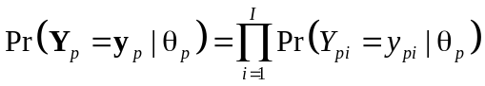.
However in practice, some subsets of items might be more interrelated than can be explained by the general latent trait underlying the test. For instance, think of items that appeal to the same specific background knowledge, are subquestions of the same problematic case, or perhaps just follow the same question format. These item subsets are sometimes called item bundles or testlets in the literature and the prototypical example here are items relating to the same reading-passage.
The presence of these residual dependencies between the items implies that conditional independence does not hold for all items anymore and that your model estimates and inferences will be distorted if you ignore it. In other words, you’ll need another, more adequate formulation of 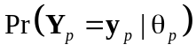, the joint probability of someone’s response vector.
Copula functions: A convenient way of accounting for these residual dependencies within an item subset are copula functions (Braeken, Tuerlinckx, & De Boeck, 2007). A copula is a type of function that is able to connect sets of marginal distributions to form a multivariate distribution that preserves these margins (for reference works on copula theory see Nelsen, 1999 and Joe, 1997). The main idea here is that instead of coupling the marginal distributions 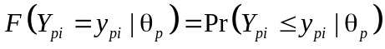 by taking their product to form the multivariate distribution under conditional independence
,
another function than the product is taken to couple these margins to form a multivariate distribution that does allow for a residual dependency structure between the different margins (i.e., items)
.
This function f is exactly the copula function, which makes already clear that the regular independence case is a specific instance of the larger class of copula functions.
In practice, this means that we will consider the total set of items 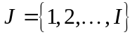 to consist of mutually exclusive item subsets 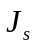 (s=1, …, S), for which conditional independence holds between the different subsets, but where the joint probability of the responses in subset s 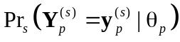 is evaluated from a copula function 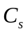 (when subset size 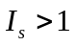) allowing for local item dependency within the subset.
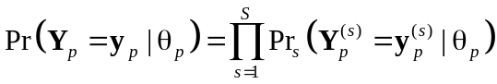.
Notice, that when S=I (i.e., 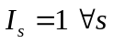), thus each item is its own subset, this formulation reduces to the regular model formulation under conditional independence.
To implement this method, the IRTm toolbox again makes use of a small variant of the previously introduced model structures. The design matrix MODEL.Copula.D is of size number of copula functions by copula properties, with a row s looking like
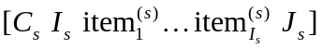.
The first column (and copula property) indicates the type of copula function , the second column indicates the number of items 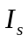 in this copula , the third column until the 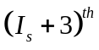 column provide the item indexes in the subset s, and the last column is a subset identification number.
In Table 5 the implemented copula functions in IRTm are listed with their corresponding type number (an overview on copula families can be found in both Nelsen, 1998 and Joe, 1997). Note that a new copula can also be composed as a convex linear combination of copula functions:
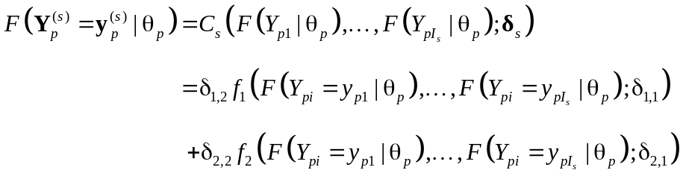
with the usual restrictions for mixture-like models 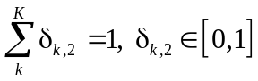.
For this reason, one needs to specify in IRTm for each (component) copula function two parameters: 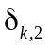, a parameter specific to the k^{th} copula in the linear combination of copula functions, and , a parameter indicating the weight of the k^{th} component within this combination. The restriction matrix .R and offset matrix .O are therefore matrices of size number of copulas by two. The parameter order in the output again follows their order in the likelihood 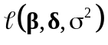, where is the matrix of copula parameters, and the first column of copula parameters is reported first and then the second column (of weights for the copula functions). A few examples are needed to further clarify this.
Example 3: A reading-comprehension test
Consider a 10 items reading-comprehension tests, taken by 1000 students applying to university. Some of the questions refer to similar parts in the main text that the students had to read, hence there may be some concern regarding the potential presence of local item dependency issues.
Model 1: To have a base of reference, a regular Rasch model is formulated under conditional independence and fitted
SETTINGS=IRTmSet;
SETTINGS.input='example_lid.txt';
SETTINGS.I=[1:10];
MODEL=IRTmModel(10,'Rasch');
OUTPUT=IRTm(SETTINGS,MODEL);
Exploration: The IRTm toolbox offers a rough tool to assist in exploring the structure of the test, based upon the comparison of the Mantel-Haenszel (MH) statistics (Mantel & Haenszel, 1959) for each pair of items. This MH statistic essentially measures whether the odds ratio for two items is equal over the different levels of the latent trait, which is implied by the conditional independence assumption. Hence, a large value of this statistic is an indication of local item dependency for the specific item pair. A call to the function IRTmLIDscan computes these statistics and displays two figures. A figure containing the matrix of MH statistics for all item pair combinations, and a dendrogam of a rough hierarchical clustering based upon these MH statistics. Both of these can assist in determining whether and where one has to account for residual dependency issues in the dataset. We will use the sum score (Sum) over items for each person as a temporary proxy for the latent trait for the division in latent trait level groups to calculate the MH statistics.
Applying this for our example, gives the following
Y = OUTPUT.Y(OUTPUT.Index,:);
Sum = OUTPUT.S(OUTPUT.Index);
IRTmLIDscan(Y,Sum);
Based upon the MH matrix one can distinguish two subsets that have a LID issue, 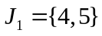 and 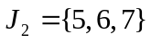, both of them also pop up as the lowest level clusters in the dendrogram. Thus, the items within each of these subsets will be coupled by means of a copula, hereby correcting for the extra interdependency they show (above the interdependency due to the latent trait), which should result in a more appropriate joint probability of the item responses and a better model for our test.
Model 2: Next we go for a copula approach to the data, and fit a Rasch model with copulas to couple the items within the respective subsets 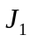 and 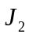. The only thing we need to add to the previous model is the copula part, which can be done as follows
MODEL(2)=MODEL;
MODEL(2).Copula.D=[3 2 4 5 0 1;
2 3 6 7 8 2];
The first copula is of type 3, which is a Gumbel-Hougaard copula, contains 2 items, being item 4 and 5, and is labeled as subset 1 (cfr., ). The second copula is of type 2, which is a Cook-Johnson copula, contains 3 items, being item 6, 7, and 8, and is labeled as subset 2. Notice that the first copula row is padded with a zero to obtain the same length for the design row of each copula function.
MODEL(2).Copula.R=logical([1 0;1 0]);
The parameter specific to each copula (first column) are set free to be estimated and the component weight parameters (second column) are fixed to one, because each subset is only modeled by one copula function.
MODEL(2).Copula.O=[1 1;0 1];
The parameter for the first copula (first row, first column), which is a Gumbel-Hougaard copula is offset by one to improve estimation. The parameters for the copula mixture weights (second column) are both offset at 1, because there is only one copula involved for each subset. This copula Rasch model is then estimated by calling
OUTPUT(2) =IRTm(SETTINGS,MODEL(2));
Looking at the parameter estimates in the summary table, IRTmSummary(OUTPUT(2), 'param',MODEL(2)) , both copula parameters appear to be significant (p<0.0001), indicating that there is indeed a LID issue in the dataset. Furthermore, when comparing the regular conditional independence Rasch model and the copula Rasch alternative, we can already see on sight that the latter model outperforms the former by far, IRTmSummary(OUTPUT,'gof') .
Model 3: Alternatively, we could have chosen other copula functions, and for instance opt for a mixture of the Fréchet-Hoeffding upper bound and the independence case instead of Gumbel-Hougaard copula for the first subset
MODEL(3)=MODEL(1);
MODEL(3).Copula.D=[0 2 4 5 0 1;
6 2 4 5 0 1;
2 3 6 7 8 2];
MODEL(3).Copula.R=logical([0 1;0 1;1 0]);
MODEL(3).Copula.O=[0 0;0 0;0 1];
SETTINGS.con=1;
MODEL(3).B.I=OUTPUT(1).param(1:10);
OUTPUT(3)=IRTm(SETTINGS,MODEL(3));
The last column in the design MODEL(3).Copula.D indicates that the first two copula functions relate to the same subset and should be put together in a linear combination. Both component weights are set free and the copula parameters are fixed as both the independence copula and Fréchet-Hoeffding upper bound copula are non-parametric limiting cases. Note that for estimation purposes the constrained optimization has to be chosen in the SETTINGS structure as the mixture parameters in the linear convex combination have to sum up to one and should each be within the interval [0,1]. To help the constrained optimization algorithm, the initial values of the item difficulty parameters are set at their parameter estimates under the regular Rasch model.
Comparing the three models, IRTmSummary(OUTPUT,'gof'), shows that our first copula model was the best one, but that the alternative model is a close second. Note that constrained optimization is a bit more demanding than regular unconstrained optimization, and that one should definitely take into account the chance of ending up with a local maximum or a non-existing solution as a result of a bad run of the algorithm. Furthermore for identification reasons, parametric copulas can only be put in a linear combination with their copula parameters as fixed and known (e.g., by estimating them separately in a first step).
In our case, running this sequence of three models took about 2 minutes in time on a personal computer running Windows XP and MATLAB7.4.0(R2007a) with a Pentium 2.8Ghz processor and 512MB RAM. You can check this for yourself by vectorizing the time field of the different OUTPUT structures, and dividing the sum of this vector by 60 gives you the total time spend in minutes, sum([OUTPUT.time])/60 .

Data Simulation
At some occasions you might be interested to set up a simulation study to investigate what the consequences are of for instance ignoring certain model assumption violations or putting constraints on specific model parameters. Alternatively, parametric bootstraps (Efron & Tibshirani, 1993), in which new data are simulated following the fitted model, and compared to the original dataset, might be useful to further assess model fit.
With the IRTm toolbox, you can simulate data from a MODEL structure you build up by means of the following function call [Y th] = IRTm_Sim(MODEL,P,Z) . The matrix Y will contain the simulated item responses, while the vector th will contain the latent trait values of the P simulated persons. To add in person covariate information an optional matrix Z, of size 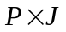, needs to be specified when calling the function. Note that the offset field will be taken as parameter values, and hence the model you will be simulating data from is
 .
Illustration: For instance, to simulate item responses for 500 persons following a Rasch model with 10 items generated from a standard normal distribution and a latent trait with mean 0 and variance 1.5, you can do the following:
MODEL=IRTmModel(10,'Rasch');
MODEL.B.O=randn(10,1);
MODEL.TS.O=1.5;
[Y th] = IRTmSim(MODEL,500); .
If you want to save all variables in your workspace in a MATLAB datafile, use
save('nameoffile.mat');
If you want to save only specific variables use the following format
save('nameoffile.mat','nameofMATLABvariable');
If you want to save the data in a space-delimited text file you can use the following
dlmwrite('nameoffile.txt',Y,' ');
Note that if you do not want to save the file in the working directory (which is the default), you have to specify the filename using an absolute address.

Discussion
In this manuscript, we presented the IRTm toolbox for fitting item response models in the MATLAB environment. We briefly illustrated some applications of a quite general, liberal and explanatory IRT model and illustrated the potential of the toolbox using some didactical examples. However, advances can still be made, and we would definitely welcome cooperation. Some potential further developments are the following: further optimize speed and memory use, for instance by accelerating the implemented EM algorithm, allow for data missing completely at random, provide other prototype MODEL structures for standard IRT models, add extra utility functions for standard IRT test statistics and plotting. Some ongoing developments include polytomous item responses and alternative LID models like the conditional interaction models (Hoskens & De Boeck, 1997) and testlet models (Wainer, Bradlow, & Wang, 2007).
When developing this toolbox, our focus was not primarily on offering an alternative for existing commercial software, but the focus was rather on model building in se. The adopted design-matrix approach allows for a lot of control and flexibility and forces you think during the model buildup stage, this in contrast to mindlessly applying one of the available and widely known standard models. This property might also make the proposed tool suitable to be used in a measurement course to acquire more insight in, and to demystify the build up of, common IRT models in practice. MATLAB is widely used by a large variety of people, both in research as well as in business, and as such this IRT toolbox may be useful to some of them. Furthermore, it is currently the only software that offers an implementation of the copula approach to LID modeling.
References
Agresti, A., Booth, J.G., Hobert, J.P., & Caffo, B. (2000). Random-effects modeling of
categorical response data. Sociological Methodology, 30, 27-80.
Andersen, E.B., & Madsen, I. (1977). Estimating the parameters of a latent population.
Psychometrika, 42, 357-374.
Bock, R. D., & Lieberman, M. (1970). Fitting a response model for n dichotomously
scored items. Psychometrika, 35, 179–197.
Braeken, J., Tuerlinckx, F., & De Boeck, P. (2007). Copulas for residual dependency.
Psychometrika, 72, 393–411.
Browne, M. W. (2000). Cross-validation methods. Journal of Mathematical Psychology,
44, 108-132.
De Boeck, P., & Wilson, M. (2004). Explanatory item response models: A generalized
linear and nonlinear approach. New York: Springer-Verlag.
Efron, B. & Tibshirani, R. (1993). An Introduction to the Bootstrap. London: Chapman &
Hall.
Fischer, G. H. (1973). The linear logistic test model as an instrument in educational
research. Acta Psychologica, 37, 359-374.
Holland, P. W., & Wainer, H. (1993). Differential item functioning. Hillsdale: Lawrence
Erlbaum Associates.
Hoskens, M., & De Boeck, P. (1997). A parametric model for local item dependencies
among test items. Psychological Methods, 2, 261–277.
Lord, F. M., & Novick, M.R. (1968). Statistical theories of mental test scores. Reading,
Addison-Wesley.
Joe, H. (1997). Multivariate models and dependence concepts. London: Chapman & Hall.
Mantel, N., & Haenszel, W. (1959). Statistical aspects of the retrospective study of
disease. Journal of the National Cancer Institute, 22, 719-748.
McLachlan, G.J., & Krishnan, T. (1997). The EM algorithm and extensions. New York:
Wiley.
McLachlan, G.J., & Peel, T (2000). Finite mixture models. New York: Wiley.
Muthén, L. K., & Muthén, B. O. (1998). Mplus user’s guide. Los Angeles: Author.
Nelsen, R.B. (1999). An introduction to copulas. New York: Springer.
Neyman, J. & Scott, E. (1948). Consistent estimates based on partially consistent
observations. Econometrica, 16, 1-32.
Rasch, G. (1960). Probabilistic models for some intelligence and achievement tests.
Copenhagen: Danish Institute for Educational Research.
Rijmen, F., Tuerlinckx, F., De Boeck, P., & Kuppens, P. (2003). A nonlinear mixed
model framework for item response theory. Psychological Methods, 8, 185-205.
SAS Institute Inc. (1999). SAS/STAT 9.1 user’s guide. NC, Cary: SAS Institute Inc.
Wainer, H., Bradlow, E., & Wang, X. (2007). Testlet response theory and its
applications. Cambridge: Cambridge University Press.

Appendix: The copula IRT model
Over the last years, it has been shown that models from item response theory can be conceptualized as generalized linear or nonlinear mixed models (see e.g., Agresti, Booth, Hobert, & Caffo, 2000; De Boeck & Wilson, 2004; and Rijmen, Tuerlinckx, De Boeck, & Kuppens, 2003), if one considers the latent trait to be a person-specific random effect with a given distribution in the population. Within this mixed model framework, we will very concisely lay out the pieces that together compose the joint marginal likelihood of the general copula IRT model the IRTm toolbox can accommodate:
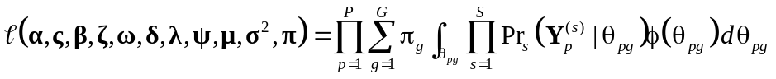.
The density of the component distribution g of the latent variable is
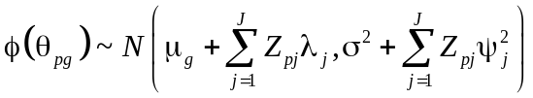,
in which both mean and variance can be decomposed in a fixed part due to the effect of a person covariate ( and 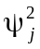, respectively) and a latent part (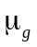and 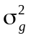, respectively). Each component of the latent trait distribution is further parameterized by means of a component weight , with 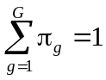. 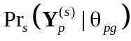 is then the joint probability of the subset s under the copula 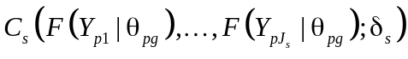 given 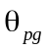, the component latent trait estimate of person p. The conditional distribution function of an item i is defined as
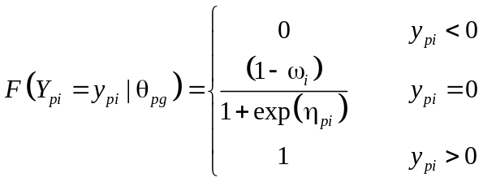,
with predictor component 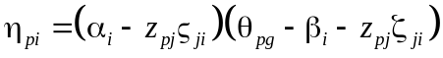, where 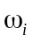 functions as lower-asymptote of the logistic function and is also known as the pseudo-guessing parameter in the 3-parameter logistic model, 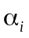 is the item discrimination parameter, is the item difficulty parameter, and and 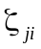 are corresponding item-covariate interaction parameters .
This model formulation allows the fitting of most known binary item response models (Rasch, 2PL, 3PL), but also accommodates the linear logistic test model (Fisher, 1973), latent regression models through person covariates, differential item functioning (Holland & Wainer, 1993), and copula models to deal with local item dependencies (LID; Braeken, Tuerlinckx, & De Boeck, 2007). Estimation of the models will be done following full information marginal maximum likelihood (Bock & Liebermann, 1970) by means of a quasi-Newton algorithm or a generalized Expectation-Maximization algorithm (McLachlan & Krishnan, 1997). The IRTm toolbox takes a marginal maximum likelihood approach to model estimation, and hence, assumes that the proficiency of the persons follows a distribution in the population. In the MML approach this population distribution is integrated out to surpass the Neymann-Scott problem (1948) leading to consistent estimates for both fixed and random parameters. The distribution of the latent trait can either be (1) parametric, a Normal distribution or (2) semi-parametric, a finite mixture of Normals (both approximated by means of Gauss-Hermite quadrature).
The integral(s) in the likelihood expression has no closed-form solution and will be approximated using Gauss-Hermite quadrature. Making use of the Bayes theorem, empirical Bayes estimates of the latent proficiencies can be computed using
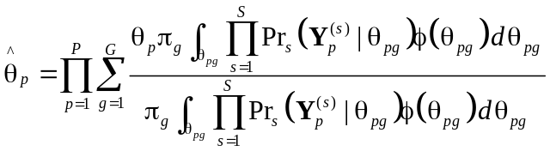.
The stopping criterion of the generalized EM algorithm uses two references, the maximal absolute difference between parameter values of two successive iterations and the corresponding difference in log likelihood. When both are below SETTINGS.crit, the algorithm stops.
Some features that will increase general computation time are nonlinear terms in the predictor component (e.g., discrimination and pseudoguessing parameters), an increasing complexity of the latent trait distribution on the model part (e.g., multiple components), a large DIF part in the model, an increasing amount of items and unique response patterns on the data part, an increasing number of quadrature points, and decreasing the stopping criterion for the generalized EM technique on the algorithmic part.
Where possible, the performance of the algorithms was crosschecked with SAS Proc Nlmixed and was found to be quite satisfactory. It should be noted that SAS biggest handicap is time, especially when Proc Nlmixed is requested to provide estimates of the latent trait.

Tables
Table 1. Field names of the IRTm SETTINGS structure and a brief description of their contents.
Field Name | Type | Contents
Input | Data | string containing path to data file or  alternatively a MATLAB matrix containing data
I | Data | vector with item column numbers
J | Data | vector with covariate column numbers (empty vector [] when not applicable)
Sel | Data | vector with persons to be included in the analysis  (empty vector [] for whole sample)
delim | Data | specifies the delimiter between columns when reading in a data file  (default is space)
alg | Algorithm | algorithm to be used : 0 for quasi-Newton and 1 for generalized EM
qp | Algorithm | number of quadrature points to be used when integrating out the latent trait
iter | Algorithm | maximum number of iterations the algorithm is allowed to run
func | Algorithm | maximum number of likelihood evaluations  an algorithm may run for one iteration
crit | Algorithm | stopping criterion value of generalized EM algorithm  (no influence on quasi-Newton)
display | Algorithm | string (‘on’ or ‘off’) regulating display of the optimization procedure’s progress
con | Algorithm | optimization type: 0 for regular unconstrained and 1 for constrained

Table 2. Field names of the IRTm OUTPUT structure and a brief description of their contents.
Field Name | Type | Contents
AIC | Fit | Akaike’s information criterion
BIC | Fit | Bayesian information criterion
Chi2 | Fit | pseudo chi-square statistic only based upon the response patterns present in the data
Freq | Data | frequencies of unique response patterns in the data
HES | Optim | Hessian matrix
HEScheck | Optim | outcome of positive definiteness check of the Hessian
Index | Data | index towards the persons with corresponding unique response pattern
LL | Fit | optimized value of the log likelihood
Npred | Pred | predicted number of persons for each of the response patterns present in the data
RMSE | Trait | root mean squared error of the latent trait estimates
S | Data | sum score over items for each of the response patterns present in the data
Y | Data | item part of the unique response patterns in the data
Z | Data | covariate part of the unique response patterns in the data
algorithm | Optim | name of the applied optimization algorithm
ebe | Trait | empirical Bayes estimate of the latent trait
ebeSE | Trait | empirical Bayes estimate of the latent trait standard error
funCount | Optim | number of likelihood function evaluations in the last quasi-Newton iteration
init | Optim | initial values for the model parameters
iterations | Optim | number of iterations run by the algorithm
l | Data | posterior probability (one column per component)
lI | Data | number of items
lJ | Data | number of covariates
lN | Data | number of persons
lP | Data | number of parameters
lX | Data | number of unique response patterns
message | Optim | general information on optimization outcome
muY | Data | proportions of items
muZ | Data | means of covariates
optim | Optim | outcome code of the optimization procedure ( 0 indicating non-convergence)
p | Pred | pvalues of Wald test for estimated model parameters
param | Pred | estimated model parameters in order of appearance in the model likelihood
paramSE | Pred | standard errors for estimated model parameters
stepsize | Optim | last step size in quasi-Newton iteration
time | Optim | total time spend by the procedure in seconds
trait | Trait | trait estimate being the sum of the ebe estimate of the residual latent trait  and the covariate effect for each unique response pattern

Table 3. Rasch estimates for IRTm, SAS, and MPLUS.
Parameter | IRTm | SAS | MPLUS
 | -0.244 (0.119) | -0.244 (0.119) | -0.244 (0.119)
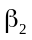 | -1.762 (0.142) | -1.762 (0.142) | -1.762 (0.142)
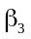 | 0.063 (0.118) | 0.063 (0.118) | 0.063 (0.118)
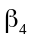 | 0.286 (0.119) | 0.286 (0.119) | 0.286 (0.119)
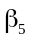 | -1.049 (0.126) | -1.049 (0.126) | -1.049 (0.127)
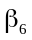 | 1.234 (0.130) | 1.234 (0.130) | 1.234 (0.130)
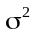 | 1.649 (0.216) | 1.649 (0.216) | 1.649 (0.208)
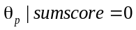 | -2.019 (0.859) | -1.927 (0.846) | -2.019 (na)
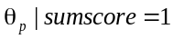 | -1.337 (0.797) | -1.281 (0.781) | -1.337 (na)
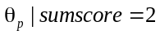 | -0.731 (0.765) | -0.701 (0.748) | -0.731 (na)
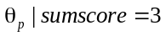 | -0.156 (0.755) | -0.159 (0.738) | -0.156 (na)
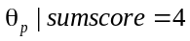 | 0.422 (0.770) | 0.389 (0.750) | 0.422 (na)
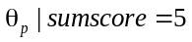 | 1.042 (0.809) | 0.975 (0.790) | 1.042 (na)
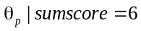 | 1.752 (0.881) | 1.647 (0.866) | 1.752 (na)
Time in seconds | 0.51 | 8.03 | 0.00 (na)

Table 4. Substructures of the IRTm MODEL structure and the model part they refer to.
Substructures | Model Part | Type
A | item discrimination 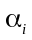 | Item
AD | item discrimination-covariate interaction 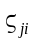 | Item
B | item difficulty | Item
BD | item difficulty-covariate interaction 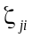 | Item
C | item pseudo-guessing 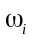 | Item
LM | covariate effect on the mean 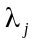 | Covariate
LS | covariate effect on the variance 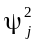 | Covariate
TM | component latent trait mean 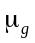 | Trait
TS | component latent trait variance 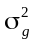 | Trait
TW | Component latent trait weight 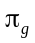 | Trait
Copula | Copula LID subset 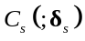 | Copula

Table 5. Implemented Copula functions in IRTm and corresponding type number.
Type | Copula function
0 | Independence (non-parametric)
1 | Frank copula
2 | Cook-Johnson copula
3 | Gumbel-Hougaard copula
4 | Placket copula (only for =2)
5 | Fréchet-Hoeffding lower bound (non-parametric)
6 | Fréchet-Hoeffding upper bound (non-parametric)
*non-parametric in the sense that no additional parameters are involved

