AgileMentor- An Interactive Scrum Learning Tool

**Software Requirements Specification**

# Revision History

| **Date** | **Revision** | **Description** | **Author** |
| --- | --- | --- | --- |
| 09-14-2023 | 1.0 | Identified primary actors and their use cases | Group_Kartik |
| 09-19-2023 | 2.0 | Changed use case model based on instructor feedback, changed primary actors and use cases | Group_Kartik |
| 09-21-2023 | 2.1 | Factored the use cases to add generalization. | Group_Kartik |
| 09-22-2023 | 3.0 | Final document | Group_Kartik |

# Table of Contents

01 Revision History 1

02 Table of Contents 2

03 Domain Model 3

03.1 References 3

03.2 Glossary, Acronyms and Abbreviations 3

03.3 Domain Model 4

04 Catalogs 10

04.1 Actor Catalog 10

Use Case Catalog 10

04.2 Supplemental Requirements Catalog 11

05 Requirements Quality Attributes Catalog 12

06 Use Cases 13

06.1 Use Case Diagram 13

06.2 Use Case Specifications 14

07 Open Issues 22

# Domain Model

## References

| **Item** | **Description** |
| --- | --- |
| Research Paper | Potineni, Sindhura & Bansal, Srividya & Amresh, Ashish. (2013). ScrumTutor: A web-based interactive tutorial for Scrum Software development. Proceedings of the 2013 International Conference on Advances in Computing, Communications and Informatics, ICACCI 2013. 1884-1890. 10.1109/ICACCI.2013.6637469. |
| Research Paper | LEE, Wee Leong. SCRUM-X: An Interactive and Experiential Learning Platform for Teaching Scrum. (2016). *The 7th International Conference on Education, Training and Informatics (ICETI 2016)*. Research Collection School Of Computing and Information Systems. |
| Research Paper | Christiane Gresse von Wangenheim, Rafael Savi, Adriano Ferreti Borgatto,  SCRUMIA—An educational game for teaching SCRUM in computing courses,  Journal of Systems and Software, Volume 86, Issue 10, 2013, Pages 2675-2687,  ISSN 0164-1212,  https://doi.org/10.1016/j.jss.2013.05.030.  (https://www.sciencedirect.com/science/article/pii/S0164121213001295) |
| Research Paper | Bassi, A. (2016). *Scrum Sim - A Simulation Game to Learn the Scrum Agile Framework*. Retrieved from https://digitalcommons.harrisburgu.edu/pmgt_dandt/11 |
| Research Paper | Emily Laue Christensen and Maria Paasivaara. 2022. Respond to change or die: an educational scrum simulation for distributed teams. In Proceedings of the ACM/IEEE 44th International Conference on Software Engineering: Software Engineering Education and Training (ICSE-SEET '22). Association for Computing Machinery, New York, NY, USA, 235–246. https://doi.org/10.1145/3510456.3514145 |
| Scrum Game  (The Coffee Game) | https://tastycupcakes.org/2016/10/the-coffee-game/ |
| Scrum Game  (Scrumble) | http://scrumble.pyxis-tech.com/ |
| Scrum Game  (Scrum Card Game) | https://scrumcardgame.com/ |
| List of Open Source Scrum Tools | https://www.opensourcescrum.com |

## Glossary, Acronyms and Abbreviations.

| **Item** | **Description** |
| --- | --- |
| Actor | Any user/relevant stakeholder of the system. |
| Trainee | Trainee refers to any user/actor tending to use the simulator to meet the learning outcomes as set by the trainer (explained next). |
| Trainer | Trainer refers to any user/actor of the simulator who is generally responsible for setting the learning outcomes of the simulation. |
| Sim User | Sim User is a generalization to represent any user/actor who will be using the simulation system. |
| Administrator | Administrator is an actor who is responsible for controlling and setting parameters of the simulation system. |
| Blocker Cards | Event Cards that lead to an unpreferable event to the development process. Basically a blocker to the development. |
| Success Cards | Event Cards that lead to a preferable event to the development process |
| Response Cards | These are Event Cards that are played in response to blocker cards either by the scrum master or the developers |

## Domain Model

Here, the team has used mainly two types of diagrams to represent the domains as they are suitable to the scenario. These models thus used are - Sequence Diagram and Activity Diagram:

**Login:**

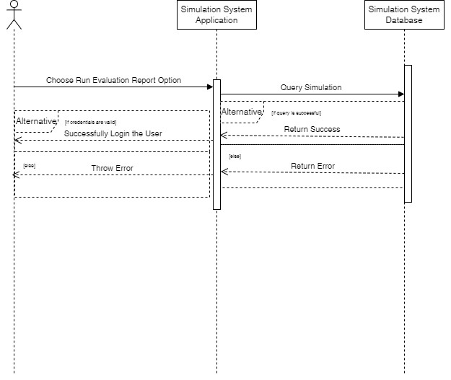

**Download Scenario Data To Evaluate And Analyze The Results:**

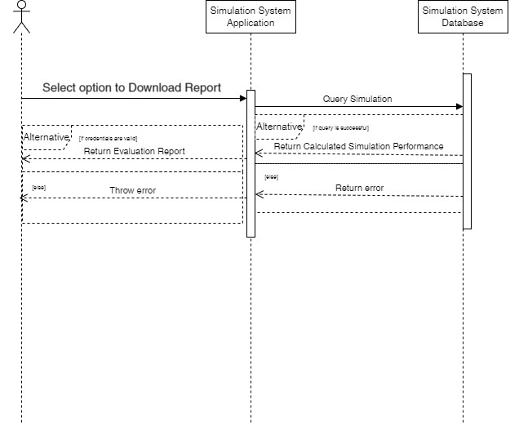

**Save Current Simulation:**

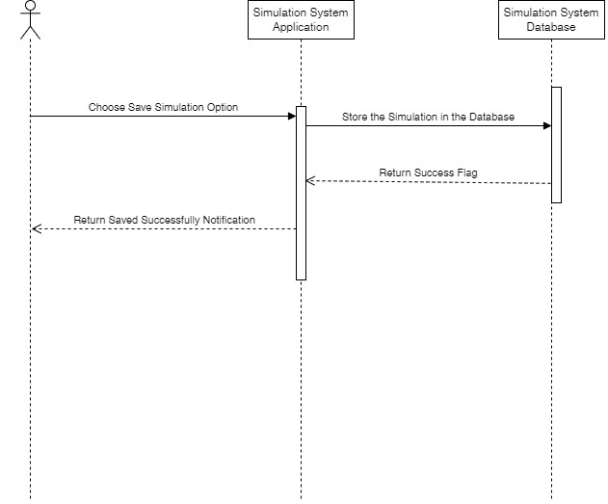

**Resume Previous Scenarios:**

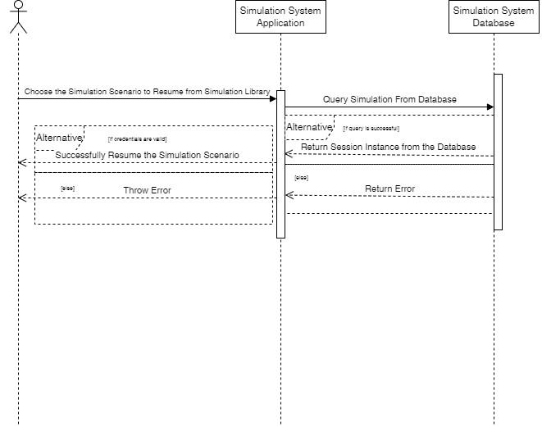

**Change System Parameters:**

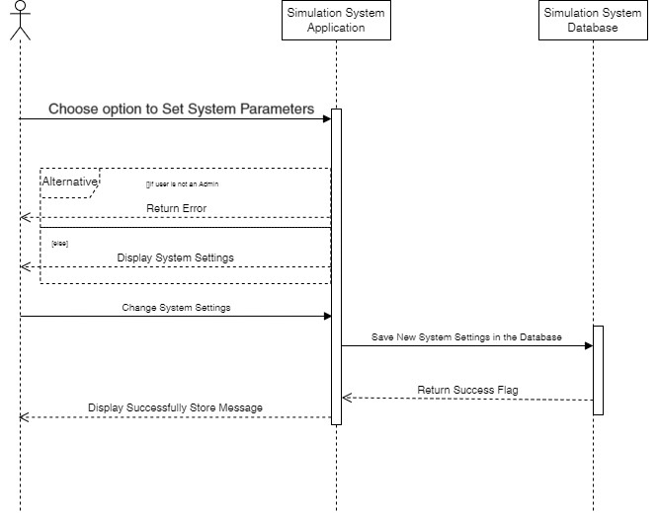

**Blocker/Success Card Scenario:**

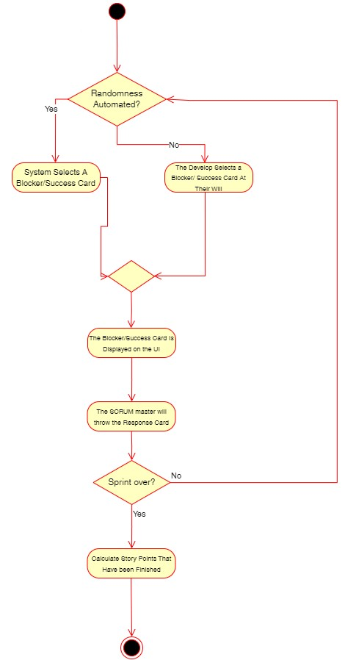

# Catalogs

## Actor Catalog

| **ID** | **Title** | **Relationships** | **Type** | **Description** |
| --- | --- | --- | --- | --- |
| 1 | Trainee | Special Case of Sim User | One of user | The trainee is the user who will be learning from the simulation. The trainee can play the game and run the simulation to learn from them. |
| 2 | Trainer | Special Case of Sim User | One of user | The trainer is responsible for creating a learning outcome for the trainee. Accessing trainee progress and keeping track of the session. The trainer is also responsible for evaluating the performance of the trainees. |
| 3 | Sim User | Special Case of User | One of user | The sim user represents the general user of the simulator. They can run the simulation and evaluate the results. They can perform exploratory data analysis on the results. |
| 4 | Administrator | Special Case of User | One of user | The administrator is responsible for managing trainee and trainer accounts and adding, and removing trainer privileges. |
| 5 | User | Independent | One of user | The user represents the most general user of the system. They log into the system and perform different tasks. |

## Use Case Catalog

| **ID** | **Title** | **Actor** | **Supports Features** | **Brief Description** | **Acceptance Test** |
| --- | --- | --- | --- | --- | --- |
| UC01 | Play The Game | Trainee | UC20 | The trainee can participate in the scrum development process. |  |
| UC02 | Select Roles | Trainee | UC01 | The trainee can select which role they want to play in the scrum development team. |  |
| UC03 | Access Personal Records | Trainee |  | The trainee can view their performance once a round of the game has ended, as well as their performance in previous games. |  |
| UC04 | Set Learning Outcome | Trainer | UC20 | The instructor can set lesson plans for trainees and add rubrics to evaluate their performance. |  |
| UC05 | Access Trainee Records | Trainer | UC10 | The instructor can view the progress and performance of their students. |  |
| UC06 | Assign Roles | Trainer | UC01 | The instructor can assign scrum roles to trainees when the gameplay option is selected. |  |
| UC07 | Add custom User Stories, Epics, Themes, and Tasks | Trainer | UC20 | The instructor can add custom User Stories, Epics, Themes, and Tasks to tailor the training according to their requirements. |  |
| UC08 | Run Simulation | Sim User |  | The sim user can run the simulation. |  |
| UC09 | Download Scenario Data To Evaluate And Analyze The Results | Sim User |  | The sim user can download the simulation scenario alongside the results to evaluate them. |  |
| UC10 | Save The Session | Sim User |  | The sim user can save the current state of their simulation to either view intermediate results or visit it at a later time. |  |
| UC11 | Resume Previous Session | Sim User |  | The sim user can resume any of their previously saved sessions from where they stopped last time. |  |
| UC12 | Introduce Random Events in Simulation | Sim User | UC08, UC11 | The sim user can optionally introduce random events into the simulation like requirements, removal of team members, etc. |  |
| UC13 | Delete Records in Simulation Library | Sim User |  | The sim user can delete records from their simulation library. |  |
| UC14 | View Simulation Results | Sim User |  | The sim user can view the complete report of their results after a simulation has ended. |  |
| UC15 | Rewind Simulation | Sim User |  | The sim user can pause simulations and rewind to previous days, undoing any changes made during that time. |  |
| UC16 | Add Trainer/Trainee Accounts | Administrator |  | The administrator can add trainer/trainee accounts in the system. |  |
| UC17 | Edit Trainer/Trainee Accounts | Administrator |  | The administrator can edit trainer/trainee accounts. |  |
| UC18 | Delete Trainer/Trainee Accounts | Administrator |  | The administrator can delete trainer/trainee accounts. |  |
| UC19 | Authenticate User | User |  | The users can provide credentials to authenticate themselves. |  |
| UC20 | Create A New Game Session | Administrator |  | The administrator can create a new game session and add a trainer and trainees in the session. |  |

## Supplemental Requirements Catalog

| **ID#** | **Short Name** | **F/NF** | **U/S** | **Requirement** |
| --- | --- | --- | --- | --- |
| SR01 | Privacy Requirements | *NF* | *U* | *The data access should be constrained by the role of the user. For example the trainee can only access the simulations that he/she was a part of.* |
| SR02 | Security requirements | *NF* | *U* | *In case of a data leakage the hacker should not be able to access the simulation data.* |

# Requirements Quality Attributes Catalog

| **ID#** | **Verifiable** | **Precision** | **Volatile** | **Priority** | **Tags** |
| --- | --- | --- | --- | --- | --- |
| UC01 | Yes | Yes | No | High |  |
| *UC02* | Yes | Yes | No | Medium |  |
| *UC03* | Yes | Yes | No | Medium |  |
| *UC04* | Yes | Yes | No | High |  |
| *UC05* | Yes | Yes | No | Medium |  |
| *UC06* | Yes | Yes | No | Medium |  |
| *UC07* | Yes | Yes | No | Medium |  |
| *UC08* | Yes | Yes | No | High |  |
| *UC09* | Yes | Yes | No | Medium |  |
| *UC10* | Yes | Yes | No | Medium |  |
| *UC11* | Yes | Yes | No | Medium |  |
| *UC12* | Yes | Yes | No | Medium |  |
| *UC13* | Yes | Yes | No | Medium |  |
| *UC14* | Yes | Yes | No | Medium |  |
| *UC15* | Yes | Yes | No | Medium |  |
| *UC16* | Yes | Yes | No | High |  |
| *UC17* | Yes | Yes | No | High |  |
| *UC18* | Yes | Yes | No | High |  |
| *UC19* | Yes | Yes | No | High |  |
| *UC20* | Yes | Yes | No | Medium |  |

# Use Cases

## Use Case Diagram

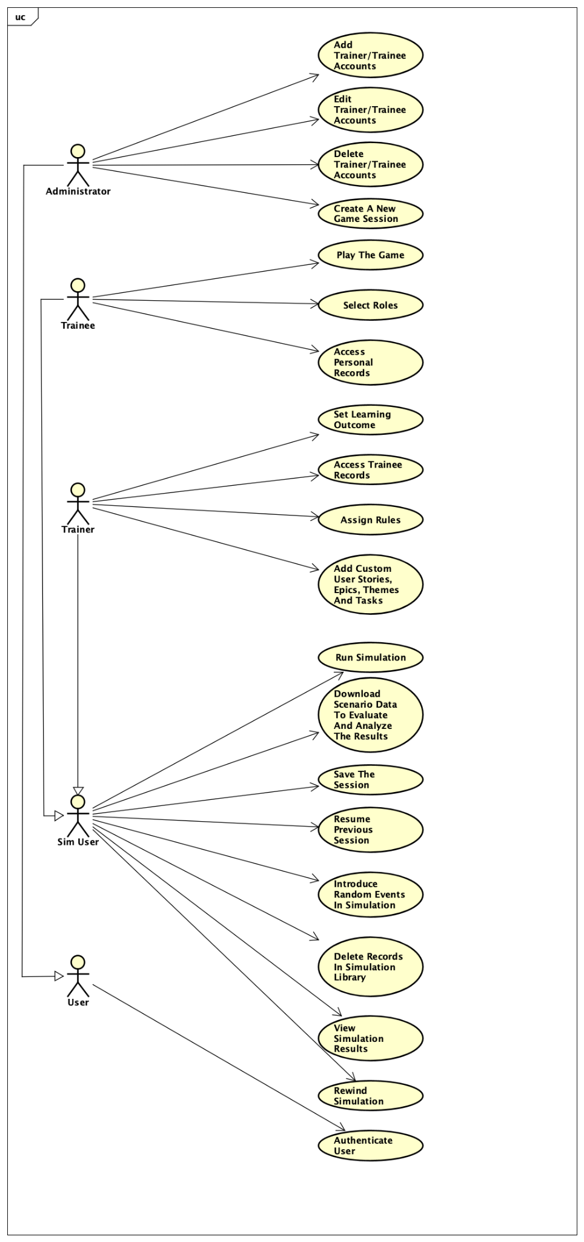

## Use Case Specifications

**Use Case UC01 : Play the Game**

**Objective :** The trainee shall participate in the training simulation.

**Dependencies :** Includes UC20

**Primary Actor :** Trainee

**Secondary Actors :** System  
**Preconditions:** The user has logged into the system.

**Post Conditions:** The user has entered the simulation.

**MAIN SUCCESS SCENARIO**

1. The user will login to the system.
2. The user selects the training session.
3. The user enters the game scenario.

**Variations :**

**Failure Variations :**

Variation ID: UC01VAR-01-F

1. The user logs into the system
2. The user encounters an error as the game fails to load

**Use Case UC02 : Select Roles**

**Objective :** The user selects one role from developer, scrum manager and product owner.

**Primary Actor :** Trainee

**Dependencies :** Includes UC01

**Trigger :** The user selects the roles option.

**Secondary Actor :** System

**Pre conditions :** The user has entered the training session.

**Post conditions :** The user has enrolled for one of the roles in the game.

**Main Success scenario :**

1. The user enters the training session.
2. The user selects the roles options.
3. The user is asked to select one of the roles from the options.
4. The user is assigned the role selected.

**Variations:**

Variation ID: UC02VAR-01

1. The user is a trainer and clicks on select roles.
2. The trainer will be able to view and assign roles.

Variation ID: UC02VAR-02

1. The user is an administrator.
2. The administrator is able to view the roles selected by the trainees in the game.

**Failure variation :**

Variation ID: UC02VAR-01-F

1. The user clicks on select roles.
2. The user is prompted to select the roles and then clicks on one of the roles.
3. The system fails to assign the role to the user.
4. The user should retry the process to select roles.

**Use Case UC03 : Access Personal Records**

**Objective :** The user shall be able to view their personal information and performance data.

**Primary Actor :** Trainee

**Dependencies :**

**Trigger :** The clicks to review their progress.

**Secondary Actor :** System

**Pre conditions :** The user has logged in the system.

**Post conditions :** The user is able to access their personal records.

**Main Success scenario :**

1. The user logs in the system.
2. The user clicks on the option to review their progress.
3. A window with user details and personal records is displayed.

**Variations:**

Variation ID: UC03VAR-01

1. The user is an administrator or a trainer.
2. The user clicks to view personal records.
3. The window with details of previous actions in each session is displayed.

**Failure variation :**

Variation ID: UC03VAR-01-F

1. The user clicks on the option to view personal records.
2. The system is unable to retrieve any data.
3. The user can check with the administrator if the data is still available or erased.
4. The user can retry the process from the main window to display the data.

**Use Case UC04 : Set Learning Outcomes**

**Objective :** The trainer will set the learning goals intended for the trainees.

**Primary Actor :** Trainer

**Dependencies :** Includes UC20

**Trigger :** The trainer clicks to set goals for the learning session.

**Secondary Actor :** System

**Preconditions :** The trainer is logged in as the trainer for the session.

**Post conditions :** The trainer sets the learning outcomes for the session.

**Main Success Scenario :**

1. The user logs in as the trainer.
2. The user selects the set learning outcome option.
3. The user enters the learning outcomes for the session.
4. The user saves the learning outcomes.

**Variations :**

Variation ID: UC04VAR-01

1. The trainer enters the learning outcome in the window.
2. The trainer clicks on exit without saving them.
3. The system will ask for the permission to save the learning outcomes or discard them.

**Failure variation :**

Variation ID: UC04VAR-01-F

1. The trainer enters the learning outcome and saves them.
2. The learning outcomes are not saved.
3. The trainer will have to reenter the learning outcomes and save them.

**Use Case UC05 : Access Trainee Records**

**Objective :** The trainer shall view the information and performance data of the trainee.

**Primary Actor :** Trainer

**Dependencies :** Includes UC10, requires a saved session to access records.

**Trigger :** The trainer clicks to view the progress of all trainees.

**Secondary Actor :** System

**Preconditions :** The user is logged in as the trainer in the session.

**Post conditions :** The user is able to access trainee records for evaluation.

**Main Success Scenario :**

1. The user logs into the session as a trainer.
2. The user selects the option to view session progress and details.
3. The user clicks on the trainee to access their records.
4. A new window with the records of the trainee is displayed.

**Variations :**

**Failure variation :**

Variation ID: UC05VAR-01-F

1. The trainer selects the session to view trainees in the session.
2. The system is unable to load all trainees or some.
3. The trainer needs to reload the page to view trainees.

**Use Case UC06 : Assign Roles**

**Objective :** The trainer shall be able to assign roles to the trainees.

**Primary Actor :** Trainer

**Dependencies :** Includes UC01, requires trainees to be playing a game.

**Trigger :** The trainer clicks on select roles.

**Secondary Actor :** Trainee

**Preconditions :**

1. The user is logged in as the trainer.
2. The trainees have entered the game.

**Post conditions :** The trainee is assigned a role by the trainer.

**Main Success Scenario :**

1. The trainer logs in the session.
2. The trainer clicks on select roles.
3. The trainer is displayed in a window with trainees and their roles.
4. The trainer selects the roles of the desired trainees.

**Variations :**

Variation ID: UC06VAR-01

1. The trainee has already selected a role.
2. The trainer changes the role of the trainee from the options.
3. The trainer asked to confirm the changes and save them.

**Failure variation :**

Variation ID: UC06VAR-01-F

1. The trainer assigns the role to the trainee.
2. The changes are not saved.
3. The trainer has to re-assign the roles.

Variation ID: UC06VAR-02-F

1. The trainer is unable to view all the roles to assign the trainee.
2. The trainer will close the window and click on select roles again.

**Use Case UC07 : Add custom User Stories, Epics, Themes, and Tasks**

**Objective :** The trainer shall add custom user stories, epics, themes and tasks for the session.

**Primary Actor :** Trainer

**Dependencies :** Includes UC20, requires a session to exist.

**Trigger:** The trainer selects on the add custom features option.

**Secondary Actor :** System

**Preconditions :** The user is logged in as the trainer.

**Post conditions :** The session will have custom user stories, epics, themes and tasks.

**Main Success Scenario :**

1. The trainer opens the desired session.
2. The trainer goes to the add custom features option.
3. A window will be displayed to enter custom user stories, epics, themes and tasks.
4. The trainer saves the custom additions.

**Variations :**

**Failure variation :**

Variation ID: UC07VAR-01-F

1. The trainer opens the custom options.
2. The system does not load the options to enter details.
3. The trainer can close the window and reopen the option.

**Use Case UC08 : Run simulation**

**Objective :** The simulation with provided details will be executed.

**Primary Actor :** Sim User

**Dependencies :**

**Trigger:** The sim user clicks on the button to run simulation

**Secondary Actor :** System

**Preconditions :** Sim User has successfully logged into the system

**Post conditions :** Sim User was able to run the simulation.

**Main Success Scenario :**

1. The sim user logs into the system.
2. The sim user clicks on start a simulation button.
3. The simulation starts running.

**Variations :**

**Failure variation :**

Variation ID: UC08VAR-01-F

1. The simulation fails because of a system crash.
2. The sim user starts the simulation again.

**Use Case UC09 : Download scenario data to evaluate and analyze the results**

**Objective :** The Sim User shall be able to evaluate and analyze the simulation results.

**Primary Actor :** Sim User

**Dependencies :**

**Trigger:** The sim clicks on the download simulation data button.

**Secondary Actor :** System

**Preconditions :** Sim User has successfully logged into the system.

**Post conditions :** Sim User was able to download the simulation data in a csv file.

**Main Success Scenario :**

1. The sim user logs into the system.
2. The sim user goes to its simulation library page.
3. The sim user goes to a particular simulation page.
4. The sim user clicks on the download simulation data button.
5. The simulation data is downloaded in a csv format.

**Variations :**

**Failure variation :**

Variation ID: UC09VAR-01-F

1. The sim user logs into the system.
2. They go to the simulation library.
3. They go to a particular simulation page.
4. They click on the download simulation data button.
5. The simulation data is not downloaded as the simulation is not finished.
6. The sim user waits for the simulation to get done or pauses it and then tries again from step 4 of the main success scenario.

**Use Case UC10 : Save the Session**

**Objective :** The Sim User shall be able to save the current progress of a session.

**Primary Actor :** Sim User

**Dependencies :**

**Trigger:** The sim clicks on save the session button on the current session’s page

**Secondary Actor :** System

**Pre conditions :** Sim User has successfully logged into the system and has started a simulation.

**Post conditions :** Sim User was able to save the current session session.

**Main Success Scenario :**

1. The sim user logs into a system.
2. The sim user starts a simulation.
3. The sim user pauses the simulation.
4. The sim user clicks on save the session button.
5. The session is saved.

**Variations :**

Variation ID:UC10VAR-01

1. The sim user logs into the system.
2. They start a simulation.
3. They wait till the simulation ends.
4. They then click on save the session button.

**Failure variation :**

**Use Case UC11 : Resume Previous Session**

**Objective :** The Sim User shall be able to resume a previously saved session.

**Primary Actor :** Sim User

**Dependencies :**

**Trigger:** The sim clicks on the resume button on the current session’s page.

**Secondary Actor :** System

**Pre conditions :** Sim User has successfully logged into the system.

**Post conditions :** Sim User was able to resume the current session.

**Main Success Scenario :**

1. The sim user logs into a system.
2. The sim user goes to the simulation library page.
3. The sim user clicks on a particular simulation.
4. The sim user clicks on the resume button.
5. The session is resumed.

**Variations :**

Variation ID:UC11VAR-01

* 1. The sim user logs into a system.
  2. The sim user goes to the simulation library page.
  3. The sim user clicks on a particular simulation.
  4. The simulation was already finished.
  5. The resume button is disabled.
  6. The sim user goes to step 2 of the main success scenario.

**Failure variation :**

**Use Case UC12 : Introduce Random Events in Simulation**

**Objective :** The Sim User can customize the simulation.

**Primary Actor :** Sim User

**Dependencies :** extends UC08 and UC11

**Trigger:** The sim clicks on the start the simulation button or the resume button on a session.

**Secondary Actor :** System

**Pre conditions :** Sim User has successfully logged into the system.

**Post conditions :** Sim User was able to resume the current session.

**Main Success Scenario :**

1. The sim user logs into a system.
2. The sim user clicks on start a simulation button.
3. The sim changes the velocity, team size, sprint size.
4. The sim user clicks on the run the simulation button.
5. The simulation starts running.

**Variations :**

Variation ID: *UC12VAR-01*

* 1. The sim user logs into a system.
  2. The sim user goes to the simulation library.
  3. The sim user goes to a particular session’s page.
  4. The sim user clicks on the resume session button.
  5. The sim changes the velocity, team size, sprint size and clicks on OK.
  6. The session is resumed.

**Failure variation :**

Variation ID: UC12VAR-01-F

**Use Case UC13 : Delete Records in Simulation Library**

**Objective :** The Sim User can customize their simulation library.

**Primary Actor :** Sim User

**Dependencies :**

**Trigger:** The sim clicks on the delete button for a simulation session.

**Secondary Actor :** System

**Pre conditions :** Sim User has successfully logged into the system.

**Post conditions :** Sim User was able to delete the current session.

**Main Success Scenario :**

1. The sim user logs into a system.
2. The sim user goes to the simulation library.
3. The sim user goes to a particular session’s page.
4. The sim user clicks on delete the simulation button.
5. The session is deleted.

**Variations :**

**Failure variation :**

**Use Case UC14 : View Simulation Results**

**Objective :** The Sim User can see simulation results of a session.

**Primary Actor :** Sim User

**Dependencies :**

**Trigger:** The sim clicks on the view results button for a simulation session.

**Secondary Actor :** System

**Pre conditions :** Sim User has successfully logged into the system.

**Post conditions :** Sim User was able to see the simulation results of a session.

**Main Success Scenario :**

1. The sim user logs into a system.
2. The sim user goes to the simulation library.
3. The sim user goes to a particular session’s page.
4. The sim user clicks on the view simulation results button.
5. The simulation results are shown.

**Variations :**

**Failure variation :**

Variation ID:UC14VAR-01F

* 1. The sim user logs into a system.
  2. The sim user goes to the simulation library.
  3. The sim user goes to a particular session’s page.
  4. The sim user clicks on the view simulation results button.
  5. The system shows error as the simulation is still running.
  6. The user either waits for it to end or pause it and then goes to step 4 of the main success scenario.

**Use Case UC15 : Rewind Simulation**

**Objective :** The Sim User can rewind the simulation to undo the work of a previous day.

**Primary Actor :** Sim User

**Dependencies :**

**Trigger:** The sim clicks on the undo button for a simulation session.

**Secondary Actor :** System

**Pre conditions :** Sim User has successfully logged into the system.

**Post conditions :** Sim User was able to undo the work of one day for a simulation session.

**Main Success Scenario :**

1. The sim user logs into a system.
2. The sim user goes to the simulation library.
3. The sim user goes to a particular session’s page.
4. The sim user clicks on the undo button.
5. The simulation has undone the progress of one day.

**Variations :**

**Failure variation :**

Variation ID:UC15VAR-01F

* 1. The sim user logs into a system.
  2. The sim user goes to the simulation library.
  3. The sim user goes to a particular session’s page.
  4. The sim user clicks on the view simulation results button.
  5. The system shows error as the simulation is still running.
  6. The user either waits for it to end or pause it and then goes to step 4 of the main success scenario.

**Use Case UC16 : Add Trainer/Trainee Accounts**

**Objective :** The Administrator can create new trainer/trainee accounts.

**Primary Actor :** Administrator

**Dependencies :**

**Trigger:** The administrator clicks on add a new account button.

**Secondary Actor :** System

**Pre conditions :** Administrator has successfully logged into the system.

**Post conditions :** The administrator was able to create a new trainer/trainee account.

**Main Success Scenario :**

1. The administrator logs into a system.
2. The administrator clicks on add a new account button.
3. The administrator adds the email address and selects the role of the user (trainer/trainee) and clicks on the OK button.
4. The new account is created.

**Variations :**

**Failure variation :**

**Use Case UC17 : Edit Trainer/Trainee Accounts**

**Objective :** The Administrator can edit existing trainer/trainee accounts.

**Primary Actor :** Administrator

**Dependencies :**

**Trigger:** The administrator clicks on the edit button of an account.

**Secondary Actor :** System

**Pre conditions :** Administrator has successfully logged into the system.

**Post conditions :** The administrator was able to edit an existing trainer/trainee account.

**Main Success Scenario :**

1. The administrator logs into a system.
2. The administrator clicks on the account list button.
3. The administrator clicks on the edit button for a particular account.
4. The administrator changes the email address and clicks on the OK button.
5. The account information has been updated.

**Variations :**

Variation ID:UC17VAR-01

* 1. The administrator logs into a system.
  2. The administrator clicks on the account list button.
  3. The administrator clicks on the particular account.
  4. The administrator changes the role and clicks on the OK button.
  5. The account information has been updated.

**Failure variation :**

**Use Case UC18 : Delete Trainer/Trainee Accounts**

**Objective :** The Administrator can delete existing trainer/trainee accounts.

**Primary Actor :** Administrator

**Dependencies :**

**Trigger:** The administrator clicks on the delete button for a particular account.

**Secondary Actor :** System

**Pre conditions :** Administrator has successfully logged into the system.

**Post conditions :** The administrator was able to delete an existing trainer/trainee account.

**Main Success Scenario :**

1. The administrator logs into a system.
2. The administrator clicks on the account list button.
3. The administrator clicks on the delete button for a particular account.
4. The account has been deleted.

**Variations :**

**Failure variation :**

**Use Case UC19 : Authenticate User**

**Objective :** The user can log into the system.

**Primary Actor :** User

**Dependencies :**

**Trigger:** The user tries to log into the system.

**Secondary Actor :** System

**Pre conditions :**

**Post conditions :** The user was able to log into the system.

**Main Success Scenario :**

1. The user puts their email address and password and clicks on the login button.
2. The user is logged in.

**Variations :**

**Failure variation :**

**Use Case UC20 : Create A New Game Session**

**Objective :** The Administrator can create a new game session.

**Primary Actor :** Administrator

**Dependencies :**

**Trigger:** The administrator clicks on the create new game session button.

**Secondary Actor :** System

**Pre conditions :** Administrator has successfully logged into the system.

**Post conditions :** The administrator was able to create a new game session.

**Main Success Scenario :**

1. The administrator logs into a system.
2. The administrator clicks on create a new game session button.
3. The administrator selects the trainer and trainees for the session and clicks on OK.
4. A new game session is created.

**Variations :**

**Failure variation :**

# Open Issues

| **ID** | **Description** | **State** | **Use Cases Affected** |
| --- | --- | --- | --- |
| **OI01** | The detailed dependencies need to be explored. |  |  |
| **OI02** | Finalize the design of the User Interface |  |  |
| **OI03** | Figure out the data storage strategy |  | UC10, UC16,UC20 |
| **OI04** | Ensuring that the system meets required accessibility standards |  |  |
| **OI05** | Implement methods to monitor system performance and improve resource allocation |  |  |