Inline Image Test
This paragraph contains a small inline image  embedded within the text flow.

The image above is centered. Below is a larger image at full width, followed by a JPEG image to test format handling.

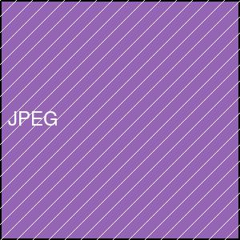
This final paragraph verifies that text layout resumes correctly after multiple images of varying sizes.

