2D Picture Effects (case57)
1. Soft Edge (small, 6pt radius)


2. Soft Edge (large, 25pt radius)
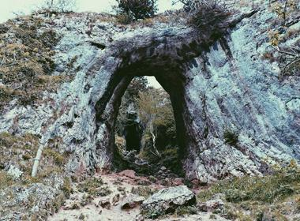

3. Reflection (standard)


4. Reflection (tight, offset)
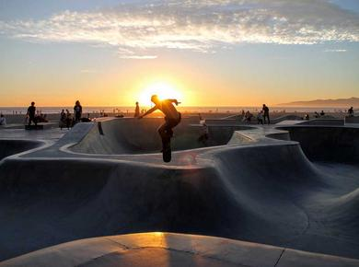

5. Glow (blue, 10pt)


6. Glow (gold, 18pt)


7. Inner Shadow (45deg)


8. Combined: outer shadow + soft edge


9. Combined: white frame + reflection


10 Oval.

10. No effects (baseline)


