3D / Deferred Picture Effects (case58)
1. Bevel (circle, top only)


2. Bevel (relaxedInset)
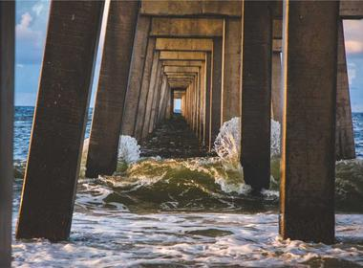

3. Bevel (artDeco)
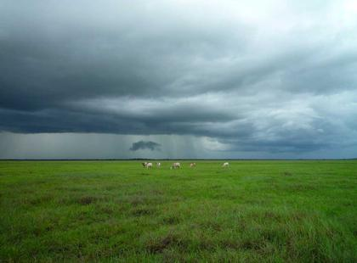

4. Metal Frame (metal material + bevel + contour)
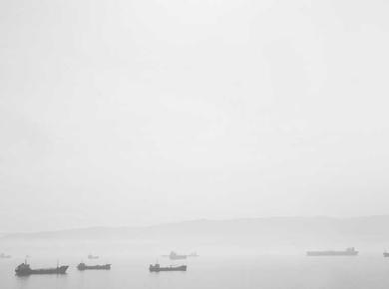

5. 3D Rotation (perspective front)


6. Soft Edge Material (softEdge + convex bevel)
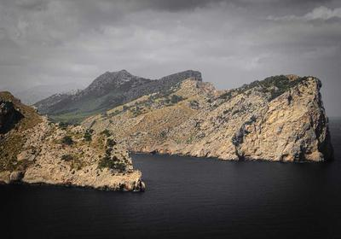

7. Preset Shadow (shdw14)


8. No effects (baseline)
