Picture cropping (a:srcRect)
1. Uncropped control, 400×300 px at 3 in wide
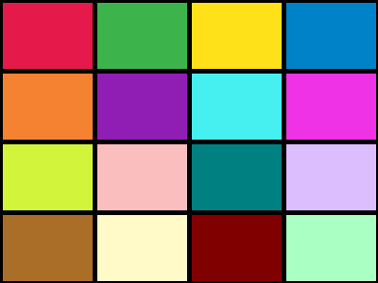
2. Top 4.505% and bottom 26.576% cropped (t=4505 b=26576)

3. All sides 25% cropped: centre 2×2 cells only

4. Negative left crop l=-20000: blank strip on the left


