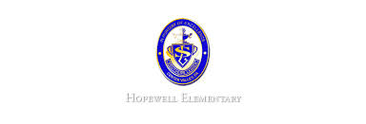


- Math: This week in math we will begin studying topic 2. We will learn about the meanings of addition and subtraction. We will also begin reviewing how to round to the nearest tens and hundreds.

- Reading: The students will continue unit 2, week 1 of Journey’s. We will be reading the story The Trial of Cardigan Jones and focusing on inferencing and predicting.

- Spelling Pattern: VC_e. Test this Thursday, September 29!

- Science: We will begin our unit of study of forces and motion. We will begin to study what motion is.

- Writing: The students will be learning how to use evidence in their writing to support. They will also learn how to use quotations in our writing.

Ask Your Child…
- Name two ways to make $2.36.
- What is the first step of the scientific method?
- Give an example of a command sentence.

- October 4: Picture Day
- October 7-10: Students Do Not Report
- October 13 5:30-7:00 PM: Open House

Upcoming Events
September 26, 2016
Team 19

Mrs. Pompella’s Classroom News

