Shadow Variations Test (case56)
Standard shadow (23pt blur, 45deg, #333 @65%)


Subtle shadow (6pt blur, 90deg down, #000 @40%)
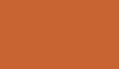

Large soft shadow (40pt blur, 45deg, #666 @50%)


Sharp shadow (no blur, 45deg, #000 @80%)


Blue colored shadow (12pt blur, 45deg, #00F @50%)
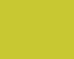

Close high-alpha shadow (12pt blur, 90deg, #000 @90%)


No shadow (baseline)


