**BUG Report**

**bug Id**: 001

**bug severity**: High

**Bug Description**: In home page we have one icon after clicking on Icon it is navigate into given page and return this xml code.

**Step to reproduce**:

1. Navigate to <https://demowebshop.tricentis.com/newproducts> URL
2. Click on wifi icon.
3. Expected : it will informed whenever new product will add into product list.
4. Actual : it is navigate to given Page.

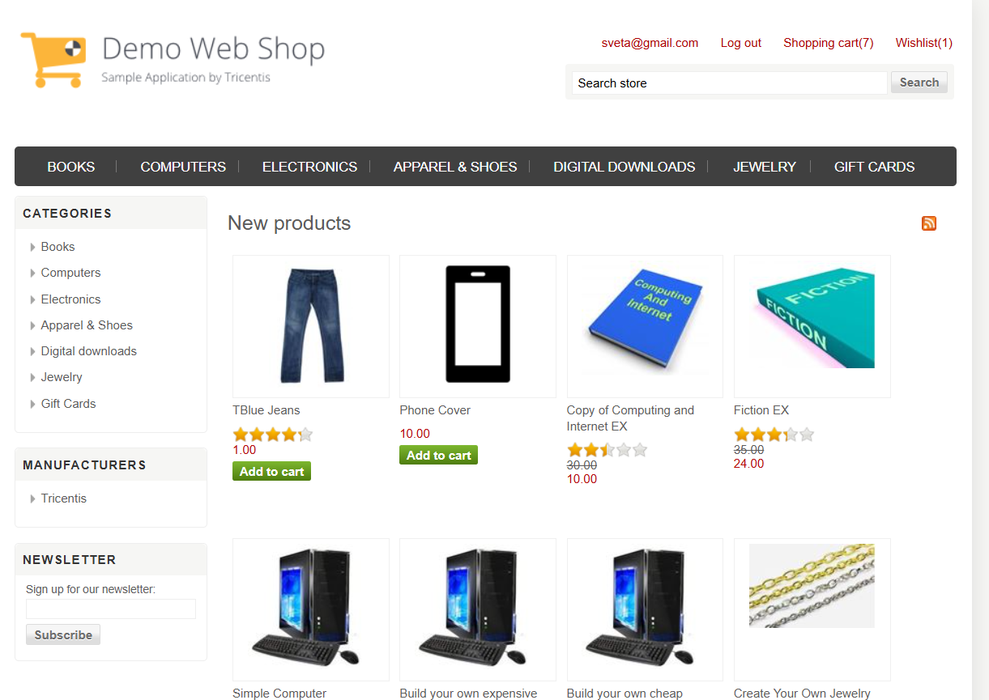

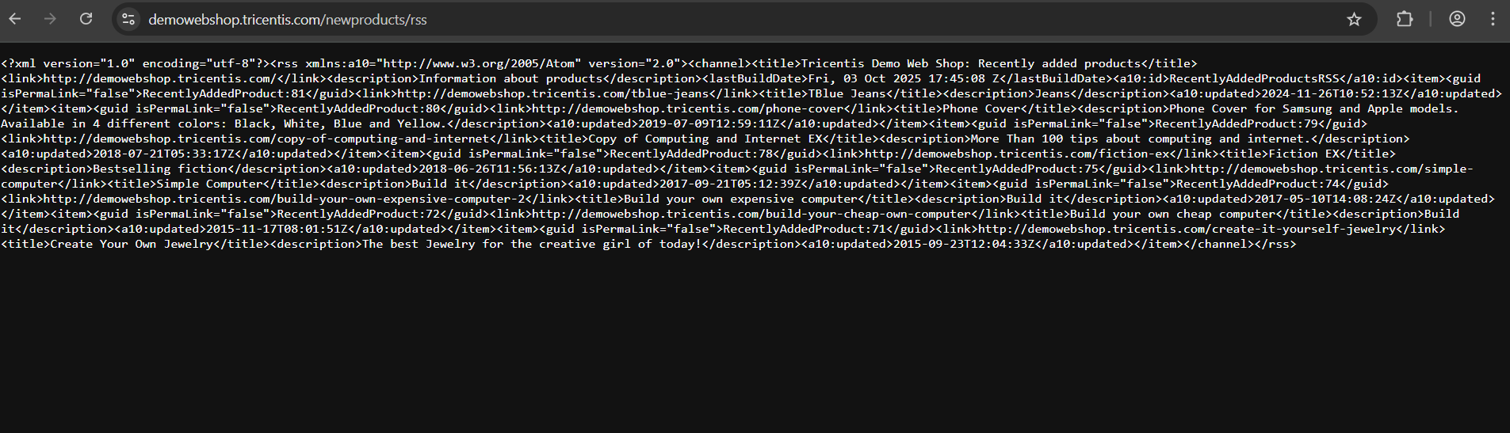

**bug Id**: 002

**bug severity**: High

**Bug Description**: In home page we have RSS Url it is not working

**Step to reproduce**:

1. Navigate to <https://demowebshop.tricentis.com/newproducts> URL
2. Click on wifi icon.
3. Scroll till end of the page.
4. Expected : it will redirect to the application page

Actual : it is navigate to given Page

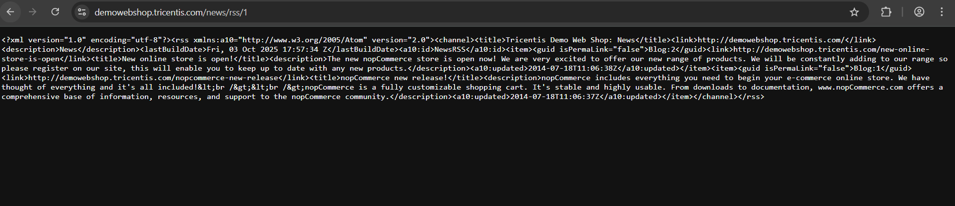

**bug Id**: 003

**bug severity**: Critical

**Bug Description**: Product price on Product page and Shipping Page both are must be same.

**Step to reproduce**:

1. Navigate to <https://demowebshop.tricentis.com/> URL
2. Click on product and add to cart.
3. Check both price. It would be same

Expected : both price should be same.

Actual : Product Page And Shipping Page both showing different price for same product.

Evidence:

Product Page:

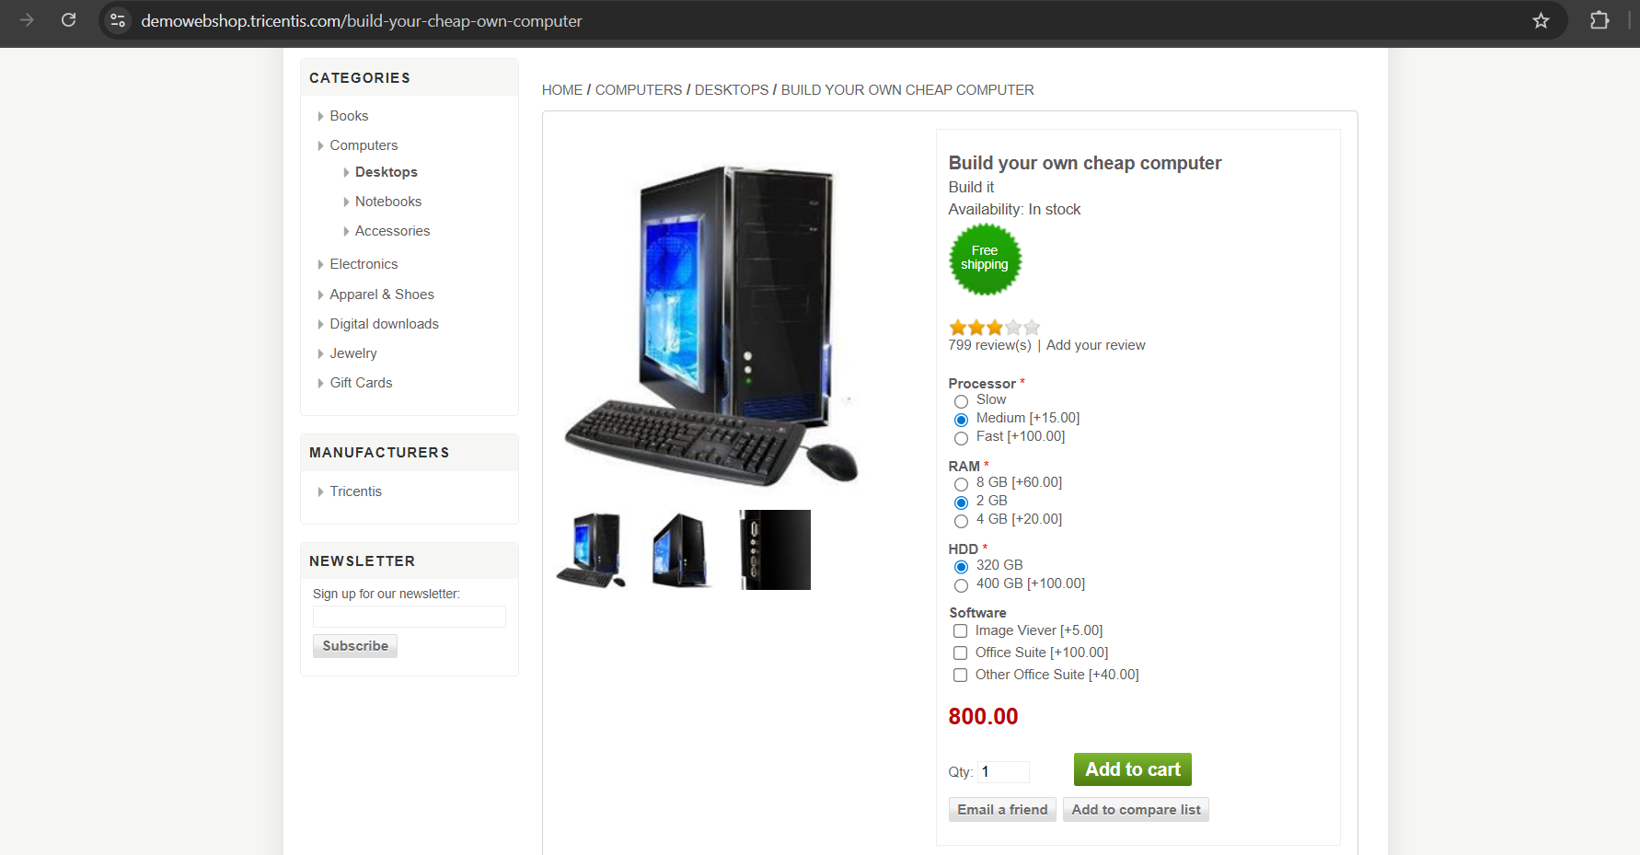

Shipping Page :

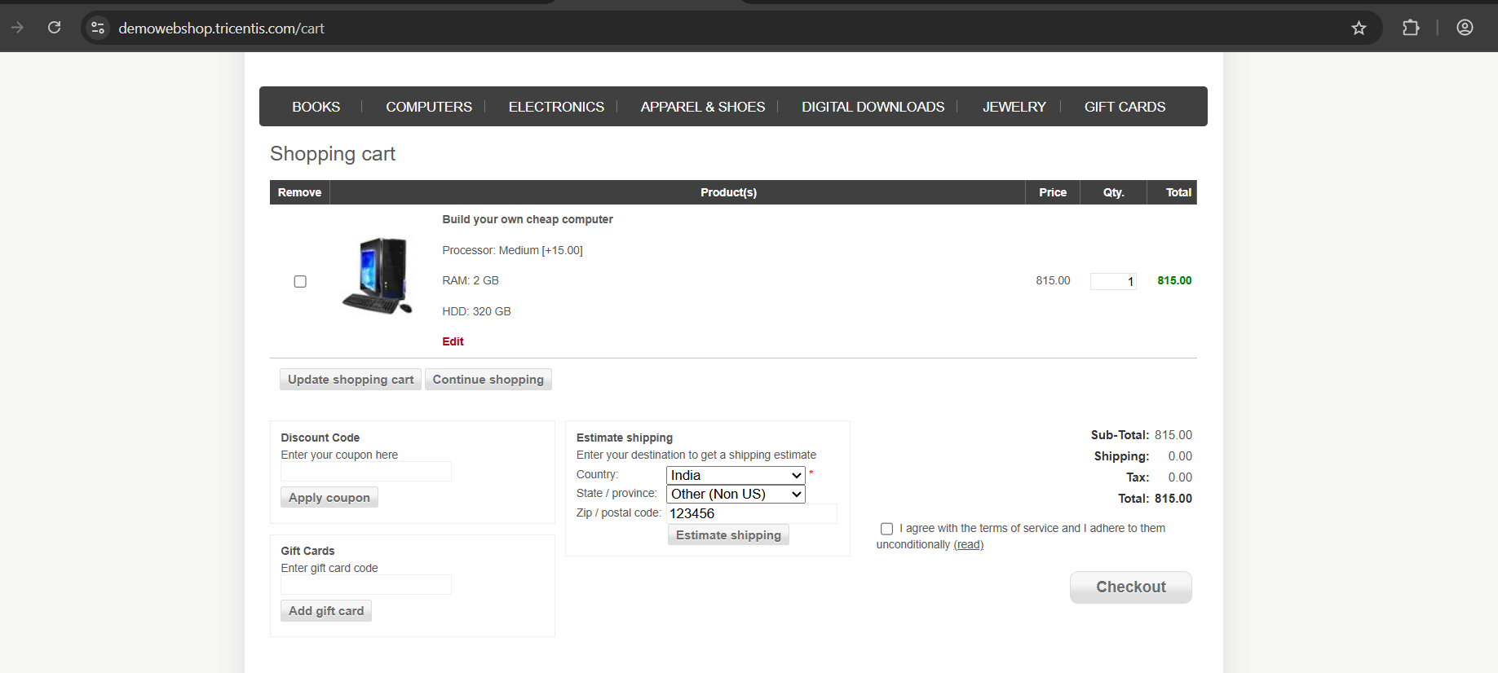

**bug Id**: 004

**bug severity**: Critical

**Bug Description**: Add to Cart button not available in some products

**Step to reproduce**:

1. Navigate to <https://demowebshop.tricentis.com/> URL
2. Click on product Check the UI Elements.

Expected : Each product contains Add to cart button or informative message like out of stock.

Actual : The product details not contains any message or Add to cart button.

Evidence:

