PHAGENT_AMR Workflow Documentation
This document provides visual documentation of the assembly-based AMR profiling pipeline.
Pipeline Overview
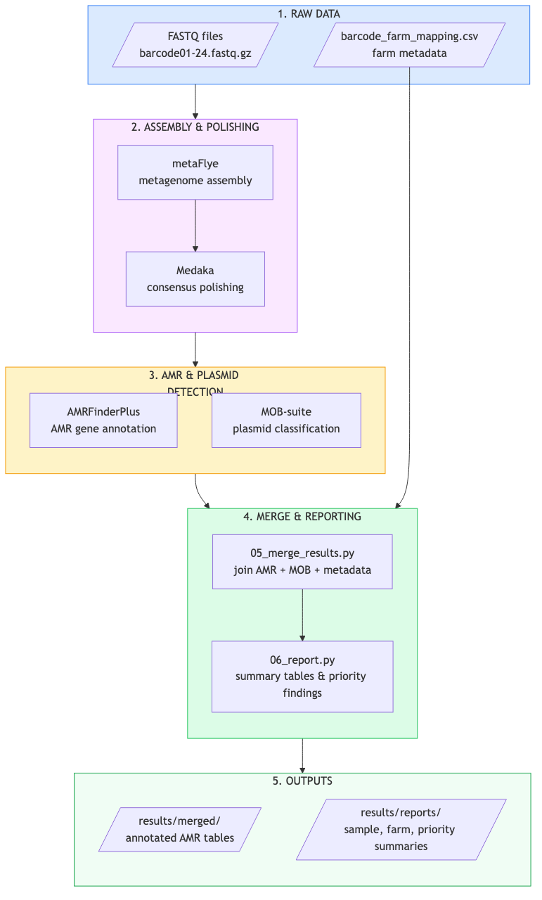

Data Flow Sequence
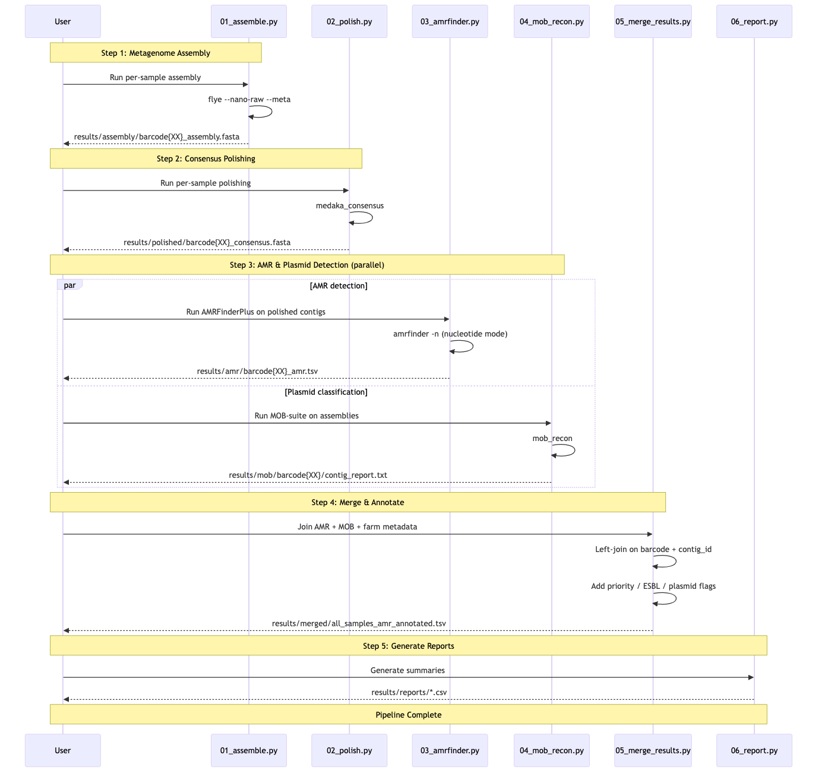

Data Transformation Diagram
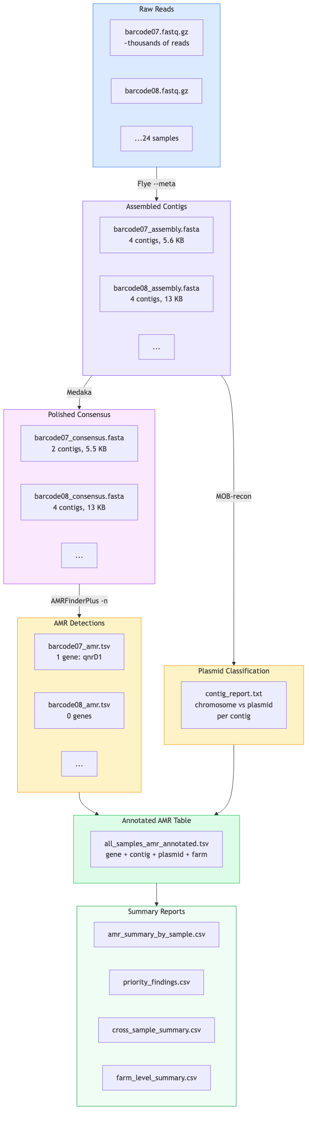

Evidence Model
Each AMR finding is traceable through the full chain:
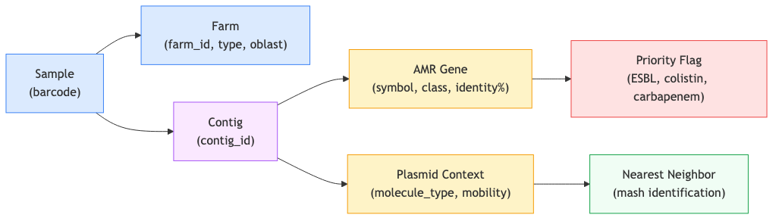
Evidence Model

Tool Chain Summary
Step | Tool | Input | Output | Key Parameters
Assembly | metaFlye | Raw FASTQ | Contigs FASTA | --nano-raw --meta
Polishing | Medaka | FASTQ + Assembly | Consensus FASTA | -m r1041_e82_400bps_sup_v5.2.0
AMR Detection | AMRFinderPlus | Polished contigs | AMR gene TSV | -n (nucleotide mode)
Plasmid Typing | MOB-suite | Assembly contigs | Contig report | mob_recon
Merge | Python/pandas | AMR + MOB + metadata | Annotated table | Left joins on barcode + contig
Report | Python/pandas | Annotated table | Summary CSVs | Priority filtering, aggregation

Comparison with Main Pipeline
Aspect | Main Pipeline | PHAGENT_AMR
AMR source | ResFinder (read-level) | AMRFinderPlus (contig-level)
Evidence type | Individual reads | Assembled contigs
Plasmid context | None | MOB-suite classification
Confidence | Coverage % + Identity % | Assembly + gene coordinates
Scope | All 24 barcodes | Currently 4 (scalable to 24)
Best for | Broad screening | High-confidence, evidence-backed findings

