Spring Data Exam

Deutsche Autohäuser
Car dealers in Germany are a key part of the country’s strong automotive industry. They range from official brand dealerships offering new cars and services to independent sellers focused on used vehicles. German dealers are known for professionalism, strict regulation, and a wide selection of both domestic and imported cars.

Functionality Overview
The application should be able to easily import hard-formatted data and support functionalities for also exporting the imported data. The application is called – Deutsche Autohaeser.
Look at the pictures below to see what must happen:
- The home page before importing anything:

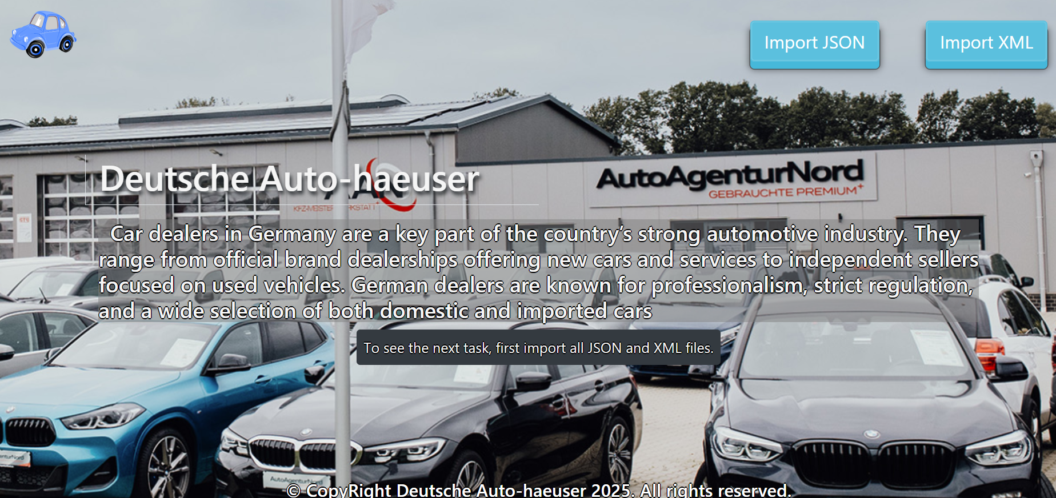

- The import JSON page before importing anything:
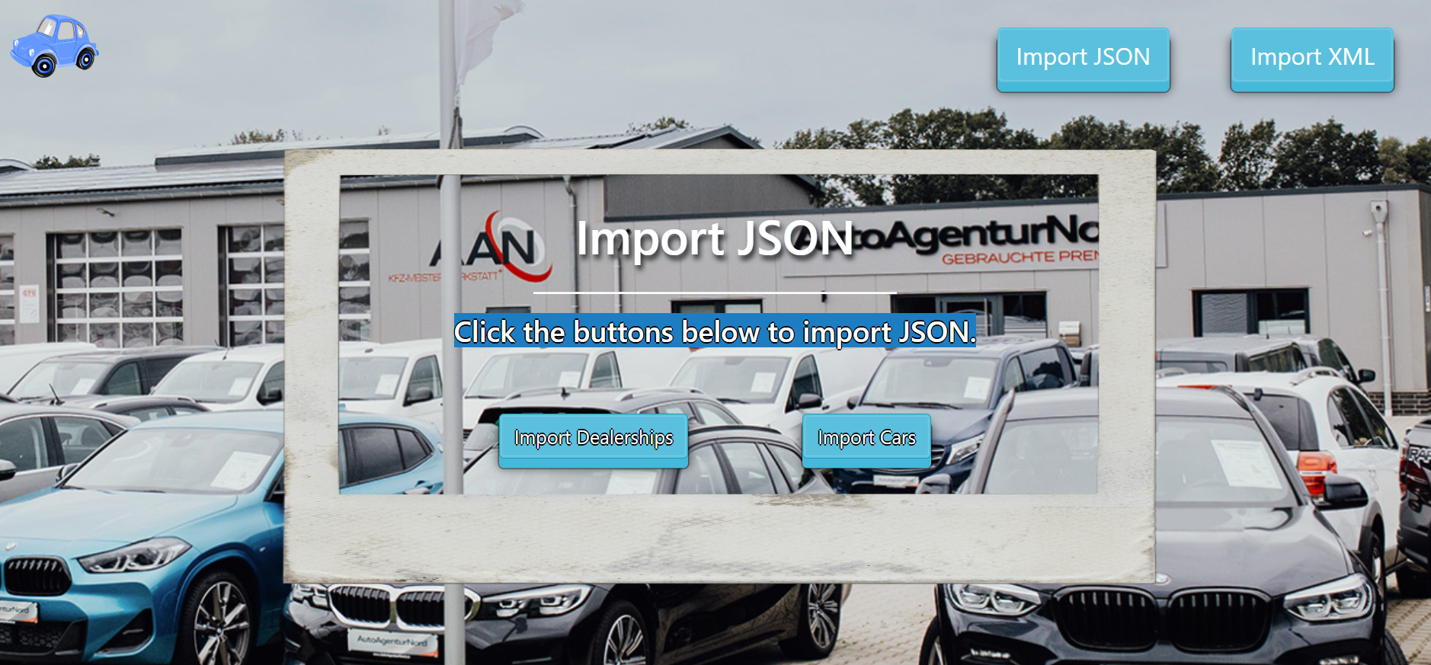

- Import the dealerships first:

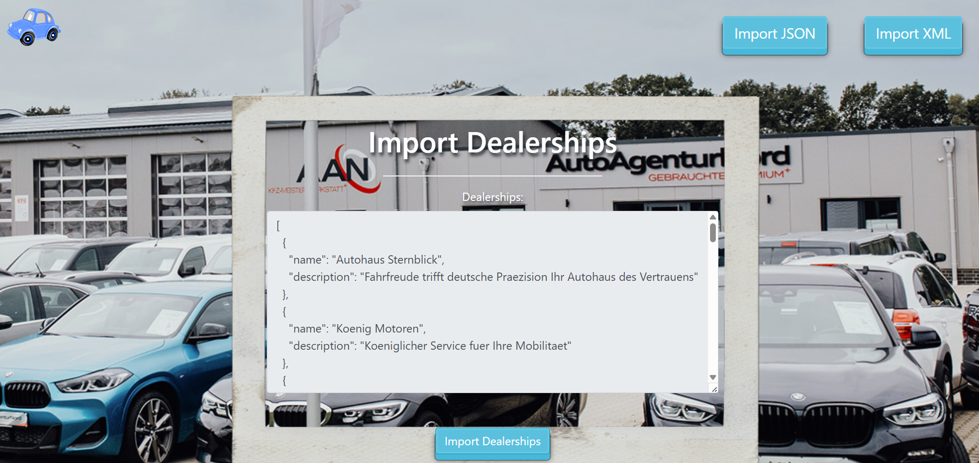

- Import the cars second:

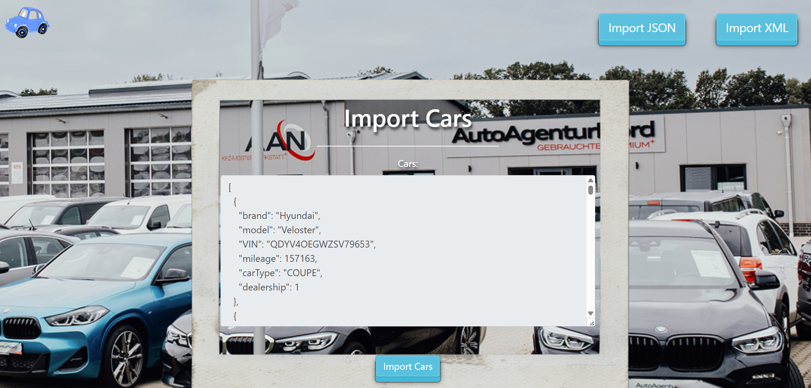

- The import JSON page after importing both files:

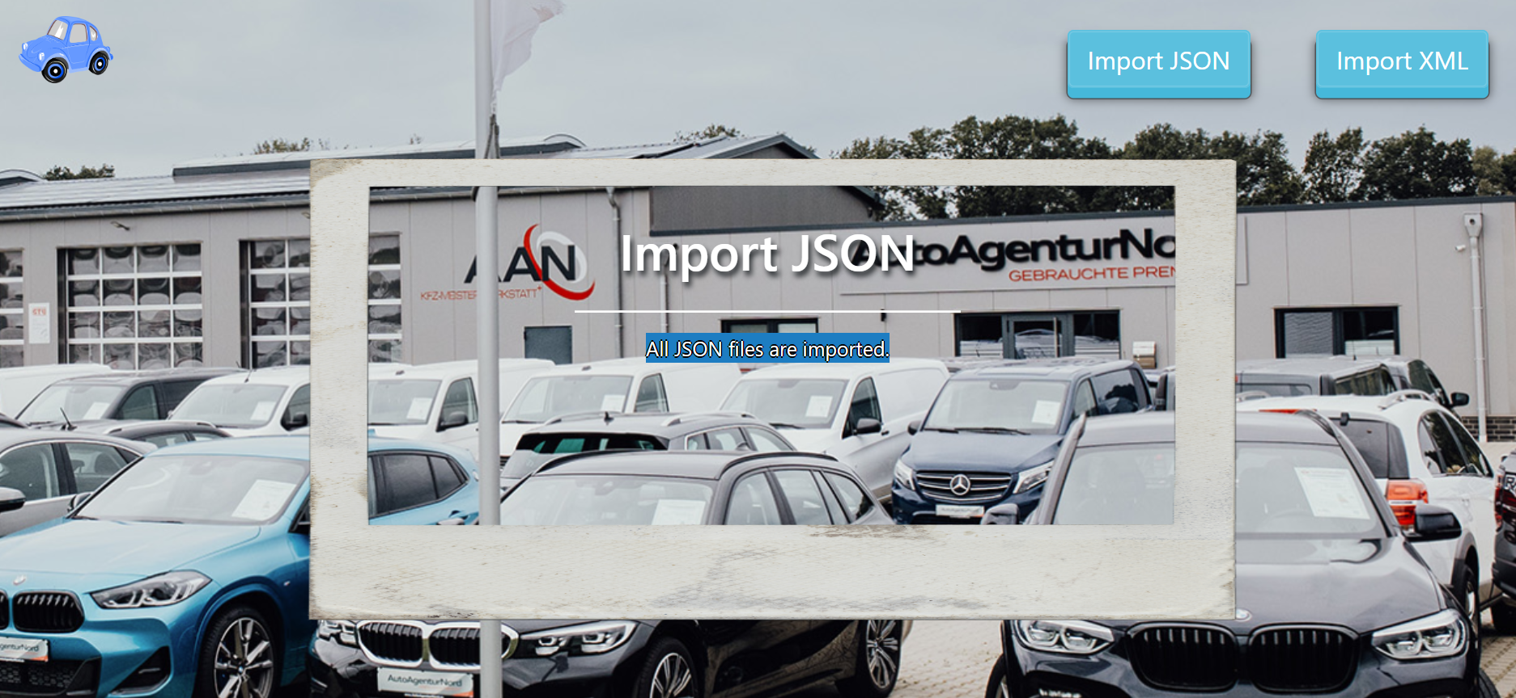

- The import XML page before importing the given data:

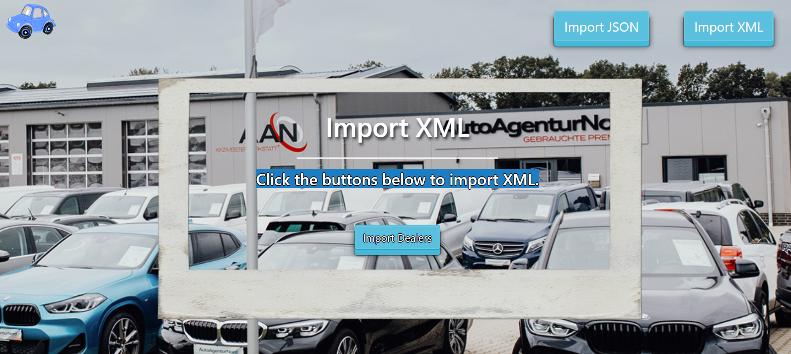

- Import the dealers data:

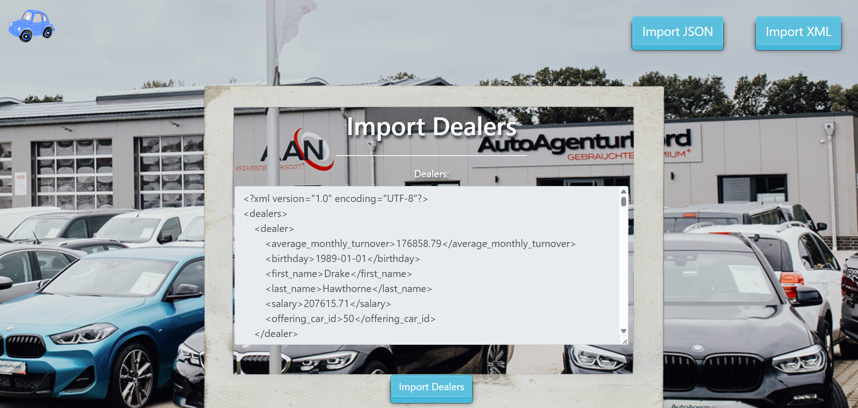

- After the XML import you will be redirected to home page and you will be able to export the cars using the “Export cars” button:

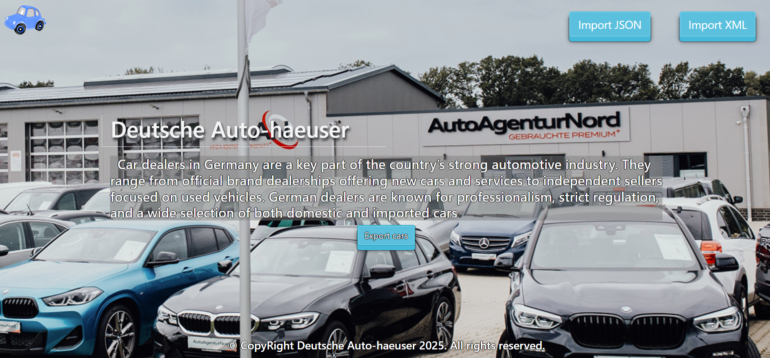

- Export all cars by type "COMBI" and mileage under 100000 km.:

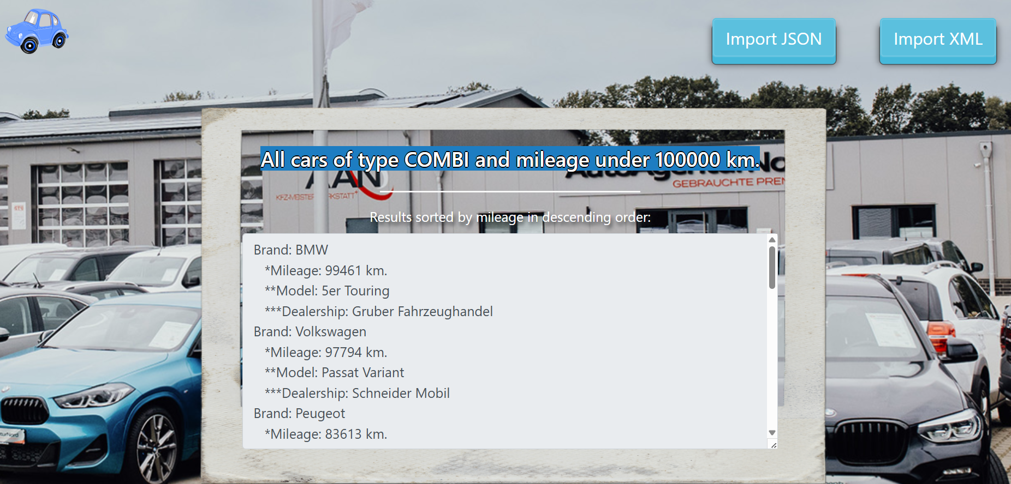

Project Skeleton Overview
You will be given a skeleton, containing a certain architecture (MVC) with several classes, some of which are completely empty. The Skeleton will include the files with which you will seed the database.
Don't change the skeleton.
When submitting your project in Judge please make a .zip file only with src folder and pom.xml file.
There are five problems in Judge:
1. Database will test the structure of your database.
2. Service will test the two methods areImported() and readClassFromFile() in every service class.
3. Import JSON will test the logic of importing JSON files.
4. Import XML will test the logic of importing XML files.
5. Export will test the logic of the final export button which is in the ExportController.

Please note that the automated system Judge may take up to 5 minutes to show results for each problem. We kindly ask you to be patient.
Be aware that Jude might not recognize the var keyword, leading to compilation errors.

To help you ensure the correctness of your solutions and gain immediate feedback, we have included a set of commented-out tests within the provided skeleton project. These tests are designed to verify the functionality of the tasks you are required to implement.

Model Definition
There are 3 main models that the Deutsche Autohaeser database application should contain in its functionality.
We have provided you with an Entity-Relationship (ER) diagram that represents the database schema. The ER diagram displays the tables and their relationships, along with the field types for each table.
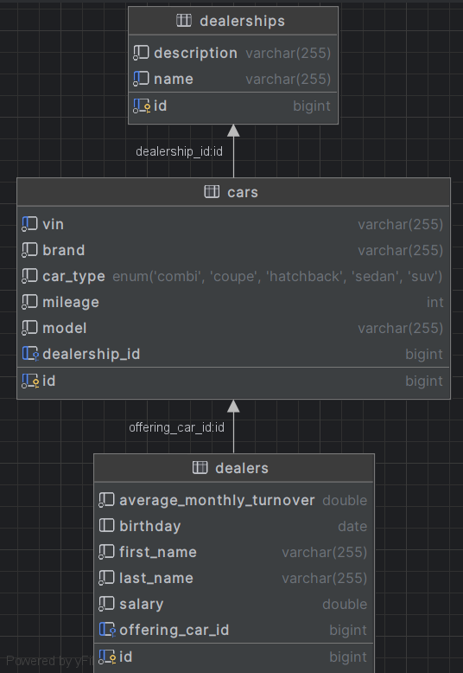

Ensure that the Java code validates data against the specified constraints before persisting it into the database. Handle any validation errors gracefully and provide meaningful feedback to the users.
Design them in the most appropriate way, considering the following data constraints:

Constraint
- Name the entities and their class members exactly in the format stated above.
- All fields are NOT NULL unless explicitly stated to be nullable.

Dealership
- id – accepts integer values; it is the primary identifier and is auto-incremented.
- name – accepts char sequence (between 3 to 30 inclusive). The values are unique in the database.
- description - accepts char sequence about the naming of the dealership with a character length value higher than or equal to 5.
- cars – a collection of all cars that are part the dealership
Constraint: The dealerships table has a relation with the cars table.

Car
- id – accepts integer values; it is the primary identifier and is auto-incremented.
- brand - accepts char sequence (between 2 to 30 inclusive).
- model - accepts char sequence (between 2 to 30 inclusive).
- VIN – char sequence consisting of exactly 17 symbols (letters and numbers). The values are unique in the database
- mileage - The mileage in km. Accepts only positive number.
- car type - categorization of the cars. String enumeration, one of the following – SUV, COMBI, COUPE, HATCHBACK, SEDAN
- dealership – reference to the dealership that offers this car for sale.
Constraint: The cars table has a relation with the dealerships table.

Dealer
- id – accepts integer values; it is the primary identifier and is auto-incremented.
- first name - accepts char sequence (between 2 to 30 inclusive).
- last name - accepts char sequence (between 2 to 30 inclusive).
- salary - accepts positive number values.
- average monthly turnover - accepts positive number values.
- birthday - a date in the "yyyy-MM-dd" format. Can be nullable.
- offering car - the current car that the dealer is offering.
Constraint: The dealers table has a relation with cars table.

Relationships
Your partners gave you a little hint about the more complex relationships in the database, so that you can implement it correctly.
One Dealer may offer only one Car, but one Car may be offered by many Dealers.
One Dealership can have many Cars, but one Car belongs to only one Dealership.

Data Import
Use the provided files to populate the database with data. Import all the information from those files into the database.
You are not allowed to modify the provided files.
ANY INCORRECT data should be ignored and a message should be printed:
"Invalid {dealership / car / dealer}"
When the import is finished:
"Successfully imported {dealership / car / dealer} {name / brand – mileage km. / full name}"
Judge will only accept file paths in a specific format. When dealing with file paths for files, please adhere to the following format: "src/main/resources/files/xml/file-name.xml"

JSON Import
Your new colleagues have prepared some JSON data for you to import.

Dealerships (dealerships.json)

Constraint
If a dealership with the same name already exists in the DB return "Invalid dealership".
If the import is successful, return "Successfully imported dealership {name}".

Dealership (dealerships.json)
[
{
"name": "Autohaus Sternblick",
"description": "Fahrfreude trifft deutsche Praezision Ihr Autohaus des Vertrauens"
},
{
"name": "Koenig Motoren",
"description": "Koeniglicher Service fuer Ihre Mobilitaet"
},
{
"name": "Koenig Motoren",
"description": "Koeniglicher Service fuer Ihre Mobilitaet"
},
{
"name": "Autotechnik Bergmann",
"description": "Tradition trifft Innovation Ihr Partner fuer Qualitaet"
},
{
"name": "Meisterwagen Lichtenfeld",
"description": "Exklusive Fahrzeuge Persoenliche Beratung Faire Preise"
},
{
"name": "Fahrzeugwelt Neumann",
"description": "Entdecken Sie unsere Welt der Automobile"
},
{
"name": "Autozentrum Falkenstein",
"description": "Stark wie ein Falke Ihr Auto in besten Haenden"
},
...
Successfully imported dealership Autohaus Sternblick
Successfully imported dealership Koenig Motoren
Invalid dealership
Successfully imported dealership Autotechnik Bergmann
Successfully imported dealership Meisterwagen Lichtenfeld
Successfully imported dealership Fahrzeugwelt Neumann
Successfully imported dealership Autozentrum Falkenstein…

Cars (cars.json)

Constraint
- If a car with the same VIN number already exists in the DB return "Invalid car".
- If the import is successful, return "Successfully imported car {brand} – {mileage} km."
The provided dealership ids will always be valid.
Car (cars.json)
[
{
"brand": "Hyundai",
"model": "Veloster",
"VIN": "QDYV4OEGWZSV79653",
"mileage": 157163,
"carType": "COUPE",
"dealership": 1
},
{
"brand": "Hyundai",
"model": "Veloster",
"VIN": "QDYV4OEGWZSV79653",
"mileage": 157163,
"carType": "COUPE",
"dealership": 1
},
{
"brand": "Skoda",
"model": "Scala",
"VIN": "I0QHZ8TNJBQA24ITV",
"mileage": 212014,
"carType": "HATCHBACK",
"dealership": 18
},
{
"brand": "Volkswagen",
"model": "Arteon",
"VIN": "8R7W1WGAAZHH737H4",
"mileage": 38437,
"carType": "SEDAN",
"dealership": 16
},
{
"brand": "Skoda",
"model": "Kodiaq",
"VIN": "QDBQEYETK896Z9PZ6",
"mileage": 193030,
"carType": "SUV",
"dealership": 3
},

...
Successfully imported car Hyundai - 157163 km.
Invalid car
Successfully imported car Skoda - 212014 km.
Successfully imported car Volkswagen - 38437 km.
Successfully imported car Skoda - 193030 km.
…

XML Import
Your new colleagues have prepared some XML data for you to import.

Dealers (dealers.xml)

Constraint
- If a dealer with the same full name (first name and last name) already exists in the DB return "Invalid dealer".
- If a dealer is offering car that doesn't exist in the DB return "Invalid dealer ".
- If the import is successful, return "Successfully imported dealer {first name} {last name}".

Dealers (dealers.xml)
<?xml version="1.0" encoding="UTF-8"?>
<dealers>
<dealer>
<average_monthly_turnover>176858.79</average_monthly_turnover>
<birthday>1989-01-01</birthday>
<first_name>Drake</first_name>
<last_name>Hawthorne</last_name>
<salary>207615.71</salary>
<offering_car_id>50</offering_car_id>
</dealer>
<dealer>
<average_monthly_turnover>300.79</average_monthly_turnover>
<birthday>1989-01-01</birthday>
<first_name>Drake</first_name>
<last_name>Hawthorne</last_name>
<salary>207615.71</salary>
<offering_car_id>50</offering_car_id>
</dealer>
<dealer>
<average_monthly_turnover>176858.79</average_monthly_turnover>
<birthday>1989-01-01</birthday>
<first_name>Drake</first_name>
<last_name>Hawthorne</last_name>
<salary>207615.71</salary>
<offering_car_id>50</offering_car_id>
</dealer>
<dealer>
<average_monthly_turnover>55537.43</average_monthly_turnover>
<birthday>1966-11-03</birthday>
<first_name>Elena</first_name>
<last_name>Sullivan</last_name>
<salary>98319.24</salary>
<offering_car_id>91</offering_car_id>
</dealer>
<dealer>
<average_monthly_turnover>105443.87</average_monthly_turnover>
<birthday>1954-09-02</birthday>
<first_name>Cassandra</first_name>
<last_name>Bellamy</last_name>
<salary>1499.52</salary>
<offering_car_id>28</offering_car_id>
</dealer>
. . .
Successfully imported dealer Drake Hawthorne
Invalid dealer
Invalid dealer
Successfully imported dealer Elena Sullivan
…
Please be aware that due to variations in local settings on different computers, the representation of decimal numbers (Double) may differ. In some regions, the decimal separator is a comma (,), while in others, it is a dot (.).
Judge local settings represent all decimal numbers using a dot (.) as the decimal separator. Locale.US

Data Export
Get ready to export the data you have imported in the previous task. Here you will have some complex database querying. Export the data in the formats specified below.

Export cars by car type and mileage from the Database
- Extract from the database, the car brand, mileage, (to second digit after decimal point), model and dealership name.
- Filter only cars of type COMBI and mileage under 100000km. Order the results by mileage in descending order.
- Return the information in this format:
"Brand: {brand}
*Mileage: {mileage} km.
**Model: {model}
***Dealership: {dealershipName}
. . ."


