# Exercise: CSS Box Model

Problems for exercises and homework for the ["HTML and CSS" course @ SoftUni](https://softuni.bg/courses/html-and-css). Submit your solutions in the SoftUni Judge system at <https://judge.softuni.org/Contests/3333/CSS-Box-Model>.

## Box Model Container

Create a web page like the following:

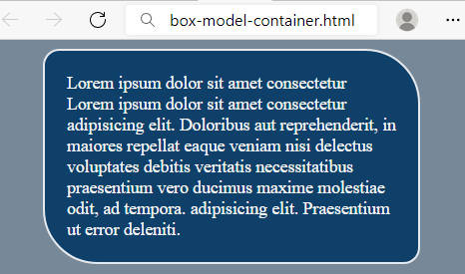

### Requirements

You will be given a skeleton with **filled** **HTML** and an **empty** **CSS** file. Write the missing **CSS** following the guidelines in the task.

* <body>:
  + Background color: **lightslategray**
* <p>:
  + Width: 300px
  + Paddings: 20px
  + **Auto** margins
  + Background color: **#0F4069**
  + Text color: **whitesmoke**
  + Solid border with size 2px and color #e6eaef
  + Top left and bottom right border radius: **15px**
  + Top right and bottom left border radius: **50px**

## Scrolling Article

Create a web page like the following:



### Requirements

HTML with <body> that contains: <section> with <article> which has <h2>, <h3> and <p>.

CSS:

* <article>:
  + Width: **500px**
  + Height: **200px**
  + Background color: **lightgray**
  + Paddings: **10px**
  + **Auto** overflow
* <h2>:
  + All characters to be **UPPERCASE**
  + Align the **text** to the **center**
* <h3>:
  + Align the **text** to the **center**
* <p>:
  + Indent text in the first line 30px

## Brazil Coffee

Create a web page like the following:

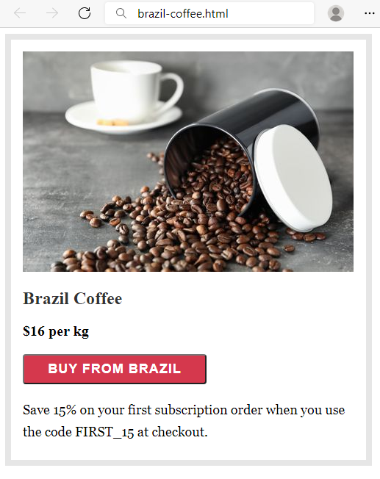

### Requirements

HTML with <body> that contains: <section> which has <img>, <h2>, <div>, <button> and <p>.

CSS:

* <section>:
  + Solid border with size 8px and color #e6e6e6
  + Paddings: **16px**
  + Width: **451px**
  + Height: **540px**
* <h2>:
  + Font: **Merriweather**
  + Generic Font: **serif**
  + Font weight **700**
  + **Top** & bottom margin 1.2rem
  + **Left** & **right** margin 0
  + Color: rgb(51, 51, 51)
* <div>:
  + Font weight **600**
  + Font size: **20px**
* <button>:
  + Width: **250px**
  + Font : **Work Sans**
  + Generic Font: **sans-serif**
  + Font weight **600**
  + Font size: **18px**
  + Border radius: **4px**
  + Background color: #**d5384d**
  + Text color: **#fff**
  + Letter spacing: **1px**
  + Align the **text** to the **center**
  + **Top** & bottom padding 8px
  + **Left** & **right** padding 16px
  + Top margin: **20px**
  + Bottom margin: **20px**
* <p>:
  + Fonts: **Georgia**, **Cambria**, **Times** **New** **Roman**, **Times**
  + Generic Font: **serif**
  + Font size: **18px**
  + Height of the line: 30px
  + Top margin: **0**

## Article

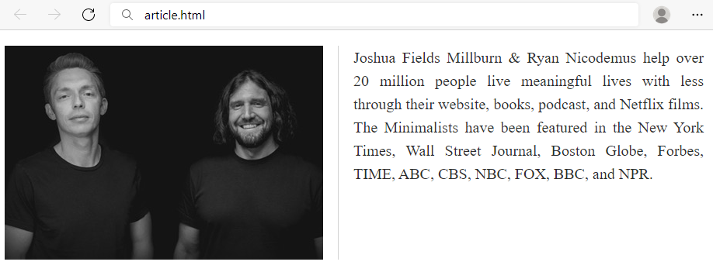

### Requirements

You will be given a skeleton with **filled** **HTML** and an **empty** **CSS** file. Write the missing **CSS** following the guidelines in the task.

* <main>:
  + Width: **900px**
  + Height: **140px**
* <img>:
  + Solid **right** border with size 1px and color **#d1d1d1**
  + Float the images on the **left**
  + Right margin: **19px**
  + Right padding: **19px**
* <p>:
  + Font size: **20px**
  + Height of the line: 30px
  + Text color: #2e2e2e
  + Text align: justify

## Blog Article

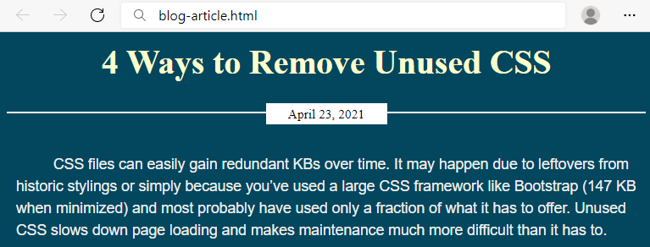

### Requirements

You will be given a skeleton with **filled** **HTML** and an **empty** **CSS** file. Write the missing **CSS** following the guidelines in the task.

* <body>:
  + Background color: **#02475e**
* **<article> :**
  + <h2>:
    - Font size: **36px**
    - Text color: **#fefecc**
    - Margins: **12px**
    - Align the text to the **center**
  + <p>:
    - Text color: **#eee**
    - Font: **Arial**
    - Generic Font: **sans-serif**
    - Height of the line: **24px**
    - Paddings: **10px**
    - Indent text in the first line **30px**
  + <div>:
    - Bottom margin: **30px**
    - Solid **top** border with size 2px and color **#fff**
    - **Relative** position
    - Top coordinates: **20px**
  + <span>:
    - Width: **120px**
    - Font size: **14px**
    - Align the **text** to the **center**
    - **Top** & bottom paddings 3px
    - **Left** & **right** paddings 5px
    - **Top** & bottom margins 0
    - **Left** & **right** margins **auto**
    - Background color: **#fff**
    - Display the span as **block**
    - **Relative** position
    - Top coordinates: -**11px**

## Navigation Inline Block

Create a web page like the following:

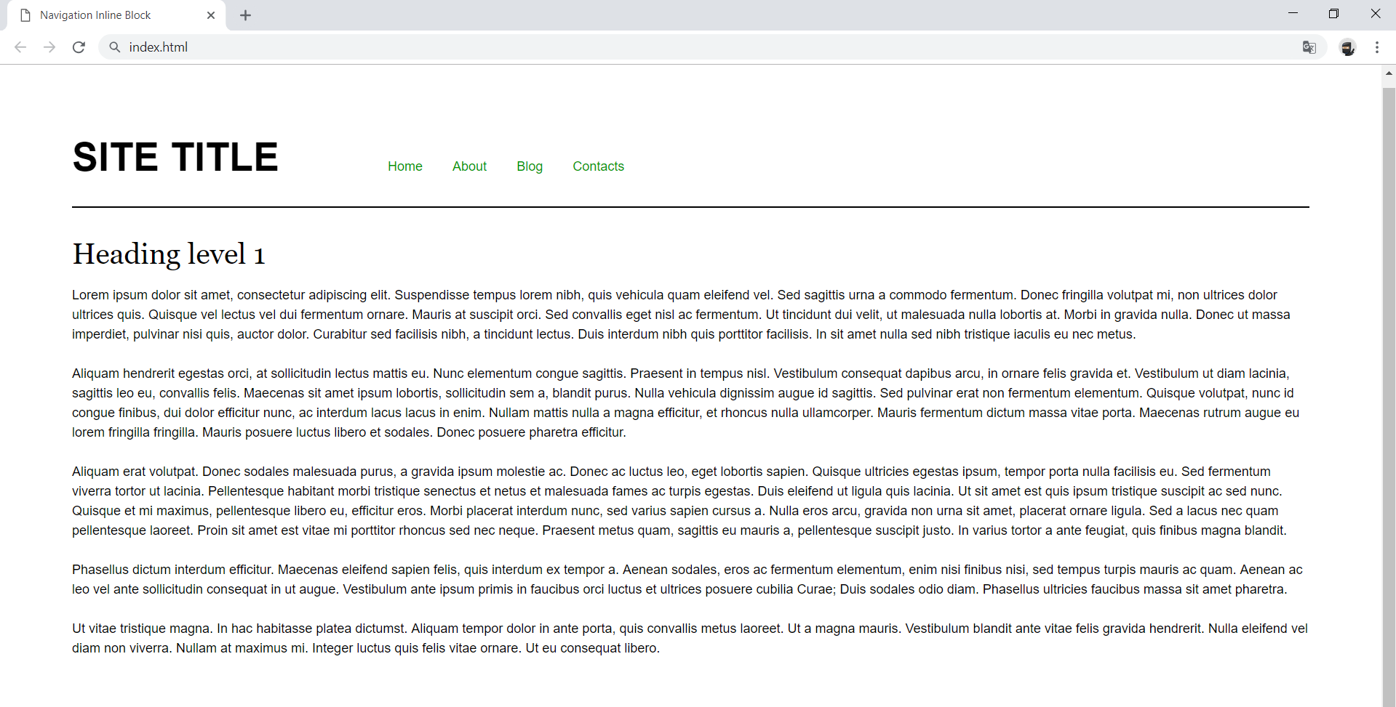

### Requirements

* Change the document title to "**Navigation Inline Block**"
* Divide your content into header and main tags
* Add font to the document: **Helvetica**, **sans-serif**
* Create a navigation bar
  + Add four list items in nav tag with a tags inside
  + Add display: inline-block; style for each item in the nav

## Make Your Own Website

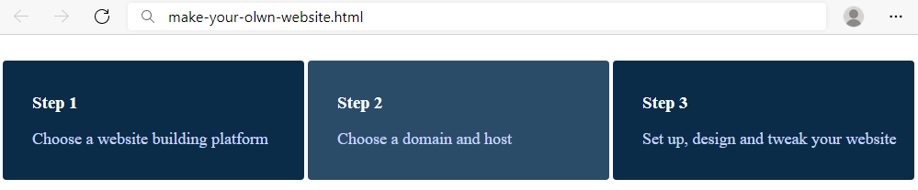

### Requirements

You will be given a skeleton with **filled** **HTML** and an **empty** **CSS** file. Write the missing **CSS** following the guidelines in the task.

* <div>:
  + Width: **280px**
  + Display the divs as **inline-block**
  + Padding top, right and bottom: **16px**
  + Padding left: **32px**
  + Top margin: **20px**
  + Background color: **#0A2C48**
  + Text color: **#fff**
  + Radius of the border: **4px**
* <div>on mouse **hover:**
  + Background color: **#2A4C68**
* <p>:
  + Text color: **#c9d6ff**
  + Font size: 18px

## Photo Gallery Inline Block

Create a web page like the following:

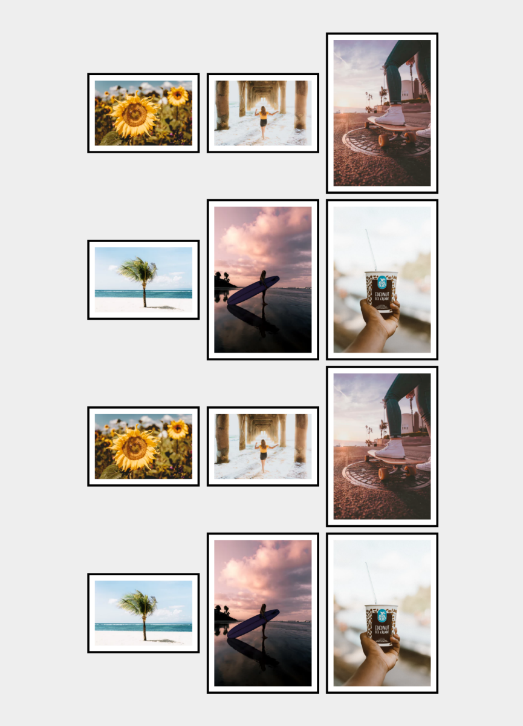

### Requirements

* Change the document title to "**Photo Gallery - Inline Block**"
* Create unordered list with **class** gallery (ul.gallery)
* Add list items with images inside
* **<body>**
  + Padding: **5rem**
  + Background color: **#eee**
* **.gallery**
  + Width: **100%**
  + Margin**: 0 auto**
  + Align the text to the **center**
* **li**
  + Width: **18rem**
  + Display the list as **inline-block**
  + Background color: **#fff**
  + Solid border with size 0.4rem and color **#000**
  + Padding: **1rem**
  + Vertical align: **middle**
  + Margin: **0.5rem**
* **img**
  + display: **block**
  + width: **100%**
  + height: **auto**

## Blog Layout Inline Block

Create a web page like the following:

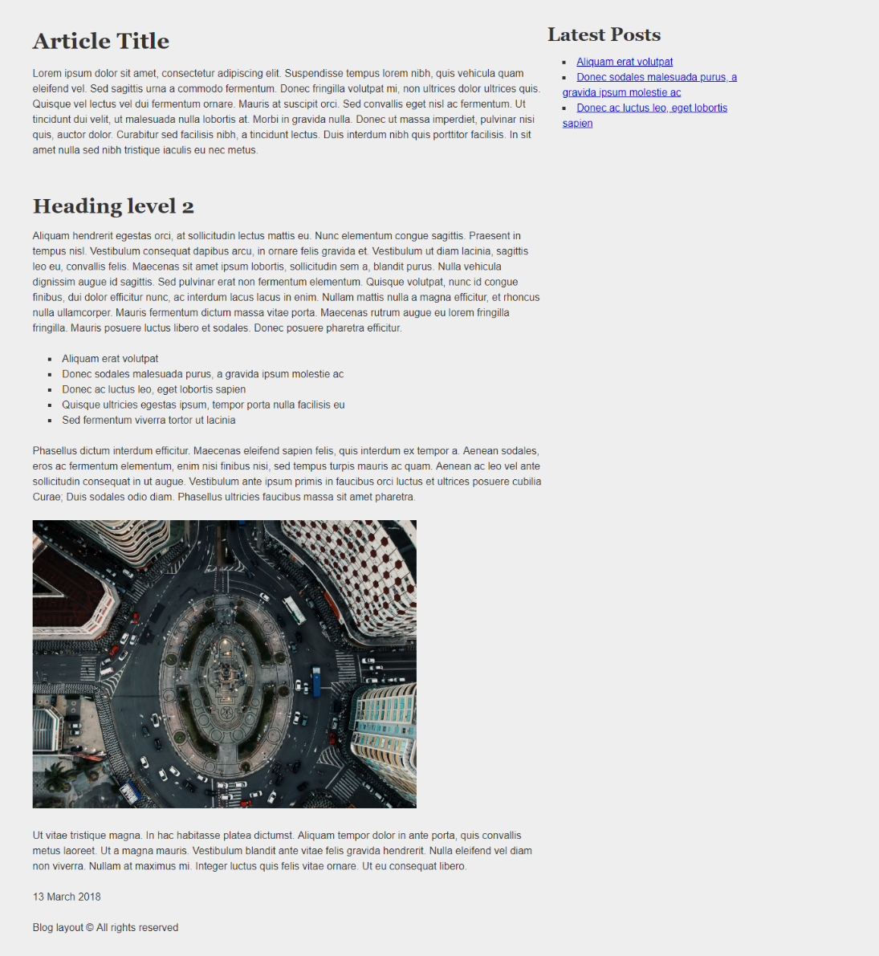

### Requirements

* Change the document title to "**Blog Layout Inline Block**"
* Add font to the document: **Helvetica**, **sans-serif**
* Use article tag to create an article
  + Divide the article content into header, section and footer tags
* Use aside tag to create aside for the **Latest** **Posts**
* Use background with color - rgb(238, 238, 238)
* Use rgb(51, 51, 51) color for the text