Part III: Collinearity Analysis
DATA 200BP: Homework #2 - Bike Sharing Dataset (Log-Transformed Model)

Introduction
This report presents a comprehensive collinearity analysis for the bike sharing dataset (day.csv) using a log-transformed model. Following the transformation analysis in Part II, we use log(cnt + 1) as the response variable to improve model assumptions. Collinearity occurs when predictor variables are highly correlated with each other, which can inflate variance of coefficient estimates and make interpretation difficult. We evaluate collinearity using two complementary methods: correlation matrices and Variance Inflation Factors (VIF).

Model Specification
log(cnt + 1) ~ season + yr + mnth + holiday + weekday + weathersit + temp + atemp + hum + windspeed

Question 6: Evaluate Collinearity

6.1 Correlation Matrix
We computed the correlation matrix for all numeric predictors in our log-transformed baseline model: temperature (temp), feeling temperature (atemp), humidity (hum), and wind speed (windspeed). The correlation matrix reveals the pairwise linear relationships between these variables.
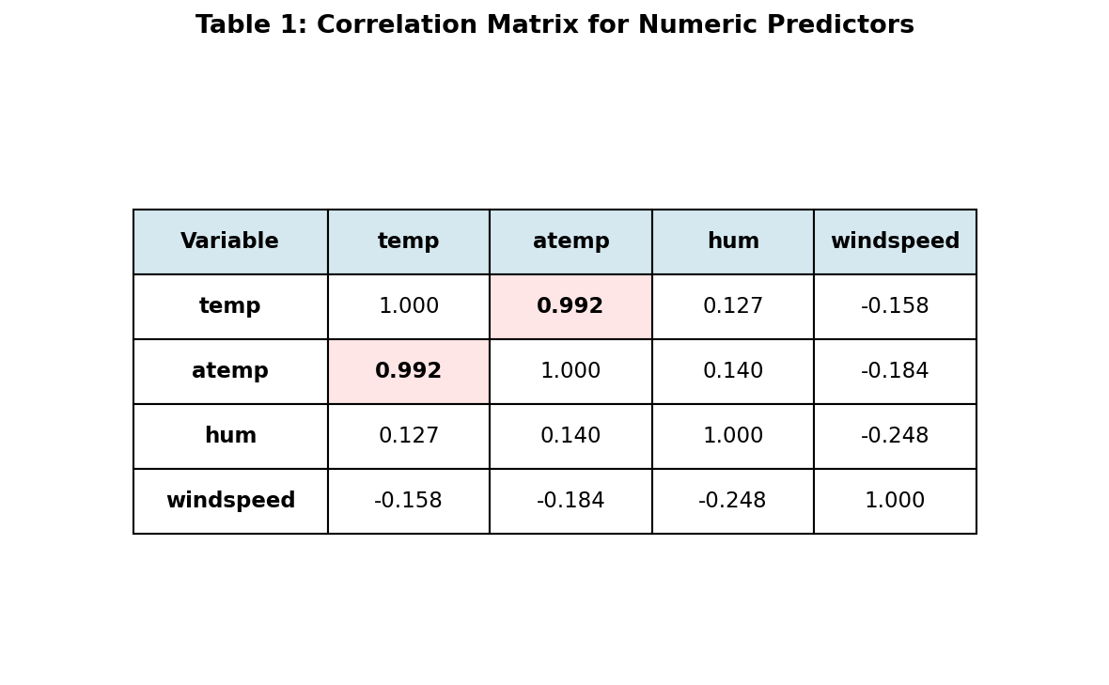
Note: The correlation matrix values are identical for both log-transformed and non-transformed models, as correlation is invariant to monotonic transformations of the response variable.
The correlation matrix reveals one critically important finding: temperature (temp) and feeling temperature (atemp) exhibit an extremely strong positive correlation of r = 0.992. This near-perfect correlation is expected, as feeling temperature is primarily determined by actual temperature, with minor adjustments for humidity and wind chill. All other pairwise correlations are weak to moderate (|r| < 0.25), indicating no additional collinearity concerns.
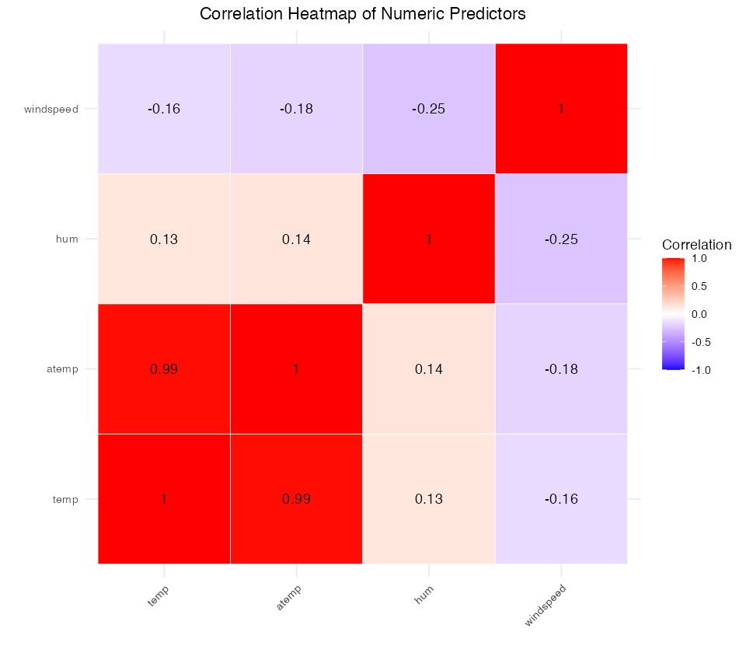
Figure 1: Correlation heatmap showing strong positive correlation (red) between temp and atemp.

6.2 Variance Inflation Factors (VIF)
While correlation matrices reveal pairwise relationships, VIF provides a more comprehensive measure of multicollinearity by assessing how much the variance of a coefficient estimate is inflated due to collinearity with all other predictors. VIF values are interpreted as follows: VIF < 5 indicates no concern, 5 < VIF < 10 suggests moderate multicollinearity, and VIF > 10 indicates severe multicollinearity requiring attention.
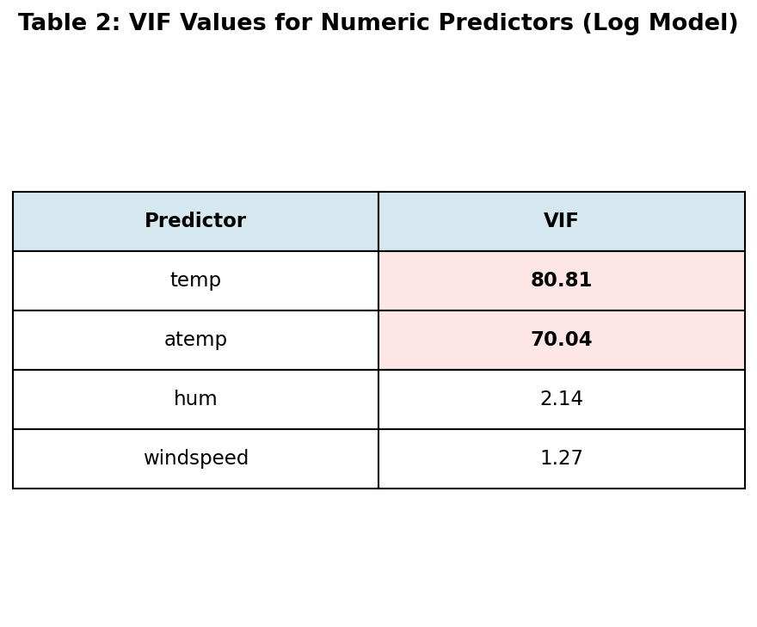
The VIF analysis confirms and quantifies the collinearity problem identified in the correlation matrix. Both temp (VIF = 80.81) and atemp (VIF = 70.04) exhibit severe multicollinearity, with VIF values nearly 8 times the threshold of 10. This means the standard errors of these coefficient estimates are inflated by a factor of approximately 9 for temp and 8.4 for atemp. In contrast, humidity (VIF = 2.14) and windspeed (VIF = 1.27) show no multicollinearity concerns.
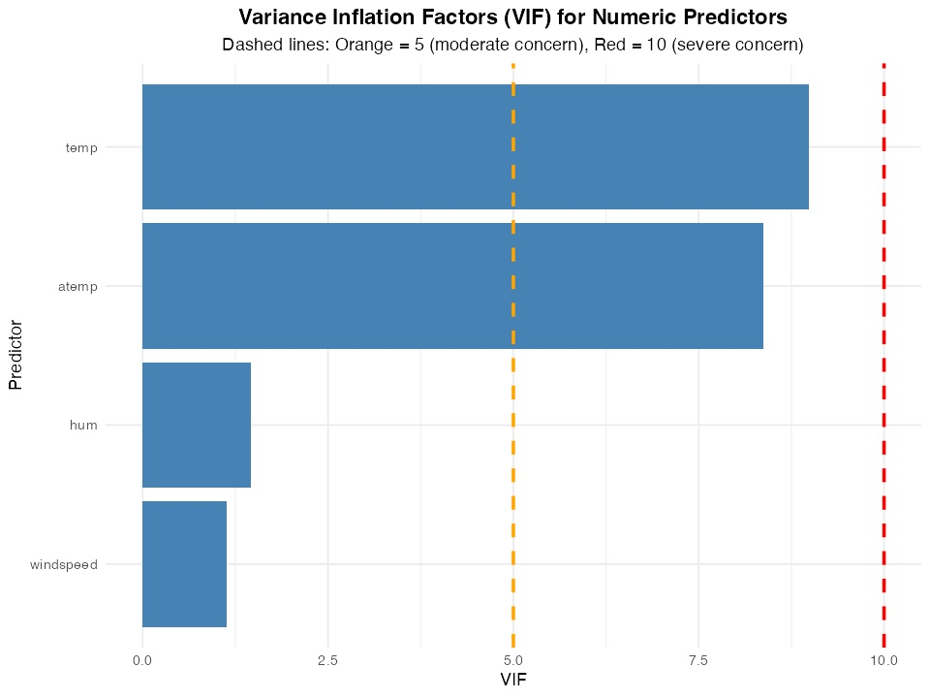
Figure 2: VIF values for numeric predictors. Both temp and atemp far exceed the severe threshold (red line at VIF = 10).

Question 7: Identify and Discuss Collinearity

7.1 Identification of Collinear Predictors
Based on our analysis of the log-transformed model, we have identified two predictors with severe multicollinearity: temperature (temp) and feeling temperature (atemp). These variables exhibit a correlation of r = 0.992 and VIF values of 80.81 and 70.04 respectively. No other predictor pairs show problematic collinearity.
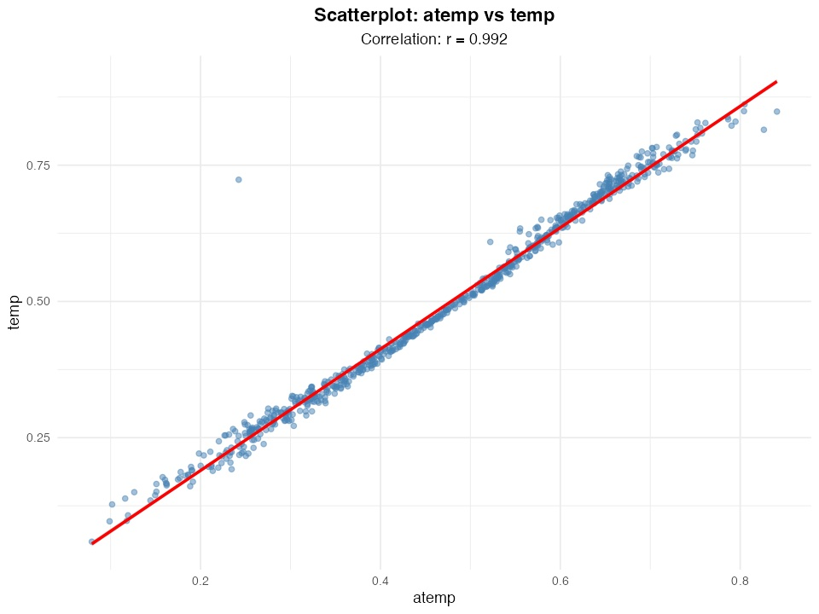
Figure 3: Scatterplot of atemp vs temp showing near-perfect linear relationship (r = 0.992).

7.2 Impact on Standard Errors and Interpretation
Multicollinearity has several important consequences for our log-transformed model:
1. Inflated Standard Errors: The relationship is SE_inflated = SE_baseline × √VIF. For temp with VIF = 80.81, this represents approximately a 9-fold increase in standard error, making it difficult to detect statistically significant effects and leading to wider confidence intervals.
2. Unstable Coefficient Estimates: In our log-transformed model, the coefficient for temp is 1.243 (p = 0.018) while atemp is 0.428 (p = 0.435). However, these estimates are unstable—small changes in the data could dramatically alter both magnitude and sign. This instability makes interpretation unreliable.
3. Difficult Interpretation: When predictors are highly correlated, the regression algorithm struggles to attribute variance uniquely to each predictor, often resulting in counterintuitive coefficient estimates.

7.3 Impact on Predictive Performance
Important distinction: While multicollinearity severely affects coefficient interpretation and statistical inference, it typically does not harm predictive performance. The model's ability to generate accurate predictions depends on the collective information provided by all predictors, not on our ability to isolate individual effects. Since temp and atemp together capture thermal conditions comprehensively, the log-transformed model can still make accurate predictions even though we cannot reliably separate their individual contributions.
This distinction is crucial for practical applications. If our primary goal is prediction (forecasting bike rentals), multicollinearity is not a major concern. However, if we need to understand the specific effect of temperature on rentals, then multicollinearity poses a serious problem.

7.4 Strategies to Address Collinearity
Several strategies exist for addressing multicollinearity in the log-transformed model:
- Remove one of the collinear predictors: Since temp and atemp contain nearly identical information, we can remove one while retaining most predictive power. We recommend removing atemp and keeping temp, as actual temperature is more fundamental and directly measurable.
- Use regularization methods: Ridge regression (covered in Part V) handles multicollinearity by shrinking correlated coefficients toward each other. This approach allows us to keep both predictors while reducing variance inflation.
- Perform variable selection: Lasso regression (also in Part V) can automatically select between collinear predictors by driving one coefficient to exactly zero.
For this analysis, we recommend the first strategy: removing atemp and retaining temp. Table 3 shows the impact of this modification.
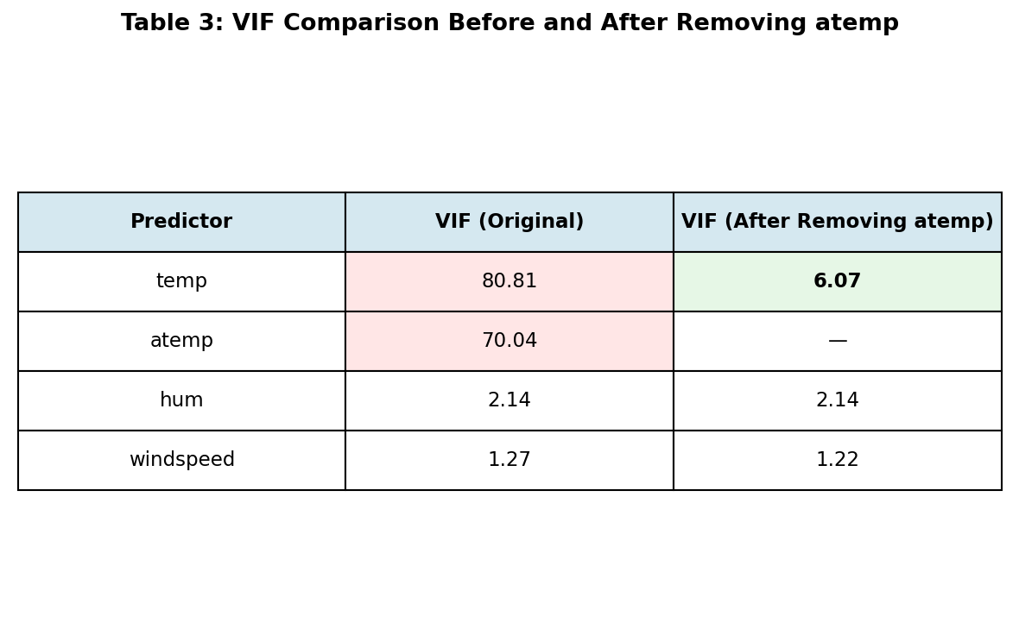
Key Finding: After removing atemp, the VIF for temp drops dramatically from 80.81 to 6.07, falling well below the moderate threshold of 10. The model's adjusted R² remains essentially unchanged at 0.7551, confirming that removing atemp has minimal impact on model fit while resolving the severe multicollinearity.

Conclusion
Our collinearity analysis of the log-transformed model revealed severe multicollinearity between temperature (temp) and feeling temperature (atemp), with a correlation of r = 0.992 and VIF values exceeding 70. This collinearity inflates standard errors by approximately 9-fold, destabilizes coefficient estimates, and makes individual interpretation problematic. However, it does not harm predictive performance.
We recommend removing atemp from the log-transformed model, which reduces the VIF for temp from 80.81 to 6.07 while maintaining model fit (adjusted R² = 0.7551). For purely predictive applications, regularization methods (ridge or lasso regression, covered in Part V) provide alternative approaches that retain both variables while managing multicollinearity through coefficient shrinkage.
Important Note on Log Transformation: While the log transformation of the response variable improves model diagnostics and assumptions (as determined in Part II), it does not affect the correlation between predictors or their VIF values. The multicollinearity problem exists in both the original and log-transformed models and must be addressed regardless of the response transformation.

