Device No.: | Version: | Revision State: | Author | Date
261503933xxxx | HW-V1 | 1 | JuSa | 19.04.2023

PCB must comply with IPC-A-600 Class 2.
PCBs must comply with Class V1 of EN60950 for flammability and temperature resistance.
PCB-Manufacture must correspond to the specifications of Würth Elektronik eiSos.
PCBs electrical tested.
PCBs must meet RoHS and Reach requirements and must be Halogen free.

Dimensions: | 80,0x22,86mm |  | Number of Layers: | 4
Tolerances: | +/- 0,2mm
After Separating (EMS) +/-0,4mm
Multiple PCB Panel: | Panel chosen by assembling service mm |  | PCBs per Panel
Step & repeat
through Manufacturer
Nominal thickness: | 1,67 mm

Material Type: |  | FR4 (135°TG) |  |  | FR4 (150°TG) |  | FR4 (170°TG)
unfilled
Separation |  | Milling |  |  | Scribing / V-Nut |  | jump
Surface |  | HAL lead-free |  |  | chem. Ni/Au |  | chem. Sn

Tin coated edges | Number of contacts |  |  | Header
 | 0 |  |  | Angular
 | Technique: cut vias |  |  | Galvanic gold

Print |  | white |  | Layer |  | 112 tprint
 |  |  |  |  |  | 26 bnames

Solder mask |  | top & bottom
Color of SM |  | rot

Drill-Scheme | Final Diameter  mm | Tol. | Aspect ratio | Number / PCB
Via smallest drill | 0,2 |  |  | 447
Plated through hole | 0,2 |  |  | 4
Plated through hole | 0,3 |  |  | 3
Plated through hole | 0,55 |  |  | 2
Plated through hole | 0,65 |  |  | 4
Plated through hole | 0,85 |  |  | 2
Plated through hole | 1 |  |  | 28
Plated through hole | 2,5 |  |  | 2
Non-plated through hole | 0,8 |  |  | 2
Non-plated through hole | 2,54 |  |  | 2

Stack Up:

Layer | Type | Material | Min. Width  mm | min. Distance  mm | min Restring  mm | Thickness  µm
1 | Top | Cu | 0,15 | 0,15 | 0,15 | 35
 |  | FR4 |  |  |  | 410
2 | Route2 | Cu | 0,15 | 0,15 | 0,15 | 35
 |  | FR4 |  |  |  | 710
15 | Route15 | Cu | 0,15 | 0,15 | 0,15 | 35
 |  | FR4 |  |  |  | 410
16 | Bottom | Cu | 0,15 | 0,15 | 0,15 | 35

Change of Material should be avoided. If not avoidable it has to be announced in advance and new samples will be necessary.

Note:
- Würth Elektronik Gerber data show the required final dimensions and positions of all structures. No compensations for process related deviations have been made to Gerber data. The supplier shall deliver the PCB with structural dimensions as defined in Würth Elektronik Gerber data.
Exception: solder resist at vias adapted by manufacture to cut outs around the drill, so that the pads are coated as complete as possible without risking of solder resist running into the vias.
 | 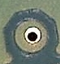

- Tin plated Edge pads:
  - No separation:
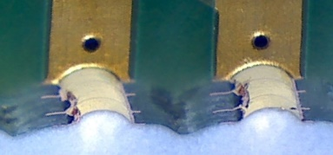
  - No chips:
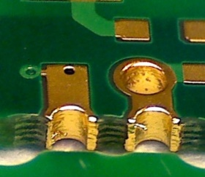
  - No metal between the pads:
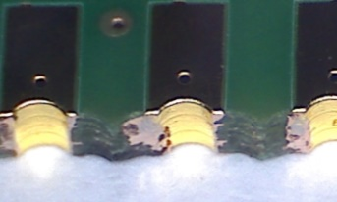

Verwendete EAGLE Version: 7.7.0

Lagenzuordnung:

Funktion der Lage | Lagenname EAGLE | Lagennr. EAGLE | Abw.  Lagenname | Abw.  Lagennr. | Verw.
Toplayer | Top | 1 | - | - | Ja
Innenlage 1 | Route2 | 2 | - | - | Ja
Innenlage 2 | Route15 | 15 | - | - | Ja
Bottomlayer | Bottom | 16 | - | - | Ja
Lötaugen | Pads | 17 | - | - | Ja
Durchsteiger | Vias | 18 | - | - | Ja
Außenkontur | Dimension | 20 | - | - | Ja
Bestückungsdruck Top | tprint | 112 | - | - | Ja
Bestückungsdruck Bottom | bnames | 26 | - | - | Ja
Lötstopp Top | tStop | 29 | - | - | Ja
Lötstopp Bottom | bStop | 30 | - | - | Ja
Paste Top | tCream | 31 | - | - | Ja
Paste Bottom | bCream | 32 | - | - | Ja
Klebung Top | tGlue | 35 | - | - | nein
Klebung Bottom | bGlue | 36 | - | - | nein
DK Bohrungen | Drills | 44 | - | - | Ja
NDK Bohrungen | Holes | 45 | - | - | Ja
Innenfräsung | Milling | 46 | - | - | Ja
Abmessungen | Measures | 47 | - | - | Nein

eigene Lagen | Lagenname  EAGLE | Lagennr.  EAGLE | Abw.  Lagenname | Abw.  Lagennr. | Verw.
Bestückungsdruck Top |  |  | tprint | 112 | Ja
Bestückungsdruck Bottom |  |  | bnames | 26 | Ja

Alle Lagen entsprechen der Eagle-Standard-Einstellung konvertieren.

Zuordnung Gerberdaten

Gerber.XXX | Beschreibung | Verw.
*.cmp | Top + Pads + Vias, Kupfer Leiterplattenoberseite | Ja
*.ly2 | Route2 + Pads + Vias, Kupfer Innenlage 1 | Ja
*.l15 | Route3 + Pads + Vias, Kupfer Innenlage 2 | Ja
*.sol | Bottom + Pads + Vias, Kupfer Leiterplattenunterseite | Ja
*.crc | tCream, Lotschablone Oberseite | Ja
*.crs | bCream, Lotschablone Unterseite | Ja
*.plc | Bestückungsdruck Top, Dimension | Ja
*.pls | Bestückungsdruck unten, Dimension5 | Ja
*.stc | tStop, Lötstopp Oberseite | Ja
*.sts | bStop, Lötstopp Unterseite | Ja
*.mil | Fräsung | Ja
*dri, drd | drill | Ja

