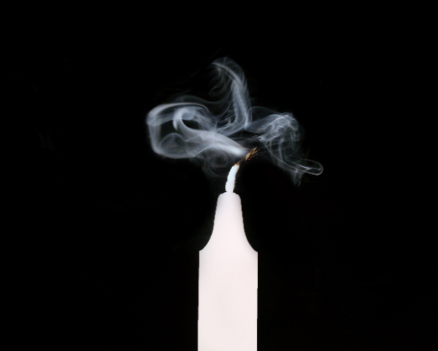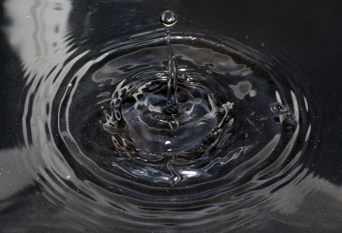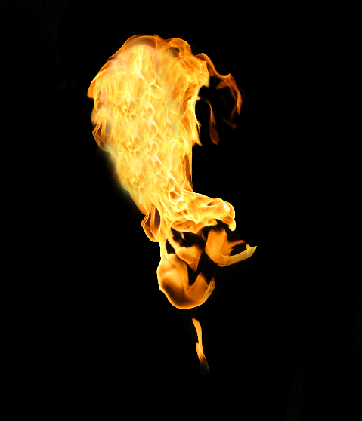V–