Problem 2:

Data collected in coordination with Param Popat and Karthik Subramanian

1,2. Coeffecient of Variation: Ratio of variance to the mean, and wild images accuracy

Run # | Machine | TTA (91%) (hrs) | Accuracy on Wild Images
1. | V100 | 4.581 | 92%
2. | V100 | 4.033 | 90%
3. | V100 | 3.833 | 88%
4. | V100 | 4.433 | 90%
5. | V100 | 3.667 | 98%
Mean |  | 4.110 | 90
Std Dev |  | 0.381 | 2.608
Coeff of Variance |  | 9.47% | -
1. | TPU | 3.012 | 88
2. | TPU | 3.050 | 86
3. | TPU | 3.117 | 92
4. | TPU | 3.565 | 92
5. | TPU | 3.667 | 90
Mean |  | 92 | 90
Std Dev |  | 3.85 | 2.608
Coeff of Variance |  | 4.20 | -

The coeffecient of variance values obtained are similar to that of the paper:
S.No | Machine Type | Our Value | ColeMan et al
1. | V100 | 9.47 | 11.2
2. | TPU | 4.2 | 4.5

3. GPU utilization varied between 85% and 100% throughout the phases of training.
Epoch 10:

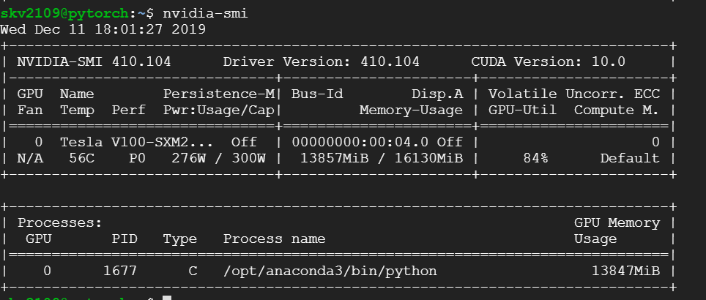

Epoch 60:

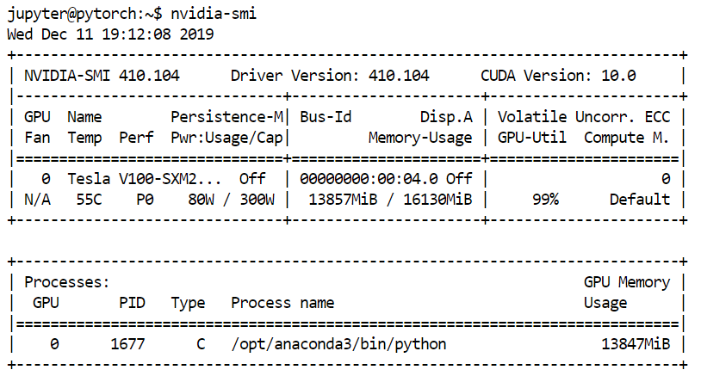

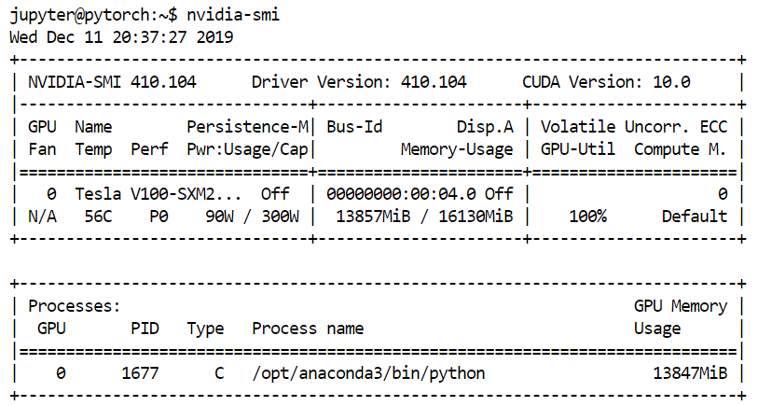
Epoch 150:

4. If the GPU utilization was indeed low, one measure we can take is to increase the batch size. This increases the amount of computation on the GPU. But we should be wary of the overall impact this has on our accuracy in itself.
If we do do so, we should also increase the learning rate as the batch size increases. This ensures the time to convergence will be in the same order of the initial setup.

