Problem 3:

Preliminaries: MobileNet evaluations:

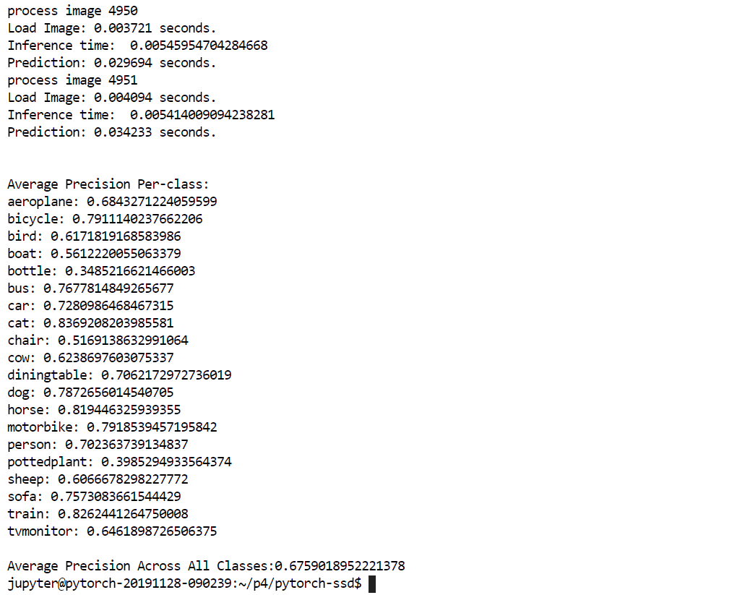

1. Gun model accuracy prior to pretraining:

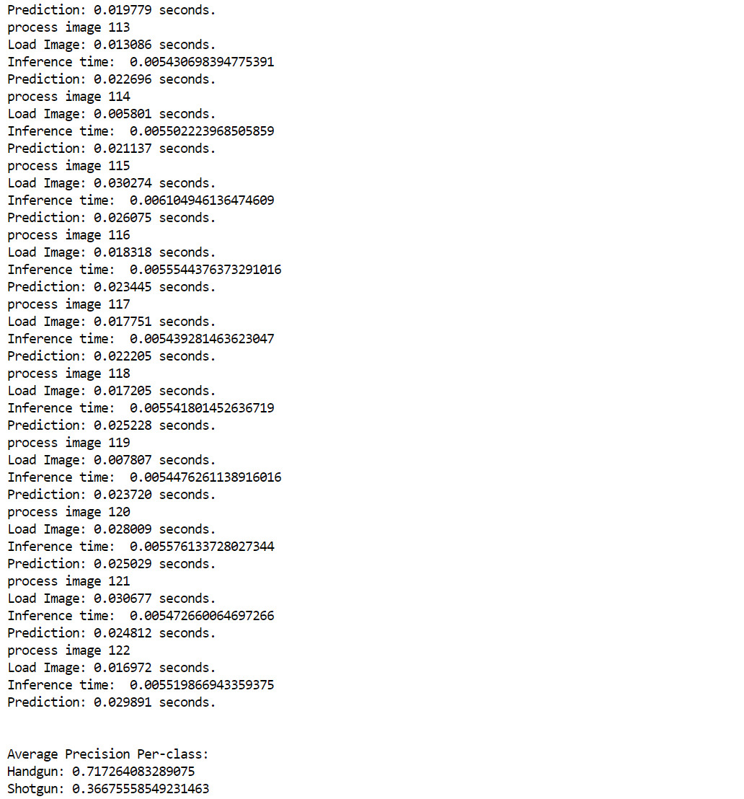

Post Retraining / FineTuning:

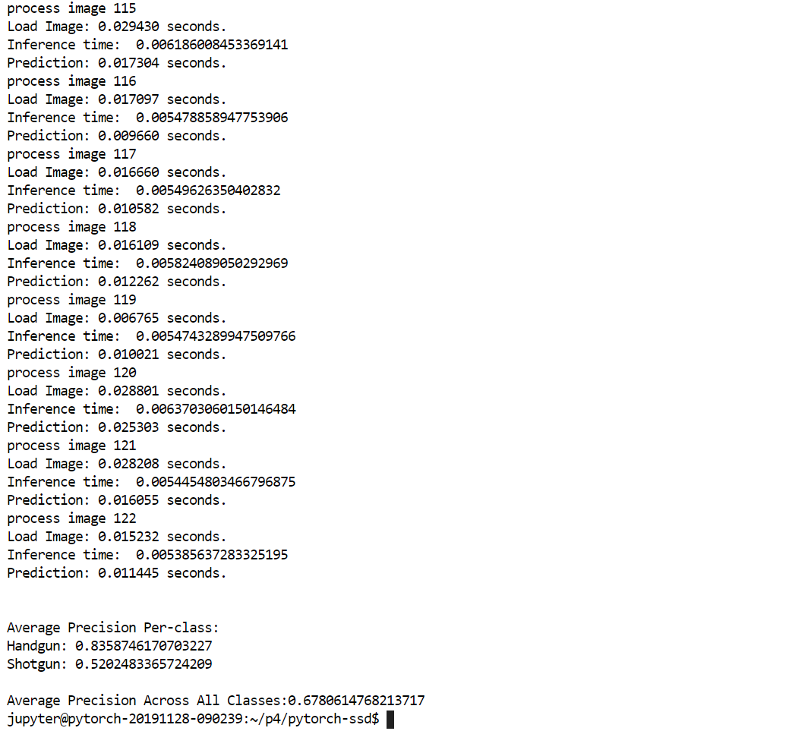

3. Sample Visualization:

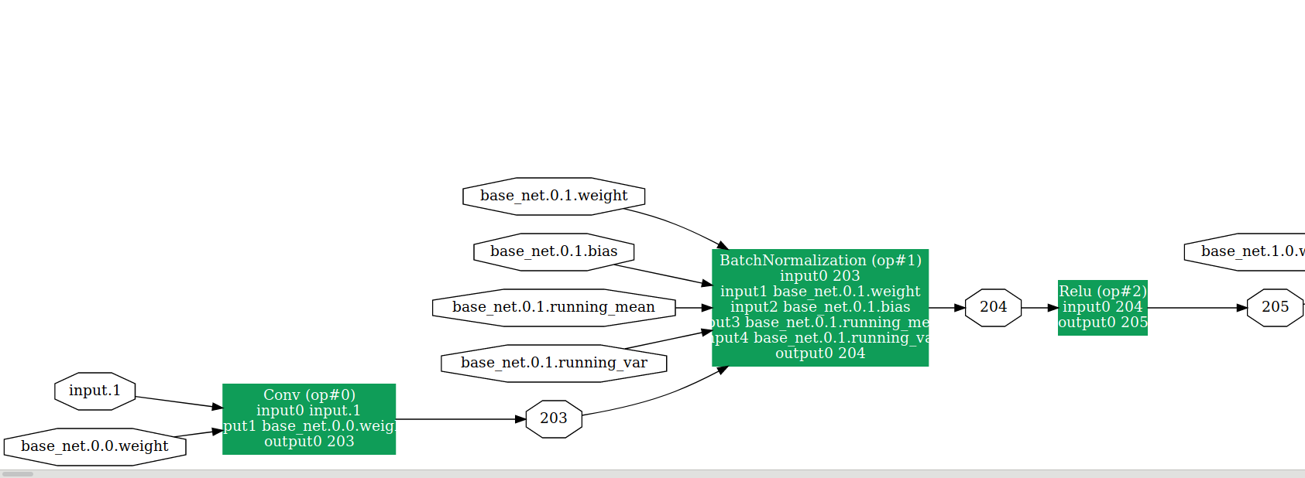

4. Onnx server running:

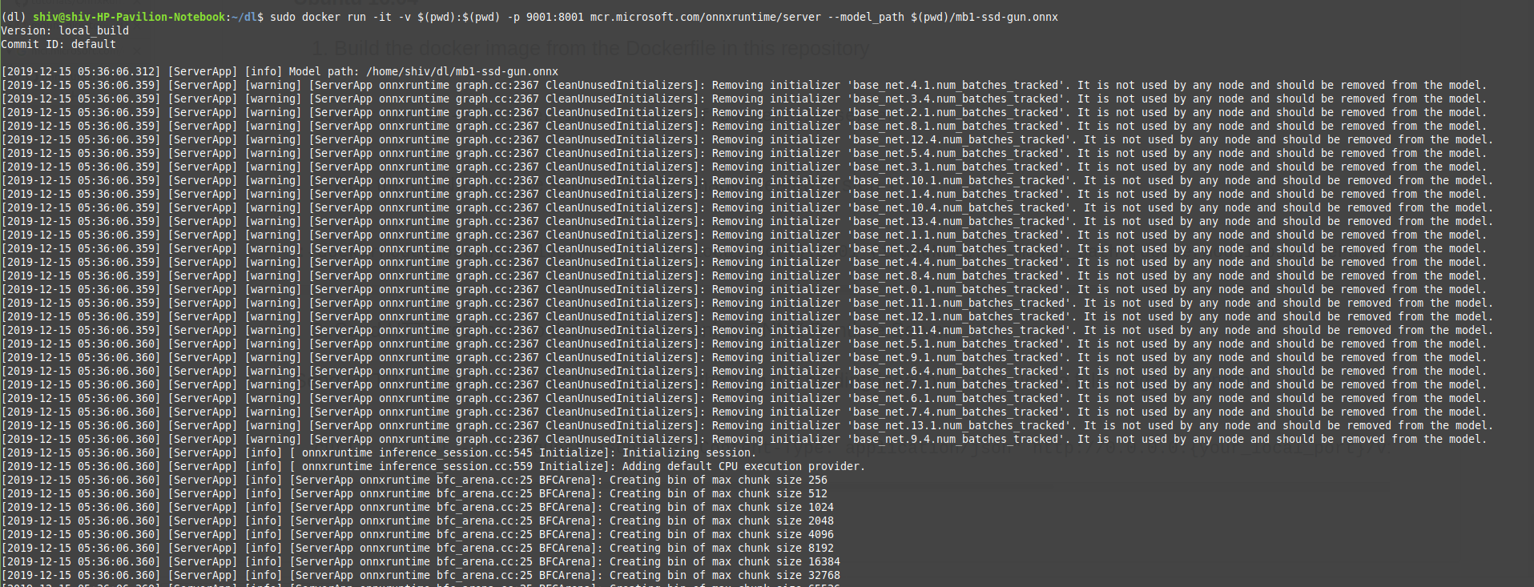

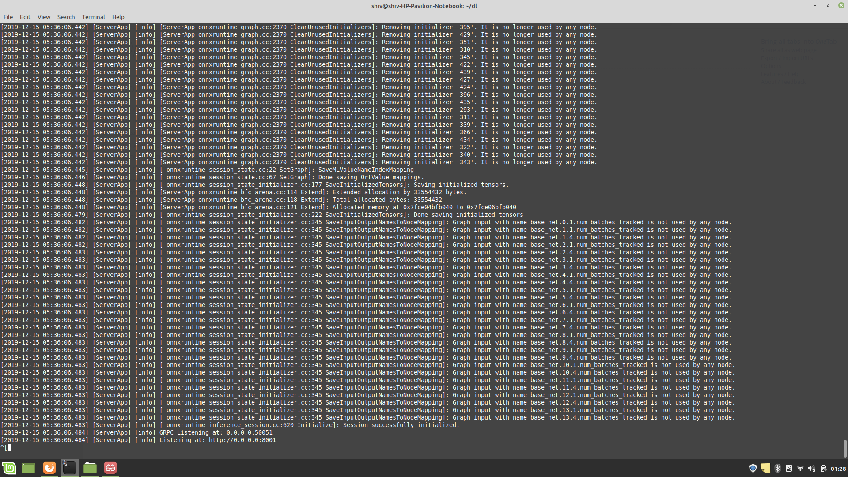

While attempting to send messages to the server, faced Protobuf errors, mostly due to version incompatibility errors.
Requires deep file optimization to rectify the errors.

