Problem 5:

1. Kubernetes cluster setup

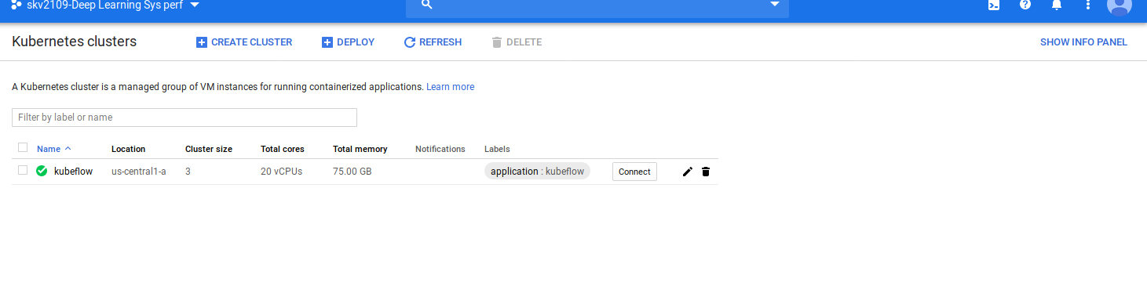
2. Container Registry Image prescence:

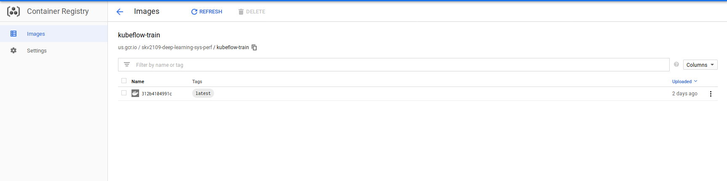

3. Job Parameters YAML file:

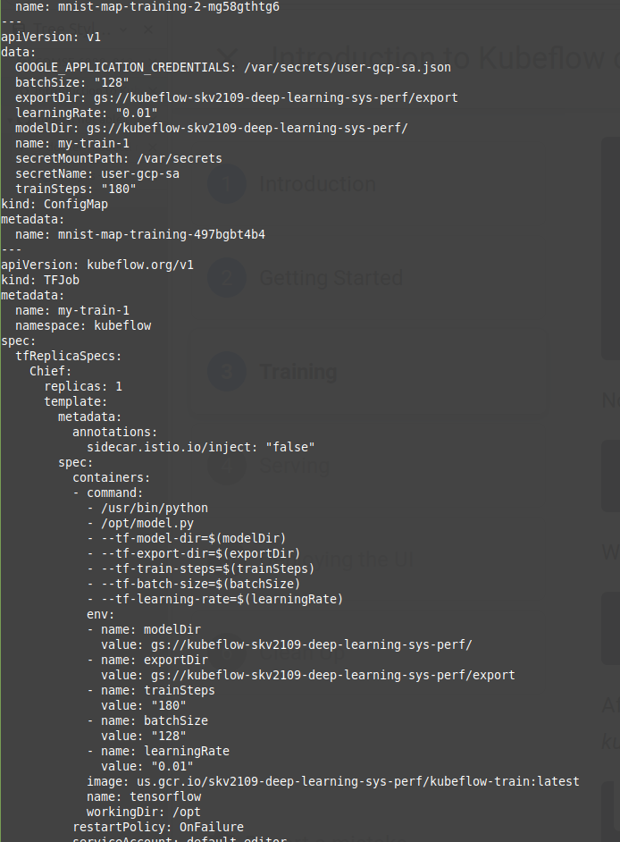

4. Job building:
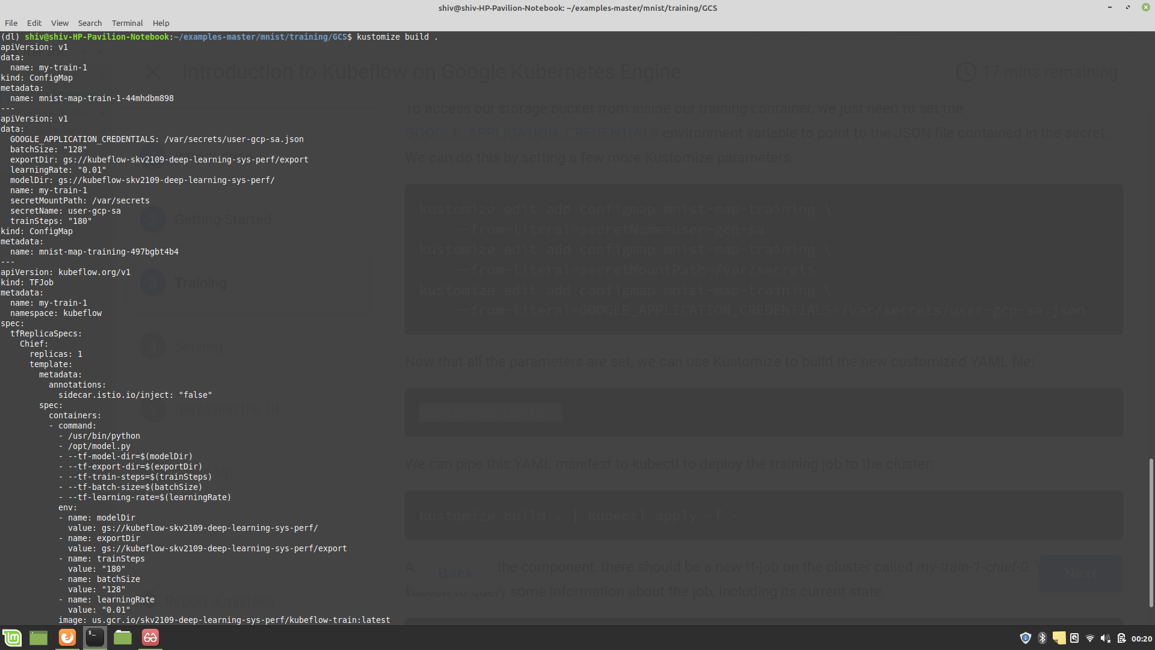

5. Job submission details:
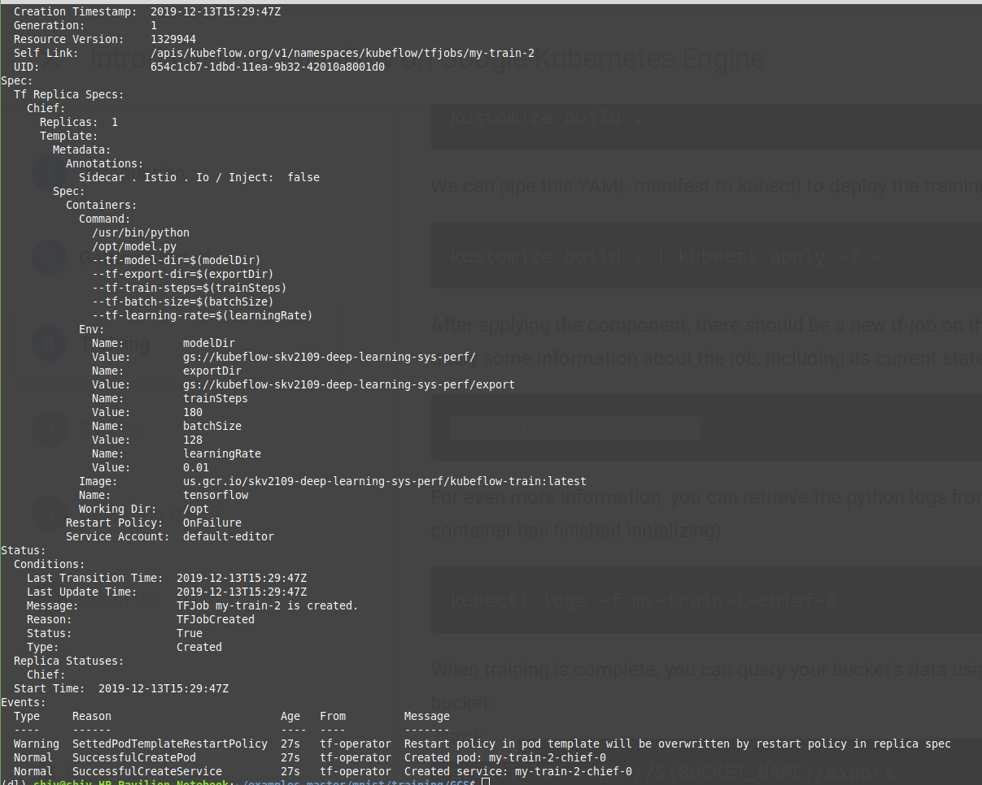

6. Error faced during cluster training, despite adding the required permissions, users and groups:

