**HeadsUp**

Contents

**HeadsUp** 1

**Short description** 3

**The idea** 3

**Demo video** 3

**The architecture** 4

**Long description** 4

**Project roadmap** 7

**Getting started** 7

**Prerequisites** 7

Software required: 7

**Installing** 7

**Live demo** 8

**Contributors** 8

**Short description**

**Problem statement:**

One of the scariest things about Covid-19 is that if we get the virus, there’s not a lot we can do. Official guidelines say to treat it at home, separate yourself from others in your living space. Covid-19 has fast developed a reputation for causing otherwise stable patients to crash alarmingly quickly. Doctors tell stories of patients who battle the virus for days or weeks seem fine, then in a matter of hours deteriorate and need to be placed on a ventilator — or worse. If you’re treating yourself for Covid-19 at home, how can you know if you’re in the middle of a serious crash? By all accounts, Covid-19 makes many people feel terrible — how can patients outside a hospital setting know when things have gone from merely awful to life-threatening?

**Can technology help?**

One potential health tool that’s rapidly emerging is the use of a home pulse oximeter. These simple devices measure the oxygen level in your blood. Pulse oximeters are especially appealing because Covid-19 has been reported to cause silent hypoxia. In this condition — which seems tailor-made to haunt the dreams of hypochondriacs — a person can walk around with a serious Covid-19 oxygen deficiency and not know about it until it’s too late. There’s only one problem — home pulse oximeters are fast becoming more scarce. It is very difficult to carry/monitor all the time. Here, we need something which can be carried always, monitored, and notify if there is any COVID-19 symptom.

**The idea**

In the modern world, everyone used to wear a watch and will be carrying the mobile most of the time. How these two will give impact to the COVID-19 to each and everyone in the world. How these two will give impact to the world in an effective and efficient way?

One potential health tool, HeadsUp developed based on the “Fitbit watch” which is going to monitor the individual’s body all the time based on heart rate and oxygen saturation rate. Fitbit watch has detailed knowledge of its users’ bodies, including their height, weight, age, heart rate trends, and overall activity levels, as well as their baseline blood oxygen levels. All this data could be integrated into a risk score for low oxygen levels — the pulse oximeter reading wouldn’t need to stand alone.

The “HeadsUp” is a very sophisticated, AI-enabled mobile application that allows early diagnosis of any health issues related to the heart, lungs, and the mind. This is a unique app that also acts as a virtual doctor, providing timely updates/notifications regarding the health condition and status to the doctor as well as the relatives, which is very useful mainly during the critical times. All the process involved here is completely automated and there is no manual intervention needed.

**Demo video**

<https://www.youtube.com/watch?v=2wZC7S2U7vc&feature=youtu.be>

**The architecture**

1. The home page of the application displays the total number of cases affected by covid-19 all over the world and in India.
2. The user can navigate to self-check feature to assess the health condition which uses Fitbit API to get the user health condition.
3. The chat box feature uses Watson assistant which is trained to answers all queries related to covid-19.
4. The application will notify the user if the user has the symptoms of covid-19.
5. The alarm is triggered if the person affected by covid-19 approaches nearby.

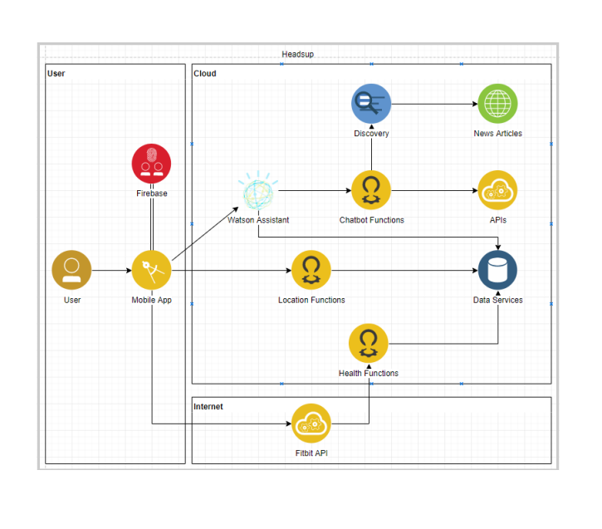

**Long description**

The HeadsUp is a user-friendly mobile application that serves as a personal health care agent. Health is the first priority for every people. The wise person will think in a way that prevention is so much better than healing because it saves the labor of being sick. To prevent illness, we should first identify it. We live in an extremely fast-moving world with hectic work schedules and lifestyles. It will be good if someone who would take care of our health, HeadsUp serves this purpose. The health conditions of the user were monitored every hour. During stress, we ignore our body health, increase in stress and anxiety will be directly related to a number of different diseases that are both physical as well as psychological. HeadsUp will track the health condition which the user has ignored. HeadsUp provides the feature to self-assess our health condition. Regular self-assessments help us to diagnose a disease before it advances to greater proportions. If something is abnormal, HeadsUp triggers the alarm at the right time. The user will receive notification about it. It is a single platform application where the user can also find the nearby hospitals and able to contact them in case of an emergency. HeadsUp will be a very useful application in this COVID-19 pandemic situation. HeadsUp has a feature to self-assess the user to check is there any chance to get affected by Covid19. It also triggers the alert if someone has the symptoms of COVID-19 is approaching the user. This application will serve its purpose beyond the pandemic situation.

**COVID19:**

COVID-19 is an infectious disease caused by severe acute respiratory syndrome coronavirus-2. There are no vaccines nor specific antiviral treatments for COVID-19. As is common with infections, there is a delay between the moment a person is first infected and the time he or she develops symptoms. An early key to the diagnosis is the tempo of the illness. Early symptoms may include a wide variety of symptoms but infrequently involves shortness of breath. Shortness of breath usually develops several days after initial symptoms. Shortness of breath that begins immediately along with fever and cough is more likely to be anxiety than COVID-19. Here is the enablement coming with HeadsUp mobile app. Which is going to monitor/notify us based on oxygen saturation rate, heart rate, and sleep time.

**Cardiovascular disease:**

Cardiovascular diseases (CVDs) are the number one cause of death globally: more people die annually from CVDs than from any other cause. An estimated 17.9 million people died from CVDs in 2016. People with cardiovascular disease or who are at high cardiovascular risk (due to the presence of one or more risk factors such as hypertension, diabetes, hyperlipidemia, or already established disease) need early detection and management using counseling and medicines, as appropriate. **HeadsUp is one choice for CVDs to save lives**.

**Pneumonia:**

Pneumonia accounts for 15% of all deaths of children under 5 years old, killing 808 694 children in 2017. Pneumonia caused by bacteria can be treated with antibiotics, but many kids are struggling with this disease in this modern world. HeadsUp can advise us to check the respiratory system in early stage using heart rate.

**Solution and benefit:**

A solution to mitigate all the chaos and mess of the current pandemic situation is an immediate thing that the entire world is waiting for. “HeadsUp” will bring a huge impact in making this possible, which allows for early detection of symptoms that cause the disease through frequent monitoring using Fitbit watch. It also facilitates effective communication by enabling regular sharing and updating of various health factors like heart rate graph, oxygen saturation rate and etc to the near and dear. This special feature is what is going to create a big difference among the rest of the health apps that are already available in the market, and hence a reliable and highly supportive application that is worth using for all the ages around the world.

**Completeness and transferability**

“HeadsUp” completed with first set of features which is very useful to this pandemic situation that can detect not only COVID-19, but also other heart/lung related issues and other mental health problems. Other useful additional features include quick communication to the doctor/relatives at emergency situations and frequent tracking of the heart, lung and the mental health. Also, this provide chatbot which provide accurate answer to COVID19 related questions and various information across the world

**Effectiveness and efficiency**

The “HeadsUp” is now a complete mobile application that comes with a first set of features and is very substantive especially in the current catastrophic COVID situations, where a lot of lives are at a high risk. This app can make a huge difference in saving people’s lives due to the early detection of symptoms that causes the disease through frequent monitoring. Early detection of symptoms is made possible by monitoring various factors such as the heart rate, oxygen saturation rate etc. For example, if in case the graph of a reading, say the total number of heart rates per minute is not within the desired threshold, it can immediately notify the registered individual for this person. So, “HeadsUp” is in fact a biggest lifesaver literally. This also comes with an inbuilt interactive chatbot that can provide accurate answer to COVID19 related questions and various information from across the world. The other main significance of this application is that it is also platform independent (supported in Android, iOS and etc).

HeadsUp can be used effectively for various danger disease like Cardiovascular disease, Pneumonia, Influenza virus and any other disease which can be capture from heart rate and oxygen saturation.

**Design and usability**

Platform independence is a significant feature for any software application because they invest a large amount of money developing a modern, sophisticated application so they don't want to artificially cut out any market segment. it implies good programming practices. if our app is made orthogonal to the platform, then changing the platform is a breeze. Here, we make use of the React Native framework, which is one of the high performing frameworks and unique for cross-platform mobile app development for both iOS and Android. Apps with this technology have a native look and feel. Moreover, some technology enthusiasts consider that react native apps are the future of hybrid mobile apps. On the other hand, it is also a good design to extract the data from various APIs.

React native isolates the functionality of the program into several independent and interchangeable blocks called modules. This architecture allows for reusability of modules making it compatible with both web and mobile APIs, quick upgrade and update of the applications.

HeadsUp app is very simple and easy to use. Usability and performance are the main criteria we have considered during the development. It is very easy to navigate from one screen to another screen. HeadsUp has simple, user-friendly menu slider which facilitates easy navigation from one screen to the other in the app. We recommend mandating this app to everyone since “HeadsUp” is specially designed to perform a continued monitoring and catching any health problems at a very early stage and can save a lot of lives.

**Creativity and innovation**

Today, one of the most intimidating problems of the world is COVID-19. Also, there are many people struggling with cardiovascular disease, Pneumonia, Influenza virus lungs disease and other common cold. “HeadsUp” can a biggest game changer for all these problems that could aid saving a huge number of lives. Most of the health conditions are treatable when detected early and “HeadsUp” can help with this and create a huge impact in improvising the quality of the people’s lives without the need of any manual effort. One of the other greatest innovations of “HeadsUp” is the unique notification feature that helps alert the family/relatives or friends (whoever is registered) which might in turn help save peoples’ lives at a crucial stage. A detailed history and summary of certain health factors like heart rate are easily kept track off by syncing up with the other apps. So, using an application like “HeadsUp” is a no brainer in the COVID season and solves a numerous amount of long-standing problems of the current situation.

**Project roadmap**

**Getting started**

These instructions will get you help you to deploy the mobile applications.

**Prerequisites**

Software required:

1. Androidstudio
2. Nodejs
3. gradle 5.4.1
4. jdk1.8.
5. react-native

**Installing**

Steps to get a development env running

Go to root folder for the project and run following command.

1. npm install
2. yarn install
3. yarn android

**Live demo**

Built with

* IBM Cloud Foundry – Used for deployment
* IBM Cloud Function – Used for chat bot and health check
* IBM Discovery service- Used for chat bot
* DB2 : This is used to store the app related information
* Fitbit Web api- To get the user health detail from Fitbit watch
* FireBase – Used for authentication

**Contributors**

* Ashwini
* Jeyakannan
* Priya
* Rajkumar
* Vijendran